Bipeen Sinha

AI Agent development
Azure Foundry

Table of Contents
1. Objective 1
2. Prerequisites 2
3. Lab Steps (Basic Chat) 3
3.1 Create Azure Foundry Chat Resource 3
3.2 Configure your agent 10
3.3 Test your agent 16

Objective
By the end of this lab, learners will be able to:
- Create an Azure AI Foundry resource and project
- Deploy and use the GPT-4o model
- Set up a Python development environment
- Build a basic chat application using Azure OpenAI SDK
- Implement an interactive conversational chatbot with memory

Prerequisites
Before starting, ensure you have:
- An active Azure Subscription
- Access to Azure AI Foundry portal
- Basic knowledge of:
  - Python
  - Command line / terminal
- Installed tools:
  - Python 3.8+
  - VS Code (or any IDE)
- Internet connection
- Permissions to create Azure resources

Lab Steps (Basic Chat)
What you are doing:
You are creating a cloud-based AI backend that hosts the GPT model.
Why this matters:
Instead of running AI locally (which is heavy), Azure provides:
- Pre-trained models
- Scalable infrastructure
- Secure API access

Create Azure Foundry Chat Resource
Follow these steps to create your AI project:
- In a web browser, open the Foundry portal at https://ai.azure.com and sign in using your Azure credentials
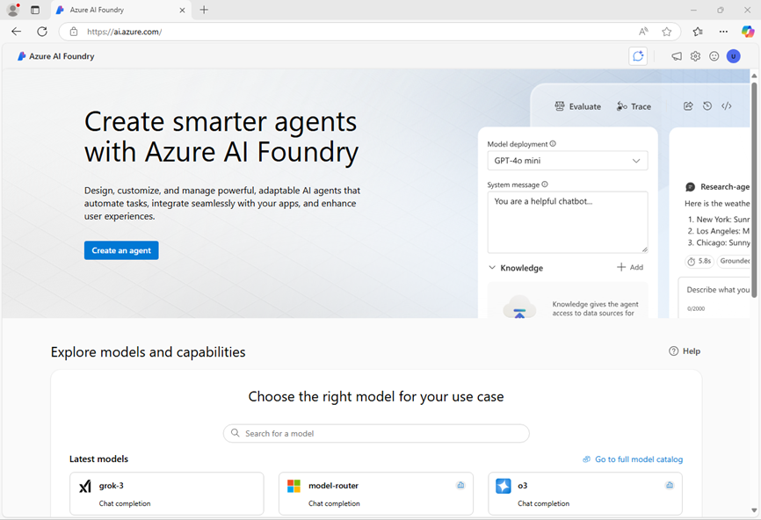
- In the home page, in the Explore models and capabilities section, search for the gpt-4o model; which we’ll use in our project. Select the gpt-4o model .
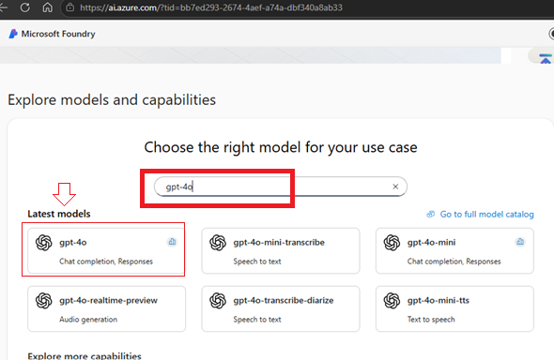
- At the top of the page for the model, select Use this model.

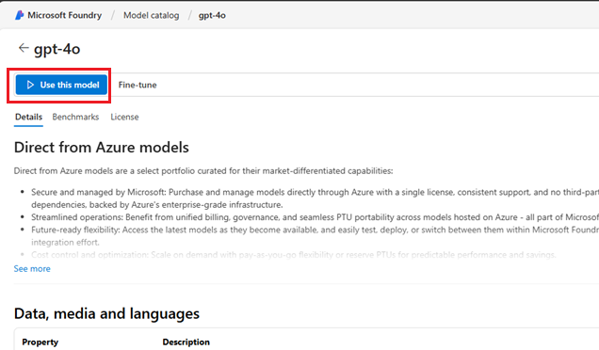

- Click drop down and select create a new project
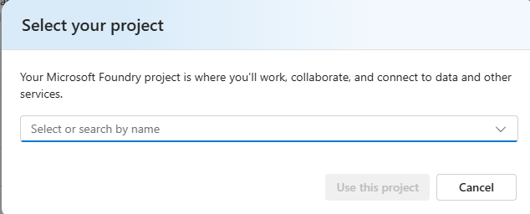

- Enter a valid name for your project and click Advance Options
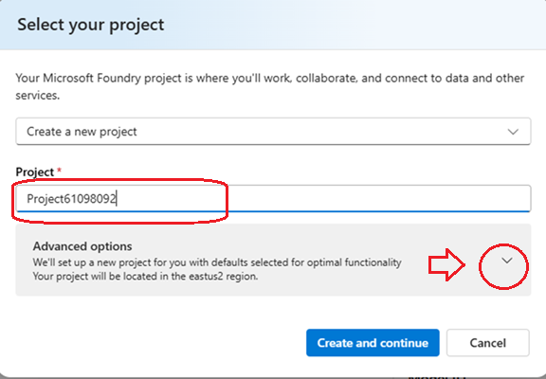

- Specify the following settings for your project:
  - Foundry resource: A valid name for your Foundry resource
  - Subscription: Your Azure subscription
  - Resource group: Create or select a resource group
  - Region: Select any AI Foundry recommended*

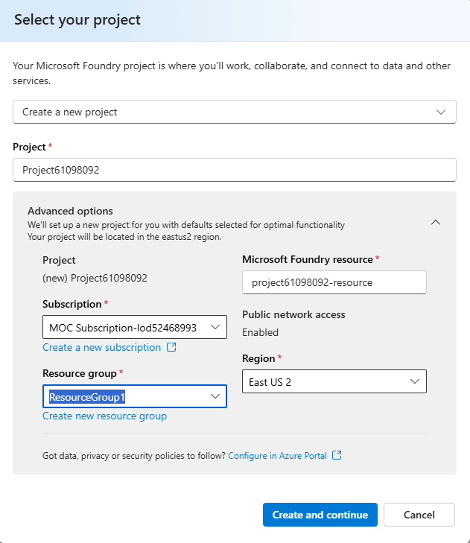
- Select Create and continue and wait for your project, including the gpt-4o model deployment you selected, to be created.
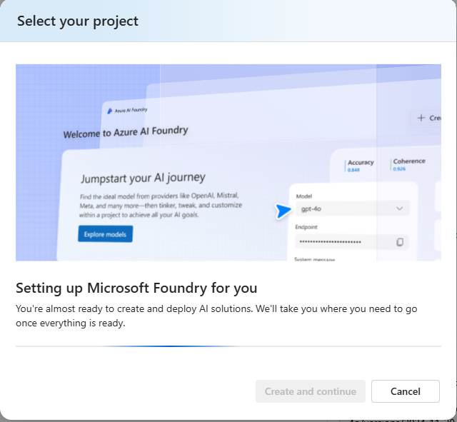

- Depending on your available quota for gpt-4o models you might receive a additional prompt to deploy the model to a resource in a different region.

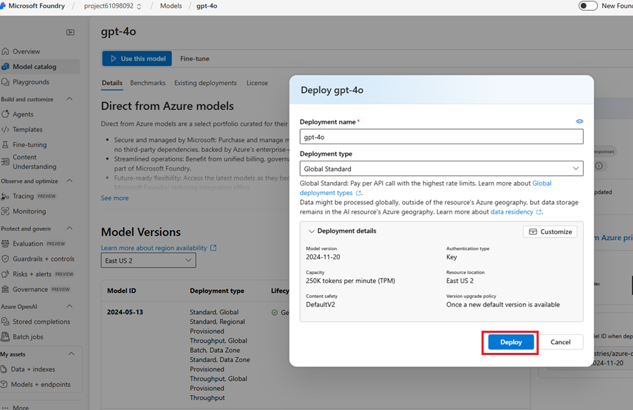

- Note the Target URI and Endpoint Key , we will use it in our lab
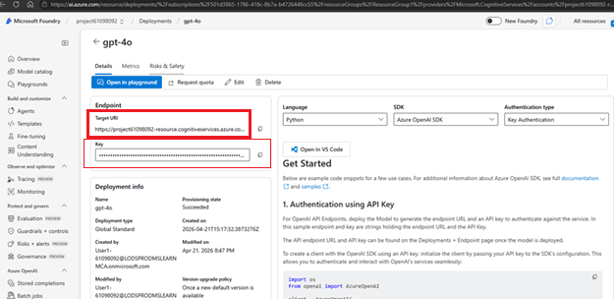

Configure your agent
Step 2.1 – Navigate to Agent Builder
- Go to Playgrounds → Agents
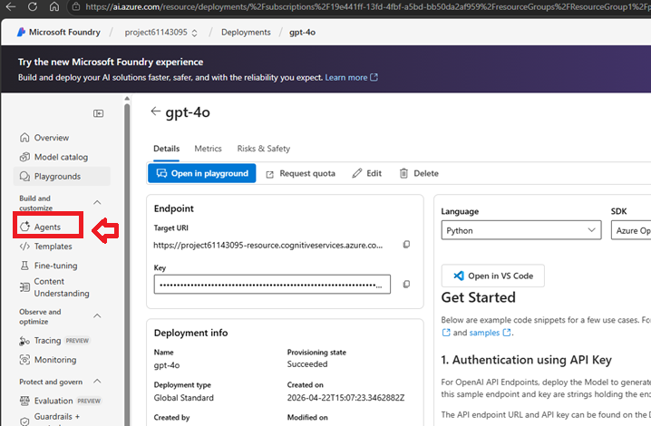

Step 3.2 – Create Agent
- Click + Create Agent
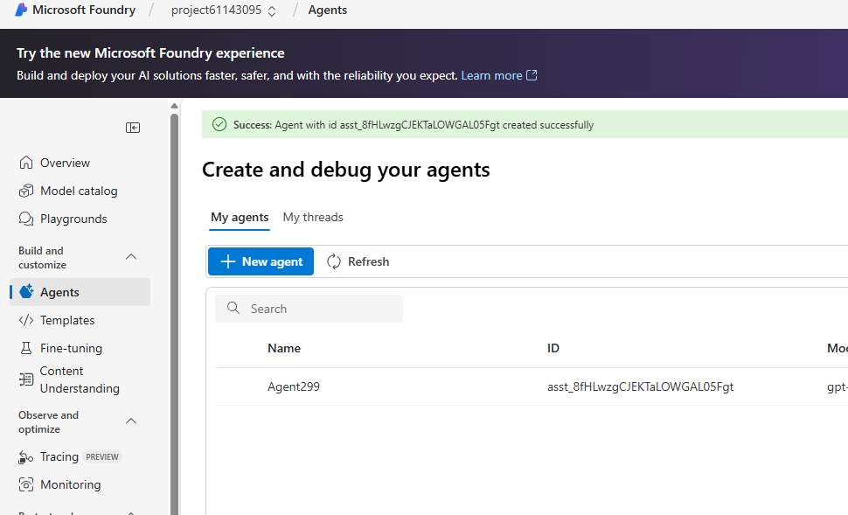
Fill details:
- Name: expense-agent
- Instructions:
You are an AI assistant for corporate expenses.
You answer questions about expenses based on the expenses policy data.
If a user wants to submit an expense claim, you get their email address, a description of the claim, and the amount to be claimed and write the claim details to a text file that the user can download.
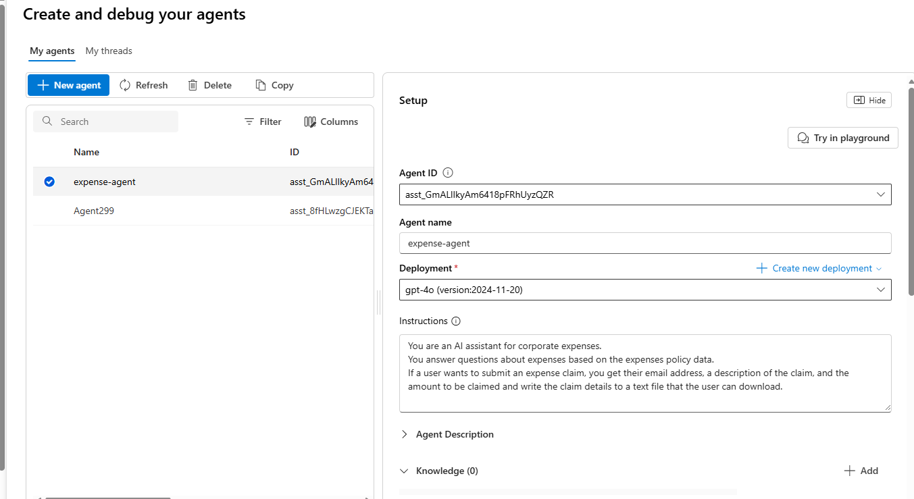
- Below the Instructions, expand the Knowledge section and click Add

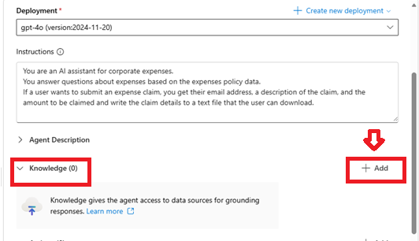

- Click Files from Add knowledge

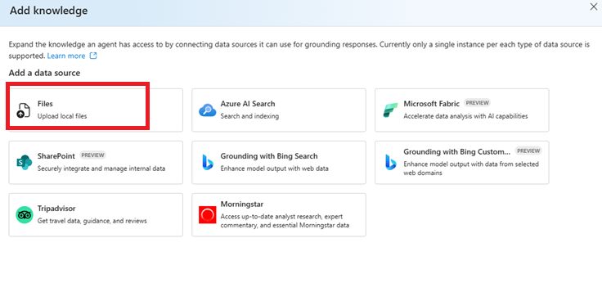
- Keep the default values for Vector store
- Use the Select local files option to upload the Expenses_policy.docx local file that you downloaded previously.

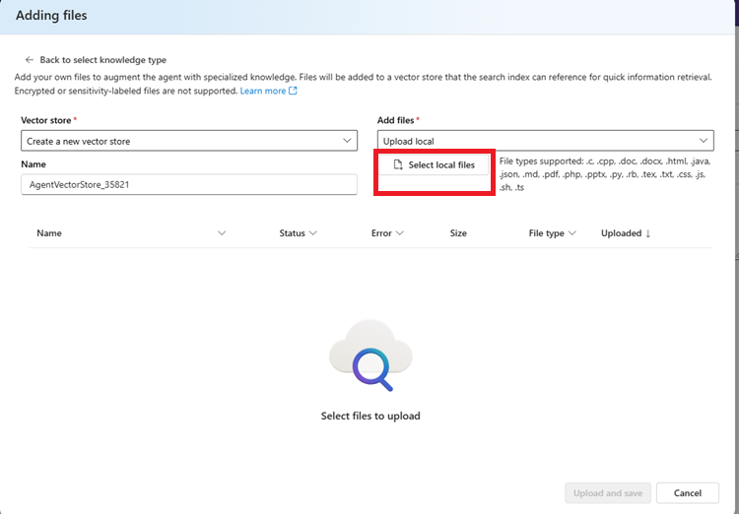

- Click upload and save

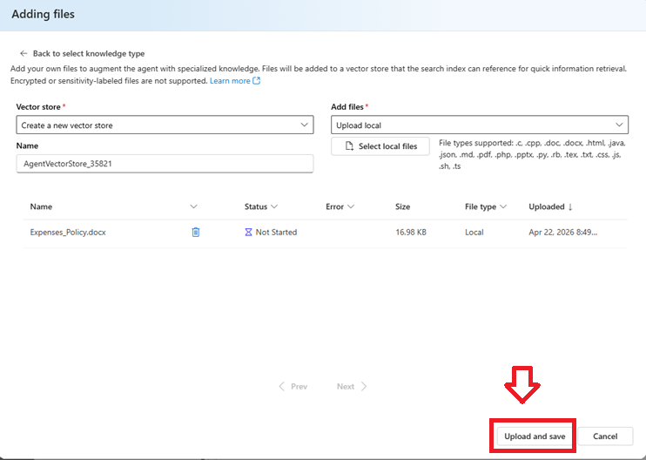

- In the Action section, select + Add.
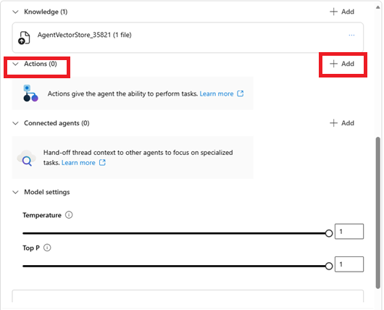

- In the Select a tool dialog box, select Code interpreter
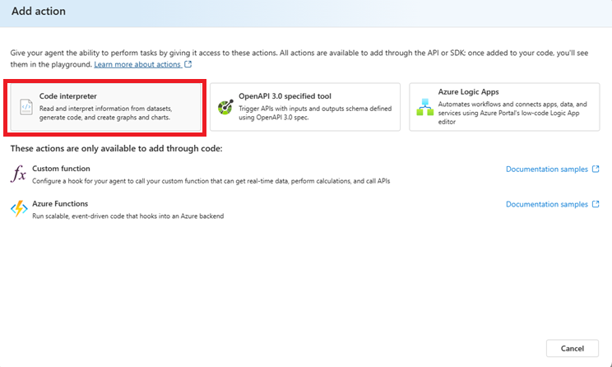
- Then select Save (you do not need to upload any files for the code interpreter).

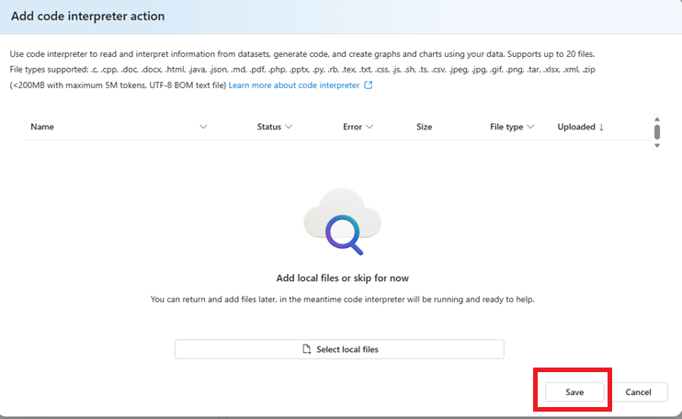

Your agent will use the document you uploaded as its knowledge source to ground its responses (in other words, it will answer questions based on the contents of this document). It will use the code interpreter tool as required to perform actions by generating and running its own Python code.

Test your agent
Now that you've created an agent, you can test it in the playground chat. Open Playground
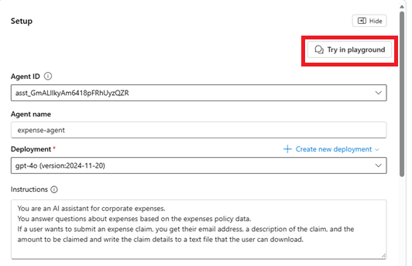
- Verify Agent Name and other details and start typing your prompt

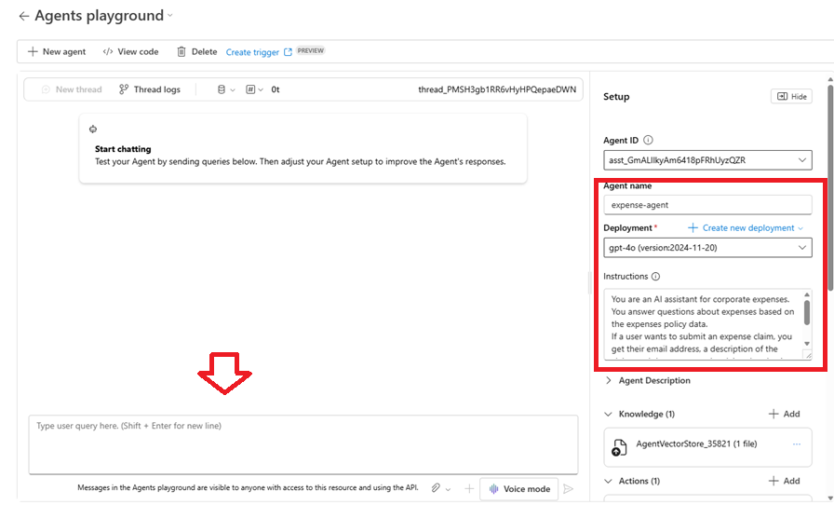

- In the playground chat entry, enter the prompt:

What's the maximum I can claim for meals?
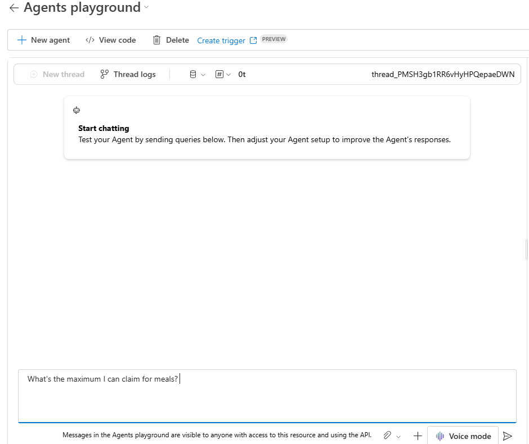

Review the agent's response - which should be based on information in the expenses policy document you added as knowledge to the agent setup.
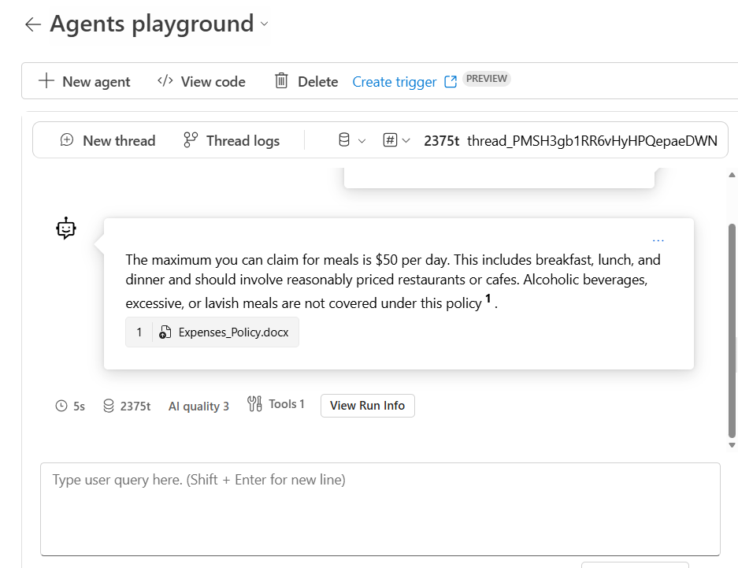

- Try the following follow-up prompt:
I'd like to submit a claim for a meal.

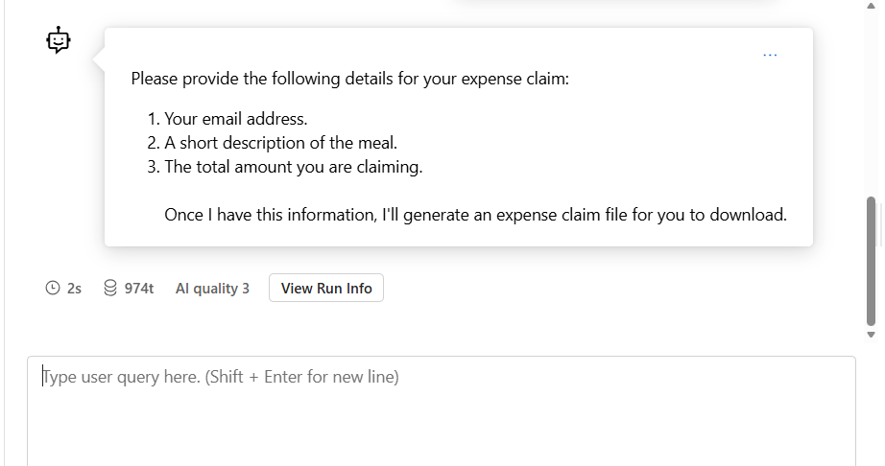
and review the response. The agent should ask you for the required information to submit a claim.
- Provide the agent with an email address; for example, fred@contoso.com. The agent should acknowledge the response and request the remaining information required for the expense claim (description and amount)

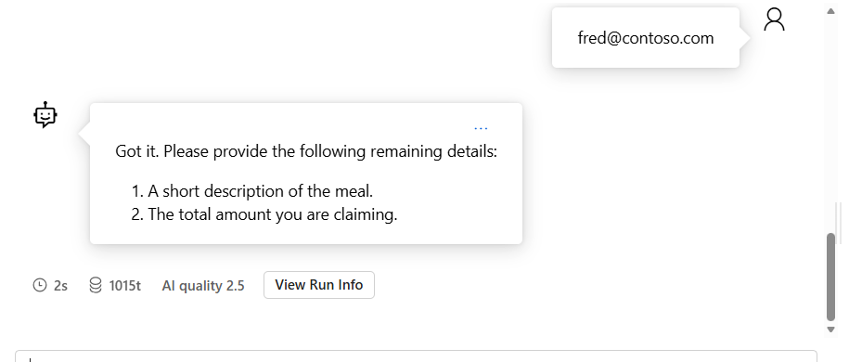

  - Submit a prompt that describes the claim and the amount; for example,
Breakfast cost me $20.

  - The agent should use the code interpreter to prepare the expense claim text file, and provide a link so you can download it.
