Bipeen Sinha

Create a generative AI chat app
Azure Foundry

Table of Contents
1. Objective 2
2. Prerequisites 2
3. Lab Steps (Basic Chat) 2
1. Create Azure Foundry Chat Resource 3
2. Set Up Local Development Environment 9
3.Create a Python virtual environment 9
4.Activate the virtual environment 10
5. Add Your Azure Details ( Configure Environment Variables) 12
6: Build Basic Chat Application (Paste Working Code) 12
7: Test Your Chatbot 13
4. Lab Step: Interactive Chat 14

Objective
By the end of this lab, learners will be able to:
- Create an Azure AI Foundry resource and project
- Deploy and use the GPT-4o model
- Set up a Python development environment
- Build a basic chat application using Azure OpenAI SDK
- Implement an interactive conversational chatbot with memory

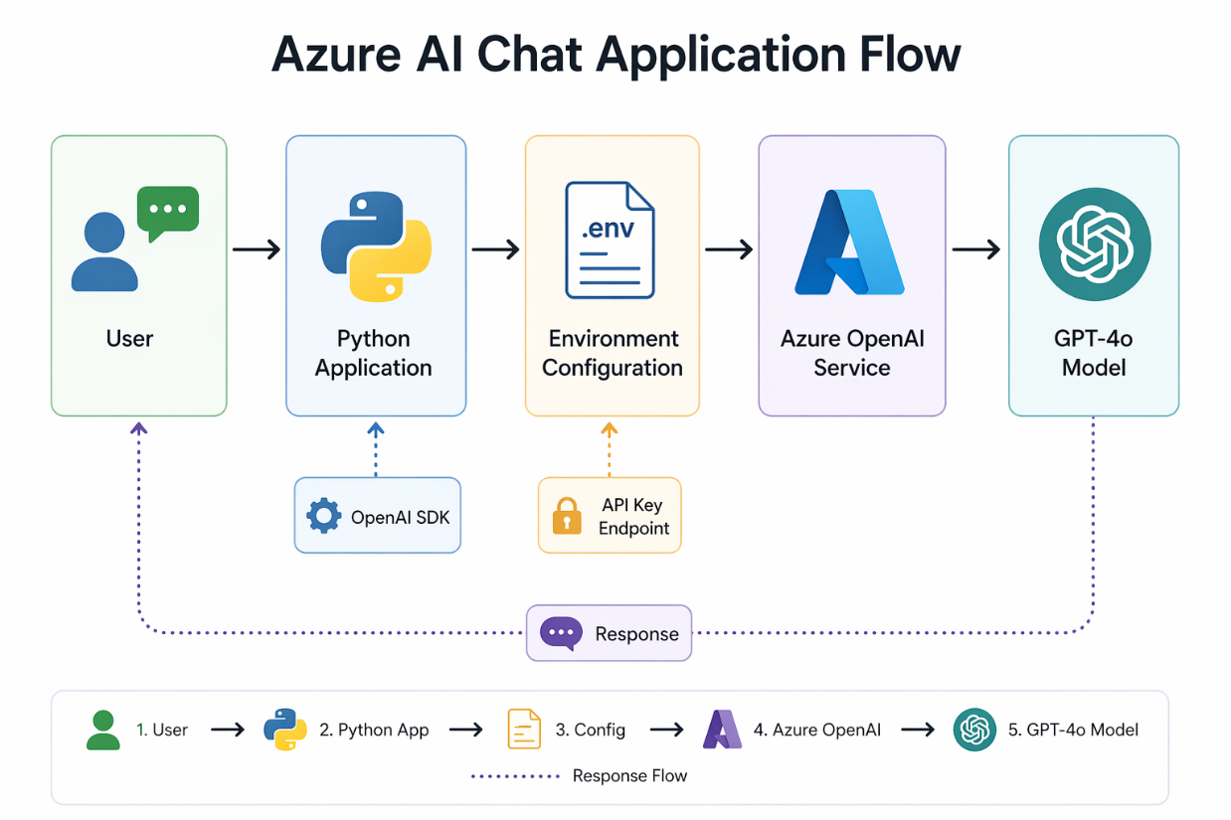

Prerequisites
Before starting, ensure you have:
- An active Azure Subscription
- Access to Azure AI Foundry portal
- Basic knowledge of:
  - Python
  - Command line / terminal
- Installed tools:
  - Python 3.8+
  - VS Code (or any IDE)
- Internet connection
- Permissions to create Azure resources

Lab Steps (Basic Chat)
What you are doing:
You are creating a cloud-based AI backend that hosts the GPT model.
Why this matters:
Instead of running AI locally (which is heavy), Azure provides:
- Pre-trained models
- Scalable infrastructure
- Secure API access
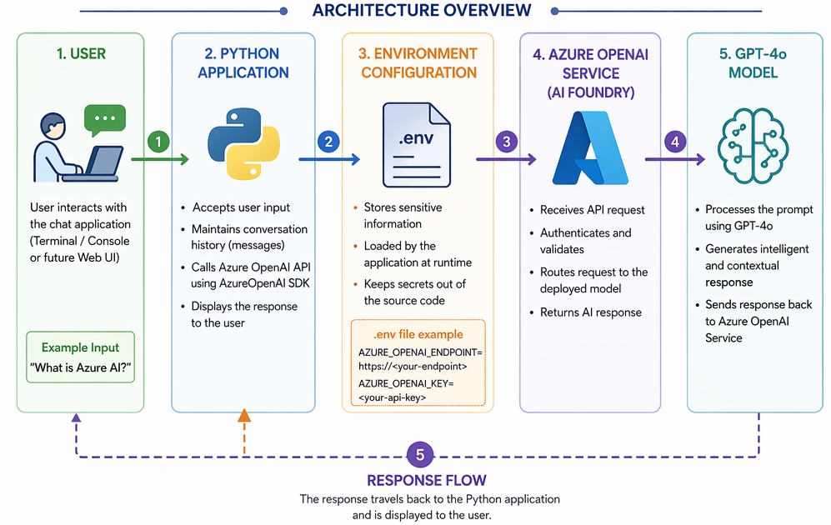

1. Create Azure Foundry Chat Resource
Follow these steps to create your AI project:
- In a web browser, open the Foundry portal at https://ai.azure.com and sign in using your Azure credentials
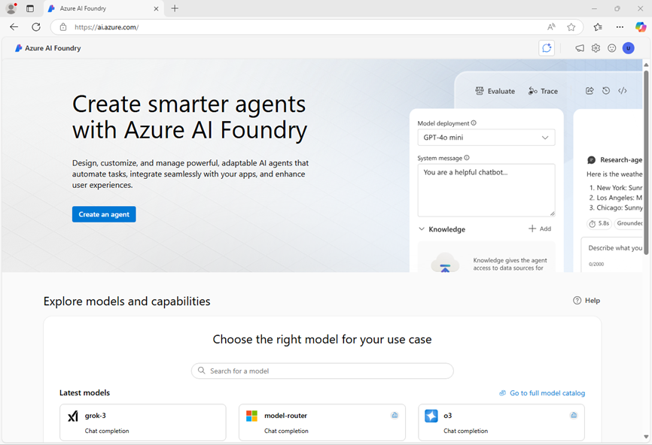
- In the home page, in the Explore models and capabilities section, search for the gpt-4o model; which we’ll use in our project. Select the gpt-4o model .
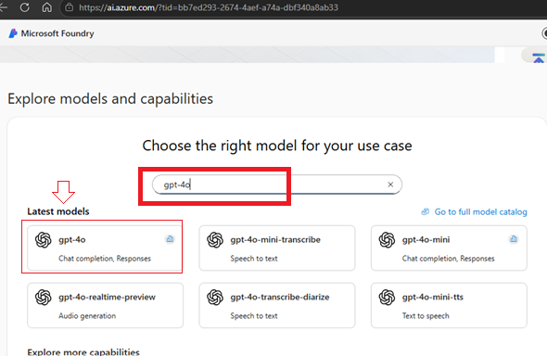
- At the top of the page for the model, select Use this model.

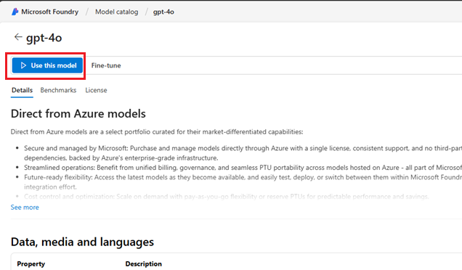

- Click drop down and select create a new project
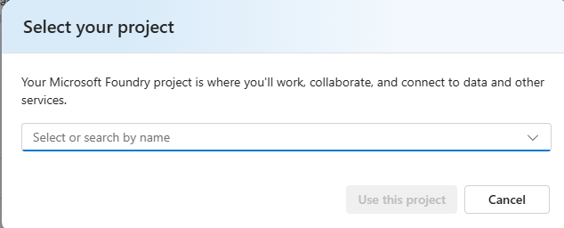

- Enter a valid name for your project and click Advance Options
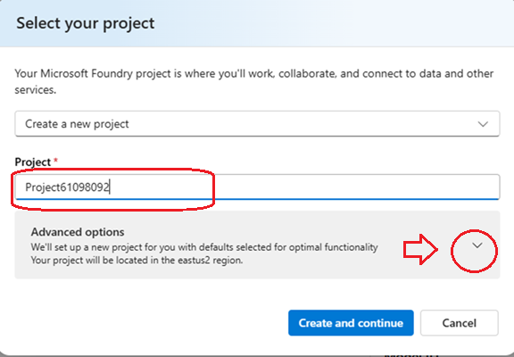

- Specify the following settings for your project:
  - Foundry resource: A valid name for your Foundry resource
  - Subscription: Your Azure subscription
  - Resource group: Create or select a resource group
  - Region: Select any AI Foundry recommended*

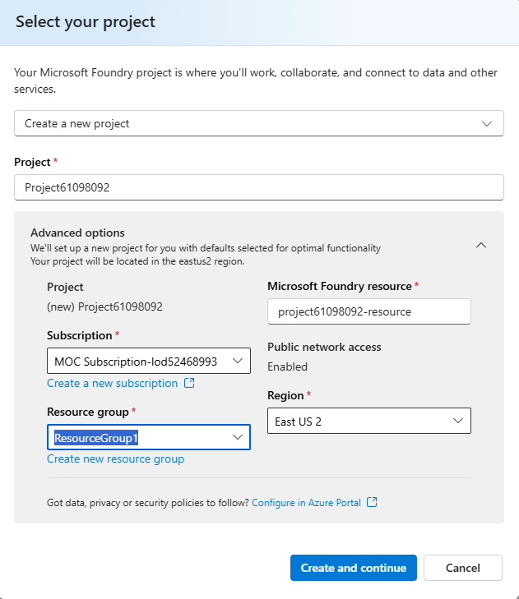
- Select Create and continue and wait for your project, including the gpt-4o model deployment you selected, to be created.
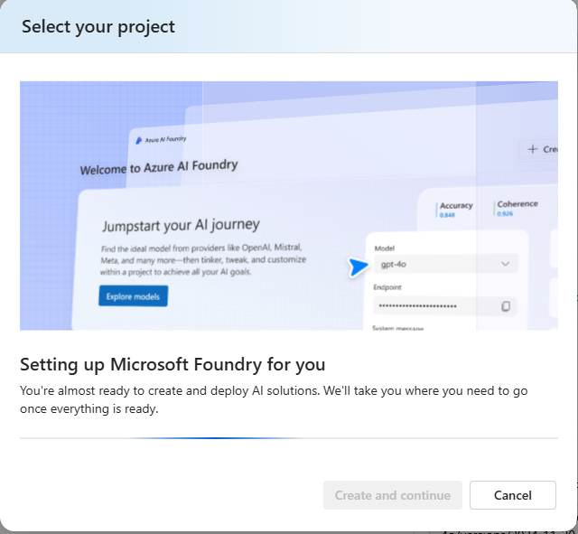

- Depending on your available quota for gpt-4o models you might receive a additional prompt to deploy the model to a resource in a different region.

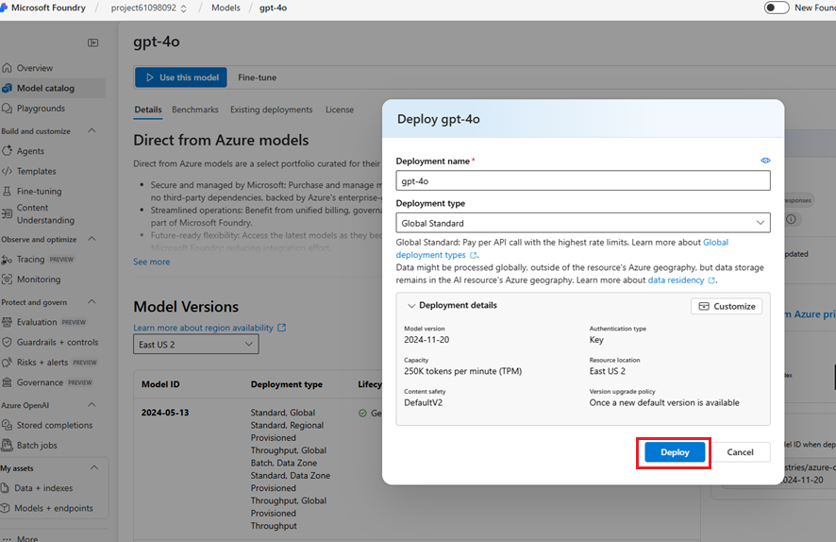

- Note the Target URI and Endpoint Key , we will use it in our lab
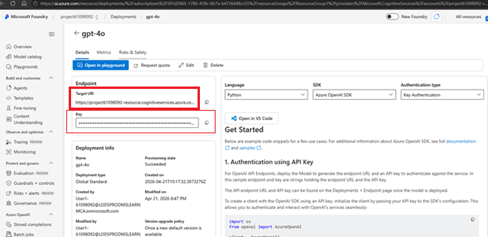

2. Set Up Local Development Environment
- Create a project folder chat-app in your C:\ drive
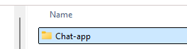
- Open the chat-app folder vs code
- In the VS Code launch PowerShell terminal

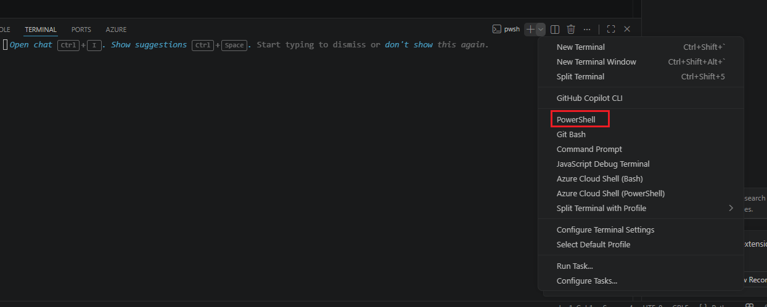

3.Create a Python virtual environment
A Python virtual environment is like a separate mini Python setup inside your project.

py -m venv labenv

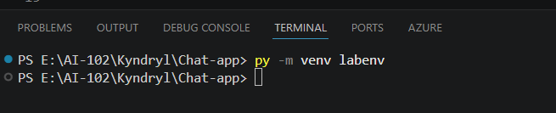

Notice new folder and files

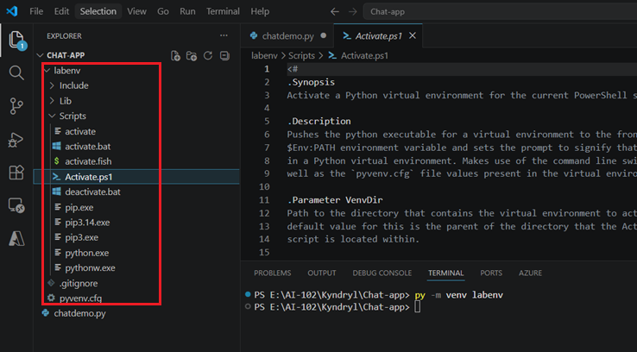

4.Activate the virtual environment
What activation does:
- Tells system: “Use this environment”
- Installs packages locally (not globally)

.\labenv\Scripts\Activate.ps1

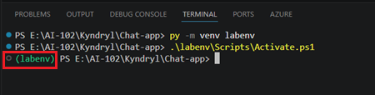

Step 4: Install Required Package

1. openai (Azure OpenAI SDK)
- Lets Python talk to Azure AI
- Sends request → gets AI response
pip install -r requirements.txt

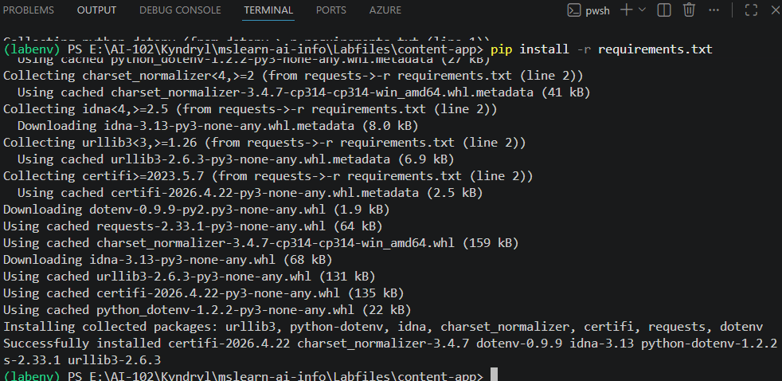

5. Add Your Azure Details ( Configure Environment Variables)
Instead of writing secrets in code , We use env to store secret
- Open file: .env
- In the code file, replace the YOUR_ENDPOINT and YOUR_KEY placeholders with the your Azure AI services endpoint and either of its keys (copied from the Azure portal), and ensure that ANALYZER_NAME is set to business-card-analyzer.
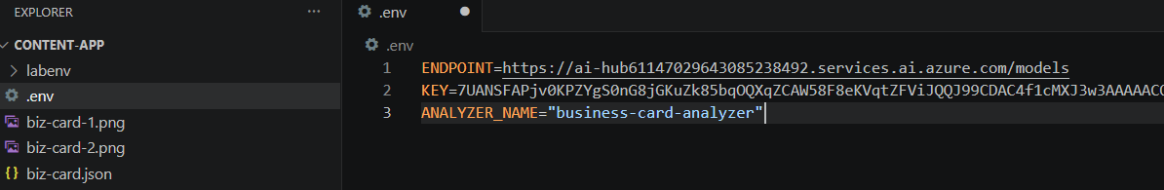

6: Build Basic Chat Application (Paste Working Code)
Create a file chatdemo.py and paste below code
import os
from openai import AzureOpenAI
from dotenv import load_dotenv

# Load environment variables
load_dotenv()

endpoint = os.getenv("AZURE_OPENAI_ENDPOINT")
api_key = os.getenv("AZURE_OPENAI_KEY")

client = AzureOpenAI(
api_version="2024-12-01-preview",
azure_endpoint=endpoint,
api_key=api_key
)

response = client.chat.completions.create(
model="gpt-4o", # deployment name
messages=[
{"role": "system", "content": "You are a helpful assistant."},
{"role": "user", "content": "I am going to Paris, what should I see?"}
],
max_tokens=200
)

print(response.choices[0].message.content)
print("Endpoint:", endpoint)
print("Key exists:", api_key is not None)

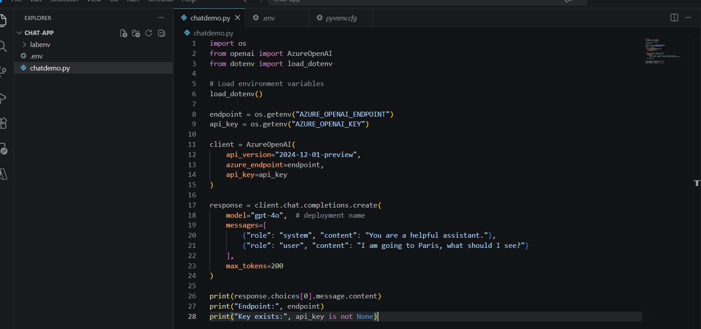

7: Test Your Chatbot
py .\chatdemo.py

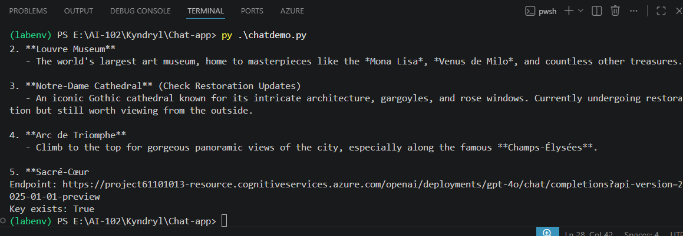

Lab Step: Interactive Chat

Create new file chatintractive.api and paste below code

import os
from openai import AzureOpenAI
from dotenv import load_dotenv

# Load env
load_dotenv()

client = AzureOpenAI(
api_version="2024-12-01-preview",
azure_endpoint=os.getenv("AZURE_OPENAI_ENDPOINT"),
api_key=os.getenv("AZURE_OPENAI_KEY")
)

# Conversation memory
messages = [
{"role": "system", "content": "You are a helpful assistant."}
]

print("💬 Chat started! Type 'exit' to quit.\n")

while True:
user_input = input("You: ")

if user_input.lower() == "exit":
print("👋 Goodbye!")
break

messages.append({"role": "user", "content": user_input})

response = client.chat.completions.create(
model="gpt-4o",
messages=messages,
max_tokens=200
)

reply = response.choices[0].message.content
print("AI:", reply, "\n")

messages.append({"role": "assistant", "content": reply})

Now Save it and run it

When it prompt ask any question like :

You: what is azure AI

You: what is the capital of France?
