HANDS-ON LAB MANUAL
AI Video Studio
Build a text-to-video web app with Sora 2 on Microsoft Foundry, FastAPI and JavaScript
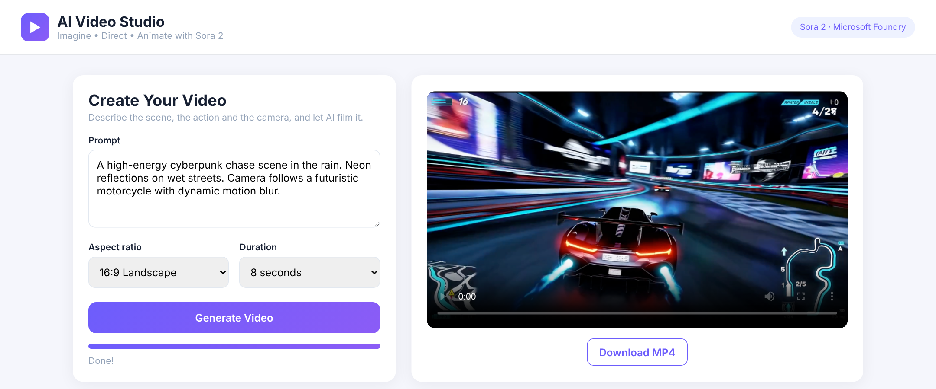

Lab ID | AI-VID-01
Level | Intermediate (200)
Duration | 75–90 minutes
Platform | Microsoft Azure — Microsoft Foundry
Model | sora-2 (Global Standard, East US 2)
Version | 1.0 · October 2026
Contents

Right-click the table and choose Update Field if page numbers do not appear.

Lab overview
In this lab you deploy OpenAI’s Sora 2 video model (sora-2) on Microsoft Foundry and build a full-stack AI Video Studio: a FastAPI backend that starts and tracks video-generation jobs, and an HTML/CSS/JavaScript frontend where users type a prompt, watch a progress bar and play the finished MP4.
Item | Detail
Lab ID | AI-VID-01
Level | Intermediate (200)
Estimated duration | 75–90 minutes (includes video render time)
Cloud platform | Microsoft Azure — Microsoft Foundry
Model | sora-2 (OpenAI, text-to-video), Global Standard deployment in East US 2
Tech stack | Python 3.12, FastAPI, Uvicorn, OpenAI Python SDK (v1 API), HTML, CSS, JavaScript
Tools | Web browser, Visual Studio Code, PowerShell terminal

Learning objectives
By the end of this lab you will be able to:
- Create a Microsoft Foundry project and resource in a region that offers Sora 2.
- Discover and deploy the sora-2 model from the Foundry model catalog.
- Test text-to-video prompts in the Foundry video playground and tune aspect ratio, resolution and duration.
- Retrieve the API key and Azure OpenAI endpoint and store them safely in a .env file.
- Build a FastAPI backend that starts Sora 2 jobs with the OpenAI Python SDK, polls their status and streams the finished MP4.
- Build a web frontend that submits prompts, shows job progress and plays the generated video.
- Run both tiers locally, validate end to end, and troubleshoot common errors.

Business scenario
Contoso Creative is a digital marketing agency. After rolling out an AI image studio, clients now ask for short motion pieces: social teasers, product reveals and animated storyboards. Producing even a 10-second concept clip today means a shoot or days of animation work.
The Head of Innovation has asked you, a cloud AI engineer, to build a prototype AI Video Studio. A marketer should be able to type a description such as “A high-energy cyberpunk chase scene in the rain. Neon reflections on wet streets. Camera follows a futuristic motorcycle with dynamic motion blur.”, pick an aspect ratio and duration, and receive a ready-to-review MP4 within a few minutes.
Requirements from the business:
- Use an enterprise-grade, Azure-hosted model so data stays within the company’s Azure subscription.
- Keep API keys on the server, never in the browser.
- Provide a clean web interface with prompt input, aspect ratio, duration, a progress indicator, playback and download.
- Make the solution easy to extend later with image-to-video, remix and a video gallery.
Your solution uses sora-2 on Microsoft Foundry, a FastAPI backend as a secure proxy, and a lightweight HTML/CSS/JS frontend.

How Sora 2 video generation works
Unlike an image model, Sora 2 does not return its result in a single call. Rendering a clip takes from about one minute to several minutes, so the API works with asynchronous jobs:
- Create a job with client.videos.create(...). The call returns at once with a job id and status queued.
- Poll the job with client.videos.retrieve(id). The status moves from queued to in_progress (with a progress percentage) and ends as completed or failed.
- Download the MP4 with client.videos.download_content(id, variant="video") once the status is completed.
Parameter | Values for sora-2 | Notes
model | Your deployment name, e.g. sora-2 | Must match the Foundry deployment exactly
prompt | Text (English or another Latin-script language works best) | Describe subject, scene, action, camera, lighting and style
size | 1280x720 (16:9 landscape) or 720x1280 (9:16 portrait) | Both are 720p; this is what the playground calls 16:9 / 720p
seconds | "4", "8" or "12" (strings) | Default is 4 seconds
input_reference | Optional JPEG/PNG/WebP image | Used as the first frame; must match size exactly

Note: Sora 2 is called through the Azure OpenAI v1 API using the standard openai Python package. The client’s base_url is your Azure OpenAI endpoint followed by /openai/v1/, and no api_version is needed. Generated jobs and their videos are kept for 24 hours, so download anything you want to keep.

Solution architecture
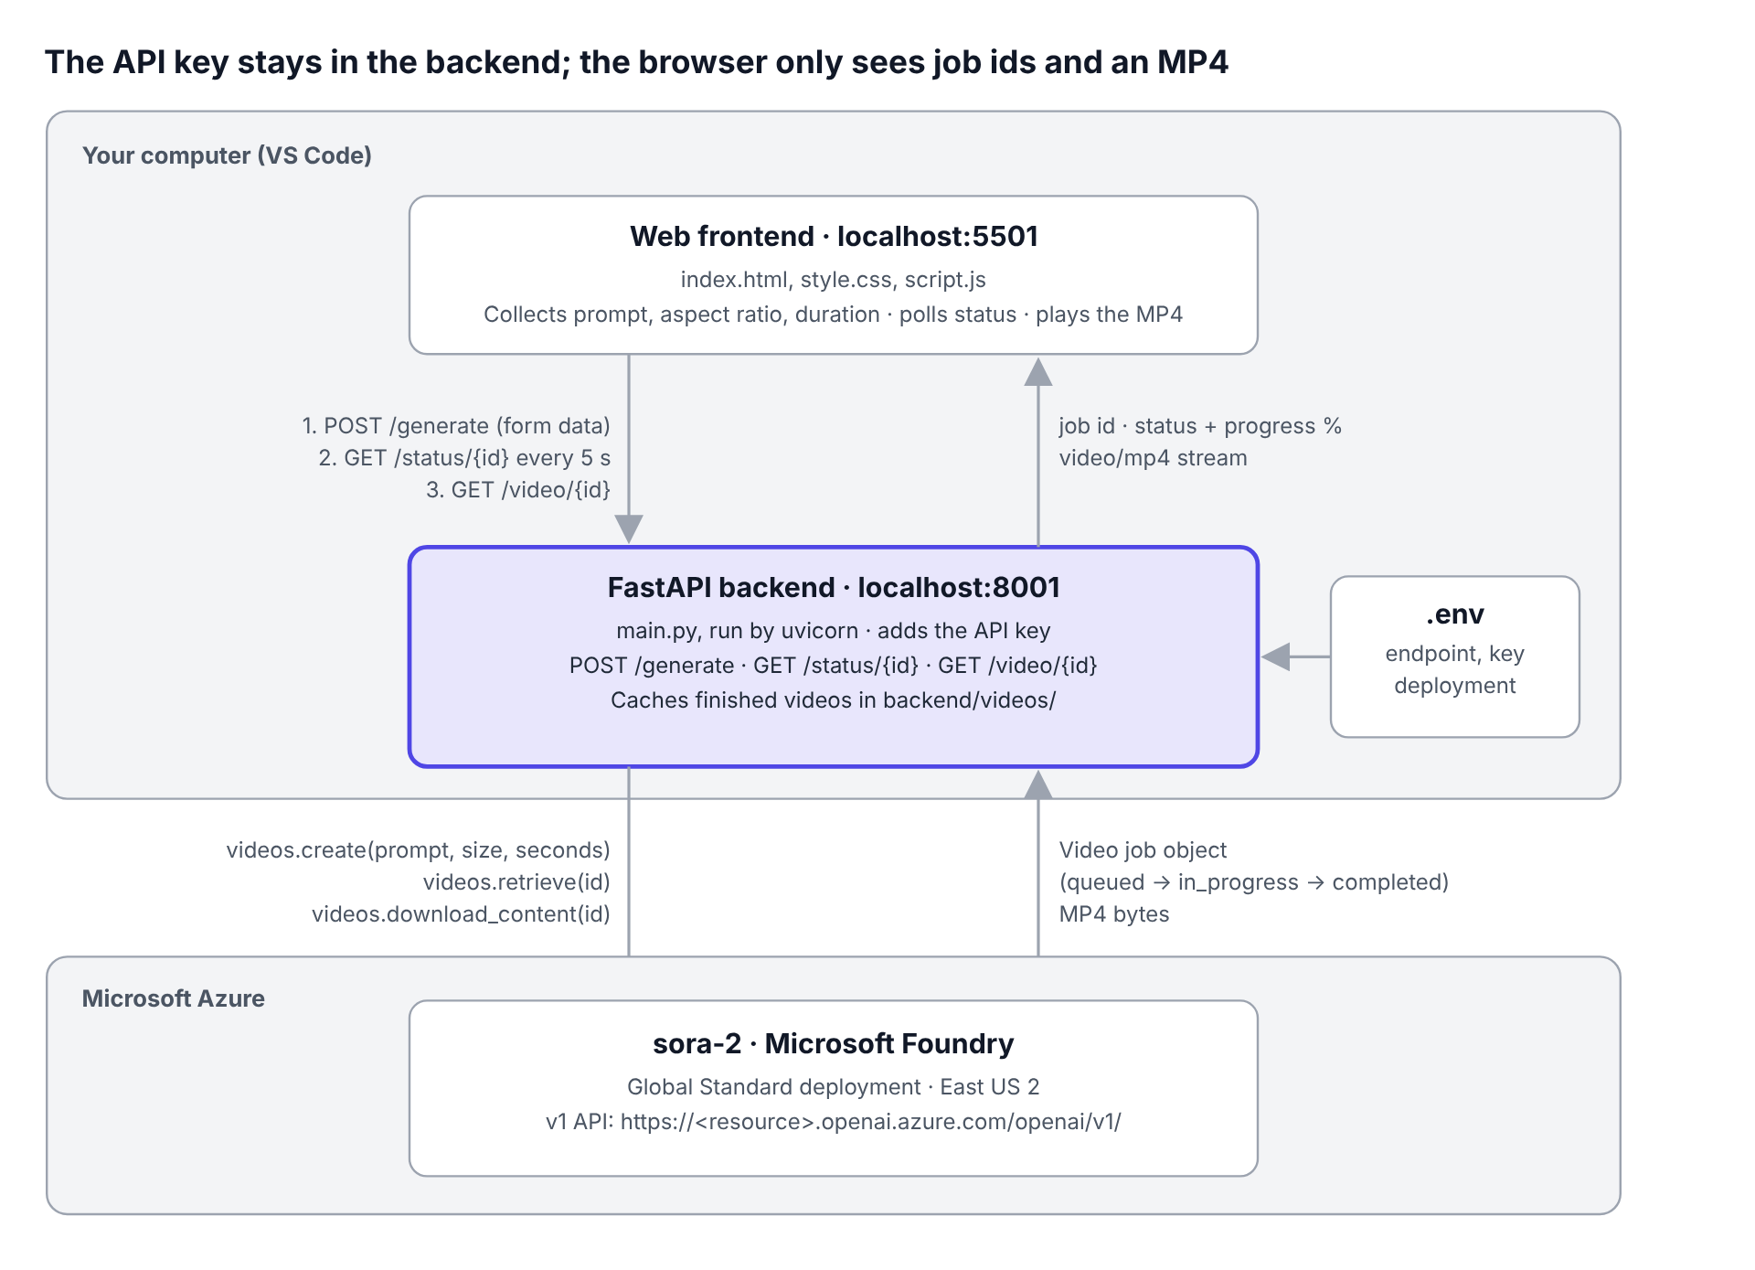
Solution architecture — frontend, backend and Foundry model
The browser talks only to the FastAPI backend. The backend reads secrets from .env, starts the Sora 2 job, reports status and progress to the page, and streams the finished MP4 back for playback and download.

Lab workflow
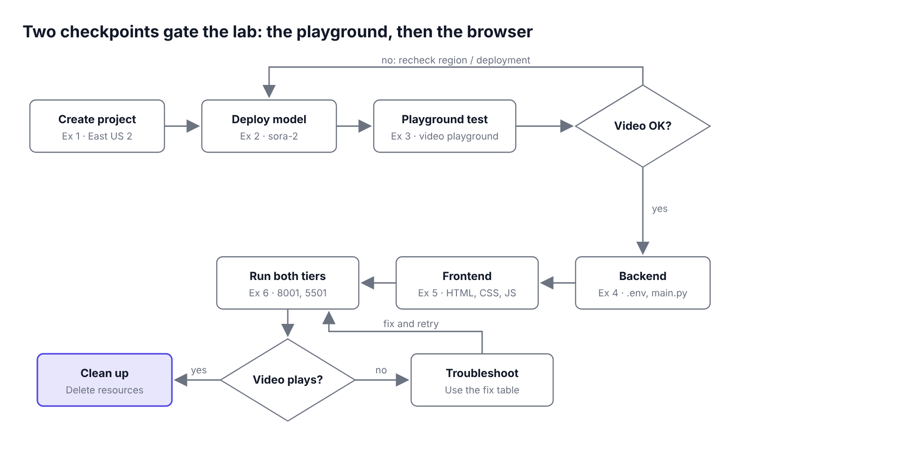
Lab workflow — six exercises and two checkpoints
Do not start coding until the playground returns a video. If the browser shows no video in Exercise 6, use the Troubleshooting table and rerun.

Prerequisites
☐ An Azure subscription (or lab sandbox) with permission to create Microsoft Foundry resources
☐ Access to sora-2 in East US 2 with Global Standard quota (check with your Azure administrator)
☐ Access to the Foundry portal at ai.azure.com
☐ Python 3.12 installed and on PATH
☐ Visual Studio Code with the Python extension
☐ A browser that plays MP4 video (Microsoft Edge or Google Chrome)
☐ Basic familiarity with Python, REST APIs and HTML

Final project structure
You will build this folder layout on your machine:
AI-Video/
├── .venv/ # Python virtual environment
├── backend/
│ ├── main.py # FastAPI app that calls sora-2
│ └── videos/ # Finished MP4s (created automatically)
├── frontend/
│ ├── index.html # Page layout
│ ├── style.css # Theme and styling
│ └── script.js # Calls the backend and polls job status
├── .env # Endpoint, key, deployment name
└── requirements.txt # Python dependencies

Ports used
Tier | Command | URL
Backend (FastAPI) | uvicorn main:app --reload --port 8001 | http://localhost:8001
Frontend (static) | python -m http.server 5501 | http://localhost:5501

Exercise 1: Create a Microsoft Foundry project
A Foundry project is the workspace that holds your model deployments, keys and endpoints. Creating it also creates a Foundry resource in the region you pick. Sora 2 is offered as a Global Standard deployment in East US 2, so create the project there.

Task 1.1 — Open the Create a project dialog
- Sign in to ai.azure.com with your lab credentials.
- Select Create a project. If you see the banner “We couldn’t set up your project automatically”, fill in the details manually as shown below.
- Enter a Project name (for example Project65952695).
- Expand Advanced options and set Region to East US 2.
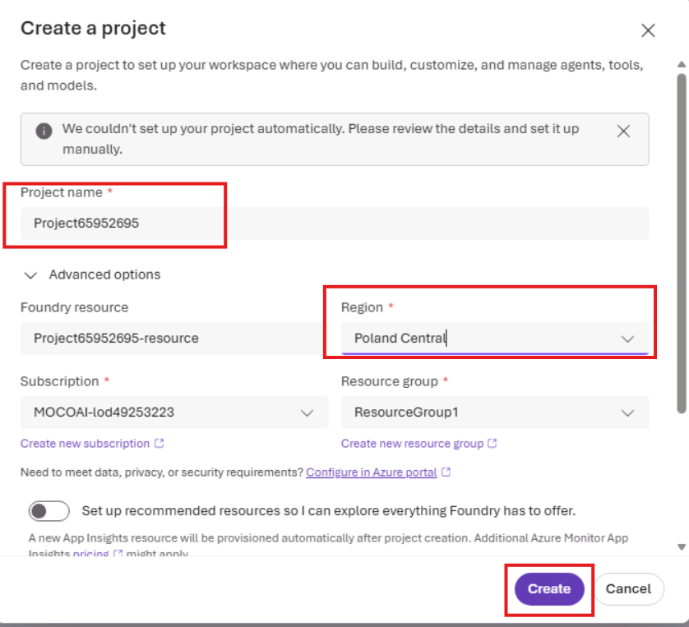
Figure 1 — Create a project: set the project name and region manually (choose East US 2 for Sora 2)

Task 1.2 — Review advanced options and create
- Confirm the auto-filled Foundry resource name (<project>-resource).
- Select your Subscription and Resource group (for example ResourceGroup1).
- Leave Set up recommended resources off to keep the lab lightweight.
- Select Create and wait for provisioning to finish (usually 1–2 minutes).
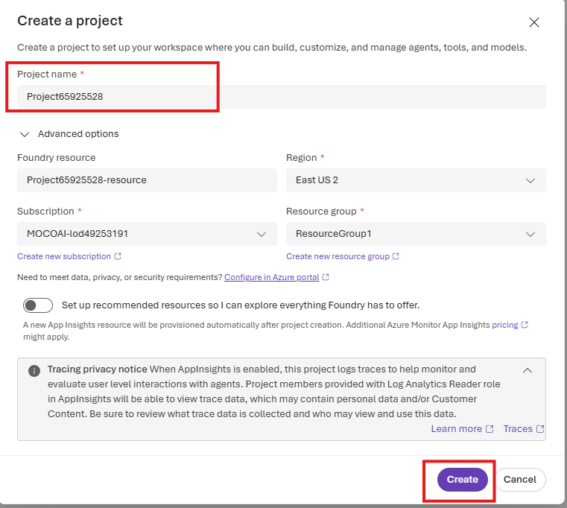
Figure 2 — Advanced options: Foundry resource, subscription, resource group and region
Checkpoint: You land on the project home page showing an API key, Project endpoint and Azure OpenAI endpoint panel.

Exercise 2: Discover and deploy sora-2
You now find Sora 2 in the Foundry model catalog, deploy it, and note the credentials your code will use.

Task 2.1 — Copy the project credentials
- On the project home page, copy the API key and the Azure OpenAI endpoint (https://<resource>.openai.azure.com/) into a notepad. You will paste them into .env in Exercise 4.
- Open the model catalog (Discover in the new Foundry experience, or Model catalog in the left pane of the Azure AI Foundry portal).
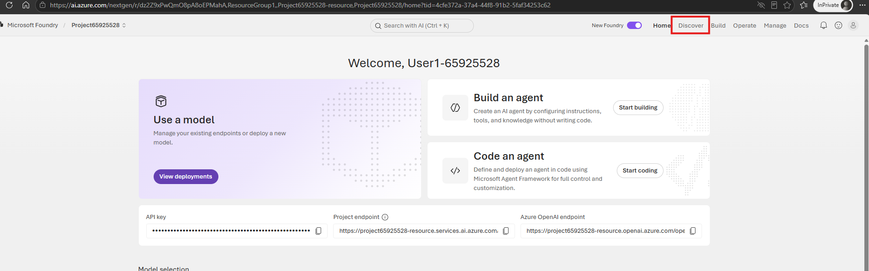
Figure 3 — Project home page: API key, endpoints and the Discover menu
Security note: Treat the API key like a password. Never commit it to Git or place it in frontend code.

Task 2.2 — Find Sora 2 in the model catalog
- In Model catalog, look for the Introducing Sora-2 card under Announcements and select Check out model.
- Alternatively, type sora-2 in the catalog search box and select the sora-2 card (OpenAI, video generation).
- Review the model card: text-to-video and image-to-video, 720p output, 4/8/12-second clips.
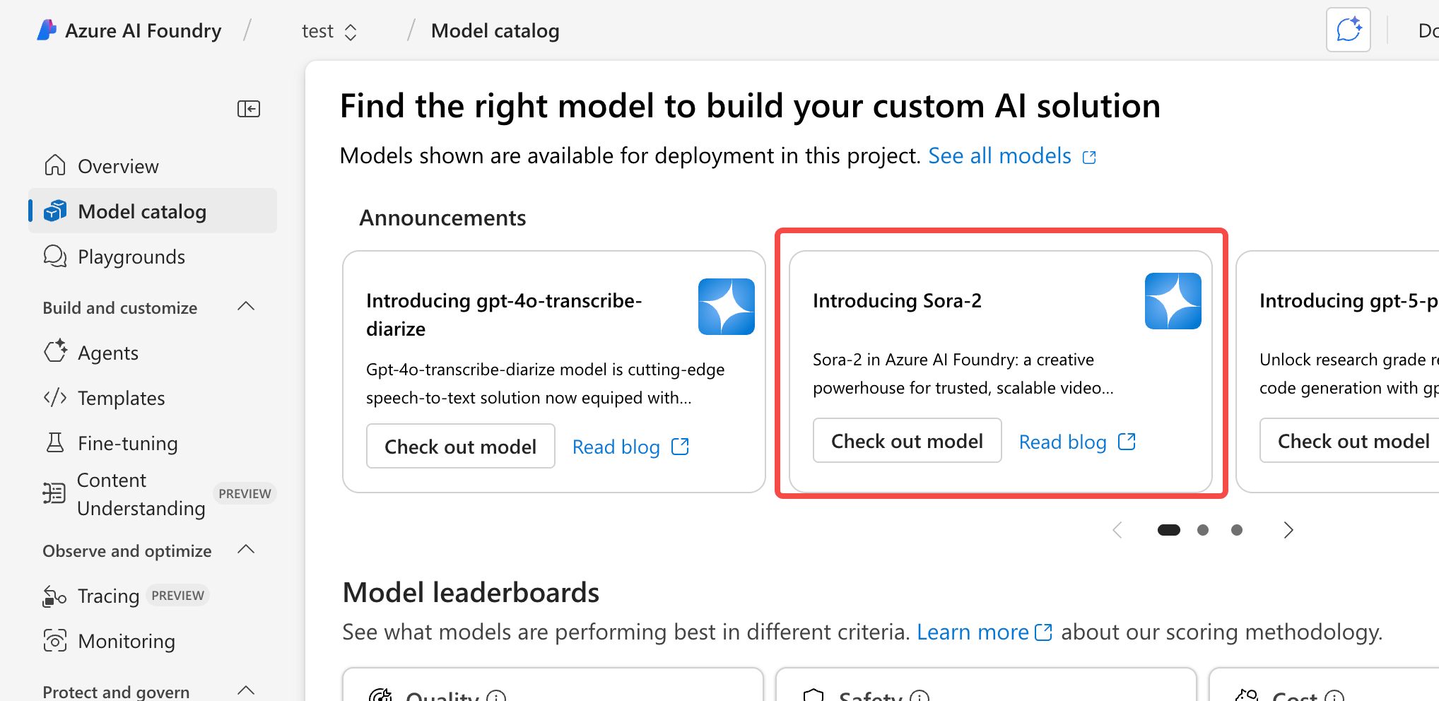
Figure 4 — Model catalog: the Introducing Sora-2 announcement card

Task 2.3 — Deploy the model
- Select Use this model (or Deploy).
- Set Deployment name to sora-2. Your backend uses this exact name.
- Set Deployment type to Global Standard.
- Review Deployment details (model version, connected resource, capacity, content filter) and select Deploy.
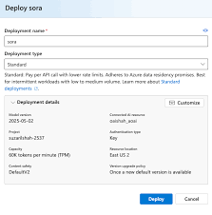
Figure 5 — Deploy dialog and deployment details. The example shows an earlier sora deployment; for this lab use the name sora-2 and the type Global Standard

Task 2.4 — Confirm the deployment
- Select Models + endpoints in the left pane.
- On the Model deployments tab, confirm that sora-2 is listed with model version 2025-10-06 (or later) and State = Succeeded.
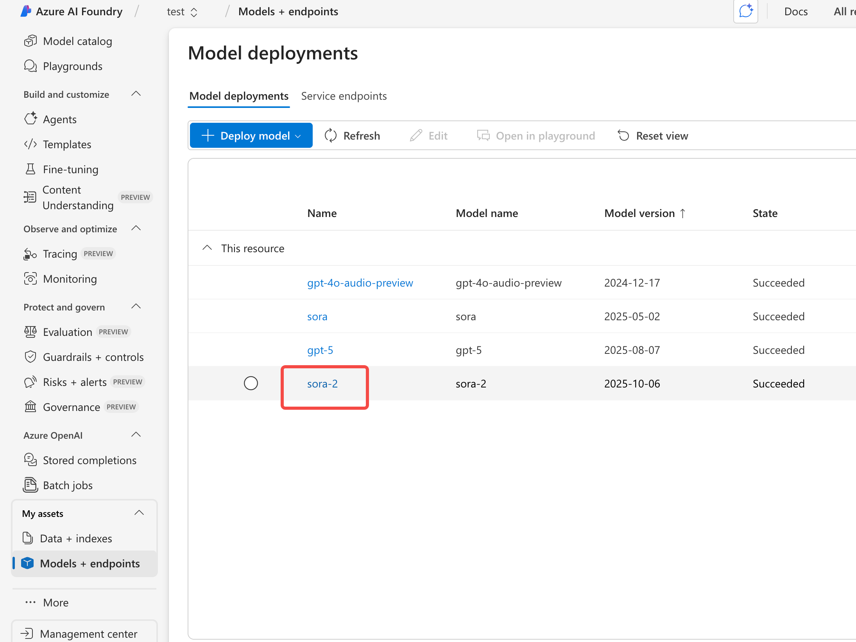
Figure 6 — Models + endpoints: the sora-2 deployment has succeeded
Checkpoint: The sora-2 deployment shows Succeeded. Note the deployment name; your backend needs it exactly.

Exercise 3: Test the model in the video playground
Before writing code, confirm the deployment works and see how prompts, aspect ratio and duration shape the output.

Task 3.1 — Open the video playground
- In Models + endpoints, select the sora-2 row and choose Open in playground (or go to Playgrounds → Video playground).
- Set Model deployment to sora-2 in the top-right corner.
- Note the two tabs: Pre-built prompts (sample scenes by industry) and Generation history (your finished jobs).
- Note the controls under the prompt box: image upload, aspect ratio (16:9), resolution (720p), duration (8 seconds), Re-write with AI and Generate.
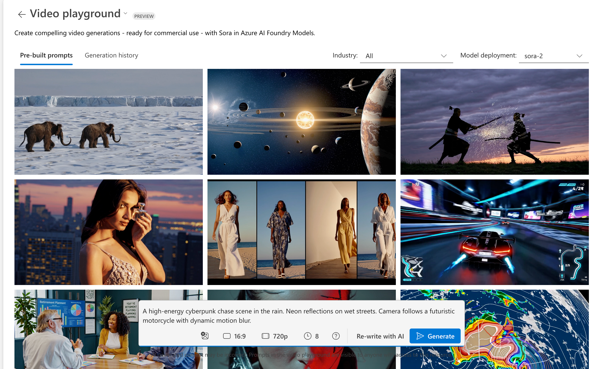
Figure 7 — The Sora 2 video playground with pre-built prompts and generation controls

Task 3.2 — Generate a first video
- Select a pre-built prompt tile or type: A high-energy cyberpunk chase scene in the rain. Neon reflections on wet streets. Camera follows a futuristic motorcycle with dynamic motion blur.
- Keep 16:9, 720p and 8 seconds, then select Generate.
- Wait for the job to finish (usually 1–5 minutes) and play the result from Generation history.

Task 3.3 — Experiment with settings
- Switch the aspect ratio to 9:16 (portrait) and generate again. Compare the framing.
- Change the duration to 4 or 12 seconds and note the difference in render time.
- Select Re-write with AI to see how the playground enriches a short prompt with camera, lighting and style details.
- If your portal shows View code, open it to see the sample call. Your backend in Exercise 4 follows the same pattern.
Note: Prompts entered in the video playground are visible to anyone with access to the Foundry resource. Do not paste confidential information.

Checkpoint: You generated at least two videos in the playground with different settings.

Exercise 4: Set up the environment and build the backend
The backend is a FastAPI service that holds the API key, starts Sora 2 jobs, reports their progress and streams the finished video to the browser.

Task 4.1 — Create the project folder and virtual environment
Open VS Code, create a folder named AI-Video, open a PowerShell terminal in it and run:
POWERSHELL
mkdir backend, frontend
python -m venv .venv
.\.venv\Scripts\Activate.ps1

Your prompt now starts with (.venv).

Task 4.2 — Add requirements and install them
Create requirements.txt in the project root:
fastapi
uvicorn
python-multipart
python-dotenv
openai

Install the packages:
POWERSHELL
pip install -r requirements.txt

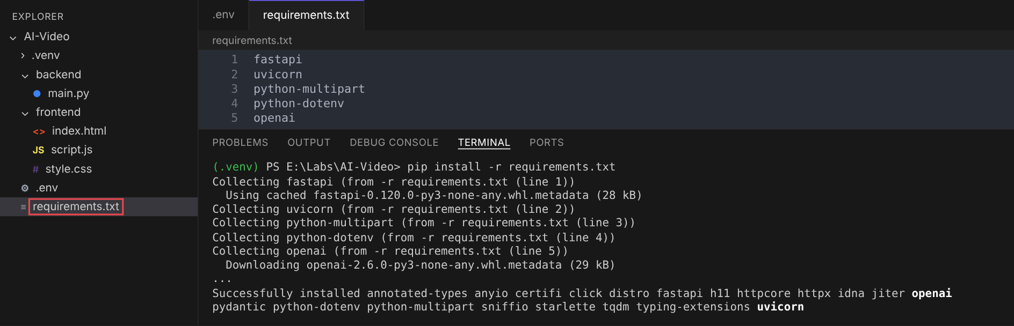
Figure 8 — requirements.txt and the pip install output
Package | Purpose
fastapi | Web framework for the REST API
uvicorn | ASGI server that runs FastAPI
python-multipart | Lets FastAPI read Form(...) fields
python-dotenv | Loads secrets from .env
openai | Official SDK; provides client.videos for Sora 2 through the Azure v1 API

Tip: If you later see AttributeError: 'OpenAI' object has no attribute 'videos', your SDK is too old. Run pip install --upgrade openai.

Task 4.3 — Store your credentials in .env
Create .env in the project root and paste the values you copied in Task 2.1. Sora 2 uses the v1 API, so no API version is required.
AZURE_OPENAI_ENDPOINT=https://<your-resource>.openai.azure.com/
AZURE_OPENAI_API_KEY=<your-api-key>
AZURE_OPENAI_DEPLOYMENT=sora-2

Tip: Add .env, .venv/ and backend/videos/ to .gitignore if you use Git.

Task 4.4 — Create backend/main.py
Create main.py inside the backend folder. The highlighted block in Figure 9 is the key difference from older Azure OpenAI samples: a plain OpenAI client pointed at the /openai/v1/ path.
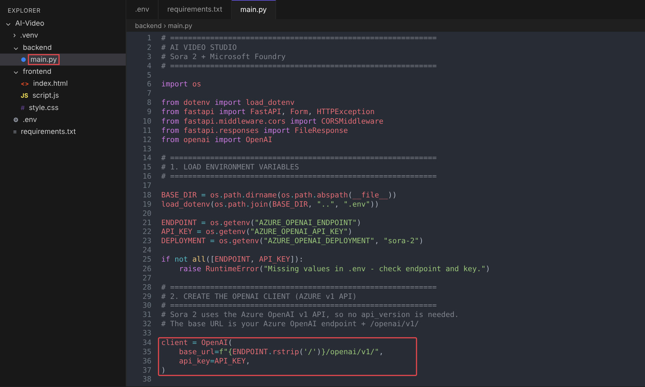
Figure 9 — main.py inside the backend folder, with the v1 client highlighted
Paste this code:
PYTHON
# ============================================================
# AI VIDEO STUDIO
# Sora 2 + Microsoft Foundry
# ============================================================

import os

from dotenv import load_dotenv
from fastapi import FastAPI, Form, HTTPException
from fastapi.middleware.cors import CORSMiddleware
from fastapi.responses import FileResponse
from openai import OpenAI

# ============================================================
# 1. LOAD ENVIRONMENT VARIABLES
# ============================================================

BASE_DIR = os.path.dirname(os.path.abspath(__file__))
load_dotenv(os.path.join(BASE_DIR, "..", ".env"))

ENDPOINT = os.getenv("AZURE_OPENAI_ENDPOINT")
API_KEY = os.getenv("AZURE_OPENAI_API_KEY")
DEPLOYMENT = os.getenv("AZURE_OPENAI_DEPLOYMENT", "sora-2")

if not all([ENDPOINT, API_KEY]):
raise RuntimeError("Missing values in .env - check endpoint and key.")

# ============================================================
# 2. CREATE THE OPENAI CLIENT (AZURE v1 API)
# ============================================================
# Sora 2 uses the Azure OpenAI v1 API, so no api_version is needed.
# The base URL is your Azure OpenAI endpoint + /openai/v1/

client = OpenAI(
base_url=f"{ENDPOINT.rstrip('/')}/openai/v1/",
api_key=API_KEY,
)

# ============================================================
# 3. CREATE THE FASTAPI APP AND ALLOW THE FRONTEND (CORS)
# ============================================================

app = FastAPI(title="AI Video Studio API")

app.add_middleware(
CORSMiddleware,
allow_origins=["http://localhost:5501", "http://127.0.0.1:5501"],
allow_methods=["*"],
allow_headers=["*"],
)

ALLOWED_SIZES = {"1280x720", "720x1280"} # 16:9 landscape, 9:16 portrait
ALLOWED_SECONDS = {"4", "8", "12"}
VIDEO_DIR = os.path.join(BASE_DIR, "videos")
os.makedirs(VIDEO_DIR, exist_ok=True)

# ============================================================
# 4. HEALTH CHECK
# ============================================================

@app.get("/")
def health():
return {"status": "ok", "model": DEPLOYMENT}

# ============================================================
# 5. START A VIDEO JOB
# ============================================================

@app.post("/generate")
def generate_video(
prompt: str = Form(...),
size: str = Form("1280x720"),
seconds: str = Form("8"),
):
prompt = prompt.strip()
if not prompt:
raise HTTPException(status_code=400, detail="Prompt is required.")
if size not in ALLOWED_SIZES:
raise HTTPException(status_code=400, detail=f"Unsupported size: {size}")
if seconds not in ALLOWED_SECONDS:
raise HTTPException(status_code=400, detail=f"Unsupported duration: {seconds}")

try:
video = client.videos.create(
model=DEPLOYMENT,
prompt=prompt,
size=size,
seconds=seconds,
)
except Exception as err:
raise HTTPException(status_code=502, detail=f"Model call failed: {err}")

# Sora works asynchronously: return the job id straight away
return {"id": video.id, "status": video.status}

# ============================================================
# 6. CHECK JOB STATUS
# ============================================================

@app.get("/status/{video_id}")
def video_status(video_id: str):
try:
video = client.videos.retrieve(video_id)
except Exception as err:
raise HTTPException(status_code=502, detail=f"Status check failed: {err}")

error = None
if video.status == "failed" and video.error:
error = video.error.message

return {
"id": video.id,
"status": video.status, # queued | in_progress | completed | failed
"progress": video.progress or 0, # 0-100
"error": error,
}

# ============================================================
# 7. DOWNLOAD THE FINISHED MP4
# ============================================================

@app.get("/video/{video_id}")
def get_video(video_id: str):
file_path = os.path.join(VIDEO_DIR, f"{video_id}.mp4")

# Download once from Foundry, then serve the local copy
if not os.path.exists(file_path):
try:
content = client.videos.download_content(video_id, variant="video")
content.write_to_file(file_path)
except Exception as err:
raise HTTPException(status_code=502, detail=f"Download failed: {err}")

return FileResponse(file_path, media_type="video/mp4", filename="ai-video.mp4")

How the code works
Section | What it does
1. Load environment | Reads endpoint, key and deployment from .env one folder up
2. Client | Creates an OpenAI client whose base_url is <endpoint>/openai/v1/ (Azure v1 API)
3. App + CORS | Allows only the frontend on port 5501 to call the API; defines allowed sizes and durations
4. Health check | GET / confirms the service is up
5. Start job | POST /generate validates the form and calls videos.create; returns the job id immediately
6. Job status | GET /status/{id} calls videos.retrieve and returns status, progress and any error
7. Download | GET /video/{id} calls videos.download_content once, caches the MP4 in backend/videos/ and streams it

Note: Sizes other than 1280x720 and 720x1280, or durations other than 4, 8 and 12 seconds, are rejected by sora-2. The backend validates them first so users get a clear 400 error.

Exercise 5: Build the frontend
The frontend is three static files. It never sees the API key: it only calls your backend at http://localhost:8001.

Task 5.1 — Create frontend/index.html
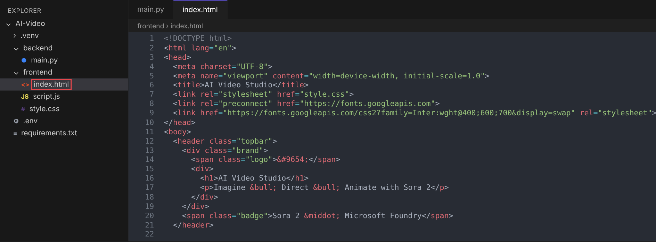
Figure 10 — index.html inside the frontend folder
HTML
<!DOCTYPE html>
<html lang="en">
<head>
<meta charset="UTF-8">
<meta name="viewport" content="width=device-width, initial-scale=1.0">
<title>AI Video Studio</title>
<link rel="stylesheet" href="style.css">
<link rel="preconnect" href="https://fonts.googleapis.com">
<link href="https://fonts.googleapis.com/css2?family=Inter:wght@400;600;700&display=swap" rel="stylesheet">
</head>
<body>
<header class="topbar">
<div class="brand">
<span class="logo">&#9654;</span>
<div>
<h1>AI Video Studio</h1>
<p>Imagine &bull; Direct &bull; Animate with Sora 2</p>
</div>
</div>
<span class="badge">Sora 2 &middot; Microsoft Foundry</span>
</header>

<main class="layout">
<section class="card">
<h2>Create Your Video</h2>
<p class="muted">Describe the scene, the action and the camera, and let AI film it.</p>

<label for="prompt">Prompt</label>
<textarea id="prompt" maxlength="4000"
placeholder="A high-energy cyberpunk chase scene in the rain. Neon reflections on wet streets. Camera follows a futuristic motorcycle with dynamic motion blur."></textarea>

<div class="row">
<div>
<label for="size">Aspect ratio</label>
<select id="size">
<option value="1280x720">16:9 Landscape</option>
<option value="720x1280">9:16 Portrait</option>
</select>
</div>
<div>
<label for="seconds">Duration</label>
<select id="seconds">
<option value="4">4 seconds</option>
<option value="8" selected>8 seconds</option>
<option value="12">12 seconds</option>
</select>
</div>
</div>

<button id="generateBtn">Generate Video</button>
<div class="progress" id="progressWrap" hidden>
<div class="progress-bar" id="progressBar"></div>
</div>
<p id="status" class="muted"></p>
</section>

<section class="card preview">
<video id="result" controls playsinline hidden></video>
<p id="placeholder" class="muted">Your generated video will appear here</p>
<a id="download" class="btn-secondary" download="ai-video.mp4" hidden>Download MP4</a>
</section>
</main>

<script src="script.js"></script>
</body>
</html>

Task 5.2 — Create frontend/style.css
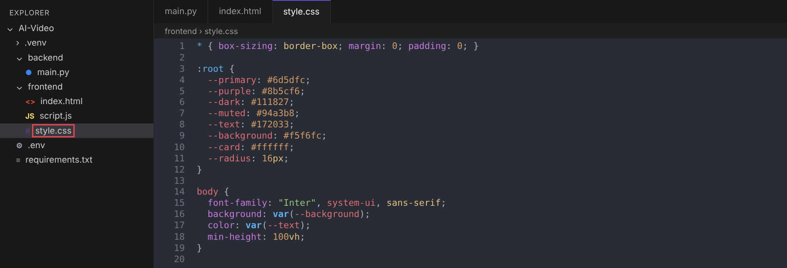
Figure 11 — style.css with the theme colour variables
CSS
* { box-sizing: border-box; margin: 0; padding: 0; }

:root {
--primary: #6d5dfc;
--purple: #8b5cf6;
--dark: #111827;
--muted: #94a3b8;
--text: #172033;
--background: #f5f6fc;
--card: #ffffff;
--radius: 16px;
}

body {
font-family: "Inter", system-ui, sans-serif;
background: var(--background);
color: var(--text);
min-height: 100vh;
}

.topbar {
display: flex; justify-content: space-between; align-items: center;
padding: 20px 32px; background: var(--card);
box-shadow: 0 1px 0 #e5e7eb;
}
.brand { display: flex; gap: 12px; align-items: center; }
.logo {
width: 44px; height: 44px; border-radius: 12px; display: grid; place-items: center;
color: #fff; font-size: 20px;
background: linear-gradient(135deg, var(--primary), var(--purple));
}
h1 { font-size: 22px; }
.brand p, .muted { color: var(--muted); font-size: 14px; }
.badge { font-size: 13px; padding: 8px 14px; border-radius: 999px; background: #eef2ff; color: var(--primary); }

.layout {
display: grid; grid-template-columns: 1fr 1.4fr; gap: 24px;
padding: 32px; max-width: 1280px; margin: 0 auto;
}
.card { background: var(--card); border-radius: var(--radius); padding: 24px; box-shadow: 0 4px 24px rgba(17, 24, 39, .06); }
.card h2 { margin-bottom: 4px; }

label { display: block; font-weight: 600; font-size: 14px; margin: 18px 0 6px; }
textarea, select {
width: 100%; padding: 12px; font: inherit; border: 1px solid #e2e8f0; border-radius: 10px;
}
textarea { min-height: 120px; resize: vertical; }
.row { display: grid; grid-template-columns: 1fr 1fr; gap: 16px; }

button {
width: 100%; margin-top: 22px; padding: 14px; border: 0; border-radius: 12px;
font: 600 16px "Inter", sans-serif; color: #fff; cursor: pointer;
background: linear-gradient(135deg, var(--primary), var(--purple));
}
button:disabled { opacity: .6; cursor: wait; }

.progress { height: 8px; margin-top: 16px; border-radius: 999px; background: #eef2ff; overflow: hidden; }
.progress-bar { height: 100%; width: 0; background: linear-gradient(90deg, var(--primary), var(--purple)); transition: width .4s; }
#status { margin-top: 10px; }

.preview { display: flex; flex-direction: column; align-items: center; justify-content: center; gap: 16px; min-height: 420px; }
.preview video { width: 100%; max-height: 560px; border-radius: 12px; background: #000; }
.btn-secondary { padding: 10px 18px; border-radius: 10px; border: 1px solid var(--primary); color: var(--primary); text-decoration: none; font-weight: 600; }

@media (max-width: 600px) {
.layout { grid-template-columns: 1fr; padding: 16px; }
.row { grid-template-columns: 1fr; }
.badge { display: none; }
}

Task 5.3 — Create frontend/script.js
The highlighted lines in Figure 12 are the settings you must check: API_URL must point at the backend port, and POLL_MS sets how often the page asks for job status.
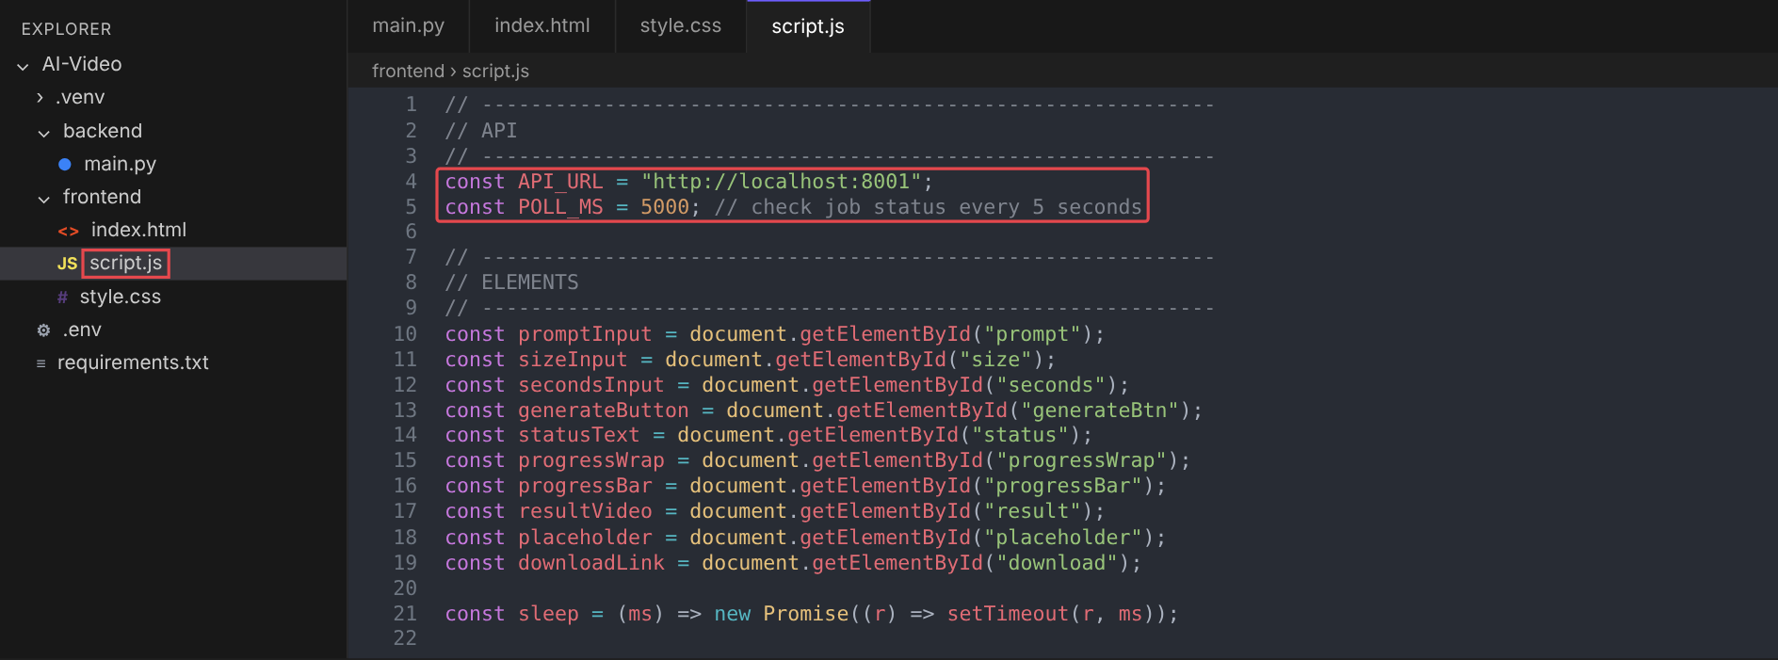
Figure 12 — script.js with API_URL pointing at the backend on port 8001
JAVASCRIPT
// ------------------------------------------------------------
// API
// ------------------------------------------------------------
const API_URL = "http://localhost:8001";
const POLL_MS = 5000; // check job status every 5 seconds

// ------------------------------------------------------------
// ELEMENTS
// ------------------------------------------------------------
const promptInput = document.getElementById("prompt");
const sizeInput = document.getElementById("size");
const secondsInput = document.getElementById("seconds");
const generateButton = document.getElementById("generateBtn");
const statusText = document.getElementById("status");
const progressWrap = document.getElementById("progressWrap");
const progressBar = document.getElementById("progressBar");
const resultVideo = document.getElementById("result");
const placeholder = document.getElementById("placeholder");
const downloadLink = document.getElementById("download");

const sleep = (ms) => new Promise((r) => setTimeout(r, ms));

function setProgress(pct) {
progressWrap.hidden = false;
progressBar.style.width = `${pct}%`;
}

// ------------------------------------------------------------
// GENERATE
// ------------------------------------------------------------
async function generateVideo() {
const prompt = promptInput.value.trim();
if (!prompt) {
statusText.textContent = "Please enter a prompt.";
return;
}

const formData = new FormData();
formData.append("prompt", prompt);
formData.append("size", sizeInput.value);
formData.append("seconds", secondsInput.value);

generateButton.disabled = true;
generateButton.textContent = "Generating...";
downloadLink.hidden = true;
setProgress(0);
statusText.textContent = "Submitting job to Sora 2...";

try {
// 1. Start the job
const startRes = await fetch(`${API_URL}/generate`, { method: "POST", body: formData });
const job = await startRes.json();
if (!startRes.ok) throw new Error(job.detail || "Request failed");

// 2. Poll until the job finishes (usually 1-5 minutes)
let status = job.status;
while (status === "queued" || status === "in_progress") {
await sleep(POLL_MS);
const res = await fetch(`${API_URL}/status/${job.id}`);
const data = await res.json();
if (!res.ok) throw new Error(data.detail || "Status check failed");
status = data.status;
if (status === "failed") throw new Error(data.error || "Video generation failed");
setProgress(data.progress);
statusText.textContent = `${status === "queued" ? "Queued" : "Rendering"}... ${data.progress}%`;
}

// 3. Show the finished video
const videoUrl = `${API_URL}/video/${job.id}`;
resultVideo.src = videoUrl;
resultVideo.hidden = false;
placeholder.hidden = true;
downloadLink.href = videoUrl;
downloadLink.hidden = false;
setProgress(100);
statusText.textContent = "Done!";
} catch (error) {
statusText.textContent = `Error: ${error.message}`;
} finally {
generateButton.disabled = false;
generateButton.textContent = "Generate Video";
}
}

generateButton.addEventListener("click", generateVideo);

The script works in three steps: it posts the form to /generate, polls /status/{id} every five seconds while the job is queued or in_progress (updating the progress bar), and finally sets the <video> source and download link to /video/{id}.

Exercise 6: Run and validate the application
You run the two tiers in two separate terminals, then generate a video from the browser.

Task 6.1 — Start the backend
In the first terminal (virtual environment active):
POWERSHELL
cd .\backend\
uvicorn main:app --reload --port 8001

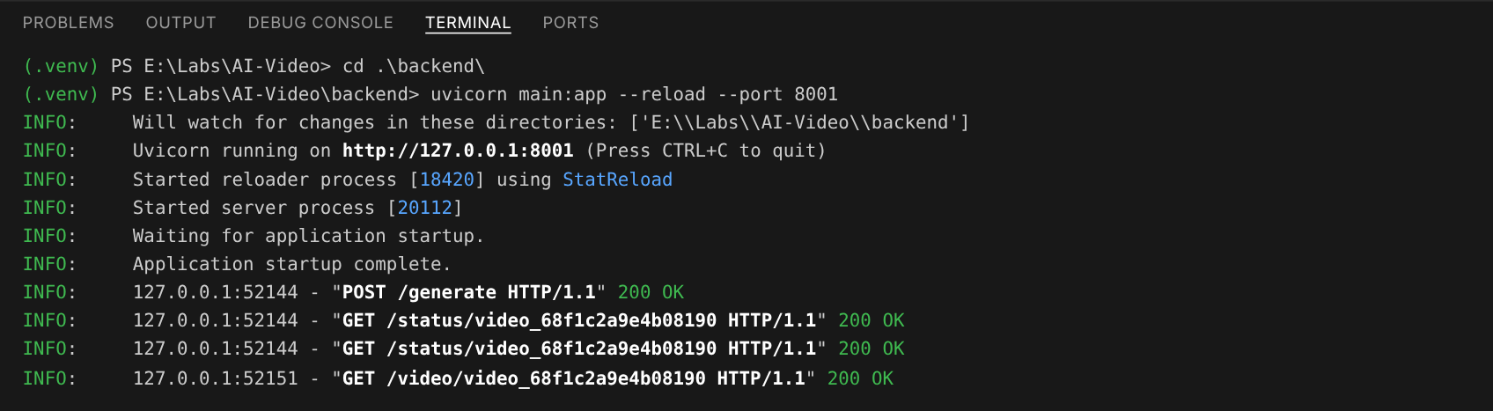
Figure 13 — Uvicorn running the backend on http://127.0.0.1:8001, with one generate, poll and download cycle
Open http://localhost:8001 in a browser. You should see {"status":"ok","model":"sora-2"}. The interactive API docs are at http://localhost:8001/docs.

Task 6.2 — Start the frontend in a new terminal
Select + in the VS Code terminal panel to open a second terminal, activate the virtual environment, then run:
POWERSHELL
.\.venv\Scripts\Activate.ps1
cd .\frontend\
python -m http.server 5501

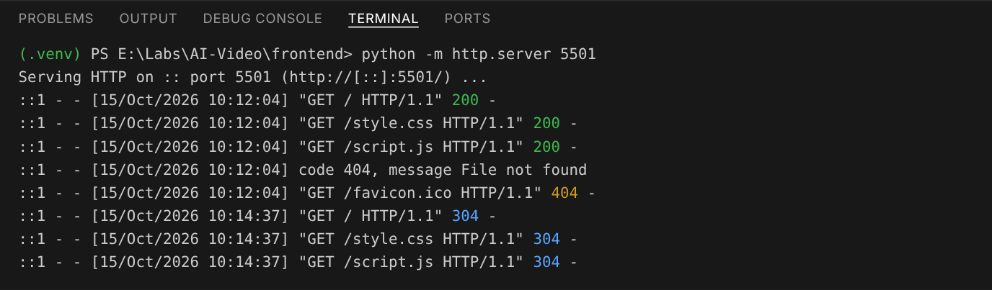
Figure 14 — Static server log for the frontend on port 5501
Note: In the log, 200 and 304 mean files were served. A 404 for favicon.ico is harmless.

Task 6.3 — Generate a video end to end
- Browse to http://localhost:5501.
- Enter a prompt, for example: A high-energy cyberpunk chase scene in the rain. Neon reflections on wet streets. Camera follows a futuristic motorcycle with dynamic motion blur.
- Choose 16:9 Landscape and 8 seconds, then select Generate Video.
- Watch the progress bar and status line move from Queued to Rendering... n%. This usually takes 1–5 minutes.
- When the status shows Done!, play the video and select Download MP4 to save it.
- Check backend/videos/: a file named <job-id>.mp4 now exists.
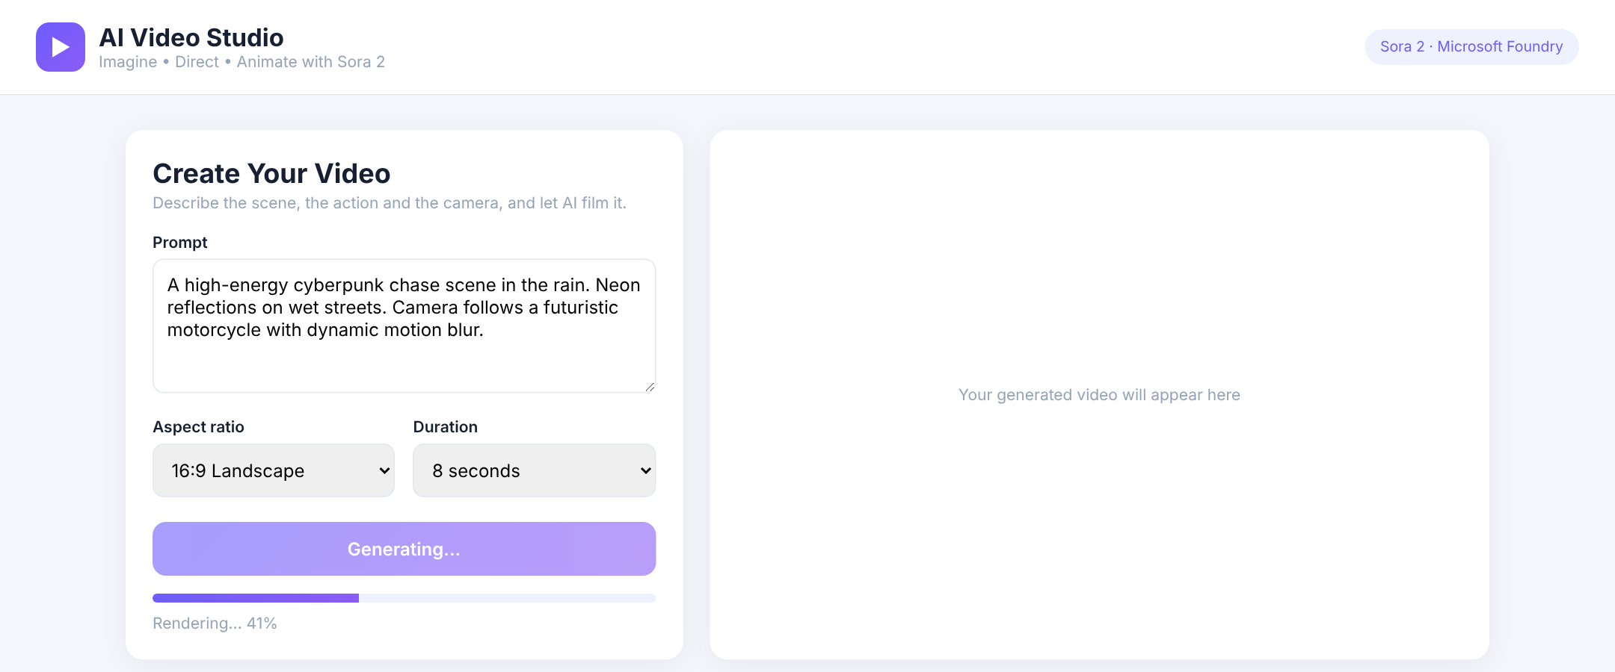
Figure 15 — The job is rendering; the page polls the backend every five seconds
Figure 16 — Finished: the video plays in the page and can be downloaded as an MP4

Validation checklist
☐ Foundry project and sora-2 deployment exist (State: Succeeded)
☐ Playground generated at least two videos
☐ GET http://localhost:8001/ returns status ok
☐ Frontend loads at http://localhost:5501 without console errors
☐ A prompt returns a playable video in the browser
☐ Download saves an MP4 file
☐ API key appears only in .env, never in frontend files

Troubleshooting
Symptom | Likely cause | Fix
sora-2 not in the model catalog | Project region does not offer Sora 2, or access is not enabled | Create the project in East US 2; ask your Azure administrator to confirm access and Global Standard quota
“We couldn’t set up your project automatically” | Default region or quota unavailable | Expand Advanced options and pick East US 2 manually (Figure 1)
RuntimeError: Missing values in .env | .env not found or a value is blank | Keep .env in the project root, one level above backend
401 Unauthorized / Access denied | Wrong API key or endpoint | Re-copy the key and Azure OpenAI endpoint from the project home page
404 Resource not found | Endpoint missing /openai/v1/, or wrong deployment name | Keep base_url as in main.py; set AZURE_OPENAI_DEPLOYMENT to the exact deployment name
AttributeError: … no attribute 'videos' | Old openai package | pip install --upgrade openai
400 Unsupported size or duration | Value not supported by sora-2 | Use 1280x720 or 720x1280, and 4, 8 or 12 seconds
Status becomes failed with a moderation error | Prompt asks for real people, copyrighted characters or music, or unsuitable content | Rephrase the prompt; Sora 2 content filters are applied by the service
429 Too Many Requests | Video job rate limit reached | Wait a minute before submitting another job
Progress stays at 0% for a long time | Job is queued behind others | Keep the page open; the job starts when capacity frees up
Video area stays black or MP4 is 0 KB | Download before the job completed, or the job expired (24 h) | Only call /video/{id} after status is completed; regenerate expired jobs
Browser console shows a CORS error | Frontend origin not allowed | Open the site at http://localhost:5501 and keep that origin in allow_origins
Form data requires “python-multipart” | Package missing | pip install python-multipart
uvicorn is not recognised | Virtual environment not active | Run .\.venv\Scripts\Activate.ps1
Activate.ps1 cannot be loaded | PowerShell execution policy | Set-ExecutionPolicy -Scope CurrentUser RemoteSigned

Clean up resources
To avoid ongoing charges after the lab:
- Press Ctrl+C in both terminals to stop the servers.
- In the Foundry portal, delete the sora-2 deployment.
- In the Azure portal, delete the resource group (for example ResourceGroup1) if it was created only for this lab.
- Optionally delete the MP4 files in backend/videos/.
Note: Sora 2 is billed per second of generated video. In a managed lab sandbox, resources are usually removed automatically when the session ends.

Extension challenges
- Image-to-video: add a file input and pass it to videos.create(..., input_reference=file). The image must match the chosen size exactly, and images containing human faces are rejected.
- Remix: add a Remix button that calls client.videos.remix(video_id=..., prompt=...) with one clearly described change, such as a new colour palette.
- Thumbnails and gallery: download variant="thumbnail" for each job and show the last 10 videos as a gallery.
- Prompt builder: add fields for subject, scene, action, camera, lighting and style, and combine them into one prompt (see Appendix B).
- Production deployment: host the backend on Azure App Service and the frontend on Azure Static Web Apps, and replace the API key with Microsoft Entra ID authentication (DefaultAzureCredential).

Appendix A: Call Sora 2 from a Python script
Use this standalone script when you want to test Sora 2 from the command line without the web app, for example in a notebook or a batch job. It uses the same openai package and v1 endpoint as the backend.

A.1 — Install the SDK
POWERSHELL
pip install --upgrade openai python-dotenv

A.2 — Configure environment variables
Create a .env file next to the script:
AZURE_OPENAI_ENDPOINT=https://<your-resource-name>.openai.azure.com/
AZURE_OPENAI_API_KEY=<your-key>
AZURE_OPENAI_DEPLOYMENT=sora-2

A.3 — Text-to-video script
Save as sora_quickstart.py and run python sora_quickstart.py:
PYTHON
# ============================================================
# SORA 2 QUICKSTART - text-to-video from a Python script
# ============================================================
import os
import time

from dotenv import load_dotenv
from openai import OpenAI

load_dotenv()

client = OpenAI(
base_url=f"{os.environ['AZURE_OPENAI_ENDPOINT'].rstrip('/')}/openai/v1/",
api_key=os.environ["AZURE_OPENAI_API_KEY"],
)

prompt = (
"A cinematic shot of a spaceship flying through a nebula "
"filled with colorful cosmic clouds."
)

# 1. Start the job (returns immediately with a job id)
video = client.videos.create(
model=os.getenv("AZURE_OPENAI_DEPLOYMENT", "sora-2"),
prompt=prompt,
size="1280x720", # "1280x720" (16:9) or "720x1280" (9:16)
seconds="8", # "4", "8" or "12"
)
print(f"Job started: {video.id}")

# 2. Poll until the job finishes
while video.status in ("queued", "in_progress"):
time.sleep(10)
video = client.videos.retrieve(video.id)
print(f" {video.status} {video.progress or 0}%")

# 3. Download the MP4
if video.status == "completed":
content = client.videos.download_content(video.id, variant="video")
content.write_to_file("output.mp4")
print("Video generated: output.mp4")
else:
print(f"Job ended with status {video.status}: {video.error}")

A.4 — Image-to-video and remix
Animate from a starting image (the image must be exactly 1280×720 or 720×1280, matching size):
PYTHON
video = client.videos.create(
model="sora-2",
prompt="The camera slowly pushes in as rain begins to fall",
size="1280x720",
seconds="8",
input_reference=open("first_frame.png", "rb"),
)

Change one aspect of a finished video while keeping its structure:
PYTHON
remix = client.videos.remix(
video_id="<completed-video-id>",
prompt="Shift the colour palette to teal, sand and rust, with a warm backlight.",
)
# Poll and download remix.id exactly as in A.3

A.5 — What the API does and does not accept
You might try | Use instead
resolution="1080p" | size="1280x720" or size="720x1280" (sora-2 output is 720p)
duration=5 | seconds="4", "8" or "12"
motion="medium", style="realistic" | Describe motion and style in the prompt text
seed=42 for repeatable output | Not supported; use a fixed descriptor block, input_reference or remix for consistency
A single call that returns the video bytes | Create → poll with retrieve → download_content once status is completed

Appendix B: Prompting tips for better videos

B.1 — Recommended prompt structure
TEMPLATE
[Main subject] + [Scene environment] + [Action] + [Camera movement] + [Lighting] + [Style]

Example:
PROMPT
A high-energy cyberpunk chase in the rain with neon reflections on wet streets.
A futuristic motorcycle speeds through; the camera tracks alongside at low angle,
dynamic motion blur capturing its sleek design and vibrant city lights.
Cinematic, moody night lighting.

B.2 — Getting consistent results
- Keep a fixed descriptor block (character, wardrobe, palette, lens) and paste it into every prompt in a series.
- Use input_reference to lock the first frame when several clips must share a look.
- Use remix for small changes, and ask for one clearly described change per remix.
- Describe one main action per clip; Sora can struggle with complex physics, left/right spatial instructions and precise timing.
- Write prompts in English or another Latin-script language for the best results.
Important: Sora 2 rejects prompts for real people (including public figures), copyrighted characters and copyrighted music, and input images containing human faces. Generated content must be suitable for audiences under 18.

Appendix C: Frequently asked questions

I can’t see Sora 2 in the catalog. What should I do?
Check that your project is in East US 2, clear any Available in my project filter, and ask your Azure administrator to confirm the subscription has access and Global Standard quota for sora-2.

What is the maximum video duration?
12 seconds per job with sora-2 (choose 4, 8 or 12). For longer pieces, generate several clips and join them in a video editor.

My generated video is empty or will not play.
Only download after the job status is completed, and save the result with download_content(id, variant="video").write_to_file(...). Jobs and their files expire 24 hours after creation.

Why does each run look different?
Sora 2 has no seed parameter, so outputs vary. Use the consistency tips in Appendix B.

Knowledge check
- Why does the browser call the FastAPI backend instead of calling Azure OpenAI directly?
- Why does the app use three endpoints (generate, status, video) instead of one call that returns the video?
- What base_url does the OpenAI client use for Sora 2, and why is no API version set?
- Which sizes and durations does sora-2 accept?
- Which three values must match between the Foundry portal and your .env file?
- Why does the backend save finished videos to backend/videos/?

Answer key
- To keep the API key on the server; anything in frontend code is visible to every user.
- Video generation is an asynchronous job that takes minutes. The page starts the job, polls its status and progress, and downloads the MP4 only when it is completed.
- https://<resource>.openai.azure.com/openai/v1/. Sora 2 uses the Azure OpenAI v1 API, which does not take an api_version.
- Sizes 1280x720 and 720x1280; durations of 4, 8 or 12 seconds.
- The Azure OpenAI endpoint, the API key and the deployment name.
- So each video is downloaded from Foundry only once, playback and download are served locally, and the file survives after the job expires (24 hours).

Summary
You created a Microsoft Foundry project in East US 2, deployed sora-2, tested prompts in the video playground, and built a two-tier AI Video Studio. The FastAPI backend keeps credentials server-side and manages Sora 2’s create, poll and download job cycle; the HTML/CSS/JS frontend collects prompts, shows progress and plays the result. This pattern — a thin secure API in front of an asynchronous Foundry model — is the foundation for any production generative video app.

