HANDS-ON LAB GUIDE
Running Generative AI Locally
Hugging Face Transformers + a Small Local Model (Qwen2.5-0.5B-Instruct)
No API key. No Azure. No OpenAI account. The model runs entirely on the student's laptop.
Prepared for: Vodafone Technical Training Session
Format: Instructor-led, hands-on

Table of Contents
Table of Contents 1
1. Objective 1
2. Lab Scenario 1
3. Prerequisites 1
4. Architecture Overview 1
4.1 Traditional Python vs. Generative AI 1
5. Part 1 — Install Dependencies 1
6. Part 2 — First AI Script (Single Question) 1
7. Part 3 — Multi-Turn Chat Demo (Recommended) 1
7.1 Sample Demonstration Transcript 1
8. Part 4 — Multi-Agent Demo (Advanced) 1
8.1 What Changes Between the Agents 1
9. What to Explain to Students 1
10. Summary 1

1. Objective
By the end of this lab, students will be able to:
- Run a real generative AI language model entirely on their own laptop, with no cloud account, API key, or internet dependency after the initial download.
- Explain — in plain terms — the difference between traditional deterministic Python logic and generative AI output.
- Build a simple command-line chatbot in Python using the Hugging Face transformers library.
- Describe, at a conceptual level, how a prompt flows through a Python script into a model and back out as a generated response.

2. Lab Scenario
You are a developer at Vodafone who has been asked to prototype a simple AI-powered customer service assistant. Before connecting to any cloud AI service, your task is to build and demonstrate a working proof-of-concept entirely offline, using a small open-source language model running on your own machine.
This lab walks through that exact exercise: installing the tools, writing a first single-turn AI script, then upgrading it into a multi-turn conversational assistant themed around Vodafone customer support (e.g., explaining 5G, latency, and network basics to a customer).
Why this matters
This mirrors a real first step many engineering teams take before adopting a paid AI API: prove the concept locally, understand the mechanics, and only then decide whether a larger hosted model is justified.

3. Prerequisites
- A laptop with Python 3.9+ installed
- Roughly 2 GB of free disk space (for the model download)
- Internet access for the initial setup only — the model runs fully offline afterward
- Basic familiarity with running Python scripts from a terminal

4. Architecture Overview
Before writing code, walk students through the flow of data from their question to the AI's answer. This can be drawn on a whiteboard or shown as the diagram below.
USER
│
│ "Explain 5G"
▼
┌───────────────┐
│ PYTHON │
│ transformers │
└───────┬───────┘
│
▼
┌─────────────────┐
│ LOCAL AI │
│ MODEL │
│ Qwen 0.5B │
└────────┬────────┘
│
▼
AI RESPONSE
Figure 1 — The question never leaves the laptop: Python passes it to a model file stored locally, which returns generated text.

4.1 Traditional Python vs. Generative AI
Traditional Python:

Input → Python Logic → Output

Example:
print(10 + 20)

Output:
30

Generative AI:

Input → Python → AI Model → Generated Output

Example: "Explain 5G"
↓
AI Model
↓
"5G is the fifth generation..."
The key distinction to emphasize: traditional code always produces the same output for the same input. A generative model produces a new, non-deterministic response each time — this is the core conceptual leap for students.

5. Part 1 — Install Dependencies
Open a terminal and install the two required libraries: Hugging Face's transformers, and PyTorch, which runs the underlying model computations.
pip install transformers torch
This is a one-time install. It may take a few minutes depending on connection speed.

6. Part 2 — First AI Script (Single Question)
Create a file named ai_demo.py with the following content:
from transformers import pipeline

# Load a small AI model
ai = pipeline(
"text-generation",
model="Qwen/Qwen2.5-0.5B-Instruct"
)

question = input("You: ")

response = ai(
question,
max_new_tokens=100,
do_sample=True,
temperature=0.7
)

print("\nAI:", response[0]["generated_text"])
Run it from the terminal:

python ai_demo.py
Instructor note
The first run downloads the model from Hugging Face (a few hundred MB) — this only happens once. Every run after that loads the model from the local cache and works fully offline.

7. Part 3 — Multi-Turn Chat Demo (Recommended)
The single-question script proves the concept, but a conversational loop makes for a far more convincing demo. Create chat_demo.py using the model's chat format, which lets the assistant remember prior turns in the conversation:

from transformers import AutoTokenizer, AutoModelForCausalLM
import torch

model_name = "Qwen/Qwen2.5-0.5B-Instruct"

print("Loading local AI model...")

tokenizer = AutoTokenizer.from_pretrained(model_name)

model = AutoModelForCausalLM.from_pretrained(
model_name,
torch_dtype="auto"
)

messages = [
{
"role": "system",
"content": "You are a helpful AI assistant."
}
]

print("\nLocal AI Chat")
print("Type 'exit' to quit.\n")

while True:

question = input("You: ")

if question.lower() == "exit":
print("AI: Goodbye!")
break

messages.append({
"role": "user",
"content": question
})

# Convert chat messages into the format expected by Qwen
text = tokenizer.apply_chat_template(
messages,
tokenize=False,
add_generation_prompt=True
)

# Convert text into model inputs
inputs = tokenizer(
[text],
return_tensors="pt"
)

# Generate response
with torch.no_grad():

outputs = model.generate(
**inputs,
max_new_tokens=100
)

# Remove the original prompt from the generated output
generated_ids = outputs[0][inputs.input_ids.shape[-1]:]

# Convert tokens back to text
answer = tokenizer.decode(
generated_ids,
skip_special_tokens=True
)

print("\nAI:", answer)

messages.append({
"role": "assistant",
"content": answer
})

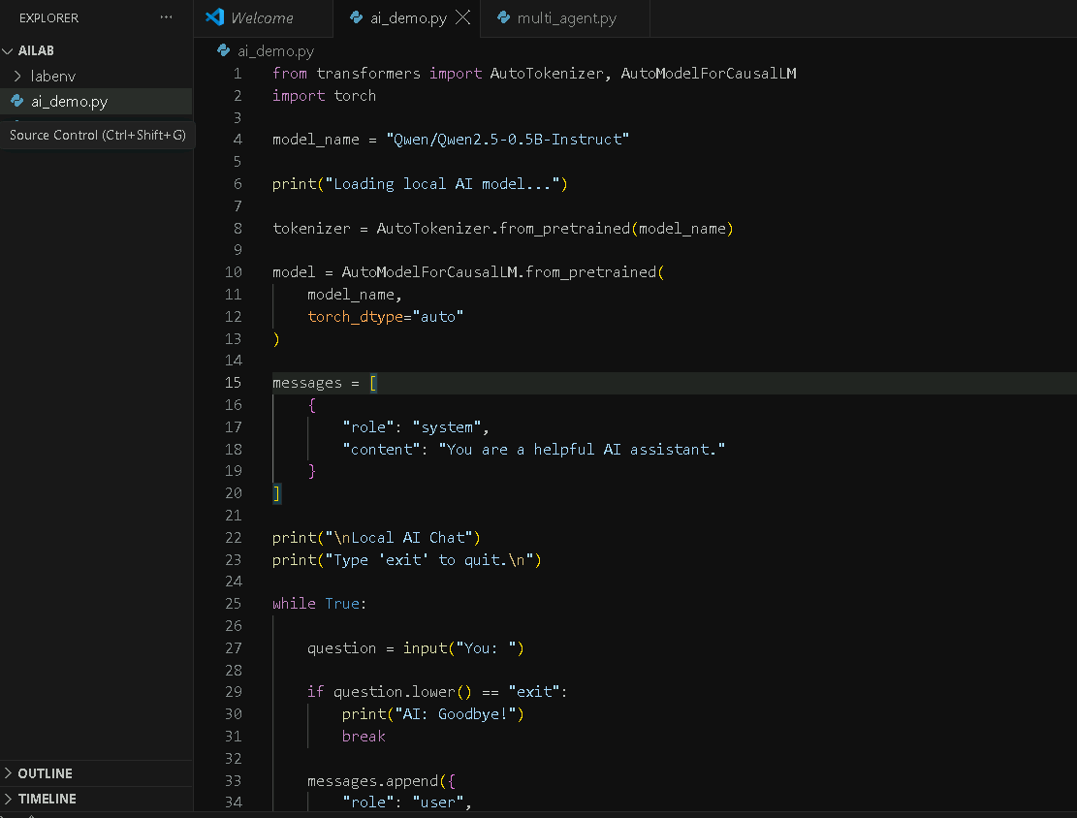

7.1 Sample Demonstration Transcript
Run the script and walk through a short conversation live, for example:
You: What is 5G?
AI: 5G is the fifth generation of mobile network technology...

You: What is the main benefit?
AI: The main benefits include higher speeds, lower latency...

You: Explain latency simply.
AI: Latency is the time it takes for data to travel...
Note the assistant's answers build on prior context (e.g., 'the main benefit' correctly refers back to 5G) — this is what distinguishes the chat-format script from Part 2's single-turn version.

8. Part 4 — Multi-Agent Demo (Advanced)
Parts 2 and 3 used a single AI call to answer a question. Real assistants often need several specialised steps chained together — this is the idea behind “multi-agent” systems. Create multi_agent.py: three small agents, each with its own role, that pass a shared context along the chain so each agent builds on the work of the one before it.
import os
from transformers import pipeline

# Load the same small local AI model used in Part 2 and Part 3
ai = pipeline(
"text-generation",
model="Qwen/Qwen2.5-0.5B-Instruct"
)

def run_agent(name, instructions, context):
"""
Runs a single agent with its own role and instructions,
but hands it the shared context built up by earlier agents.
"""
messages = [
{
"role": "system",
"content": f"You are the {name}. {instructions}"
},
{
"role": "user",
"content": context
}
]

response = ai(
messages,
max_new_tokens=150,
temperature=0.7,
do_sample=True
)

return response[0]["generated_text"][-1]["content"]

# Shared context — this is what makes it "multi-agent":
# each agent reads what earlier agents wrote, then adds to it.
shared_context = """
Customer complaint: "My bill this month is way higher than usual
and I don't understand why. I didn't change my plan."
"""

print("\n======================================")
print(" VODAFONE MULTI-AGENT DEMO")
print("======================================")

# =============================================
# AGENT 1
# =============================================
print("\n🤖 AGENT 1 — CUSTOMER ANALYST")
print("--------------------------------------")
agent1 = run_agent(
"Customer Analyst",
"""
Identify the customer's problem and
what should be investigated.
""",
shared_context
)
print(agent1)

shared_context += f"""
Agent 1 Analysis:
{agent1}
"""
print("\n➡️ Context passed to Agent 2...")

# =============================================
# AGENT 2
# =============================================
print("\n🤖 AGENT 2 — BILLING SPECIALIST")
print("--------------------------------------")
agent2 = run_agent(
"Billing Specialist",
"""
Identify likely billing causes such as
extra data, roaming or additional services.
Use Agent 1's analysis.
""",
shared_context
)
print(agent2)

shared_context += f"""
Agent 2 Analysis:
{agent2}
"""
print("\n➡️ Context passed to Agent 3...")

# =============================================
# AGENT 3
# =============================================
print("\n🤖 AGENT 3 — RESOLUTION AGENT")
print("--------------------------------------")
agent3 = run_agent(
"Customer Resolution Specialist",
"""
Review the previous analysis and give
the best recommendation for the customer.
""",
shared_context
)
print(agent3)

# =============================================
# END
# =============================================
print("\n======================================")
print(" DEMO COMPLETE")
print("======================================\n")

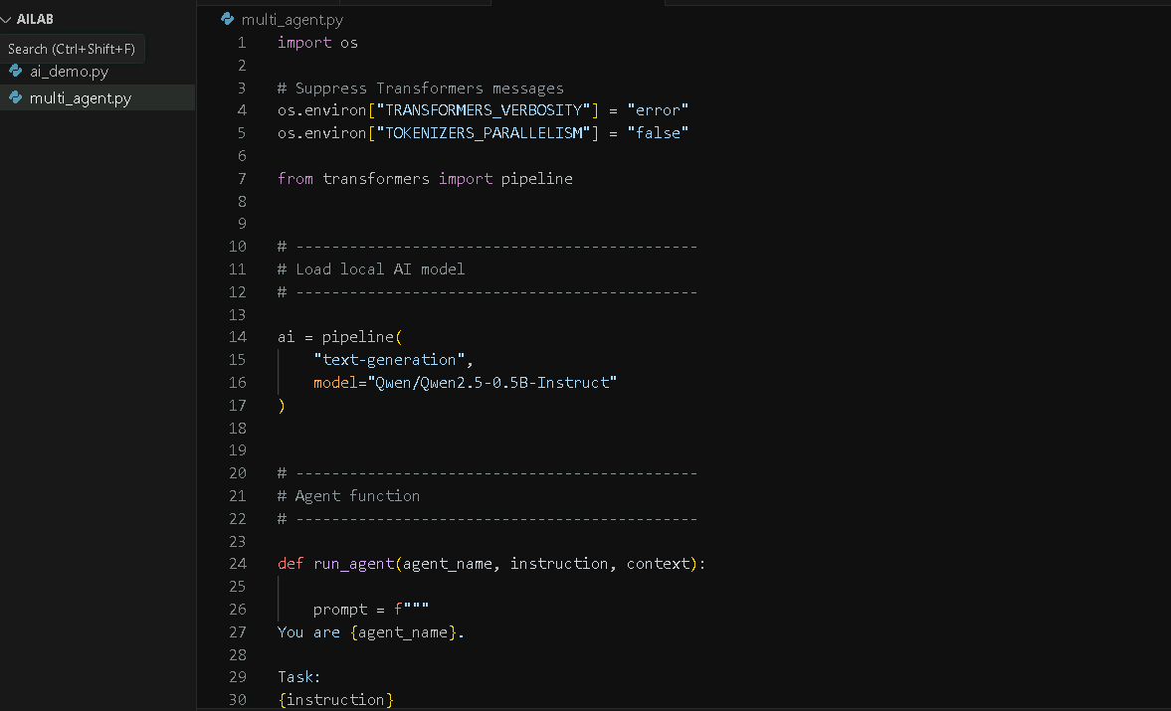
Run it from the terminal:
python multi_agent.py

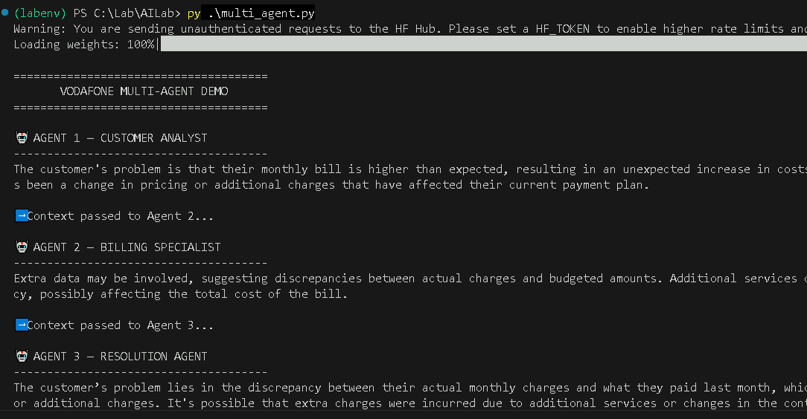

8.1 What Changes Between the Agents
1. run_agent() takes a name and a set of instructions, and builds a fresh system message from them for every call — this is what gives each agent its distinct role.
2. shared_context is passed in as the user message. Each agent's reply is appended to it before the next agent runs, so the chain accumulates analysis instead of starting over.
3. The three agents run strictly in sequence — Billing Specialist only sees the Customer Analyst's output because it was already appended to shared_context by the time Agent 2 runs.
4. The final agent (Resolution Specialist) has the full trail of reasoning available to it, which is why its answer can reference both the diagnosis and the likely billing cause.

Multi_Agent_With_input.py
===========================
import os

# Keep the terminal clean by suppressing Transformers warnings/info
os.environ["TRANSFORMERS_VERBOSITY"] = "error"
os.environ["TOKENIZERS_PARALLELISM"] = "false"

from transformers import pipeline

# ------------------------------------------------
# Load ONE local AI model
# ------------------------------------------------

print("\nLoading local AI model...")

ai = pipeline(
"text-generation",
model="Qwen/Qwen2.5-0.5B-Instruct"
)

print("Model ready!")

# ------------------------------------------------
# Function used by each agent
# ------------------------------------------------

def run_agent(agent_name, instruction, context):

prompt = f"""
You are {agent_name}.

Your task:
{instruction}

Shared context from the customer and other agents:
{context}

Give only 2-3 short sentences.
Do not repeat the entire context.
Focus only on your assigned task.
"""

messages = [
{
"role": "system",
"content": f"You are {agent_name}. Be concise and practical."
},
{
"role": "user",
"content": prompt
}
]

response = ai(
messages,
max_new_tokens=60
)

return response[0]["generated_text"][-1]["content"].strip()

# ------------------------------------------------
# Get customer request from the user
# ------------------------------------------------

print("\n======================================")
print(" VODAFONE MULTI-AGENT DEMO")
print("======================================")

print("\nEnter the customer request.")
print("Type END when you have finished.\n")

lines = []

while True:
line = input()

if line.strip().upper() == "END":
break

lines.append(line)

customer_request = "\n".join(lines).strip()

if not customer_request:
print("\nNo customer request entered. Exiting.")
raise SystemExit

# ------------------------------------------------
# Shared context
# ------------------------------------------------

shared_context = f"""
Customer Request:
{customer_request}
"""

# ------------------------------------------------
# AGENT 1
# ------------------------------------------------

print("\n🤖 AGENT 1 — CUSTOMER ANALYST")
print("--------------------------------------")

agent1 = run_agent(
"Customer Analyst",
"""
Understand the customer's problem.
Identify the important facts and what should
be investigated.
""",
shared_context
)

print(agent1)

shared_context += f"""

Agent 1 - Customer Analyst:
{agent1}
"""

print("\n➡️ Context passed to Agent 2...")

# ------------------------------------------------
# AGENT 2
# ------------------------------------------------

print("\n🤖 AGENT 2 — BILLING SPECIALIST")
print("--------------------------------------")

agent2 = run_agent(
"Billing Specialist",
"""
Analyze the possible billing causes.
Consider data usage, roaming, additional services,
plan limits, or unexpected charges.
Use the original request and Agent 1's analysis.
""",
shared_context
)

print(agent2)

shared_context += f"""

Agent 2 - Billing Specialist:
{agent2}
"""

print("\n➡️ Context passed to Agent 3...")

# ------------------------------------------------
# AGENT 3
# ------------------------------------------------

print("\n🤖 AGENT 3 — RESOLUTION AGENT")
print("--------------------------------------")

agent3 = run_agent(
"Customer Resolution Specialist",
"""
Review the customer's problem and the analysis
from the other agents.
Recommend the best next step and provide a
short, customer-friendly response.
""",
shared_context
)

print(agent3)

# ------------------------------------------------
# Demonstrate the shared context
# ------------------------------------------------

print("\n======================================")
print(" CONTEXT FLOW")
print("======================================")

print("""
Customer Request
↓
Agent 1
↓
Shared Context
↓
Agent 2
↓
Shared Context
↓
Agent 3
↓
Final Response
""")

print("======================================")
print(" DEMO COMPLETE")
print("======================================\n")

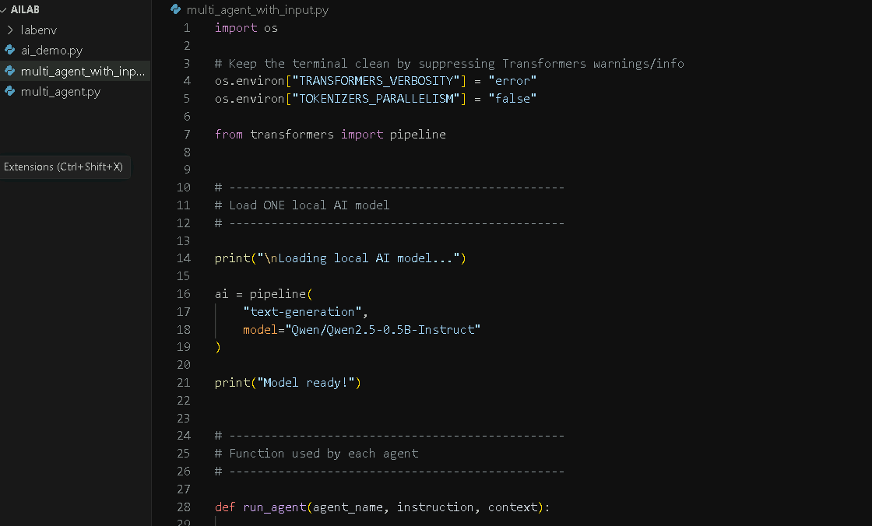

Sample 1 — High bill
My Vodafone bill is £95 this month.
Normally I pay around £40.
I want to understand why my bill increased so much.
END
Sample 2 — International roaming
I travelled to Dubai last week.
After returning home I received a Vodafone bill
that is much higher than normal.
Can you investigate what might have happened?
END

Sample 3 — Data usage
I normally use about 10 GB of mobile data.
This month I used 35 GB and my Vodafone bill
has increased significantly.
What could be causing the additional charge?
END
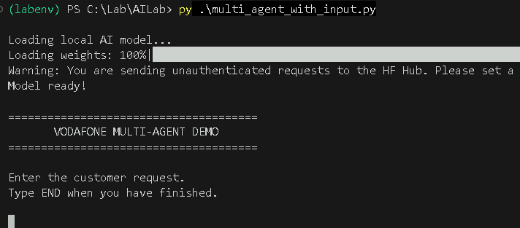

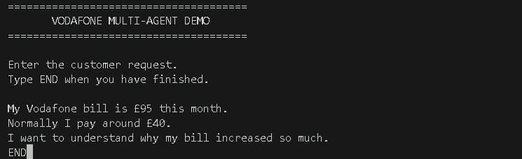
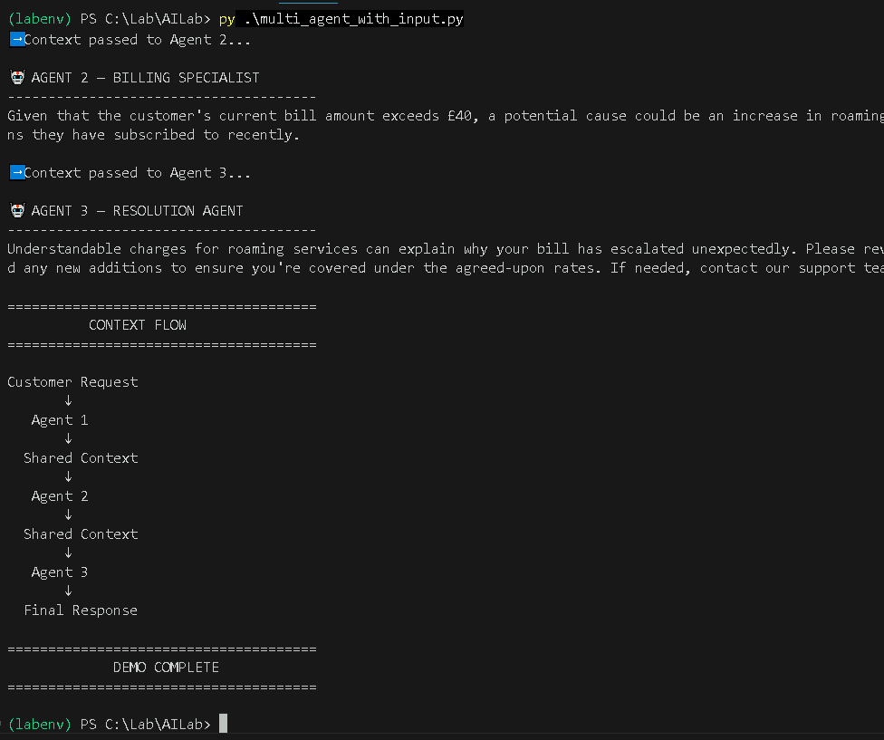

9. What to Explain to Students
Use these talking points alongside the whiteboard diagram in Section 4 as you run the live demo:
- The question is just a Python string — nothing magic happens until it's handed to the model.
- The model (Qwen 0.5B) is a small, open-source file sitting in a local cache folder on disk — it is not calling out to any external service.
- temperature and do_sample control randomness: a lower temperature gives more predictable, repetitive answers; a higher one gives more varied, creative answers.
- max_new_tokens caps how long the response can be — useful for keeping demos fast and readable.
- In the chat version, the entire messages list is re-sent on every turn — this is how the model 'remembers' the conversation, since the model itself has no memory between calls.

10. Summary
Students leave this lab having built and run two working generative AI scripts, entirely offline, using nothing beyond open-source Python libraries and a small pre-trained model. This hands-on foundation — running a model locally and understanding the request/response flow — is the same mental model that applies when later working with larger hosted models such as those behind commercial AI APIs.
Suggested next step
Once comfortable with this local workflow, students can compare it against a hosted API-based model to discuss trade-offs: model quality and speed vs. cost, data privacy, and infrastructure control.

