


Lab Manual- implement common deployment strategies with Kubernetes primitives (Blue-Green)

Prepared for:

Date: 18th Dec 2024

Prepared by:
Document Name: Lab Manual Document Number CKAD-Lab06
Contributor:

Contents
1. Implement common deployment strategies using Kubernetes 2
1.1 Common Deployment Strategies 3
1.2 Kubernetes Primitives Used (with Role + Example) 3
2. Lab 1- Blue-Green Deployment 3
2.1 Create Blue , Green Deployment and Service which Point Initially to Blue 3
2.1 Test the Deployment 7
2.2 Switch the traffic to green 7
2.1 Clean-up the lab 8

Implement common deployment strategies using Kubernetes

When you update your application, you want to release new versions safely without breaking what's already running.

Common Deployment Strategies

Strategy | What it Does | When to Use
Rolling Update | Replaces old pods with new ones gradually | Default in Kubernetes, low risk
Blue/Green | Runs both old and new; switch all traffic at once | Quick rollback, zero downtime
Canary | Sends traffic to new version slowly | Test real traffic, detect bugs early

Kubernetes Primitives Used (with Role + Example)
Tool | Role | Example / Explanation
Deployment | Run versions of your app | Deploy nginx:1.21 as Blue, and nginx:1.22 as Green using two separate deployments.
Service | Route traffic | Service named app-service sends requests to either Blue or Green pods based on selector.
Labels | Identify version/pods | Pods have labels like app=myapp, version=blue to help group or filter them.
Selectors | Control routing in services | Service uses selector version=blue to route traffic to Blue pods only.
ReplicaSet | Keep specific number of pod copies | When you set replicas: 2 in Deployment, ReplicaSet ensures 2 pods are always running.
Pod | Run containerized app | A pod runs the actual nginx container (e.g., nginx:1.21 or nginx:1.22).

Lab 1- Blue-Green Deployment

Create Blue , Green Deployment and Service which Point Initially to Blue

- Create the Blue deployment, Open the Blue deployment YAML file in nano editor
nano Deploy-blue.yaml

# Deploy Blue (nginx:1.21)

apiVersion: apps/v1
kind: Deployment
metadata:
name: app-blue
spec:
replicas: 2
selector:
matchLabels:
app: myapp
version: blue
template:
metadata:
labels:
app: myapp
version: blue
spec:
containers:
- name: nginx
image: nginx:1.21
ports:
- containerPort: 80

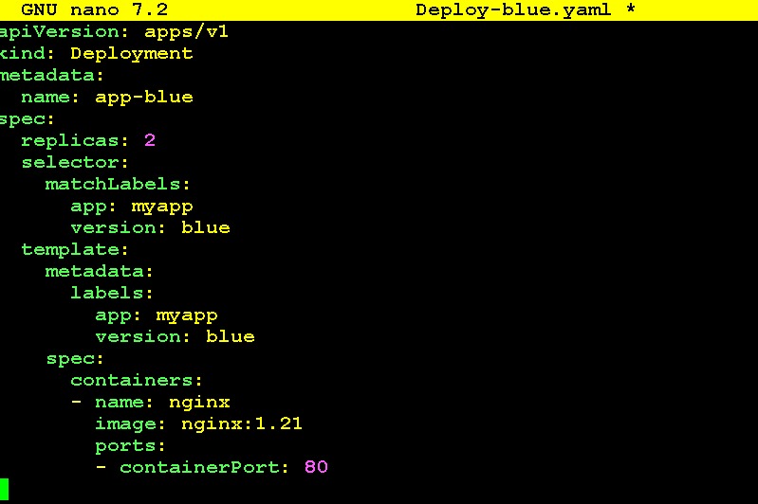

- Create the Green deployment, Open the green deployment YAML file in nano editor

nano Deploy-green.yaml

apiVersion: apps/v1
kind: Deployment
metadata:
name: app-green
spec:
replicas: 2
selector:
matchLabels:
app: myapp
version: green
template:
metadata:
labels:
app: myapp
version: green
spec:
containers:
- name: nginx
image: nginx:1.22
ports:
- containerPort: 80

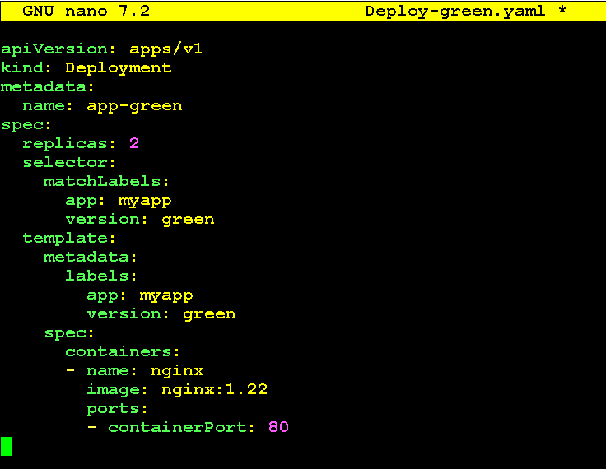

- Open the service YAML file that routes traffic to app-blue pods

nano serviceblue.yaml

apiVersion: v1
kind: Service
metadata:
name: app-service
spec:
selector:
app: myapp
ports:
- port: 80
targetPort: 80
nodePort: 30080
protocol: TCP
type: NodePort

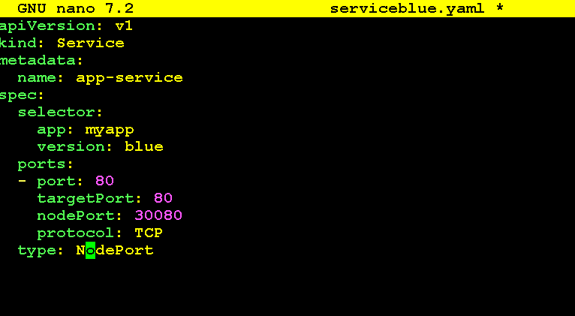
- Apply the Deployments and Service

kubectl apply -f Deploy-blue.yaml
kubectl apply -f Deploy-green.yaml
kubectl apply -f serviceblue.yaml

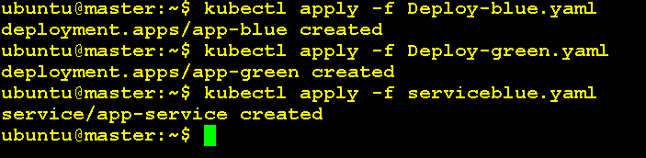

- List all pods to verify Blue and Green pods are up

kubectl get pod

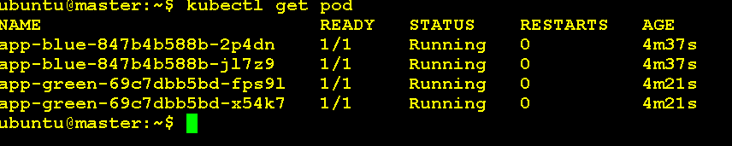

- Check the service is created and listening on NodePort

kubectl get svc

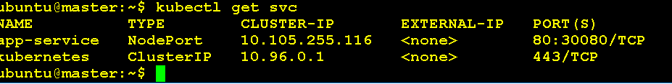

Test the Deployment

- Use curl to check the response from Blue version through NodePort

curl -I http://192.168.88.128:30080

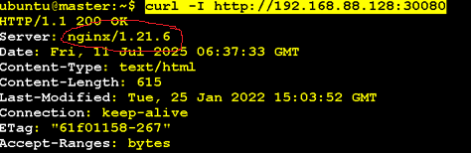

Switch the traffic to green

- Edit the serviceblue.yaml and change selector version to green from blue

nano serviceblue.yaml
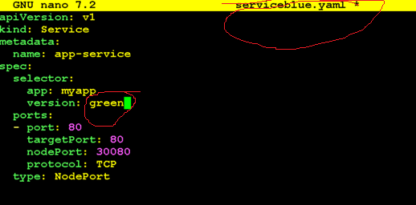

- Apply the changes to see the version upgrade

kubectl apply -f serviceblue.yaml

- Use curl to check the response from Green version through NodePort

curl -I http://192.168.88.128:30080

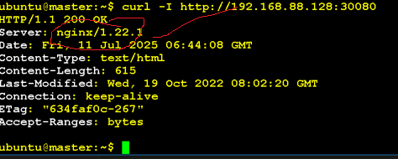

Clean-up the lab

kubectl delete -f serviceblue.yaml
kubectl delete-f Deploy-blue.yaml
kubectl delete -f Deploy-green.yaml

