


Lab Manual- implement common deployment strategies with Kubernetes primitives (Canary)

Prepared for:

Date: 18th Dec 2024

Prepared by:
Document Name: Lab Manual Document Number CKAD-Lab09
Contributor:

Contents
1. Implement common deployment strategies using Kubernetes 2
1.1 Common Deployment Strategies 3
1.2 Kubernetes Primitives Used (with Role + Example) 3
2. Lab 1- Canary Deployment 3
2.1 Create Stable,Canary and Service which Point Initially to Blue 3
2.1 Test Traffic Split 7
2.1 Clean-up the lab 7

Implement common deployment strategies using Kubernetes

When you update your application, you want to release new versions safely without breaking what's already running.

Common Deployment Strategies

Strategy | What it Does | When to Use
Rolling Update | Replaces old pods with new ones gradually | Default in Kubernetes, low risk
Blue/Green | Runs both old and new; switch all traffic at once | Quick rollback, zero downtime
Canary | Sends traffic to new version slowly | Test real traffic, detect bugs early

Kubernetes Primitives Used (with Role + Example)
Tool | Role | Example / Explanation
Deployment | Run versions of your app | Deploy nginx:1.21 as Blue, and nginx:1.22 as Green using two separate deployments.
Service | Route traffic | Service named app-service sends requests to either Blue or Green pods based on selector.
Labels | Identify version/pods | Pods have labels like app=myapp, version=blue to help group or filter them.
Selectors | Control routing in services | Service uses selector version=blue to route traffic to Blue pods only.
ReplicaSet | Keep specific number of pod copies | When you set replicas: 2 in Deployment, ReplicaSet ensures 2 pods are always running.
Pod | Run containerized app | A pod runs the actual nginx container (e.g., nginx:1.21 or nginx:1.22).

Lab 1- Canary Deployment

Create Stable,Canary and Service which Point Initially to Blue

- Create the Stable deployment, Open the Stable deployment YAML file in nano editor
nano Stable-deployment.yaml

# Deploy Stable NGNIX (v1.21) with 3 Replica
apiVersion: apps/v1
kind: Deployment
metadata:
name: app-stable
spec:
replicas: 3
selector:
matchLabels:
app: myapp
version: stable
template:
metadata:
labels:
app: myapp
version: stable
spec:
containers:
- name: nginx
image: nginx:1.21
ports:
- containerPort: 80

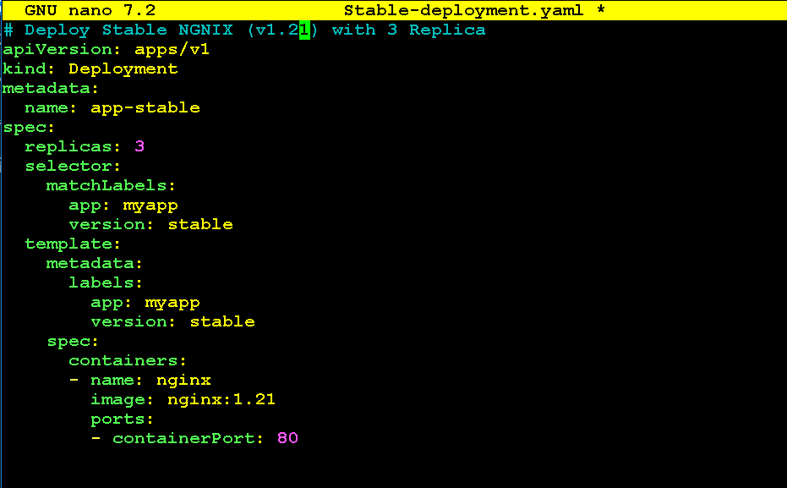

- Create the Canary deployment, Open the Canary deployment YAML file in nano editor

nano Canary-deployment.yaml

apiVersion: apps/v1
kind: Deployment
metadata:
name: app-canary
spec:
replicas: 1
selector:
matchLabels:
app: myapp
version: canary
template:
metadata:
labels:
app: myapp
version: canary
spec:
containers:
- name: nginx
image: nginx:1.22
ports:
- containerPort: 80

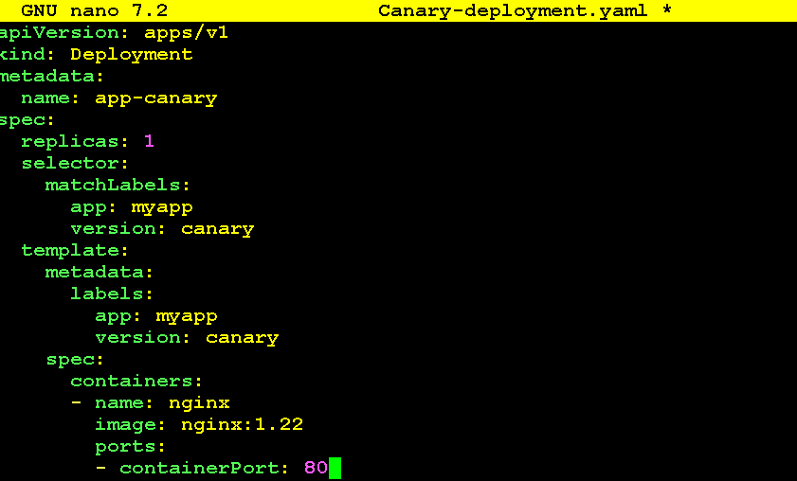

- Open the service YAML file that routes traffic to both Stable and Canary

nano service-stable-canary.yaml

apiVersion: v1
kind: Service
metadata:
name: app-service
spec:
selector:
app: myapp
ports:
- port: 80
targetPort: 80
nodePort: 30080
protocol: TCP
type: NodePort

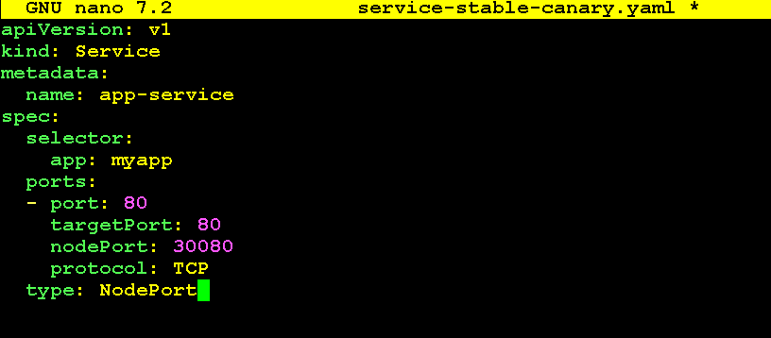

- Apply the Deployments and Service

kubectl apply -f Stable-deployment.yaml
kubectl apply -f Canary-deployment.yaml
kubectl apply -f service-stable-canary.yaml

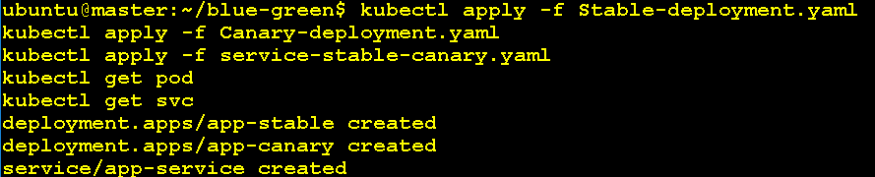

- List all pods to verify Stable and Canary pods are up

kubectl get pod

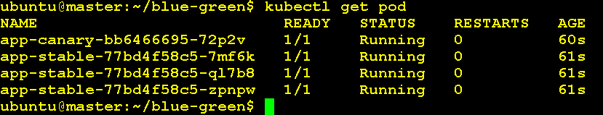

kubectl get pod -l app=myapp -o wide

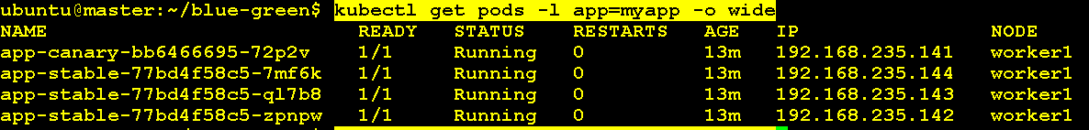

- Check the service is created and listening on NodePort

kubectl get svc

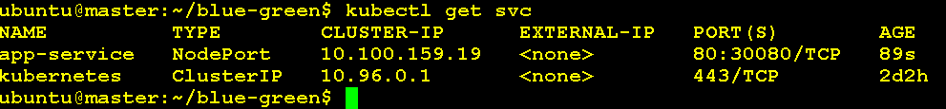

Test Traffic Split

# Use a loop:

for i in {1..10}; do curl -s -I http://192.168.88.128:30080 | grep Server; sleep 1; done

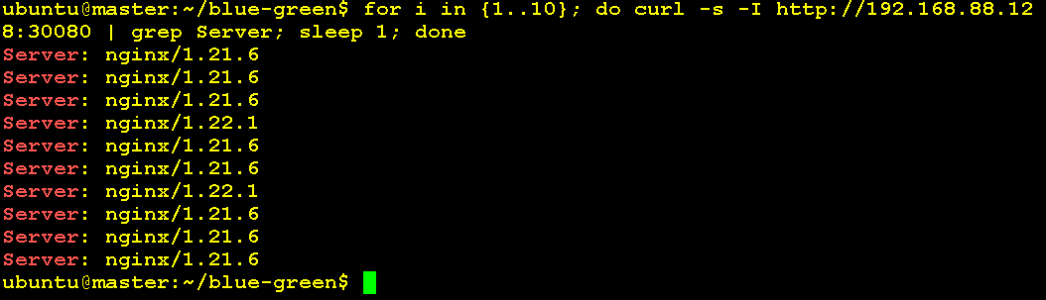

Part | Purpose
curl -s -I | Silent + fetch only headers (not HTML body)
grep Server | Extracts line like Server: nginx/1.21.6
sleep 1 | Pause 1 second between requests
for i in {1..10} | Loop 10 times

Clean-up the lab

kubectl delete -f Stable-deployment.yaml
kubectl delete -f Canary-deployment.yaml
kubectl delete -f service-stable-canary.yaml

