


Lab Manual- Authentication , Authorization and Admission control in Kubernetes

Prepared for:

Date: 18th Dec 2024

Prepared by:
Document Name: Lab Manual Document Number CKAD-Lab06
Contributor:

Contents
1 Understanding Authentication and Authorization in Kubernetes 3
1.1 The journey of every request 3
1.2 Authentication – Proving Who You Are 3
1.3 Authorization – Checking What You Are Allowed to Do 4
1.4 Summary Table 5
1.5 Before you start 5
2 Lab 1 – Authentication and Authorization in Kubernetes 7
2.1 Authentication – Create a ServiceAccount 7
2.2 Verify the ServiceAccount 7
2.3 Authorization – Try to List Pods Without Permission 8
2.4 Authorize the ServiceAccount: write the Role 9
2.5 Authorize the ServiceAccount: write the RoleBinding 9
2.6 Apply the Role and RoleBinding 11
2.7 Verify the Role and RoleBinding 12
2.8 Test the Roles 12
2.9 Cleanup 14
3 Admission Control in Kubernetes 15
3.1 What Admission Control does 15
3.2 Lab Admission Control – Write the LimitRange 15
3.3 Write a Pod with no memory settings 16
3.4 Apply the LimitRange 17
3.5 Create the Pod 18
3.6 See what Admission Control changed 18
3.7 Optional: see Admission Control reject a Pod 20
3.8 Delete the LimitRange and Pod 20
4 Summary and troubleshooting 22
4.1 What each step proved 22
4.2 Troubleshooting 22
4.3 Self-check 22

Understanding Authentication and Authorization in Kubernetes
In Kubernetes, secure access to resources is controlled by three checks that every request must pass in order: Authentication, Authorization and Admission Control.
This lab explains each check in a simple, real-world way, then lets you see it working in a real cluster: you create an identity, watch it being refused, give it exactly the permissions it needs, and finally watch Kubernetes change a Pod as it is being created.

The journey of every request
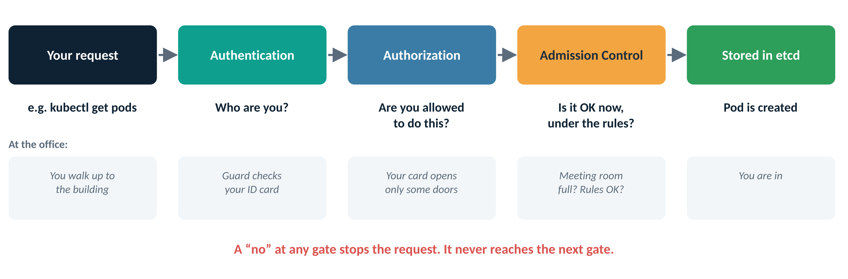
Figure 1: Every request passes three gates before anything is saved
Gate | The question it asks | Office comparison | In Kubernetes
1. Authentication | Who are you? | The guard at the entrance checks your ID card | Certificates, tokens, company login (OIDC)
2. Authorization | Are you allowed to do this? | Your card opens the development floor, but not the server room | RBAC: Roles and RoleBindings
3. Admission Control | Is it OK right now, under the rules? | You may use the meeting room, but it is already full | LimitRange, ResourceQuota, policy plugins

Note
The gates always run in this order. If authentication fails, Kubernetes never asks about permissions. If authorization fails, admission rules are never checked.

Authentication – Proving Who You Are
Authentication is the process of verifying the identity of a user or program that is trying to talk to the Kubernetes API.
Real-world analogy
You arrive at an office building. At the entrance, the security guard checks your company ID card to confirm who you are. That is authentication: confirming you are who you claim to be. It says nothing yet about which rooms you may enter.

How Kubernetes checks identity
Method | Who typically uses it | Example
Client certificates | Administrators and kubectl users | The admin kubeconfig created by kubeadm holds a certificate
Bearer tokens | ServiceAccounts (apps and scripts) | A Pod running as test-user presents a token issued by Kubernetes
Authentication plugins (OIDC, LDAP) | People in larger companies | Developers sign in with their company account

For example, when a user runs a kubectl command, kubectl sends a certificate or a token with the request. Kubernetes checks that it is genuine and has not expired.
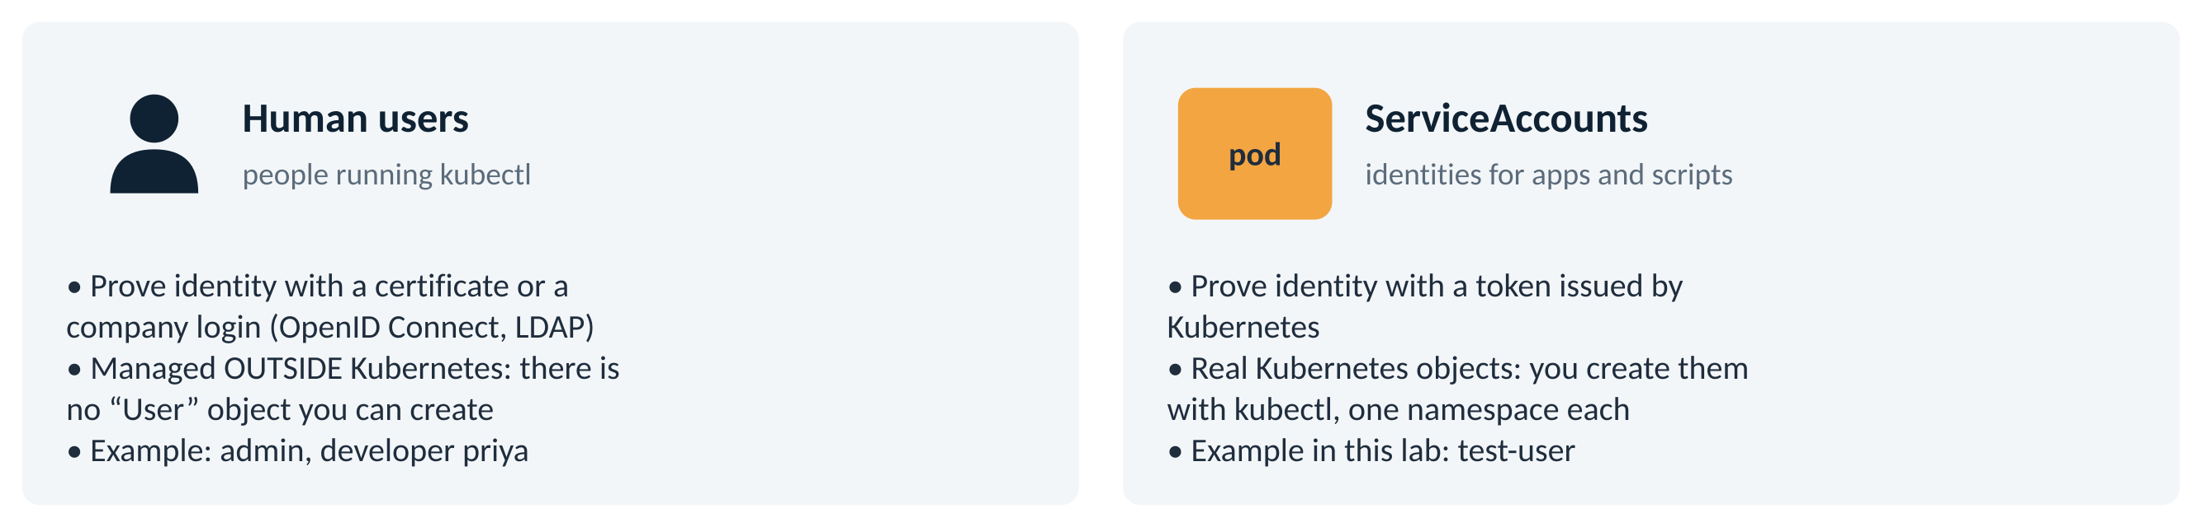
Figure 2: Kubernetes has two kinds of identity: people and ServiceAccounts

Authorization – Checking What You Are Allowed to Do
Once Kubernetes knows who you are, it must check whether you have permission for the specific action you asked for. This is authorization.
Real-world analogy
You are inside the office now. You may be allowed into the development area but not the server room. Whether a particular door opens depends on the access rights on your card. That is authorization.

Kubernetes uses Role-Based Access Control (RBAC) to authorize actions:
RBAC object | What it does | In this lab
Role | A list of allowed actions (verbs) on resources, inside one namespace | pod-reader: get, list and watch Pods
RoleBinding | Gives a Role to a user, group or ServiceAccount, inside one namespace | read-pods-binding gives pod-reader to test-user
ClusterRole / ClusterRoleBinding | The same idea, but across the whole cluster | Not used in this lab

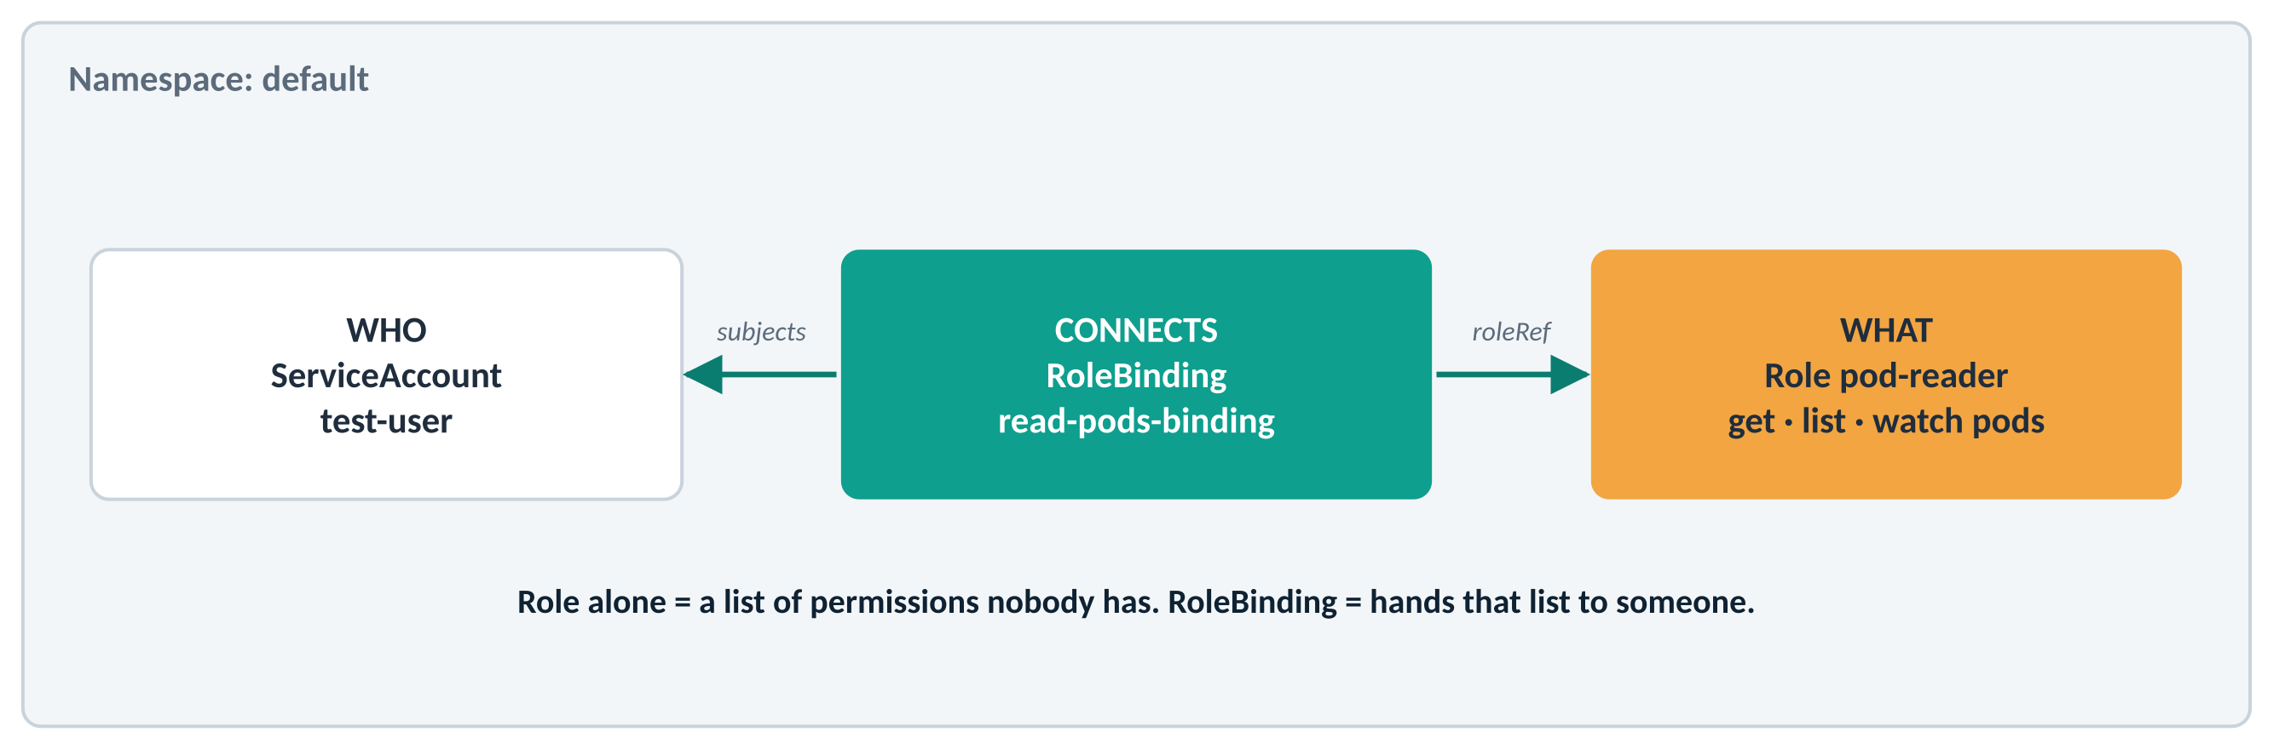
Figure 3: How the Role and RoleBinding in this lab connect
Even if a user is authenticated, they cannot list Pods unless an RBAC rule explicitly allows it. In RBAC, everything is denied until something allows it.

Summary Table
Component | The question | Real-world analogy | Kubernetes mechanism
Authentication | Who are you? | Showing your ID at the office gate | Certificates, tokens (ServiceAccount), OIDC
Authorization | What may you do? | Being allowed onto certain floors | RBAC: Role and RoleBinding
Admission Control | Is it OK now, under the rules? | The meeting room has space and is not booked | LimitRange, ResourceQuota, policies

Before you start
- You need a working cluster and a kubeconfig with admin rights (for example on the kubeadm master node).
- Everything happens in the default namespace.
- Commands that begin with kubectl auth can-i only ask a question. They never change anything, so you can run them as often as you like.
Files you will create
File | Creates | Used in
role.yaml | Role pod-reader | Section 2 (authorization)
rolebinding.yaml | RoleBinding read-pods-binding | Section 2 (authorization)
limitrange.yaml | LimitRange mem-limit-range | Section 3 (admission control)
pod-no-memory.yaml | Pod nopod | Section 3 (admission control)

Lab roadmap
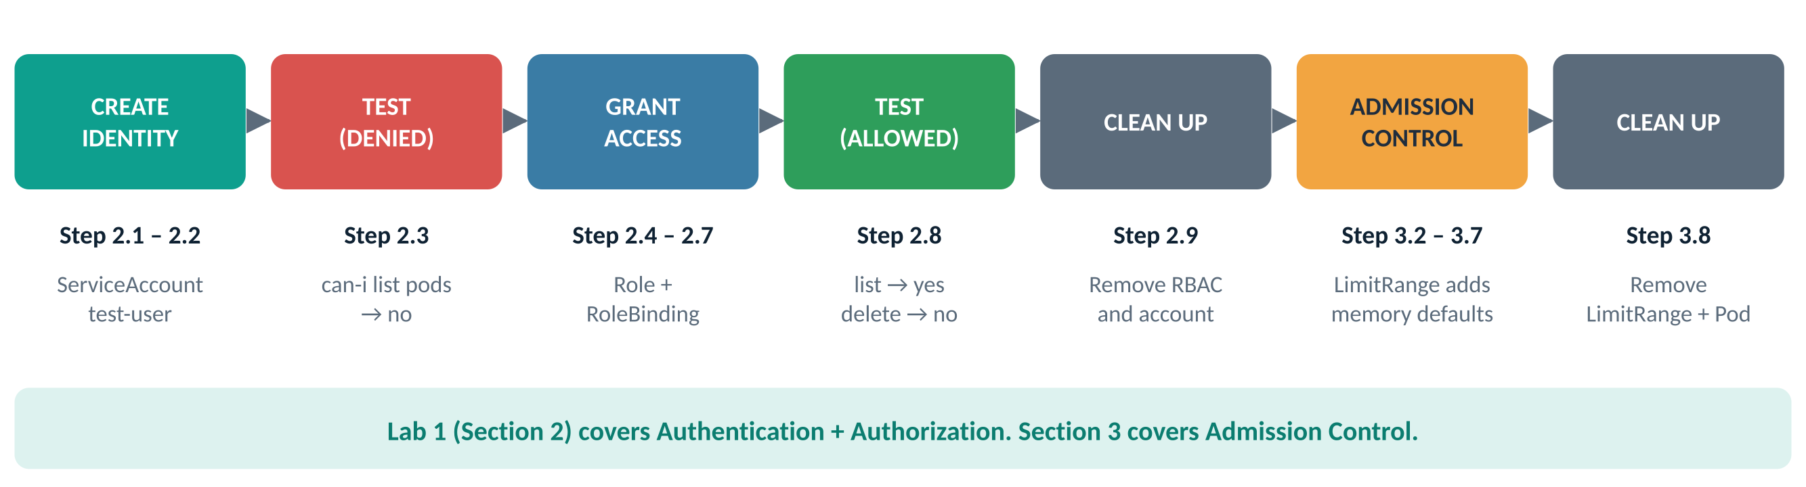
Figure 4: The lab at a glance: section and step numbers match the headings

Lab 1 – Authentication and Authorization in Kubernetes
In this lab you will see:
- Authentication, using a ServiceAccount as the identity,
- Authorization, using RBAC rules (a Role and a RoleBinding),
- Admission Control, using a LimitRange (Section 3).
Each step follows the same pattern: why you are doing it, what to type, the screenshot you should see with numbered highlights, a table explaining each highlight, and a checkpoint that tells you when to move on.

Authentication – Create a ServiceAccount
Why: A ServiceAccount is an identity for an app or script. Creating one gives Kubernetes a “person” it can recognise. It proves who it is with a token that Kubernetes issues.
Do this
kubectl create serviceaccount test-user
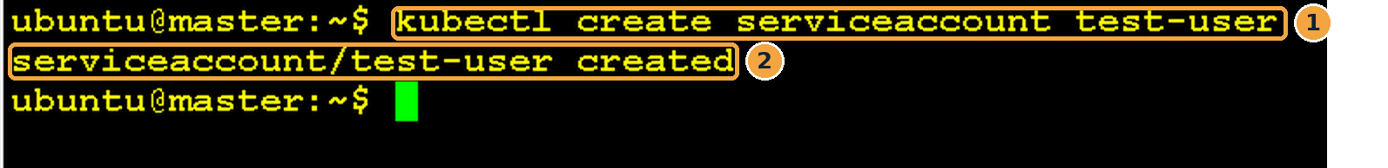
Screenshot 1: Creating the ServiceAccount test-user
What this screenshot shows
# | What you see | What it means
1 | kubectl create serviceaccount test-user | Asks Kubernetes to create a new identity called test-user in the current (default) namespace.
2 | serviceaccount/test-user created | The identity now exists. It has no permissions yet.

Checkpoint: you are ready for the next step when…
The output says serviceaccount/test-user created.

Verify the ServiceAccount
Why: Confirm the identity really exists before you test what it can do.
Do this
kubectl get serviceaccounts # "serviceaccount" (singular) also works
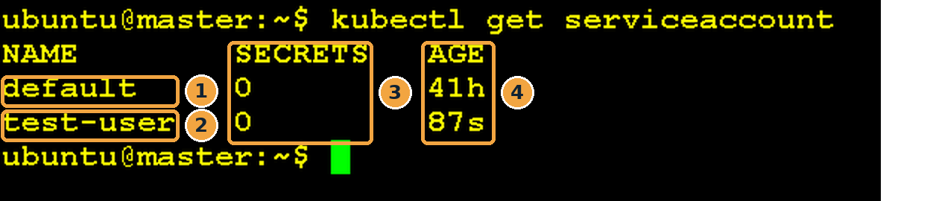
Screenshot 2: ServiceAccounts in the default namespace
What this screenshot shows
# | What you see | What it means
1 | default | Every namespace gets a ServiceAccount called default automatically. Pods use it when you do not choose another.
2 | test-user | The ServiceAccount you just created.
3 | SECRETS 0 | Normal on Kubernetes 1.24 and later: tokens are no longer stored as Secrets. They are created on demand and expire automatically.
4 | AGE 87s | Created 87 seconds ago. default is older because it was made with the namespace.

Optional check (no screenshot): see a real token
kubectl create token test-user # prints a short-lived token
This token is what an app running as test-user would send with each request. Kubernetes checks it at the authentication gate.
Note
📌 test-user is now an identity that can authenticate with a token. It still has no permissions, which you will prove in the next step.

Checkpoint: you are ready for the next step when…
You see test-user in the list.

Authorization – Try to List Pods Without Permission
Why: Before granting anything, prove that a brand-new identity is not allowed to do anything. RBAC denies by default.
Do this
kubectl auth can-i list pods --as=system:serviceaccount:default:test-user
You should get: no
Screenshot 3: test-user is not allowed to list Pods
What this screenshot shows
# | What you see | What it means
1 | kubectl auth can-i list pods | Ask the authorization gate a yes/no question: “Is this allowed?”
2 | --as=system:serviceaccount:default:test-user | Ask on behalf of test-user instead of yourself (called impersonation). You are the admin, so you are allowed to ask this.
3 | no | test-user is authenticated (Kubernetes knows it), but not authorized to list Pods.

How to read the --as value
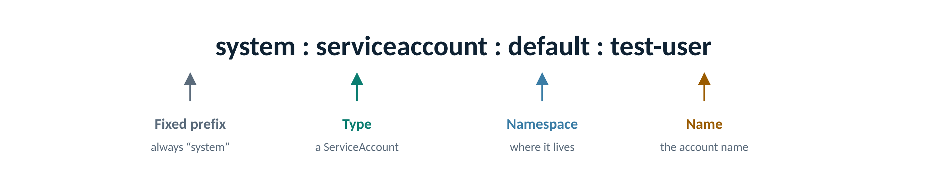
Figure 5: The full name Kubernetes uses for a ServiceAccount
Tip
Without --as, the command checks your own permissions. As the admin you would get yes, which proves nothing about test-user.

Checkpoint: you are ready for the next step when…
The answer is no. → test-user is authenticated but not authorized.

Authorize the ServiceAccount: write the Role
Why: A Role is a written list of permissions. It says what may be done, but not yet who may do it.
Do this
nano role.yaml
# role.yaml
apiVersion: rbac.authorization.k8s.io/v1
kind: Role
metadata:
name: pod-reader
namespace: default
rules:
- apiGroups: [""]
resources: ["pods"]
verbs: ["get", "list", "watch"]
Save with Ctrl+O, Enter, and exit with Ctrl+X.
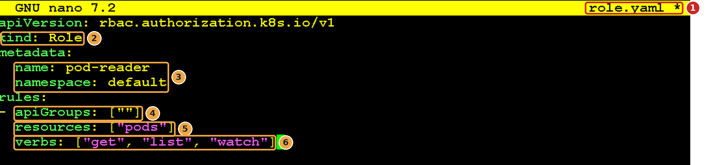
Screenshot 4: role.yaml open in nano
What this screenshot shows
# | What you see | What it means
1 | role.yaml * in the title bar | You are editing the right file. The * means there are unsaved changes.
2 | kind: Role | A namespaced permission list (a ClusterRole would apply cluster-wide).
3 | name: pod-reader, namespace: default | The Role’s name, and the only namespace where it applies.
4 | apiGroups: [""] | The empty string means the core API group, where Pods, Services and Secrets live.
5 | resources: ["pods"] | The permissions cover Pods only. Services, Secrets, Deployments and others are not included.
6 | verbs: ["get", "list", "watch"] | Read-only actions. create, update and delete are not listed, so they stay denied.

Checkpoint: you are ready for the next step when…
The file is saved and the verbs line has exactly get, list and watch.

Authorize the ServiceAccount: write the RoleBinding
Why: The RoleBinding hands the Role to a specific identity. Without it, the Role is a list of permissions that nobody has.
Do this
nano rolebinding.yaml
apiVersion: rbac.authorization.k8s.io/v1
kind: RoleBinding
metadata:
name: read-pods-binding
namespace: default
subjects:
- kind: ServiceAccount
name: test-user
namespace: default
roleRef:
kind: Role
name: pod-reader
apiGroup: rbac.authorization.k8s.io
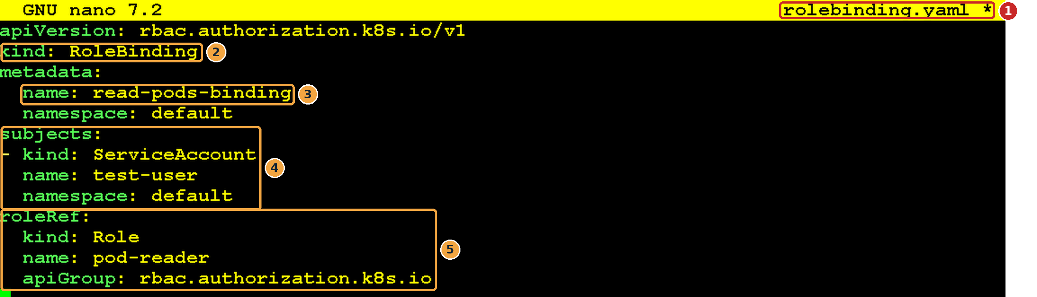
Screenshot 5: rolebinding.yaml open in nano
What this screenshot shows
# | What you see | What it means
1 | rolebinding.yaml * in the title bar | A separate file from the Role.
2 | kind: RoleBinding | This object connects a “who” to a “what”.
3 | name: read-pods-binding | The binding’s own name, used when you list or delete it.
4 | subjects: ServiceAccount test-user in default | WHO receives the permissions. The namespace must match where the ServiceAccount lives.
5 | roleRef: Role pod-reader | WHAT permissions they receive. roleRef cannot be changed later; to point at another Role, delete and recreate the binding.

Figure 6: The RoleBinding links test-user (subjects) to pod-reader (roleRef)
Checkpoint: you are ready for the next step when…
subjects names test-user and roleRef names pod-reader, both spelled exactly as before.

Apply the Role and RoleBinding
Why: Send both files to Kubernetes so the permissions actually take effect.
Do this: apply the Role
kubectl apply -f role.yaml
Screenshot 6: The Role was created
What this screenshot shows
# | What you see | What it means
1 | role.rbac.authorization.k8s.io/pod-reader created | The Role exists in the default namespace. Nobody has it yet.

Then apply the RoleBinding
kubectl apply -f rolebinding.yaml
Screenshot 7: The RoleBinding was created
What this screenshot shows
# | What you see | What it means
1 | rolebinding.rbac.authorization.k8s.io/read-pods-binding created | test-user now holds the pod-reader permissions. This takes effect immediately; nothing needs restarting.

Checkpoint: you are ready for the next step when…
Both commands end in created.

Verify the Role and RoleBinding
Why: Check that both objects exist and are connected the way you expect.
Do this
kubectl get roles
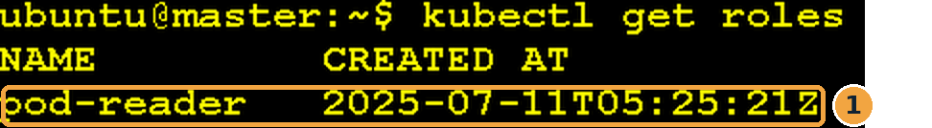
Screenshot 8: The pod-reader Role
What this screenshot shows
# | What you see | What it means
1 | pod-reader 2025-07-11T05:25:21Z | Your Role, with the time it was created (in UTC).

kubectl get rolebinding
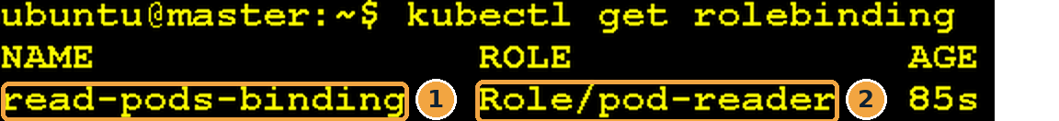
Screenshot 9: The read-pods-binding RoleBinding
What this screenshot shows
# | What you see | What it means
1 | read-pods-binding | Your RoleBinding.
2 | Role/pod-reader | Confirms which Role it hands out.

Optional check (no screenshot): see who the binding is for
kubectl describe rolebinding read-pods-binding # Subjects: ServiceAccount test-user
Checkpoint: you are ready for the next step when…
The binding shows Role/pod-reader.

Test the Roles
Why: Ask the same question as in Step 2.3, plus two actions that the Role does not allow. This proves the permissions are exactly as written: no more, no less.
Test 1: list Pods (allowed by the Role)
kubectl auth can-i list pods --as=system:serviceaccount:default:test-user
Screenshot 10: list pods is now allowed
What this screenshot shows
# | What you see | What it means
1 | list pods | The same question as Step 2.3.
2 | yes | The answer changed from no to yes, because the RoleBinding gave test-user the list verb.

Test 2: delete Pods (not in the Role)
kubectl auth can-i delete pods --as=system:serviceaccount:default:test-user
Screenshot 11: delete pods is still denied
What this screenshot shows
# | What you see | What it means
1 | delete pods | A destructive action.
2 | no | delete is not in the verbs list, so it stays denied.

Test 3: create Pods (not in the Role)
kubectl auth can-i create pods --as=system:serviceaccount:default:test-user
Screenshot 12: create pods is still denied
What this screenshot shows
# | What you see | What it means
1 | create pods | Another action that was not granted.
2 | no | create is not in the verbs list either. test-user can look, but cannot change anything.

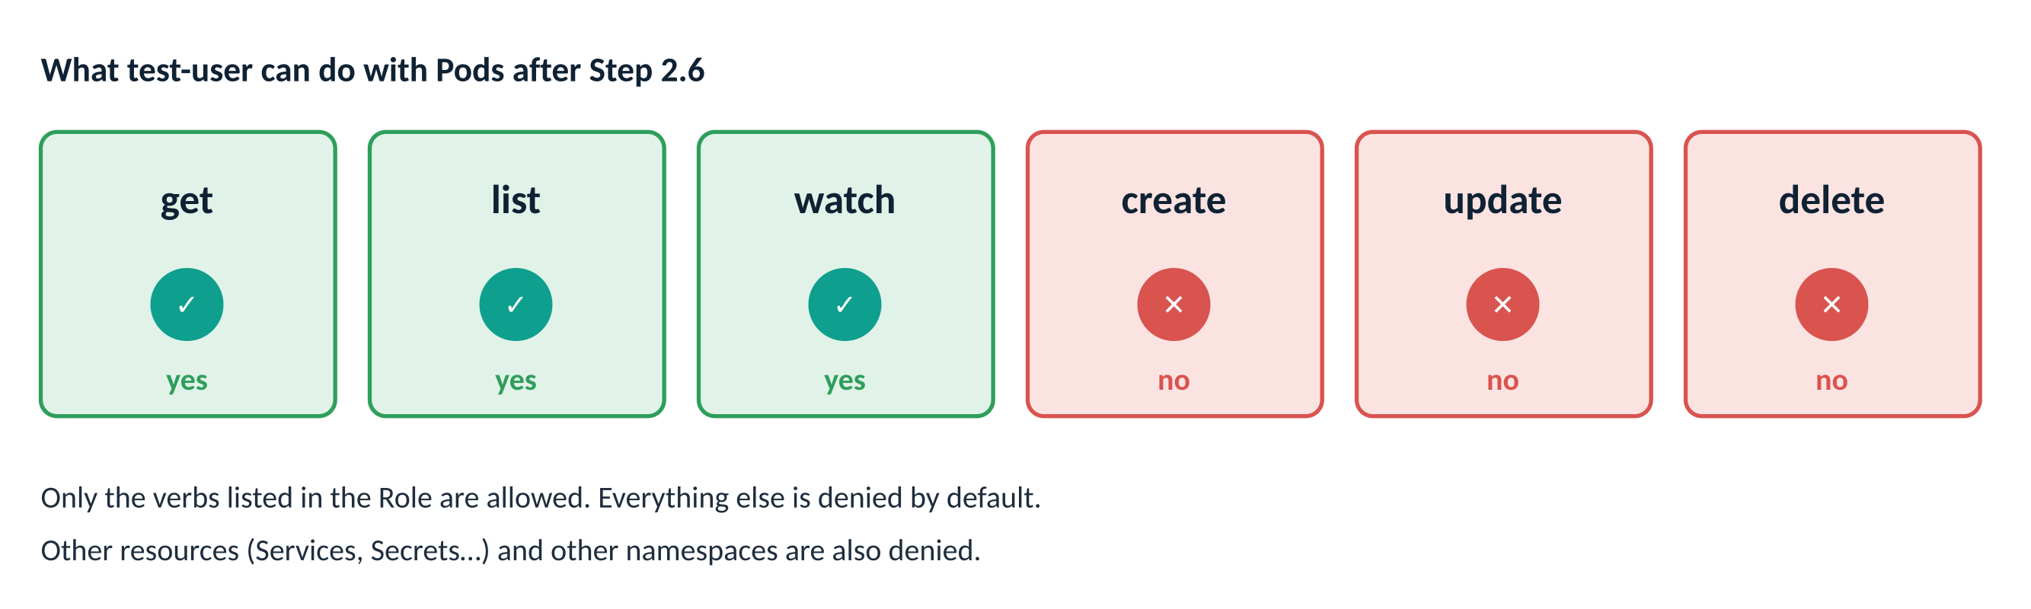
Figure 7: Summary of what test-user can and cannot do
Optional check (no screenshot): see every permission at once
kubectl auth can-i --list --as=system:serviceaccount:default:test-user
Real-world use
A monitoring dashboard needs to show which Pods are running, but must never be able to delete them. Giving its ServiceAccount a read-only Role like pod-reader is exactly how teams do this in production. This is called least privilege: give only the permissions that are needed.

Checkpoint: you are ready for the next step when…
list → yes, delete → no, create → no.

Cleanup
Why: Remove everything from this part of the lab so it does not affect later labs.
Do this
kubectl delete -f role.yaml
kubectl delete -f rolebinding.yaml
kubectl get roles
kubectl delete serviceaccount test-user
kubectl get serviceaccounts
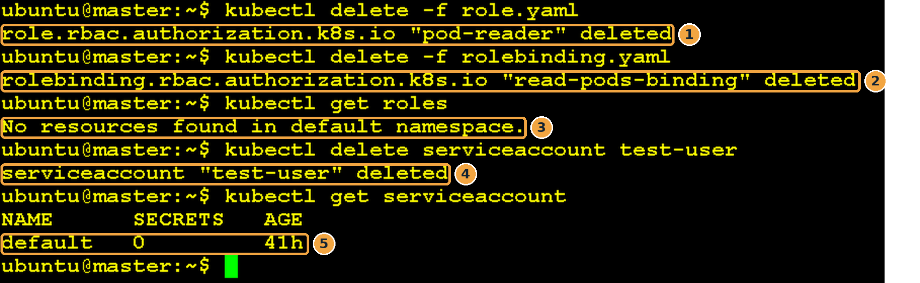
Screenshot 13: The Role, RoleBinding and ServiceAccount are removed
What this screenshot shows
# | What you see | What it means
1 | role… "pod-reader" deleted | The permission list is gone.
2 | rolebinding… "read-pods-binding" deleted | The link between test-user and the Role is gone.
3 | No resources found in default namespace. | kubectl get roles confirms no Roles are left.
4 | serviceaccount "test-user" deleted | The identity itself is removed. Note that you must name it: kubectl delete serviceaccount test-user.
5 | default 0 41h | Only the built-in default ServiceAccount remains. Never delete it.

Checkpoint: you are ready for the next step when…
kubectl get serviceaccounts shows only default.

Admission Control in Kubernetes

What Admission Control does
Admission Control is the last gate. It checks policies, quotas and limits. Its question is: “Can you do it now, under the current rules?”
Real-world analogy
Suppose you are authorized to use the meeting room, but it is already full.
🚦 Admission Control checks whether the system can allow the request right now.
✅ If the room has space and the conditions are fine, you are admitted.
❌ If the room is full or booked, you are denied, even though you are authorized.

So even when a user is authorized, Kubernetes still checks rules and policies. For example:
- Is there a policy saying every Pod must have certain labels?
- Has the namespace’s resource quota already been used up?
- Does the Pod ask for more memory than allowed?
✔️ All checks pass → the Pod is created. ❌ Any check fails → the request is rejected.
Admission controllers can do two different things
Type | What it does | Example
Mutating | Changes the request before it is saved, usually to fill in missing settings | LimitRanger adds default memory values to a Pod that has none (you will see this in Step 3.6)
Validating | Accepts or rejects the request, without changing it | LimitRanger rejects a Pod that asks for more than the maximum (optional Step 3.7)

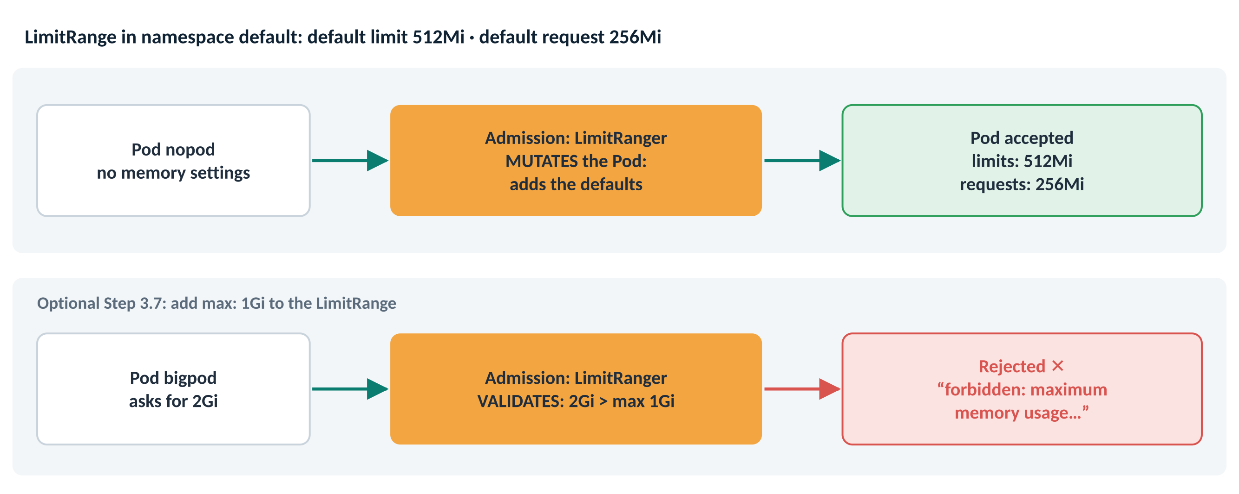
Figure 8: The same LimitRange can fill in defaults (mutate) or reject a Pod (validate)

Lab Admission Control – Write the LimitRange
Why: A LimitRange sets memory rules for every container in a namespace. This one says: “if a container does not say how much memory it needs, give it these defaults.”
Do this
nano limitrange.yaml
apiVersion: v1
kind: LimitRange
metadata:
name: mem-limit-range
namespace: default
spec:
limits:
- default:
memory: 512Mi
defaultRequest:
memory: 256Mi
type: Container
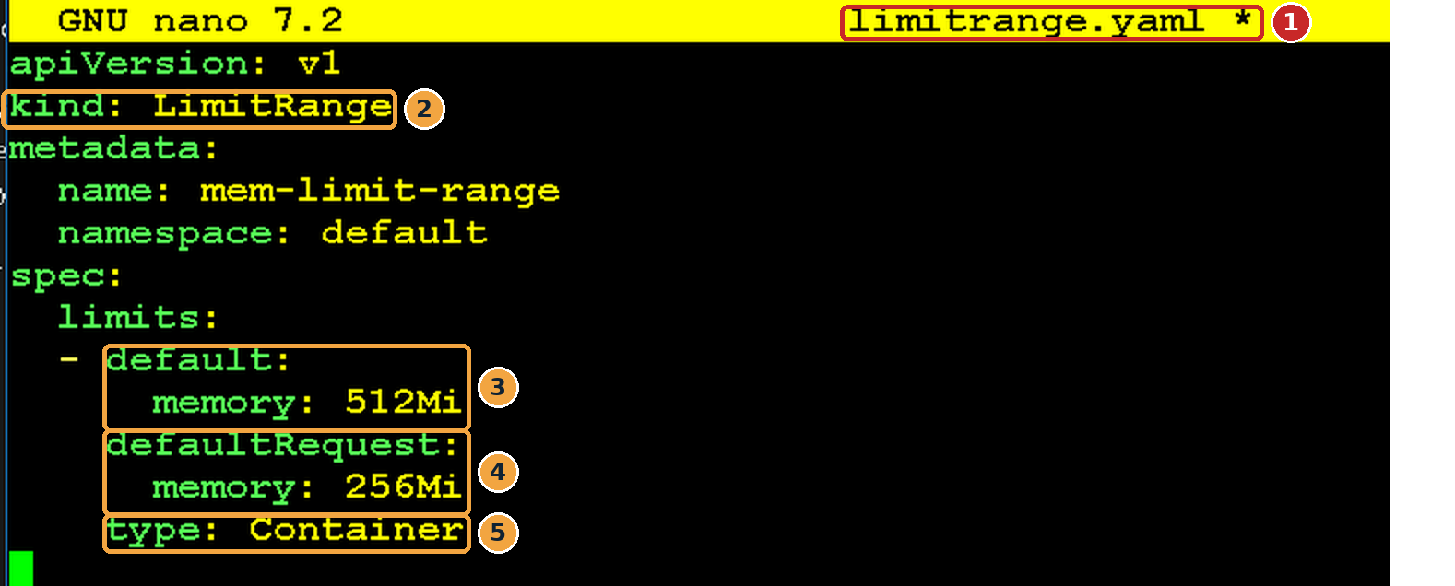
Screenshot 14: limitrange.yaml open in nano
What this screenshot shows
# | What you see | What it means
1 | limitrange.yaml * in the title bar | The file you are editing.
2 | kind: LimitRange | A namespace-wide rule about how much CPU or memory each container may use.
3 | default: memory: 512Mi | The memory LIMIT given to a container that does not set one. It cannot use more than 512 MiB.
4 | defaultRequest: memory: 256Mi | The memory REQUEST given to a container that does not set one. The scheduler reserves 256 MiB for it.
5 | type: Container | The rules apply to each container (not to the Pod as a whole).

Note
This LimitRange does not reject Pods that leave out memory settings. It fills in the defaults for them. To reject Pods, a LimitRange needs max or min values (see optional Step 3.7).

Checkpoint: you are ready for the next step when…
The file is saved with default 512Mi and defaultRequest 256Mi.

Write a Pod with no memory settings
Why: This Pod deliberately says nothing about memory, so you can see what Admission Control does with it.
Do this
nano pod-no-memory.yaml
apiVersion: v1
kind: Pod
metadata:
name: nopod
spec:
containers:
- name: busybox
image: busybox
command: ["sleep", "3600"]
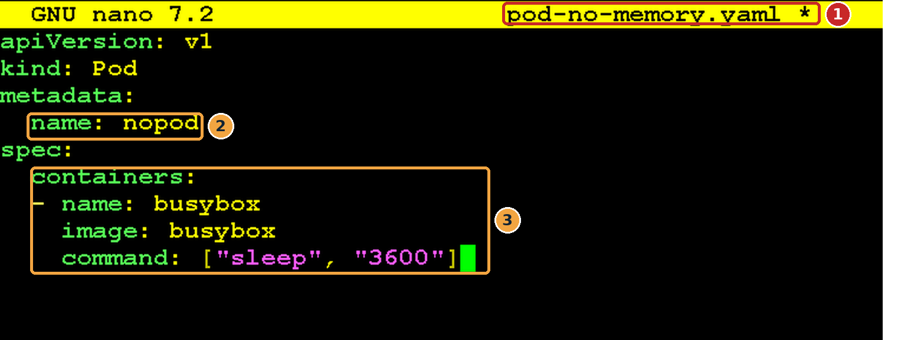
Screenshot 15: pod-no-memory.yaml open in nano
What this screenshot shows
# | What you see | What it means
1 | pod-no-memory.yaml * in the title bar | The file you are editing.
2 | name: nopod | The Pod’s name; you will look it up in Step 3.6.
3 | containers: busybox, sleep 3600 (no resources: section) | There is no resources section at all, so no memory request or limit. busybox just sleeps for an hour.

Checkpoint: you are ready for the next step when…
The file has no resources: section.

Apply the LimitRange
Why: The rules must exist before the Pod is created. A LimitRange only affects Pods created after it; existing Pods are not changed.
Do this
kubectl apply -f limitrange.yaml
Screenshot 16: The LimitRange was created
What this screenshot shows
# | What you see | What it means
1 | limitrange/mem-limit-range created | The memory rules are now active in the default namespace.

kubectl get limitrange
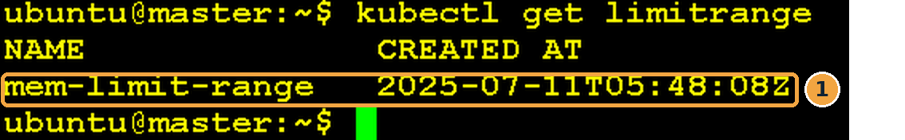
Screenshot 17: The LimitRange is listed
What this screenshot shows
# | What you see | What it means
1 | mem-limit-range 2025-07-11T05:48:08Z | Your LimitRange and when it was created.

Optional check (no screenshot)
kubectl describe limitrange mem-limit-range # defaults 512Mi / 256Mi
Checkpoint: you are ready for the next step when…
kubectl get limitrange lists mem-limit-range.

Create the Pod
Why: Send the Pod through all three gates. You are the admin, so authentication and authorization pass. Admission Control then applies the LimitRange.
Do this
kubectl apply -f pod-no-memory.yaml
Screenshot 18: The Pod was accepted
What this screenshot shows
# | What you see | What it means
1 | pod/nopod created | All three gates passed. But the Pod that was stored is not exactly the one you wrote, as the next step shows.

Note
Depending on the admission plugins configured in your cluster, a Pod like this may be rejected (for example, by a policy that requires memory settings) or given default limits (this lab). With only the LimitRange above, it gets defaults.

Checkpoint: you are ready for the next step when…
The output says pod/nopod created.

See what Admission Control changed
Why: Compare the stored Pod with your file. The memory settings you never wrote are proof that the admission controller changed (mutated) the request.
Do this
kubectl get pod nopod -o yaml
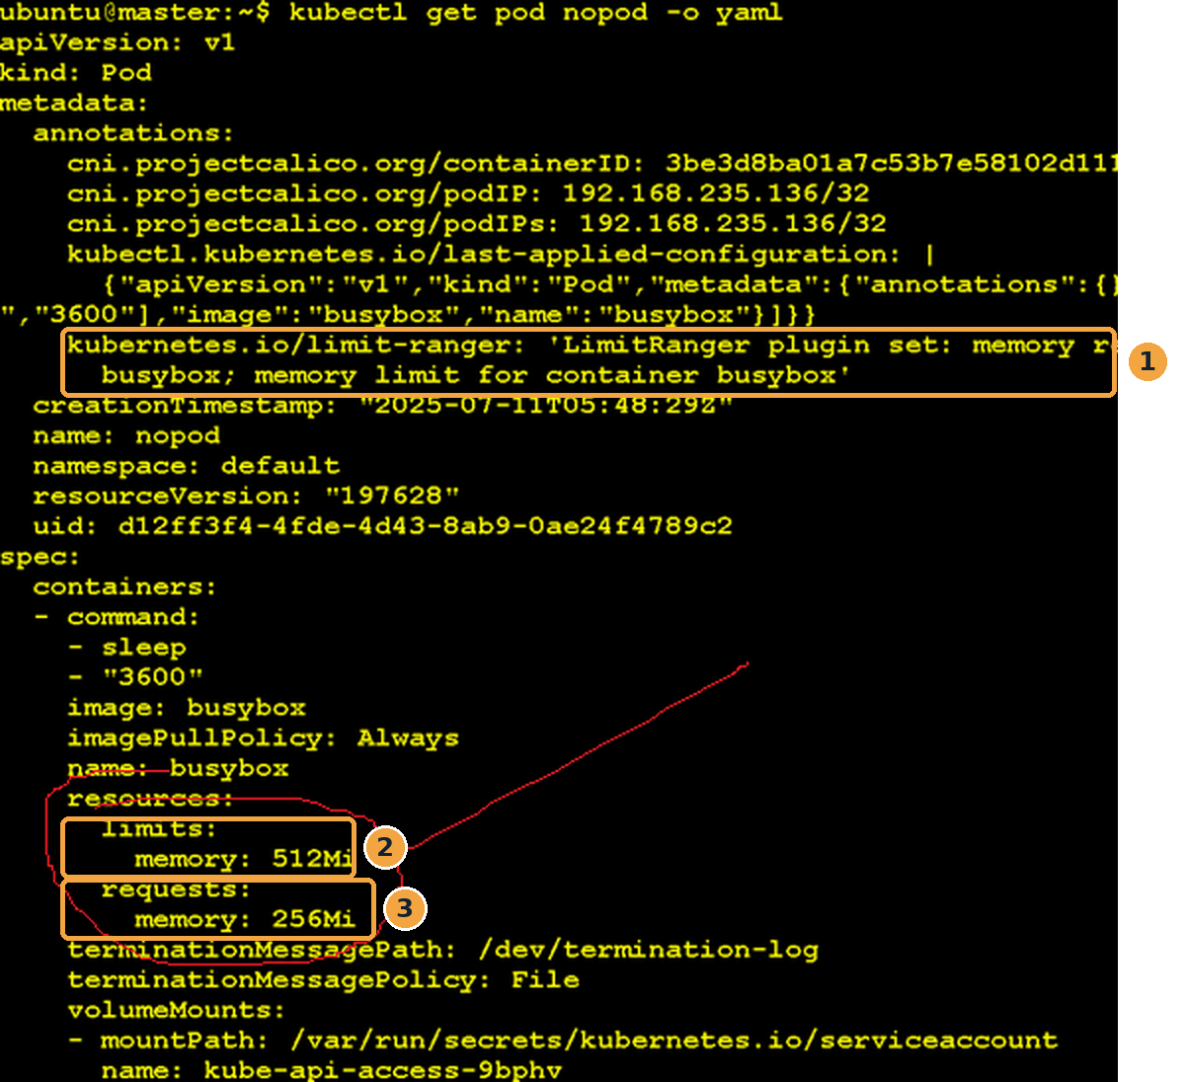
Screenshot 19: The stored Pod now has memory limits and requests
What this screenshot shows
# | What you see | What it means
1 | kubernetes.io/limit-ranger annotation: “LimitRanger plugin set: memory request … memory limit for container busybox” | Kubernetes leaves a note saying the LimitRanger admission plugin changed this container.
2 | resources → limits → memory: 512Mi | Added automatically from the LimitRange default. It was not in your file.
3 | resources → requests → memory: 256Mi | Added automatically from defaultRequest.

Optional check (no screenshot): a shorter view
kubectl describe pod nopod # see Limits and Requests
kubectl get pod nopod -o jsonpath='{.spec.containers[0].resources}'
Real-world use
A platform team shares one cluster with many developers. Some forget to set memory limits, and one runaway container could use all the memory on a node. A LimitRange with sensible defaults quietly protects everyone, without developers having to change their YAML.

Checkpoint: you are ready for the next step when…
The Pod YAML shows limits: memory: 512Mi and requests: memory: 256Mi.

Optional: see Admission Control reject a Pod
Why: Mutating is only half of Admission Control. This step shows the validating half: a request that breaks a rule is refused. There is no screenshot for this step.
Do this: add a maximum to the LimitRange
nano limitrange.yaml
apiVersion: v1
kind: LimitRange
metadata:
name: mem-limit-range
namespace: default
spec:
limits:
- default:
memory: 512Mi
defaultRequest:
memory: 256Mi
max:
memory: 1Gi # new: no container may have a limit above 1Gi
type: Container
kubectl apply -f limitrange.yaml # output: limitrange/mem-limit-range configured
Then write a Pod that asks for 2Gi
nano pod-big.yaml
apiVersion: v1
kind: Pod
metadata:
name: bigpod
spec:
containers:
- name: busybox
image: busybox
command: ["sleep", "3600"]
resources:
limits:
memory: 2Gi # more than the 1Gi maximum
kubectl apply -f pod-big.yaml
You should see an error similar to: pods "bigpod" is forbidden: maximum memory usage per Container is 1Gi, but limit is 2Gi.
The user was authenticated and authorized, but the request failed the admission rule, so nothing was created.
Checkpoint: you are ready for the next step when…
kubectl get pod bigpod returns NotFound.

Delete the LimitRange and Pod
Why: Remove the admission rule and the test Pod so later labs are not affected by the memory defaults.
Do this
kubectl delete -f limitrange.yaml
kubectl delete -f pod-no-memory.yaml
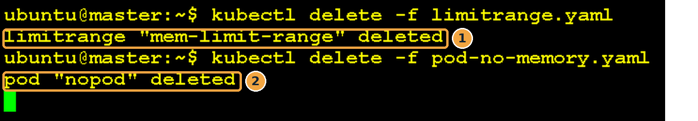
Screenshot 20: The LimitRange and Pod are deleted
What this screenshot shows
# | What you see | What it means
1 | limitrange "mem-limit-range" deleted | New Pods in default no longer get memory defaults.
2 | pod "nopod" deleted | The test Pod is removed. Deleting a Pod can take a few seconds while its container stops.

Checkpoint: you are ready for the next step when…
kubectl get limitrange,pod shows No resources found (apart from any Pods from other work).

Summary and troubleshooting

What each step proved
Step | What you did | What it proved
2.1 – 2.2 | Created ServiceAccount test-user | Kubernetes can now identify (authenticate) test-user
2.3 | can-i list pods → no | Authenticated does not mean authorized; RBAC denies by default
2.4 – 2.7 | Created Role + RoleBinding | Permissions come from a Role handed out by a binding
2.8 | list → yes; delete, create → no | Only the verbs in the Role are allowed (least privilege)
3.2 – 3.6 | LimitRange + Pod without memory | Admission Control can change (mutate) a request
3.7 (optional) | Pod asking for 2Gi | Admission Control can also reject (validate) a request

Troubleshooting
What you see | Likely cause | Fix
can-i still says no after Step 2.6 | A name or namespace in the RoleBinding does not match | Check kubectl describe rolebinding read-pods-binding; the subject must be ServiceAccount test-user in default
can-i says yes in Step 2.3 | You left out --as, so it checked your admin permissions | Add --as=system:serviceaccount:default:test-user
error: unknown field "verb" | Typo in role.yaml | The field is verbs (plural), and resources, apiGroups
error: resource name may not be empty | kubectl delete serviceaccount without a name | Use kubectl delete serviceaccount test-user
nopod has no memory limits | The LimitRange was applied after the Pod, or in another namespace | Delete the Pod, apply the LimitRange first, then create the Pod again
Error from server (Forbidden) on any command | Your own kubeconfig is not an admin | Run the lab from the control-plane node or with an admin kubeconfig

Self-check
- In which order do the three gates run?
Answer: Authentication, then Authorization, then Admission Control.
- test-user existed but could not list Pods. Which gate said no?
Answer: Authorization. It was authenticated (a known identity) but had no RBAC permission.
- You created the Role but forgot the RoleBinding. Can test-user list Pods?
Answer: No. A Role on its own gives permissions to nobody.
- Why did can-i delete pods still say no after the binding?
Answer: delete is not in the Role’s verbs list; only get, list and watch were granted.
- Your Pod had no memory settings, yet the stored Pod has 512Mi. What happened?
Answer: The LimitRanger admission controller mutated the request and added the LimitRange defaults.

