LAB MANUAL
Building a Docker Image with GitHub Actions
Build with GitHub Actions, store in Docker Hub, and deploy to a local Kubernetes cluster
Lab details
Repository | bipeensinha/AI-200-AKS
Container image | bipeen2001/kyndryl:ai-200-aks-v1
Tools | GitHub Actions, Docker Hub, Kubernetes (kubectl)
Level | Beginner friendly, step by step
Date | 27 September 2026

Contents

1. Lab overview
In this lab, GitHub Actions builds your application's Docker image, pushes it to Docker Hub, and your local Kubernetes cluster pulls and runs it. You never install Docker on your own machine: GitHub's cloud runner does the build for you.
Objective: automate the path from code to a running application using CI/CD (Continuous Integration / Continuous Delivery).
By the end of this lab you will be able to:
- Create a Docker Hub access token and store it safely as a GitHub secret
- Write a GitHub Actions workflow that builds and pushes a Docker image on every push
- Confirm the image in Docker Hub
- Deploy the image to Kubernetes with a Deployment and a NodePort Service
- Open the running application and fix the most common errors
Lab setup used in this manual
Item | Value
GitHub repository | bipeensinha/AI-200-AKS
Docker Hub repository (public) | bipeen2001/kyndryl
Image tag | ai-200-aks-v1
Full image name | bipeen2001/kyndryl:ai-200-aks-v1
Kubernetes | Your existing local cluster (Ubuntu)
App port / NodePort | 5000 / 30050

💡 Tip: If you use your own accounts, replace these names everywhere they appear in this manual.

2. Prerequisites
Check every item below before you start. Each one is needed in a later step.
☐ A GitHub account with access to the repository bipeensinha/AI-200-AKS
☐ A Docker Hub account (bipeen2001) with the public repository kyndryl
☐ A local Kubernetes cluster running on Ubuntu, with kubectl working (test with kubectl get nodes)
☐ A terminal on the Ubuntu machine and a text editor such as nano
☐ Internet access, so the cluster can pull images from Docker Hub
Your repository must contain these files:
AI-200-AKS/
├── Dockerfile
├── app.py
├── requirements.txt
├── local_model.pkl
├── templates/
└── static/

Key terms in plain words
Term | What it means
Dockerfile | A recipe that tells Docker how to package your app
Docker image | The packaged app, ready to run anywhere
Docker Hub | An online store for Docker images
GitHub Actions | GitHub's robot that runs tasks when you push code
Workflow | A YAML file listing the steps the robot runs
Secret | A password saved in GitHub, hidden from the code
Pod | The smallest unit that runs your container in Kubernetes
Deployment | Tells Kubernetes which image to run and how many copies
NodePort Service | Opens a fixed port on the machine so you can reach the app

3. Workflow overview
The whole lab is one pipeline: you push code once, and everything after that happens automatically until you deploy to Kubernetes.
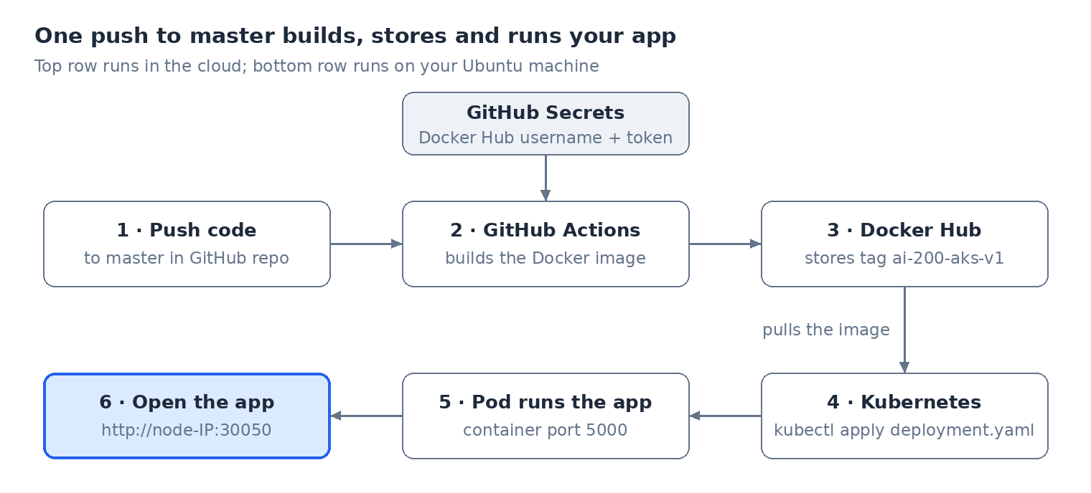
Workflow diagram: End-to-end CI/CD workflow, six stages from push to browser.
The secrets let GitHub Actions log in to Docker Hub without writing your token in the code. Kubernetes then pulls the same image name the workflow pushed.

4. Lab procedure
Follow the steps in order. Part A builds and stores the image; Part B runs it on Kubernetes.

Part A: Build and push the image with GitHub Actions

Step 1: Check your Dockerfile
Open your repository on GitHub and confirm that Dockerfile sits in the top folder, next to app.py. It should look like this:
FROM python:3.11-slim

WORKDIR /app

COPY requirements.txt .
RUN pip install --no-cache-dir -r requirements.txt

COPY . .

EXPOSE 5000

CMD ["gunicorn", "--bind", "0.0.0.0:5000", "--timeout", "600", "app:app"]

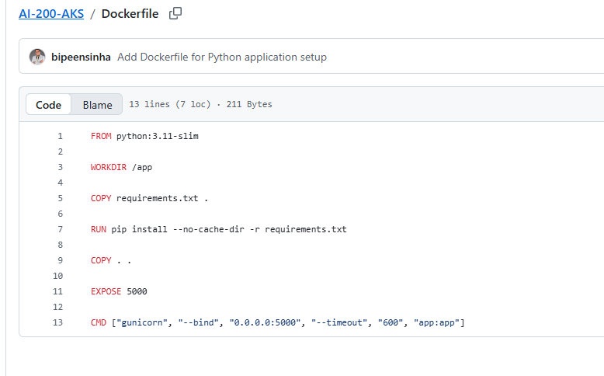
Figure 1: The Dockerfile as it appears in the GitHub repository.
What each line does:
- FROM starts from a small official Python 3.11 image.
- WORKDIR makes /app the working folder inside the container.
- The first COPY and RUN install your Python packages.
- COPY . . copies the rest of your code and the model file.
- EXPOSE 5000 and CMD start the app with Gunicorn on port 5000. The 600-second timeout gives the ML model time to load.

Step 2: Create a Docker Hub access token
A token lets GitHub log in to Docker Hub without using your password.
1. Sign in to Docker Hub as bipeen2001.
2. Click your profile icon (top right) and choose Account settings.
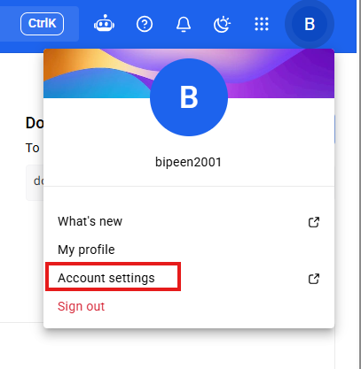
Figure 2: Profile menu → Account settings.
3. In the left menu, click Personal access tokens, then click Generate new token.
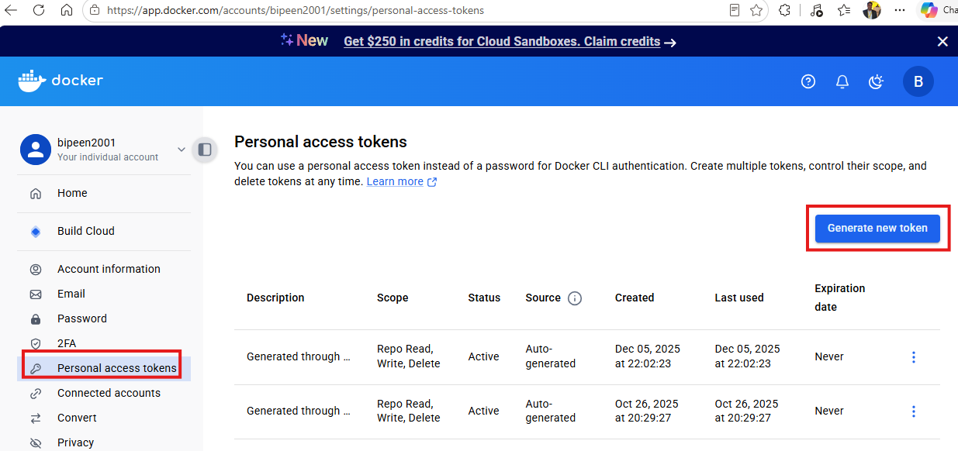
Figure 3: Personal access tokens page.
4. Enter the description github-actions-ai200-aks.
5. Set access permissions to Read & Write.
6. Click Generate.
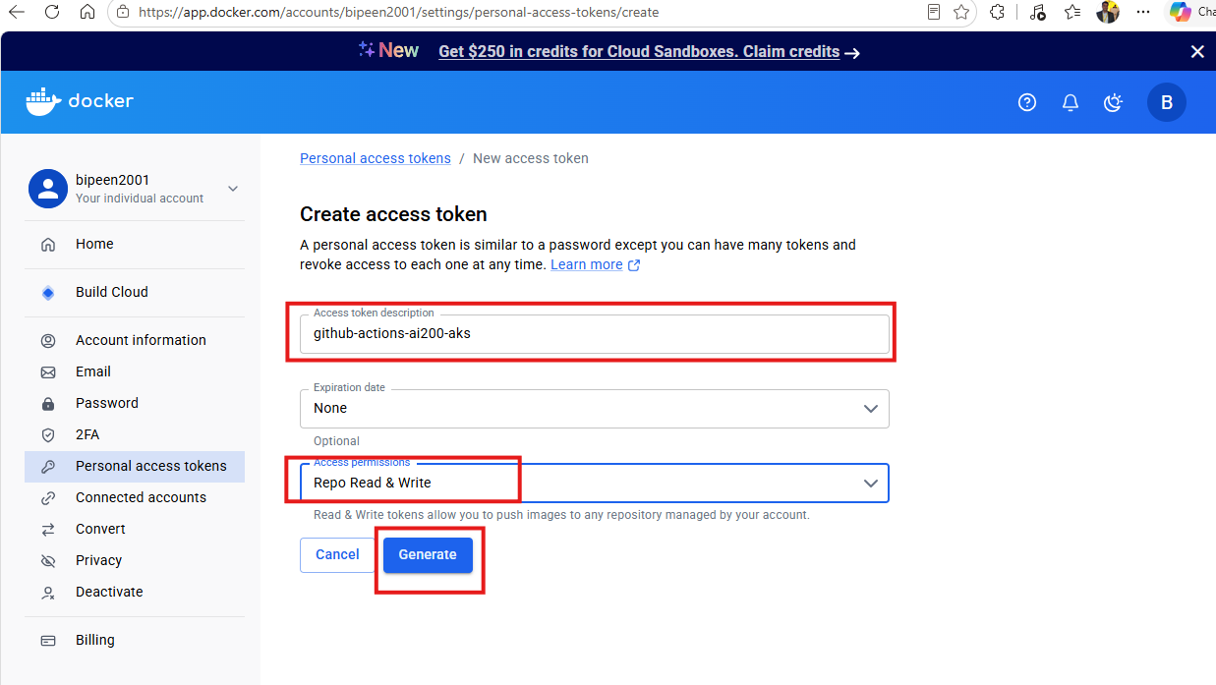
Figure 4: Fill in the description, choose Read & Write, then Generate.
7. You will see a value like dckr_pat_xxxxxxxxxxxxxxxxx. Click Copy and keep it somewhere safe for Step 3. Docker Hub shows it only once.
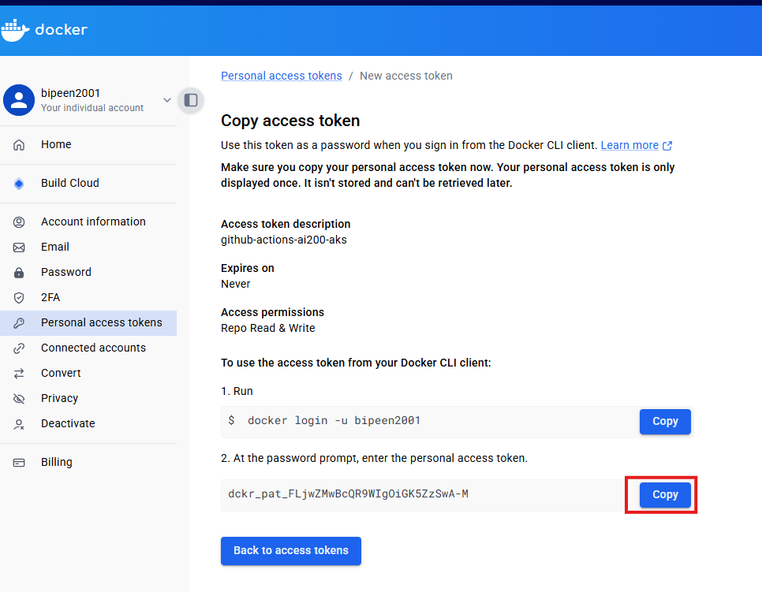
Figure 5: Copy the token before leaving this page.
⚠ Warning: Never paste the token inside your workflow file or any file in the repository. Anyone who can read the repository could then push to your Docker Hub account.

Step 3: Add Docker Hub credentials to GitHub as secrets
1. Open the repository bipeensinha/AI-200-AKS on GitHub and click the Settings tab.
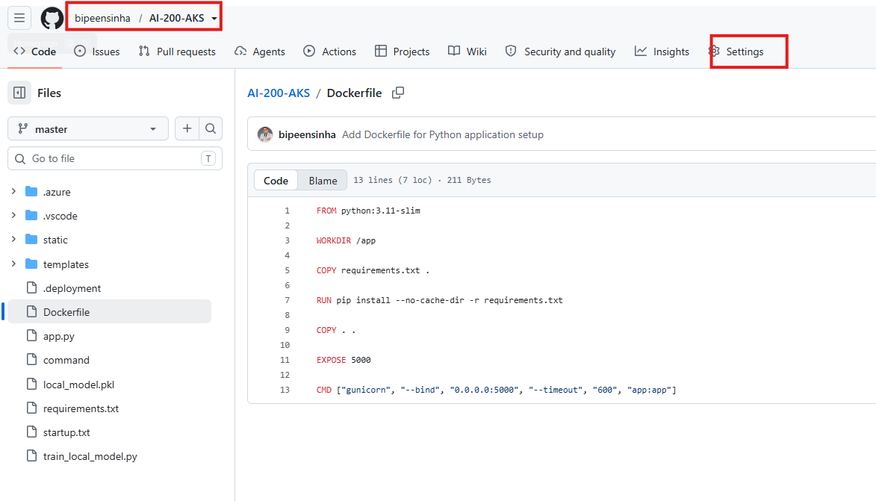
Figure 6: Open the repository's Settings tab.
2. In the left menu, open Secrets and variables → Actions.
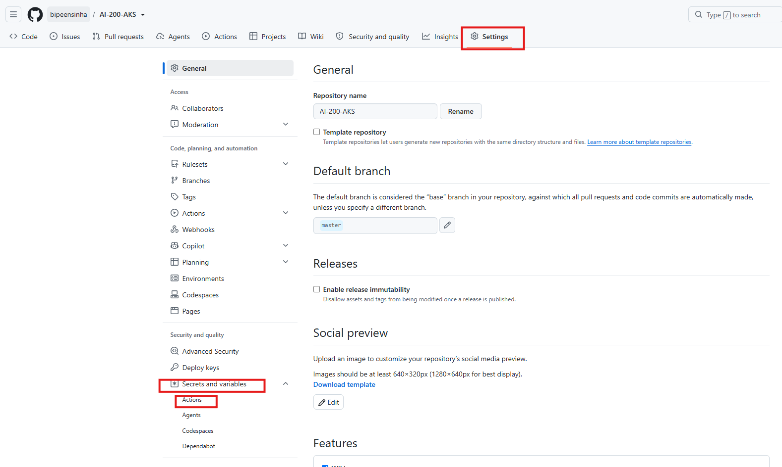
Figure 7: Secrets and variables → Actions.
3. Click New repository secret.
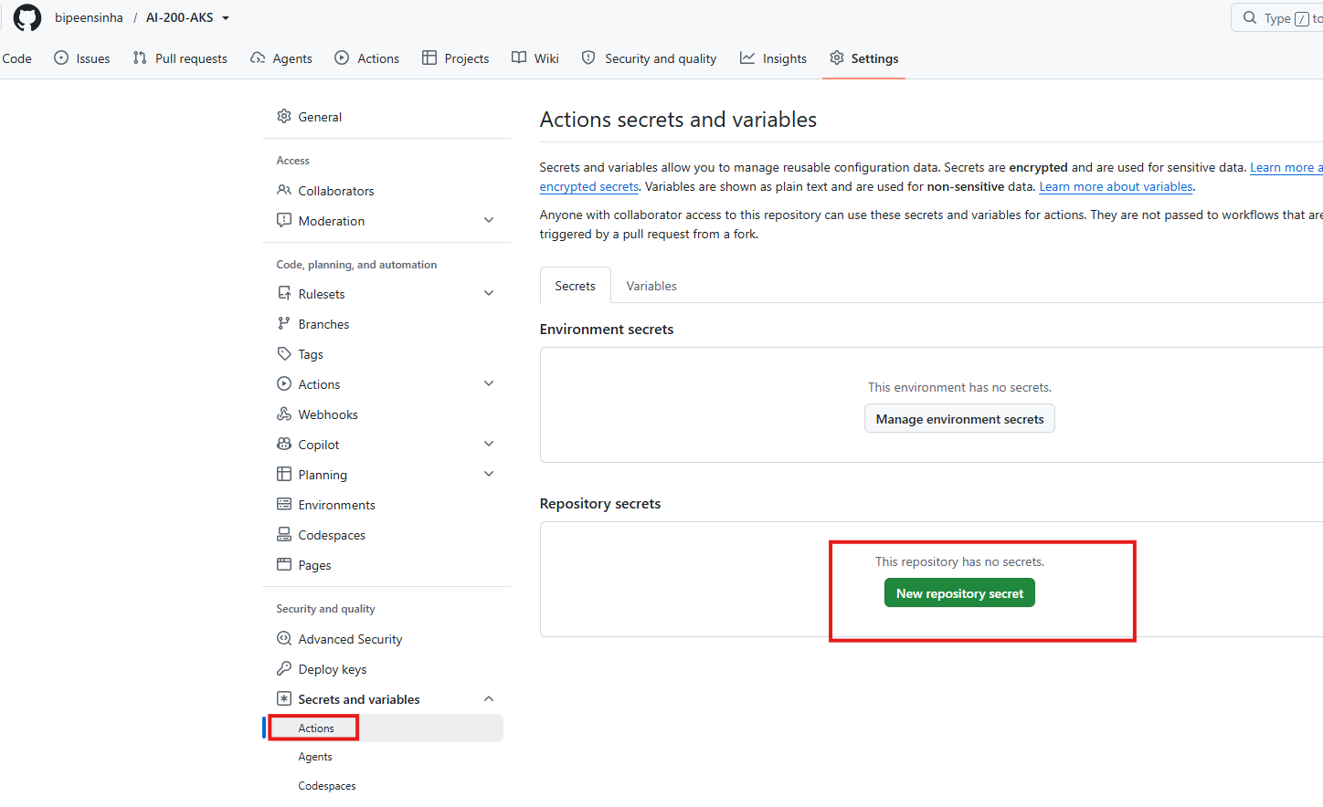
Figure 8: The New repository secret button.
4. Create the two secrets below, clicking Add secret after each one.
Secret name | Value
DOCKERHUB_USERNAME | bipeen2001
DOCKERHUB_TOKEN | The dckr_pat_... token from Step 2

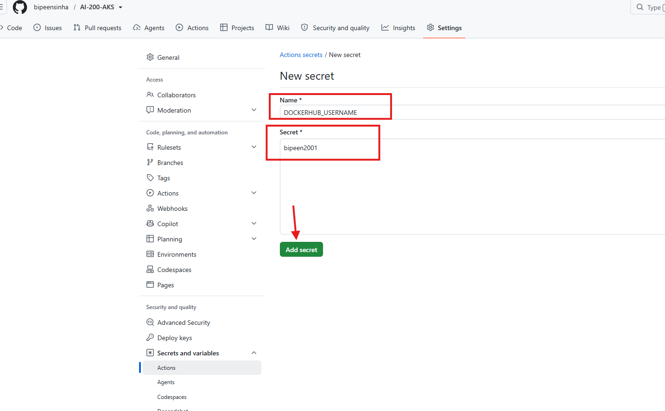
Figure 9: Secret 1, DOCKERHUB_USERNAME.
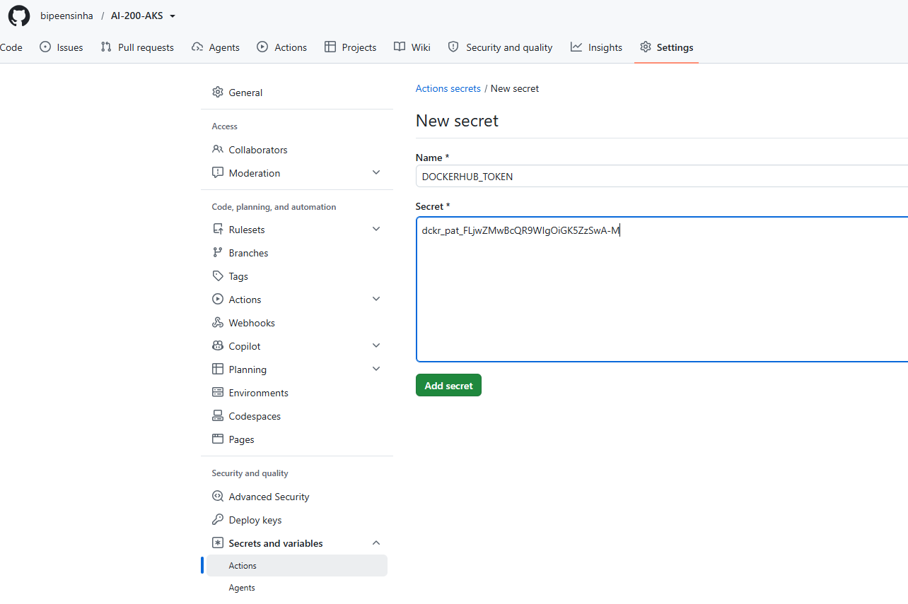
Figure 10: Secret 2, DOCKERHUB_TOKEN.
Check: the Repository secrets list now shows DOCKERHUB_USERNAME and DOCKERHUB_TOKEN. Names must match exactly, in capital letters.
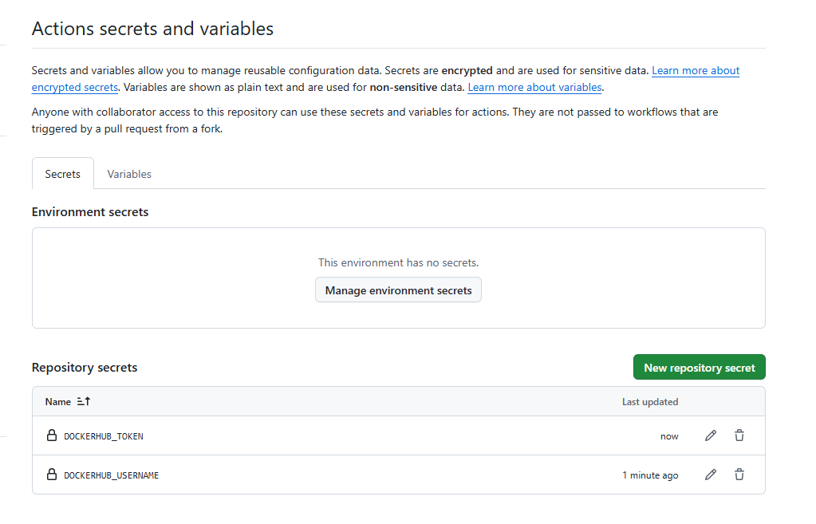
Figure 11: Both secrets saved.

Step 4: Create the GitHub Actions workflow
1. Go back to the repository's main page.
2. Click Add file → Create new file.
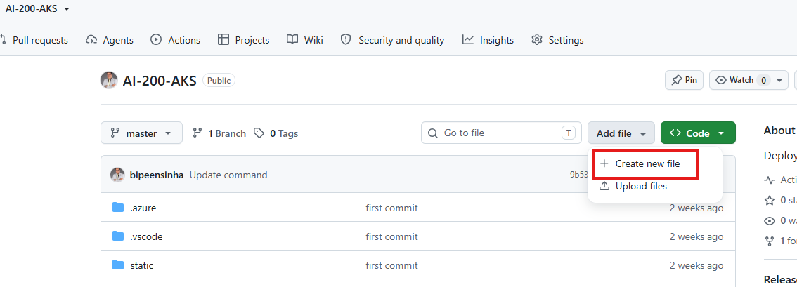
Figure 12: Add file → Create new file.
3. Type this file name (the slashes create the folders): .github/workflows/docker-build.yml
4. Paste the workflow below. Keep the spacing exactly as shown, because YAML uses indentation.
name: Build and Push Docker Image

on:
push:
branches:
- master

jobs:
docker:
runs-on: ubuntu-latest

steps:
- name: Checkout source code
uses: actions/checkout@v4

- name: Login to Docker Hub
uses: docker/login-action@v3
with:
username: ${{ secrets.DOCKERHUB_USERNAME }}
password: ${{ secrets.DOCKERHUB_TOKEN }}

- name: Build Docker Image
run: |
docker build -t bipeen2001/kyndryl:ai-200-aks-v1 .

- name: Push Docker Image
run: |
docker push bipeen2001/kyndryl:ai-200-aks-v1

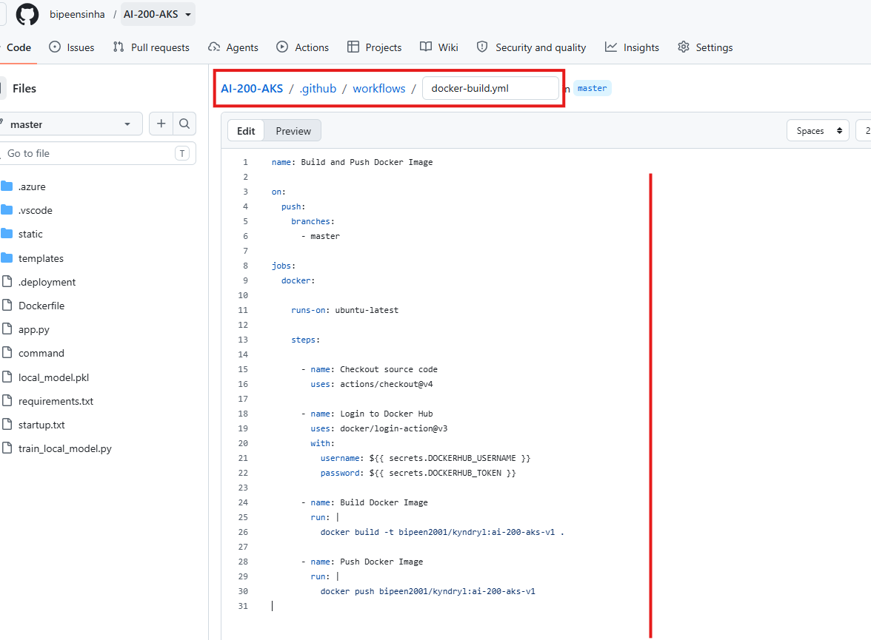
Figure 13: The file path and the pasted workflow in the GitHub editor.
5. Click Commit changes, then confirm the commit to the master branch.
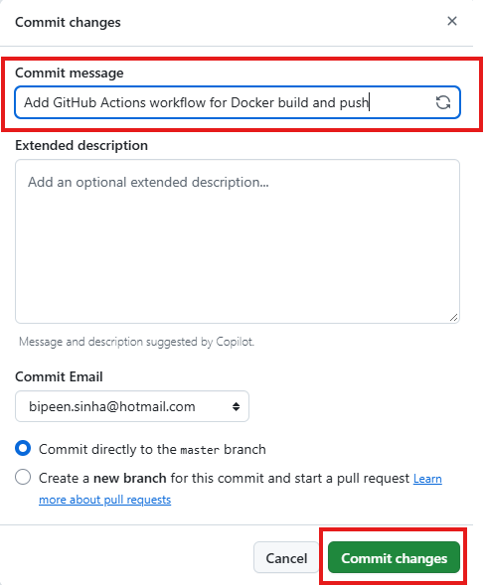
Figure 14: Commit directly to the master branch.
How to read the workflow: on: push runs it on every push to master. runs-on: ubuntu-latest uses a free GitHub cloud machine. The four steps download your code, log in with the secrets, build the image, and upload it.
💡 Tip: If your repository's default branch is main, change - master to - main, or the workflow will never start.

Step 5: Watch the build run
Committing the file is a push, so the build starts on its own.
1. Click the Actions tab of the repository.
2. Click the run named after your commit, under the workflow Build and Push Docker Image.
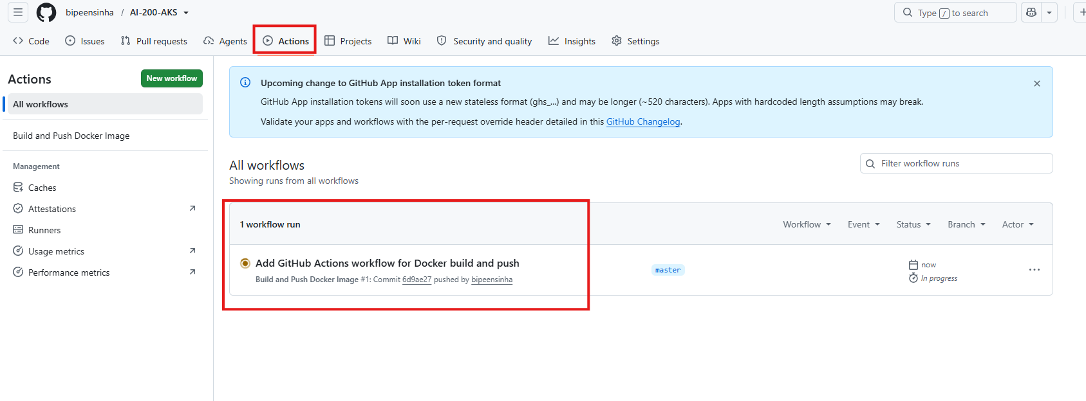
Figure 15: The workflow run in the Actions tab.
3. Click the docker job to see each step.
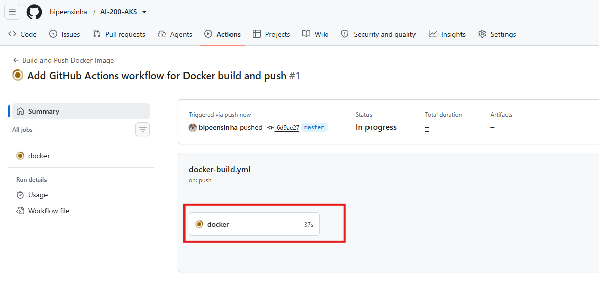
Figure 16: The run in progress; click the docker job.
While it runs you will see:
✓ Checkout source code
✓ Login to Docker Hub
⏳ Build Docker Image
⏳ Push Docker Image

4. Wait until every step shows a green tick. A red cross means a step failed; open it to read the error and see Section 6.
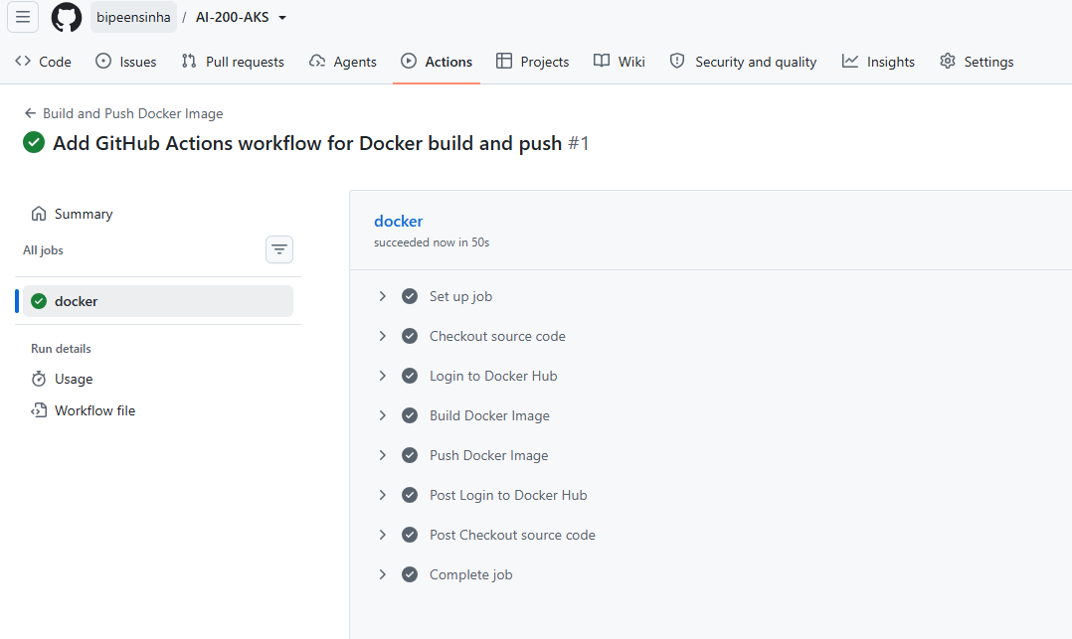
Figure 17: A successful run: every step has a green tick.

Step 6: Confirm the image in Docker Hub
1. Open the Docker Hub repository bipeen2001/kyndryl.
2. Click the Tags tab.
3. Confirm the tag ai-200-aks-v1 is listed with a recent push time.
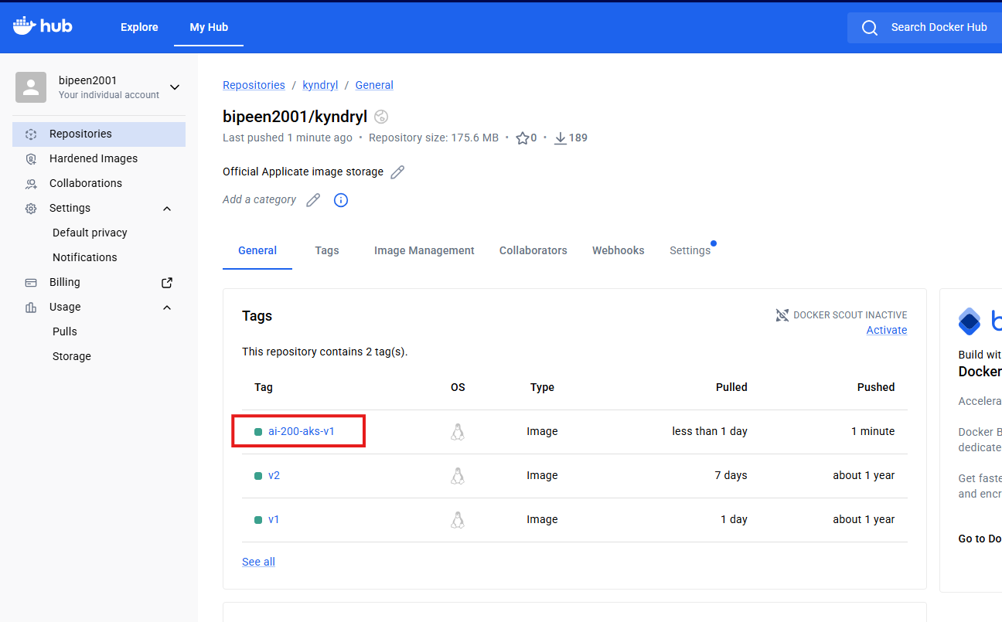
Figure 18: The ai-200-aks-v1 tag in Docker Hub.
Your complete image name is now bipeen2001/kyndryl:ai-200-aks-v1. Part A is done: the image is built and stored in Docker Hub.

Part B: Deploy the image to your local Kubernetes cluster
Run all commands in this part in a terminal on your Ubuntu machine.

Step 7: Create the deployment file
1. Create a new file:
nano deployment.yaml

2. Paste the content below. It holds two objects separated by ---: a Deployment that runs the image, and a Service that opens it on port 30050.
apiVersion: apps/v1
kind: Deployment
metadata:
name: ai-200-aks
spec:
replicas: 1
selector:
matchLabels:
app: ai-200-aks
template:
metadata:
labels:
app: ai-200-aks
spec:
containers:
- name: ai-200-aks
image: bipeen2001/kyndryl:ai-200-aks-v1
imagePullPolicy: Always
ports:
- containerPort: 5000
---
apiVersion: v1
kind: Service
metadata:
name: ai-200-aks-service
spec:
type: NodePort
selector:
app: ai-200-aks
ports:
- port: 5000
targetPort: 5000
nodePort: 30050

3. Save and exit: press Ctrl+O, then Enter, then Ctrl+X.
Key settings: image must match the Docker Hub name exactly. imagePullPolicy: Always makes Kubernetes download the newest copy each time a pod starts. The app: ai-200-aks label is how the Service finds the pod.

Step 8: Apply the deployment
kubectl apply -f deployment.yaml

Expected output:
deployment.apps/ai-200-aks created
service/ai-200-aks-service created

Step 9: Check the pod
kubectl get pods -o wide

At first the pod may show 0/1 ContainerCreating while the image downloads. Wait a minute and run kubectl get pods again until you see:
ai-200-aks-xxxxxxxxxx 1/1 Running

Step 10: Check the service
kubectl get svc

Expected output (the cluster IP will differ):
NAME TYPE CLUSTER-IP EXTERNAL-IP PORT(S)
ai-200-aks-service NodePort 10.x.x.x <none> 5000:30050/TCP

The important part is 5000:30050/TCP. It means traffic arriving on the machine's port 30050 is sent to the pod's port 5000.

Step 11: Find your machine's IP and open the app
1. Find the Ubuntu machine's IP address:
ip addr

You can also use ip route show. Look for an address such as 192.168.1.100.
2. Test from the Ubuntu terminal first:
curl http://localhost:30050

If localhost does not respond in your setup, use the machine IP instead: curl http://192.168.1.100:30050
3. Open a browser and go to http://<your-IP>:30050, for example http://192.168.1.100:30050. Your application's home page should load.

5. Verification checklist
The lab is complete when every row below shows the expected result. Tick each one as you confirm it.
Check | Where / command | Expected result
Secrets exist | GitHub: Settings → Secrets and variables → Actions | DOCKERHUB_USERNAME and DOCKERHUB_TOKEN listed
Workflow succeeded | GitHub: Actions tab | All 4 steps show a green tick
Image stored | Docker Hub: bipeen2001/kyndryl → Tags | Tag ai-200-aks-v1 present
Objects created | kubectl apply -f deployment.yaml | Deployment and Service created
Pod running | kubectl get pods | 1/1 Running
Port open | kubectl get svc | 5000:30050/TCP
App responds | curl http://localhost:30050 or the browser | The app's home page loads

☐ All seven checks pass

6. Troubleshooting
When something fails, start with these two commands. They show the pod's events and the app's own log messages:
kubectl describe pod -l app=ai-200-aks
kubectl logs -l app=ai-200-aks

Symptom | Likely cause | Fix
Workflow never starts after commit | Branch name in the workflow does not match your branch | Change - master to your branch name (often main)
"Login to Docker Hub" step fails | Secret name typo, or token expired or read-only | Recheck both secret names; create a new Read & Write token and update DOCKERHUB_TOKEN
"Build Docker Image" step fails | Dockerfile error or a package in requirements.txt fails to install | Open the failed step's log and fix the line it names
Pod shows ImagePullBackOff or ErrImagePull | Wrong image name, wrong tag, or the workflow did not push | Confirm the tag in Docker Hub; the image must be exactly bipeen2001/kyndryl:ai-200-aks-v1
Pod stuck in ContainerCreating | The image is still downloading | Wait a few minutes and run kubectl get pods again
Pod shows CrashLoopBackOff | The app starts and then crashes | Read kubectl logs -l app=ai-200-aks for the Python error
curl localhost:30050 gets no response | NodePort not reachable through localhost in your setup | Use the machine IP from ip addr instead

💡 Tip: After fixing code, push again to rebuild the image. Then run kubectl rollout restart deployment ai-200-aks so the pod pulls the new copy.

7. Summary and review questions
You built a working CI/CD pipeline: a push to GitHub builds and publishes a Docker image with no local Docker, and Kubernetes runs that image on port 30050.
Review questions
1. Why do we store the Docker Hub token as a GitHub secret instead of in the workflow file?
2. Which event starts the workflow, and where is that set in docker-build.yml?
3. What is the full image name used in this lab, and which two files must use it?
4. What does imagePullPolicy: Always change when a pod starts?
5. In 5000:30050/TCP, what does each number mean?
6. A pod shows ImagePullBackOff. Name three possible causes.
7. Which two commands do you run first when a pod will not start?
Extension task (optional): change the tag to ai-200-aks-v2 in both the workflow and deployment.yaml, push, and redeploy. Confirm the new tag appears in Docker Hub and the pod runs it.

