Kubernetes Component Health Check Guide
A simple, step-by-step guide for a kubeadm cluster on Ubuntu 24.04 LTS
This guide shows you how to check whether each part of your Kubernetes cluster is healthy, in the order that makes troubleshooting easiest. Every step tells you where to run the command, what to run, what a healthy result looks like, and what to do if it is not healthy.
This guide assumes
- Kubernetes installed with kubeadm on Ubuntu 24.04 LTS
- Container runtime is containerd, managed by systemd
- kubectl is configured for your user (the file ~/.kube/config exists)
- Commands starting with sudo or curl 127.0.0.1 must be run on the node itself (via SSH)

1. Know Your Cluster
Before checking anything, it helps to know what runs where. The diagram below shows the main components of a kubeadm cluster on Ubuntu 24.04.
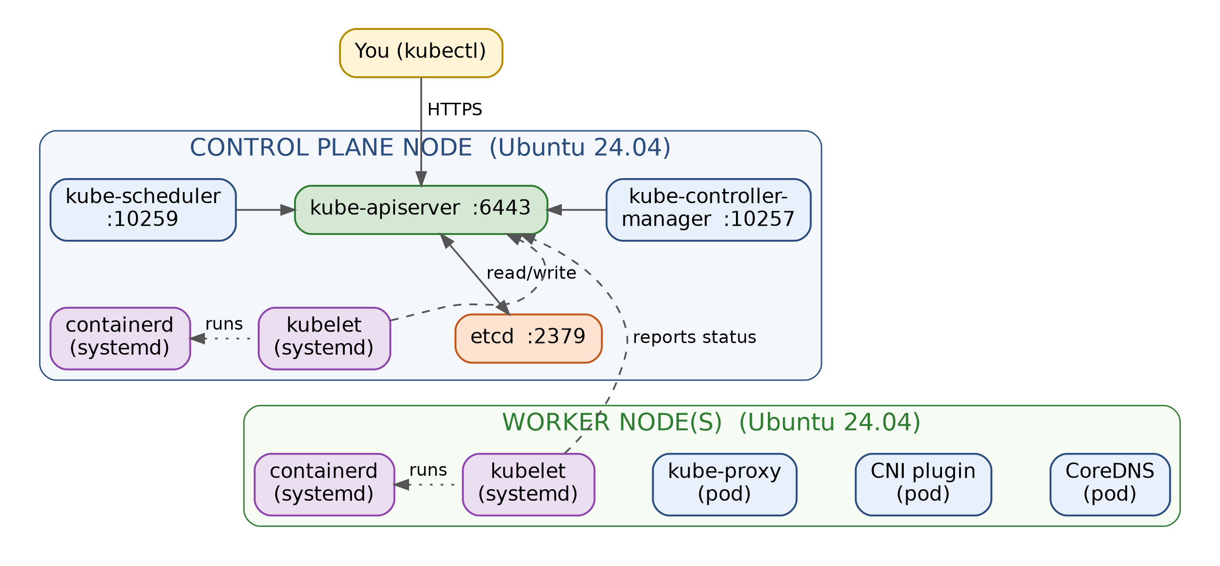
Figure 1 – What runs where in a kubeadm cluster
Important: how kubeadm runs the control plane
On a kubeadm cluster, the API server, etcd, scheduler and controller manager are static pods, not systemd services. Their definitions live in /etc/kubernetes/manifests/ and the kubelet starts them automatically.
This means systemctl status kube-apiserver (or etcd, kube-scheduler) will say "Unit could not be found". That is normal. Only kubelet and containerd are systemd services.

Quick Reference Table
Component | Runs as | Runs on | Fastest health check
containerd | systemd service | Every node | systemctl status containerd
kubelet | systemd service | Every node | curl http://127.0.0.1:10248/healthz
kube-apiserver | Static pod | Control plane | kubectl get --raw=/readyz
etcd | Static pod | Control plane | kubectl get --raw=/readyz/etcd
kube-scheduler | Static pod | Control plane | curl -k https://127.0.0.1:10259/healthz
kube-controller-manager | Static pod | Control plane | curl -k https://127.0.0.1:10257/healthz
kube-proxy | DaemonSet | Every node | kubectl get ds kube-proxy -n kube-system
CNI plugin | DaemonSet | Every node | ls /etc/cni/net.d/
CoreDNS | Deployment | Any node | kubectl get pods -n kube-system -l k8s-app=kube-dns

2. The Health Check Flow
Kubernetes components depend on each other from the bottom up: the host must be ready before containerd works, containerd before the kubelet, the kubelet before the control plane pods, and so on. Check in this order and you will find the root cause instead of a symptom.
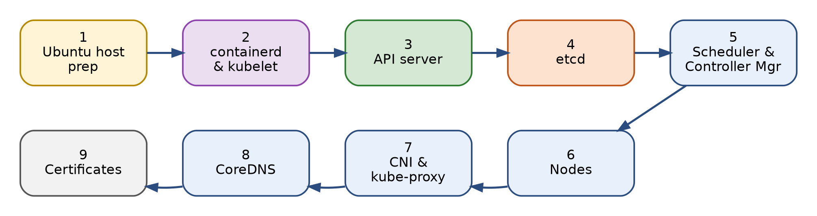
Figure 2 – Recommended order of checks (Steps 1 to 9)

The 60-Second Check
Start here. If all three commands look good, your cluster is healthy and you can stop.
RUN ON Any machine with kubectl
kubectl get nodes # every node should be Ready
kubectl get pods -n kube-system # every pod should be Running
kubectl get --raw='/readyz?verbose' # last line: readyz check passed

If something fails, follow the flowchart below to jump to the right step.
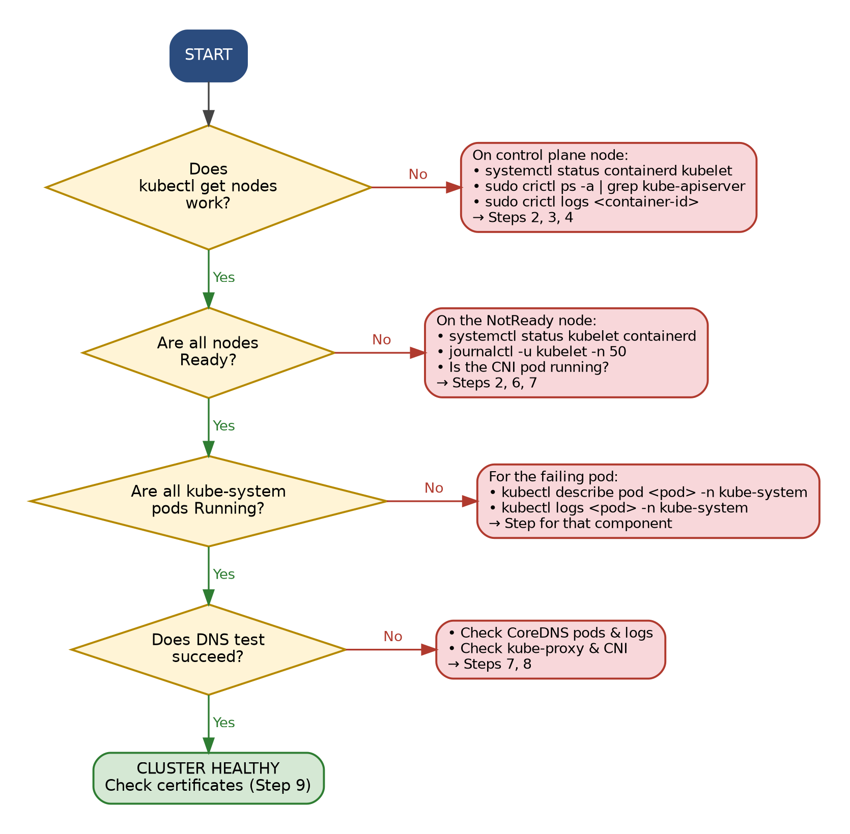
Figure 3 – Troubleshooting decision flow

3. Step-by-Step Component Checks

Step 1 – Ubuntu Host Prerequisites
RUN ON Every node | Kubernetes will not work correctly if these are wrong
swapon --show # should print nothing
lsmod | grep -E 'overlay|br_netfilter' # both modules listed
sysctl net.ipv4.ip_forward net.bridge.bridge-nf-call-iptables
df -h / /var/lib # disk space
free -h # memory

Healthy looks like
- swapon --show prints nothing (swap is off)
- Both overlay and br_netfilter appear
- Both sysctl values are = 1
- Disk usage is below about 85% (the kubelet starts evicting pods when the disk gets too full)

If something is wrong
Turn swap off now, and stop it coming back after reboot by commenting out the swap line in /etc/fstab:

sudo swapoff -a
sudo sed -i '/ swap / s/^/#/' /etc/fstab

Load the modules and re-apply kernel settings:

sudo modprobe overlay
sudo modprobe br_netfilter
sudo sysctl --system

Step 2 – containerd and kubelet
RUN ON Every node | These are the only two systemd services
containerd runs the containers. The kubelet is the node agent that tells containerd what to run and reports back to the API server. If either is down, nothing else on that node works.
systemctl status containerd --no-pager
systemctl status kubelet --no-pager
curl -s http://127.0.0.1:10248/healthz ; echo # kubelet health
sudo crictl ps # containers running on this node
grep SystemdCgroup /etc/containerd/config.toml # Ubuntu 24.04 check

Healthy looks like
- Both services show active (running) in green
- The kubelet health check prints ok
- crictl ps lists running containers (on the control plane you will see kube-apiserver, etcd, etc.)
- SystemdCgroup = true

If something is wrong
Read the most recent log lines. The error is almost always in the last 50 lines:

sudo journalctl -u kubelet -n 50 --no-pager
sudo journalctl -u containerd -n 50 --no-pager
sudo systemctl restart containerd kubelet

Common causes: swap is on (Step 1), cgroup driver mismatch (SystemdCgroup = false), expired certificates (Step 9), or a full disk.
If crictl complains about the runtime endpoint, point it at containerd once:

sudo crictl config --set runtime-endpoint=unix:///run/containerd/containerd.sock

Ubuntu 24.04 specific
Ubuntu 24.04 uses cgroup v2. Kubernetes expects containerd to use the systemd cgroup driver, so SystemdCgroup = true must be set in /etc/containerd/config.toml. If you change it, run sudo systemctl restart containerd kubelet.

Step 3 – API Server (kube-apiserver)
RUN ON Any machine with kubectl | the front door of the cluster
Every kubectl command, and every other component, talks to the API server on port 6443. If it is down, kubectl stops working entirely.
kubectl cluster-info
kubectl get --raw='/livez' # is it alive?
kubectl get --raw='/readyz?verbose' # is it ready? (shows each sub-check)
kubectl get pods -n kube-system -l component=kube-apiserver

Healthy looks like
- /livez prints ok
- /readyz?verbose shows a list of [+] lines ending in readyz check passed
- The kube-apiserver pod is Running with 1/1 ready

If something is wrong
If kubectl says connection refused on port 6443, kubectl cannot help you. SSH into the control plane node and check the container directly:

sudo crictl ps -a --name kube-apiserver # is it running or exited?
sudo crictl logs <container-id> # read why it stopped
sudo ss -tlnp | grep 6443 # is anything listening?
ls /etc/kubernetes/manifests/ # manifest file still present?

Also confirm kubectl is using the right config: kubectl config view --minify. If the API server container keeps restarting, check etcd (Step 4) and certificates (Step 9).

Step 4 – etcd (Cluster Database)
RUN ON Control plane node | stores all cluster state
etcd holds every object in the cluster. If etcd is unhealthy, the API server cannot read or save anything.
kubectl get pods -n kube-system -l component=etcd
kubectl get --raw='/readyz/etcd' # API server's view of etcd

For a deeper check, run etcdctl inside the etcd pod. Replace <node-name> with your control plane hostname (run hostname to see it):
kubectl -n kube-system exec etcd-<node-name> -- etcdctl \
--endpoints=https://127.0.0.1:2379 \
--cacert=/etc/kubernetes/pki/etcd/ca.crt \
--cert=/etc/kubernetes/pki/etcd/server.crt \
--key=/etc/kubernetes/pki/etcd/server.key \
endpoint health

# Swap "endpoint health" for "endpoint status -w table"
# or "member list -w table" to see more detail.

Healthy looks like
- The etcd pod is Running 1/1
- /readyz/etcd prints ok
- etcdctl says https://127.0.0.1:2379 is healthy: successfully committed proposal

If something is wrong

sudo crictl ps -a --name etcd
sudo crictl logs <container-id>
df -h /var/lib/etcd

- Log messages like "apply request took too long" mean the disk is too slow. etcd needs a fast disk (SSD).
- A full disk will stop etcd. Free up space on the partition that holds /var/lib/etcd.

Step 5 – Scheduler and Controller Manager
RUN ON Control plane node | the "brains" that place and manage pods
The scheduler decides which node each new pod runs on. The controller manager keeps things in the desired state (for example, it makes sure a Deployment with 3 replicas really has 3 pods).
kubectl get pods -n kube-system -l component=kube-scheduler
kubectl get pods -n kube-system -l component=kube-controller-manager

# Run these ON the control plane node:
curl -k https://127.0.0.1:10259/healthz ; echo # scheduler
curl -k https://127.0.0.1:10257/healthz ; echo # controller manager

Healthy looks like
- Both pods are Running 1/1
- Both curl commands print ok

If something is wrong
Read the logs of the failing component:

kubectl logs -n kube-system -l component=kube-scheduler --tail=50
kubectl logs -n kube-system -l component=kube-controller-manager --tail=50

- Symptom of a broken scheduler: new pods stay Pending and kubectl describe pod shows no scheduling events.
- Symptom of a broken controller manager: Deployments do not create pods, or scaling does nothing.

Step 6 – Nodes
RUN ON Any machine with kubectl
kubectl get nodes -o wide
kubectl describe node <node-name> # look at the "Conditions" section
kubectl top nodes # CPU/memory (needs metrics-server)

In kubectl describe node, check the Conditions section. Here is what each condition should say:
Condition | Healthy value | What it means if wrong
Ready | True | The kubelet is not healthy or cannot reach the API server
MemoryPressure | False | The node is running out of memory
DiskPressure | False | The node is running out of disk space
PIDPressure | False | Too many processes are running on the node
NetworkUnavailable | False | The network (CNI) plugin is not set up on this node

If something is wrong
- Node NotReady → SSH into that node and go back to Step 2 (kubelet and containerd).
- Message mentions NetworkPluginNotReady or cni plugin not initialized → go to Step 7.
- DiskPressure or MemoryPressure → free up resources on that node (Step 1 commands).

Step 7 – Pod Networking (CNI) and kube-proxy
RUN ON Any machine with kubectl | plus the node for the last two commands
The CNI plugin (Calico, Flannel, Cilium, etc.) gives each pod an IP address and connects pods across nodes. kube-proxy makes Services work by routing traffic to the right pods. Both run one pod on every node.
# CNI plugin pods (Calico may use the calico-system namespace)
kubectl get pods -A -o wide | grep -Ei 'calico|flannel|cilium|weave'

# kube-proxy: DESIRED should equal READY
kubectl get ds kube-proxy -n kube-system
kubectl get pods -n kube-system -l k8s-app=kube-proxy -o wide

# On each node:
ls /etc/cni/net.d/ # CNI config file exists
curl -s http://127.0.0.1:10256/healthz ; echo # kube-proxy health

Healthy looks like
- One CNI pod and one kube-proxy pod per node, all Running
- In kubectl get ds kube-proxy, DESIRED = READY
- /etc/cni/net.d/ contains a config file (for example 10-calico.conflist)
- kube-proxy /healthz returns a JSON response with a recent lastUpdated time

If something is wrong

kubectl logs -n kube-system -l k8s-app=kube-proxy --tail=30
kubectl describe pod <cni-pod-name> -n <namespace>

- If /etc/cni/net.d/ is empty, the CNI plugin was never installed or has not started on that node.
- Check that the firewall is not blocking CNI traffic between nodes (see Section 5).

Step 8 – CoreDNS (Cluster DNS)
RUN ON Any machine with kubectl
CoreDNS lets pods find Services by name (for example my-service.default.svc.cluster.local). It is the last thing to check because it depends on everything above.
kubectl get deploy coredns -n kube-system
kubectl get pods -n kube-system -l k8s-app=kube-dns

# Real DNS test from inside a temporary pod (deleted automatically):
kubectl run dnstest --image=busybox:1.36 --rm -it --restart=Never \
-- nslookup kubernetes.default

Healthy looks like
- CoreDNS pods are Running (usually 2 of them)
- The test prints an address for kubernetes.default.svc.cluster.local (usually 10.96.0.1)

If something is wrong

kubectl logs -n kube-system -l k8s-app=kube-dns --tail=30

- CoreDNS stuck in Pending → the CNI plugin is not installed (Step 7).
- CoreDNS in CrashLoopBackOff with a "Loop ... detected" log → a DNS loop with Ubuntu's systemd-resolved. The kubelet must point to the real resolver file. Check it with:

grep resolvConf /var/lib/kubelet/config.yaml
# should be: resolvConf: /run/systemd/resolve/resolv.conf

Step 9 – Certificates
RUN ON Control plane node
kubeadm certificates are valid for 1 year. When they expire, the API server and kubelet stop trusting each other and the cluster suddenly breaks.
sudo kubeadm certs check-expiration

Healthy looks like
- Every certificate shows RESIDUAL TIME of more than about 30 days

If something is wrong
Renew all certificates:

sudo kubeadm certs renew all

Then restart the control plane static pods so they load the new certificates. The kubeadm documentation recommends temporarily moving the manifest files out of /etc/kubernetes/manifests/ for about 20 seconds and then moving them back. Finally, refresh your kubectl config:

sudo cp /etc/kubernetes/admin.conf $HOME/.kube/config
sudo chown $(id -u):$(id -g) $HOME/.kube/config

Tip: running kubeadm upgrade also renews certificates, so clusters upgraded at least once a year rarely hit this.

4. Pod Status Cheat Sheet
When you run kubectl get pods -n kube-system, the STATUS column tells you where to look next.
Status | What it means | What to do first
Running (1/1) | Healthy | Nothing
Running (0/1) | Container started but is failing its readiness check | kubectl describe pod and read Events
Pending | No node can take the pod yet | kubectl describe pod: look for scheduling, CNI or resource messages
ContainerCreating | Waiting for network or storage to be set up | Usually CNI (Step 7); check Events
CrashLoopBackOff | Container starts, crashes, and restarts repeatedly | kubectl logs <pod> --previous
ImagePullBackOff / ErrImagePull | Cannot download the container image | Check internet/DNS on the node and the image name
Terminating (stuck) | Pod cannot finish shutting down | Check the kubelet on that node (Step 2)

Two commands that help with almost any pod problem:
kubectl describe pod <pod-name> -n kube-system # read the Events at the bottom
kubectl logs <pod-name> -n kube-system --previous # logs from the last crash

5. Firewall Ports (Ubuntu ufw)
Ubuntu ships with the ufw firewall. If it is enabled, these ports must be open between nodes. Check with sudo ufw status.
Port(s) | Component | Needed on
6443 | kube-apiserver | Control plane
2379–2380 | etcd | Control plane
10250 | kubelet API | All nodes
10256 | kube-proxy health | All nodes
10257 | kube-controller-manager | Control plane
10259 | kube-scheduler | Control plane
30000–32767 | NodePort Services | Worker nodes
Varies | CNI plugin (e.g. Calico BGP 179, Flannel VXLAN UDP 8472) | All nodes

6. All-in-One Health Check Script
Save this as k8s-health.sh on the control plane node and run it with bash k8s-health.sh. Run it as your normal user (the one that has kubectl configured). It will ask for your password for the sudo part.
#!/usr/bin/env bash
# k8s-health.sh - quick health check for a kubeadm cluster on Ubuntu 24.04

check() { # usage: check "description" command...
local desc="$1"; shift
if "$@" >/dev/null 2>&1; then echo " [OK] $desc"
else echo " [FAIL] $desc"; fi
}

echo "== Step 1: Host =="
check "Swap is off" bash -c '[ -z "$(swapon --show)" ]'
check "overlay loaded" bash -c 'lsmod | grep -q ^overlay'
check "br_netfilter loaded" bash -c 'lsmod | grep -q ^br_netfilter'
check "IP forwarding on" bash -c '[ "$(sysctl -n net.ipv4.ip_forward)" = 1 ]'

echo "== Step 2: Node services =="
check "containerd running" systemctl is-active --quiet containerd
check "kubelet running" systemctl is-active --quiet kubelet
check "kubelet /healthz" curl -sf http://127.0.0.1:10248/healthz

echo "== Steps 3-5: Control plane =="
check "API server /livez" kubectl get --raw=/livez
check "API server /readyz" kubectl get --raw=/readyz
check "etcd" kubectl get --raw=/readyz/etcd
check "Scheduler /healthz" curl -skf https://127.0.0.1:10259/healthz
check "Controller mgr /healthz" curl -skf https://127.0.0.1:10257/healthz

echo "== Step 6: Nodes =="
kubectl get nodes --no-headers | awk '{ s = ($2 ~ /^Ready/) ? "[OK] " : "[FAIL]";
print " " s " node " $1 " (" $2 ")" }'

echo "== Steps 7-8: kube-system pods =="
bad=$(kubectl get pods -n kube-system --no-headers | awk '$3 != "Completed" {
split($2, r, "/"); if ($3 != "Running" || r[1] != r[2]) print " " $1 " " $2 " " $3 }')
if [ -z "$bad" ]; then echo " [OK] all kube-system pods Running and Ready"
else echo " [FAIL] these pods need attention:"; echo "$bad"; fi
check "kube-proxy /healthz" curl -sf http://127.0.0.1:10256/healthz

echo "== Step 9: Certificates =="
sudo kubeadm certs check-expiration | sed -n '/^CERTIFICATE /,/^$/p'

Any line that says [FAIL] points you to the step in Section 3 to follow.

7. Changes from the Previous Version
The earlier version of this document included some commands that do not work on a kubeadm cluster on Ubuntu. They have been replaced:
Old command | Why it was replaced | Use instead
kubectl get componentstatuses | Deprecated since Kubernetes 1.19 and unreliable | kubectl get --raw='/readyz?verbose'
sudo systemctl status kube-apiserver | The API server is a static pod, not a systemd unit | sudo crictl ps --name kube-apiserver
sudo systemctl status kube-scheduler | Static pod, not a systemd unit | curl -k https://127.0.0.1:10259/healthz
sudo systemctl status etcd | Static pod, not a systemd unit | etcdctl endpoint health (Step 4)
Example names like etcd-minikube | Those are minikube names | On kubeadm, names end in your node hostname, e.g. etcd-<hostname>

