


Lab Manual- implement common deployment strategies with Kubernetes primitives (Blue-Green)

Prepared for:

Date: 18th Dec 2024

Prepared by:
Document Name: Lab Manual Document Number CKAD-Lab06
Contributor:

Contents
1 Implement common deployment strategies using Kubernetes 3
1.1 Common Deployment Strategies 3
1.2 Kubernetes Primitives Used (with Role + Example) 3
1.3 How labels and selectors route traffic 4
1.4 How Blue-Green works in this lab 4
1.5 Before you start 5
2 Lab 1 – Blue-Green Deployment 6
2.1 Create the Blue Deployment 6
2.2 Create the Green Deployment 7
2.3 Create the Service that points to Blue 9
2.4 Apply the Deployments and Service 10
2.5 Verify the Blue and Green Pods 11
2.6 Verify the Service 12
2.7 Test the Deployment (Blue is live) 12
2.8 Switch the traffic to Green: edit the Service 13
2.9 Apply the change 14
2.10 Test again (Green is live) 15
2.11 Roll back to Blue (optional) 16
2.12 Clean up the lab 16
3 Summary and troubleshooting 18
3.1 What changed at each step 18
3.2 Troubleshooting 18
3.3 Blue-Green: strengths and trade-offs 18
3.4 Self-check 19

Implement common deployment strategies using Kubernetes
When you update an application, you want to release the new version safely, without breaking what is already running and with a quick way back if something goes wrong. Kubernetes gives you a few building blocks (Deployments, Services, labels and selectors) that you can combine into different release strategies.
This lab focuses on Blue-Green: you run the old version (Blue) and the new version (Green) side by side, then move all users from one to the other with a single change.

Common Deployment Strategies
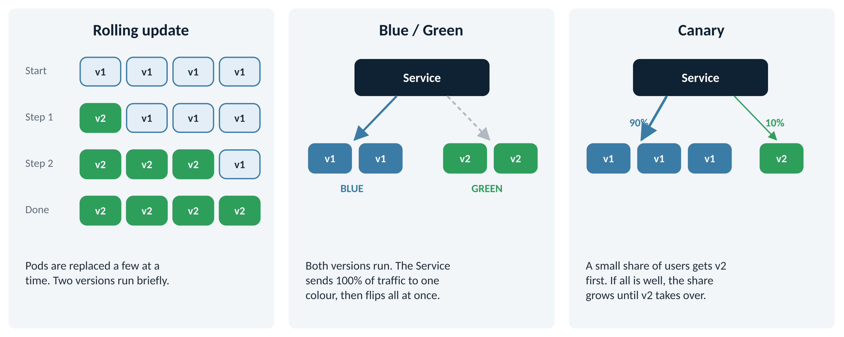
Figure 1: Three ways to release a new version
Strategy | What it does | When to use | Everyday comparison
Rolling Update | Replaces old Pods with new ones gradually, a few at a time | The Kubernetes default; low risk for most apps | Changing the bulbs in a hall one at a time, so the room never goes dark
Blue/Green | Runs old and new side by side, then switches all traffic at once | You need zero downtime and an instant rollback | Building a new bridge next to the old one, then opening it and closing the old one on the same day
Canary | Sends a small share of traffic to the new version first | You want to test with real users and catch bugs early | A restaurant offering a new dish to a few tables before adding it to the menu

Kubernetes Primitives Used (with Role + Example)
Tool | Role | Example in this lab
Deployment | Runs one version of your app | Two Deployments: app-blue runs nginx:1.21 and app-green runs nginx:1.22.
Service | Gives users one stable address and routes traffic | app-service listens on NodePort 30080 and forwards requests to either the Blue or the Green Pods.
Labels | Name tags on Pods | Every Pod has app=myapp, plus version=blue or version=green.
Selectors | The rule a Service uses to pick Pods | The Service selector version=blue sends traffic to Blue Pods only. Changing it to green is the whole switch.
ReplicaSet | Keeps the right number of Pod copies | replicas: 2 in each Deployment. If a Pod dies, the ReplicaSet starts a new one.
Pod | Runs the actual container | Each Pod runs one nginx container on port 80.

How labels and selectors route traffic
Labels and selectors are the heart of this lab, so it is worth understanding them before you type anything.
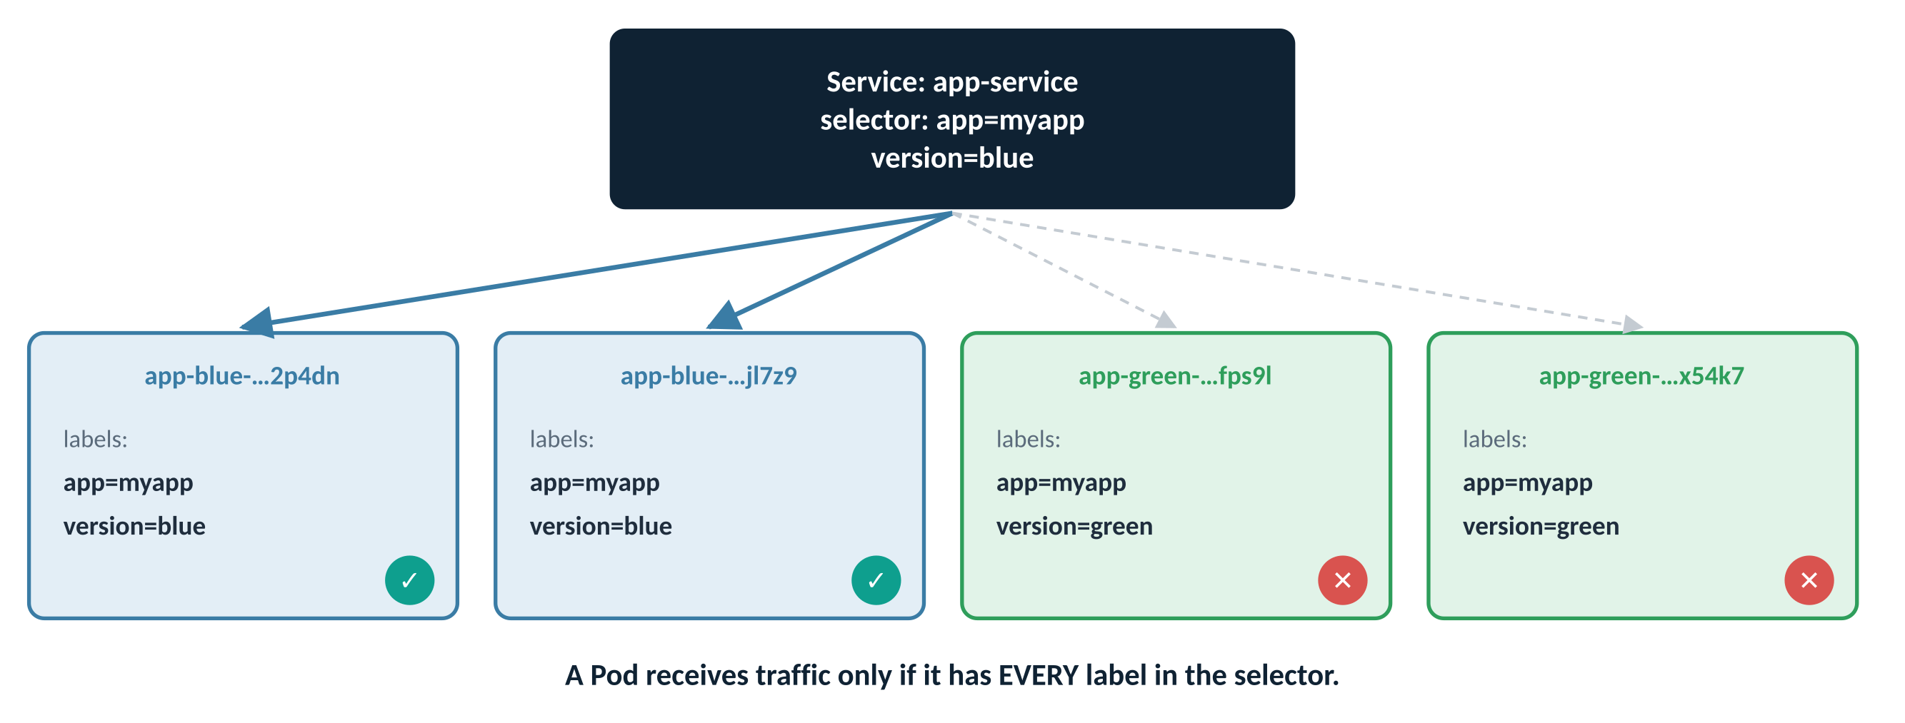
Figure 2: The Service selector matches Blue Pods; Green Pods are ignored
- A label is a key=value tag on a Pod, such as version=blue.
- A selector is a list of labels. The Service sends traffic only to Pods that carry every label in the list.
- The Service selector says app=myapp and version=blue. Blue Pods have both labels, so they get traffic. Green Pods have app=myapp but version=green, so they are skipped.
Watch out
If you leave version out of the Service selector, both Blue and Green Pods match app=myapp. Traffic is then split between the two versions and curl returns nginx 1.21 or 1.22 at random. Always include version in the selector for Blue-Green.

How Blue-Green works in this lab
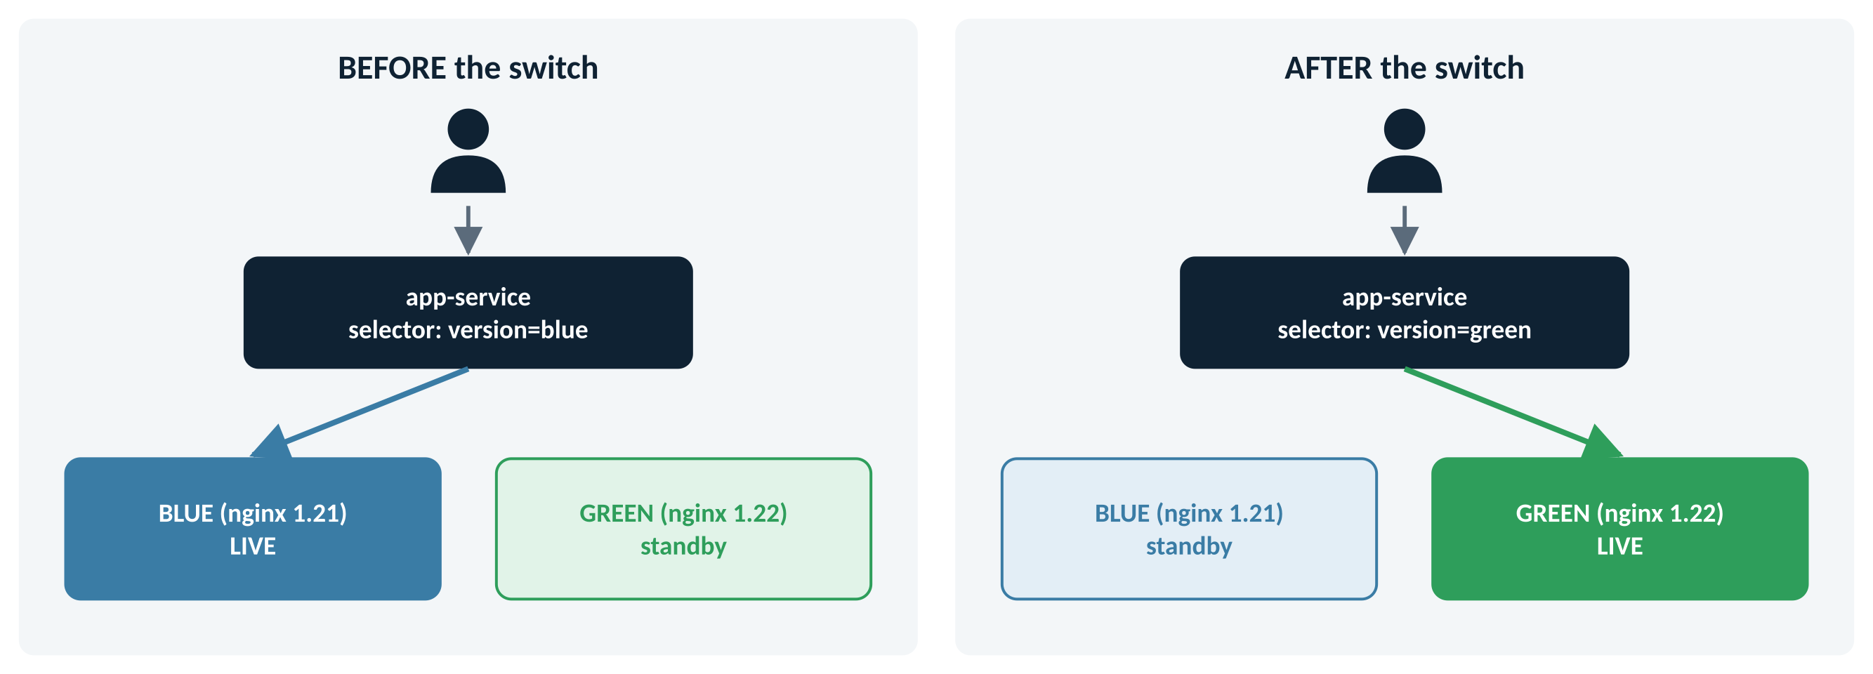
Figure 3: Before and after the switch: only the Service selector changes
- Blue (the current version) is live and serving every user.
- Green (the new version) is started alongside it. It is fully running, but receives no traffic yet.
- You test Green, then change one word in the Service selector: blue → green.
- All new requests now go to Green. Blue keeps running as a standby, so rolling back is the same one-word change in reverse.
Real-world example
A bank is releasing a new version of its mobile-banking API on Saturday night. The new version runs next to the old one all evening while testers check it. At midnight, one change moves every customer to the new version. If a problem appears on Sunday morning, the old version is still running and customers are back on it within seconds.

Before you start
Item | Value used in this lab | Change it if…
Node IP address | 192.168.88.128 | Your node has a different IP. Find it with kubectl get nodes -o wide (INTERNAL-IP column).
NodePort | 30080 | Port 30080 is already used. Any free port from 30000–32767 works.
Namespace | default | You use your own namespace. Add -n <name> to every command.
Editor | nano | You prefer vi or another editor.

Files you will create
File | Creates | Purpose
Deploy-blue.yaml | Deployment app-blue | The current version: nginx:1.21, label version=blue
Deploy-green.yaml | Deployment app-green | The new version: nginx:1.22, label version=green
serviceblue.yaml | Service app-service | One stable address; its selector decides which colour is live

Note
File names on Linux are case-sensitive: Deploy-blue.yaml and deploy-blue.yaml are different files. Type them exactly as shown.

Lab roadmap
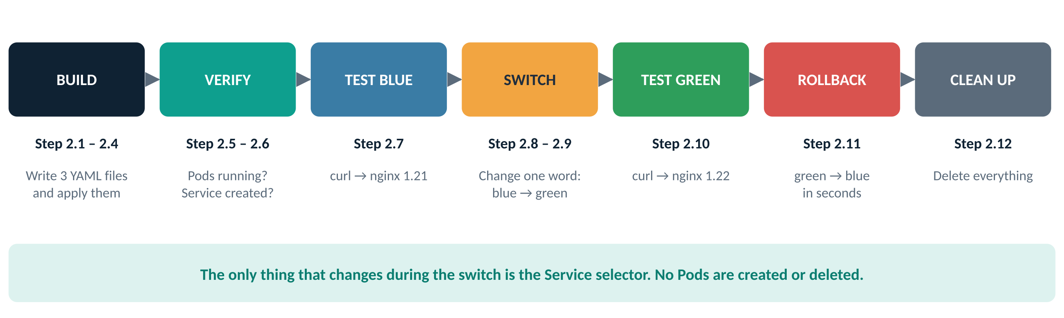
Figure 4: The 12 steps of the lab, grouped into phases

Lab 1 – Blue-Green Deployment
Each step below follows the same pattern: why you are doing it, what to type, a screenshot of the expected result with numbered highlights, a table explaining each highlight, and a checkpoint that tells you when you can move on.

Create the Blue Deployment
Why: Blue is the version your users are on today. It runs nginx 1.21 and carries the label version=blue, which the Service will use to find it.
Do this: open a new file in nano
nano Deploy-blue.yaml
Type (or paste) this YAML, then save with Ctrl+O, Enter, and exit with Ctrl+X
# Deploy Blue (nginx:1.21)
apiVersion: apps/v1
kind: Deployment
metadata:
name: app-blue
spec:
replicas: 2
selector:
matchLabels:
app: myapp
version: blue
template:
metadata:
labels:
app: myapp
version: blue
spec:
containers:
- name: nginx
image: nginx:1.21
ports:
- containerPort: 80
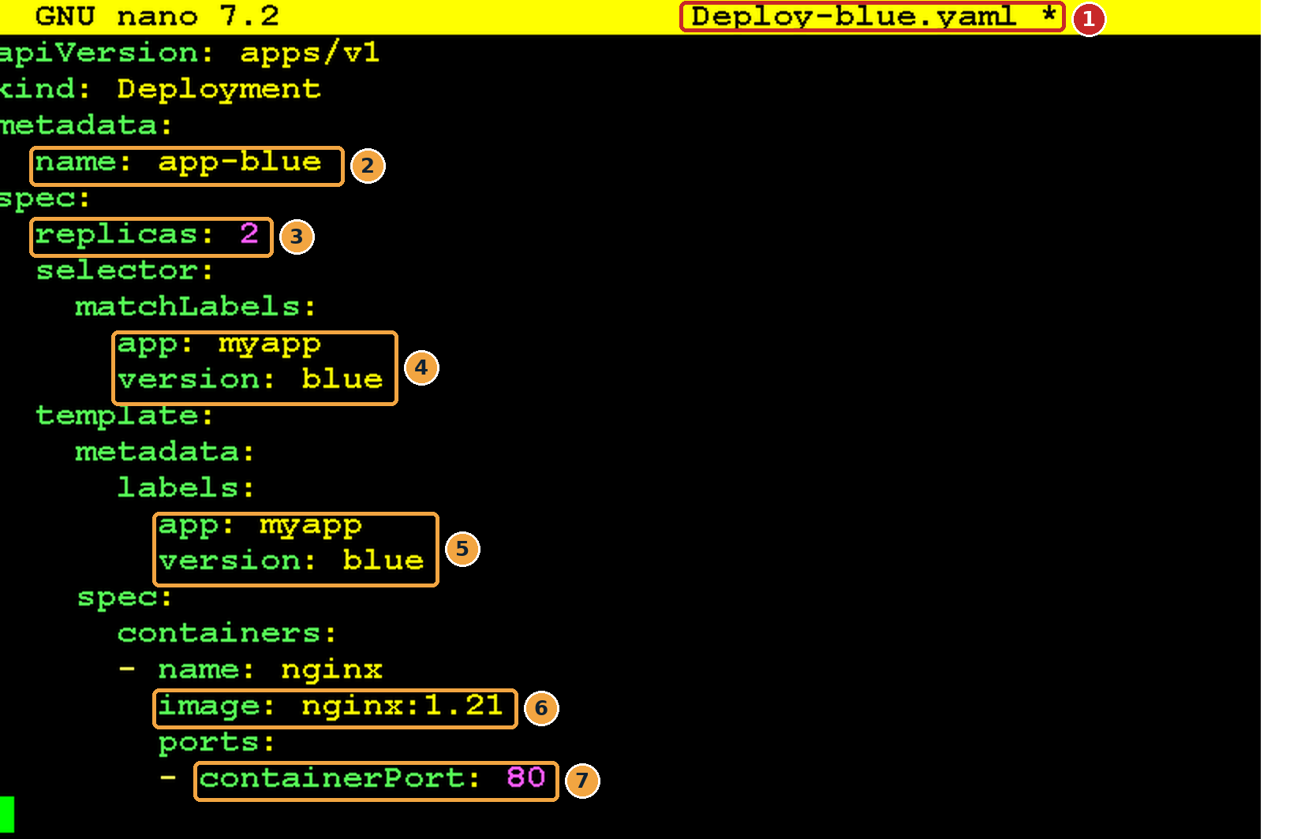
Screenshot 1: Deploy-blue.yaml open in nano
What this screenshot shows
# | What you see | What it means
1 | File name Deploy-blue.yaml in the nano title bar (a * appears while there are unsaved changes) | You are editing the right file. Save before you exit.
2 | name: app-blue | The Deployment’s name. You will see it at the start of every Blue Pod name.
3 | replicas: 2 | Run two copies of Blue, so one can fail without an outage.
4 | selector → matchLabels: app: myapp, version: blue | Tells the Deployment which Pods belong to it. Must match the template labels below.
5 | template → labels: app: myapp, version: blue | The labels stamped on every Pod it creates. The Service will look for version: blue.
6 | image: nginx:1.21 | The Blue version of the app. This is what curl will report in Step 2.7.
7 | containerPort: 80 | nginx listens on port 80 inside the container.

Checkpoint: you are ready for the next step when…
The file is saved and the two label blocks (items 4 and 5) both say version: blue.

Create the Green Deployment
Why: Green is the new version (nginx 1.22). It will run next to Blue but get no traffic until you switch the Service.
Do this
nano Deploy-green.yaml
apiVersion: apps/v1
kind: Deployment
metadata:
name: app-green
spec:
replicas: 2
selector:
matchLabels:
app: myapp
version: green
template:
metadata:
labels:
app: myapp
version: green
spec:
containers:
- name: nginx
image: nginx:1.22
ports:
- containerPort: 80
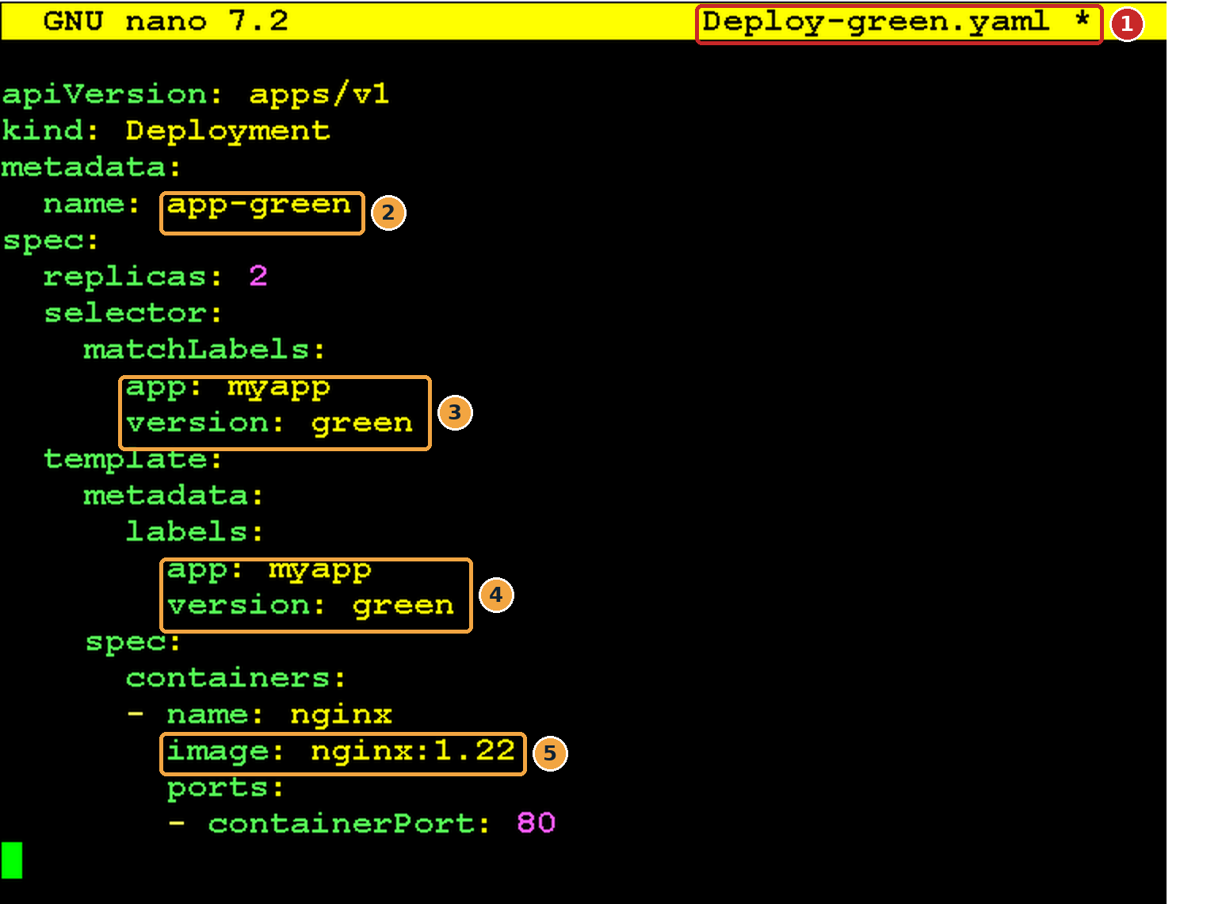
Screenshot 2: Deploy-green.yaml open in nano
What this screenshot shows
# | What you see | What it means
1 | File name Deploy-green.yaml | A separate file from Blue.
2 | name: app-green | A different Deployment name, so it does not replace Blue.
3 | selector: version: green | This Deployment manages only Green Pods.
4 | template labels: version: green | Every Green Pod gets version=green, so the Service can tell it apart from Blue.
5 | image: nginx:1.22 | The new version you are releasing.

Only three things differ from the Blue file
Field | Blue | Green
metadata.name | app-blue | app-green
version label (selector and template) | blue | green
image | nginx:1.21 | nginx:1.22

Checkpoint: you are ready for the next step when…
The file is saved, and name, both version labels and image all say green / 1.22.

Create the Service that points to Blue
Why: Users never talk to Pods directly. They talk to the Service, which forwards each request to whichever Pods match its selector. Right now that must be Blue.
Do this
nano serviceblue.yaml
apiVersion: v1
kind: Service
metadata:
name: app-service
spec:
selector:
app: myapp
version: blue # this one word decides which colour is live
ports:
- port: 80
targetPort: 80
nodePort: 30080
protocol: TCP
type: NodePort
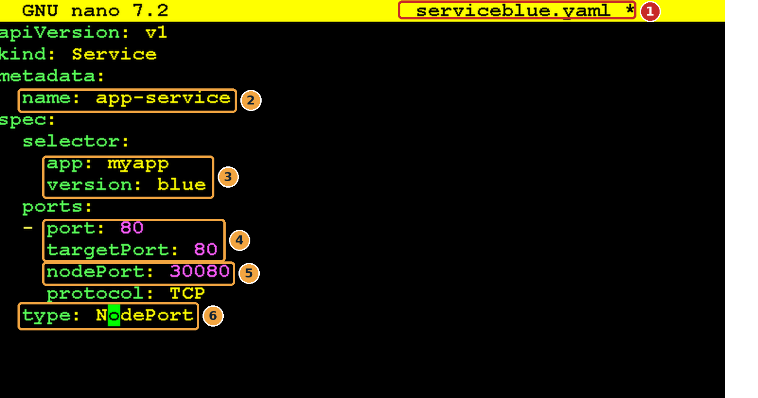
Screenshot 3: serviceblue.yaml open in nano
What this screenshot shows
# | What you see | What it means
1 | File name serviceblue.yaml | The Service definition. You will edit this same file to switch colours.
2 | name: app-service | The stable name of the Service. It never changes during the lab.
3 | selector: app: myapp, version: blue | Send traffic only to Pods with BOTH labels, which means Blue Pods only.
4 | port: 80, targetPort: 80 | The Service listens on 80 and forwards to port 80 in the container.
5 | nodePort: 30080 | The port opened on the node, so you can reach the app from outside the cluster.
6 | type: NodePort | Makes the Service reachable at <node IP>:30080.

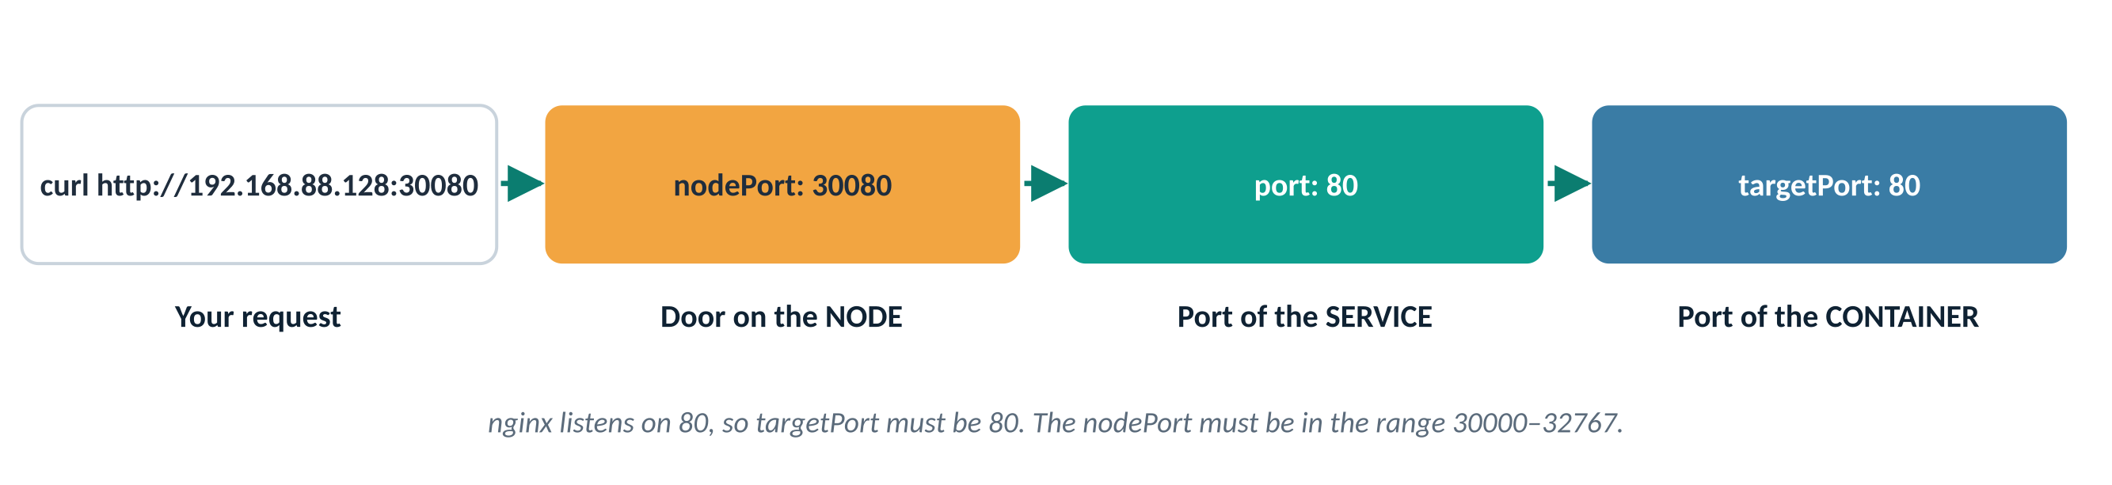
Figure 5: How a request travels through the three port settings
Checkpoint: you are ready for the next step when…
The selector has both app: myapp and version: blue.

Apply the Deployments and Service
Why: So far you have only written files. kubectl apply sends them to Kubernetes, which then creates the objects.
Do this
kubectl apply -f Deploy-blue.yaml
kubectl apply -f Deploy-green.yaml
kubectl apply -f serviceblue.yaml
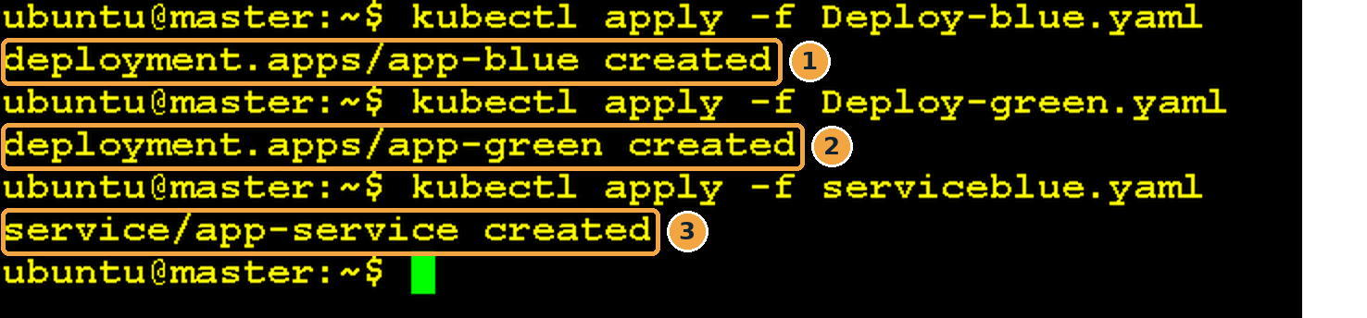
Screenshot 4: Output of the three apply commands
What this screenshot shows
# | What you see | What it means
1 | deployment.apps/app-blue created | Kubernetes accepted the Blue Deployment and is starting two Blue Pods.
2 | deployment.apps/app-green created | The Green Deployment is accepted. Two Green Pods are starting too.
3 | service/app-service created | The Service exists and is already selecting Blue Pods.

Note
If you run apply again on an unchanged file, the output says unchanged. After you edit a file, it says configured (you will see this in Step 2.9).

Checkpoint: you are ready for the next step when…
All three lines end in “created” with no error messages.

Verify the Blue and Green Pods
Why: Before sending any traffic, confirm that both versions are actually running.
Do this
kubectl get pod
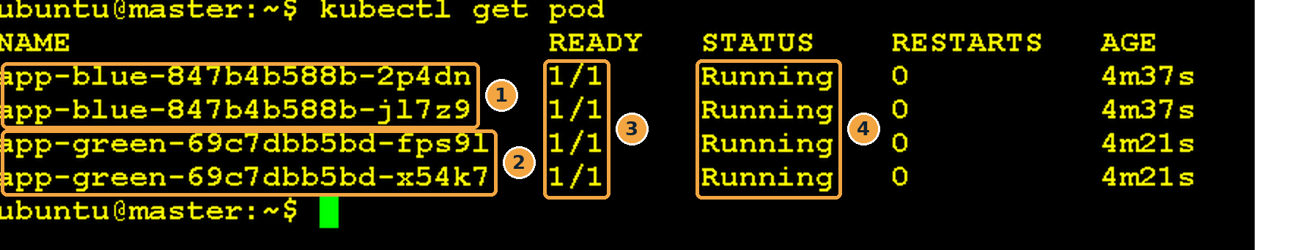
Screenshot 5: Four Pods running: two Blue and two Green
What this screenshot shows
# | What you see | What it means
1 | Two app-blue-… Pods | The two replicas of the Blue Deployment.
2 | Two app-green-… Pods | The two replicas of the Green Deployment, running but not yet receiving traffic.
3 | READY 1/1 | The one container in each Pod is up and ready.
4 | STATUS Running | All four Pods are healthy. RESTARTS 0 means none has crashed.

How to read a Pod name

Figure 6: Every Pod name has three parts
Optional check (no screenshot): see the labels
kubectl get pods -L version # adds a VERSION column: blue / green
Checkpoint: you are ready for the next step when…
You see 4 Pods, all 1/1 Running. If any say Pending or ImagePullBackOff, see the Troubleshooting section before continuing.

Verify the Service
Why: Confirm that the Service exists, has the right type and is listening on the NodePort you chose.
Do this
kubectl get svc
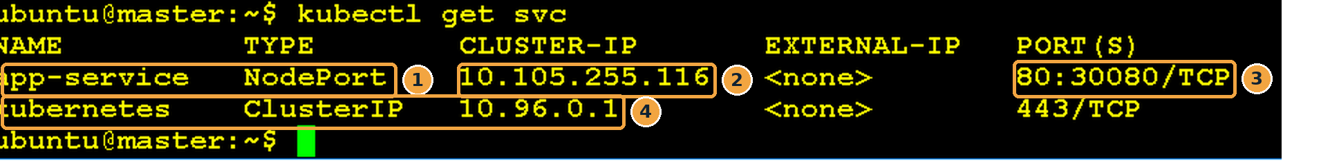
Screenshot 6: The app-service Service listening on NodePort 30080
What this screenshot shows
# | What you see | What it means
1 | app-service NodePort | Your Service, of type NodePort.
2 | CLUSTER-IP 10.105.255.116 | The internal IP used by apps inside the cluster. Yours will be different; that is fine.
3 | PORT(S) 80:30080/TCP | Service port 80 is opened on every node as port 30080. This is the port you will curl.
4 | kubernetes ClusterIP | A built-in Service for the Kubernetes API. It is always there; ignore it.

Optional check (no screenshot): which Pods is the Service using?
kubectl get endpoints app-service # should list only the 2 Blue Pod IPs
kubectl get pods -o wide -l version=blue # compare with these IPs
Checkpoint: you are ready for the next step when…
PORT(S) shows 80:30080/TCP, and the endpoints list shows exactly two IPs (the Blue Pods).

Test the Deployment (Blue is live)
Why: Prove, from outside the cluster, that users are being served by Blue.
Do this (replace the IP with your node’s IP)
curl -I http://192.168.88.128:30080
curl -I asks only for the response headers, not the whole web page. The Server header tells you which nginx version answered, which is an easy way to tell Blue from Green.
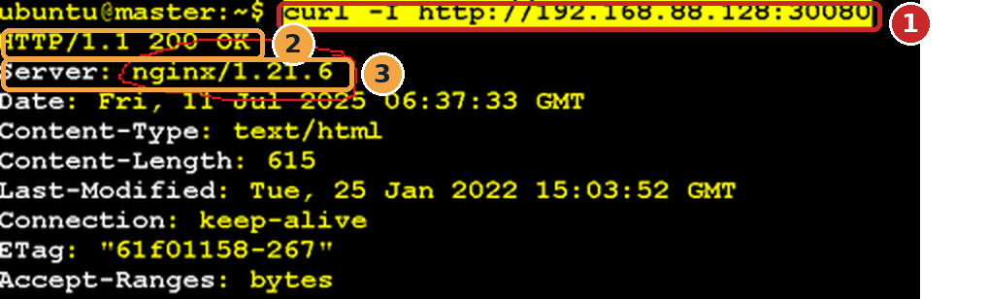
Screenshot 7: curl response served by Blue (nginx 1.21.6)
What this screenshot shows
# | What you see | What it means
1 | curl -I http://192.168.88.128:30080 | Your request, sent to the node IP on NodePort 30080.
2 | HTTP/1.1 200 OK | The request succeeded.
3 | Server: nginx/1.21.6 | Proof that a Blue Pod answered (Blue uses the nginx:1.21 image).

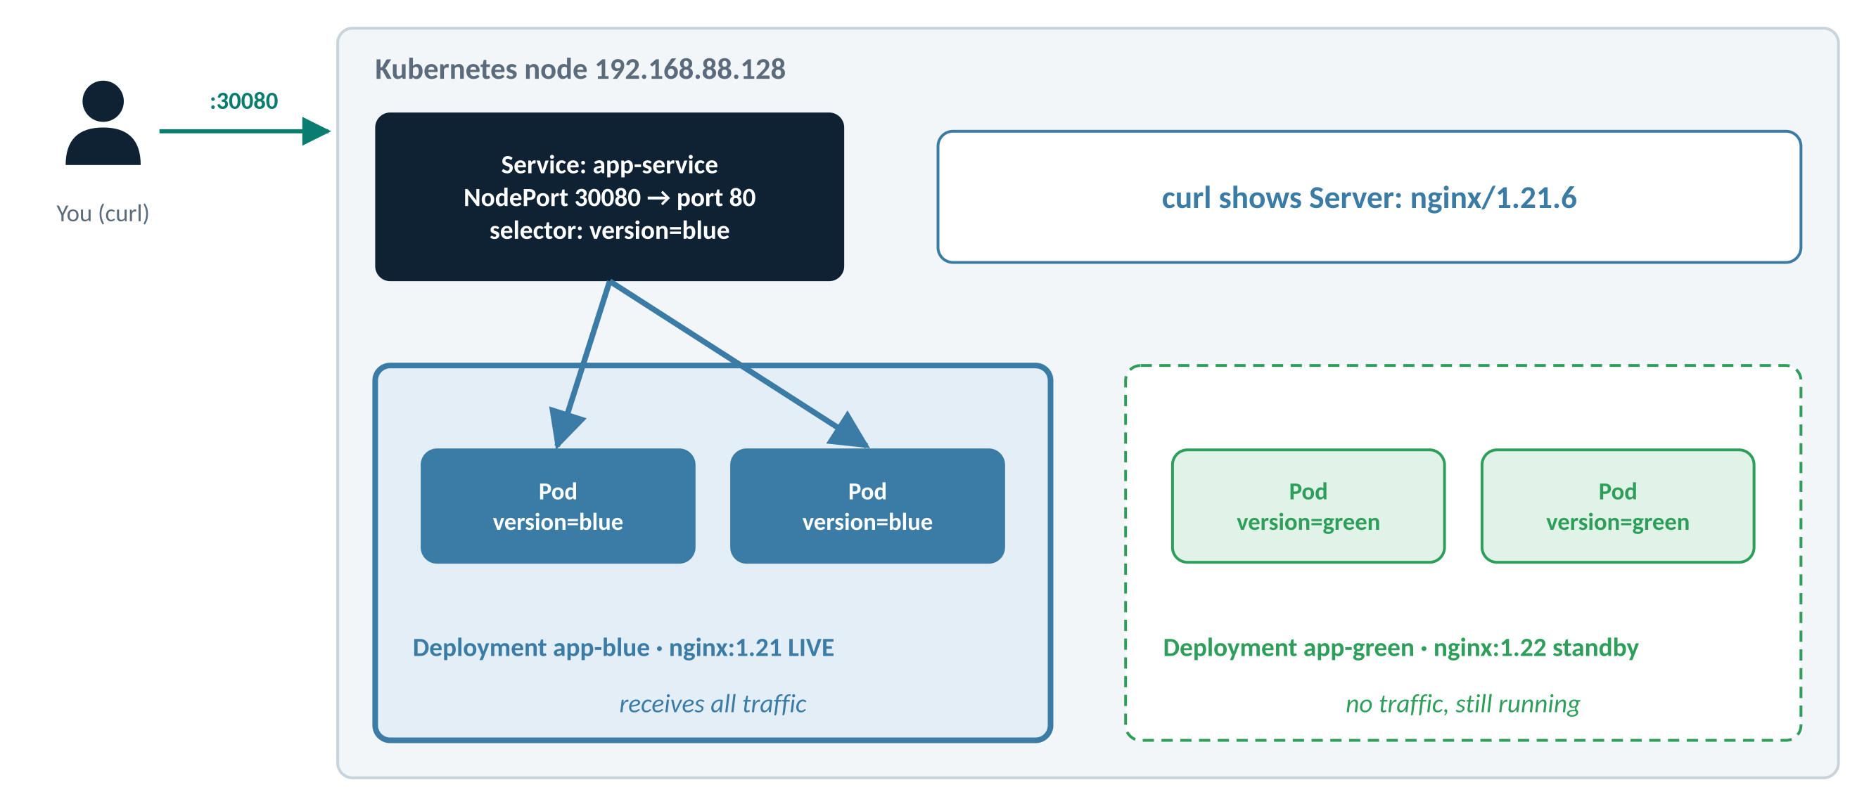
Figure 7: Traffic flow now: every request goes to Blue
Checkpoint: you are ready for the next step when…
Running curl several times always shows nginx/1.21.x. If you sometimes see 1.22, your Service selector is missing version: blue.

Switch the traffic to Green: edit the Service
Why: This is the Blue-Green switch. You change one word in the Service selector. The Pods themselves are not touched.
Do this
nano serviceblue.yaml
Change the selector line from version: blue to version: green, then save (Ctrl+O, Enter) and exit (Ctrl+X). The file should now look like this:
apiVersion: v1
kind: Service
metadata:
name: app-service
spec:
selector:
app: myapp
version: green # changed from blue
ports:
- port: 80
targetPort: 80
nodePort: 30080
protocol: TCP
type: NodePort
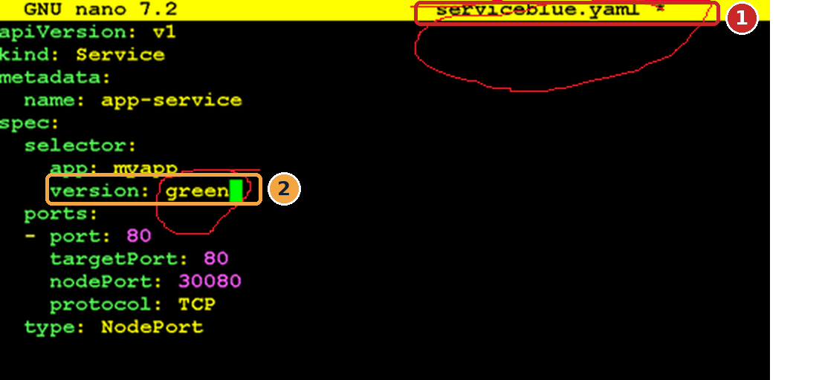
Screenshot 8: The selector changed from blue to green
What this screenshot shows
# | What you see | What it means
1 | serviceblue.yaml * in the title bar | Same file as before; the * shows there are unsaved edits. The file name still says “blue”; only its content matters.
2 | version: green | The only change. From now on the Service will select Green Pods.

Note
Saving the file does not change anything in the cluster yet. The switch happens only when you apply it in the next step.

Checkpoint: you are ready for the next step when…
The file is saved with version: green and nothing else changed.

Apply the change
Why: Send the edited Service to Kubernetes. The switch is instant: new requests go to Green straight away.
Do this
kubectl apply -f serviceblue.yaml
Screenshot 9: The Service was updated
What this screenshot shows
# | What you see | What it means
1 | service/app-service configured | “configured” (not “created”) means an existing object was updated. The Service now selects Green.

Try it: see zero downtime
Want to watch the switch happen live? Before applying, open a second terminal and run:
while true; do curl -sI http://192.168.88.128:30080 | grep Server; sleep 1; done
You will see the lines change from nginx/1.21.6 to nginx/1.22.1 the moment you apply, with no failed requests in between. Stop the loop with Ctrl+C.

Checkpoint: you are ready for the next step when…
The output says configured.

Test again (Green is live)
Why: Prove that users are now served by Green, the new version.
Do this
curl -I http://192.168.88.128:30080
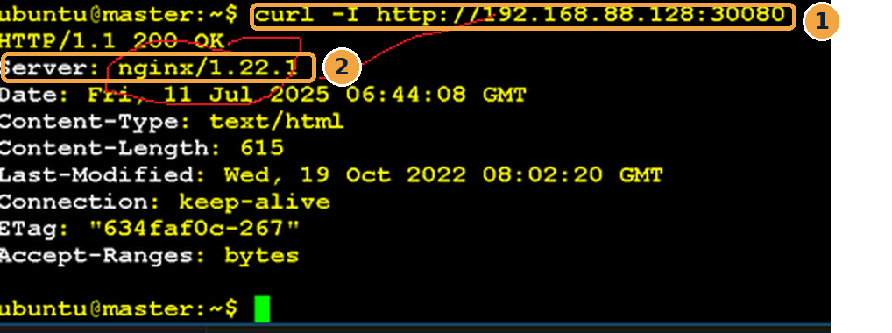
Screenshot 10: curl response now served by Green (nginx 1.22.1)
What this screenshot shows
# | What you see | What it means
1 | Same URL: curl -I http://192.168.88.128:30080 | Users did not have to change anything: same address, same port.
2 | Server: nginx/1.22.1 | Proof that a Green Pod answered. The release is complete.

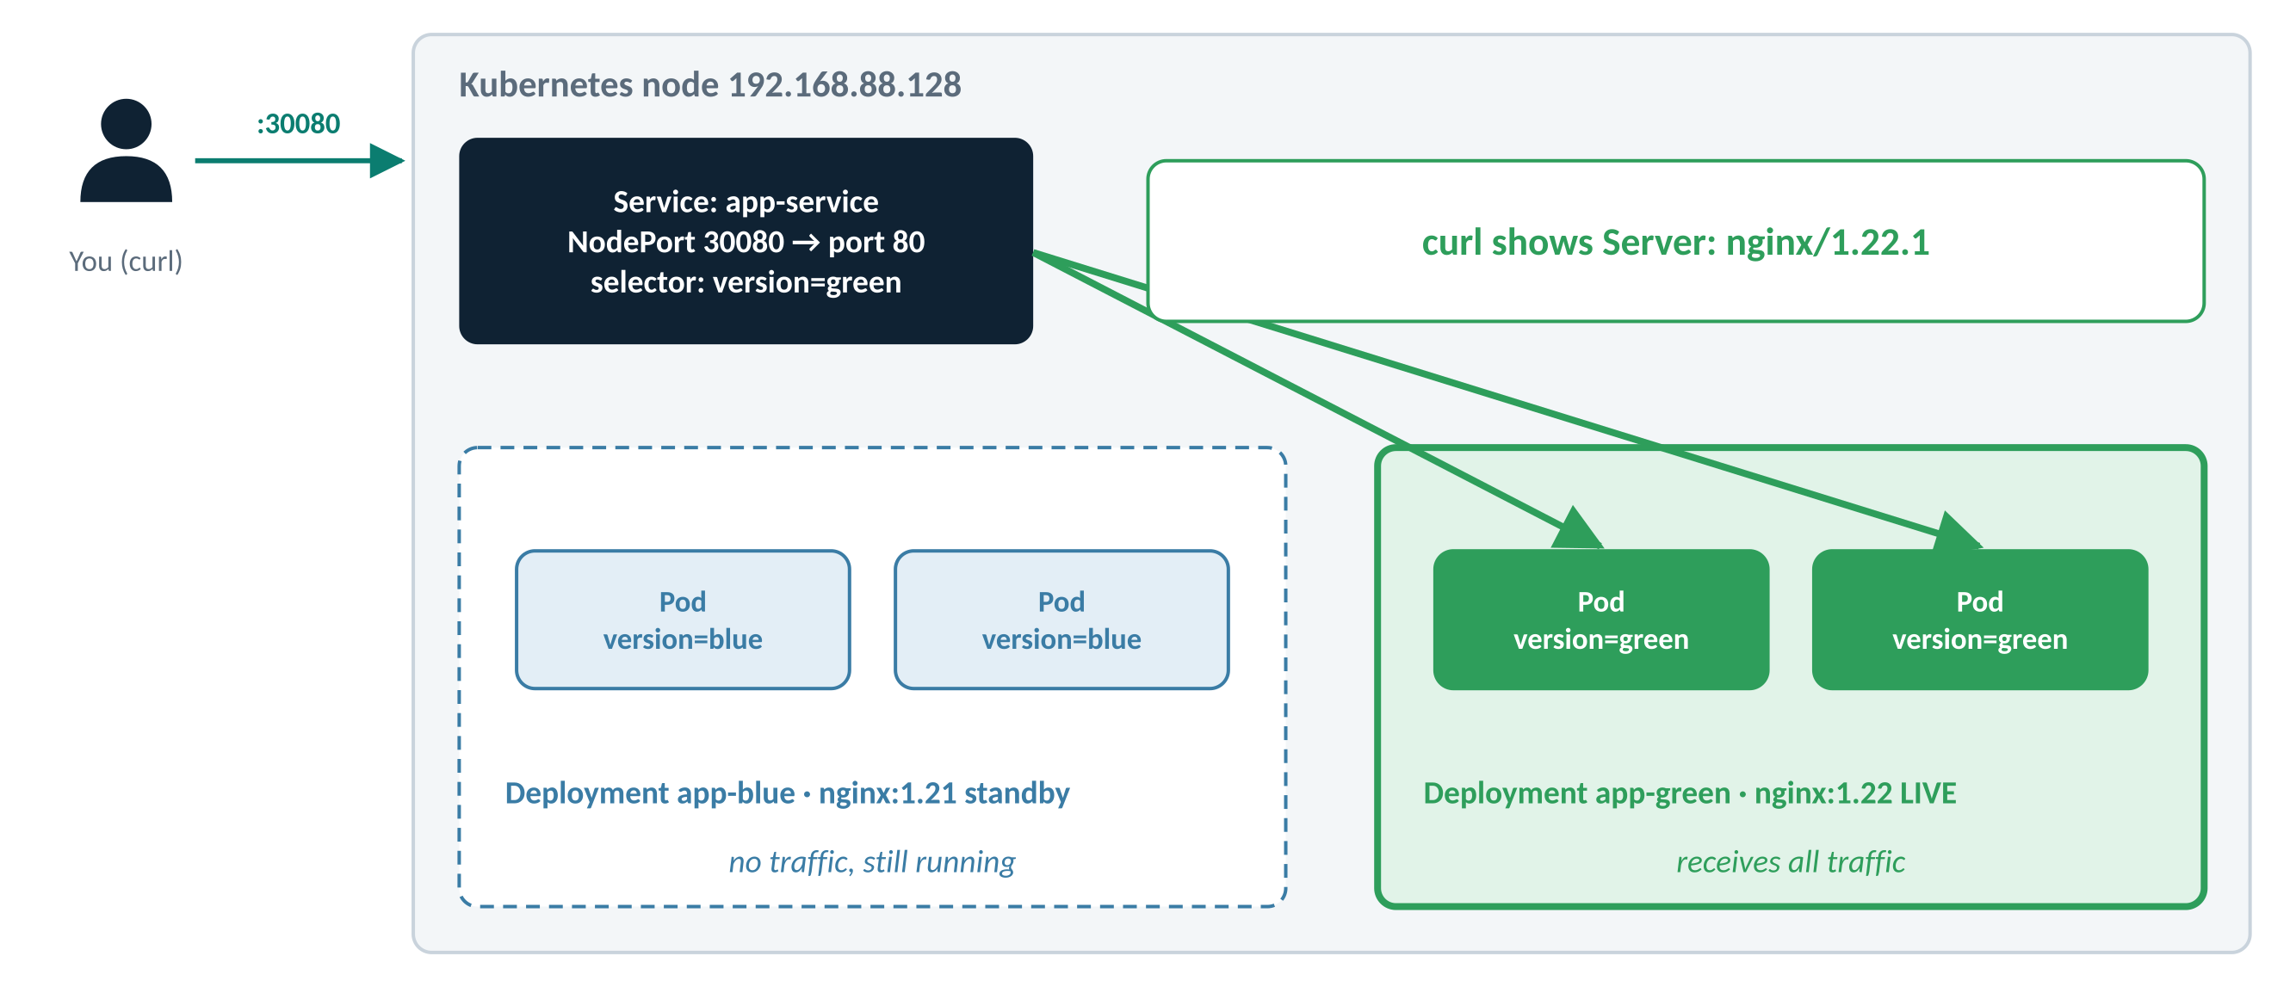
Figure 8: Traffic flow after the switch: every request goes to Green; Blue waits on standby
Optional check (no screenshot)
kubectl get endpoints app-service # now lists the 2 Green Pod IPs
Checkpoint: you are ready for the next step when…
curl always returns nginx/1.22.x, and Blue Pods are still Running (check with kubectl get pod).

Roll back to Blue (optional)
Why: Imagine users report a bug in the new version. Because Blue is still running, going back takes seconds. This step has no screenshot; it mirrors Steps 2.8–2.10 in reverse.
Option A: edit the file (same as before, in reverse)
nano serviceblue.yaml # change version: green back to version: blue
kubectl apply -f serviceblue.yaml # output: service/app-service configured
curl -I http://192.168.88.128:30080 # Server: nginx/1.21.6 again
Option B: one command, no editor
kubectl patch service app-service -p '{"spec":{"selector":{"app":"myapp","version":"blue"}}}'
curl -I http://192.168.88.128:30080
Watch out
If you use Option B, the file serviceblue.yaml still says green. Update the file too, otherwise the next kubectl apply of that file will switch you back to Green by surprise.

Checkpoint: you are ready for the next step when…
curl shows nginx/1.21.x again. To finish the release, switch back to Green before cleaning up, or clean up straight away.

Clean up the lab
Why: Remove everything you created so the next lab starts from a clean cluster.
Do this
kubectl delete -f serviceblue.yaml
kubectl delete -f Deploy-green.yaml
kubectl delete -f Deploy-blue.yaml
Then confirm nothing is left
kubectl get pod
kubectl get svc
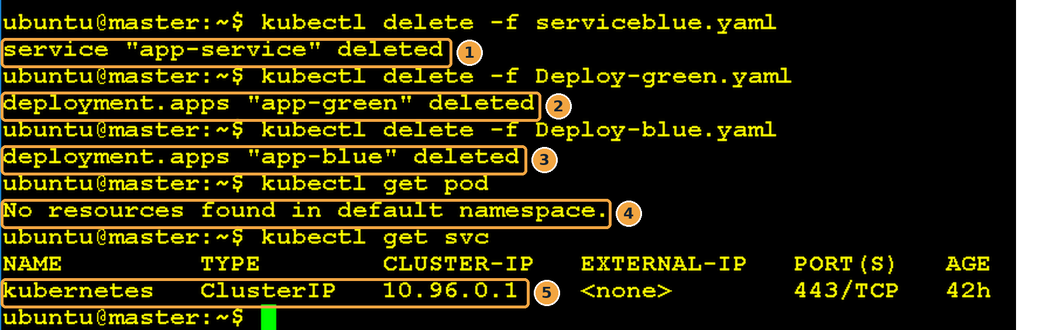
Screenshot 11: Everything deleted; only the built-in kubernetes Service remains
What this screenshot shows
# | What you see | What it means
1 | service "app-service" deleted | The Service is gone, so nothing is reachable on port 30080 any more.
2 | deployment.apps "app-green" deleted | The Green Deployment and its Pods are removed.
3 | deployment.apps "app-blue" deleted | The Blue Deployment and its Pods are removed.
4 | No resources found in default namespace. | No Pods are left.
5 | kubernetes ClusterIP 10.96.0.1 | The built-in API Service. It is part of every cluster and must NOT be deleted.

Note
Deleting a Deployment also deletes its ReplicaSet and Pods automatically. You never need to delete Pods one by one.

Checkpoint: you are ready for the next step when…
kubectl get pod says No resources found, and kubectl get svc shows only kubernetes.

Summary and troubleshooting

What changed at each step
Step | What you did | What changed in the cluster | How you proved it
2.1 – 2.3 | Wrote three YAML files | Nothing yet (files only) | Screenshots 1–3
2.4 | Applied the files | 4 Pods and 1 Service created | “created” × 3
2.5 – 2.6 | Checked Pods and Service | Nothing (read-only) | 4 × Running, 80:30080/TCP
2.7 | Tested with curl | Nothing (read-only) | Server: nginx/1.21.6
2.8 – 2.9 | Changed the selector to green and applied it | Only the Service selector | “configured”
2.10 | Tested again | Nothing (read-only) | Server: nginx/1.22.1
2.11 | Rolled back (optional) | Only the Service selector | Server: nginx/1.21.6
2.12 | Deleted everything | All lab objects removed | No resources found

Troubleshooting
What you see | Likely cause | Fix
curl shows 1.21 and 1.22 at random | The Service selector is missing version, so it matches both colours | Add version: blue (or green) to the selector and apply again
curl: connection refused or timeout | Wrong IP or port, or a firewall is blocking 30080 | Check the IP with kubectl get nodes -o wide and the port with kubectl get svc
Pods stuck in Pending | Not enough CPU or memory on the nodes | kubectl describe pod <name> and read the Events at the bottom
ImagePullBackOff or ErrImagePull | Image name typo, or the node has no internet access | Check the image line, e.g. nginx:1.21; test with docker pull or crictl pull on the node
kubectl get endpoints app-service shows <none> | No Pod matches the selector (a typo in a label) | Compare kubectl get pods --show-labels with the Service selector
The Service port is already allocated | Another Service already uses NodePort 30080 | Pick another port between 30000 and 32767
error: the path "Deploy-blue.yaml" does not exist | Wrong folder or wrong capital letters in the file name | Run ls and type the name exactly

Blue-Green: strengths and trade-offs
Strengths | Trade-offs
Zero downtime: users never see an outage during the switch | Needs double the resources while both colours run
Instant rollback: the old version is still running | Database changes must work with both versions at the same time
The new version can be fully tested before any user sees it | Everyone switches at once, so a hidden bug hits all users (canary limits this)

Tip
In production, teams usually delete the old colour only after the new one has run cleanly for a while (for example, a day). Until then, the old colour is your safety net.

Self-check
- Which single field decides whether users get Blue or Green?
Answer: The Service’s selector, specifically the version label.
- Why do Blue and Green need different Deployment names?
Answer: Otherwise the second apply would update the first Deployment instead of creating a new one, and there would be no side-by-side versions.
- After the switch, are the Blue Pods deleted?
Answer: No. They keep running with no traffic, ready for an instant rollback.
- What does “configured” mean in kubectl output?
Answer: An existing object was updated (as opposed to “created” or “unchanged”).
- curl alternates between 1.21 and 1.22. What is wrong?
Answer: The Service selector is missing the version label, so it matches Pods of both colours.

