syste1
lsb_release -a
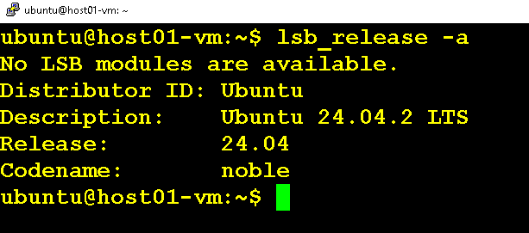

sudo apt update && sudo apt upgrade -y
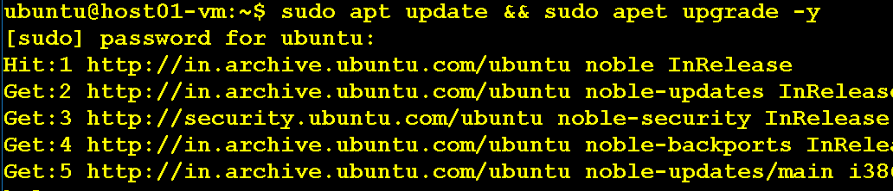

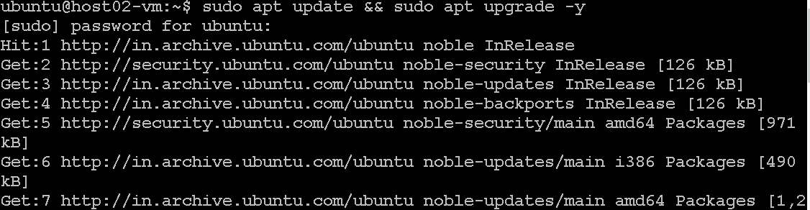

# On Master:
sudo hostnamectl set-hostname master
# On Worker Node:
sudo hostnamectl set-hostname worker1

Ifconfig
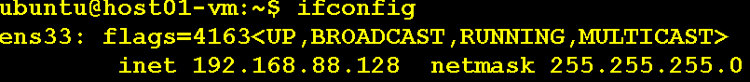

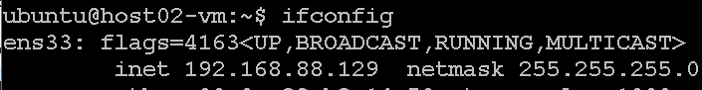

sudo nano /etc/hosts
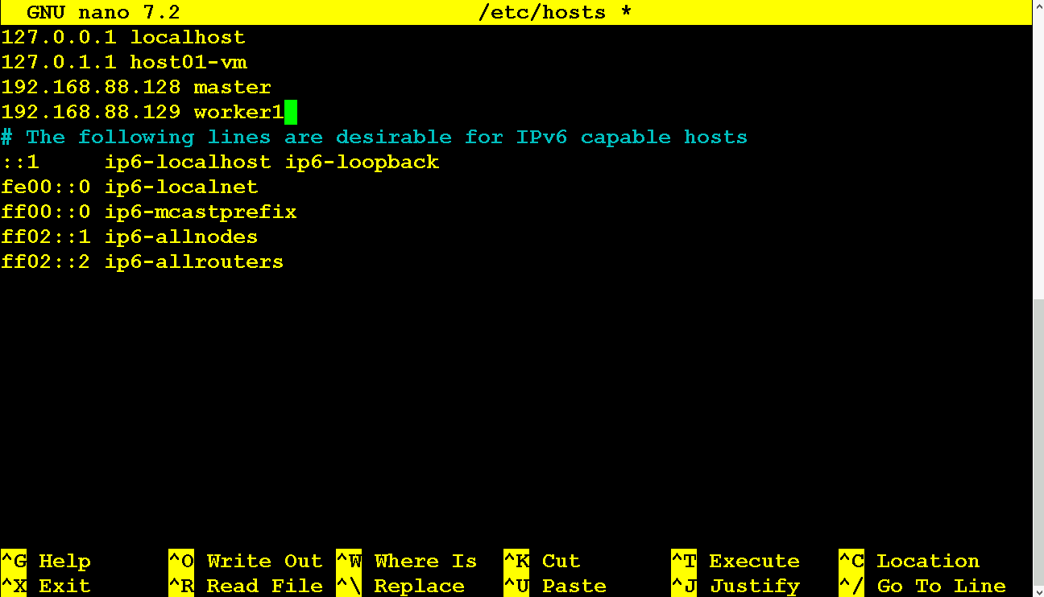

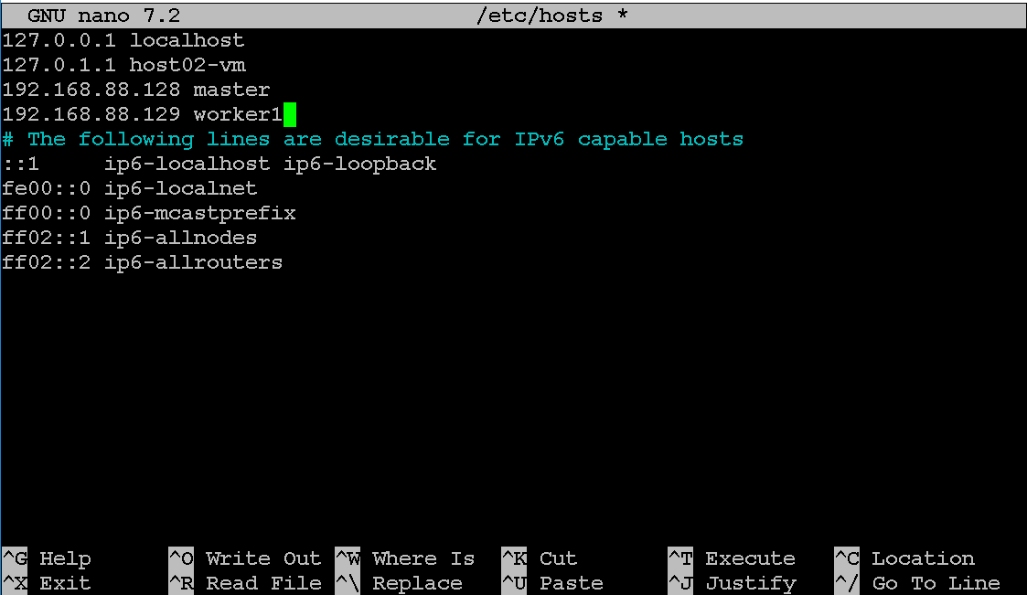

ping worker1
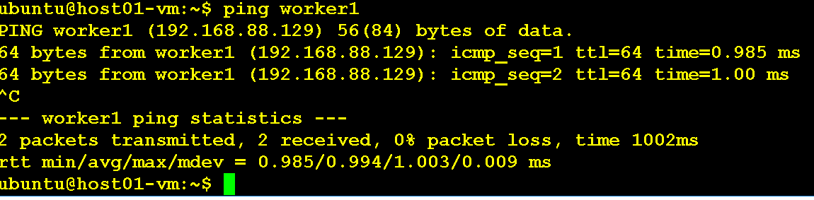
ping master

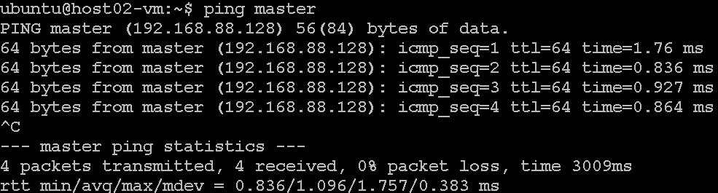

sudo swapoff -a
sudo sed -i '/ swap / s/^/#/' /etc/fstab

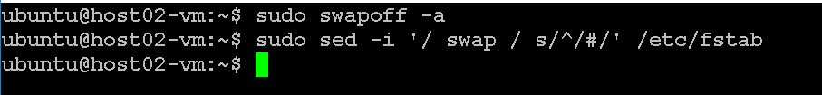

cat <<EOF | sudo tee /etc/modules-load.d/k8s.conf
overlay
br_netfilter
EOF

sudo modprobe overlay
sudo modprobe br_netfilter

# sysctl params required by setup, params persist across reboots
cat <<EOF | sudo tee /etc/sysctl.d/k8s.conf
net.bridge.bridge-nf-call-iptables = 1
net.bridge.bridge-nf-call-ip6tables = 1
net.ipv4.ip_forward = 1
EOF

# Apply sysctl params without reboot
sudo sysctl --system

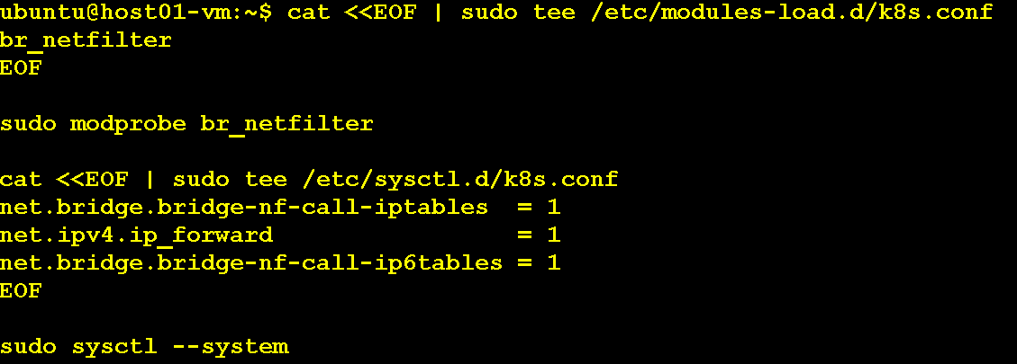

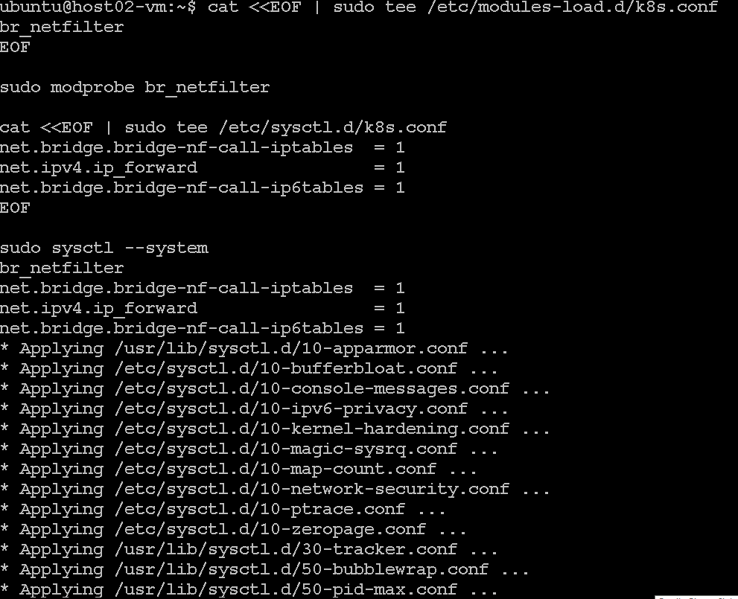

Configure persistent loading of modules with the following command
sudo tee /etc/modules-load.d/k8s.conf <<EOF
overlay
br_netfilter
EOF

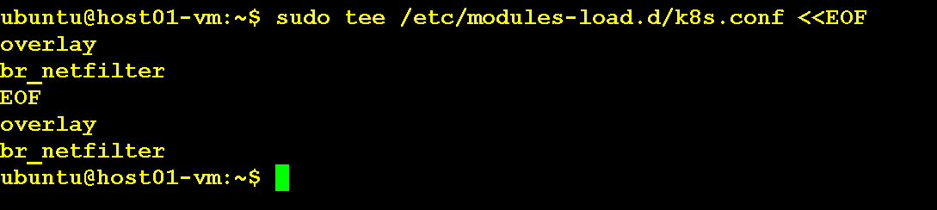

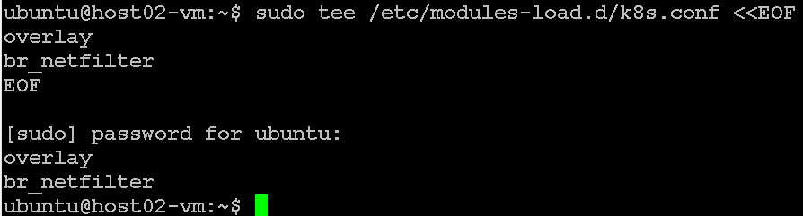
Reload sysctl with the following command
sudo sysctl --system
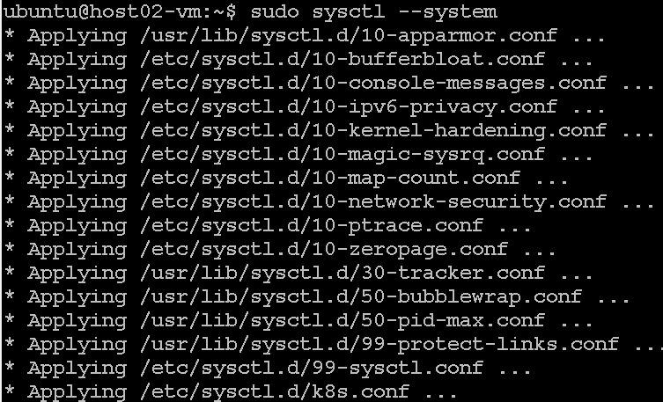

Step 4: Install container runtime (containerd)
- Set up Docker’s apt repository.
# Add Docker's official GPG key:
sudo apt-get update
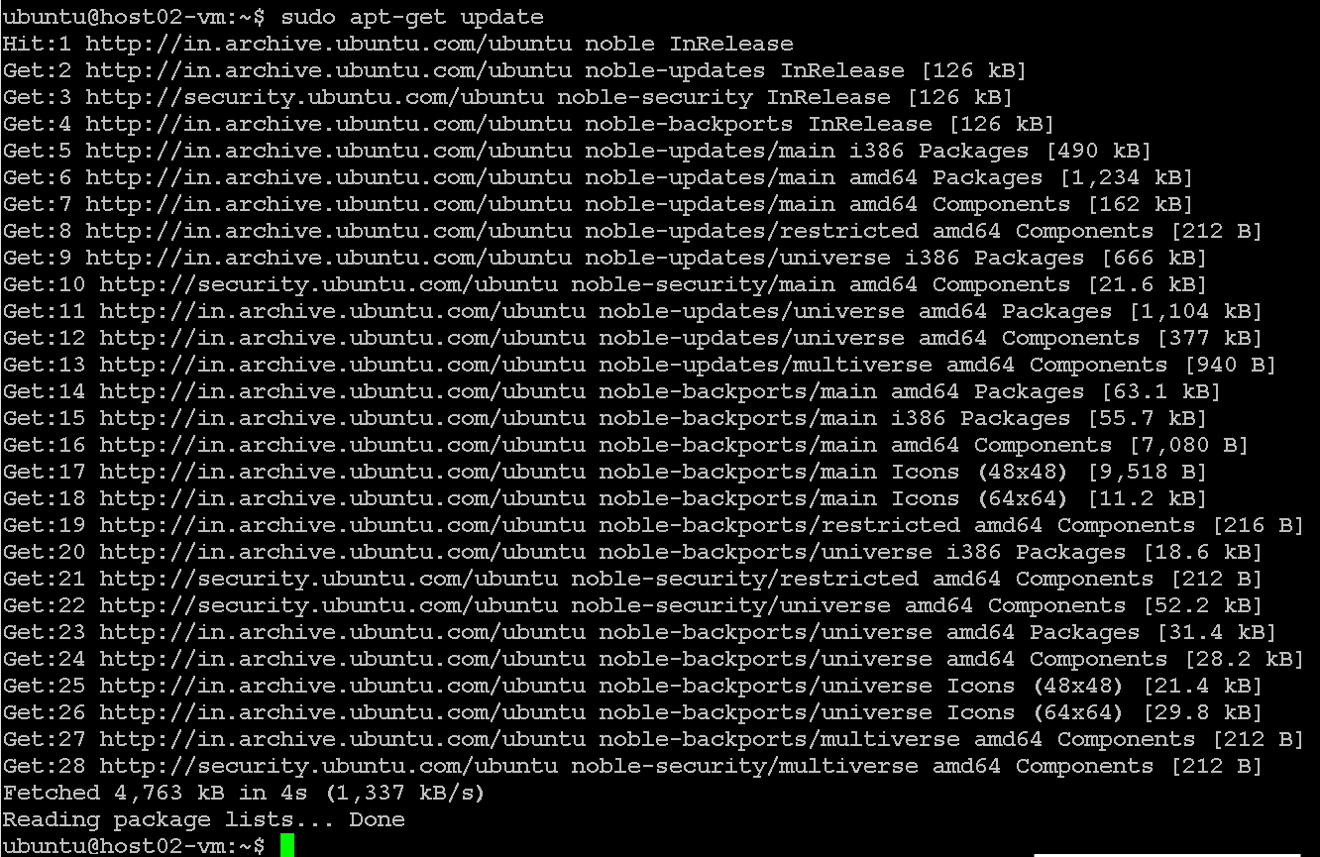
sudo apt-get install apt-transport-https ca-certificates curl gpg
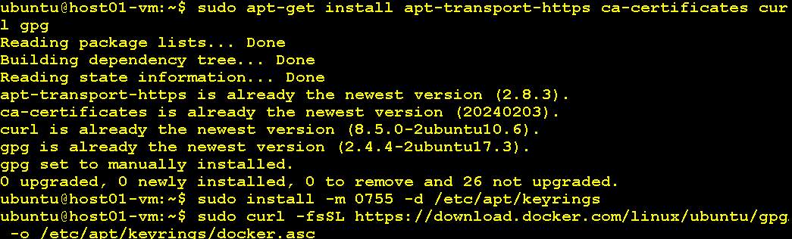

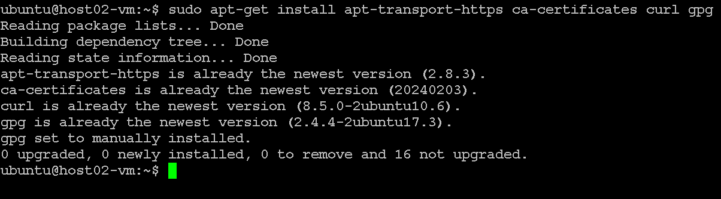
sudo install -m 0755 -d /etc/apt/keyrings
sudo curl -fsSL https://download.docker.com/linux/ubuntu/gpg -o /etc/apt/keyrings/docker.asc

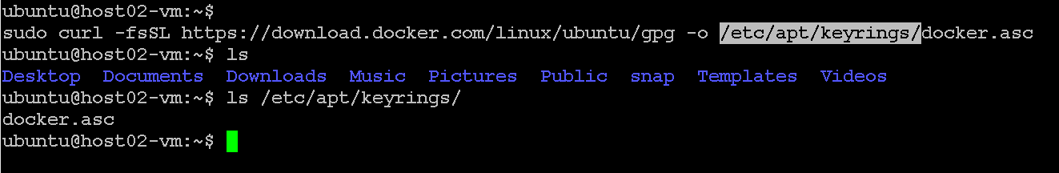
sudo chmod a+r /etc/apt/keyrings/docker.asc

# Add the repository to Apt sources:

echo \
"deb [arch=$(dpkg --print-architecture) signed-by=/etc/apt/keyrings/docker.asc] https://download.docker.com/linux/ubuntu \
$(. /etc/os-release && echo "$VERSION_CODENAME") stable" | \
sudo tee /etc/apt/sources.list.d/docker.list > /dev/null

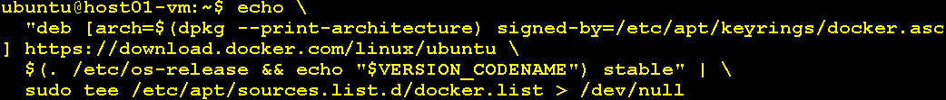

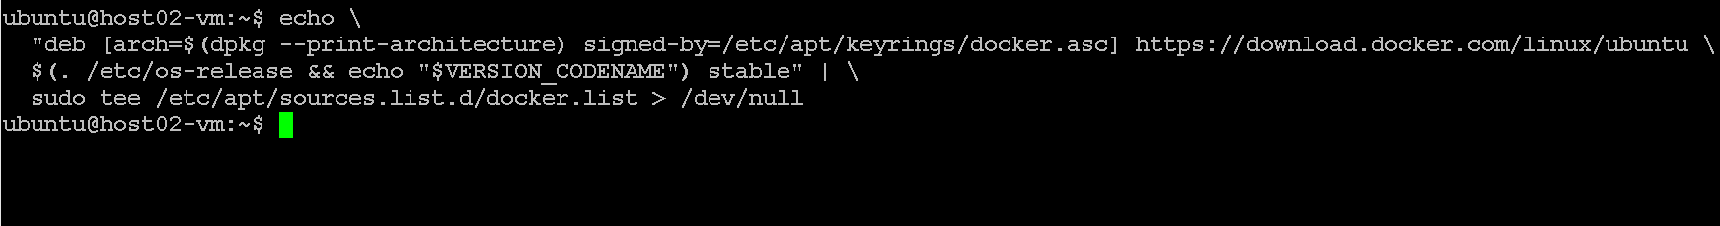
sudo apt-get update
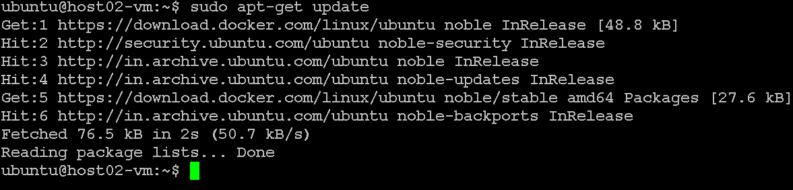

- Install containerd
sudo apt-get install containerd.io
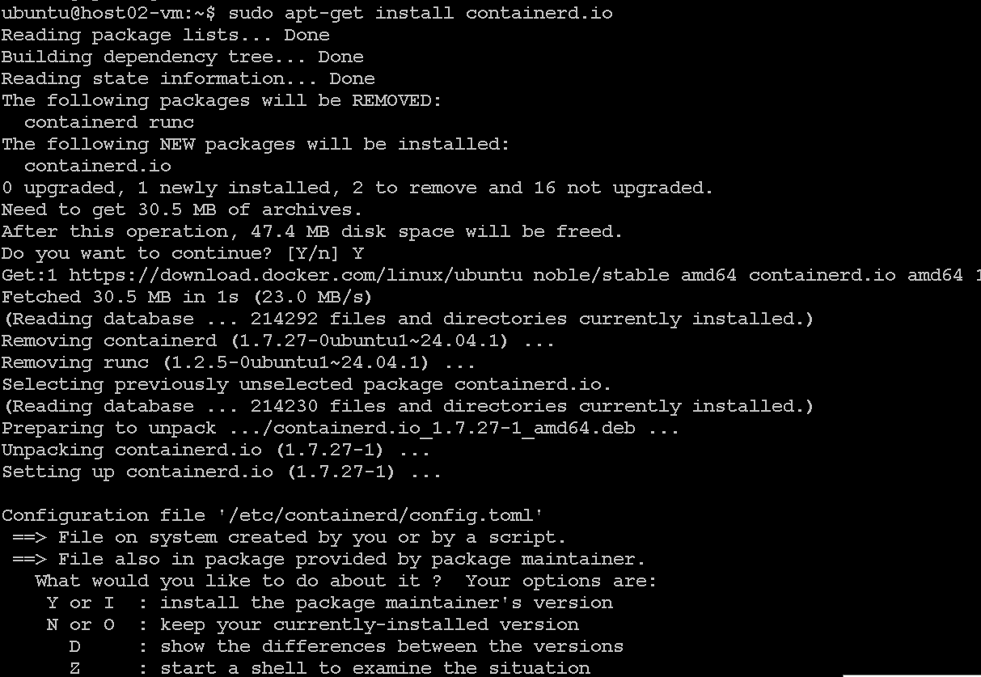
- Run the following commands to configure containerd
sudo mkdir -p /etc/containerd
sudo containerd config default | sudo tee /etc/containerd/config.toml

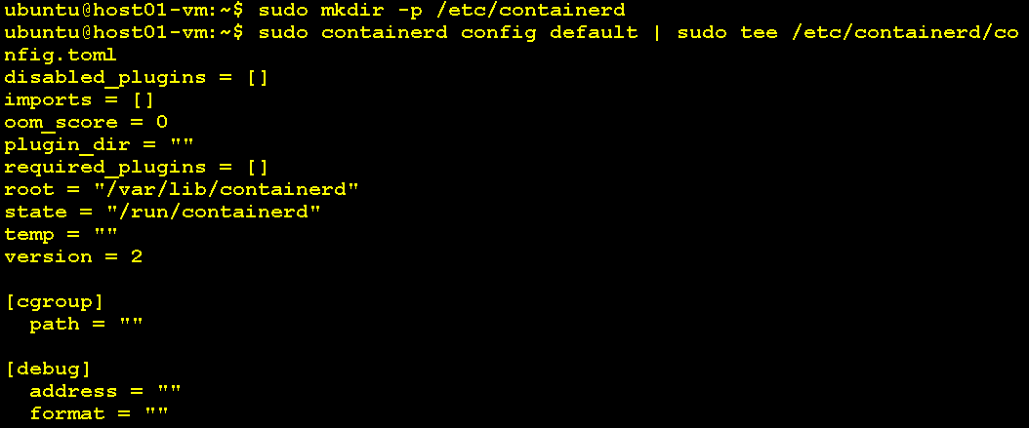
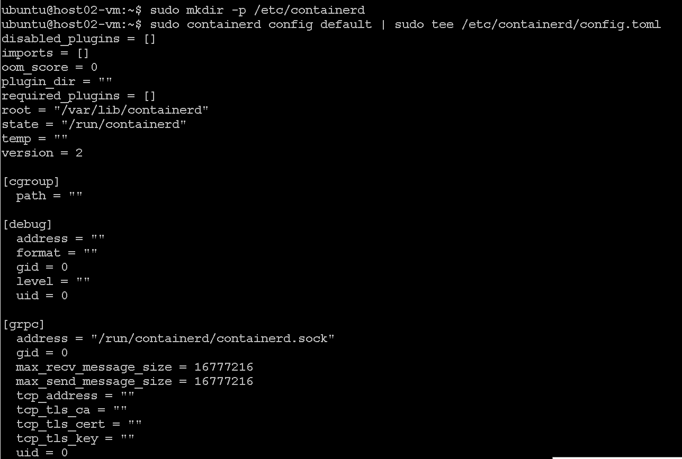
- Verify that the configuration is correct, particularly the plugins.”io.containerd.grpc.v1.cri” section. Ensure the sandbox_image is properly set:
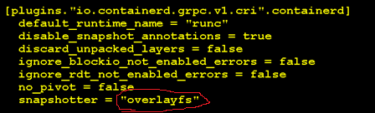

containerd is using SystemdCgroup = true in its config file:

grep SystemdCgroup /etc/containerd/config.toml
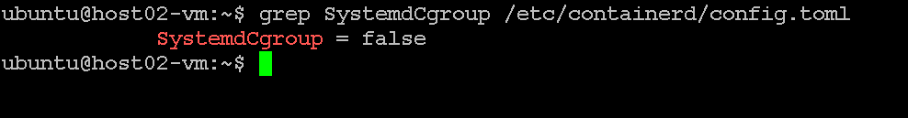
If you see false , edit this file
sudo nano /etc/containerd/config.toml
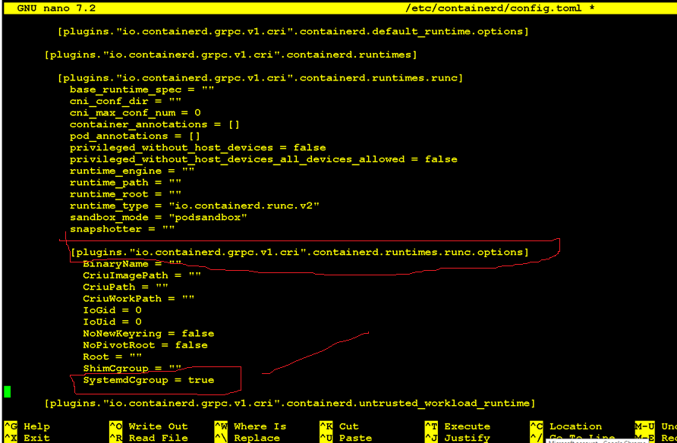
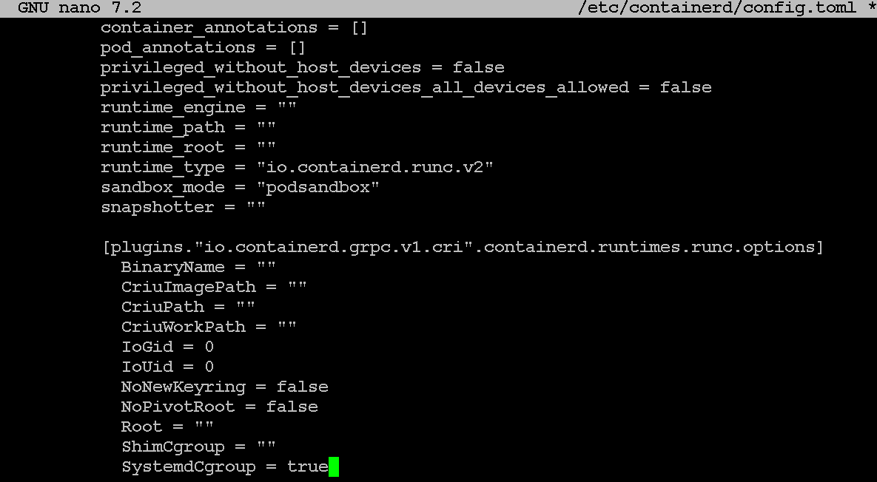
Now it should return true
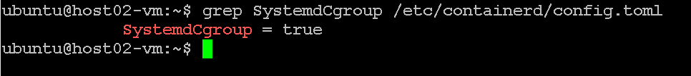
- Restart containerd

sudo systemctl restart containerd
sudo systemctl enable containerd
systemctl status containerd

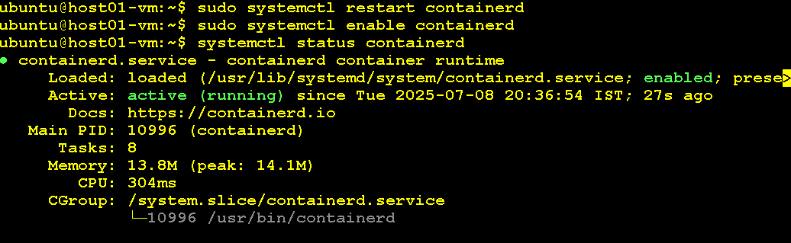
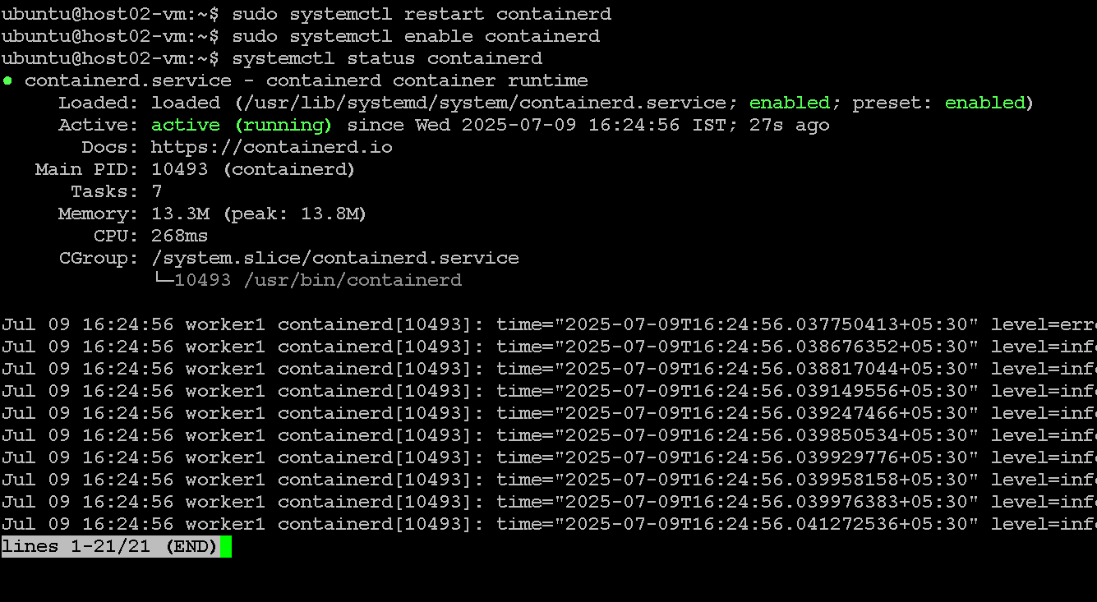
- Enable IP Forwarding
Enable IP forwarding temporarily and permanently:
- Temporary option
echo 1 | sudo tee /proc/sys/net/ipv4/ip_forward

- Permanently Add the following line to /etc/sysctl.conf:
sudo sh -c "echo 'net.ipv4.ip_forward = 1' >> /etc/sysctl.conf"

- Apply the changes:
sudo sysctl -p

- Validate IP Forwarding Verify that IP forwarding is enabled:
cat /proc/sys/net/ipv4/ip_forward
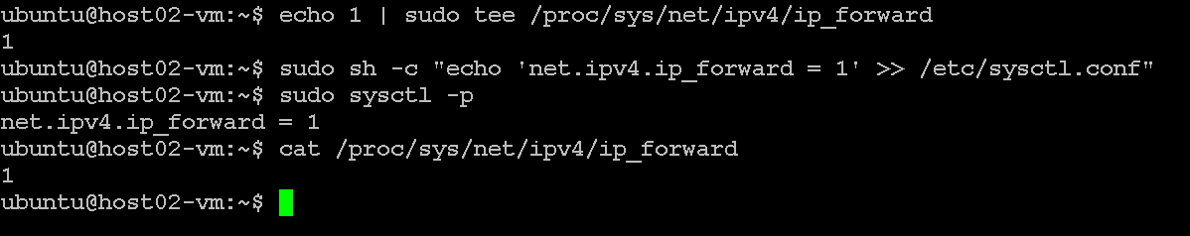

Install Kubeadm, Kubectl and Kubelet

- Download the public signing key for the Kubernetes package repositories. If the directory /etc/apt/keyrings does not exist, it should be created before the curl command, read the note below.
sudo mkdir -p -m 755 /etc/apt/keyrings

- Then write the following curl command.
curl -fsSL https://pkgs.k8s.io/core:/stable:/v1.30/deb/Release.key | sudo gpg --dearmor -o /etc/apt/keyrings/kubernetes-apt-keyring.gpg
- Add the appropriate Kubernetes apt repository. Note that This will overwrite any existing configuration in
echo 'deb [signed-by=/etc/apt/keyrings/kubernetes-apt-keyring.gpg] https://pkgs.k8s.io/core:/stable:/v1.30/deb/ /' | sudo tee /etc/apt/sources.list.d/kubernetes.list
- Update the apt package index, install kubelet, kubeadm and kubectl, and pin their version:

sudo apt-get update

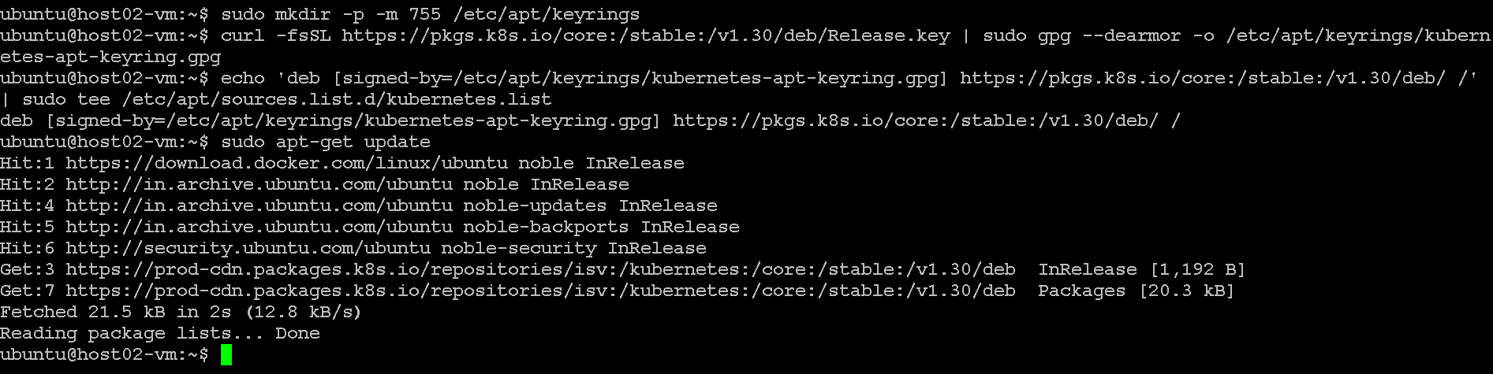
sudo apt-get install kubelet kubeadm kubectl

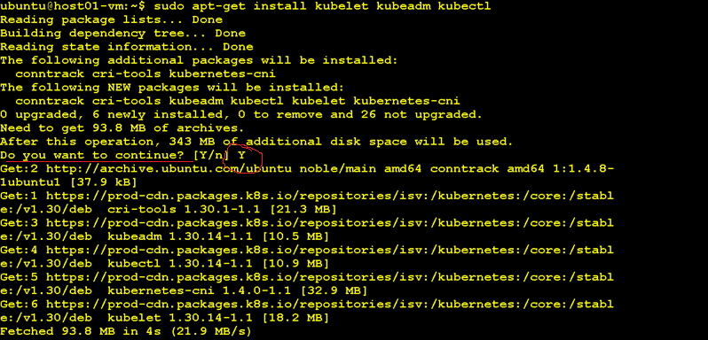
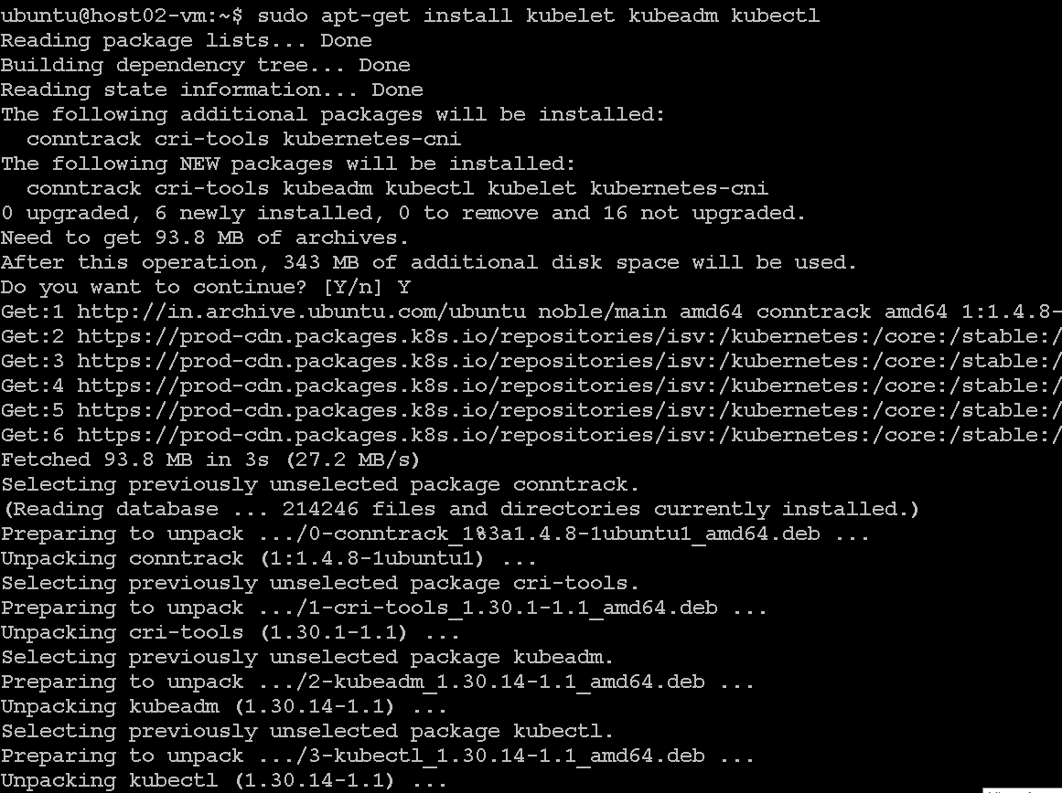
sudo apt-mark hold kubelet kubeadm kubectl
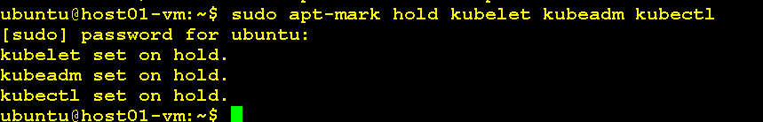
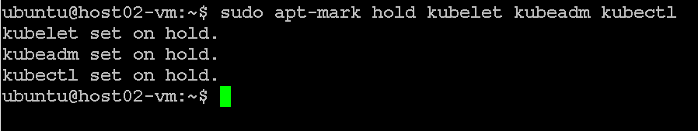
- (Optional) Enable the kubelet service before running kubeadm:
sudo systemctl enable --now kubelet

Creating a cluster with kubeadm

Network setup
kubeadm similarly to other Kubernetes components tries to find a usable IP on the network interfaces associated with a default gateway on a host. To find out what this IP is on a Linux host you can use:
ip route show # Look for a line starting with "default via"
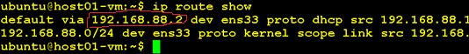
[IMPORTANT] Before go to next steps the following criteria must be satisfied.
- Worker nodes must be ready!
- Need to make sure network connectivity between cluster nodes!
- kubectl, kubelet and kubeadm must be installed and enabled

Initialize control-plane node (Master Node only)
To initialize the control-plane node run:

sudo kubeadm init --pod-network-cidr=192.168.0.0/16 --cri-socket=/var/run/containerd/containerd.sock --v=5
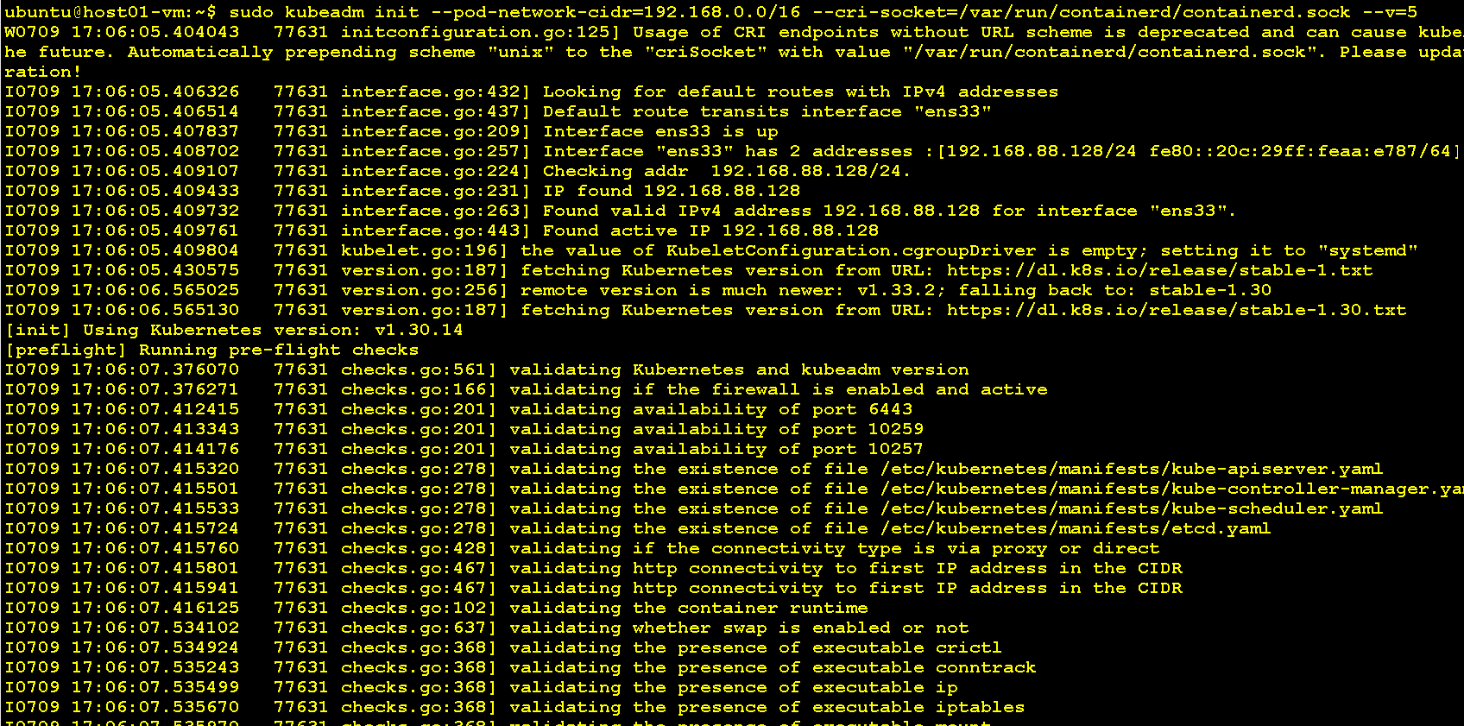
It’ll produce output like the following snippet.
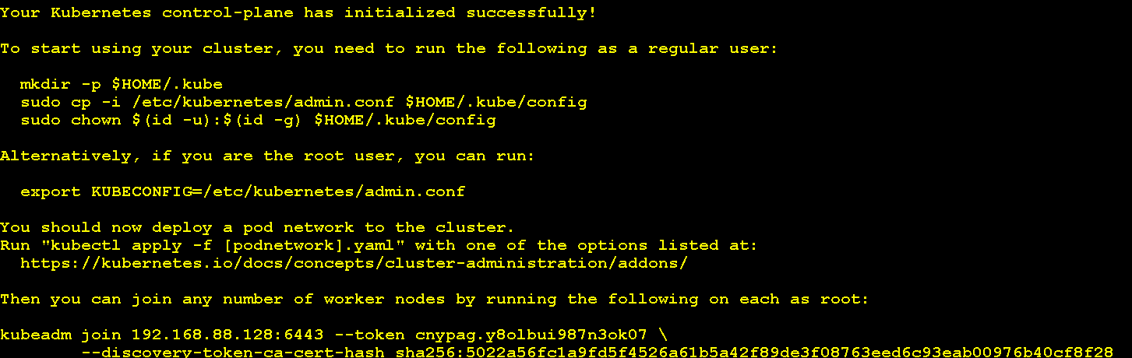
Note down the above output carefully and follow the instructions carefully for next steps. First write the following commands
mkdir -p $HOME/.kube

sudo cp -i /etc/kubernetes/admin.conf $HOME/.kube/config

sudo chown $(id -u):$(id -g) $HOME/.kube/config

Then run the following command:

export KUBECONFIG=/etc/kubernetes/admin.conf

Permissions of admin.config (Master Node only)
Write the following command to set permissions of admin.config
sudo chmod -R 755 /etc/kubernetes/admin.conf

Install Pod network add-on (Only on Master Node)
This section contains important information about networking setup and deployment order. Read all of this advice carefully before proceeding. You must deploy a Container Network Interface (CNI) based Pod network add-on so that your Pods can communicate with each other.

Install calico
Check the Kubernetes API server’s address and port configuration. Typically, the API server runs on port 6443
kubectl apply -f https://raw.githubusercontent.com/projectcalico/calico/v3.27.0/manifests/calico.yaml

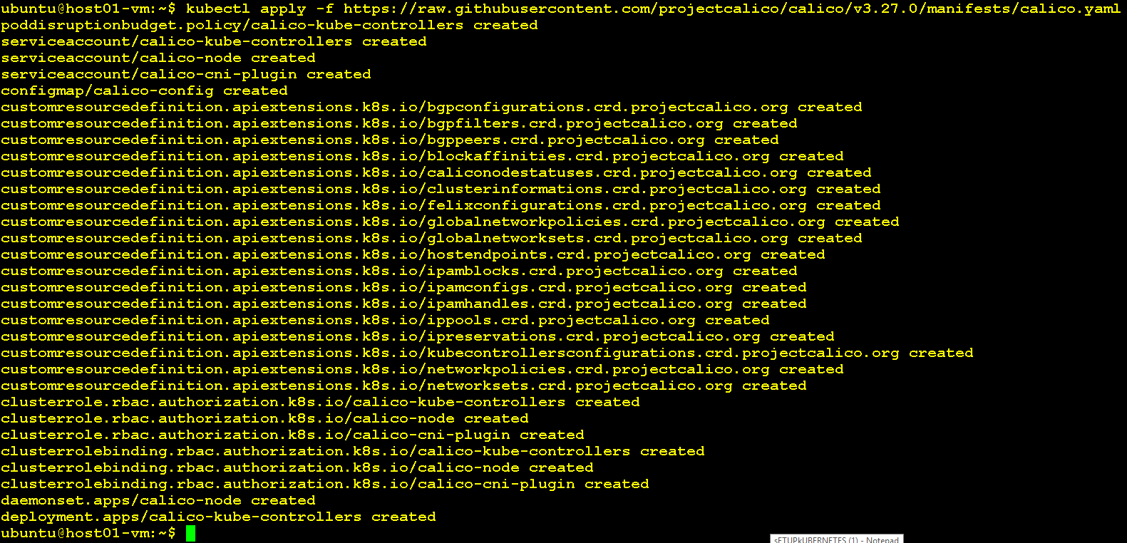

Now Check Calico Pod should running

kubectl get pods -n kube-system | grep calico

Join with kubernetes cluster (Worker Node only)
Write the following similar command to join with master node. Note: this command comes from above output from master.

Use sudo in beginning

sudo kubeadm join <MASTER_IP>:6443 --token <your-token> \
--discovery-token-ca-cert-hash sha256:<your-ca-hash>

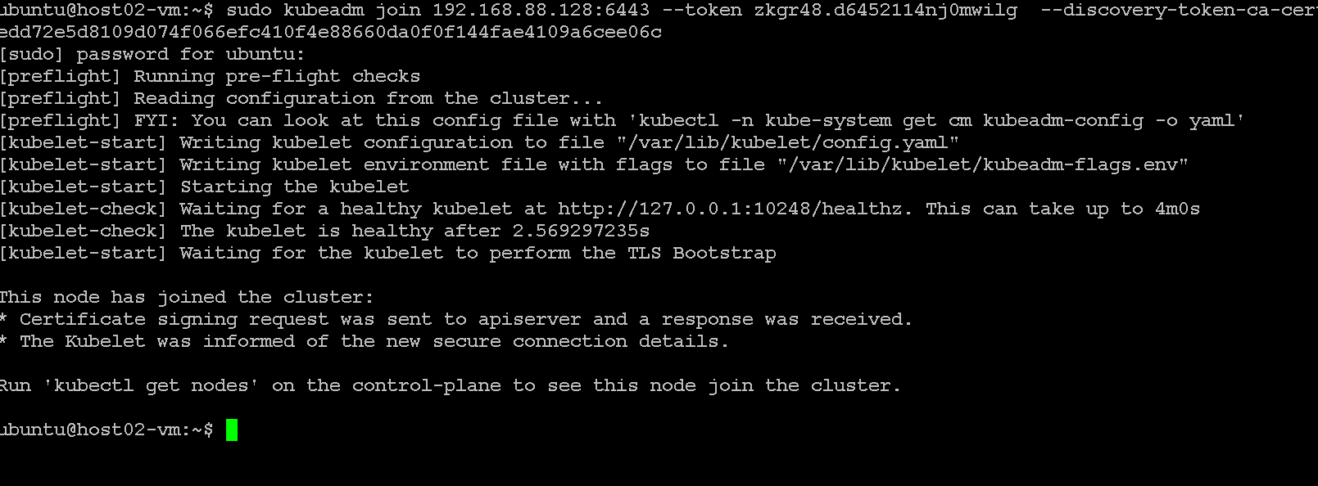

Deploy First Application
Kubectl get nodes
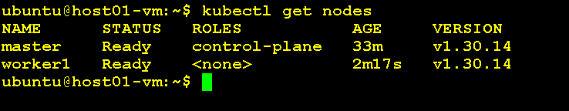
kubectl cluster-info
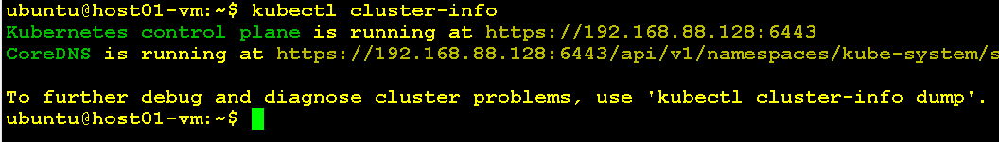
kubectl create deployment nginx --image=nginx
kubectl expose deployment nginx --port=80 --type=NodePort

kubectl get pods -o wide
Note port no
kubectl get svc

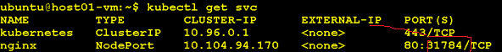

Now access the app with Master IP + Port

