


Lab Manual- Authentication , Authorization and Admission control in Kubernetes

Prepared for:

Date: 18th Dec 2024

Prepared by:
Document Name: Lab Manual Document Number CKAD-Lab06
Contributor:

Contents
1. Understanding Authentication and Authorization in Kubernetes 3
1.1 Authentication – Proving Who You Are 3
1.2 Authorization – Checking What You Are Allowed to Do 4
1.3 🔍 Summary Table 4
2. Lab 1- Authentication and Authorization in Kubernetes 4
2.1 STEP 1: Authentication – Create a Service Account 4
2.2 STEP 2: Authorization – Try to List Pods Without Permission 5
2.3 STEP 3: Authorize the ServiceAccount Using RBAC 5
2.4 STEP 4: Test the Roles 7
2.5 STEP 5: Cleanup 7
3. Admission Control in Kubernetes 7
3.1 Lab Admission Control – Apply a LimitRange 8
3.2 Delete the limitrange and pod 10

Understanding Authentication and Authorization in Kubernetes
In Kubernetes, secure access to resources is controlled by three main mechanisms: Authentication, Authorization, and Admission Control.

This document explains Authentication and Authorization in a simple, real-world way and then relates it to Kubernetes.

Authentication – Proving Who You Are
Authentication is the process of verifying the identity of a user or system trying to interact with the Kubernetes API.
🔑 Real-World Analogy:
Imagine you arrive at an office building. At the entrance, the security guard checks your company ID card to confirm your identity. This is authentication — confirming that you are who you claim to be.
🔧 Kubernetes Example:
In Kubernetes, authentication is handled via:
- Certificates
- Bearer tokens (like ServiceAccounts)
- Authentication plugins (e.g., OpenID, LDAP)
Example: A user uses a kubectl command with a valid token or certificate. Kubernetes checks if the token is real and not expired.

Authorization – Checking What You Are Allowed to Do
Once a user is authenticated, Kubernetes must check if they have permission to perform a specific action. This is called authorization.
🛂 Real-World Analogy:
You’re inside the office now. You may be allowed to enter the development area but not the server room. Whether or not you can open a specific door depends on your access rights. That’s authorization.
🔧 Kubernetes Example:
Kubernetes uses Role-Based Access Control (RBAC) to authorize actions.
- Role: Defines permissions (e.g., list pods, create deployments).
- RoleBinding: Assigns a role to a user or ServiceAccount.
Example: Even if a user is authenticated, they can’t list pods unless an RBAC role explicitly allows it.

🔍 Summary Table
Component | Real-World Analogy | Kubernetes Mechanism
Authentication | Showing your ID at office gate | Certificates, Tokens (ServiceAccount)
Authorization | Allowed to enter certain office floors | RBAC: Role and RoleBinding

Lab 1- Authentication and Authorization in Kubernetes

- Authentication – using a ServiceAccount
- Authorization – using RBAC rules
- Admission Control – using a LimitRange or NamespaceQuota

STEP 1: Authentication – Create a Service Account

kubectl create serviceaccount test-user

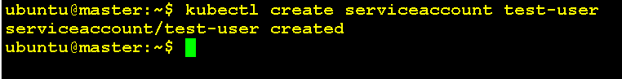
Check if it was created:

kubectl get serviceaccounts

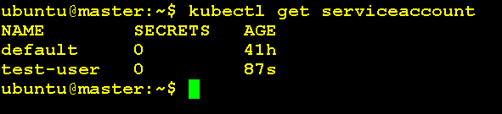
📌 This test-user is an identity — it authenticates itself via a token.

STEP 2: Authorization – Try to List Pods Without Permission

kubectl auth can-i list pods --as=system:serviceaccount:default:test-user

You should get:
No

➡️ This shows that the user is authenticated, but not authorized to list pods.

STEP 3: Authorize the ServiceAccount Using RBAC

Create a Role + RoleBinding:

nano role.yaml

# role.yaml
apiVersion: rbac.authorization.k8s.io/v1
kind: Role
metadata:
name: pod-reader
namespace: default
rules:
- apiGroups: [""]
resources: ["pods"]
verbs: ["get", "list", "watch"]

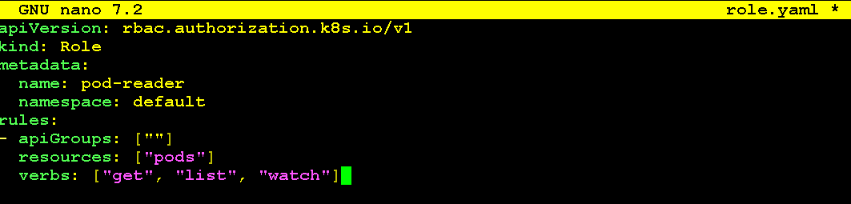

nano rolebinding.yaml

apiVersion: rbac.authorization.k8s.io/v1
kind: RoleBinding
metadata:
name: read-pods-binding
namespace: default
subjects:
- kind: ServiceAccount
name: test-user
namespace: default
roleRef:
kind: Role
name: pod-reader
apiGroup: rbac.authorization.k8s.io

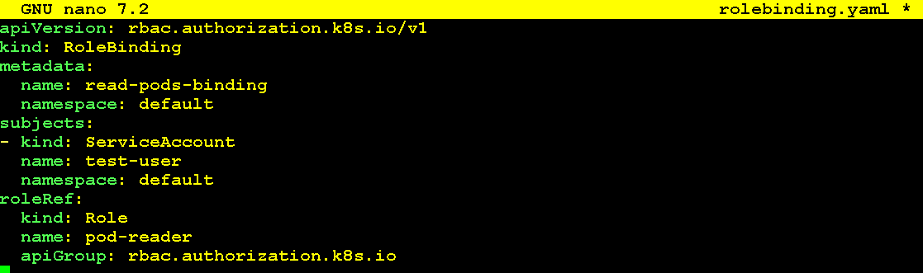

kubectl apply -f role.yaml

kubectl apply -f rolebinding.yaml

Kubectl get roles

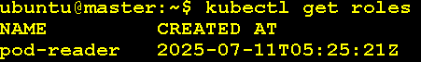
Kubectl get rolebinding

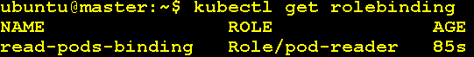

STEP 4: Test the Roles

kubectl auth can-i list pods --as=system:serviceaccount:default:test-user

kubectl auth can-i delete pods --as=system:serviceaccount:default:test-user

kubectl auth can-i create pods --as=system:serviceaccount:default:test-user

STEP 5: Cleanup

kubectl delete -f role.yaml
kubectl delete -f rolebinding.yaml
kubectl get roles
kubectl delete serviceaccount
kubectl get serviceaccounts

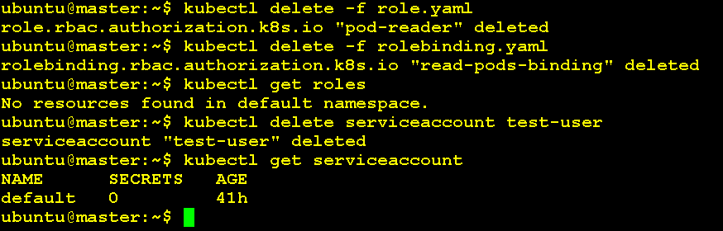

Admission Control in Kubernetes

Admission Control is Check policies, quotas, limits

- Admission Control – "Can you do it now, under current conditions?"
Suppose you’re authorized to enter the meeting room, but it’s already full.
- 🚦 Admission Control checks if the system can allow it right now.
- ✅ If the room has space and conditions are fine, you’re admitted.
- ❌ If the room is full or booked, you’re denied even though you are authorized.

Now, even if the user is authorized, Kubernetes checks rules and policies.
Example:
- Is there a policy saying you must add labels to all pods?
- Is there a resource quota limit already reached?
✔️ All checks passed → Pod is created.
❌ Failed → request is rejected.

Lab Admission Control – Apply a LimitRange

Let’s create a policy that all pods must specify memory limits.

nano limitrange.yaml

apiVersion: v1
kind: LimitRange
metadata:
name: mem-limit-range
namespace: default
spec:
limits:
- default:
memory: 512Mi
defaultRequest:
memory: 256Mi
type: Container

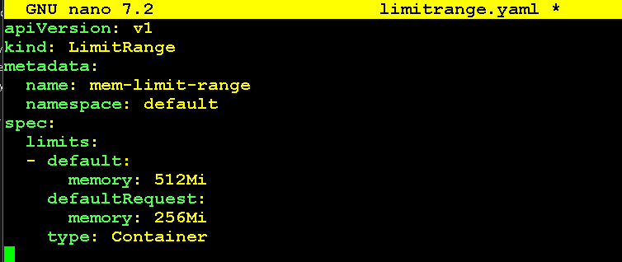

nano pod-no-memory.yaml

apiVersion: v1
kind: Pod
metadata:
name: nopod
spec:
containers:
- name: busybox
image: busybox
command: ["sleep", "3600"]

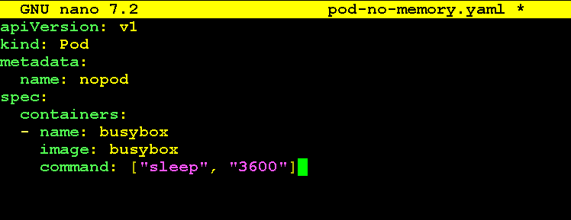

kubectl apply -f limitrange.yaml

kubectl get limitrange

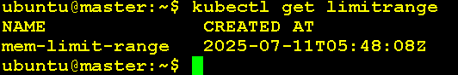
kubectl apply -f pod-no-memory.yaml

If your admission plugin is configured, this may fail or get auto-assigned default limits depending on your setup.

kubectl get pod nopod -o yaml

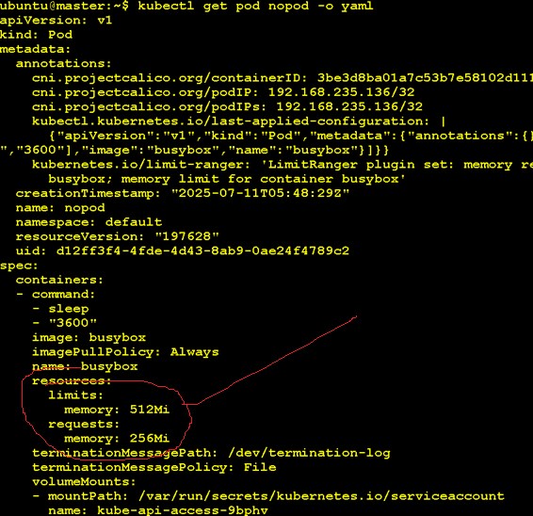
kubectl describe pod nopod

Delete the limitrange and pod

kubectl delete -f limitrange.yaml

kubectl delete -f pod-no-memory.yaml

