


Lab Manual- Kubernetes PersistentVolume (PV) and PersistentVolumeClaim (PVC) in a Pod.

Prepared for:

Date: 18th May 2025

Prepared by:
Document Name: Lab Manual Document Number CKAD-Lab12
Contributor:

Contents
1 What is PV and PVC in Kubernetes? 3
1.1 The problem: container storage is temporary 3
1.2 PV, PVC and Pod: who does what 3
1.3 How a PVC finds its PV 4
1.4 The life of a PersistentVolume 5
2 Lab 1 – Using PV and PVC in Pods 6
2.1 Scenario Setup 6
2.2 Step 1: Create a PersistentVolume (PV) 7
2.3 Step 2: Create a PersistentVolumeClaim (PVC) 8
2.4 Step 3: Create a Pod that uses the PVC 8
2.5 Step 4: Apply all in order 9
2.6 Step 5: Verify the PV, PVC and Pod 10
2.7 Step 6: Write data into the volume 11
2.8 Step 7: Read the file through nginx 12
2.9 Step 8: Delete the Pod and check the data on the node 13
2.10 Step 9: Mount the same PVC in another Pod 13
2.11 Step 10: Verify the data is still there 14
2.12 Steps to Clean 15
3 Summary and troubleshooting 17
3.1 What each step proved 17
3.2 Troubleshooting 17
3.3 Self-check 17

What is PV and PVC in Kubernetes?
Containers are designed to be thrown away and replaced. That is great for web servers, but a problem for anything that must keep data: logs, uploaded files, databases. Kubernetes solves this with three objects that work together:
- PersistentVolume (PV): a piece of storage in the cluster, provisioned by an admin or created automatically through a StorageClass.
- PersistentVolumeClaim (PVC): a request for storage by a user (for a Pod). It states the size, the access mode and so on.
- Pod: uses the PVC to mount the storage into its containers.

The problem: container storage is temporary
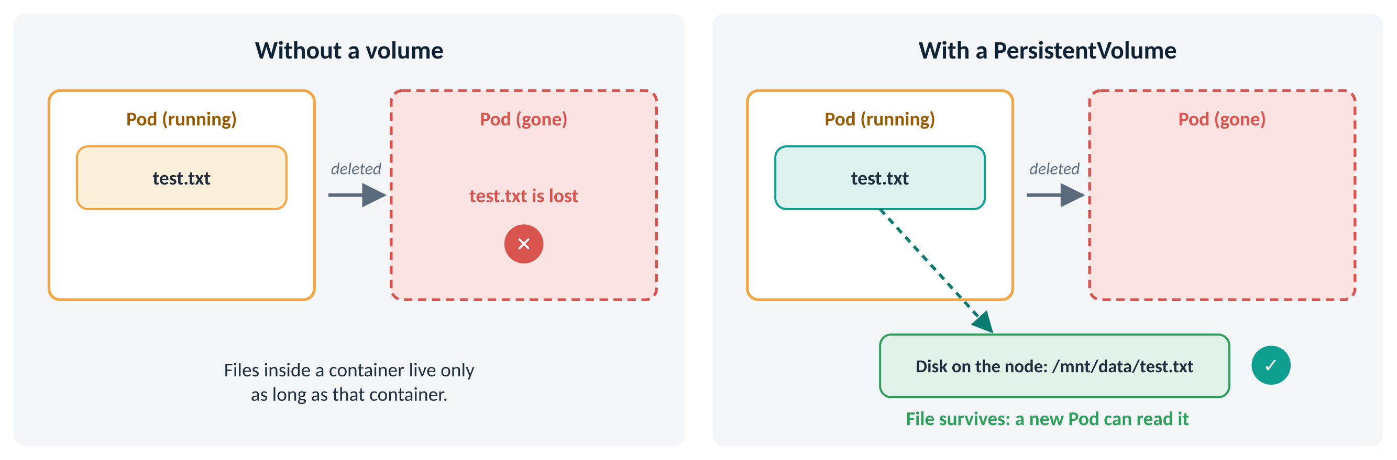
Figure 1: A file written inside a container disappears with the Pod, unless it is on a volume
Anything a container writes to its own filesystem is deleted when the container or Pod is deleted. A PersistentVolume lives outside the Pod, so the data survives and a new Pod can pick it up.

PV, PVC and Pod: who does what
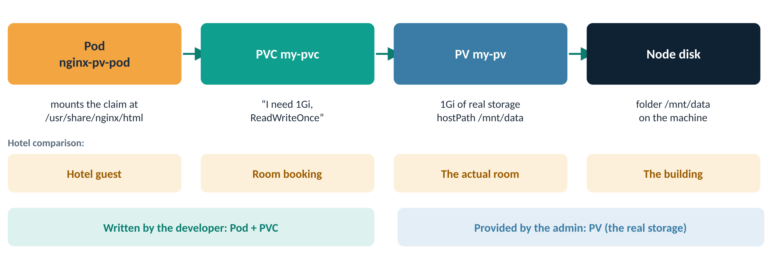
Figure 2: The chain from Pod to real disk used in this lab
Object | Written by | Answers the question | In this lab
PersistentVolume (PV) | Cluster admin (or a StorageClass automatically) | What storage exists? | my-pv: 1Gi, stored in /mnt/data on the node
PersistentVolumeClaim (PVC) | Developer | What storage does my app need? | my-pvc: asks for 1Gi, ReadWriteOnce
Pod | Developer | Where do I want it inside my container? | nginx-pv-pod mounts it at /usr/share/nginx/html

Real-world analogy
Booking a hotel room. You ask for “a room with two beds” (the PVC). The hotel gives you an actual room (the PV). You, the guest (the Pod), stay in the room. When you check out, the room and whatever you left in it are still there until housekeeping clears it.

Real-world use
An online shop runs its product database in a Pod. When the Pod is moved to another server for maintenance, the database files must still be there, or every order is lost. The database Pod uses a PVC so that its data outlives any single Pod.

How a PVC finds its PV
When you create a PVC, Kubernetes looks for a PV that satisfies it and binds the two together. A bound PV belongs to that one PVC.
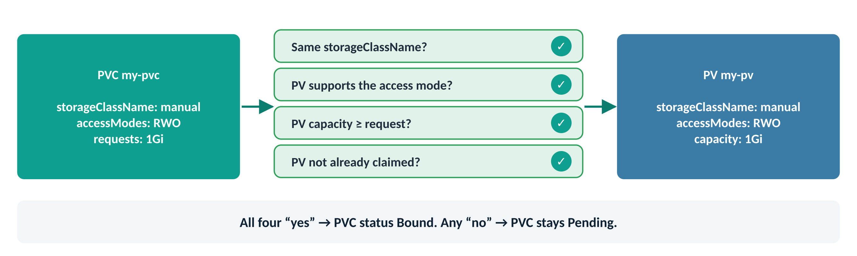
Figure 3: The four checks Kubernetes makes before binding a PVC to a PV
Access modes
Access mode | Short name | Plain meaning
ReadWriteOnce | RWO | Read-write, mounted by one node at a time (used in this lab)
ReadOnlyMany | ROX | Read-only, many nodes at once
ReadWriteMany | RWX | Read-write from many nodes at once; needs shared storage such as NFS
ReadWriteOncePod | RWOP | Read-write by a single Pod only

Watch out
StorageClass matters. If a PVC does not name a StorageClass and your cluster has a default StorageClass (common on Minikube, kind and cloud clusters), the PVC is given that class. It then will not bind to a manually created PV and may create a new disk instead, or stay Pending.
This lab sets storageClassName: manual on both the PV and the PVC so they always match.

The life of a PersistentVolume
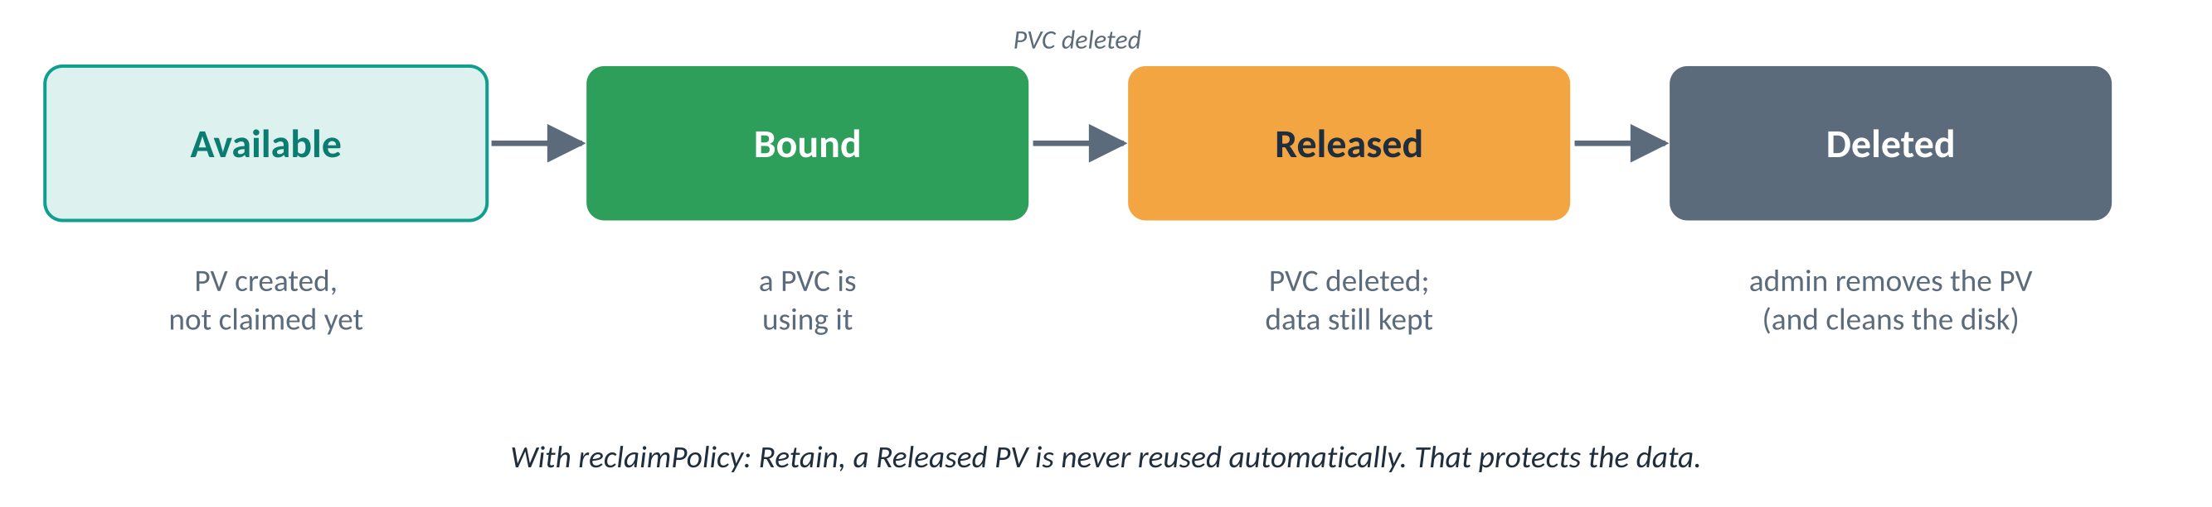
Figure 4: PV status changes you will see during the lab
Reclaim policy | What happens when the PVC is deleted
Retain | The PV becomes Released and keeps its data. An admin decides what to do with it. This is the default for PVs you create by hand.
Delete | The PV and its underlying storage are deleted automatically. This is the usual default for PVs created by a StorageClass.

Lab 1 – Using PV and PVC in Pods

Scenario Setup
Say we want to run an nginx web server whose files are stored on a persistent volume, so they are preserved even if the Pod is deleted. You will write a file from one Pod, delete that Pod, and read the same file from a brand-new Pod.
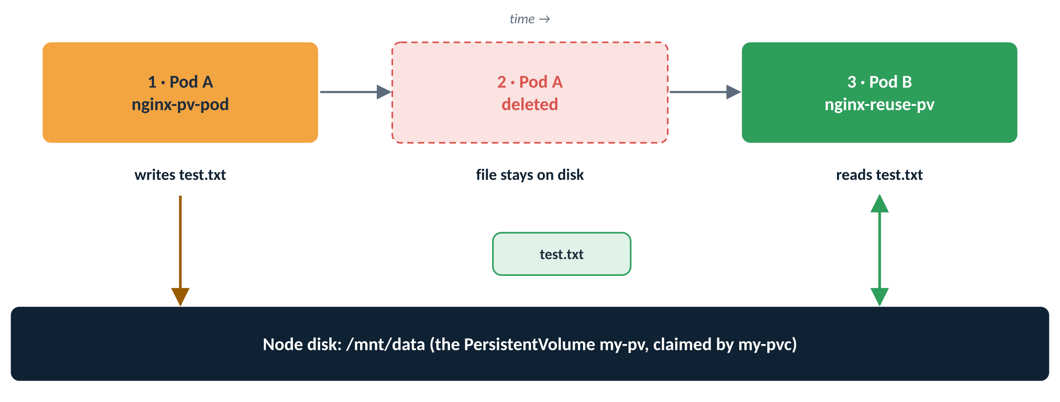
Figure 5: Flow of the lab: the file outlives the Pod that wrote it
Files you will create
File | Creates | Purpose
pv.yaml | PersistentVolume my-pv | 1Gi of storage backed by the folder /mnt/data on the node
pvc.yaml | PersistentVolumeClaim my-pvc | The request for 1Gi that the Pods use
pod.yaml | Pod nginx-pv-pod | Pod A: writes the test file
pod-reuse.yaml | Pod nginx-reuse-pv | Pod B: reads the file after Pod A is gone

Before you start
- You need a working cluster and an admin kubeconfig.
- hostPath storage is a folder on one node. It is ideal for learning, but not for production: if a Pod lands on a different node, it sees a different, empty folder. See the note in Step 1 if your cluster has more than one worker node.
- The Expected output boxes show what you should see. Ages, times and some column sets differ slightly between Kubernetes versions; the values that matter are explained in the table under each box.
Lab roadmap
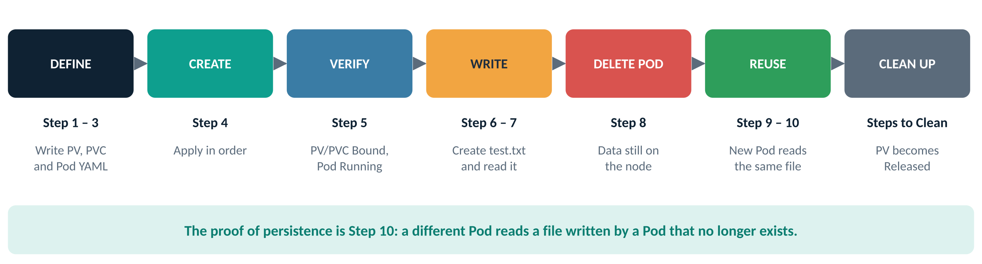
Figure 6: The steps of the lab

Step 1: Create a PersistentVolume (PV)
Why: The PV is the real storage. Here it is a folder, /mnt/data, on the node. In production it would be a cloud disk, an NFS share or a SAN volume.
Do this
nano pv.yaml
# pv.yaml
apiVersion: v1
kind: PersistentVolume
metadata:
name: my-pv
spec:
capacity:
storage: 1Gi
accessModes:
- ReadWriteOnce
persistentVolumeReclaimPolicy: Retain
storageClassName: manual
hostPath: # for testing on Minikube or a local setup
path: /mnt/data
type: DirectoryOrCreate # create the folder if it does not exist
What each part means
Field | Value | Meaning
kind | PersistentVolume | A cluster-wide piece of storage (PVs do not belong to a namespace)
capacity.storage | 1Gi | How much space this PV offers
accessModes | ReadWriteOnce | It can be mounted read-write by one node at a time
persistentVolumeReclaimPolicy | Retain | Keep the data when the claim is deleted
storageClassName | manual | A label that the PVC must match. “manual” is just a name we chose
hostPath.path | /mnt/data | The folder on the node where files are really stored
hostPath.type | DirectoryOrCreate | Create /mnt/data automatically if it is missing

Note
Cluster with several worker nodes? hostPath is local to one node. To make sure every Pod in this lab uses the same node, add this block under spec: in pv.yaml, replacing worker1 with a node name from kubectl get nodes:
nodeAffinity: {required: {nodeSelectorTerms: [{matchExpressions: [{key: kubernetes.io/hostname, operator: In, values: [worker1]}]}]}}
Kubernetes then schedules any Pod that uses this PV onto that node.

Checkpoint: you are ready for the next step when…
pv.yaml is saved, and storageClassName is manual.

Step 2: Create a PersistentVolumeClaim (PVC)
Why: Apps never point at a PV directly. They ask for storage through a PVC, and Kubernetes finds a matching PV.
Do this
nano pvc.yaml
# pvc.yaml
apiVersion: v1
kind: PersistentVolumeClaim
metadata:
name: my-pvc
spec:
storageClassName: manual # must match the PV
accessModes:
- ReadWriteOnce
resources:
requests:
storage: 1Gi
Field | Value | Meaning
kind | PersistentVolumeClaim | A request for storage. PVCs live in a namespace (here: default)
storageClassName | manual | Only PVs with the same class can satisfy it
accessModes | ReadWriteOnce | The PV must support this mode
resources.requests.storage | 1Gi | The PV must offer at least this much

Checkpoint: you are ready for the next step when…
pvc.yaml is saved with the same class (manual), access mode and size as the PV.

Step 3: Create a Pod that uses the PVC
Why: The Pod connects the claim to a folder inside the container. Anything nginx serves from /usr/share/nginx/html will actually live on the PV.
Do this
nano pod.yaml
apiVersion: v1
kind: Pod
metadata:
name: nginx-pv-pod
spec:
containers:
- name: nginx
image: nginx
volumeMounts:
- mountPath: "/usr/share/nginx/html" # where the volume appears in the container
name: storage-volume # must match the volume name below
volumes:
- name: storage-volume
persistentVolumeClaim:
claimName: my-pvc # use the claim from Step 2
Part | Meaning
volumes → storage-volume → claimName: my-pvc | Declares a volume for this Pod, backed by the claim my-pvc
volumeMounts → name: storage-volume | Connects that volume to this container (the names must match)
mountPath: /usr/share/nginx/html | The folder inside the container where the volume appears. It is nginx’s web root, so files here can be fetched over HTTP

Note
Mounting the volume replaces what was in /usr/share/nginx/html, including nginx’s default index.html. So curl http://localhost:8080/ will return 403 Forbidden until you add files. That is expected; in this lab you fetch /test.txt instead.

Checkpoint: you are ready for the next step when…
The two name: values (volumeMounts and volumes) are both storage-volume.

Step 4: Apply all in order
Why: Order matters: the PV should exist before the PVC asks for it, and the PVC must exist before the Pod can use it. A Pod whose claim is missing or unbound stays Pending.
Do this
kubectl apply -f pv.yaml
kubectl apply -f pvc.yaml
kubectl apply -f pod.yaml
Expected output
$ kubectl apply -f pv.yaml
persistentvolume/my-pv created
$ kubectl apply -f pvc.yaml
persistentvolumeclaim/my-pvc created
$ kubectl apply -f pod.yaml
pod/nginx-pv-pod created
# | What you see | What it means
1 | persistentvolume/my-pv created | The storage is registered in the cluster. Its status is Available.
2 | persistentvolumeclaim/my-pvc created | The claim is accepted. Within a second or two Kubernetes binds it to my-pv.
3 | pod/nginx-pv-pod created | The Pod is accepted and will start once its volume is ready.

Checkpoint: you are ready for the next step when…
All three lines end in created.

Step 5: Verify the PV, PVC and Pod
Why: Before writing any data, confirm that the claim is bound to the right volume and the Pod is running with it mounted.
5a. Check the PersistentVolume
kubectl get pv
Expected output
$ kubectl get pv
NAME CAPACITY ACCESS MODES RECLAIM POLICY STATUS CLAIM STORAGECLASS AGE
my-pv 1Gi RWO Retain Bound default/my-pvc manual 40s
# | What you see | What it means
1 | STATUS Bound | The PV has been claimed. Before Step 4’s second command it said Available.
2 | CLAIM default/my-pvc | Which claim owns it: namespace default, PVC my-pvc.
3 | RECLAIM POLICY Retain | The data will be kept when the claim is deleted (you will see this at clean-up).

5b. Check the PersistentVolumeClaim
kubectl get pvc
Expected output
$ kubectl get pvc
NAME STATUS VOLUME CAPACITY ACCESS MODES STORAGECLASS AGE
my-pvc Bound my-pv 1Gi RWO manual 35s
# | What you see | What it means
1 | STATUS Bound | The claim found a matching PV. Pending would mean no PV matched (see Troubleshooting).
2 | VOLUME my-pv | The PV it is bound to.

5c. Check the Pod
kubectl get pods -o wide
kubectl describe pod nginx-pv-pod
Expected output
$ kubectl get pods -o wide
NAME READY STATUS RESTARTS AGE IP NODE
nginx-pv-pod 1/1 Running 0 30s 192.168.x.x worker1
$ kubectl describe pod nginx-pv-pod
...
Mounts:
/usr/share/nginx/html from storage-volume (rw)
...
Volumes:
storage-volume:
Type: PersistentVolumeClaim (a reference to a PersistentVolumeClaim in the same namespace)
ClaimName: my-pvc
ReadOnly: false
# | What you see | What it means
1 | STATUS Running, READY 1/1 | nginx started successfully with the volume mounted.
2 | NODE worker1 (your node name) | Write this down. With hostPath, the file will be stored in /mnt/data on THIS node.
3 | Mounts: /usr/share/nginx/html from storage-volume (rw) | The volume is mounted read-write at nginx’s web root.
4 | Volumes: Type PersistentVolumeClaim, ClaimName my-pvc | The Pod’s storage comes from the claim, as defined in pod.yaml.

Checkpoint: you are ready for the next step when…
PV and PVC both show Bound, and the Pod is 1/1 Running.

Step 6: Write data into the volume
Why: Create a file from inside the container, in the mounted folder. Because that folder is the PV, the file is really written to /mnt/data on the node.
Do this: open a shell in the Pod, write a file, and leave
kubectl exec -it nginx-pv-pod -- /bin/bash
echo "Hello from Bipeen PV Test" > /usr/share/nginx/html/test.txt
cat /usr/share/nginx/html/test.txt
exit
Expected output
$ kubectl exec -it nginx-pv-pod -- /bin/bash
root@nginx-pv-pod:/# echo "Hello from Bipeen PV Test" > /usr/share/nginx/html/test.txt
root@nginx-pv-pod:/# cat /usr/share/nginx/html/test.txt
Hello from Bipeen PV Test
root@nginx-pv-pod:/# exit
exit
# | What you see | What it means
1 | root@nginx-pv-pod:/# | You are now inside the container, as root.
2 | echo "…" > …/test.txt | Writes one line of text into a new file on the mounted volume. It prints nothing if it works.
3 | Hello from Bipeen PV Test | cat reads the file back, proving it was written.
4 | exit | Leaves the container and returns to the node’s shell. The Pod keeps running.

Checkpoint: you are ready for the next step when…
cat prints Hello from Bipeen PV Test.

Step 7: Read the file through nginx
Why: Prove the file is served by the web server, just as a real app would serve uploaded content from a volume.
Terminal 1: start the port-forward (it keeps running)
kubectl port-forward pod/nginx-pv-pod 8080:80
Expected output
$ kubectl port-forward pod/nginx-pv-pod 8080:80
Forwarding from 127.0.0.1:8080 -> 80
Forwarding from [::1]:8080 -> 80
# | What you see | What it means
1 | Forwarding from 127.0.0.1:8080 -> 80 | Port 8080 on this machine now leads to port 80 in the Pod. The command waits here; leave it running.

Terminal 2: fetch the file
curl http://localhost:8080/test.txt
Expected output
$ curl http://localhost:8080/test.txt
Hello from Bipeen PV Test
# | What you see | What it means
1 | Hello from Bipeen PV Test | nginx served the file from its web root, which is the persistent volume.

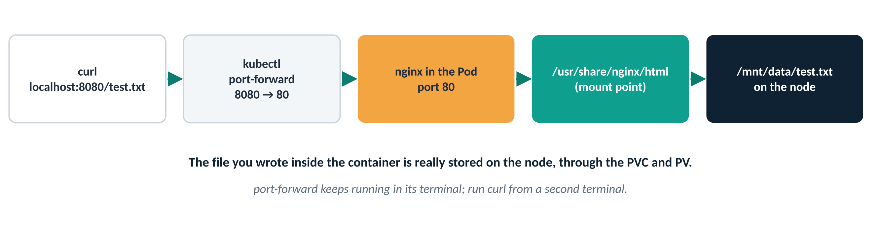
Figure 7: The path of the curl request, all the way to the node’s disk
When you are done, go back to Terminal 1 and press Ctrl+C to stop the port-forward (you will see Handling connection for 8080 lines while it is in use).
Checkpoint: you are ready for the next step when…
curl returns Hello from Bipeen PV Test.

Step 8: Delete the Pod and check the data on the node
Why: This is the key moment. Delete the Pod that wrote the file. Without a PV the file would be gone; with a PV it stays on the node.
Do this
kubectl delete pod nginx-pv-pod
kubectl get pvc # the claim is still Bound
Expected output
$ kubectl delete pod nginx-pv-pod
pod "nginx-pv-pod" deleted
$ kubectl get pvc
NAME STATUS VOLUME CAPACITY ACCESS MODES STORAGECLASS AGE
my-pvc Bound my-pv 1Gi RWO manual 6m
# | What you see | What it means
1 | pod "nginx-pv-pod" deleted | Pod A and its container are gone.
2 | my-pvc Bound | Deleting a Pod does not delete its claim. The storage is still reserved.

Optional: look at the folder on the node (in Ubuntu Linux)
Run this on the node that the Pod ran on (the NODE column from Step 5c). On a single-node cluster, that is the machine you are on.
cd /mnt/data
ls -l
cat /mnt/data/test.txt
Expected output
$ cd /mnt/data
$ ls -l
total 4
-rw-r--r-- 1 root root 26 Jul 12 11:20 test.txt
$ cat /mnt/data/test.txt
Hello from Bipeen PV Test
# | What you see | What it means
1 | test.txt in /mnt/data | The file written inside the container is a normal file on the node’s disk.
2 | root root | It is owned by root because the container ran as root.
3 | Hello from Bipeen PV Test | The data survived the Pod being deleted.

Checkpoint: you are ready for the next step when…
ls -l /mnt/data shows test.txt.

Step 9: Mount the same PVC in another Pod
Why: A different Pod, with a different name, claims the same storage. If it can see test.txt, the data truly outlives any single Pod.
Do this: create pod-reuse.yaml
nano pod-reuse.yaml
apiVersion: v1
kind: Pod
metadata:
name: nginx-reuse-pv # a new Pod name
spec:
containers:
- name: nginx
image: nginx
volumeMounts:
- mountPath: "/usr/share/nginx/html"
name: storage-volume
volumes:
- name: storage-volume
persistentVolumeClaim:
claimName: my-pvc # the SAME claim as before
kubectl apply -f pod-reuse.yaml
kubectl get pods
Expected output
$ kubectl apply -f pod-reuse.yaml
pod/nginx-reuse-pv created
$ kubectl get pods
NAME READY STATUS RESTARTS AGE
nginx-reuse-pv 1/1 Running 0 15s
# | What you see | What it means
1 | pod/nginx-reuse-pv created | Pod B exists. Only its name differs from Pod A; it uses the same claim, my-pvc.
2 | 1/1 Running | Pod B started with the existing volume mounted.

Checkpoint: you are ready for the next step when…
nginx-reuse-pv is 1/1 Running.

Step 10: Verify the data is still there
Why: Read the file from Pod B. Pod B never wrote it; it can only see it because the data lives on the PV.
Do this
kubectl exec -it nginx-reuse-pv -- cat /usr/share/nginx/html/test.txt
Expected output
$ kubectl exec -it nginx-reuse-pv -- cat /usr/share/nginx/html/test.txt
Hello from Bipeen PV Test
# | What you see | What it means
1 | Hello from Bipeen PV Test | The file written by Pod A (now deleted) is read by Pod B. This is persistence.

Watch out
If you get No such file or directory on a multi-node cluster, Pod B probably started on a different node from Pod A, and that node’s /mnt/data is empty. Compare the NODE columns with kubectl get pods -o wide, and use the nodeAffinity note in Step 1.

Checkpoint: you are ready for the next step when…
Pod B prints Hello from Bipeen PV Test.

Steps to Clean
Why: Remove the Pod, the claim and the volume, and watch the PV pass through the Released state described in Section 1.4.
Do this: delete the Pod and the claim first
kubectl delete -f pod-reuse.yaml
kubectl delete -f pvc.yaml
kubectl get pv
Expected output
$ kubectl delete -f pod-reuse.yaml
pod "nginx-reuse-pv" deleted
$ kubectl delete -f pvc.yaml
persistentvolumeclaim "my-pvc" deleted
$ kubectl get pv
NAME CAPACITY ACCESS MODES RECLAIM POLICY STATUS CLAIM STORAGECLASS AGE
my-pv 1Gi RWO Retain Released default/my-pvc manual 15m
# | What you see | What it means
1 | pod "nginx-reuse-pv" deleted | No Pod is using the storage any more.
2 | persistentvolumeclaim "my-pvc" deleted | The claim is gone.
3 | STATUS Released | Because of Retain, the PV and its data are kept, but it will not be handed to a new claim automatically.

Then delete the PV and, optionally, the data on the node
kubectl delete -f pv.yaml
kubectl get pv,pvc
sudo rm -rf /mnt/data # on the node, only if you want the data gone
Expected output
$ kubectl delete -f pv.yaml
persistentvolume "my-pv" deleted
$ kubectl get pv,pvc
No resources found
# | What you see | What it means
1 | persistentvolume "my-pv" deleted | The PV object is removed. The files in /mnt/data are NOT deleted by this; Kubernetes never cleans up hostPath folders.
2 | No resources found | The lab is fully cleaned up in Kubernetes.

Note
Delete in this order: Pod → PVC → PV. If you delete a PVC while a Pod is still using it, the PVC waits in Terminating until the Pod is gone (this protection prevents data loss).

Checkpoint: you are ready for the next step when…
kubectl get pv,pvc shows No resources found.

Summary and troubleshooting

What each step proved
Step | What you did | What it proved
1 – 3 | Wrote PV, PVC and Pod YAML | Storage (PV), request (PVC) and use (Pod) are separate objects
4 – 5 | Applied them; PV and PVC Bound | Kubernetes matched the claim to the volume automatically
6 – 7 | Wrote test.txt and fetched it with curl | The mounted folder is real, writable storage
8 | Deleted the Pod; file still in /mnt/data | Data outlives the Pod that wrote it
9 – 10 | A new Pod read the same file | Any Pod using the claim gets the same data
Clean | PVC deleted; PV Released | Retain keeps data safe until an admin decides

Troubleshooting
What you see | Likely cause | Fix
PVC stays Pending | No PV matches: different storageClassName, access mode, or too small | kubectl describe pvc my-pvc (read Events); make class, mode and size match the PV
PVC Bound to a volume named pvc-… | A default StorageClass created a new volume instead of using my-pv | Set storageClassName: manual on both the PV and the PVC
Pod stuck in ContainerCreating or Pending | The claim is not Bound yet, or claimName is misspelled | kubectl describe pod nginx-pv-pod; check claimName: my-pvc
curl http://localhost:8080/ gives 403 | The volume hides nginx’s default index.html | Expected. Fetch /test.txt instead
curl: connection refused | The port-forward is not running, or it stopped | Start it again in Terminal 1 and leave it open
test.txt missing in Step 10 or on the node | Pods ran on different nodes (hostPath is per node) | Compare NODE in kubectl get pods -o wide; use nodeAffinity (Step 1 note)
PVC stuck in Terminating | A Pod is still using it | Delete the Pod first

Self-check
- Who normally writes a PV, and who writes a PVC?
Answer: An admin (or a StorageClass) provides the PV; the developer writes the PVC for their app.
- Name two things that must match for a PVC to bind to a PV.
Answer: Any two of: storageClassName, access mode, enough capacity, and the PV not already being claimed.
- You deleted the Pod. Is the PVC deleted too?
Answer: No. The PVC and its data remain until you delete the PVC yourself.
- After deleting the PVC, why does the PV show Released instead of Available?
Answer: Its reclaim policy is Retain, so Kubernetes keeps the data and will not reuse the PV automatically.
- Why is hostPath not suitable for production?
Answer: It stores data on one node only; if the Pod moves to another node, it cannot see the data.

