Kubernetes Kustomize Lab
Environment-Based Deployments with Base and Overlays
Application image: bipeen2001/kyndryl:ai-200-aks-v1 · Kustomize built into kubectl
Contents
1. Lab Overview 2
2. Architecture 3
3. Prerequisites 4
Verify the kubectl installation 4
Verify cluster health 4
4. Lab Steps 6
Step 1: Verify Kustomize availability 6
Step 2: Create the lab directory structure 7
Step 3: Create the base Deployment 8
Step 4: Create the base Service 10
Step 5: Create the base kustomization file 12
Step 6: Validate the base configuration 13
Step 7: Create a Development overlay 14
Step 8: Create a Production overlay 16
Step 9: Create environment namespaces 17
Step 10: Deploy the Development environment 18
Step 11: Access the Dev application 19
Step 12: Deploy the Production environment 21
Step 13: Compare Development and Production 22
Step 14: Inspect the generated manifests 23
Step 15: Clean up 25
5. Enterprise Takeaways 27
Key commands summary 27
Troubleshooting 27
Self-check 28
Lab conclusion 28

1. Lab Overview
In enterprise Kubernetes environments, keeping separate YAML files for Development, Test, Staging and Production quickly becomes difficult and error-prone. Kustomize solves this by letting teams keep a single base configuration and apply environment-specific changes through overlays.
In this lab you will deploy an AI application, bipeen2001/kyndryl:ai-200-aks-v1, to two environments from one set of YAML files, and see how Kustomize enables configuration reuse, consistency and simpler application lifecycle management.
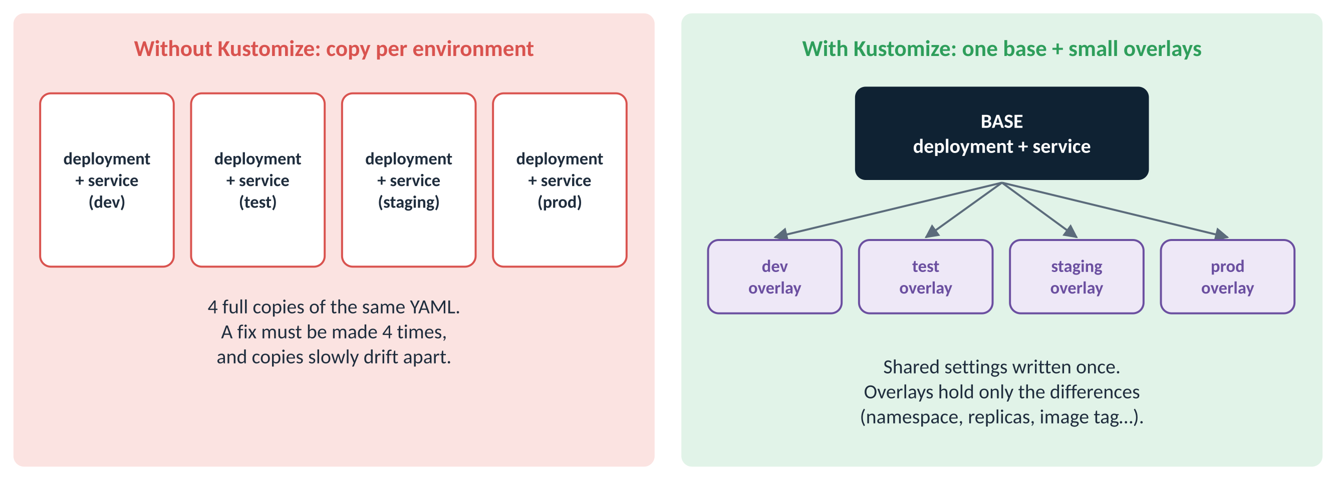
Figure 1: Copying YAML per environment vs one base with small overlays
Real-world analogy
A tailor keeps one master pattern for a shirt (the base). For each customer they note only the changes: longer sleeves, a different colour (the overlay). They never redraw the whole pattern, and a fix to the master pattern reaches every customer’s shirt.

Real-world use
A bank runs the same payments service in dev, test and production. Dev needs 1 copy and debug logging; production needs 5 copies, a different database address and a pinned image version. With Kustomize, the shared 95% lives in one base, and each environment’s folder holds just its few differences, reviewed in Git like any other code.

Learning objectives
After completing this lab, you will be able to:
- Understand the purpose and benefits of Kustomize
- Create reusable Kubernetes base manifests
- Build Development and Production overlays
- Change replica counts without editing the source manifests
- Override container image versions per environment
- Deploy applications with Kustomize (kubectl apply -k)
- Validate the generated Kubernetes resources (kubectl kustomize)
- Access the application through a Kubernetes Service
- Recognise real-world DevOps deployment patterns

2. Architecture
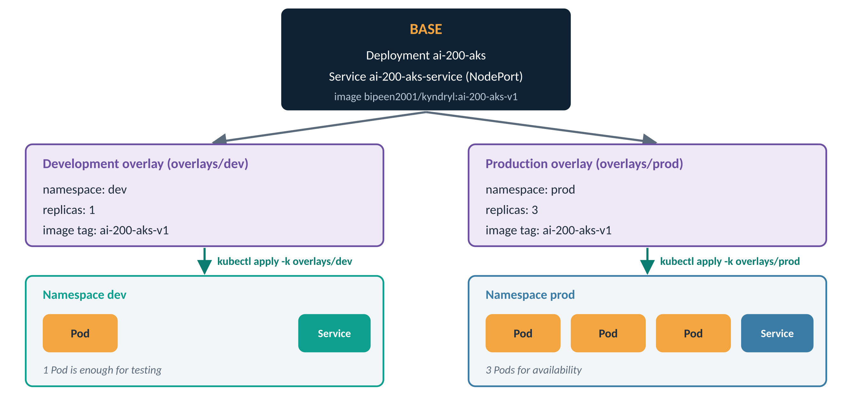
Figure 2: One base, two overlays, two isolated environments
Note
Key principle: define resources once in the base, and customise them per environment through overlays.

Term | What it is | In this lab
Base | A folder with the YAML shared by every environment, plus a kustomization.yaml listing it | base/: Deployment + Service
Overlay | A folder with a kustomization.yaml that points at the base and lists only the changes | overlays/dev and overlays/prod
kustomization.yaml | The instruction file Kustomize reads in every base and overlay folder | Three of them: base, dev, prod
kubectl kustomize <dir> | Builds and PRINTS the final YAML. Changes nothing in the cluster | Steps 6 and 14
kubectl apply -k <dir> | Builds the final YAML and APPLIES it to the cluster | Steps 10 and 12

What each environment gets
Setting | Base | Development overlay | Production overlay
Namespace | none (not set) | dev | prod
Replicas | 1 | 1 | 3
Image tag | ai-200-aks-v1 | ai-200-aks-v1 | ai-200-aks-v1 (change it here to release a new version)

3. Prerequisites
Make sure the following are installed and working:
- Ubuntu Linux
- A Kubernetes cluster deployed with kubeadm
- containerd runtime
- kubectl client
- Internet access to pull container images from Docker Hub

Verify the kubectl installation
Why: Kustomize is part of kubectl, so the kubectl version also tells you which Kustomize version you have.
kubectl version --client
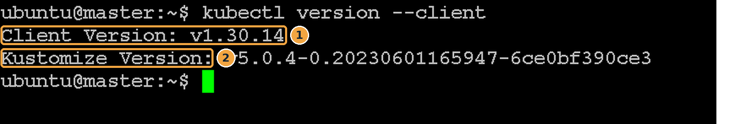
Screenshot 1: kubectl and its built-in Kustomize version
What this screenshot shows
# | What you see | What it means
1 | Client Version: v1.30.14 | Your kubectl version. Any recent version (1.14 or later) includes Kustomize.
2 | Kustomize Version: v5.0.4-… | The Kustomize engine built into this kubectl. Version 5 supports everything used in this lab.

Verify cluster health
Why: The application will run on the cluster’s nodes, so they must be healthy.
kubectl get nodes
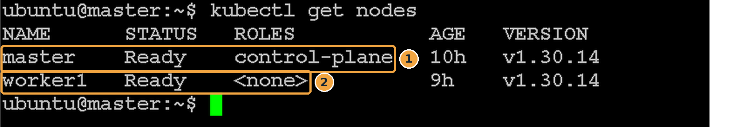
Screenshot 2: Two healthy nodes
What this screenshot shows
# | What you see | What it means
1 | master Ready control-plane | The control-plane node is up.
2 | worker1 Ready <none> | The worker node is up. Application Pods will usually run here.

Checkpoint: you are ready for the next step when…
Every node shows Ready.

4. Lab Steps
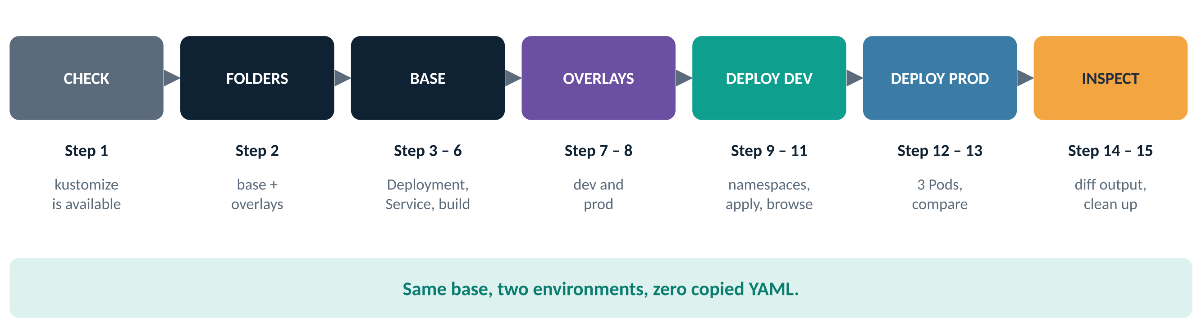
Figure 3: The 15 steps of the lab

Step 1: Verify Kustomize availability
Why: Confirm that the kubectl kustomize sub-command exists, so you do not need to install a separate tool.
kubectl kustomize --help
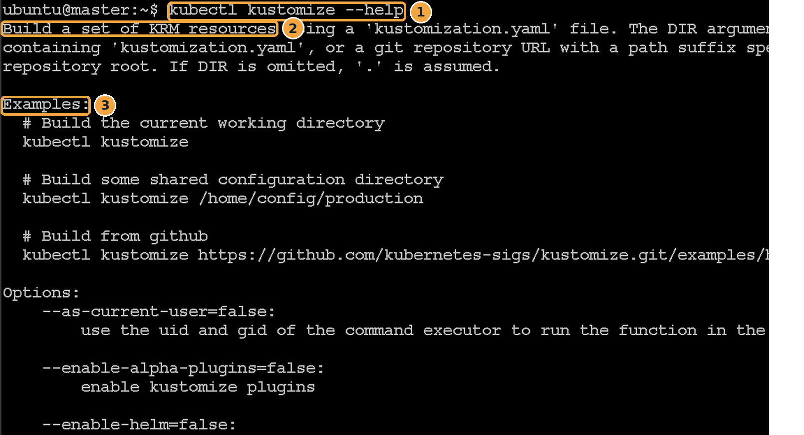
Screenshot 3: Help text for kubectl kustomize
What this screenshot shows
# | What you see | What it means
1 | kubectl kustomize --help | Asks kubectl to describe its kustomize sub-command.
2 | Build a set of KRM resources using a kustomization.yaml file | What it does: reads a kustomization.yaml and builds Kubernetes resources (KRM = Kubernetes Resource Model) from it.
3 | Examples: | Shows you can build from the current folder, another folder, or even a Git URL.

Checkpoint: you are ready for the next step when…
You see the help text and examples, not “unknown command”.

Step 2: Create the lab directory structure
Why: Kustomize is folder-based: each base and overlay is a folder with its own kustomization.yaml.
Create and enter a working directory
mkdir -p kustomize-lab
cd kustomize-lab
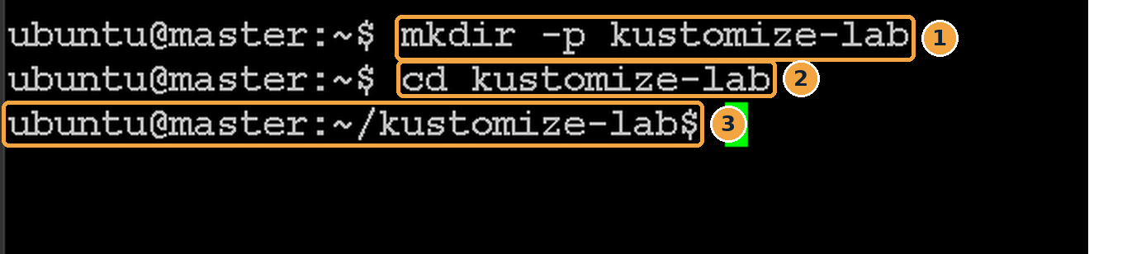
Screenshot 4: The working directory is created and opened
What this screenshot shows
# | What you see | What it means
1 | mkdir -p kustomize-lab | Creates the folder (-p: no error if it already exists).
2 | cd kustomize-lab | Moves into it.
3 | ubuntu@master:~/kustomize-lab$ | The prompt now shows you are inside kustomize-lab. Run every later command from here.

Create the base and overlay folders
mkdir -p base
mkdir -p overlays/dev
mkdir -p overlays/prod
ls
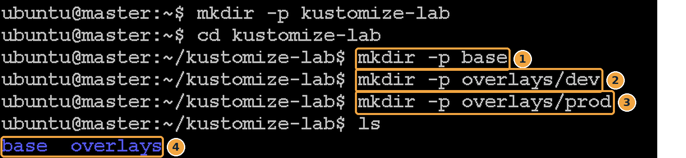
Screenshot 5: Base and overlay folders created
What this screenshot shows
# | What you see | What it means
1 | mkdir -p base | The folder for shared resources.
2 | mkdir -p overlays/dev | The Development overlay folder (-p also creates overlays/).
3 | mkdir -p overlays/prod | The Production overlay folder.
4 | base overlays | ls confirms the two top-level folders exist.

The finished structure (files are added in the next steps)
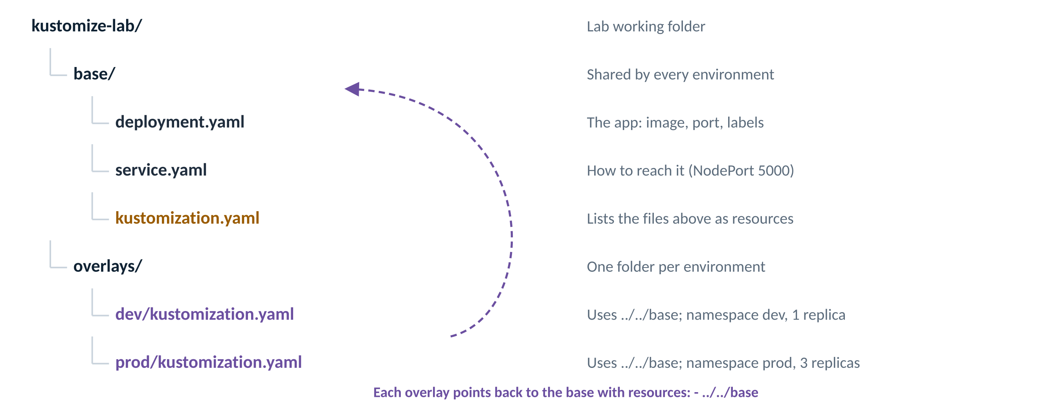
Figure 4: What each file in the lab is for
Checkpoint: you are ready for the next step when…
ls shows base and overlays.

Step 3: Create the base Deployment
Why: The base holds the application settings common to every environment: name, labels, image and port.
nano base/deployment.yaml
Screenshot 6: Opening base/deployment.yaml in nano
What this screenshot shows
# | What you see | What it means
1 | nano base/deployment.yaml | Creates and opens the file inside the base folder.

Add the following content, then save with Ctrl+O, Enter, and exit with Ctrl+X:
apiVersion: apps/v1
kind: Deployment
metadata:
name: ai-200-aks
spec:
replicas: 1
selector:
matchLabels:
app: ai-200-aks
template:
metadata:
labels:
app: ai-200-aks
spec:
containers:
- name: ai-200-aks
image: bipeen2001/kyndryl:ai-200-aks-v1
ports:
- containerPort: 5000
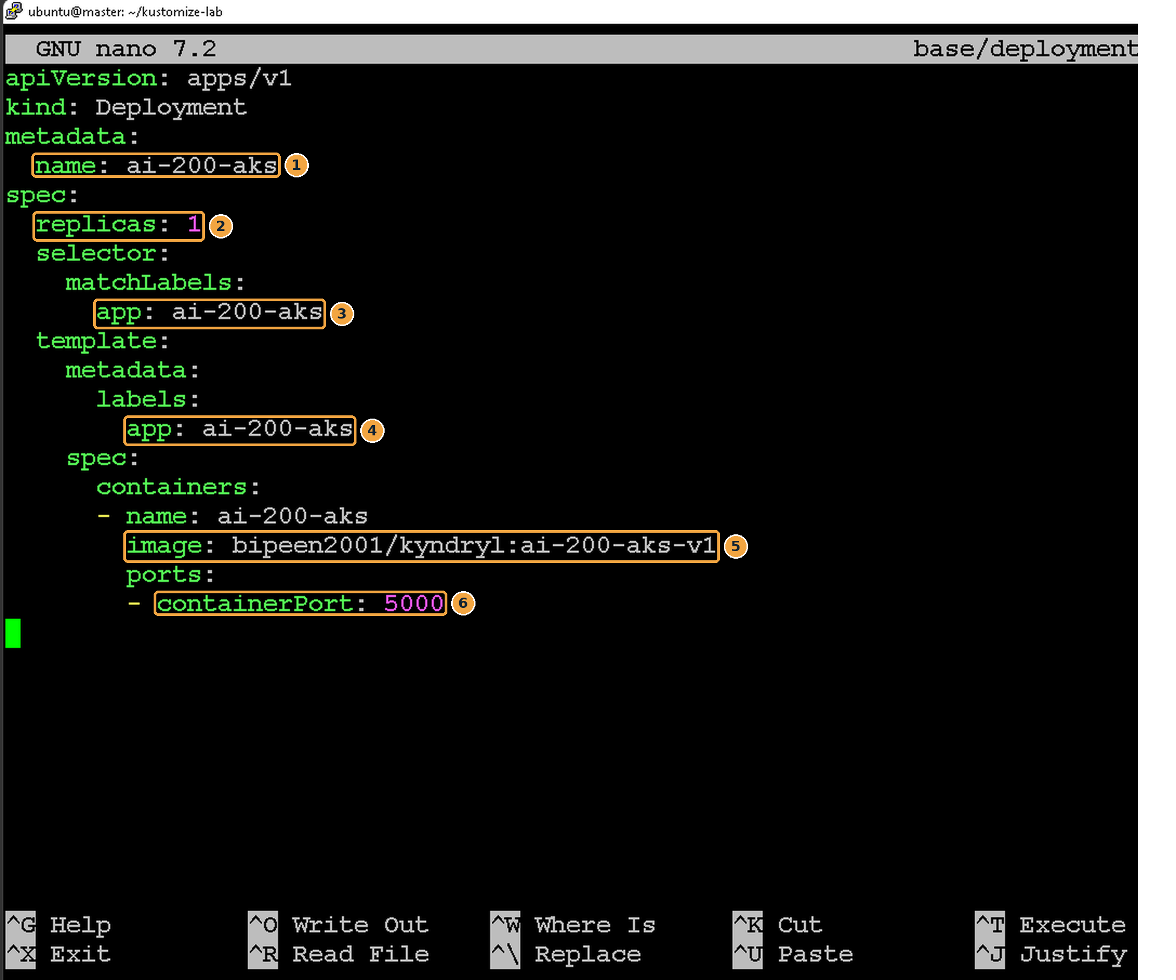
Screenshot 7: base/deployment.yaml in nano
What this screenshot shows
# | What you see | What it means
1 | name: ai-200-aks | The Deployment’s name. Overlays use this exact name to change its replica count.
2 | replicas: 1 | A sensible default. Overlays override it per environment.
3 | selector app: ai-200-aks | Tells the Deployment which Pods it manages.
4 | template label app: ai-200-aks | The label put on every Pod. It must match the selector, and the Service also uses it.
5 | image: bipeen2001/kyndryl:ai-200-aks-v1 | Repository bipeen2001/kyndryl, tag ai-200-aks-v1. Overlays can swap the tag.
6 | containerPort: 5000 | The app listens on port 5000 inside the container.

Note
Why put replicas in the base? The base should work on its own and represent a sensible default. Each overlay then overrides the value for its environment, without touching this file.

Checkpoint: you are ready for the next step when…
The file is saved and the two app: labels match exactly.

Step 4: Create the base Service
Why: The Service gives the Pods one stable address and makes the app reachable from outside the cluster.
nano base/service.yaml
Screenshot 8: Opening base/service.yaml in nano
What this screenshot shows
# | What you see | What it means
1 | nano base/service.yaml | Creates and opens the Service file in the base folder.

apiVersion: v1
kind: Service
metadata:
name: ai-200-aks-service
spec:
type: NodePort
selector:
app: ai-200-aks
ports:
- port: 5000
targetPort: 5000
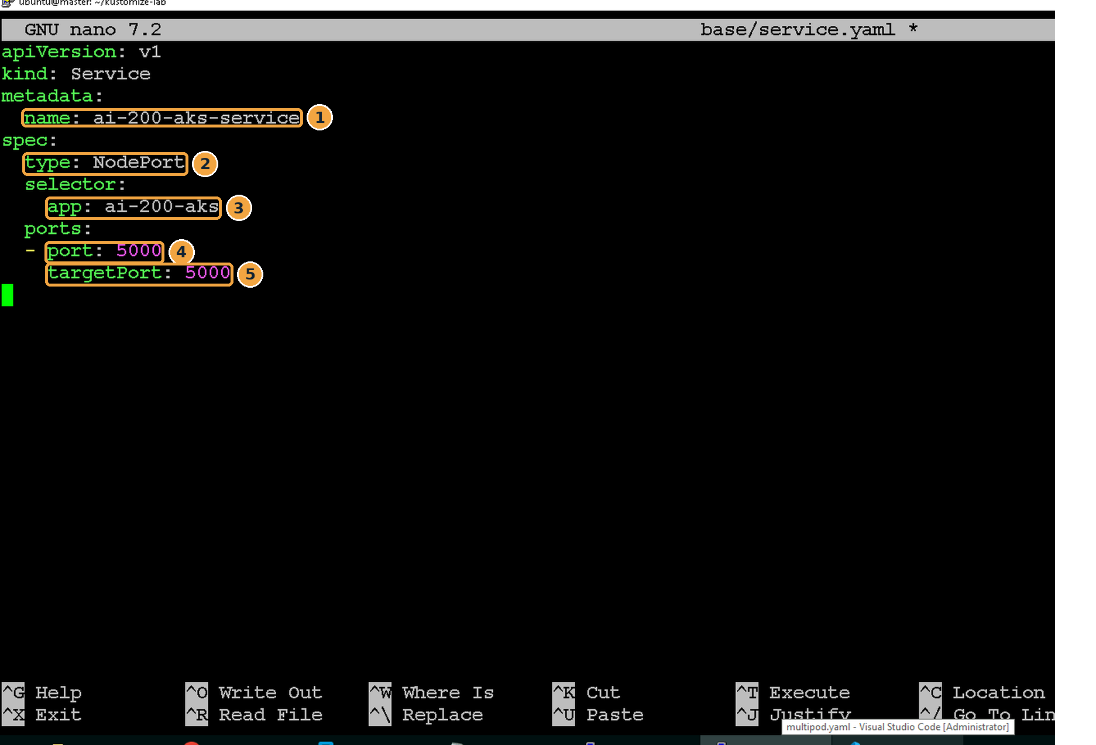
Screenshot 9: base/service.yaml in nano
What this screenshot shows
# | What you see | What it means
1 | name: ai-200-aks-service | The Service name. It is the same in dev and prod; the namespaces keep them apart.
2 | type: NodePort | Opens a port (30000–32767) on every node so you can reach the app from a browser.
3 | selector app: ai-200-aks | Sends traffic to Pods with this label, i.e. the Pods from Step 3.
4 | port: 5000 | The port the Service listens on inside the cluster.
5 | targetPort: 5000 | The container port traffic is forwarded to (matches containerPort in Step 3).

Component | Purpose
Service | Provides stable network access to changing Pods
NodePort | Exposes the application outside the cluster
Port 5000 | The application’s listening port
Selector | Routes traffic to Pods with matching labels

Checkpoint: you are ready for the next step when…
The selector says app: ai-200-aks, the same label as the Deployment’s Pods.

Step 5: Create the base kustomization file
Why: A folder only becomes a Kustomize base when it has a kustomization.yaml. It lists which files belong to the base.
nano base/kustomization.yaml
Screenshot 10: Opening base/kustomization.yaml in nano
What this screenshot shows
# | What you see | What it means
1 | nano base/kustomization.yaml | Creates the instruction file for the base folder.

apiVersion: kustomize.config.k8s.io/v1beta1
kind: Kustomization
resources:
- deployment.yaml
- service.yaml
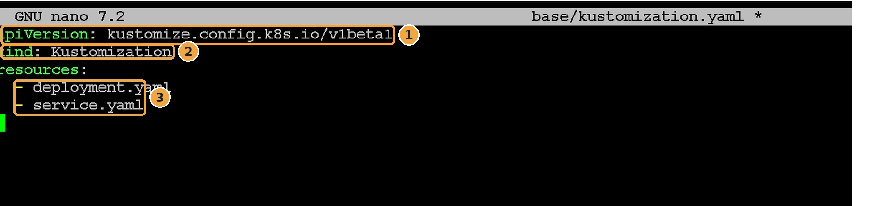
Screenshot 11: base/kustomization.yaml in nano
What this screenshot shows
# | What you see | What it means
1 | apiVersion: kustomize.config.k8s.io/v1beta1 | This is a Kustomize file, not a Kubernetes object. It is never sent to the cluster.
2 | kind: Kustomization | Marks the folder as a Kustomize base or overlay.
3 | resources: deployment.yaml, service.yaml | The files to include. Anything not listed here is ignored.

The base layer is now complete.
Checkpoint: you are ready for the next step when…
base/ contains three files: deployment.yaml, service.yaml and kustomization.yaml.

Step 6: Validate the base configuration
Why: Always preview what Kustomize will generate before deploying. kubectl kustomize prints the YAML and changes nothing.
kubectl kustomize base
Kustomize combines all base resources and prints the final Kubernetes YAML. Expected resources: a Service and a Deployment.
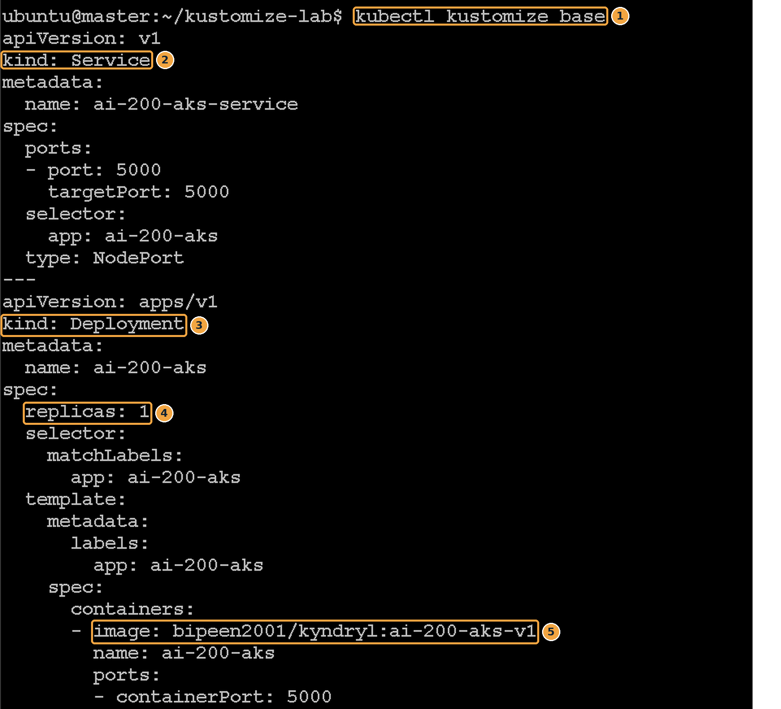
Screenshot 12: The generated YAML for the base
What this screenshot shows
# | What you see | What it means
1 | kubectl kustomize base | Build the base folder and print the result.
2 | kind: Service | The first resource. Kustomize prints Services before Deployments; the order does not matter to Kubernetes.
3 | kind: Deployment | The second resource, after the --- separator.
4 | replicas: 1 | The base default, unchanged because no overlay is involved yet.
5 | image: bipeen2001/kyndryl:ai-200-aks-v1 | The base image. Keys may appear in a different order from your file (alphabetical); that is normal.

Note
Important concept: Kustomize does not replace Kubernetes YAML. It generates standard Kubernetes YAML from reusable pieces. Anything Kubernetes accepts, Kustomize can produce.

Checkpoint: you are ready for the next step when…
The output contains one Service and one Deployment, with no errors.

Step 7: Create a Development overlay
Why: The dev overlay says: “take the base, put it in namespace dev, run 1 replica, and use image tag ai-200-aks-v1”.
nano overlays/dev/kustomization.yaml
Screenshot 13: Opening the dev overlay file in nano
What this screenshot shows
# | What you see | What it means
1 | nano overlays/dev/kustomization.yaml | Creates the kustomization file inside the dev overlay folder.

apiVersion: kustomize.config.k8s.io/v1beta1
kind: Kustomization
namespace: dev
resources:
- ../../base
replicas:
- name: ai-200-aks
count: 1
images:
- name: bipeen2001/kyndryl
newTag: ai-200-aks-v1
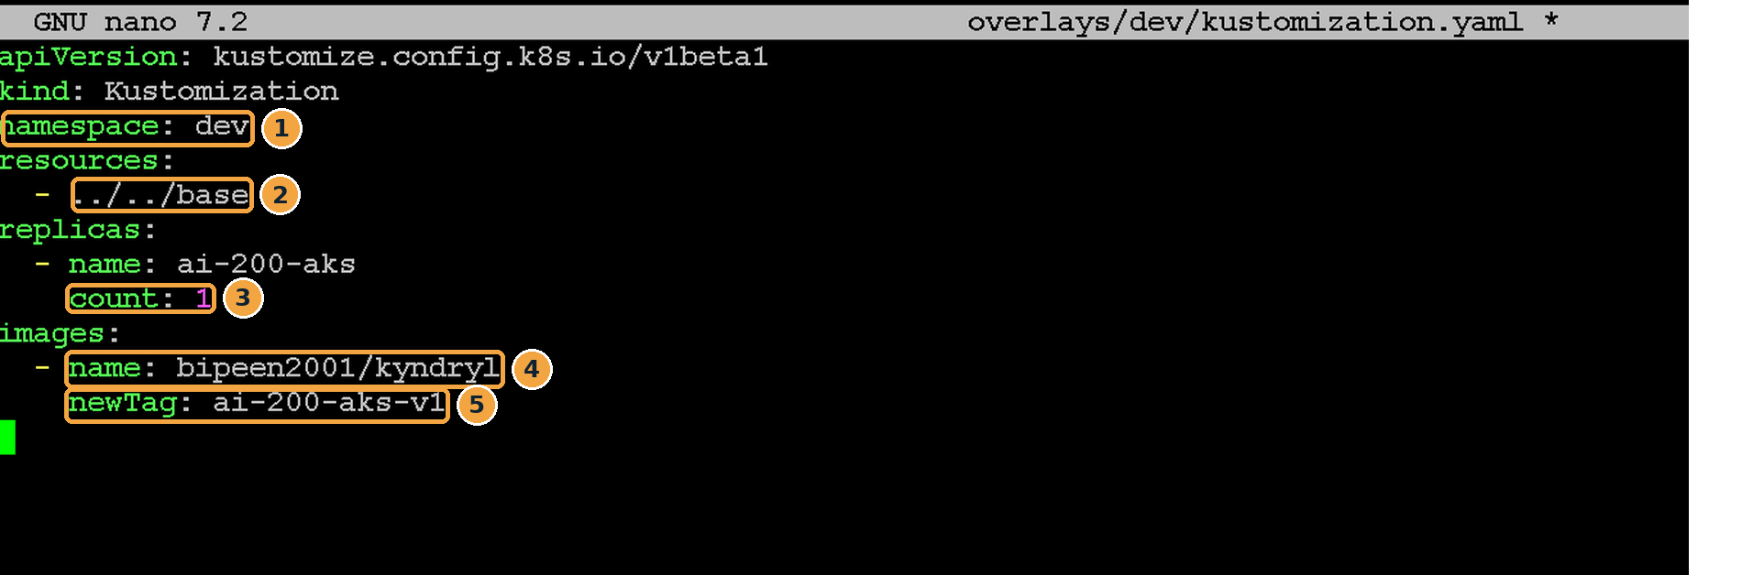
Screenshot 14: overlays/dev/kustomization.yaml in nano
What this screenshot shows
# | What you see | What it means
1 | namespace: dev | Puts every generated resource into the dev namespace.
2 | ../../base | The path from overlays/dev back to the base folder. This is how the overlay reuses the base.
3 | count: 1 | Sets replicas to 1 for the Deployment named ai-200-aks.
4 | name: bipeen2001/kyndryl | The image repository to change (written without a tag).
5 | newTag: ai-200-aks-v1 | The tag to use in dev.

Parameter | Dev value
Namespace | dev
Replicas | 1
Image version | ai-200-aks-v1

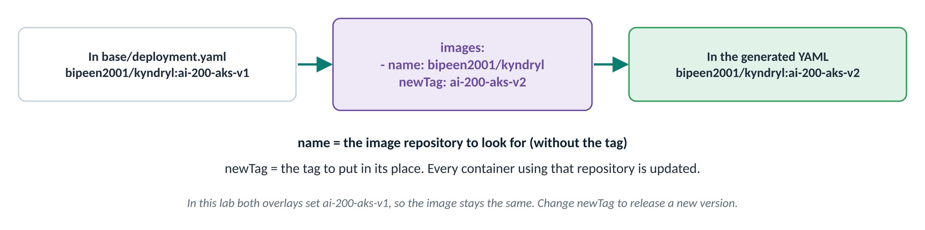
Figure 5: How the images override works (example with a v2 tag)
Checkpoint: you are ready for the next step when…
The file is saved and resources points to ../../base.

Step 8: Create a Production overlay
Why: Production needs more copies for availability. Only the namespace and replica count differ from dev.
nano overlays/prod/kustomization.yaml
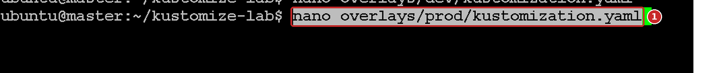
Screenshot 15: Opening the prod overlay file in nano
What this screenshot shows
# | What you see | What it means
1 | nano overlays/prod/kustomization.yaml | Creates the kustomization file inside the prod overlay folder.

apiVersion: kustomize.config.k8s.io/v1beta1
kind: Kustomization
namespace: prod
resources:
- ../../base
replicas:
- name: ai-200-aks
count: 3
images:
- name: bipeen2001/kyndryl
newTag: ai-200-aks-v1
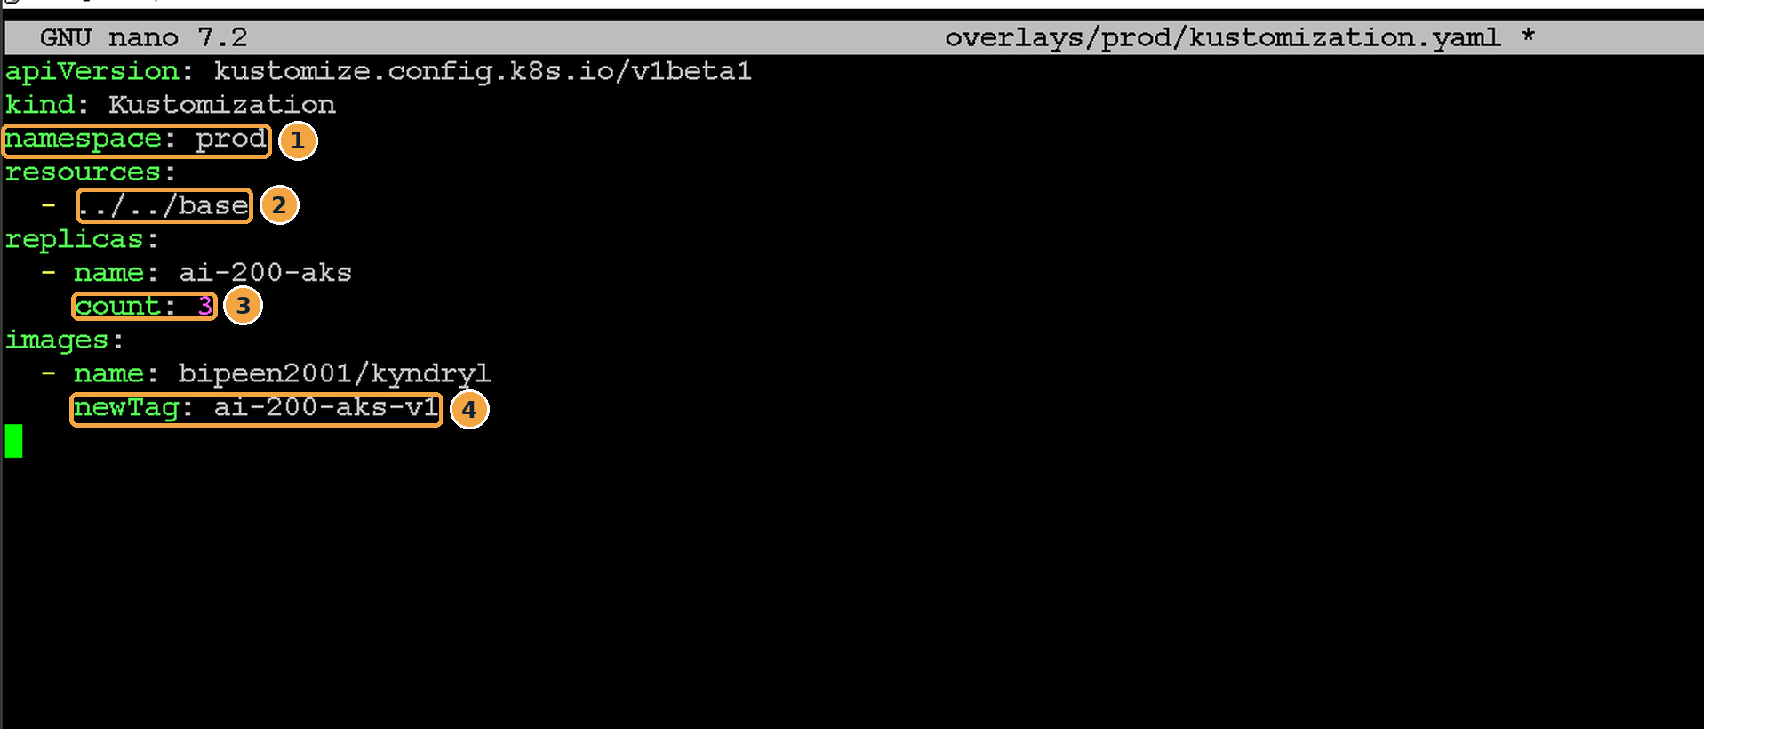
Screenshot 16: overlays/prod/kustomization.yaml in nano
What this screenshot shows
# | What you see | What it means
1 | namespace: prod | Everything goes into the prod namespace.
2 | ../../base | The same base as dev: no YAML is copied.
3 | count: 3 | Three replicas in production.
4 | newTag: ai-200-aks-v1 | Same version as dev for now. To release a new version to prod only, change just this line.

Parameter | Prod value
Namespace | prod
Replicas | 3
Image version | ai-200-aks-v1

Checkpoint: you are ready for the next step when…
The only differences from the dev file are namespace: prod and count: 3.

Step 9: Create environment namespaces
Why: The overlays put resources into namespaces called dev and prod, but they do not create those namespaces. Applying into a namespace that does not exist fails.
kubectl create namespace dev
kubectl create namespace prod
kubectl get ns
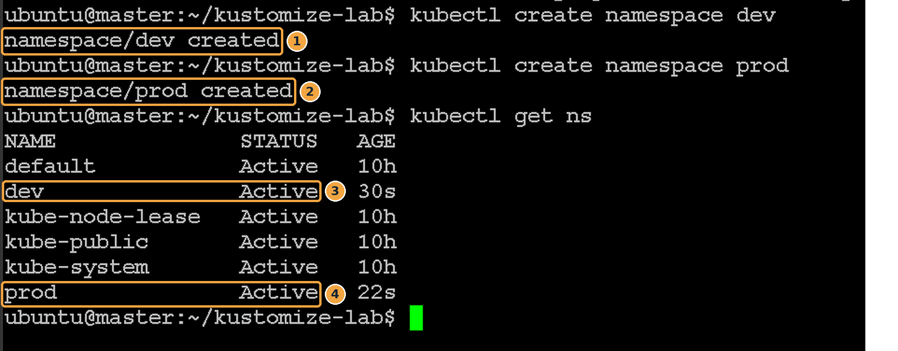
Screenshot 17: dev and prod namespaces created
What this screenshot shows
# | What you see | What it means
1 | namespace/dev created | The Development namespace exists.
2 | namespace/prod created | The Production namespace exists.
3 | dev Active | Listed and ready to use.
4 | prod Active | Listed and ready. default, kube-system and the others are built in.

Checkpoint: you are ready for the next step when…
kubectl get ns shows both dev and prod as Active.

Step 10: Deploy the Development environment
Why: apply -k builds the dev overlay (base + dev changes) and sends the result to the cluster in one command.
kubectl apply -k overlays/dev
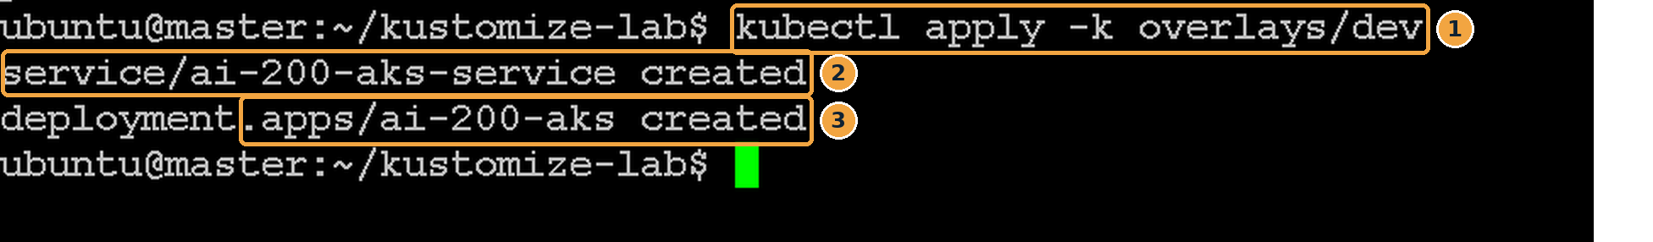
Screenshot 18: The dev overlay applied
What this screenshot shows
# | What you see | What it means
1 | kubectl apply -k overlays/dev | -k means “build this Kustomize folder, then apply it” (instead of -f for a single file).
2 | service/ai-200-aks-service created | The Service was created, in namespace dev.
3 | deployment.apps/ai-200-aks created | The Deployment was created, in namespace dev.

Verify all resources in dev
kubectl get all -n dev
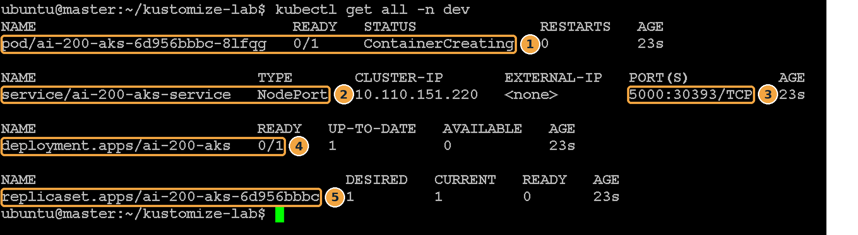
Screenshot 19: Everything in the dev namespace, a few seconds after applying
What this screenshot shows
# | What you see | What it means
1 | pod/… 0/1 ContainerCreating | The Pod is still downloading the image. This is normal for the first run; wait a minute.
2 | service/ai-200-aks-service NodePort | The Service from the base, now in dev.
3 | 5000:30393/TCP | Service port 5000 is exposed on every node as NodePort 30393. Your number will differ.
4 | deployment.apps/ai-200-aks 0/1 | 0 of 1 replica ready yet (1 because of the dev overlay).
5 | replicaset.apps/ai-200-aks-6d956bbbc | The ReplicaSet created by the Deployment to keep 1 Pod running.

Verify the Pod
kubectl get pods -n dev
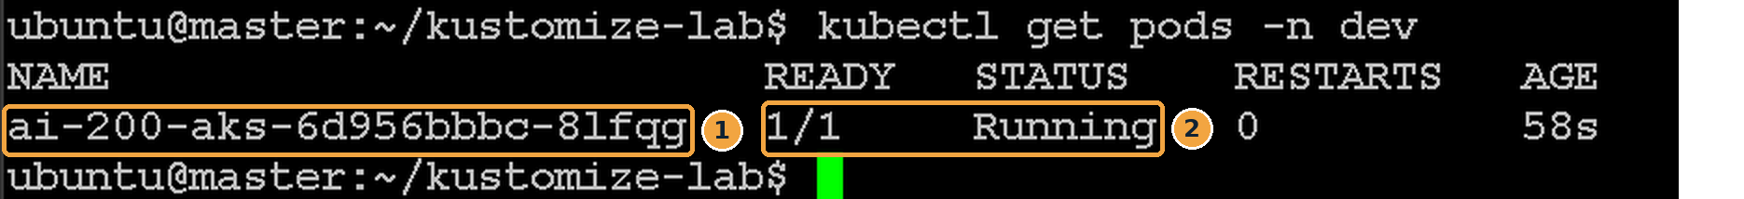
Screenshot 20: The dev Pod is running
What this screenshot shows
# | What you see | What it means
1 | ai-200-aks-6d956bbbc-8lfqg | One Pod: Deployment name, ReplicaSet ID, random suffix.
2 | 1/1 Running | The app container has started.

Checkpoint: you are ready for the next step when…
The dev Pod is 1/1 Running.

Step 11: Access the Dev application
Why: Prove the app works end to end, from your browser to the Pod.
Find the NodePort
kubectl get svc -n dev
Screenshot 21: The dev Service and its NodePort
What this screenshot shows
# | What you see | What it means
1 | ai-200-aks-service NodePort | The dev Service.
2 | 5000:30393/TCP | The number after the colon (30393) is the port to use in the browser.

Find the node’s IP address
hostname -I
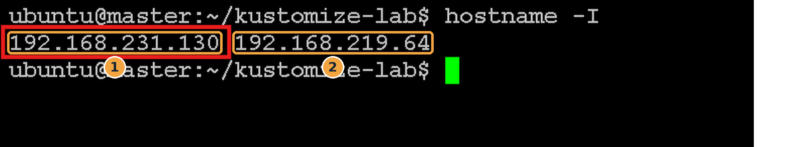
Screenshot 22: IP addresses of the master node
What this screenshot shows
# | What you see | What it means
1 | 192.168.231.130 | The node’s main network address. Use this one in the browser.
2 | 192.168.219.64 | An internal address added by the network plugin (Calico) for Pod traffic. Do not use it.

Open the application in a browser
Browse to http://<node-IP>:<NodePort>, in this example http://192.168.231.130:30393. Any node’s IP works with a NodePort.
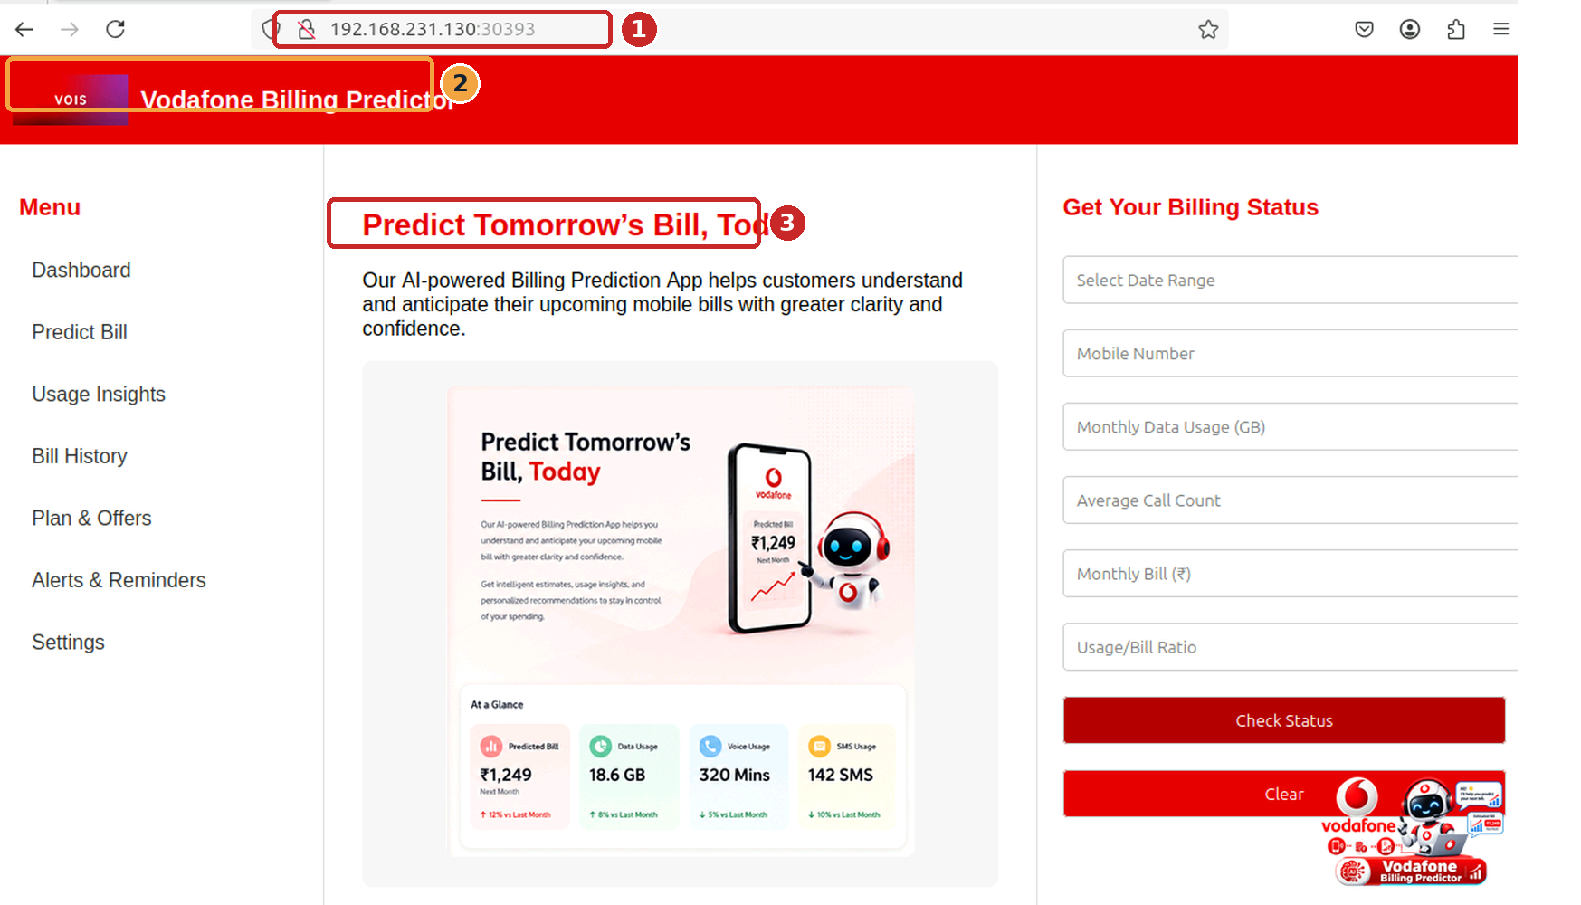
Screenshot 23: The AI application running in the dev environment
What this screenshot shows
# | What you see | What it means
1 | Address bar 192.168.231.130:30393 | Node IP plus NodePort from the previous two commands.
2 | Application header | The app’s page loaded, so the Service reached the Pod.
3 | Main content | The application is fully working in the dev environment.

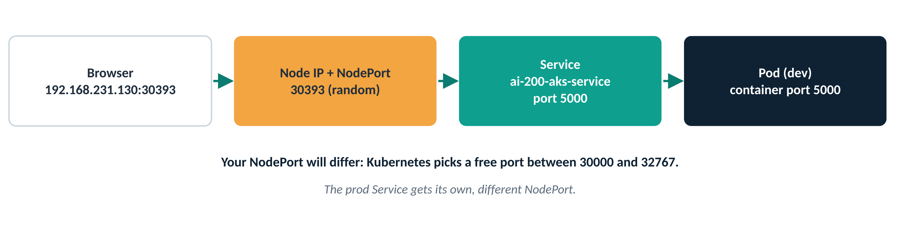
Figure 6: How your browser request reaches the Pod
Checkpoint: you are ready for the next step when…
The application page loads in the browser.

Step 12: Deploy the Production environment
Why: The same base now goes to production with three replicas, by pointing at a different overlay.
kubectl apply -k overlays/prod
kubectl get pods -n prod
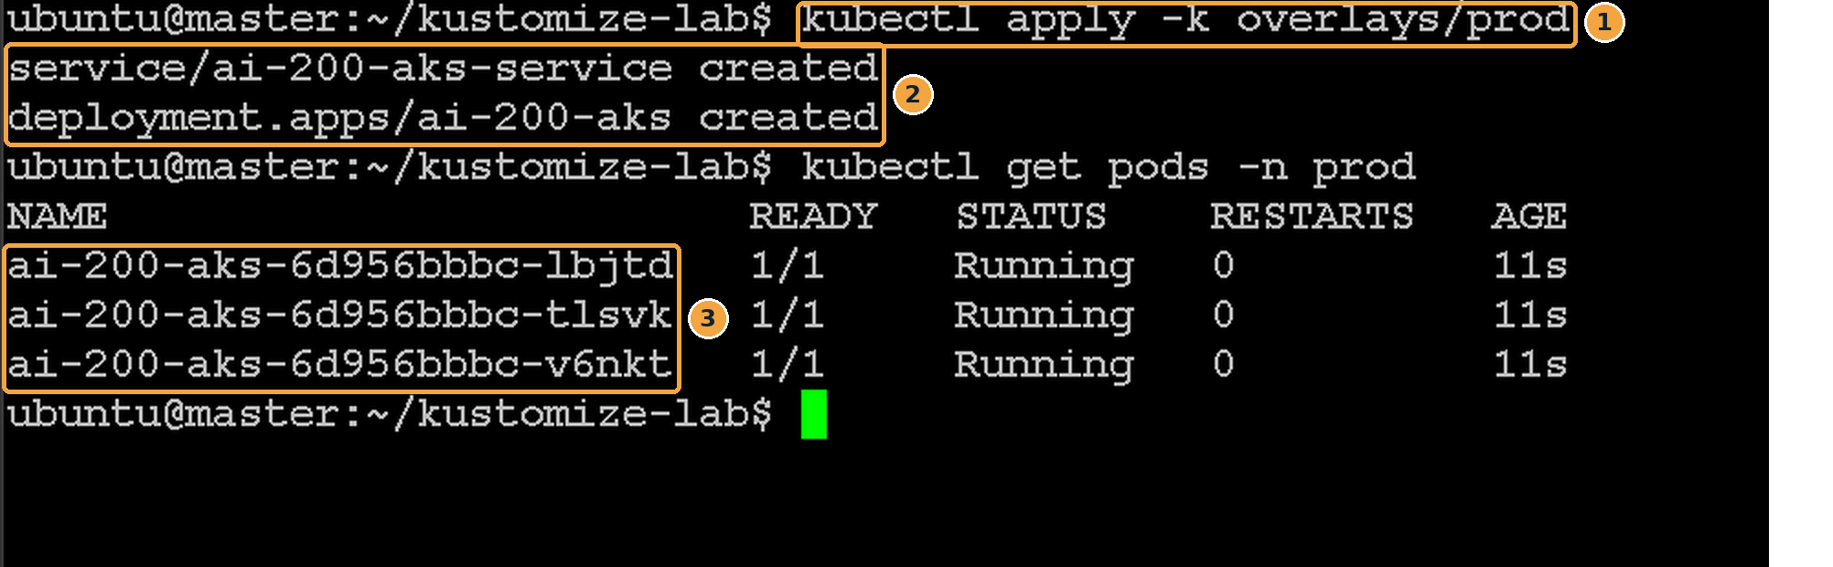
Screenshot 24: Production deployed with three Pods
What this screenshot shows
# | What you see | What it means
1 | kubectl apply -k overlays/prod | Build base + prod overlay and apply it.
2 | service … created, deployment … created | The same two resources as dev, this time in namespace prod.
3 | Three ai-200-aks-… Pods, 1/1 Running | count: 3 from the prod overlay produced three Pods.

Note
Why three Pods? The Production overlay overrides the replica count with count: 3, giving higher availability and capacity than Development.
Notice that the prod Pods share the ID 6d956bbbc with the dev Pod: the Pod template (image, labels, ports) is identical, only the count and namespace differ.

Checkpoint: you are ready for the next step when…
Three prod Pods are 1/1 Running.

Step 13: Compare Development and Production
Why: See both environments side by side: same app, same YAML source, different size.
kubectl get pods -n dev
kubectl get pods -n prod
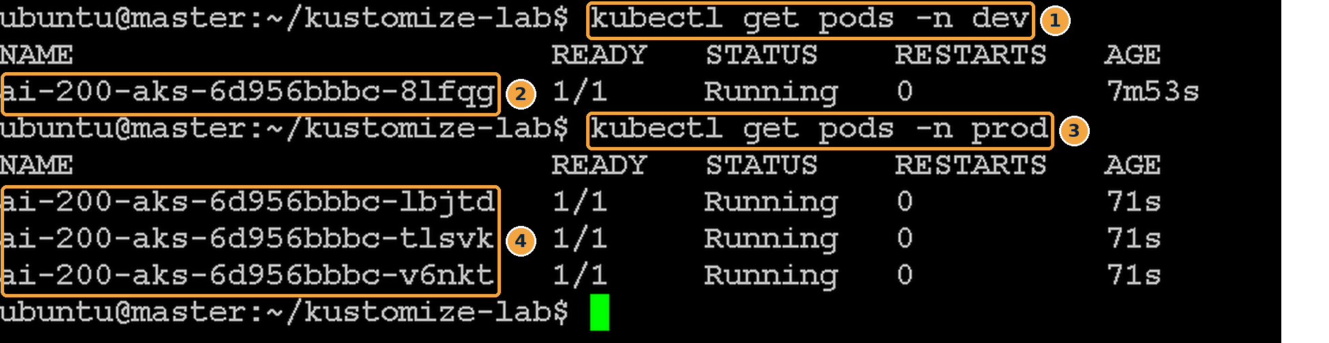
Screenshot 25: One Pod in dev, three in prod
What this screenshot shows
# | What you see | What it means
1 | kubectl get pods -n dev | List Development Pods.
2 | One ai-200-aks Pod | Dev runs 1 replica.
3 | kubectl get pods -n prod | List Production Pods.
4 | Three ai-200-aks Pods | Prod runs 3 replicas.

 | Development | Production
Namespace | dev | prod
Pods | 1 | 3
Source YAML | base/ (shared) | base/ (shared)

This shows environment-specific customisation without duplicating deployment manifests.
Checkpoint: you are ready for the next step when…
dev shows 1 Pod and prod shows 3 Pods.

Step 14: Inspect the generated manifests
Why: Look at exactly what Kustomize produced for each environment. This is also how you review a change before applying it.
kubectl kustomize overlays/dev
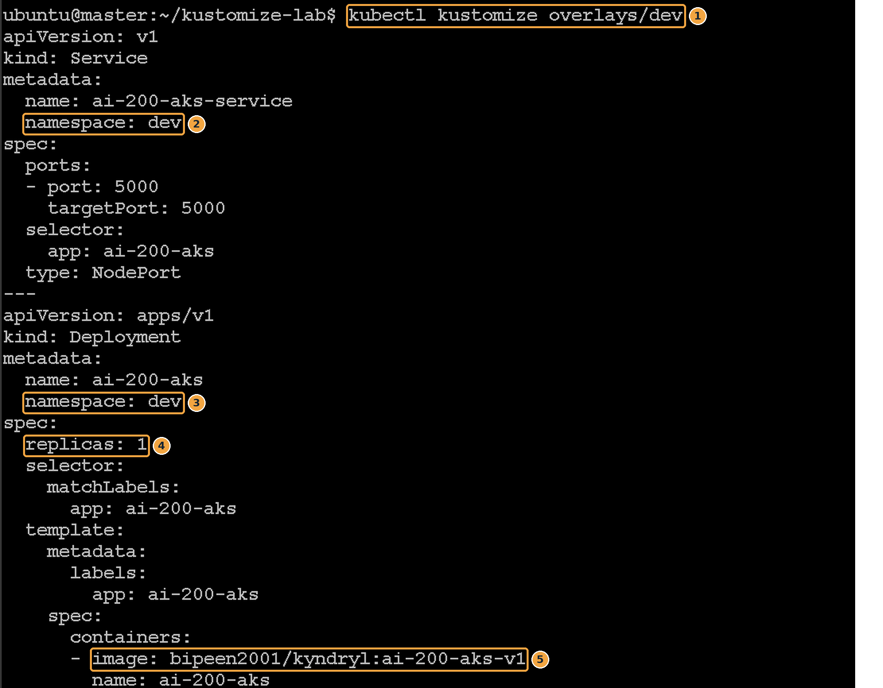
Screenshot 26: Generated YAML for Development
What this screenshot shows
# | What you see | What it means
1 | kubectl kustomize overlays/dev | Build the dev overlay and print it (nothing is applied).
2 | namespace: dev (Service) | Added by the overlay; it is not in base/service.yaml.
3 | namespace: dev (Deployment) | Added to the Deployment too: namespace applies to every resource.
4 | replicas: 1 | From count: 1 in the dev overlay.
5 | image: …:ai-200-aks-v1 | From newTag in the dev overlay.

kubectl kustomize overlays/prod
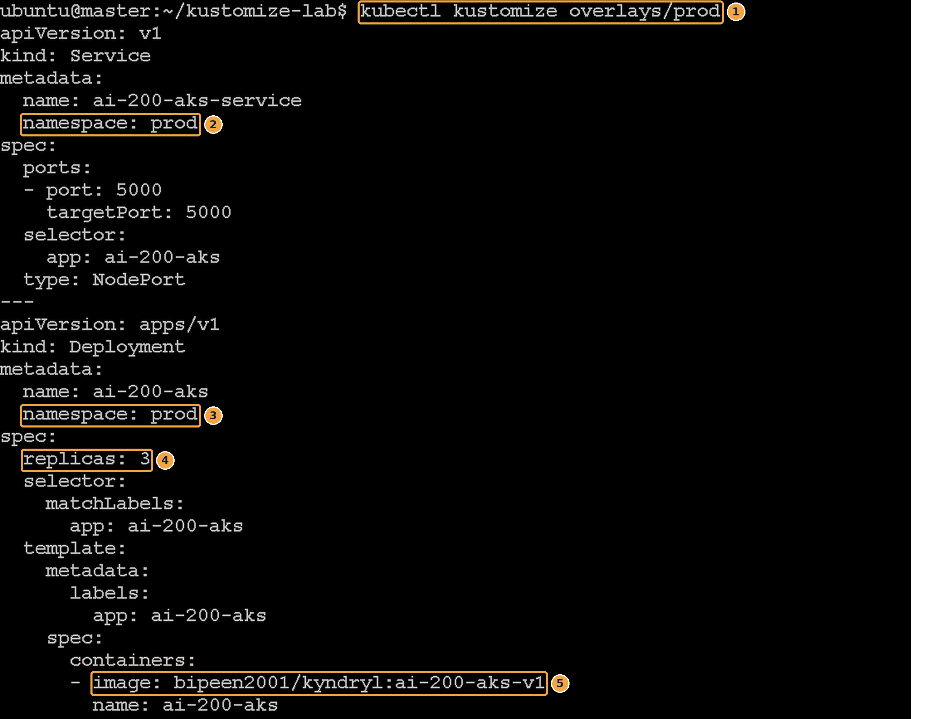
Screenshot 27: Generated YAML for Production
What this screenshot shows
# | What you see | What it means
1 | kubectl kustomize overlays/prod | Build the prod overlay and print it.
2 | namespace: prod (Service) | Now prod instead of dev.
3 | namespace: prod (Deployment) | Every resource moves to prod.
4 | replicas: 3 | From count: 3 in the prod overlay.
5 | image: …:ai-200-aks-v1 | Same tag as dev in this lab.

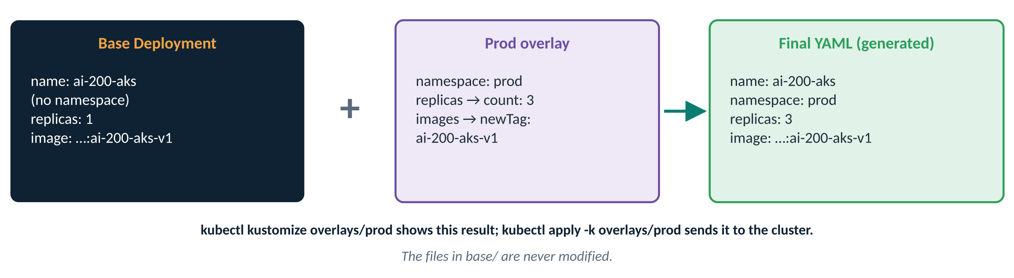
Figure 7: How Kustomize combines the base and an overlay
Setting | DEV | PROD
namespace | dev | prod
replicas | 1 | 3

Notice that base/deployment.yaml remains unchanged. This is the core benefit of Kustomize.
Optional (no screenshot): preview a change before applying it
kubectl diff -k overlays/prod # shows what would change in the cluster; no output = no changes
Checkpoint: you are ready for the next step when…
The two outputs differ only in namespace and replicas.

Step 15: Clean up
Why: Remove both environments so the next lab starts clean.
kubectl delete -k overlays/dev
kubectl delete -k overlays/prod
kubectl delete namespace dev
kubectl delete namespace prod
Expected output
$ kubectl delete -k overlays/dev
service "ai-200-aks-service" deleted
deployment.apps "ai-200-aks" deleted
$ kubectl delete -k overlays/prod
service "ai-200-aks-service" deleted
deployment.apps "ai-200-aks" deleted
$ kubectl delete namespace dev
namespace "dev" deleted
$ kubectl delete namespace prod
namespace "prod" deleted
What you see | What it means
service … deleted, deployment.apps … deleted | delete -k builds the overlay again and deletes exactly the resources it describes.
namespace "dev" deleted | Removes the namespace and anything left inside it. This can take a few seconds.

Note
The folders and YAML files stay on disk. Delete them with cd ~ && rm -rf kustomize-lab if you no longer need them.

Checkpoint: you are ready for the next step when…
kubectl get ns no longer lists dev or prod.

5. Enterprise Takeaways
Layer | Contains | Typical examples
Base | Common Kubernetes resources shared by all environments | Deployment, Service, ConfigMaps, Secret references, Ingress
Overlay | Only the environment-specific differences | Namespace, replica count, image version, resource limits, labels, annotations
Kustomize | Combines them | Base + Overlay = Final Kubernetes manifest

Key commands summary
Task | Command
Generate (preview) manifests | kubectl kustomize overlays/dev
Deploy Dev | kubectl apply -k overlays/dev
Deploy Prod | kubectl apply -k overlays/prod
Preview changes against the cluster | kubectl diff -k overlays/prod
View resources | kubectl get all -n dev / kubectl get all -n prod
Delete resources | kubectl delete -k overlays/dev / kubectl delete -k overlays/prod

Troubleshooting
What you see | Likely cause | Fix
namespaces "dev" not found | The namespace was not created before apply -k | Run Step 9, then apply again
must build at directory: … kustomization.yaml not found | Wrong folder, or file misnamed (e.g. kustomize.yaml) | Run from kustomize-lab; the file must be named kustomization.yaml
accumulating resources … no such file | Wrong path in resources: | From overlays/dev the base is ../../base
Replicas not changed | replicas: name does not match the Deployment name | Use exactly ai-200-aks
Image tag not changed | images: name includes the tag, or has a typo | Use the repository only: bipeen2001/kyndryl
Pod stuck in ImagePullBackOff | No internet, or the tag does not exist | Check kubectl describe pod -n dev; verify the tag on Docker Hub
Browser cannot connect | Wrong IP or NodePort, or a firewall | Use the first IP from hostname -I and the port from kubectl get svc

Self-check
- What is the difference between kubectl kustomize and kubectl apply -k?
Answer: kustomize only prints the generated YAML; apply -k generates it and applies it to the cluster.
- Which file did you change to run 3 Pods in production?
Answer: Only overlays/prod/kustomization.yaml (count: 3). The base was never edited.
- Why did you create the dev and prod namespaces yourself?
Answer: The overlays set the namespace on resources but do not create the Namespace object.
- How would you release image tag ai-200-aks-v2 to prod only?
Answer: Change newTag in overlays/prod/kustomization.yaml and run kubectl apply -k overlays/prod.
- Both environments use a Service named ai-200-aks-service. Why is there no clash?
Answer: They are in different namespaces, dev and prod.

Lab conclusion
In this lab you implemented a real-world Kustomize workflow: a reusable base configuration plus Development and Production overlays. You changed replicas, namespaces and image versions without modifying the original Kubernetes manifests, a foundational GitOps and DevOps practice used on enterprise Kubernetes platforms. The primary advantage is clear: write once, customise everywhere, and manage deployments consistently across environments.

