


Lab Manual- Kubernetes Network Policies

Prepared for:

Date: 18th Dec 2024

Prepared by:
Document Name: Lab Manual Document Number CKAD-Lab11
Contributor:

Contents
1. Network Policies in Kubernetes 3
1.1 What is a Network Policy? 3
2. Lab 1- Block all traffic except from specific pods using labels. 3
2.1 Scenario Setup 3
2.2 Flow Diagram 4
2.3 Steps of Execution 4
• Step 1: Create the Target Pod (nginx) 4
• Step 2: Apply Network Policy 5
• Step 3: Create an Allowed Pod 6
• Step 4: Create PODS and Policy 6
• Step 5: Test Connectivity 7
2.4 Steps to Clean 9

Network Policies in Kubernetes

Network Policies in Kubernetes are like firewalls for your pods. They control how pods are allowed to communicate with each other and with external endpoint.

What is a Network Policy?
A NetworkPolicy is a Kubernetes resource that controls the inbound (ingress) and outbound (egress) traffic to/from pods, based on:
- Namespace
- Labels on pods
- IP blocks
- Ports and protocols

By default, all traffic is allowed between pods in Kubernetes. Once you apply a NetworkPolicy, only the allowed traffic is permitted, everything else is denied.

Lab 1- Block all traffic except from specific pods using labels.
Allow the nginx pod to receive traffic only from pods that have the label access=true, and block all other traffic.

Scenario Setup
Component | Description
Pod: nginx | Label: app=nginx
Namespace | default
Policy | Allow ingress (incoming traffic) only from pods with label access=true
Result | Pods without access=true label will be blocked from accessing nginx

Flow Diagram
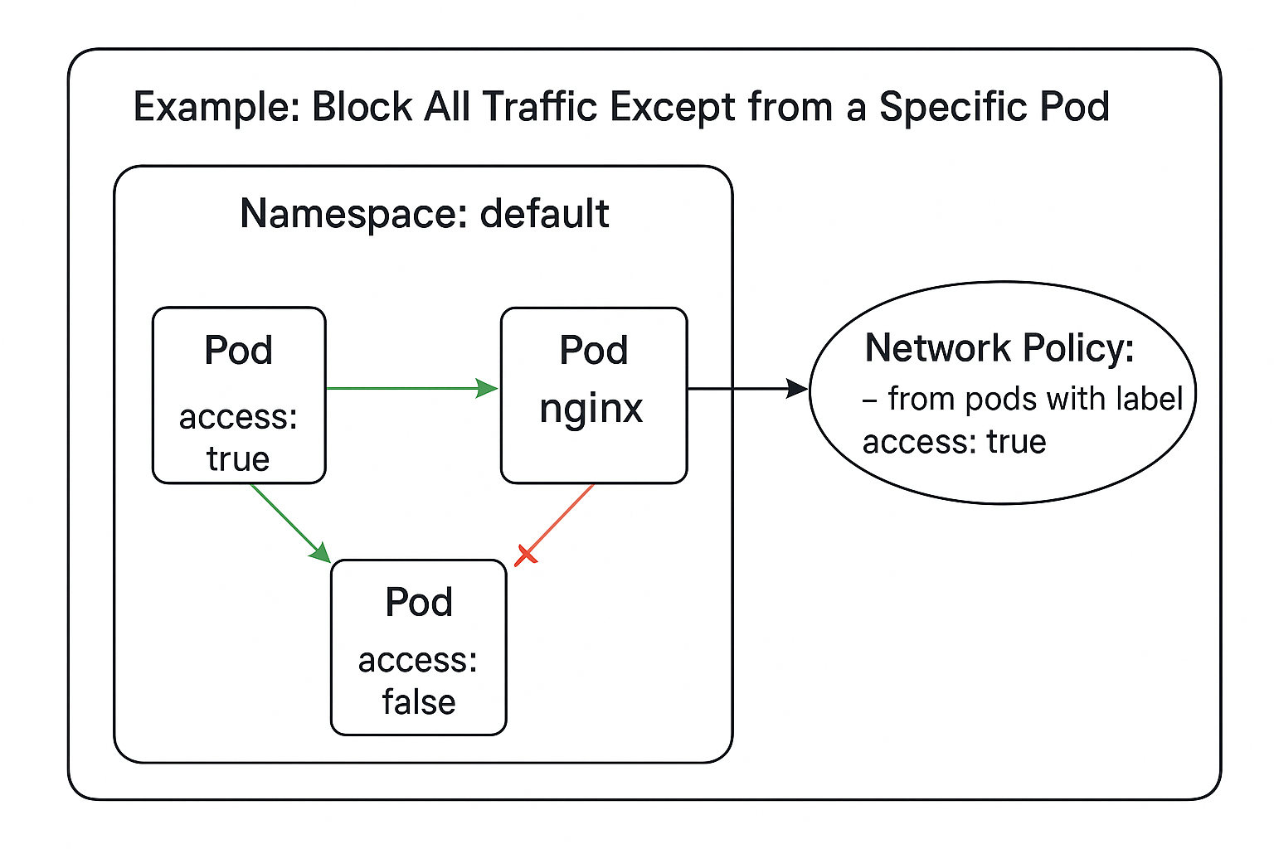

Steps of Execution

Step 1: Create the Target Pod (nginx)

nano nginx-pod.yaml

apiVersion: v1
kind: Pod
metadata:
name: nginx
labels:
app: nginx
spec:
containers:
- name: nginx
image: nginx

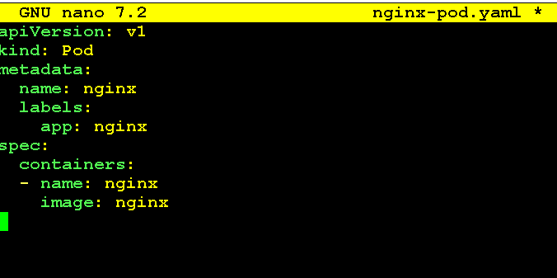

Step 2: Apply Network Policy

➡️ Now, only pods with label access=true can send traffic to nginx.
🚫 All other pods are blocked (default deny once policy is applied).

nano allow-from-specific-pod.yaml

apiVersion: networking.k8s.io/v1
kind: NetworkPolicy
metadata:
name: allow-specific
spec:
podSelector:
matchLabels:
app: nginx
ingress:
- from:
- podSelector:
matchLabels:
access: "true"

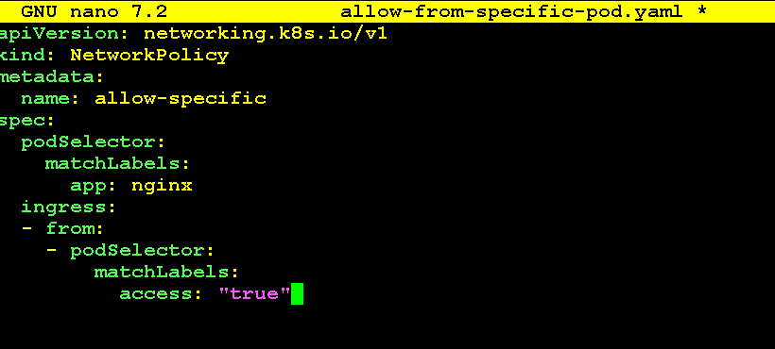

Step 3: Create an Allowed Pod

➡️ This pod is allowed to access nginx.
nano allowed-pod.yaml

apiVersion: v1
kind: Pod
metadata:
name: allowed
labels:
access: "true"
spec:
containers:
- name: busybox
image: busybox
command: ["sleep", "3600"]

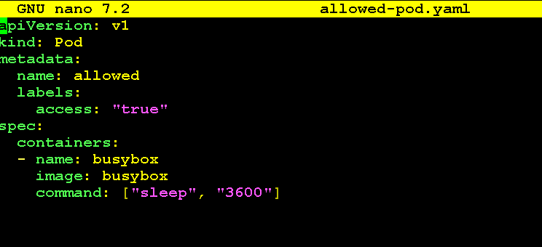

Step 4: Create PODS and Policy

kubectl apply -f nginx-pod.yaml
kubectl apply -f allow-from-specific-pod.yaml
kubectl apply -f allowed-pod.yaml

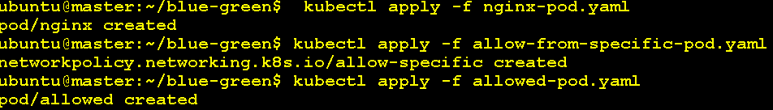

kubectl get pods

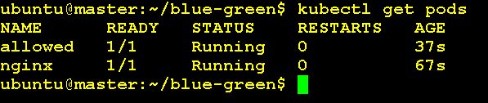

kubectl get networkpolicy

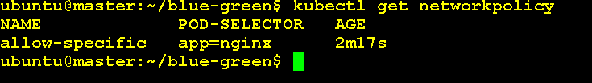

kubectl describe networkpolicy allow-specific

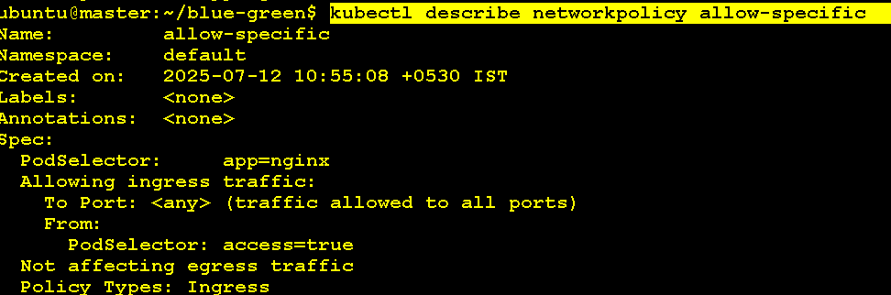

Step 5: Test Connectivity
- Expose the nginx pod as a Service

kubectl expose pod nginx --port=80 --target-port=80 --name=nginx

- Create a Denied Pod (with different label)

kubectl run denied --rm -i --tty --image=busybox --labels="access=false" -- /bin/sh

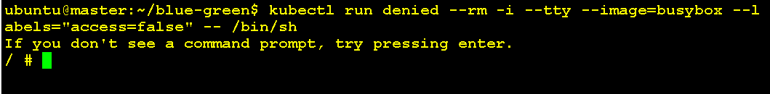
You get Interactive Terminal Inside denied pod, run below command , it should fail

wget --spider --timeout=1 nginx
# ❌ Should fail (connection timed out)

Now exit from denied port

exit
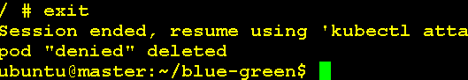

- Inside allowed pod:

kubectl exec -it allowed -- wget --spider --timeout=1 nginx

# ✅ Should succeed

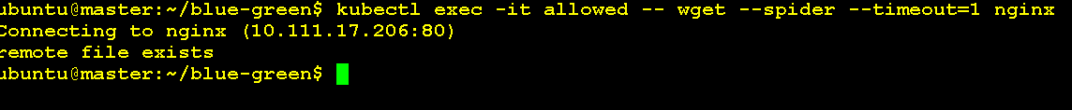

wget --spider is a way to test if the URL is reachable, without downloading the file.

When it says:

Remote file exists.

That means it successfully connected to the service and received a valid response (HTTP 200/301/etc.)

If you want to see the actual content (HTML page) served by the nginx pod (instead of just testing connectivity with --spider), you can simply remove --spider from the wget command:

kubectl exec -it allowed -- wget -qO- http://nginx

    - -q = quiet mode (suppress progress)
    - -O- = Capital O , output to stdout (i.e., print page to terminal)
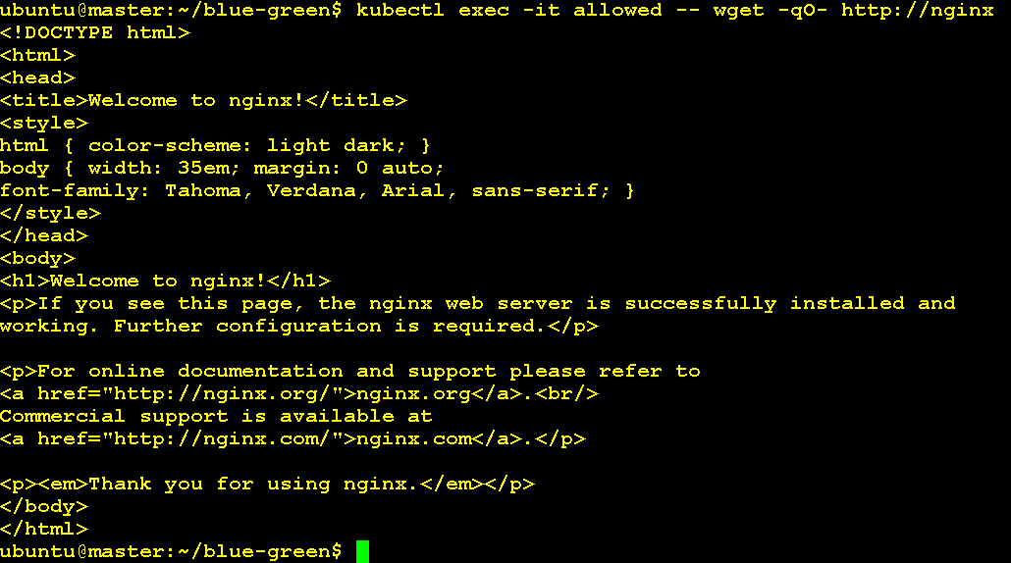

Steps to Clean

kubectl delete -f nginx-pod.yaml
kubectl delete -f allow-from-specific-pod.yaml
kubectl delete -f allowed-pod.yaml

