


Lab Manual- Kubernetes Thinking

Prepared for:

Date: 18th Dec 2023

Prepared by:
Document Name: Lab Manual Document Number AZLabn916
Contributor:

Contents
1. Objective 3
2. Pods: the smallest unit 5
1. Same Pod or separate Pods? 6
2. Scaling: horizontal and vertical 6
3. Example: your first Pod 6
3. Problems with Pods (Why Use ReplicaSets instead?) 8
1. ReplicaSet 8
4. Kubernetes Objects 10
1. The four parts of every YAML file 10
2. Everyday commands 10
3. The object family at a glance 11
5. Workloads: running your apps 13
1. Deployment 13
2. StatefulSet 14
3. DaemonSet 15
4. Job 16
5. CronJob 16
6. Which workload should I use? 17
6. Networking: reaching your apps 18
1. Service 18
2. Ingress 19
7. Configuration: ConfigMaps and Secrets 21
1. ConfigMap 21
2. Secret 21
8. Storage: keeping data safe 23
1. PersistentVolume (PV) 23
2. PersistentVolumeClaim (PVC) 23
3. StorageClass 24
9. Organising and securing the cluster 25
1. Namespace 25
2. RBAC in one picture 25
3. ServiceAccount 26
4. Role 26
5. ClusterRole 27
6. RoleBinding 27
7. ClusterRoleBinding 27
10. Scaling and reliability 29
1. HorizontalPodAutoscaler (HPA) 29
2. PodDisruptionBudget (PDB) 30
11. Cheat sheet and self-check 31
1. All objects on one page 31
2. Self-check questions 31

Objective
This lab manual teaches you to think the Kubernetes way: you describe what you want, and Kubernetes keeps working, all day and every day, to make it true. Instead of logging in to servers and starting programs by hand, you hand Kubernetes a short YAML file and let it do the rest.
To keep things concrete, every object in this manual has a real job in one running example: QuickBite, an online food-ordering app.
By the end of this lab you will know that:
- Pods run your containers.
- ReplicaSets keep the right number of Pods alive.
- Deployments roll out new versions safely (they manage ReplicaSets for you).
- Services give Pods a stable address, and Ingress brings in traffic from outside.
- ConfigMaps and Secrets configure Pods without rebuilding images.
- Labels are the glue that ties all of these together.
Meet QuickBite, our example app
Part of the app | What it does | Kubernetes objects that run it
Website (web) | The page customers use to browse menus and order | Deployment + Service + Ingress
Orders API (api) | Takes, tracks and updates orders | Deployment + Service + HorizontalPodAutoscaler
Database (postgres) | Stores menus, customers and orders | StatefulSet + PersistentVolumeClaim
Log agent | Ships logs from every server to one place | DaemonSet
Nightly sales report | Emails yesterday’s sales to managers at 2 AM | CronJob
Settings and passwords | Database address, API keys, log level | ConfigMap + Secret
Teams and environments | dev, test and prod kept apart; people get only the access they need | Namespace + RBAC

How to read Figure 1
In Figure 1, notice the label app=web on each Pod. The Service uses it to decide where to send traffic, and the ReplicaSet uses it to count how many Pods exist. Labels are just name tags, but almost everything in Kubernetes finds things by label.

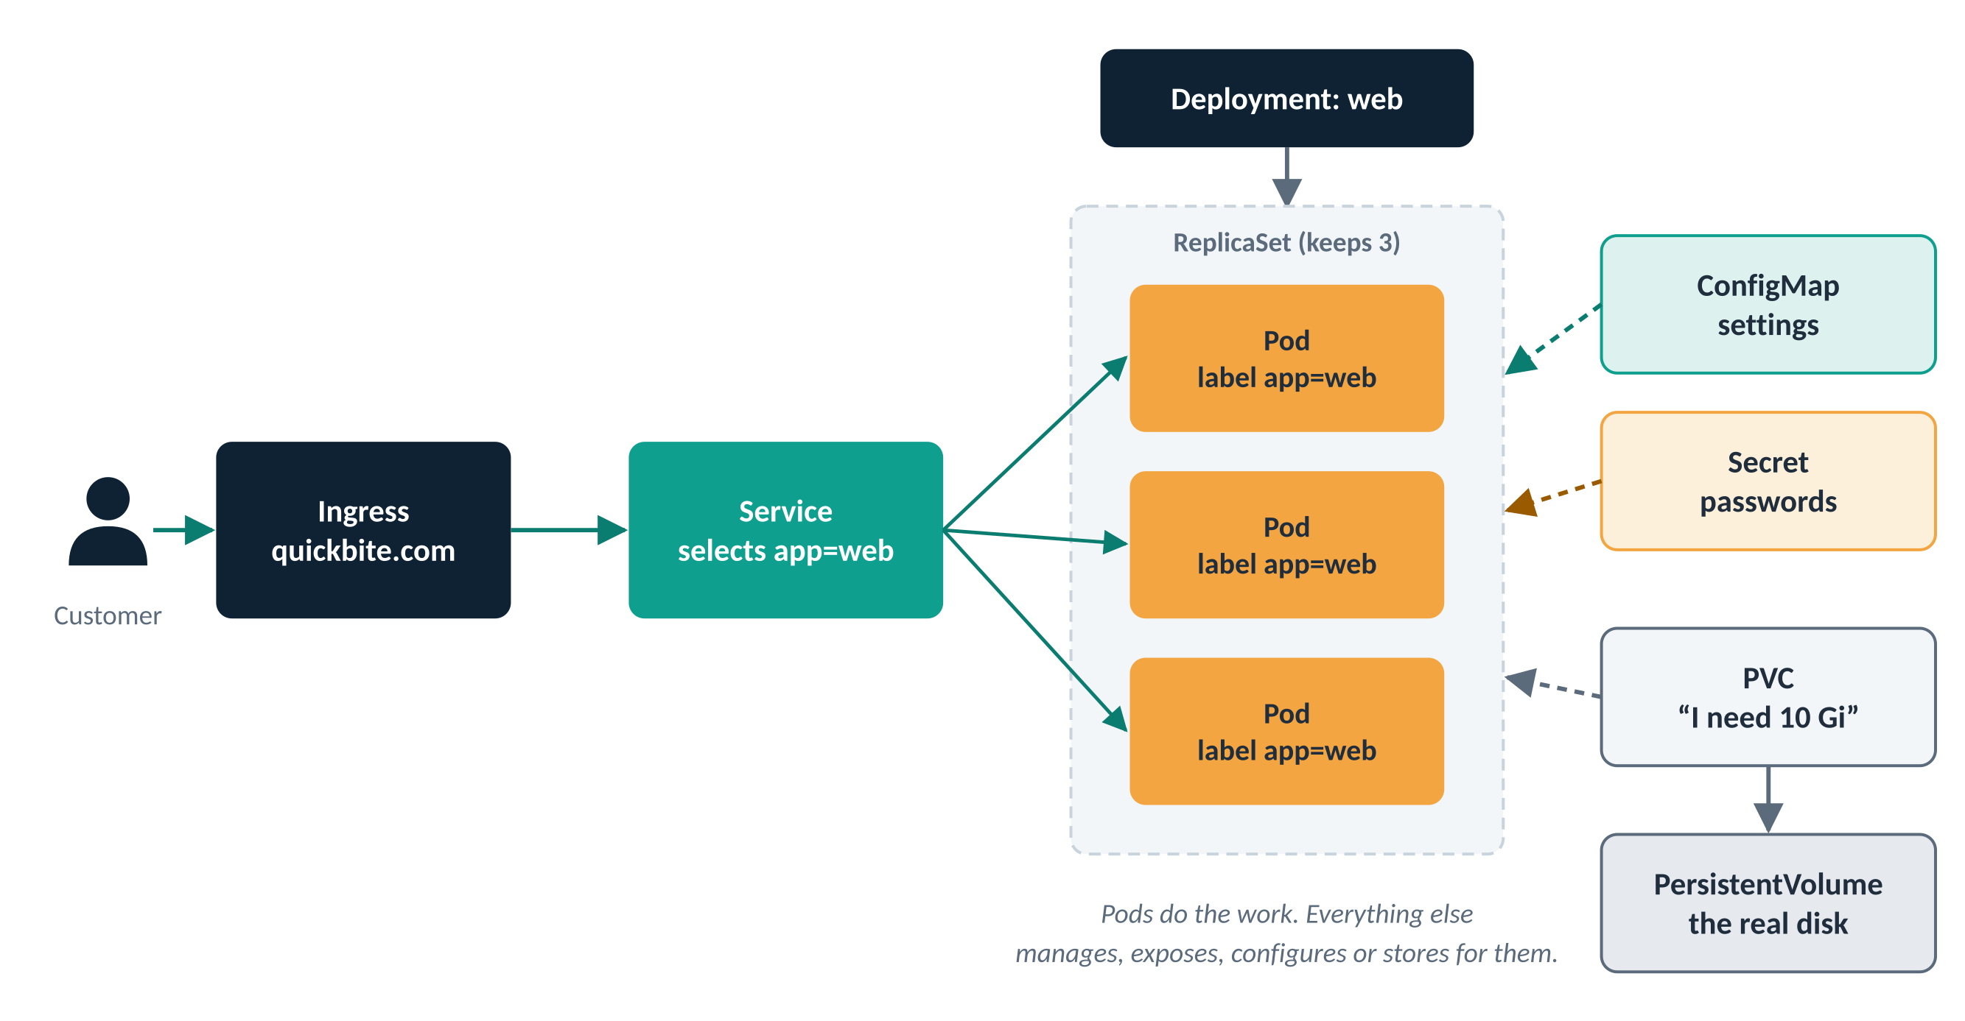
Figure 1: How the main objects fit together for QuickBite’s website

Pods: the smallest unit
A Pod is a small wrapper around one or more containers that belong together. Kubernetes never runs a bare container: it always runs a Pod.
It is tempting to think of a Kubernetes node as “the machine”, like servers in the past. That is not quite right. A Pod is the closest thing to the old idea of a machine: it has its own IP address, its own hostname, and the programs inside it can talk to each other on localhost.
Think of it as
A flat in an apartment building. The containers inside are flatmates: they share the address (IP), the front door (ports) and the kitchen (volumes), but each has their own room (their own CPU and memory limits). The building is the node. Neighbours in other flats live in the same building but do not share your flat.

What containers in the same Pod share
Resource | Shared inside a Pod? | What it means in practice
Network namespace (IP, ports) | Shared | Containers reach each other on localhost; they must not use the same port.
Hostname (UTS namespace) | Shared | Every container sees the same hostname.
IPC namespace | Shared | Containers can use shared memory or message queues with each other.
Storage (volumes) | Shared, if mounted | One container can write a file that the other reads.
cgroup (CPU and memory limits) | Private | The only private thing: each container has its own resource limits.

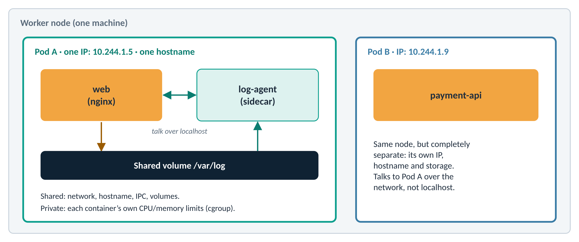
Figure 2: Two containers sharing one Pod, and a separate Pod on the same node
The big difference is that different Pods, even those scheduled on the same node, are isolated from each other. They do not share a hostname, an IP address or an IPC namespace. They talk over the network like two separate machines.
QuickBite use case
QuickBite’s web container writes access logs into /var/log. A small log-agent sidecar in the same Pod reads that folder and ships the logs to a central system. The two must start, stop and move together, so they share a Pod. The payment-api has nothing to do with the website, so it gets its own Pod.

Same Pod or separate Pods?
Put containers in the SAME Pod when… | Use SEPARATE Pods when…
They must share files or talk over localhost | They can run on their own
They must always start, stop and move together | They need to scale differently
One is a helper for the other (a “sidecar”): log shipper, proxy, security agent | They are different parts of the app, such as web and database

Scaling: horizontal and vertical
All of these components need to be scaled separately, and in different ways. A stateless web app can easily scale horizontally: just run 20 extra copies of it. A database usually scales vertically: you keep a single copy of the PostgreSQL process and give it more memory and CPU time.
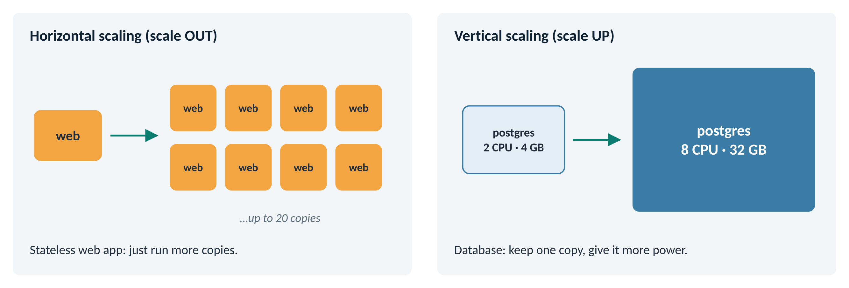
Figure 3: Scale out by adding copies; scale up by adding power to one copy
QuickBite use case
Friday, 8 PM, the dinner rush. QuickBite scales web from 3 copies to 20 in a couple of minutes. The postgres database was given 8 CPUs and 32 GB of memory ahead of the weekend, because you cannot simply run 20 independent copies of one database.

Example: your first Pod
apiVersion: v1
kind: Pod
metadata:
name: example-pod
labels:
app: example
spec:
containers:
- name: container-1
image: nginx
ports:
- containerPort: 80
Try it
kubectl apply -f pod.yaml # create the Pod
kubectl get pods -o wide # status, node and IP
kubectl describe pod example-pod # details and events
kubectl logs example-pod # what the container printed
kubectl exec -it example-pod -- sh # open a shell inside it
kubectl delete pod example-pod # remove it

Problems with Pods (Why Use ReplicaSets instead?)
A Pod on its own has no one looking after it. It is like a single delivery rider with no manager: if they fall ill, nobody sends a replacement.
Problem with a bare Pod | What actually happens | How a ReplicaSet fixes it
A node fails after the Pod is scheduled | The Pod is lost and is not rescheduled anywhere | It notices the missing Pod and creates a new one on a healthy node
You need several copies of the same Pod | You would have to copy the YAML and rename every Pod by hand | Set replicas: 3 and it keeps exactly three running
A Pod is stuck on one node | Once scheduled, a Pod never moves | It deletes and recreates Pods, so work can land on other nodes

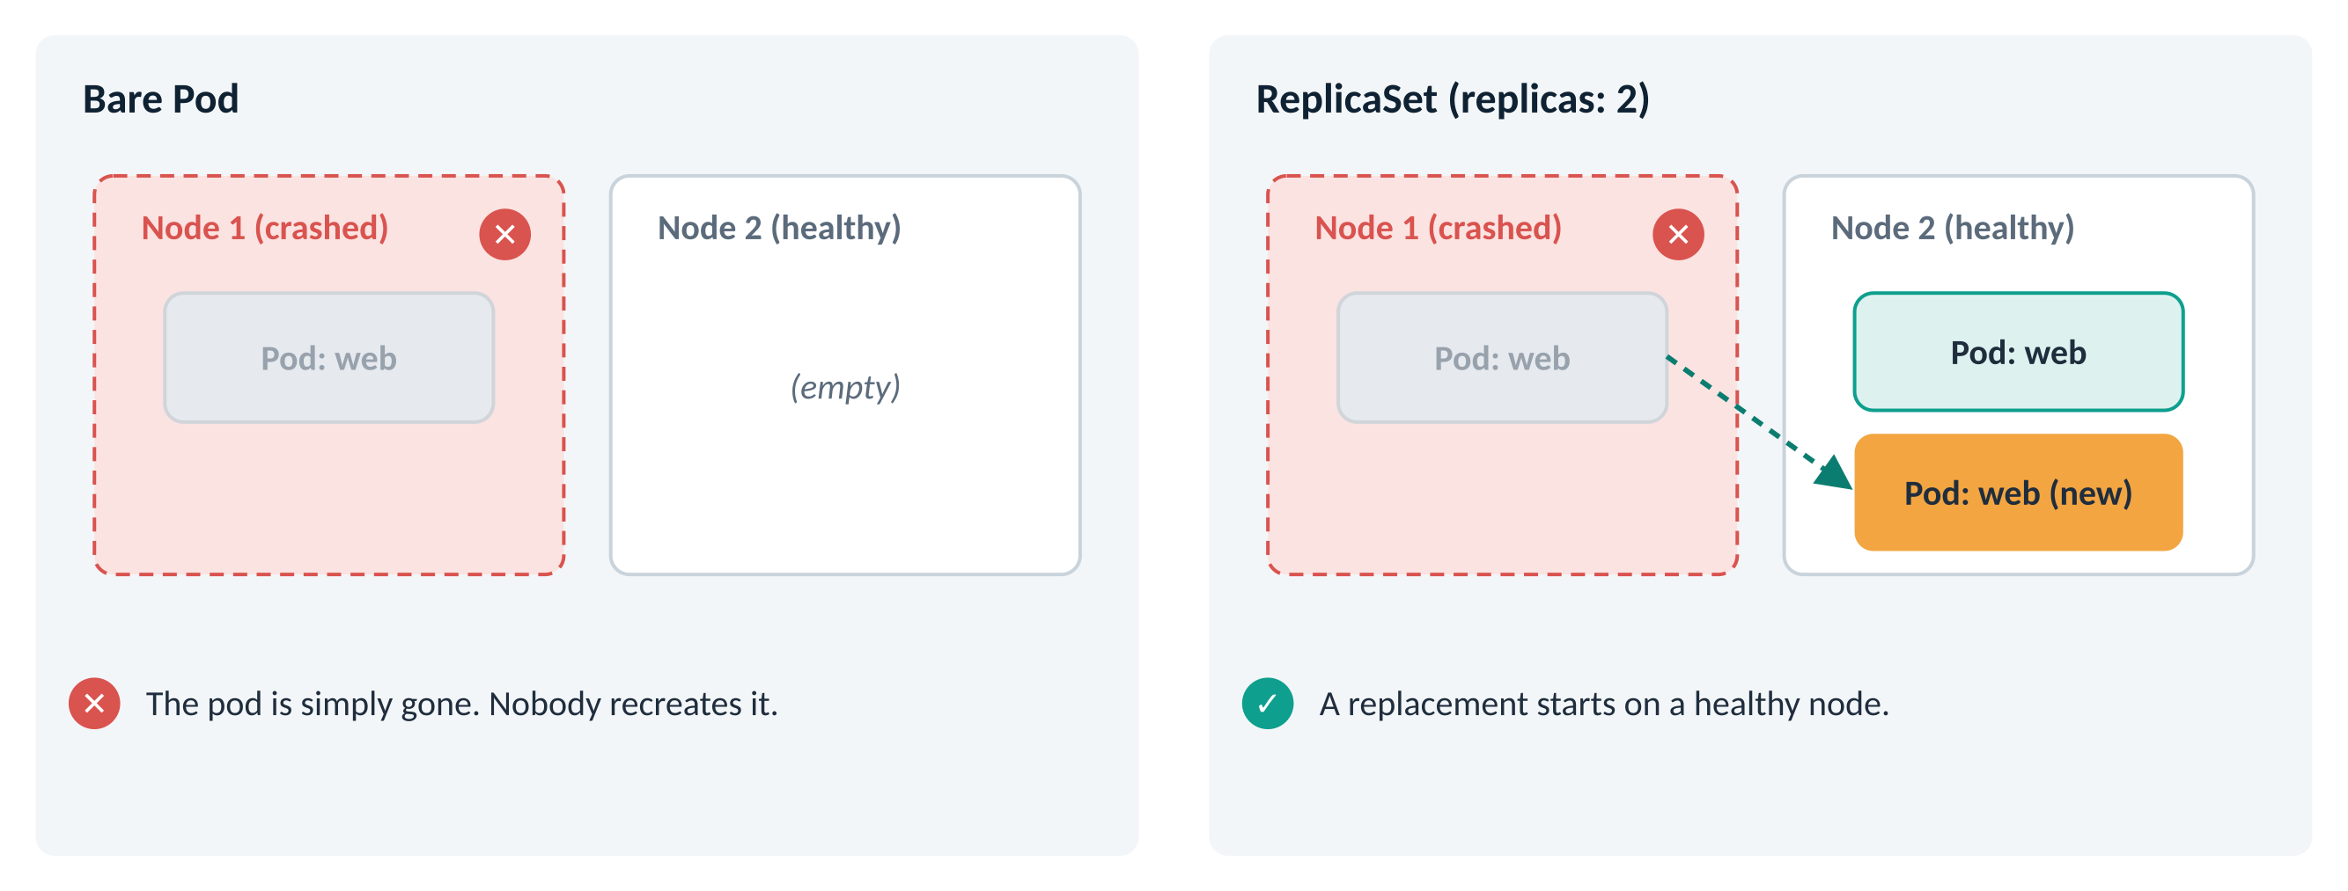
Figure 4: What happens when a node crashes: bare Pod vs ReplicaSet

ReplicaSet
In one line: a ReplicaSet keeps a stable number of identical Pods running at all times.
Think of it as
A shift manager who must always keep three counters open. If one cashier goes home sick, the manager calls in someone new straight away. Nobody has to ask.

apiVersion: apps/v1
kind: ReplicaSet
metadata:
name: web-rs
spec:
replicas: 3
selector:
matchLabels:
app: web # "count every Pod with this label"
template: # the Pod to create when one is missing
metadata:
labels:
app: web
spec:
containers:
- name: web
image: nginx
Try it: watch self-healing happen
kubectl apply -f replicaset.yaml
kubectl get pods -l app=web # three Pods
kubectl delete pod <one-of-the-pods> # "crash" one
kubectl get pods -l app=web -w # a new one appears within seconds
Note
In real projects you rarely create ReplicaSets yourself. You create a Deployment, and it creates and manages the ReplicaSet for you (see the Workloads section).

Kubernetes Objects
Every Kubernetes object is a record of what you want. Objects are:
- written as YAML (or JSON) files,
- sent to the Kubernetes API with kubectl,
- (or received as output from kubectl after it queries the Kubernetes API for you).
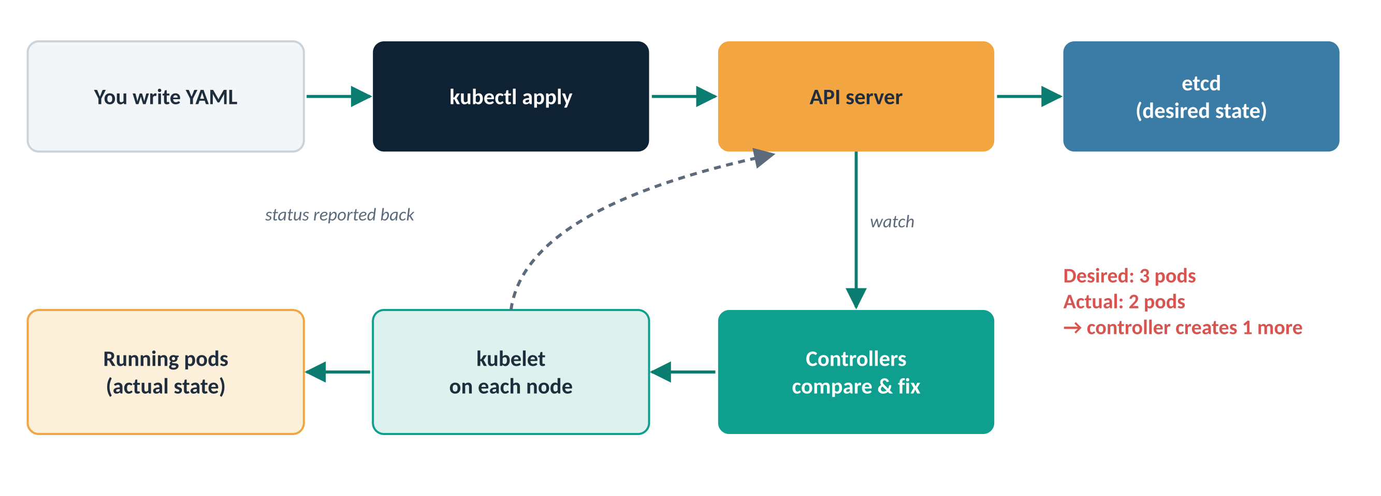
Figure 5: You declare the desired state; controllers keep the actual state matching it
Think of it as
An air-conditioner thermostat. You set 24 °C once. The AC keeps measuring and correcting on its own; you never switch the compressor on and off yourself. Kubernetes controllers work the same way with Pods, disks and network rules.

The four parts of every YAML file
Field | What it says | Bank-form comparison
apiVersion | Which version of the Kubernetes API understands this object | The edition of the form
kind | What you are creating: Pod, Service, Deployment… | The type of form: “New account”
metadata | Name, namespace and labels, so you can find it later | Your name and branch
spec | What you actually want: image, ports, number of copies… | What you are requesting

Everyday commands
Whatever type of object you are dealing with, the basic syntax is the same:
kubectl apply -f obj.yaml
Command | What it does
kubectl apply -f obj.yaml | Create the object, or update it if it already exists
kubectl get pods / deploy / svc | List objects of a type
kubectl describe pod <name> | Show full details, including recent events
kubectl edit <resource> <name> | Edit the live object in your text editor
kubectl diff -f obj.yaml | Preview what apply would change, before changing it
kubectl delete -f obj.yaml | Remove the objects described in the file
kubectl explain deployment.spec | Built-in documentation for any field

You can edit an object interactively with kubectl edit <resource-name> <obj-name>. This will:
- download a YAML copy of the object from the Kubernetes API,
- open your $EDITOR on that text file,
- upload your saved changes to the Kubernetes API, which re-evaluates the object and makes the necessary changes.
Tip
Prefer changing the YAML file in Git and running kubectl apply. Your change is then saved, reviewable and repeatable. Keep kubectl edit for quick experiments.

The object family at a glance
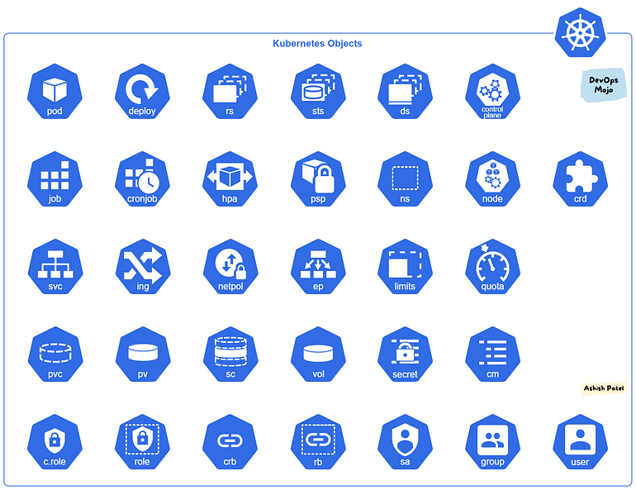
Figure 6: The main Kubernetes object types
Group | Objects | Question it answers
Workloads | Pod, ReplicaSet, Deployment, StatefulSet, DaemonSet, Job, CronJob | What runs, and how?
Networking | Service, Ingress | How do people and other apps reach it?
Configuration | ConfigMap, Secret | How is it configured?
Storage | PersistentVolume, PersistentVolumeClaim, StorageClass | Where is the data kept?
Organisation and access | Namespace, ServiceAccount, Role, ClusterRole, RoleBinding, ClusterRoleBinding | Who can do what, and where?
Scaling and reliability | HorizontalPodAutoscaler, PodDisruptionBudget | How does it cope with load and maintenance?

The rest of this manual walks through each group. For every object you get a one-line definition, an everyday comparison, a QuickBite use case and a working YAML example.

Workloads: running your apps

Deployment
In one line: a Deployment runs a set of identical Pods and replaces them safely when you ship a new version. It manages the creation and scaling of Pods through ReplicaSets.
Think of it as
A restaurant manager changing the menu one table at a time. Diners keep eating while the switch happens, and if the new dish is a disaster the old menu comes straight back.

QuickBite use case
On a Tuesday afternoon the team ships api v1.6. The Deployment starts one new Pod, waits until it is healthy, then removes one old Pod, and repeats. Customers keep ordering throughout. When a bug shows up, one command rolls back to v1.5.

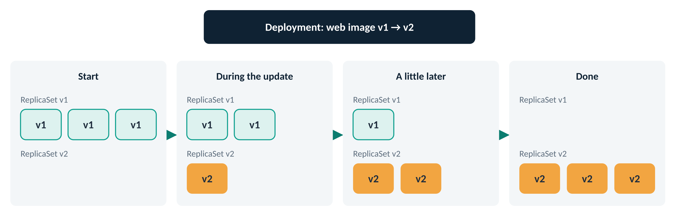
Figure 7: A rolling update: the Deployment grows the new ReplicaSet and shrinks the old one
apiVersion: apps/v1
kind: Deployment
metadata:
name: example-deployment
spec:
replicas: 3
selector:
matchLabels:
app: example
template:
metadata:
labels:
app: example
spec:
containers:
- name: container-1
image: nginx:1.25
resources:
requests: # needed later for autoscaling
cpu: 100m
memory: 128Mi
Try it
kubectl apply -f deployment.yaml
kubectl set image deployment/example-deployment container-1=nginx:1.26
kubectl rollout status deployment/example-deployment
kubectl rollout history deployment/example-deployment
kubectl rollout undo deployment/example-deployment # back to 1.25
kubectl scale deployment/example-deployment --replicas=5

StatefulSet
In one line: a StatefulSet runs Pods that need a fixed identity: a stable name, a stable network address and their own disk, kept across restarts.
Think of it as
Numbered lockers at a gym. Locker 0 always holds the same person’s things. If the locker door breaks, it is repaired and the same things go back inside; they are not handed to someone else.

QuickBite use case
QuickBite’s postgres database. Its Pod is always called db-0 and always gets back the same disk after a restart, so no orders are lost. Other common examples: Kafka, Elasticsearch, MongoDB, Redis clusters.

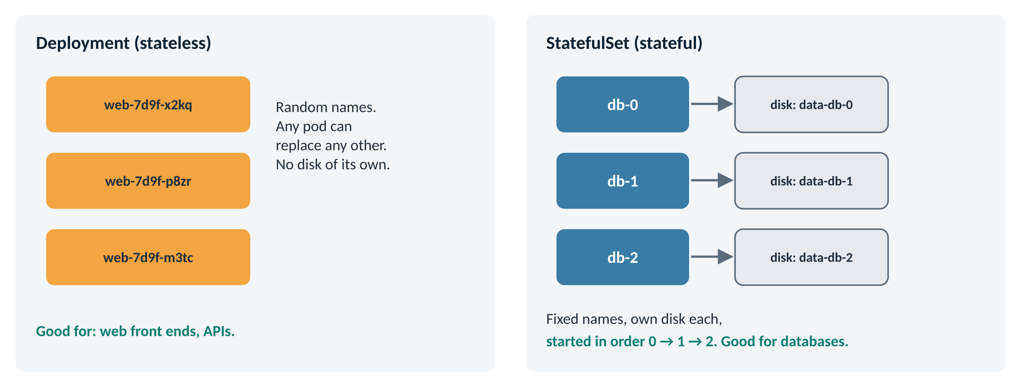
Figure 8: Deployment Pods are interchangeable; StatefulSet Pods keep their names and disks
In this example, the StatefulSet (example-statefulset) keeps three replicas of the Nginx container running. It uses a volumeClaimTemplate to create a PersistentVolumeClaim with a unique name for each replica (data-example-statefulset-0, -1, -2). A “headless” Service gives each Pod its own stable DNS name.
apiVersion: v1
kind: Service
metadata:
name: example
spec:
clusterIP: None # headless: one DNS name per Pod
selector:
app: example-app
ports:
- port: 80
---
apiVersion: apps/v1
kind: StatefulSet
metadata:
name: example-statefulset
spec:
serviceName: "example"
replicas: 3
selector:
matchLabels:
app: example-app
template:
metadata:
labels:
app: example-app
spec:
containers:
- name: web
image: nginx:latest
ports:
- containerPort: 80
volumeMounts:
- name: data
mountPath: /usr/share/nginx/html
volumeClaimTemplates:
- metadata:
name: data
spec:
accessModes: [ "ReadWriteOnce" ]
resources:
requests:
storage: 1Gi

DaemonSet
In one line: a DaemonSet makes sure every node (or every node that matches a rule) runs exactly one copy of a Pod. Add a node and the Pod appears on it automatically.
Think of it as
A security guard on every floor of an office building. Open a new floor and a guard is posted there on day one.

QuickBite use case
QuickBite’s log-agent must collect logs from every server. Other typical DaemonSets: node monitoring (such as Prometheus node-exporter), network plugins (such as Calico) and storage drivers.

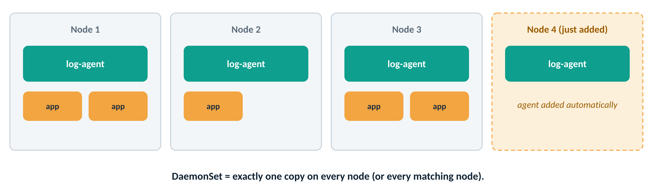
Figure 9: One agent Pod per node, including nodes added later
In this DaemonSet example (example-daemonset), a copy of the busybox container runs on each node in the cluster. The container prints a message every 10 seconds.
apiVersion: apps/v1
kind: DaemonSet
metadata:
name: example-daemonset
spec:
selector:
matchLabels:
app: example-app
template:
metadata:
labels:
app: example-app
spec:
containers:
- name: daemon-container
image: busybox:latest
command: ["/bin/sh", "-c", "while true; do echo Hello from $(hostname); sleep 10; done"]
Try it
kubectl get pods -l app=example-app -o wide # one Pod per node

Job
In one line: a Job creates one or more Pods and makes sure a set number of them finish successfully. If a Pod fails, the Job retries it.
Think of it as
A one-off task such as “deep-clean the kitchen tonight”. Once it is done, it is done; nobody keeps cleaning forever.

QuickBite use case
Before releasing api v1.6, QuickBite runs a database migration Job that adds a new column. Other examples: importing a menu file, sending month-end invoices.

apiVersion: batch/v1
kind: Job
metadata:
name: db-migrate
spec:
backoffLimit: 3 # retry up to 3 times if it fails
template:
spec:
restartPolicy: Never
containers:
- name: migrate
image: busybox:latest
command: ["/bin/sh", "-c", "echo Migrating database...; sleep 5; echo Done"]

CronJob
In one line: a CronJob creates a Job on a repeating schedule.
Think of it as
An alarm clock that starts the same task at the same time every day.

QuickBite use case
Every night at 2 AM QuickBite builds a sales report and emails it to managers.

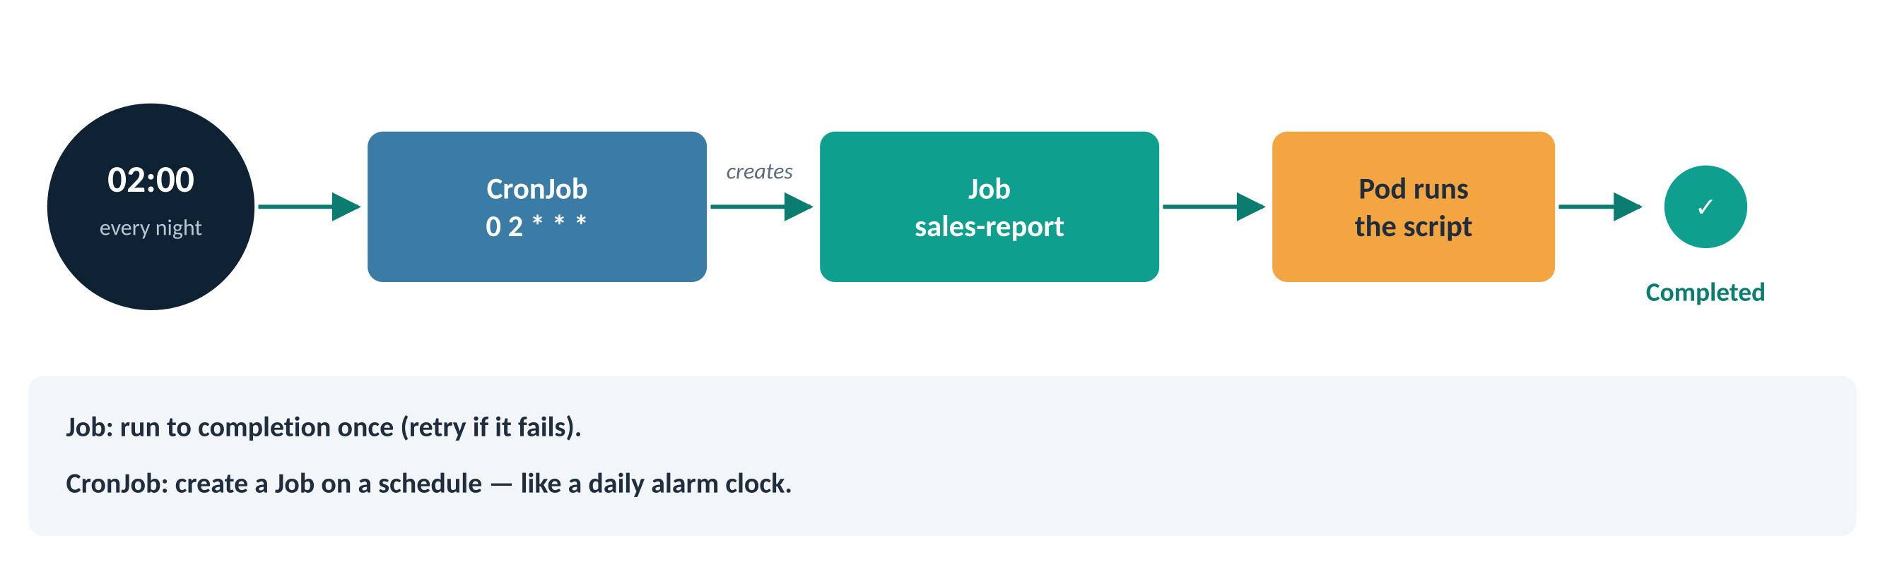
Figure 10: A CronJob creates a Job on schedule; the Job runs a Pod until it completes
The schedule uses standard cron format: minute hour day-of-month month day-of-week. 0 2 * * * means “at 02:00 every day”. For a quick lab test, use */1 * * * * to run every minute.
apiVersion: batch/v1
kind: CronJob
metadata:
name: sales-report
spec:
schedule: "0 2 * * *" # lab tip: "*/1 * * * *" = every minute
jobTemplate:
spec:
template:
spec:
restartPolicy: OnFailure
containers:
- name: report
image: busybox:latest
command: ["/bin/sh", "-c", "date; echo Building yesterday's sales report"]
Try it
kubectl get cronjobs
kubectl get jobs --watch # a new Job each run
kubectl create job manual-run --from=cronjob/sales-report # run it now

Which workload should I use?
Your situation | Use | QuickBite example
Stateless app, many identical copies | Deployment | web, api
Each copy needs its own name and disk | StatefulSet | postgres
One copy on every node | DaemonSet | log-agent
Run once until it finishes | Job | database migration
Run on a schedule | CronJob | nightly sales report
Quick test or debugging only | Pod | a throw-away busybox shell

Networking: reaching your apps

Service
In one line: a Service exposes a set of Pods as a network service with a stable IP address and DNS name, and spreads traffic across them.
Think of it as
A customer-care phone number. The number never changes, even though a different agent answers each call. The Service is the number; the Pods are the agents.

QuickBite use case
QuickBite’s website calls the orders API at http://orders-svc. Pods come and go and get new IPs, but that name keeps working.

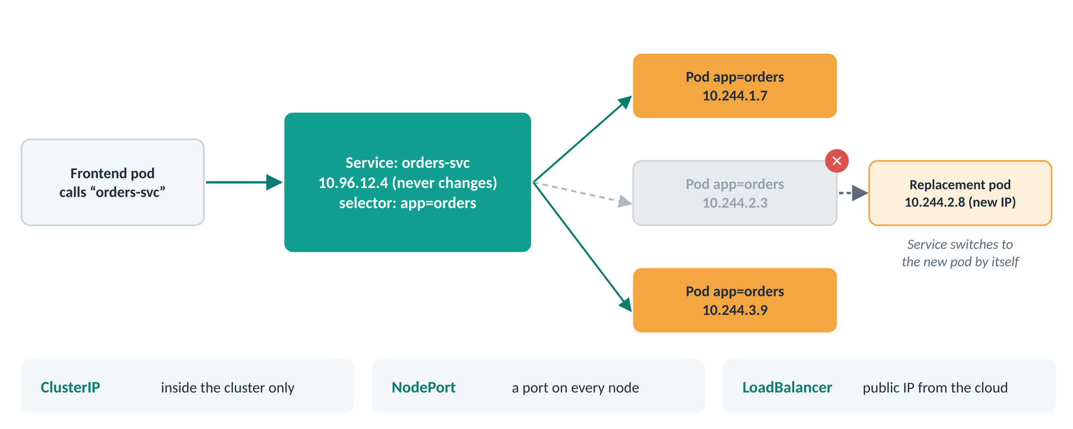
Figure 11: The Service keeps the same address while the Pods behind it change
apiVersion: v1
kind: Service
metadata:
name: example-service
spec:
type: ClusterIP # the default
selector:
app: example # send traffic to Pods with this label
ports:
- protocol: TCP
port: 80 # port the Service listens on
targetPort: 80 # port the container listens on
Service type | Who can reach it | Typical use
ClusterIP (default) | Only apps inside the cluster | web → api, api → database
NodePort | Anyone who can reach a node, on a port from 30000–32767 | Labs and quick testing
LoadBalancer | The internet, through a cloud load balancer with a public IP | Production entry point for one app

Try it
kubectl get svc example-service
kubectl get endpoints example-service # the Pod IPs behind it
kubectl run tmp --rm -it --image=busybox -- wget -qO- http://example-service

Ingress
In one line: an Ingress manages external HTTP(S) access to Services, routing requests by host name and URL path.
Think of it as
A shopping mall entrance with a directory board: one door in, and signs sending you to the food court, the cinema or the shops.

QuickBite use case
One public address serves the whole of QuickBite: quickbite.com/ goes to the website, quickbite.com/api goes to the orders API, and admin.quickbite.com goes to the admin portal. Without Ingress, each would need its own paid load balancer and public IP.

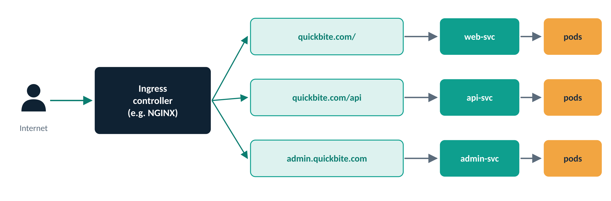
Figure 12: One Ingress routing to three Services by host and path
In this example, the Ingress defines rules for the host example.com. Requests to /app go to the Service app-service on port 80; everything else goes to web-service.
apiVersion: networking.k8s.io/v1
kind: Ingress
metadata:
name: example-ingress
spec:
ingressClassName: nginx
rules:
- host: example.com
http:
paths:
- path: /app
pathType: Prefix
backend:
service:
name: app-service
port:
number: 80
- path: /
pathType: Prefix
backend:
service:
name: web-service
port:
number: 80
Note
An Ingress is only a set of rules. It needs an Ingress controller (for example ingress-nginx) running in the cluster to act on them. The newer Gateway API does the same job with more features.

Configuration: ConfigMaps and Secrets
The golden rule is build once, configure everywhere. The same container image should run in dev, test and prod; only the settings change. Hard-coding a database address or password inside the image breaks that rule and is a security risk.
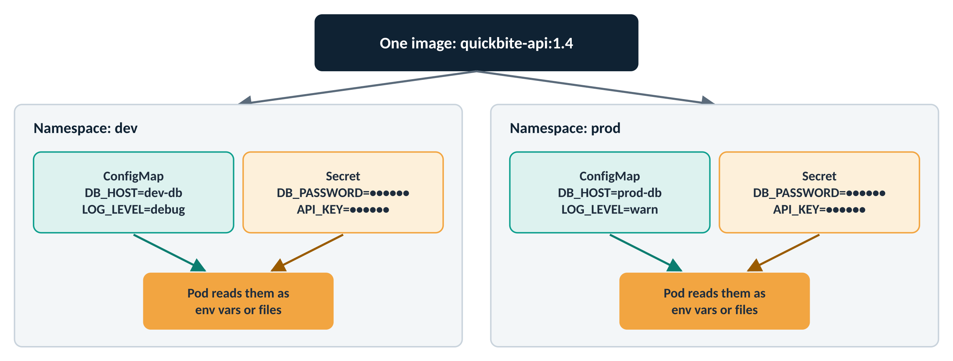
Figure 13: One image, different settings per environment

ConfigMap
In one line: a ConfigMap holds non-secret configuration data as key-value pairs for Pods to use.
Think of it as
The settings screen of an app on your phone: the app stays the same, and you change how it behaves.

QuickBite use case
In dev, QuickBite’s API points at dev-db with LOG_LEVEL=debug. In prod it points at prod-db with LOG_LEVEL=warn. Same image, two ConfigMaps.

apiVersion: v1
kind: ConfigMap
metadata:
name: example-configmap
data:
DB_HOST: dev-db
LOG_LEVEL: debug
app.properties: |
feature.newCheckout=true
orders.pageSize=20
Using it in a Pod (as environment variables)
spec:
containers:
- name: api
image: quickbite/api:1.6
envFrom:
- configMapRef:
name: example-configmap

Secret
In one line: a Secret stores sensitive information, such as passwords, tokens and keys, in base64-encoded form.
Think of it as
A sealed envelope. People can’t read it at a glance, but it is sealed, not locked: anyone allowed to open it can read it.

apiVersion: v1
kind: Secret
metadata:
name: example-secret
type: Opaque
stringData: # plain text here; Kubernetes stores it base64-encoded
DB_USER: quickbite
DB_PASSWORD: S3cure!Pass
Try it: see why base64 is not encryption
kubectl create secret generic db-cred --from-literal='DB_PASSWORD=S3cure!Pass'
# read the stored value - it is only base64
kubectl get secret db-cred -o jsonpath='{.data.DB_PASSWORD}'
# decode it: prints S3cure!Pass
kubectl get secret db-cred -o jsonpath='{.data.DB_PASSWORD}' | base64 -d
Watch out
Base64 is encoding, not encryption. Anyone who can read the Secret can decode it in one command.
Protect Secrets by turning on encryption at rest for etcd, limiting who can read them with RBAC, and never committing Secret YAML with real values to Git.

 | ConfigMap | Secret
Holds | Ordinary settings | Passwords, tokens, keys, certificates
Stored as | Plain text | Base64-encoded (can be encrypted at rest)
Used as | Environment variables or files | Environment variables or files
QuickBite example | DB_HOST, LOG_LEVEL | DB_PASSWORD, payment API key

Storage: keeping data safe
Files written inside a container disappear when the container restarts. That is fine for a web server, but a database would lose every order. Kubernetes solves this with three objects that separate “what I need” from “what exists”.
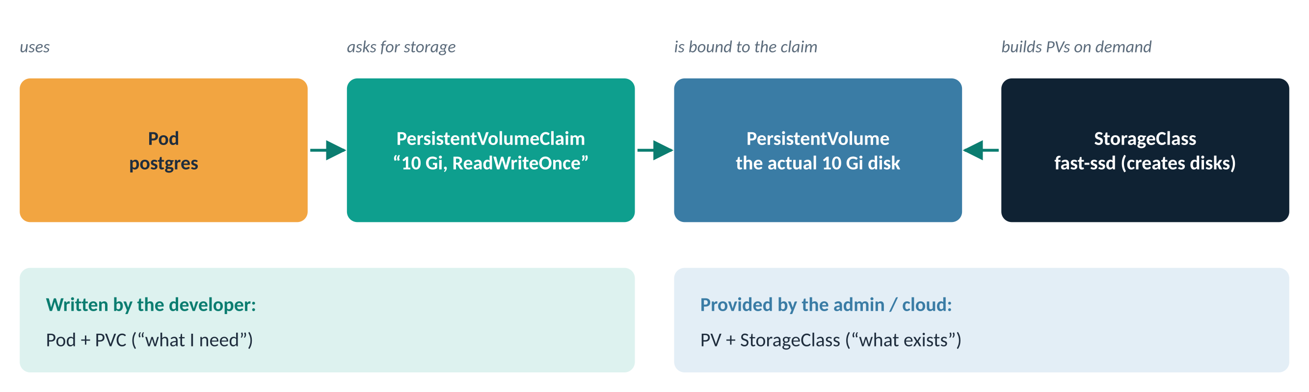
Figure 14: Pod → PersistentVolumeClaim → PersistentVolume, created by a StorageClass
Think of it as
Booking a hotel room. You ask for “a room with two beds” (the claim). The hotel gives you an actual room (the volume). A large hotel chain can build new rooms on demand (the StorageClass).

PersistentVolume (PV)
In one line: a piece of storage in the cluster, provisioned by an administrator or created automatically by a StorageClass.
This example uses hostPath to represent a folder on the node (fine for labs, not for production). It has a capacity of 1Gi, the ReadWriteOnce access mode, and Retain keeps the data even when the claim is deleted.
apiVersion: v1
kind: PersistentVolume
metadata:
name: example-pv
spec:
capacity:
storage: 1Gi
accessModes:
- ReadWriteOnce
persistentVolumeReclaimPolicy: Retain
storageClassName: manual
hostPath:
path: /mnt/data

PersistentVolumeClaim (PVC)
In one line: a request for storage. Kubernetes finds (or creates) a matching PersistentVolume and binds it to the claim.
QuickBite use case
QuickBite’s database asks for 10 Gi of fast disk. The developer never needs to know which cloud disk it ends up on.

apiVersion: v1
kind: PersistentVolumeClaim
metadata:
name: example-pvc
spec:
storageClassName: manual # matches the PV above
accessModes:
- ReadWriteOnce
resources:
requests:
storage: 1Gi
Using the claim in a Pod
apiVersion: v1
kind: Pod
metadata:
name: pvc-demo
spec:
containers:
- name: app
image: nginx
volumeMounts:
- name: data
mountPath: /usr/share/nginx/html
volumes:
- name: data
persistentVolumeClaim:
claimName: example-pvc

StorageClass
In one line: a StorageClass describes a type of storage (fast SSD, cheap HDD…) and creates PersistentVolumes automatically when a claim asks for that type.
apiVersion: storage.k8s.io/v1
kind: StorageClass
metadata:
name: fast-ssd
provisioner: ebs.csi.aws.com # depends on your cloud or storage system
parameters:
type: gp3
reclaimPolicy: Delete
volumeBindingMode: WaitForFirstConsumer
allowVolumeExpansion: true
Access mode | Plain meaning
ReadWriteOnce (RWO) | Read-write, mounted by one node at a time. Most block disks.
ReadOnlyMany (ROX) | Read-only, many nodes at once.
ReadWriteMany (RWX) | Read-write from many nodes at once. Needs shared storage such as NFS.
ReadWriteOncePod (RWOP) | Read-write by a single Pod only.

Reclaim policy: Retain keeps the disk and its data after the claim is deleted (an admin cleans up by hand). Delete removes the disk too.

Organising and securing the cluster

Namespace
In one line: a Namespace divides one cluster into separate areas for different teams, projects or environments.
Think of it as
Folders on a shared drive, or floors in an office building. Two teams can each have a file called “web” as long as it is in a different folder.

QuickBite use case
QuickBite runs dev, test and prod in one cluster. Each has its own web, its own Secrets and its own CPU quota, so a load test in test cannot starve production.

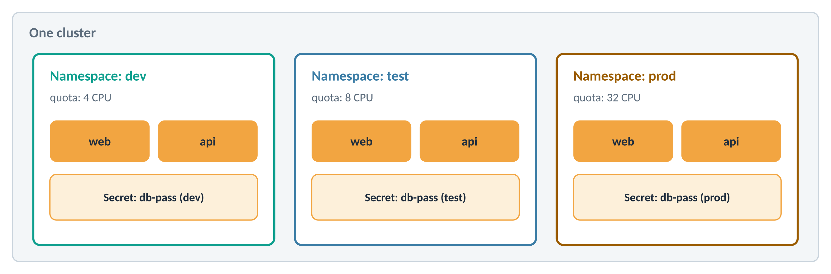
Figure 15: Three namespaces in one cluster, each with its own objects and quota
apiVersion: v1
kind: Namespace
metadata:
name: example-namespace
Try it
kubectl create namespace dev
kubectl get pods -n dev
kubectl get pods -A # all namespaces
kubectl config set-context --current --namespace=dev # make dev the default

RBAC in one picture
Role-Based Access Control answers one question: who can do what, and where? It always has three parts: who (a user, group or ServiceAccount), what (a Role listing allowed actions) and a binding that connects them.
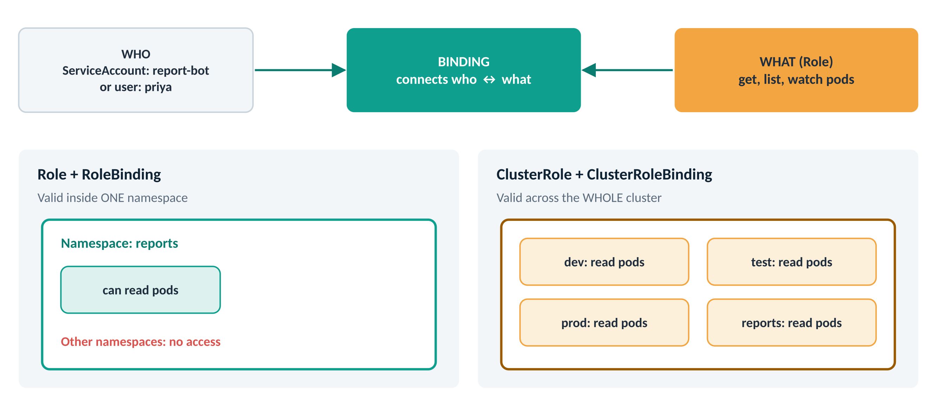
Figure 16: Roles grant access inside one namespace; ClusterRoles grant it across the cluster
Think of it as
Office access cards. Your card (the binding) says which doors (resources) you can open, on which floor (namespace) or in the whole building (cluster).

Object | Scope | Job
ServiceAccount | Namespace | An identity for a Pod (a “robot user”)
Role | Namespace | A list of allowed actions inside one namespace
ClusterRole | Whole cluster | A list of allowed actions everywhere, or on cluster-level things such as nodes
RoleBinding | Namespace | Gives a Role (or ClusterRole) to someone, inside one namespace
ClusterRoleBinding | Whole cluster | Gives a ClusterRole to someone, everywhere

ServiceAccount
In one line: a ServiceAccount gives a Pod an identity so it can talk to the Kubernetes API with only the permissions it has been granted.
QuickBite use case
QuickBite’s report-bot Pod lists running Pods to include in a health report. It runs as its own ServiceAccount, not as an administrator.

apiVersion: v1
kind: ServiceAccount
metadata:
name: example-service-account
A Pod uses it by setting serviceAccountName: example-service-account in its spec.

Role
This Role grants permission in the default namespace to get, list, create, update and delete Pods.
apiVersion: rbac.authorization.k8s.io/v1
kind: Role
metadata:
name: example-role
namespace: default
rules:
- apiGroups: [""] # "" = the core API group (Pods, Services...)
resources: ["pods"]
verbs: ["get", "list", "create", "update", "delete"]
Tip
Grant the least access that does the job. A reporting tool only needs get, list and watch.

ClusterRole
This ClusterRole grants the same Pod permissions, but across all namespaces.
apiVersion: rbac.authorization.k8s.io/v1
kind: ClusterRole
metadata:
name: example-cluster-role
rules:
- apiGroups: [""]
resources: ["pods"]
verbs: ["get", "list", "create", "update", "delete"]

RoleBinding
This RoleBinding gives example-role to example-service-account within the default namespace.
apiVersion: rbac.authorization.k8s.io/v1
kind: RoleBinding
metadata:
name: example-role-binding
namespace: default
subjects:
- kind: ServiceAccount
name: example-service-account
namespace: default
roleRef:
kind: Role
name: example-role
apiGroup: rbac.authorization.k8s.io

ClusterRoleBinding
This ClusterRoleBinding gives example-cluster-role to example-service-account at the cluster level.
apiVersion: rbac.authorization.k8s.io/v1
kind: ClusterRoleBinding
metadata:
name: example-cluster-role-binding
subjects:
- kind: ServiceAccount
name: example-service-account
namespace: default
roleRef:
kind: ClusterRole
name: example-cluster-role
apiGroup: rbac.authorization.k8s.io
Try it: check permissions before you rely on them
SA=system:serviceaccount:default:example-service-account
kubectl auth can-i list pods --as=$SA # yes
kubectl auth can-i delete nodes --as=$SA # no

Scaling and reliability

HorizontalPodAutoscaler (HPA)
In one line: an HPA automatically changes the number of Pods in a Deployment (or StatefulSet) based on load, such as average CPU use.
Think of it as
A restaurant that calls in extra staff when the queue gets long and sends them home when it is quiet.

QuickBite use case
QuickBite’s orders API runs 2 Pods in the afternoon, grows to 5 during the 8 PM dinner rush, and shrinks back to 2 by 11 PM, without anyone touching it.

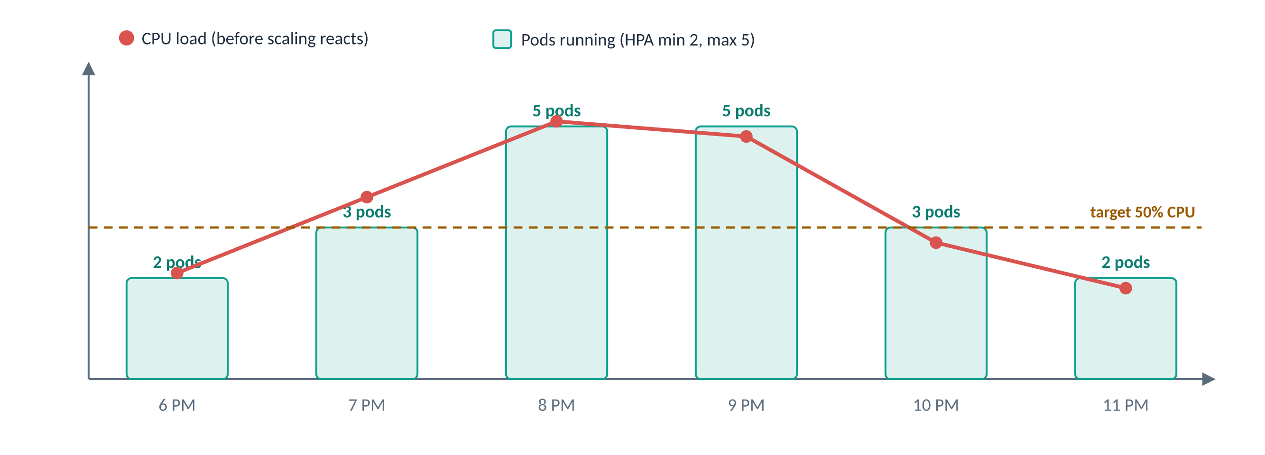
Figure 17: The HPA adds Pods when CPU goes above the target and removes them when it drops
In this example, the HPA targets the Deployment example-deployment. It scales between 2 and 5 replicas to keep average CPU use around 50%.
apiVersion: autoscaling/v2
kind: HorizontalPodAutoscaler
metadata:
name: example-hpa
spec:
scaleTargetRef:
apiVersion: apps/v1
kind: Deployment
name: example-deployment
minReplicas: 2
maxReplicas: 5
metrics:
- type: Resource
resource:
name: cpu
target:
type: Utilization
averageUtilization: 50
Note
The HPA needs metrics-server installed, and the containers must have CPU requests set (see the Deployment example). Without requests, “50% CPU” has nothing to be 50% of.

Try it
kubectl autoscale deployment example-deployment --cpu-percent=50 --min=2 --max=5
kubectl get hpa --watch
kubectl top pods

PodDisruptionBudget (PDB)
In one line: a PDB limits how many Pods of an app can be taken down at the same time during planned maintenance, such as draining a node or upgrading the cluster.
Think of it as
A shop rule: “at least two cashiers must stay open, even during staff breaks.”

QuickBite use case
The platform team patches QuickBite’s servers on Sunday morning. The PDB makes sure at least 2 website Pods are always serving customers while nodes are drained one by one.

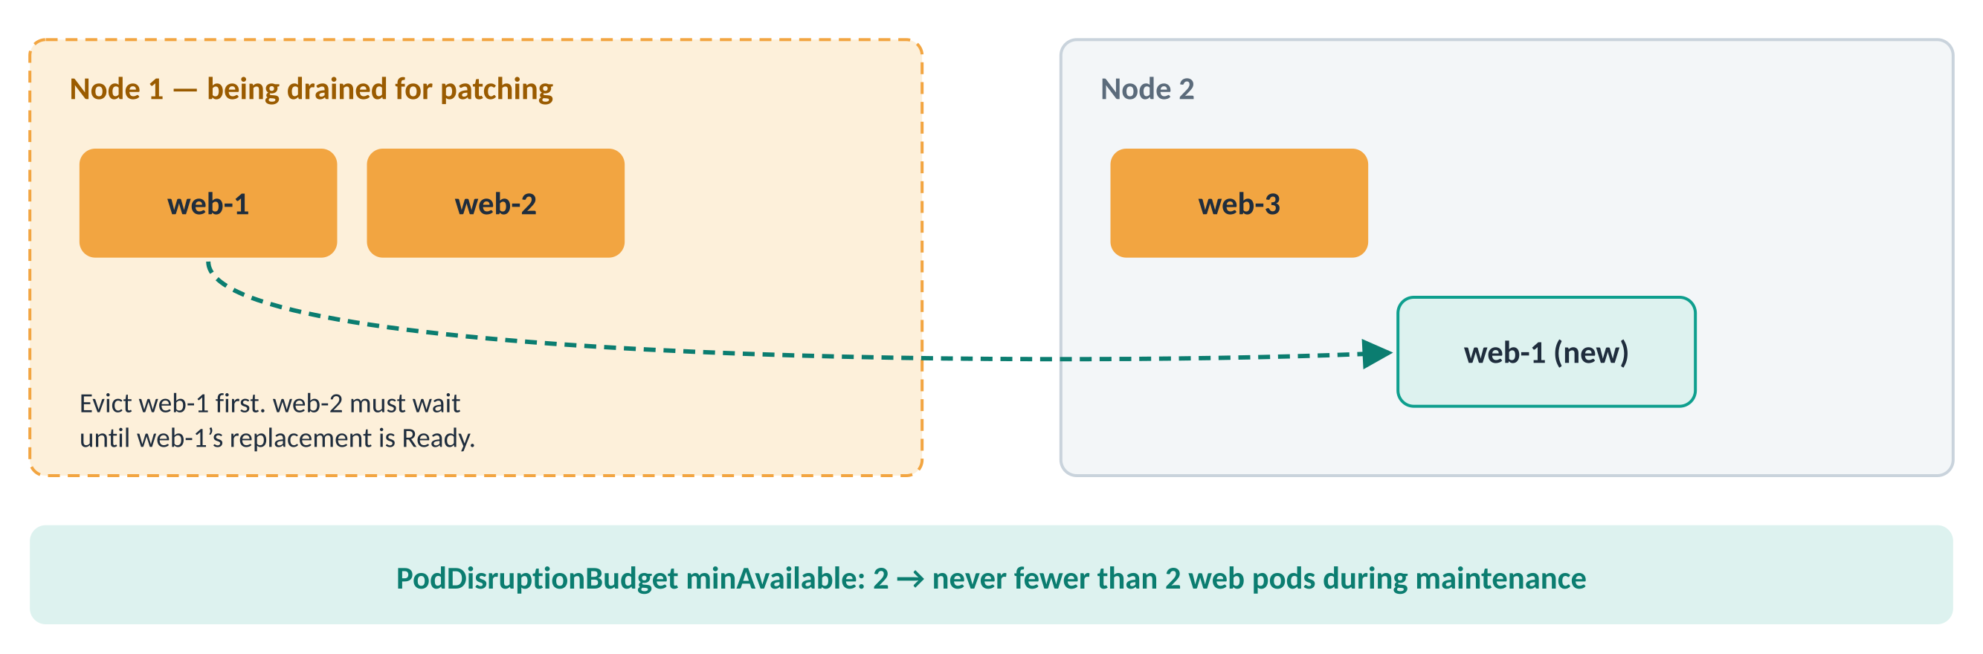
Figure 18: During a node drain, the PDB holds back evictions until replacements are ready
This PodDisruptionBudget keeps at least 2 Pods labelled app: example-app available during voluntary disruptions.
apiVersion: policy/v1
kind: PodDisruptionBudget
metadata:
name: example-pdb
spec:
minAvailable: 2
selector:
matchLabels:
app: example-app
Note
A PDB protects against voluntary disruptions (drains, upgrades, scale-downs). It cannot stop a node from crashing; that is what running several replicas across nodes is for.

Cheat sheet and self-check

All objects on one page
Object | In one line | Think of it as
Pod | One or more containers running together | A flat with flatmates
ReplicaSet | Keeps N identical Pods alive | A shift manager
Deployment | Rolls out new versions safely | Changing the menu table by table
StatefulSet | Pods with fixed names and own disks | Numbered gym lockers
DaemonSet | One Pod on every node | A guard on every floor
Job | Runs until the task is done | A one-off cleaning job
CronJob | Runs a Job on a schedule | An alarm clock
Service | Stable address for changing Pods | A customer-care number
Ingress | Routes outside HTTP traffic by host and path | A mall directory board
ConfigMap | Ordinary settings | An app’s settings screen
Secret | Sensitive settings (base64) | A sealed envelope
PersistentVolume | An actual piece of storage | A hotel room
PersistentVolumeClaim | A request for storage | A room booking
StorageClass | A type of storage that creates volumes | A hotel chain building rooms
Namespace | A separate area inside the cluster | A folder or an office floor
ServiceAccount | An identity for Pods | A robot’s ID badge
Role / ClusterRole | What actions are allowed | The doors a card can open
RoleBinding / ClusterRoleBinding | Who gets which role | Handing out the access card
HorizontalPodAutoscaler | Adds or removes Pods based on load | Calling in extra staff
PodDisruptionBudget | Keeps a minimum running during maintenance | “Two cashiers always open”

Self-check questions
- Two containers must share files and talk over localhost. Same Pod or separate Pods?
Answer: Same Pod: they share network and volumes.
- A Pod created without a Deployment or ReplicaSet was on a node that crashed. What happens to it?
Answer: It is gone for good. Nothing recreates a bare Pod; use a Deployment.
- Your Pods keep getting new IP addresses. How do other apps find them reliably?
Answer: Through a Service, using its stable DNS name.
- You need a log collector on every node, including nodes added next month. Which object?
Answer: A DaemonSet.
- Your database Pod must keep the same name and its own disk after restarts. Which workload?
Answer: A StatefulSet with a volumeClaimTemplate.
- Is a Secret encrypted by default?
Answer: No. It is only base64-encoded. Enable encryption at rest and restrict access with RBAC.
- A node must be patched, but at least two web Pods must keep running. Which object helps?
Answer: A PodDisruptionBudget with minAvailable: 2.

