


Lab Manual- Kubernetes PersistentVolume (PV) and PersistentVolumeClaim (PVC) in a Pod.

Prepared for:

Date: 18th May 2025

Prepared by:
Document Name: Lab Manual Document Number CKAD-Lab12
Contributor:

Contents
1. Network Policies in Kubernetes 3
1.1 What is a Network Policy? 3
2. Lab 1- Block all traffic except from specific pods using labels. 3
2.1 Scenario Setup 3
2.2 Flow Diagram 4
2.3 Steps of Execution 4
• Step 1: Create the Target Pod (nginx) 4
• Step 2: Apply Network Policy 5
• Step 3: Create an Allowed Pod 6
• Step 4: Create PODS and Policy 6
• Step 5: Test Connectivity 7
2.4 Steps to Clean 9

What is PV and PVC in Kubernetes?

- PersistentVolume (PV): A piece of storage in the cluster provisioned by an admin or dynamically via storage classes.
- PersistentVolumeClaim (PVC): A request for storage by a user (like a pod). It specifies size, access mode, etc.
- Pod: Uses the PVC to mount the storage.

Lab 1- Using PV and PVC in PODs
Let’s say we want to run an nginx web server that stores logs into a persistent volume, so the logs are preserved even if the pod restarts.

Scenario Setup

Steps of Execution

Step 1: Create a PersistentVolume (PV)

nano pv.yaml

# pv.yaml
apiVersion: v1
kind: PersistentVolume
metadata:
name: my-pv
spec:
capacity:
storage: 1Gi
accessModes:
- ReadWriteOnce
hostPath: # For testing on Minikube or local setup
path: /mnt/data

Step 2: Create a PersistentVolumeClaim (PVC)

nano pvc.yaml

# pvc.yaml
apiVersion: v1
kind: PersistentVolumeClaim
metadata:
name: my-pvc
spec:
accessModes:
- ReadWriteOnce
resources:
requests:
storage: 1Gi

Step 3: Create Pod and Use PVC in a Pod

nano pod.yaml

apiVersion: v1
kind: Pod
metadata:
name: nginx-pv-pod
spec:
containers:
- name: nginx
image: nginx
volumeMounts:
- mountPath: "/usr/share/nginx/html"
name: storage-volume
volumes:
- name: storage-volume
persistentVolumeClaim:
claimName: my-pvc

Step 4: Apply all in Order

kubectl apply -f pv.yaml
kubectl apply -f pvc.yaml
kubectl apply -f pod.yaml
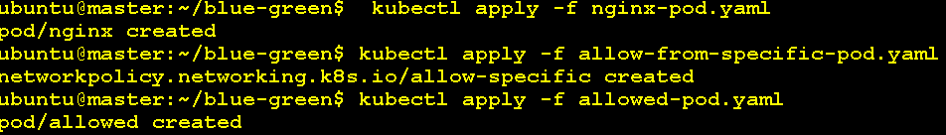

kubectl get pods

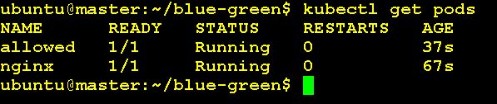

kubectl get networkpolicy

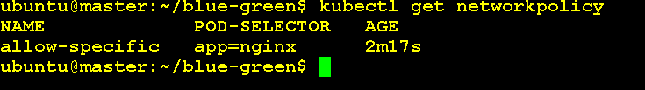

kubectl describe networkpolicy allow-specific

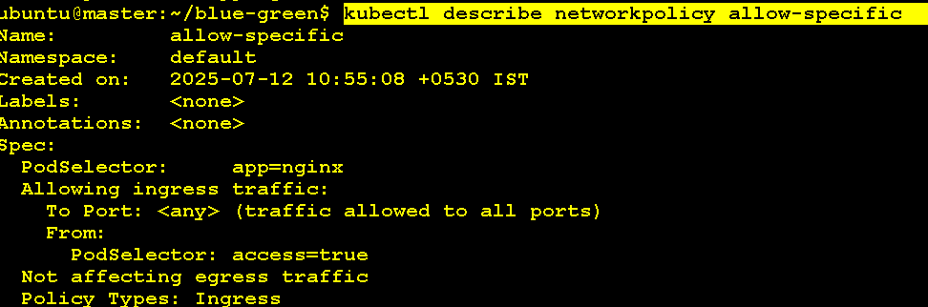

Step 5: Test Data on PV

# 1. Exec into the pod and create a file:

kubectl exec -it nginx-pv-pod -- /bin/bash

echo "Hello from Bipeen PV Test" > /usr/share/nginx/html/test.txt

exit

# 2. Access the content via a port-forward:

kubectl port-forward pod/nginx-pv-pod 8080:80
curl http://localhost:8080/test.txt

# Step 3: Delete the Pod

kubectl delete pod nginx-pv-pod

# Optional : in Ubuntu Linux

cd /mnt/data
ls -l
cat /mnt/data/hello.txt

# Mount in Another POD

kubectl apply -f pod-reuse.yaml

# Step 5: Verify Data is Still There

kubectl exec -it nginx-reuse-pv -- cat /usr/share/nginx/html/test.txt

Steps to Clean

kubectl delete -f nginx-pod.yaml
kubectl delete -f allow-from-specific-pod.yaml
kubectl delete -f allowed-pod.yaml

