


Lab Manual- Multicontainer in Single POD

Prepared for:

Date: 18th Dec 2024

Prepared by:
Document Name: Lab Manual Document Number CKAD-Lab03
Contributor:

Contents
1. What is a Multi-Container Pod? 3
2. Common Use Cases: 3
3. NON-TECHNICAL EXPLANATION 3
4. When to Use Multi-Container Pods? 3
5. Lab1:- Multicontainer – Each POD with single container 4
6. Lab2:- Multicontainer – Each POD with single container 6
7. Lab3:- Multicontainer – Each POD with single container and communicate with each other 9

What is a Multi-Container Pod?
A Pod in Kubernetes is the smallest deployable unit. It can contain one or more containers that:
- Share the same network namespace (i.e., same IP address and ports).
- Can communicate via localhost.
- Can share storage volumes.
- Why use multiple containers in a single Pod?
You use multiple containers when they are tightly coupled and must work together on the same host, within the same lifecycle.

Common Use Cases:
- Sidecar Pattern
  - A helper container that supports the main container.
  - 📦 Example: NGINX + log collector.
- Ambassador Pattern
  - A container acting as a proxy or communication bridge.
  - 📦 Example: App + Envoy proxy for secure service mesh communication.
- Adapter Pattern
  - One container writes data, the other transforms/forwards it.
  - 📦 Example: App + log parser.

NON-TECHNICAL EXPLANATION
Imagine a Coffee Truck

Think of a Pod as a food truck, and the containers as different people inside it doing specific tasks.

Example:
- Main Container: The Barista who makes the coffee (main app).
- Sidecar Container: The Cashier who handles payments (log collector, or metrics exporter).
- They are in the same truck (pod):
  - Share the same kitchen (resources).
  - Talk freely to each other.
  - If the truck moves or breaks down, both go with it.
You don’t put the cashier in a different truck — because their jobs are tied together.

When to Use Multi-Container Pods?
Use when:
- You need tight coupling and shared resources.
- The containers are not independent apps.
- You want simple intra-pod communication.
Avoid when:
- Each container can scale or crash independently → Use separate pods and services.

Lab1:- Multicontainer – Each POD with single container

mkdir multicontainer

cd multicontainer

nano multipod.yaml

# kubectl apply -f multipod.yaml
# kubectl logs logger-pod
# curl http://<NodeIP>:<NodePort>

apiVersion: v1
kind: Pod
metadata:
name: nginx-pod
labels:
app: nginx
spec:
containers:
- name: nginx
image: nginx
ports:
- containerPort: 80
---
apiVersion: v1
kind: Pod
metadata:
name: logger-pod
spec:
containers:
- name: logger
image: busybox
command: ["sh", "-c", "echo Logger is running; sleep 3600"]
---
apiVersion: v1
kind: Service
metadata:
name: nginx-service
spec:
selector:
app: nginx
type: NodePort
ports:
- port: 80
targetPort: 80
nodePort: 30080 # Optional; you can let Kubernetes assign if omitted

kubectl apply -f multipod.yaml

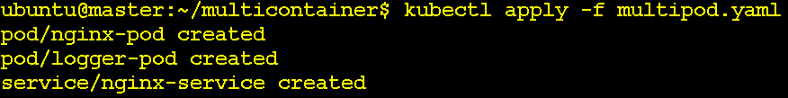

Kubectl get pod
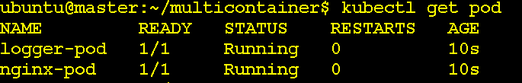

Kubectl get svc

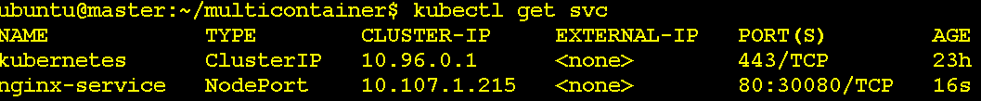

Curl http://192.168.88.128:30080

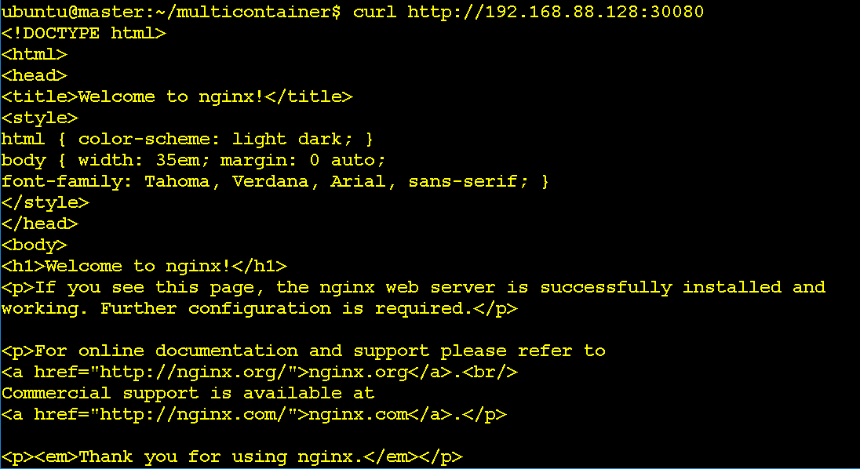

Kubectl logs logger-pod

Kubectl delete -f multipod.yaml

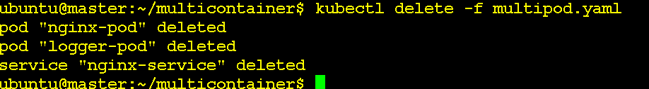

Lab2:- Multicontainer – Each POD with single container

nano multi-container.pod.yaml

# kubectl apply -f multi-container-pod.yaml
# kubectl logs multi-container-pod -c sidecar-container

apiVersion: v1
kind: Pod
metadata:
name: multi-container-pod
spec:
containers:
- name: nginx-container
image: nginx
ports:
- containerPort: 80

- name: sidecar-container
image: busybox
command: ["sh", "-c", "while true; do echo Bipeen Sidecar working; sleep 10; done"]

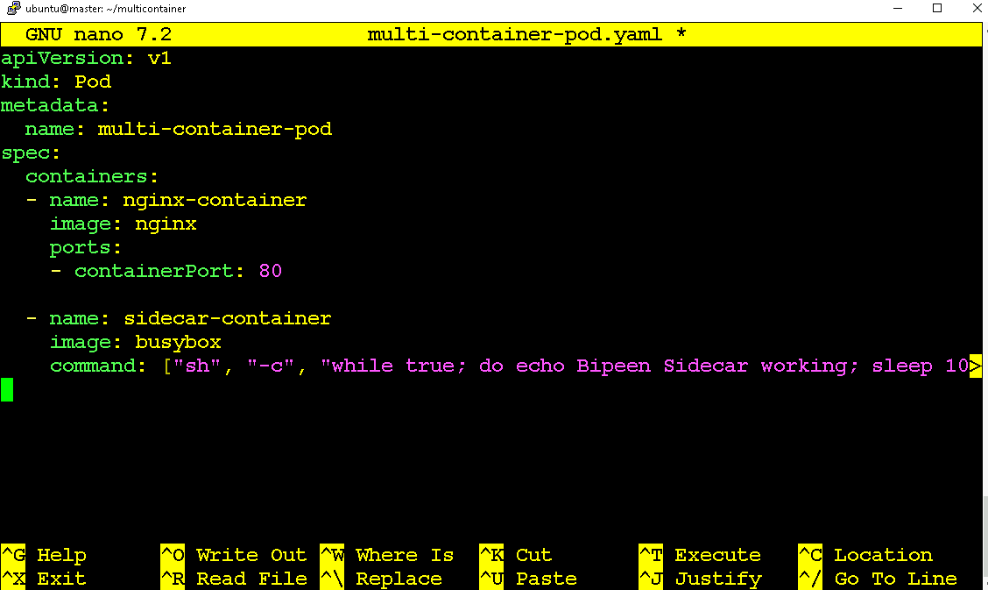

kubectl apply -f multi-container-pod.yaml

kubectl get pod

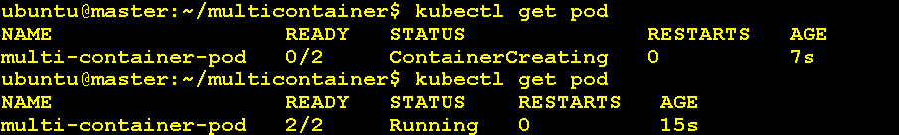

kubectl get pod multi-container-pod -o jsonpath='{.spec.containers[*].name}'

kubectl describe pod multi-container-pod

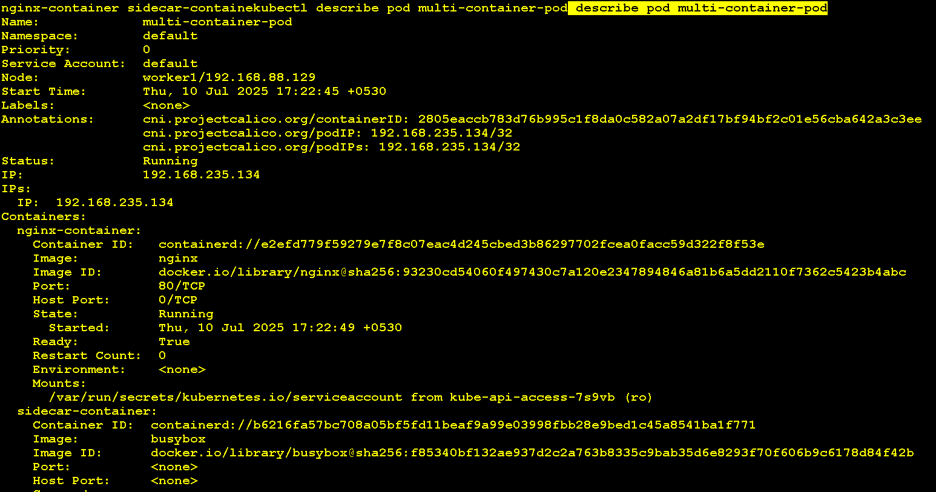

kubectl logs multi-container-pod -c sidecar-container

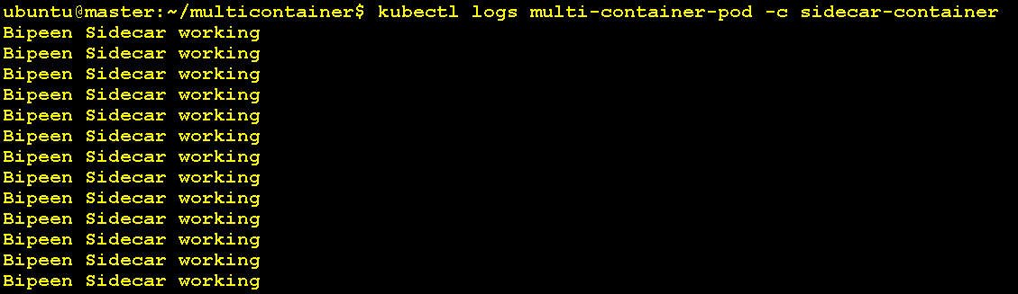

kubectl port-forward pod/multi-container-pod 8888:80
curl http://localhost:8888

After 1 min Ctrl+C

kubectl logs multi-container-pod -c nginx-container

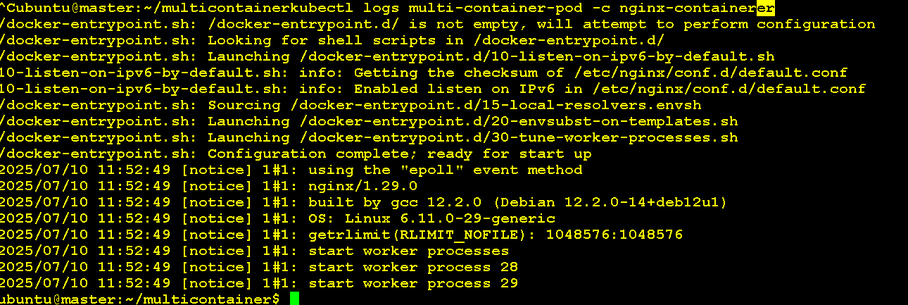

kubectl delete -f multi-container-pod.yaml

Lab3:- Multicontainer – Each POD with single container and communicate with each other
nano nginx-log-watcher-pod.yaml

# kubectl apply -f nginx-log-watcher-pod.yaml
# curl http://<NodeIP>:<NodePort>
# kubectl logs nginx-log-watcher -c log-watcher

aapiVersion: v1
kind: Pod
metadata:
name: nginx-log-watcher
labels:
run: nginx-log-watcher
spec:
volumes:
- name: shared-logs
emptyDir: {}

containers:
- name: nginx
image: nginx
volumeMounts:
- name: shared-logs
mountPath: /var/log/nginx
ports:
- containerPort: 80

- name: log-watcher
image: busybox
command: ["sh", "-c", "tail -f /var/log/nginx/access.log"]
volumeMounts:
- name: shared-logs
mountPath: /var/log/nginx
---
apiVersion: v1
kind: Service
metadata:
name: nginx-nodeport
spec:
selector:
run: nginx-log-watcher
type: NodePort
ports:
- port: 80
targetPort: 80
nodePort: 30080

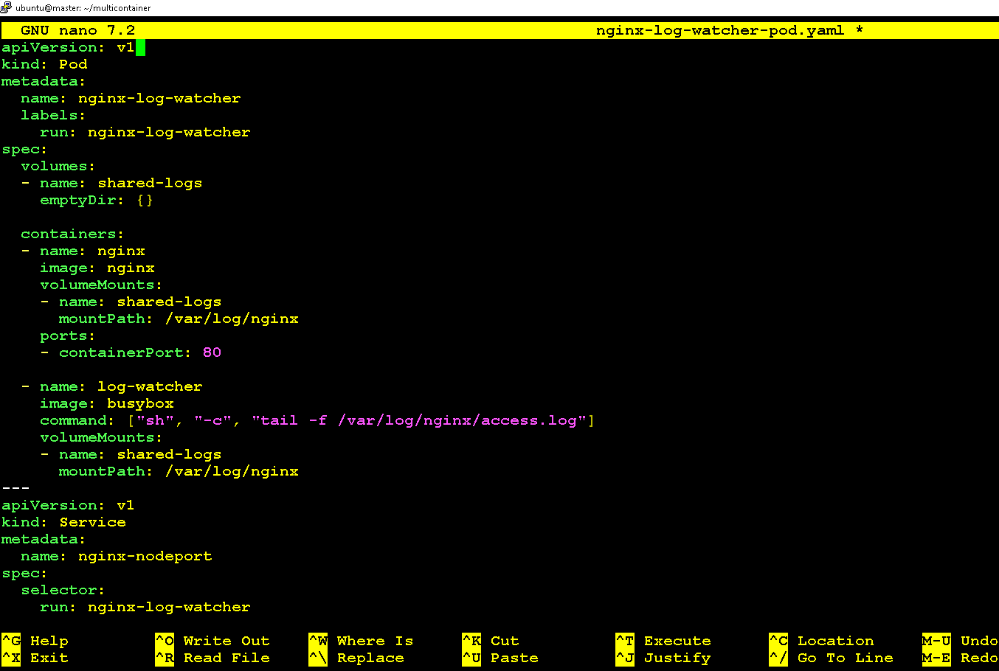

kubectl apply -f nginx-log-watcher-pod.yaml

kubectl get pod

kubectl get svc

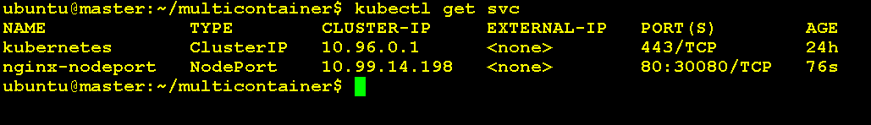

Curl http://192.168.88.128:30080

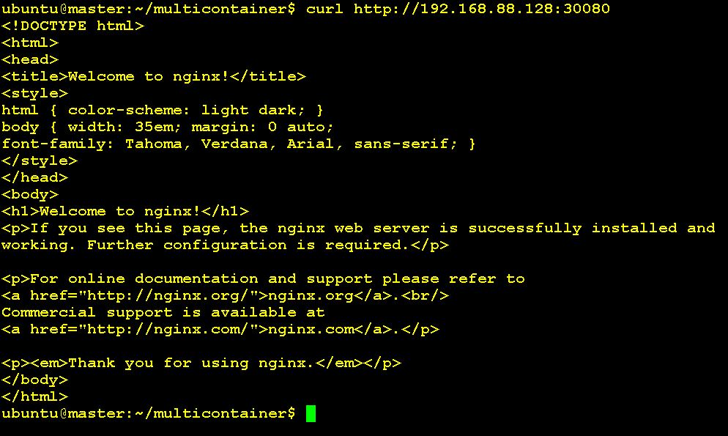

kubectl logs nginx-log-watcher -c log-watcher

kubectl delete -f nginx-log-watcher-pod.yaml

