npnp



**Lab Manual- React Fist Program Lab1**

**Prepared for**:

**Dat**

**Date:** 18th June 2024

**Prepared by:**

Document Name: Lab Manual **Document Number** SDLabn916

**Contributor:**

Contents

1. Objective 3

2. Creating a First React program 3

3. Run the React Application 4

4. Explore the React Application 6

5. Make Changes in App.js and Index.js 8

# Objective

**React** is a powerful JavaScript library for building dynamic and interactive user interfaces (UIs). It is developed by Facebook. React is known for its **component-based architecture**which allows you to create reusable UI elements, making complex web applications easier to manage and maintain. React is used to build single-page applications.

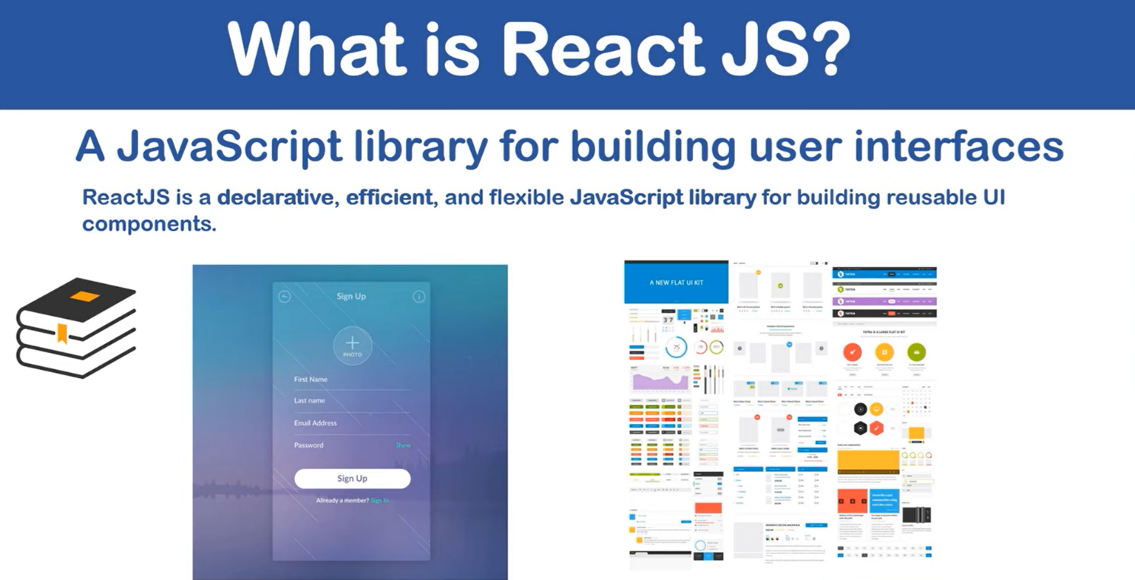

**How does React Work?**

**React creates a VIRTUAL DOM in memory. Instead of manipulating the browser's DOM directly, React creates a virtual DOM in memory, where it does all the necessary manipulating, before making the changes in the browser DOM. React only changes what needs to be changed! React finds out what changes have been made, and changes only what needs to be changed.**

# Creating a First React program

Run this command to create a React application named my-react-app:

**npx create-react-app my-react-app**

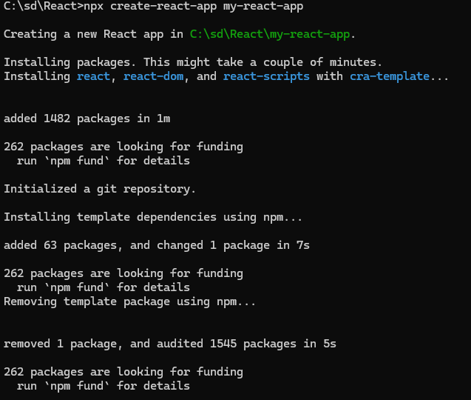

create-react-app will set up everything you need to run a React application.

# Run the React Application

* Run this command to move to the my-react-app directory:

**cd my-react-app**

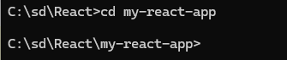

* Run this command to execute the React application my-react-app:

**npm start**

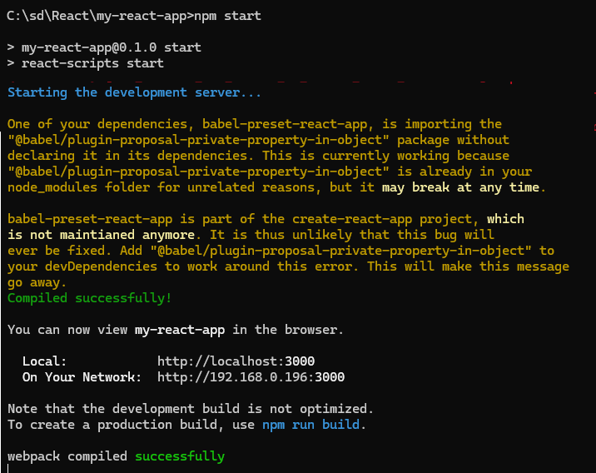

* A new browser window will pop up with your newly created React App! If not, open your browser and type localhost:3000 in the address bar.

The result:

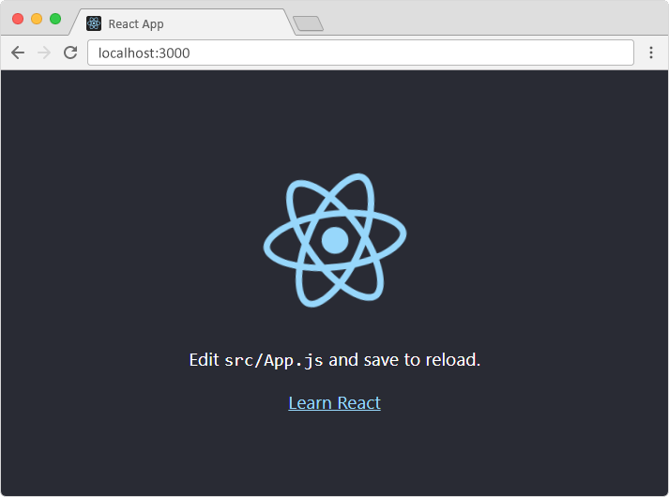

# Explore the React Application

* Open the React Application in VSCode

**Code .**

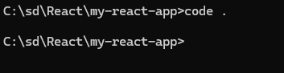

* Application gets open in VSCode

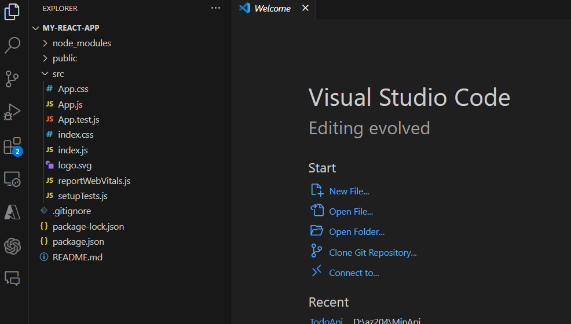

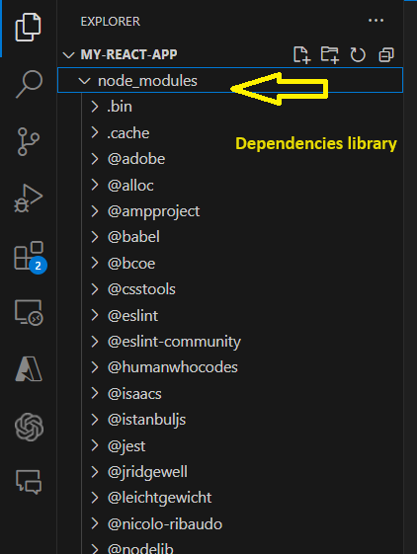

**Check Main index.js**

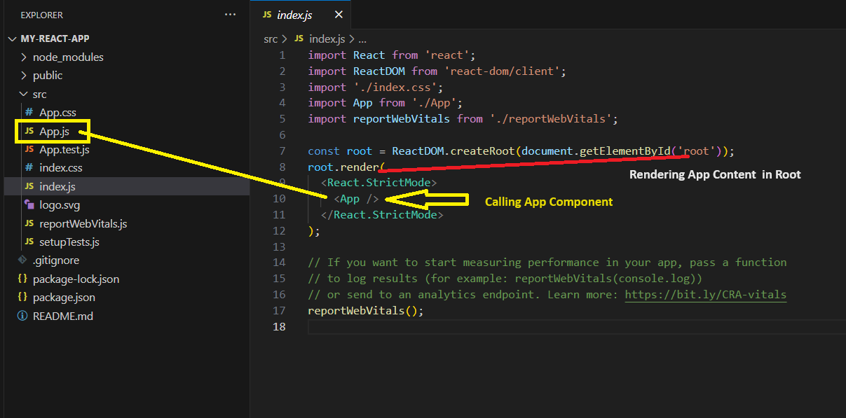

**Lets Explore App.js**

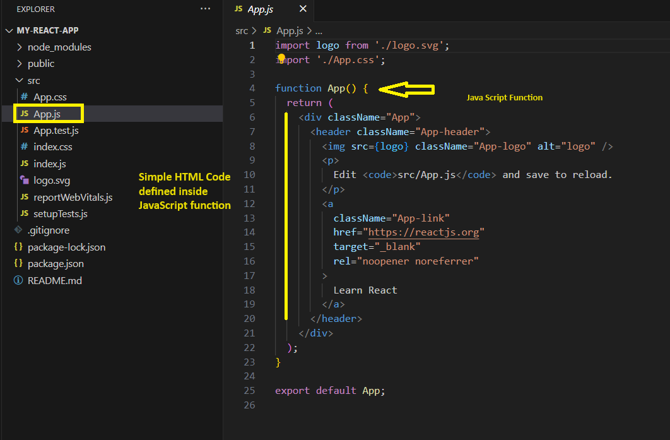

# Make Changes in App.js and Index.js

**Comment the Line as show below with /* */ and write simple HTML <h1> tag**

<h1>This Program is developed by Bipeen</h1>

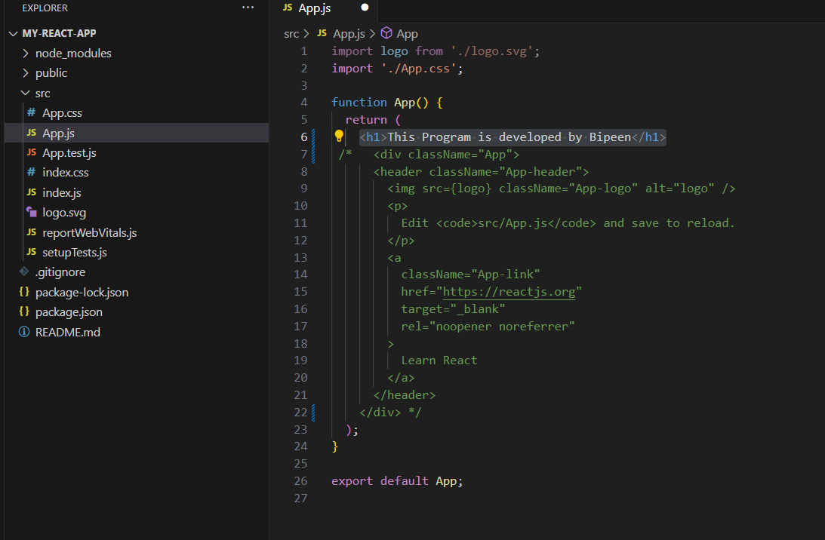

**Now update the code in index.js**

**Simple comment out lines and called <App > Component and Reder inside Document root**

root.render( <App />,document.getElementById('root'));

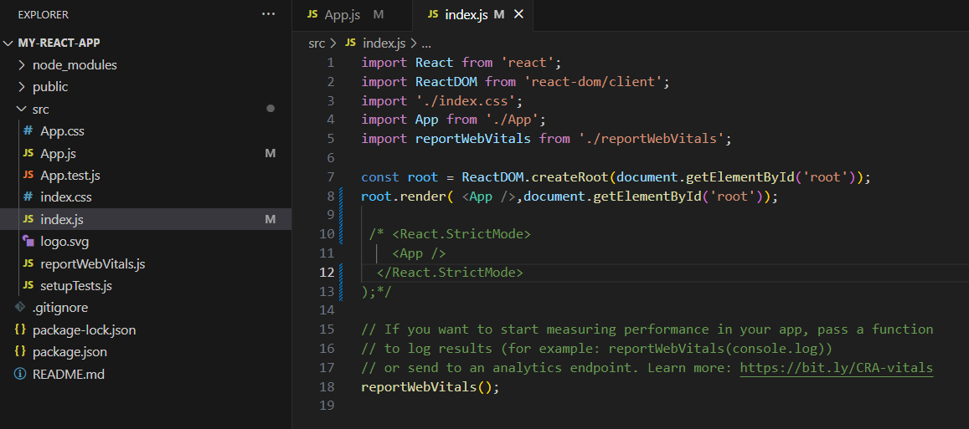

**Now Save and Run it again**

**Npm start**

