

**Lab Manual- Git with BitBucket**

**Prepared for**:

**Date:** 18th June 2024

**Prepared by:**

Document Name: Lab Manual **Document Number** SDLab006

**Contributor:**

Contents

1. Objective 3

2. Create a Bitbucket Workspace 3

3. Create a Repository 5

4. Push data to Repository 7

5. Push the changes to Repository 10

6. Fork the Public Repository from other Account 12

# Objective

# Create a Bitbucket Workspace

A

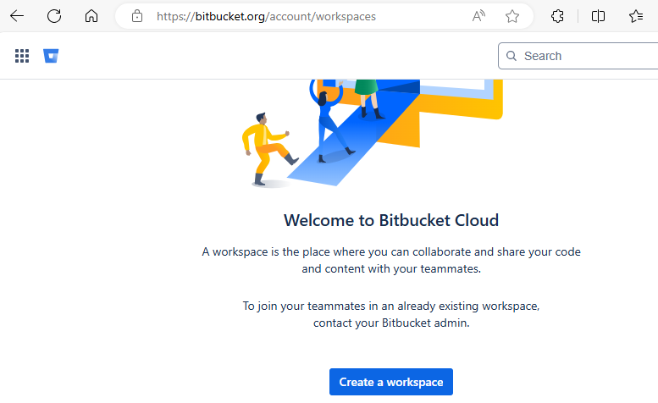

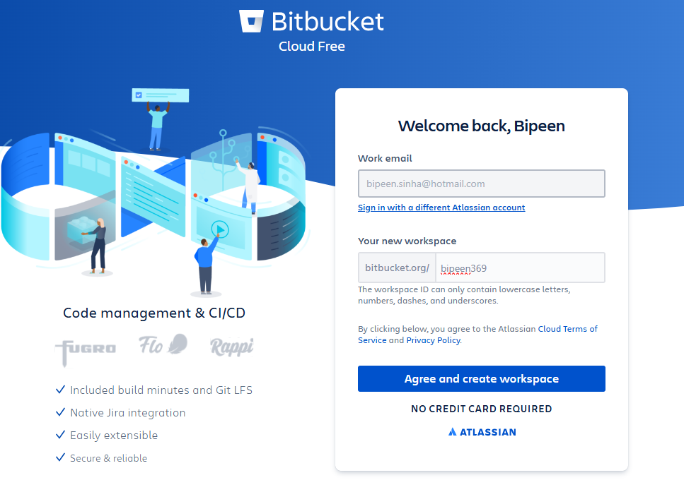

* Workspace start provisioning

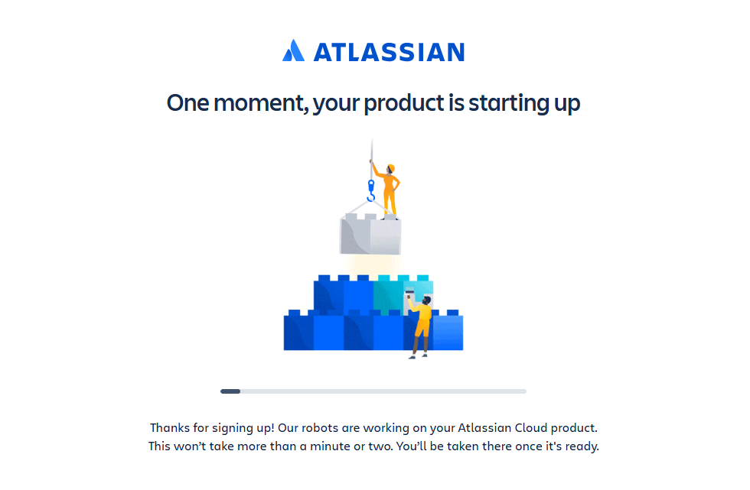

* You should able to see this login

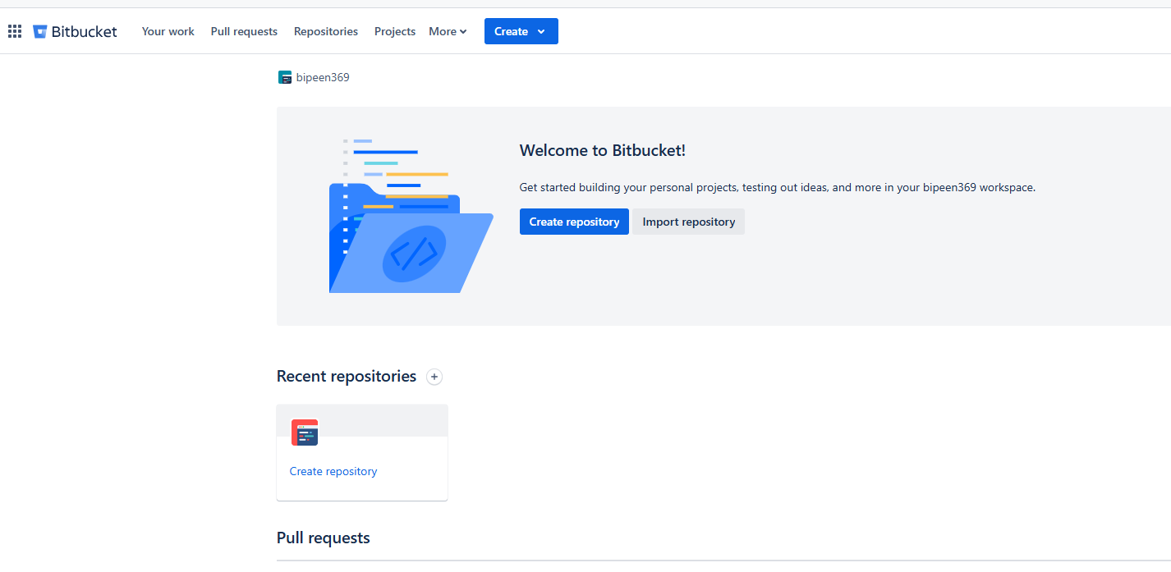

# Create a Repository

* Log in to BitBucket and navigate to the "**Create repository**" page.

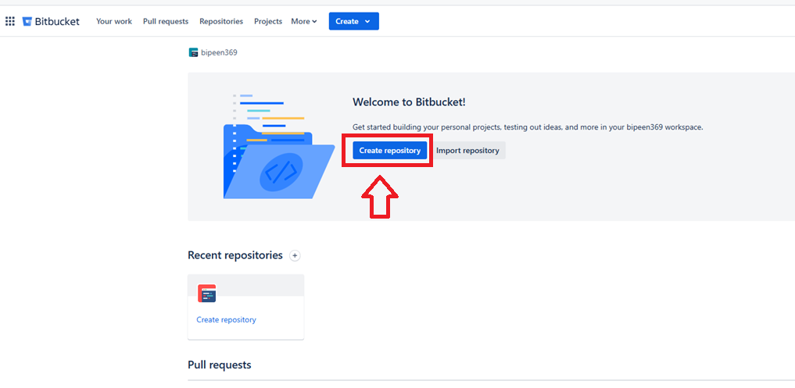

* Fill in the **Project Name , Repository name** and other details and Click "**Create repository**".

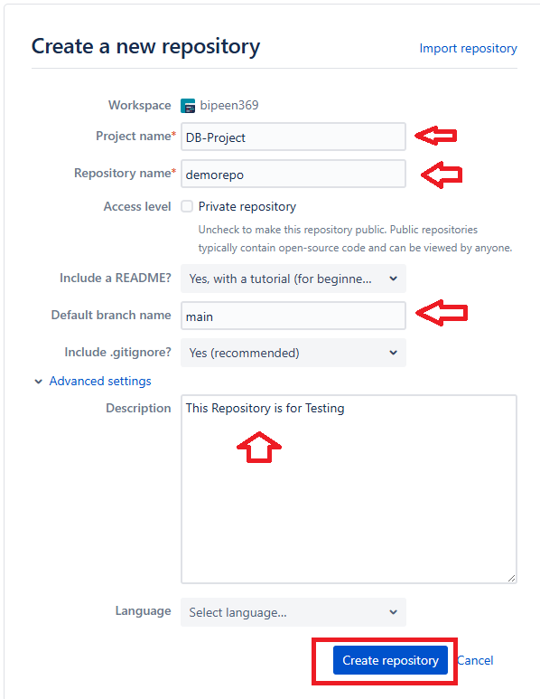

* Your Repository should be ready

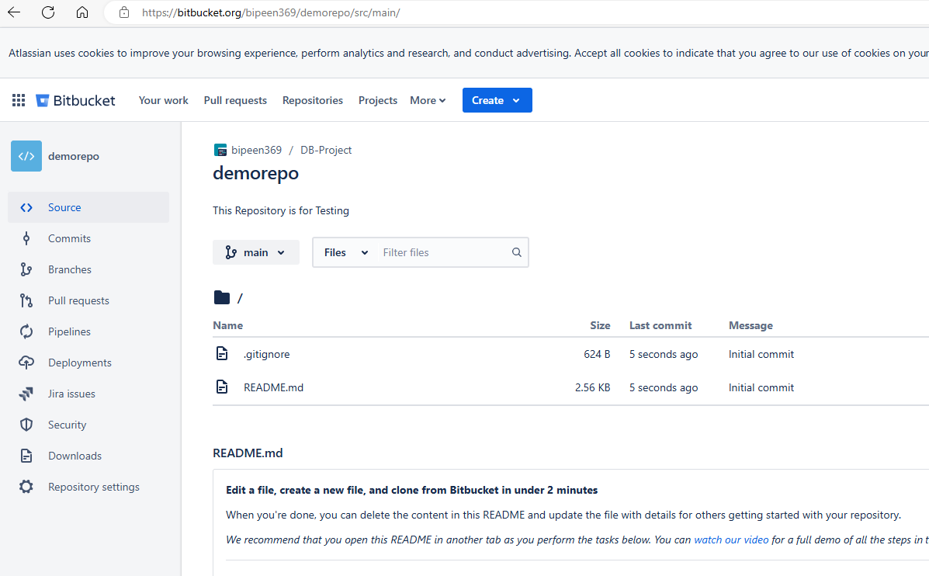

# Push data to Repository

* Go to your project directory and Initialize directory for git

**git init**

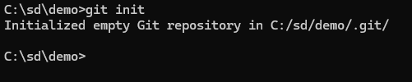

* Add your files in git queue

**git add .**

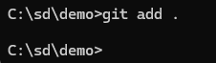

* Add your BitBucket Repository Address

**git remote add origin** [**https://bipeensinha@bitbucket.org/bipeen369/demorepo.git**](https://bipeensinha@bitbucket.org/bipeen369/demorepo.git)



**Optional : To set your global username/email configuration:**

1. **Set your username:  
   git config --global user.name "bipeensinha"**
2. **Set your email address:  
   git config --global user.email "MY_NAME@gmail.com"**

* Commit the Files to git queue

**git commit -m "My First Commit"**

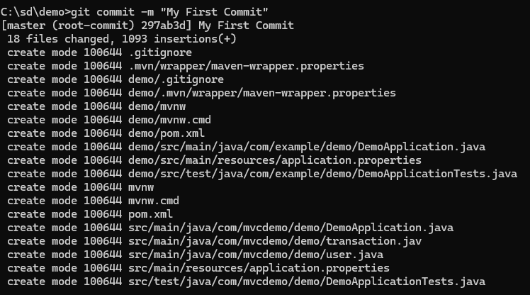

* Push the code

**git push –all**



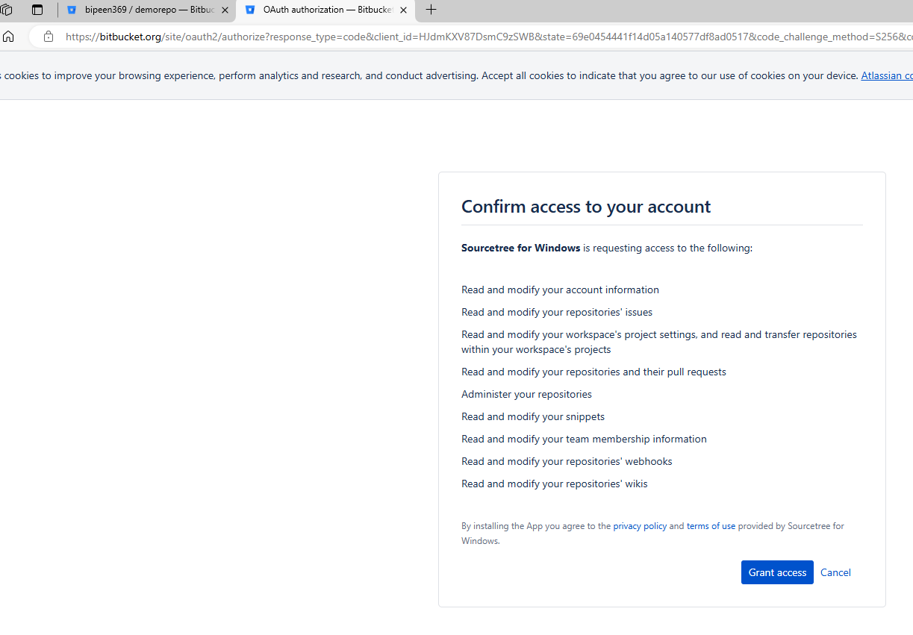

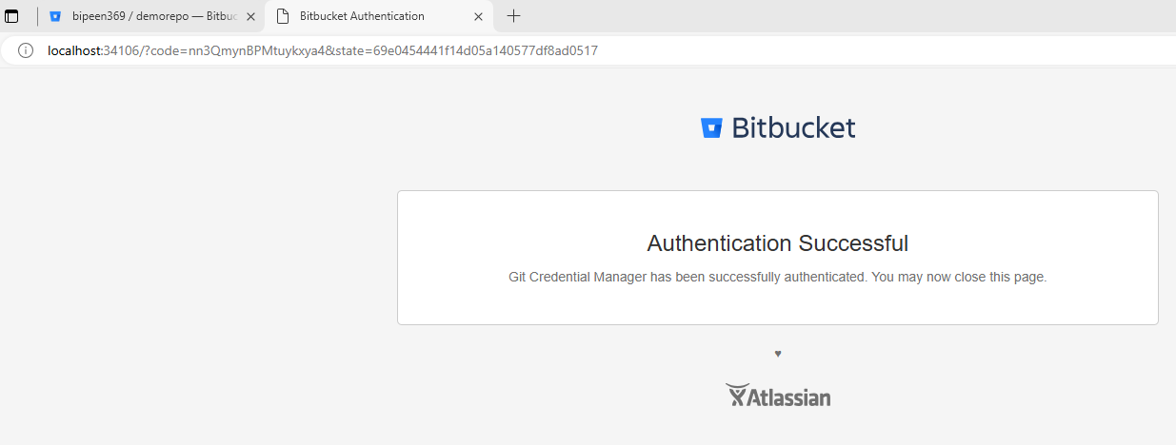

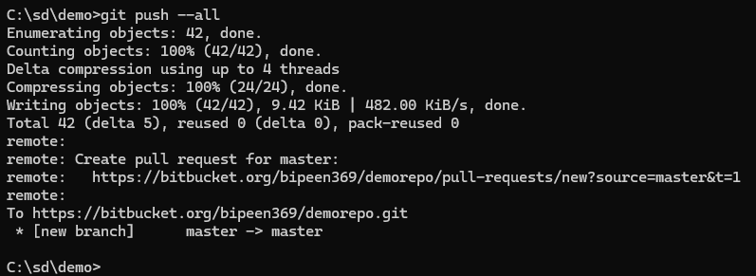

* To View the push code, change the Branch to Master

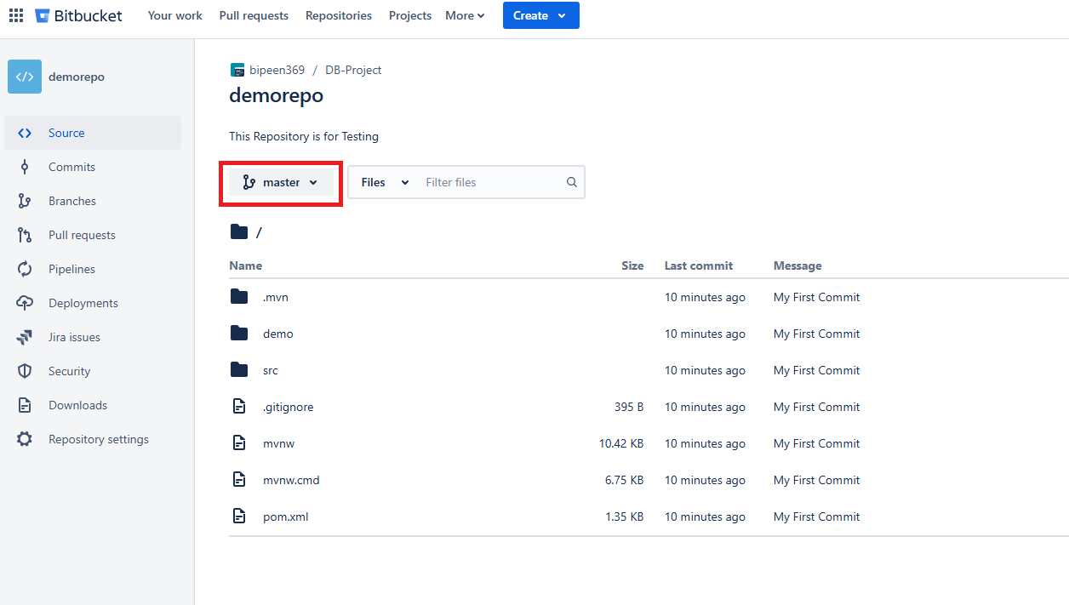

# Push the changes to Repository

* Create New File or modify existing file

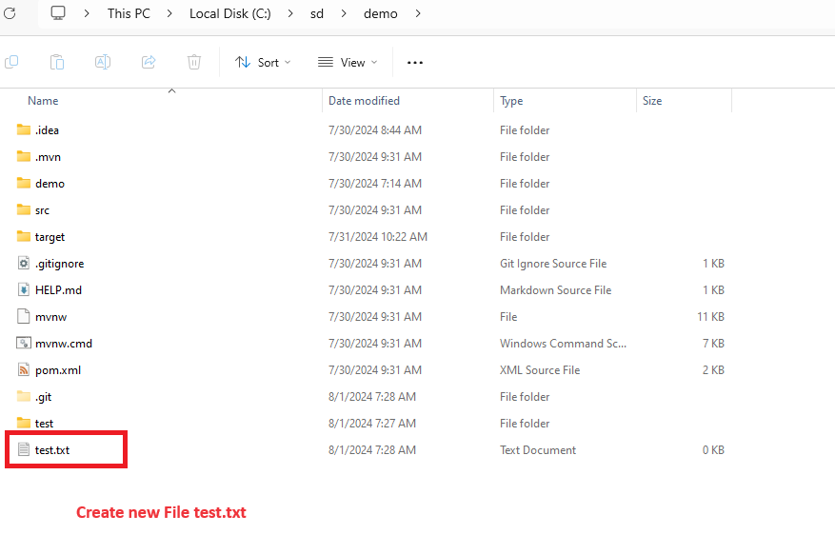

* Run following 3 command to push the changes

**git add .**

**git commit -m "My 2nd Commit"**

**git push --all**

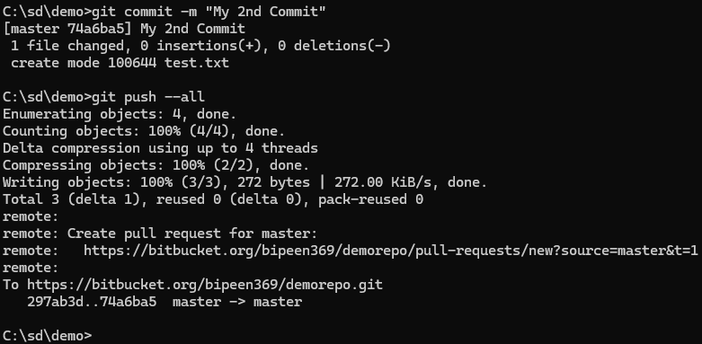

* See the changes in bitbucket

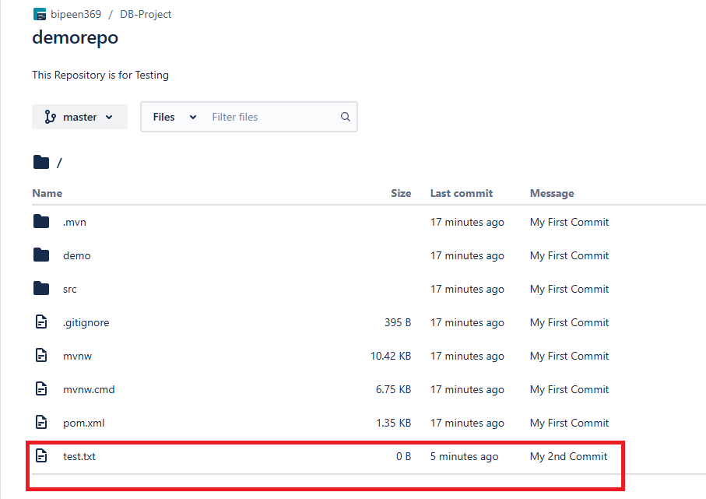

# Fork the Public Repository from other Account

