

**Lab Manual- React Bootstrapping- Lab1**

**Prepared for**:

**Date:** 18th June 2024

**Prepared by:**

Document Name: Lab Manual **Document Number** SDLab360

**Contributor:**

Contents

1. Objective 3

2. Install React Strap library 3

3. Create Button 4

4. Install Message Component Toastify 7

# Objective

**React** is a powerful JavaScript library for building dynamic and interactive user interfaces (UIs). It is developed by Facebook. React is known for its **component-based architecture**which allows you to create reusable UI elements, making complex web applications easier to manage and maintain. React is used to build single-page applications.

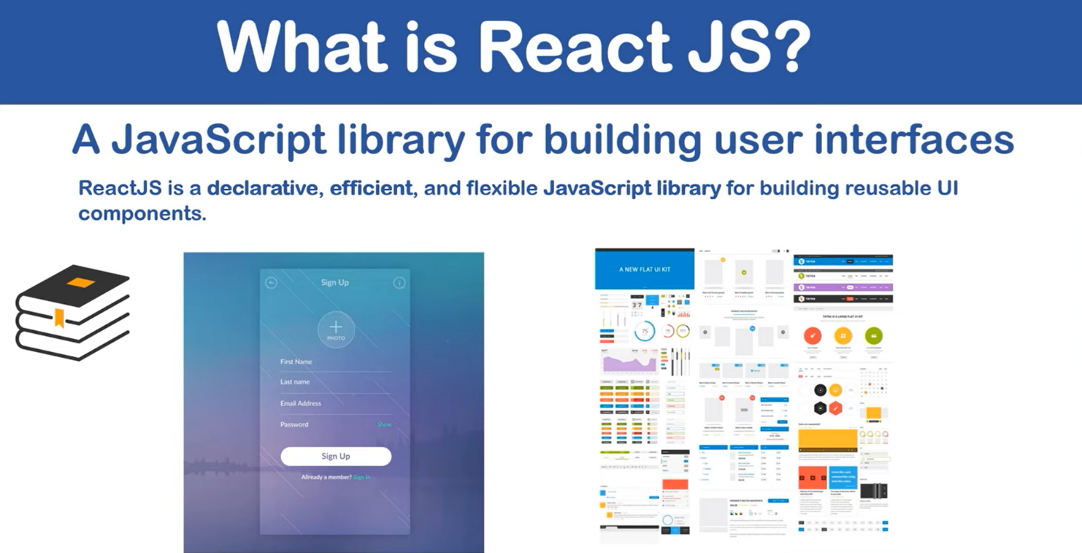

**How does React Work?**

**React creates a VIRTUAL DOM in memory. Instead of manipulating the browser's DOM directly, React creates a virtual DOM in memory, where it does all the necessary manipulating, before making the changes in the browser DOM. React only changes what needs to be changed! React finds out what changes have been made, and changes only what needs to be changed.**

# Install React Strap library

* Goto GitHub url for detail understanding

<https://reactstrap.github.io/?path=/story/home-installation--page>

* Now on Terminal type below command to install **reactstrap**

**npm install bootstrap reactstrap**

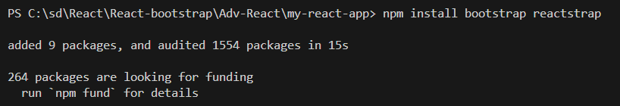

* Now Go to **Index.js** and import **reactstrap** in your application code

**import 'bootstrap/dist/css/bootstrap.min.css';**

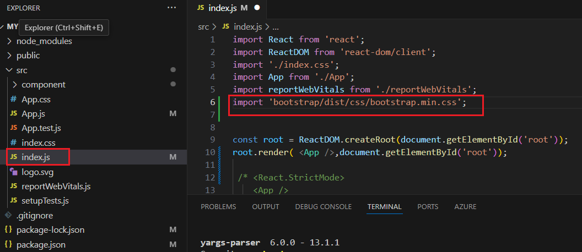

# Create Button

* Go to **App.js** and first import button using **reactstrap**

import { Button } from 'reactstrap';

* Now inside the function write below code

function App() {

  return (

    <div>

    <h1> This is bootstrap Component </h1>

    <Button>Submmit</Button>

    </div>

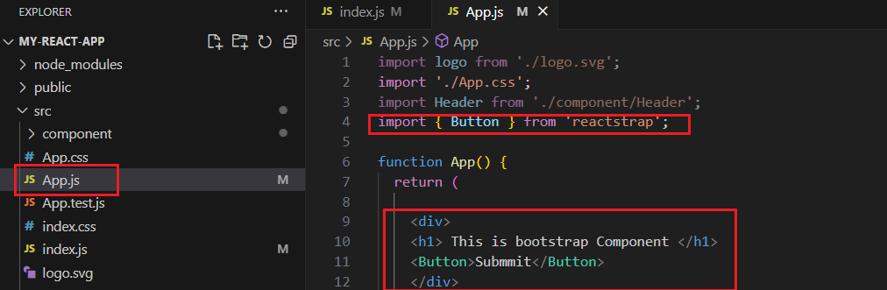

* Save it and recompile it

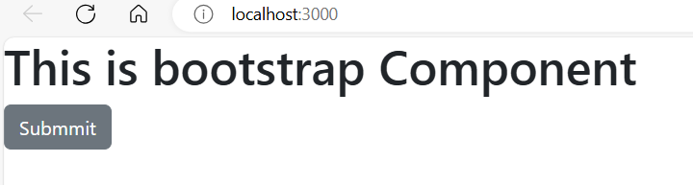

* To Change the color of **button** , lets review on github about Button component

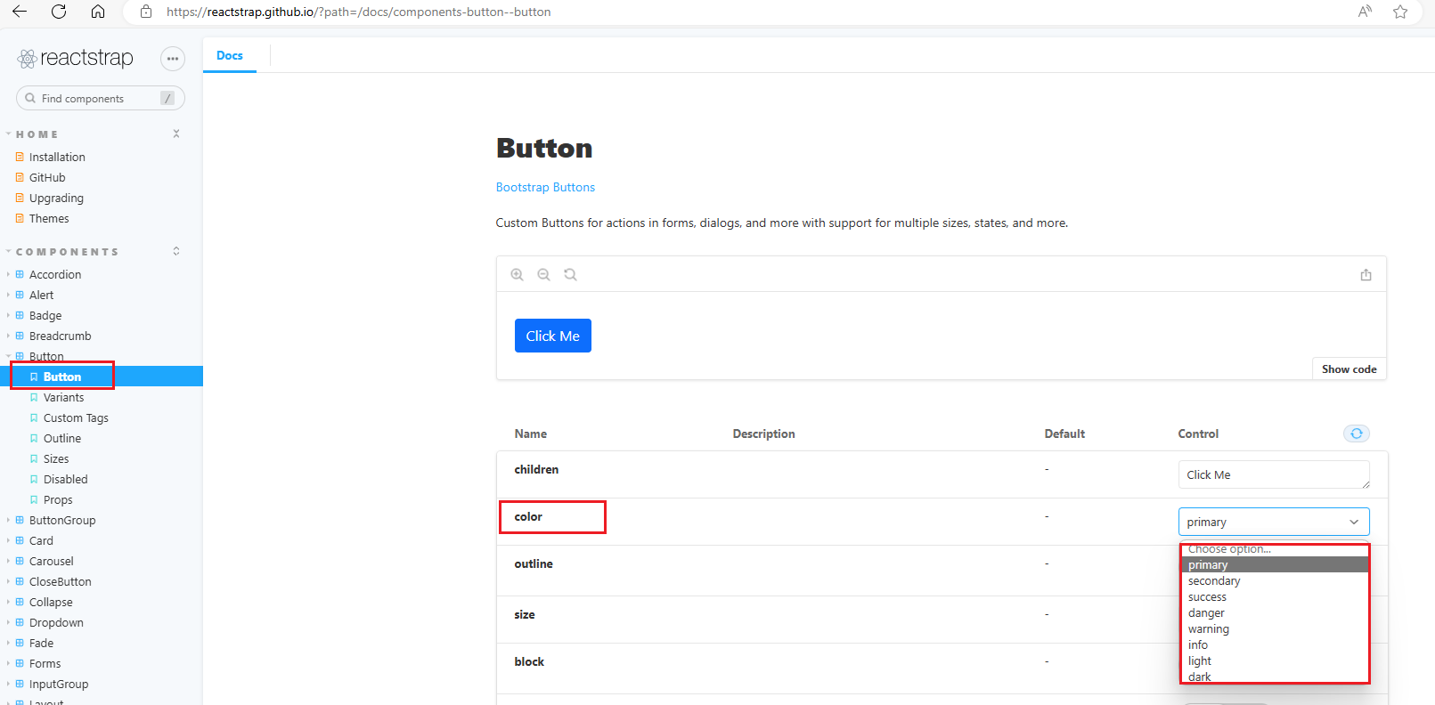

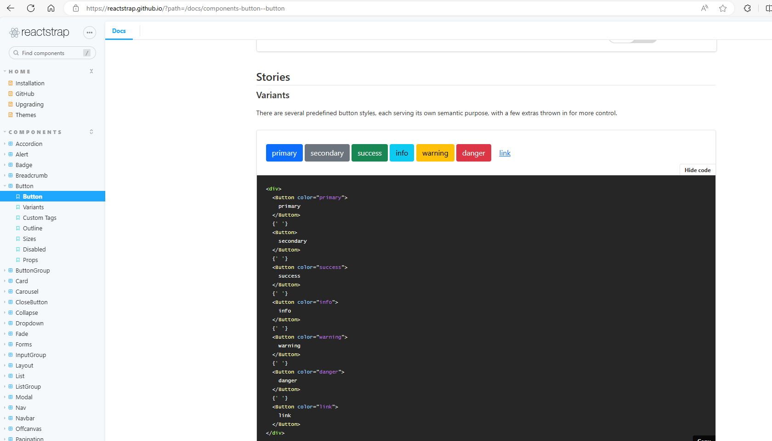

* Lets Change the color of **button** to Primary

<Button color="primary">Submmit</Button>

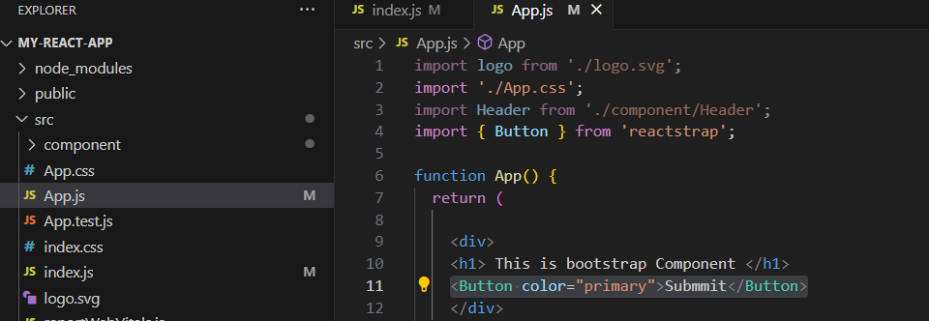

* Save and Recompile

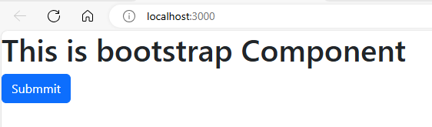

# Install Message Component Toastify

* For more info visit this url

<https://getbootstrap.com/docs/5.1/components/toasts/>

* To Install run below command

npm install react-toastify

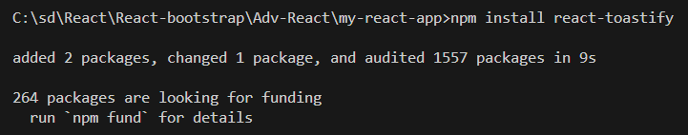

* Now Go to **Index.js** and import **reactstrap** in your application code

**import 'bootstrap/dist/css/bootstrap.min.css';**

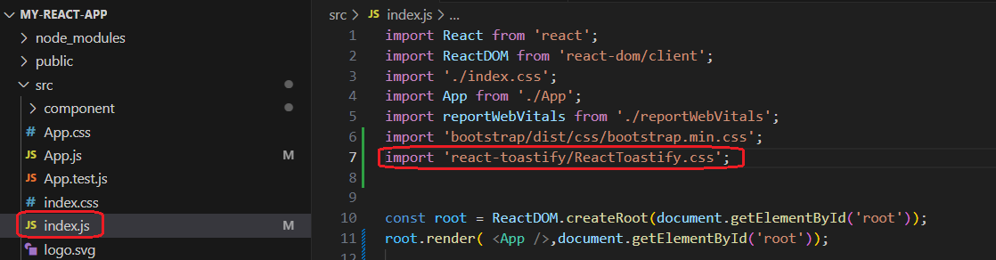

* Now in **App.js** first **import** and the create **Arrow Function** for toast and then use button inside **< ToastContainer />**

import { ToastContainer, toast } from 'react-toastify';

function App() {

  const btnHandle = () => {

    toast ("This is my First Message");

  };

  return (

    <div>

      <ToastContainer />

        <h1> This is bootstrap Component </h1>

        <Button color="primary" onClick={btnHandle}>Submmit</Button>

    </div>

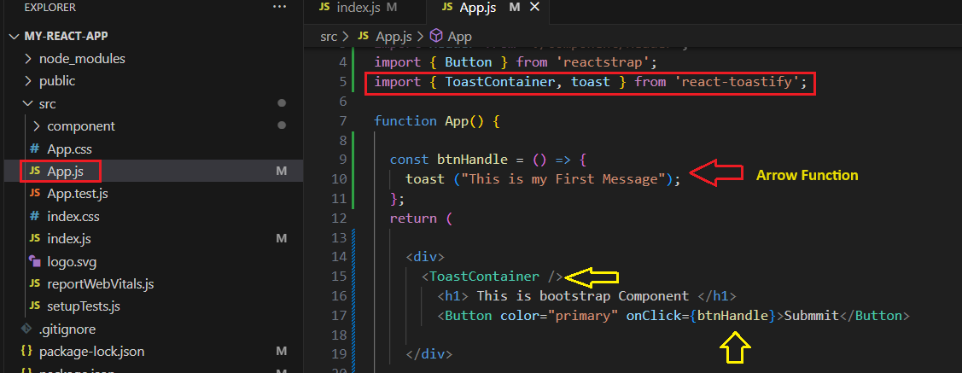

* Now Save and Recompile. When you click the Button, a message appears

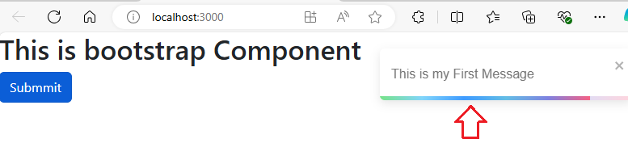

* We can use Toast Feature like **Toast.success** , **toast.error**

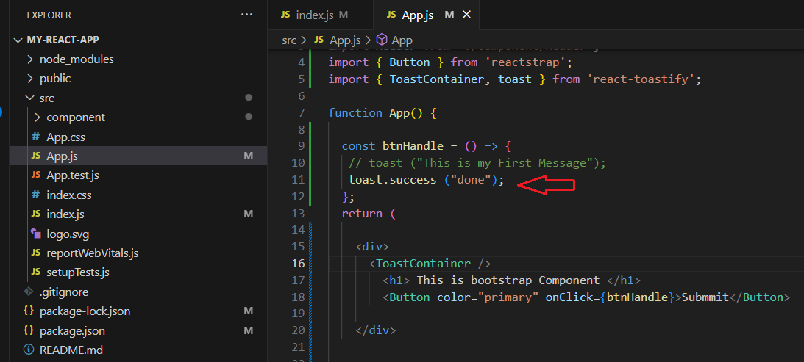

* Now Save and Recompile it

