

**Lab Manual- React Custom Component- Lab2**

**Prepared for**:

**Dat**

**Date:** 18th June 2024

**Prepared by:**

Document Name: Lab Manual **Document Number** SDLab360

**Contributor:**

Contents

1. Objective 3

2. Parent and Child Component 3

2.1 Create Error by Defining Parller Component 3

3. Create own custom Component Called Header like <H1> or <P> 5

4. Use own custom Component -Header In App.js 7

5. Use own custom Component -Header in App.js multiple times (Reusable) 9

6. Use Style in -Header 10

7. Use Dynamic Value Passing (Props) -Name Changes 12

8. Use Dynamic Value Passing (Props) -Name & Title Changes 14

# Objective

**React** is a powerful JavaScript library for building dynamic and interactive user interfaces (UIs). It is developed by Facebook. React is known for its **component-based architecture**which allows you to create reusable UI elements, making complex web applications easier to manage and maintain. React is used to build single-page applications.

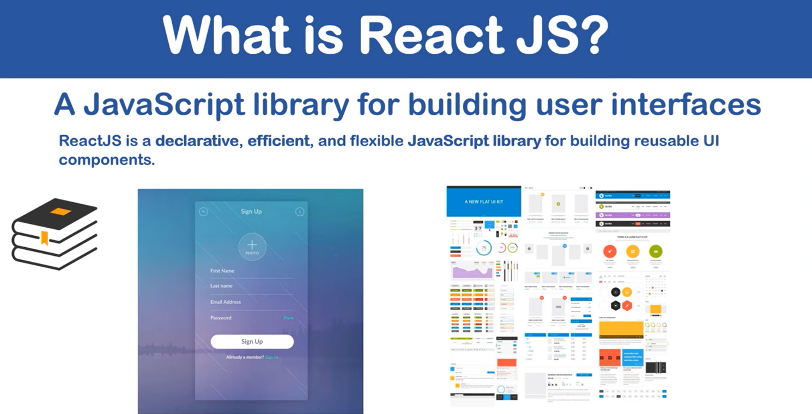

**How does React Work?**

**React creates a VIRTUAL DOM in memory. Instead of manipulating the browser's DOM directly, React creates a virtual DOM in memory, where it does all the necessary manipulating, before making the changes in the browser DOM. React only changes what needs to be changed! React finds out what changes have been made, and changes only what needs to be changed.**

# Parent and Child Component

## 2.1 Create Error by Defining Parller Component

Let’s add **<p>** component in parallel to **<h1>** in **App.js**

 <h1>This Program is developed by Bipeen</h1>

    <p> This is Test of component in React and i am sure it through error</p>

    <p> Because we try to add parllel component like h1 an p </p>

Note error it is looking for **parent** element

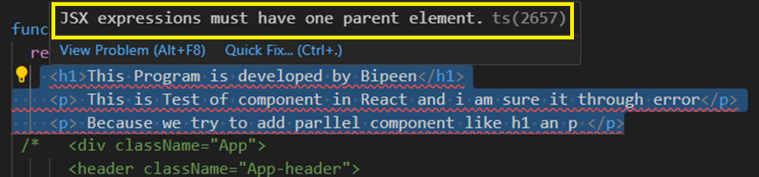

***2.2 Define Parent Element <div>***

* Defining **<div>** as parent component means **Return method** Return only **Parent** component and Parent may contains **multiple child**

 <div>

    <h1>This Program is developed by Bipeen</h1>

    <p> This is Test of component in React and i am sure it through error</p>

    <p> Because we try to add parllel component like h1 an p </p>

    </div>

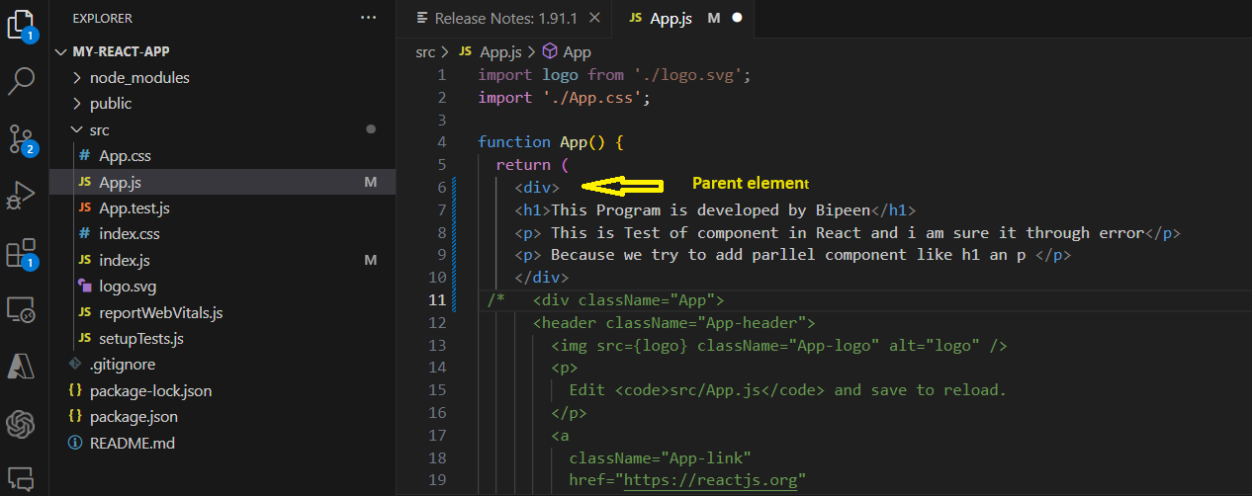

* Now Save the program and rerun it , you Notice the changes

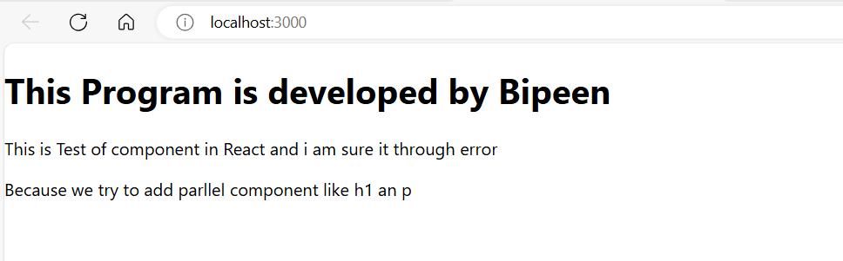

# Create own custom Component Called Header like <H1> or <P>

* Right Click the **SRC** and Create **New Folder** and Name it as ‘ **Component**’

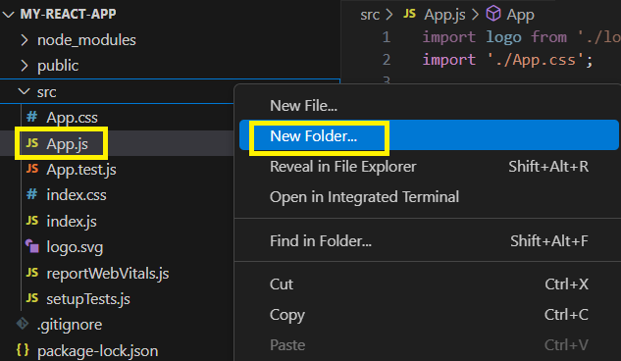

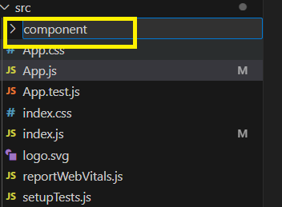

* Now Right Click the **Component Folder** and Create **New file** called **Header.js**

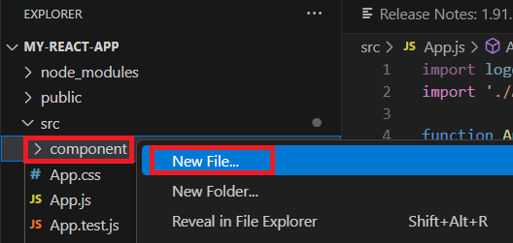

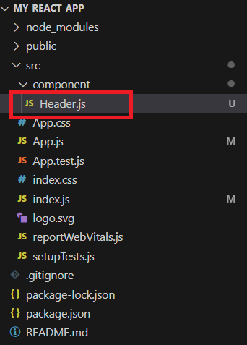

* Inside Header.js, first **import React Class**

import React from "react"

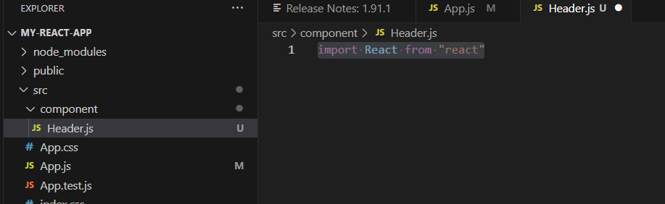

* Now Create a **Function** called Header and Return simple HTML

function Header () {

    return (

        <div>

            <h1> My Header</h1>

            <h1> Learn React from bipeen</h1>

            <p>

                This is my customer Header component we are going to use in React

            </p>

        </div>

    )

}

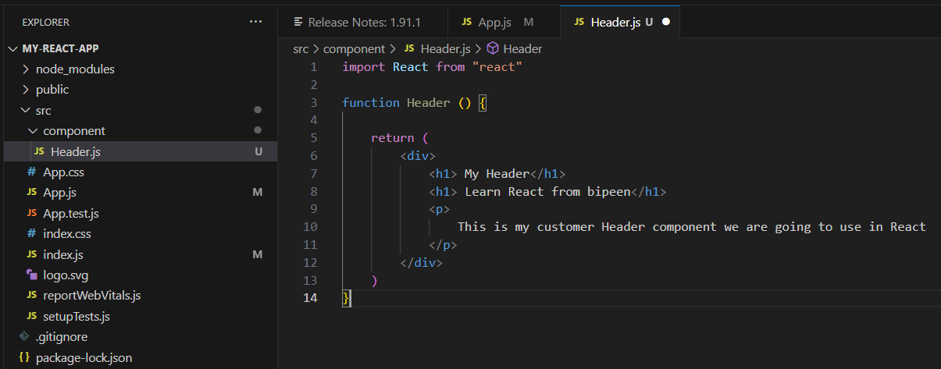

# Use own custom Component -Header In App.js

* Now if you want to use Header Component Like we use <h1> or <p> we need to
* first **export** it from Header.js
* **Import** it in App.js

Export Statement in header.js

export default Header;

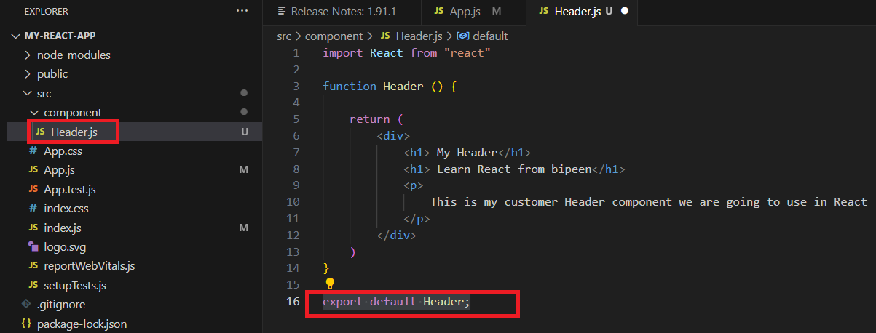

Import in **App.js**

import Header from './component/Header';

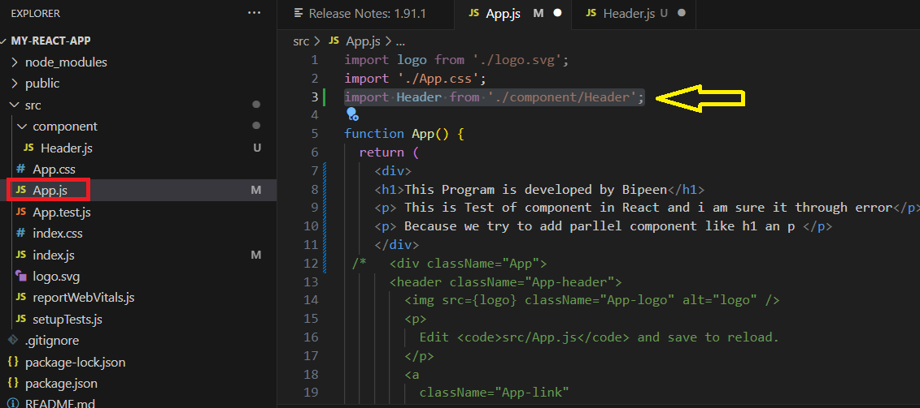

Now Called it in App.js function, inside <div>

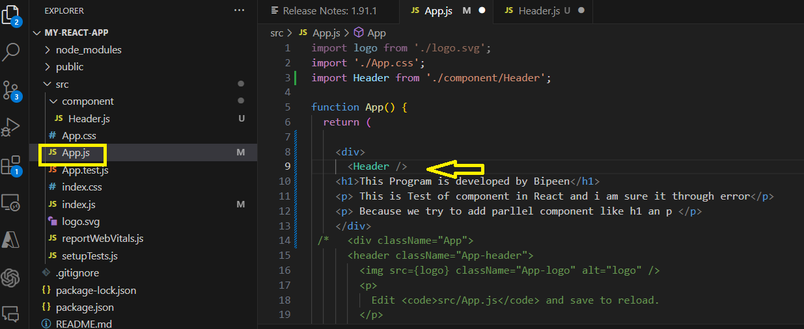

Now Save it and Recompile

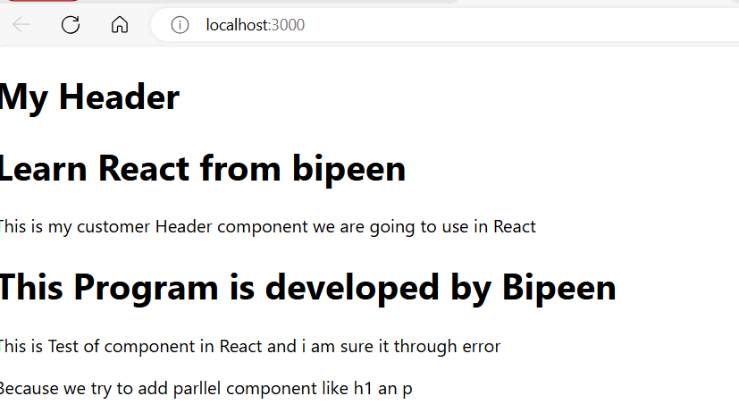

# Use own custom Component -Header in App.js multiple times (Reusable)

* You can call <Header> inside app.js multiple times , because Header Reusable

    <div>

    <Header />

    <Header />

    <h1>This Program is developed by Bipeen</h1>

    <p> This is Test of component in React and i am sure it through error</p>

    <p> Because we try to add parllel component like h1 an p </p>

    <Header />

    </div>

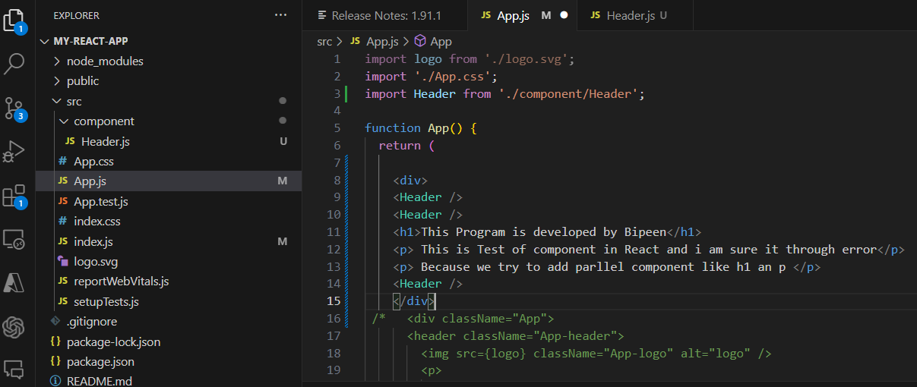’

* Now save it and recompile

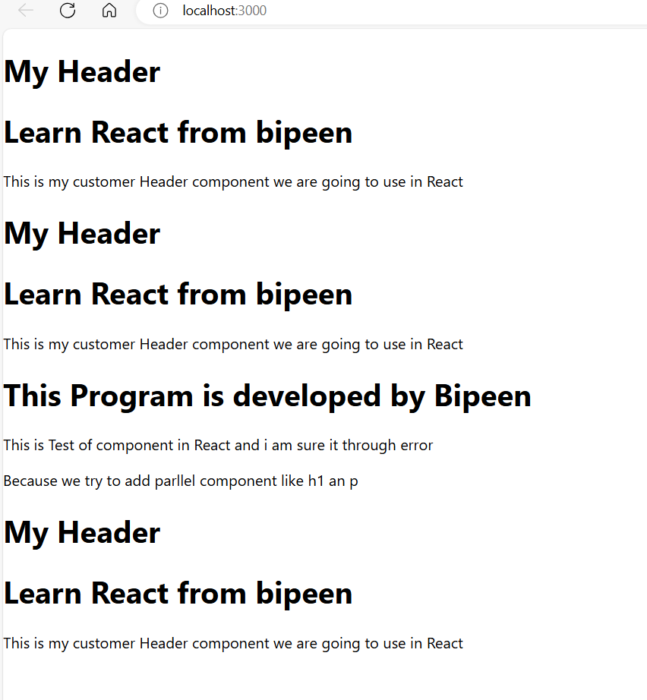

# Use Style in -Header

* Now you use formatting using style in Header

<div style={ { background: "red"}}>

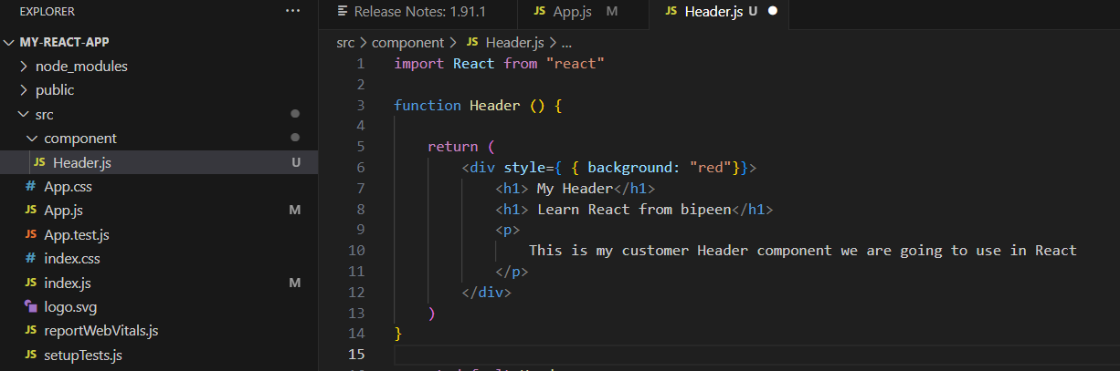

* Now Save and Recompile

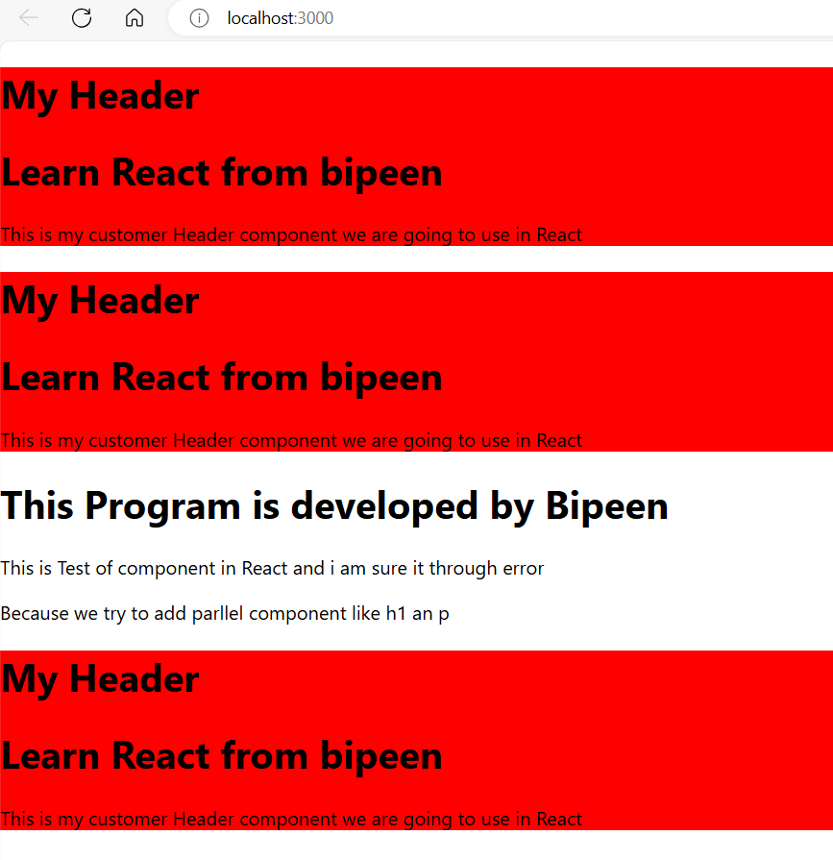

* Now you Padding also inside JavaScript object formatting using style in Header
* <div style={ { background: "red", padding: 20}}>

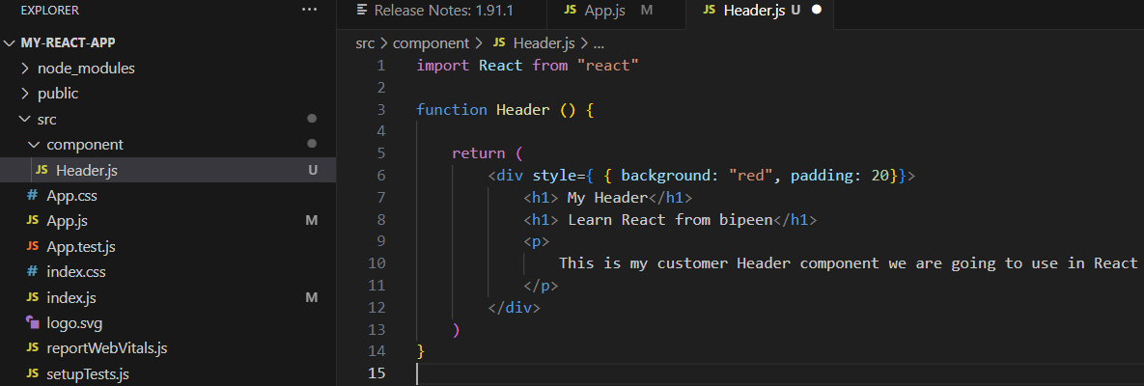

* Now Save and Recompile it

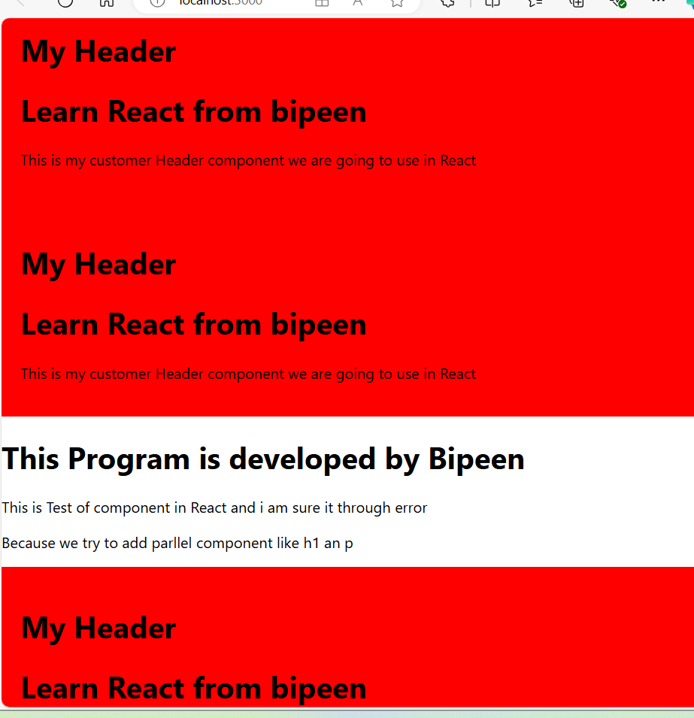

# Use Dynamic Value Passing (Props) -Name Changes

* Now Lets we want to change the name , so we need to pass the value inside Header when we called it . This Technique is Called **Props**

<Header name= ‘ John “ >

* Go to **Header.js** and Ask argument **Name** in side **java script bracket** { name } into header and also inside <**h1>** tag

import React from "react"

function Header ( { name }) {

    return (

        <div style={ { background: "red", padding: 20}}>

            <h1> My Header</h1>

            <h1> Learn React from { name }</h1>

            <p>

                This is my customer Header component we are going to use in React

            </p>

        </div>

    )

}

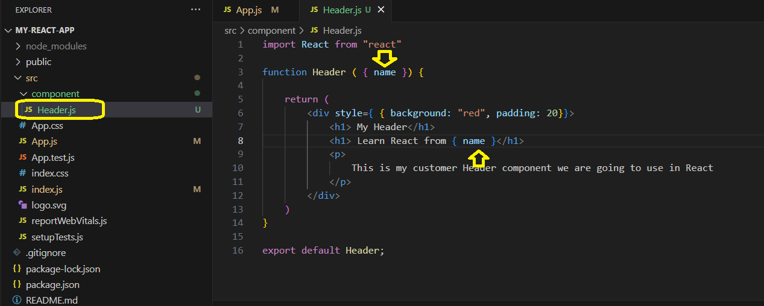

* **And now inside App.js while calling Header pass the value to name Argument**

function App() {

  return (

    <div>

    <Header name=" John Mathew" />

    <Header name=" Lilly Jonson" />

    <h1>This Program is developed by Bipeen</h1>

    <p> This is Test of component in React and i am sure it through error</p>

    <p> Because we try to add parllel component like h1 an p </p>

    <Header name=" Donald Trump" />

    </div>

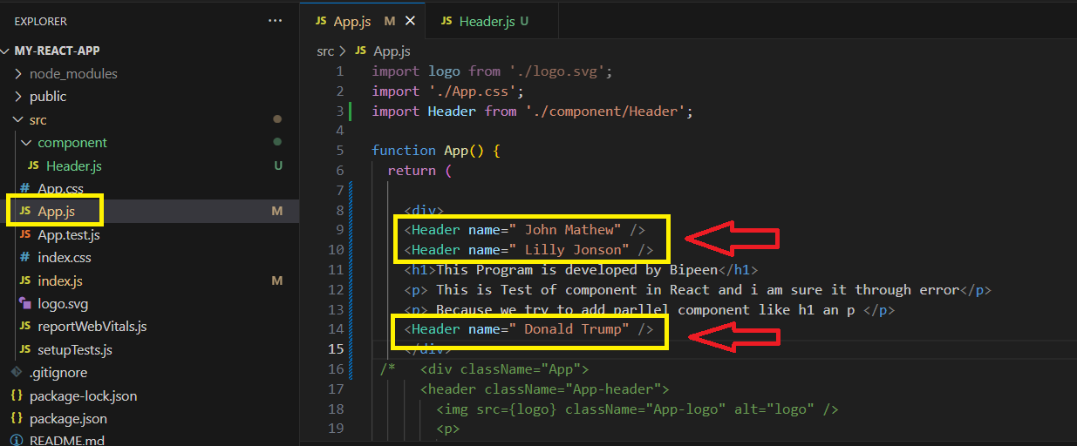

* Now Save it and Recompile

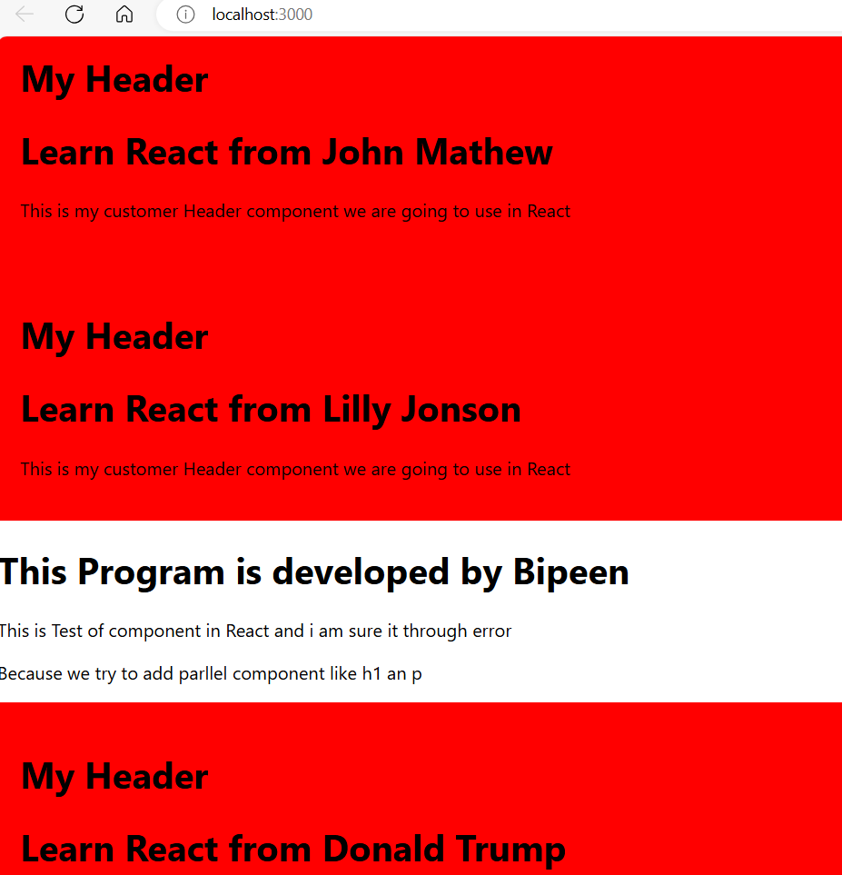

# Use Dynamic Value Passing (Props) -Name & Title Changes

* Now in similar way we want to change the **Title** , so again we need to accept the value inside Header and Then we can call it inside **<h1>** tag , we can also fix the **Width** of the card under **Style** statement

import React from "react"

function Header ( { name, title }) {

    return (

        <div style={ { background: "red", padding: 20 , width:400}}>

            <h1> { title } </h1>

            <h1> Learn React from { name }</h1>

            <p>

                This is my customer Header component we are going to use in React

            </p>

        </div>

    )

}

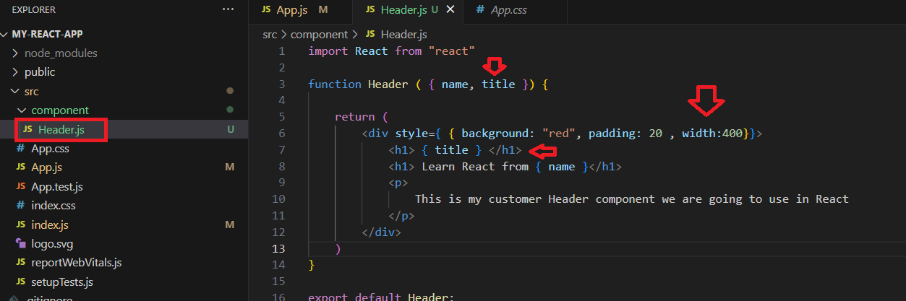

Now Pass the value in App.js and also use HR Tag for space

function App() {

  return (

    <div>

    <Header name=" John Mathew" title="First Card" />

    <hr />

    <Header name=" Lilly Jonson" title="Second Card" />

    <hr />

    <h1>This Program is developed by Bipeen</h1>

    <p> This is Test of component in React and i am sure it through error</p>

    <p> Because we try to add parllel component like h1 an p </p>

    <hr />

    <Header name=" Donald Trump" title="Third Card" />

    </div>

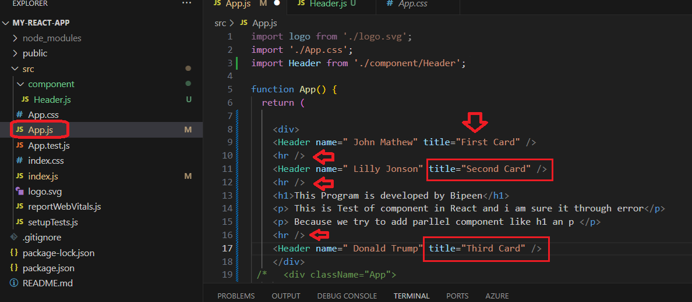

Now Save and Recompile it

