

**Lab Manual- Spring Boot Zipkin , Swagger and SpringAdmin**

**Prepared for**:

**Date:** 18th June 2024

**Prepared by:**

Document Name: Lab Manual **Document Number** SDLab333

**Contributor:**

Contents

1. Objective 3

2. Clone the Code from Git Repository and Download Zipkin 3

2.1 Clone the Git Repository 3

2.2 Download the Zipkin 4

3. Understand FruitController class 6

1. Code Explanation 6

2. Zipkin's Point of View 6

3. Summary 7

4. Update Code for Zipkin | get Endpoint | Monitor with Zipkin | Get Document with Swagger (SpringDoc) 7

3.1 Customized Code for Zipkin 7

3.1 Get the EndPoint 9

1. Breakdown of the URL 9

2. What Happens When You Access the URL 10

2.1 Get the Traces with Zipkin 10

2.1 Get the API Visual Documentation with Swagger 11

3. Launch Swagger UI 13

5. Update Code SpringAdmin 13

5.1 Key Features of Spring Boot Admin 14

5.2 How to Set Up Spring Boot Admin (Example) 14

1. Set Up Spring Boot Admin Server 14

2. Set Up Spring Boot Admin Client 14

3. Enable Spring Boot Admin Server: 14

5.3 How to Set Up Spring Boot Admin (Demo) 15

# Objective

# Clone the Code from Git Repository and Download Zipkin

## Clone the Git Repository

* Open **PowerShell** in Administrative Mode, Change Directory and Create New Directory

**Cd /**

**Mkdir ZipKin**

**Cd ZipKin**

**Git clone** [**https://github.com/sidoncode/VioletApple.git**](https://github.com/sidoncode/VioletApple.git)

**Cd VioletApple**



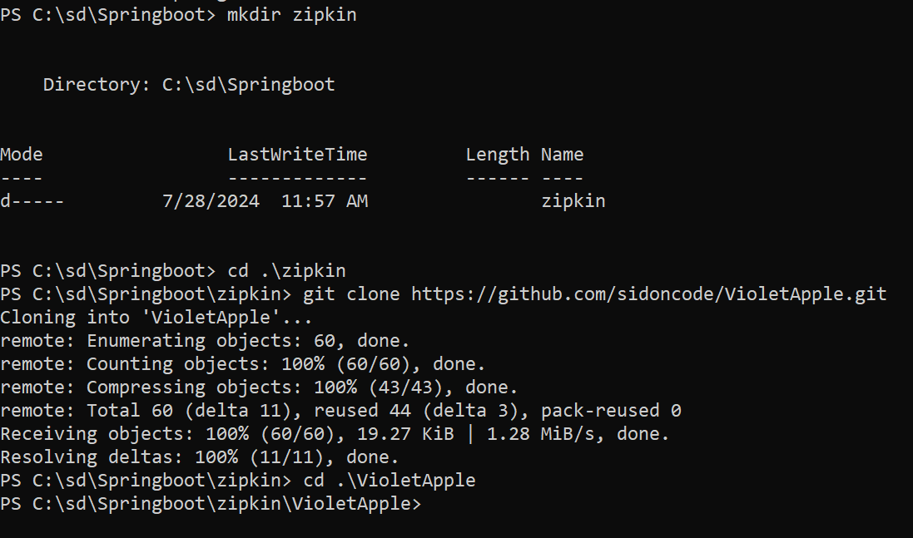

## Download the Zipkin

* Download **Zipkin** on windows under **Java – Latest Release**

<https://zipkin.io/pages/quickstart.html>

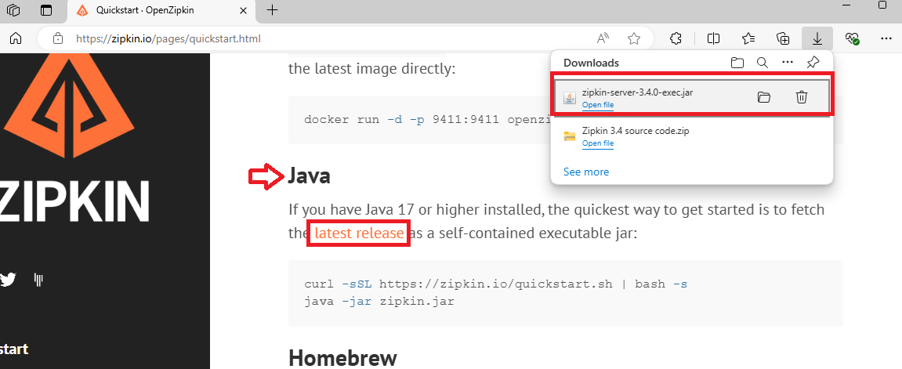

* Copy the downloaded **.jar** file to your git cloned project

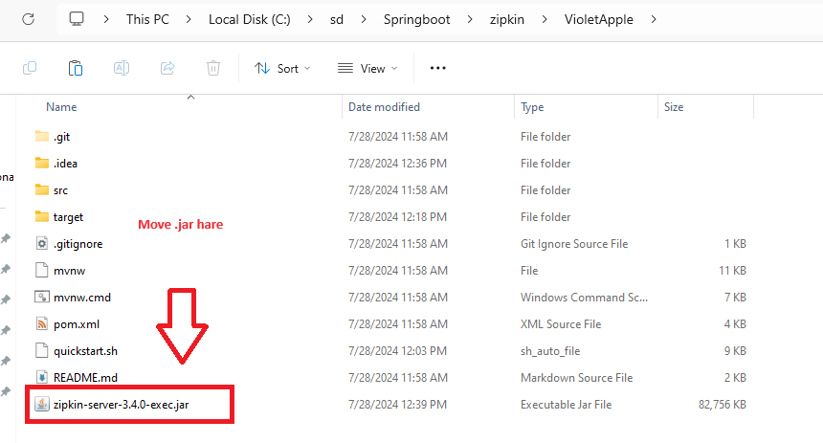

* Execute the .**jar** file make Zipkin up inside VioletApple Directory .

**java -jar .\zipkin-server-3.4.0-exec.jar**

Note : After Executing Jar File you should able to see the url in the last http://127.0.0.0/9411/

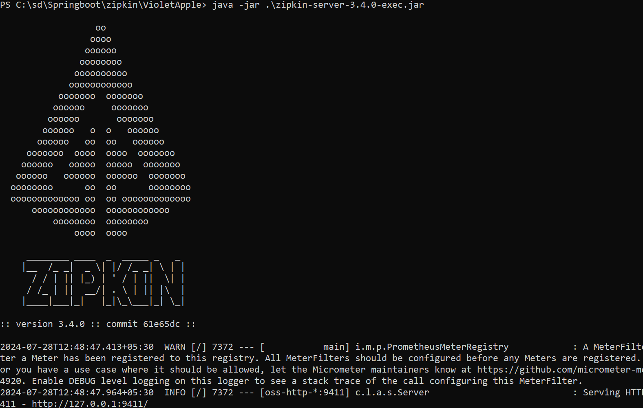

* Download **Zipkin** on windows

**Invoke-WebRequest -Uri https://zipkin.io/quickstart.sh -OutFile quickstart.sh**



# Understand FruitController class

The **FruitController class** is a **REST controller** in a Spring Boot application.

When viewed from the perspective of **Zipkin**, which is a **distributed tracing system**, this class is significant because it **represents an endpoint** that can be **traced for performance** and **debugging purposes**.

Here is a breakdown of the code and its relevance to Zipkin:

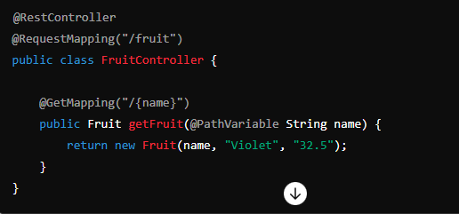

### Code Explanation

1. **Annotations:**
   * @RestController: This annotation indicates that the class is a REST controller, meaning it handles HTTP requests and returns responses in a RESTful manner.
   * @RequestMapping("/fruit"): This annotation maps HTTP requests to /fruit to methods in this controller.
2. **Class Definition:**
   * public class FruitController: Defines a public class named FruitController.
3. **Method:**
   * @GetMapping("/{name}"): This annotation maps HTTP GET requests to /fruit/{name} to the getFruit method.
   * public Fruit getFruit(@PathVariable String name): This method takes a path variable name from the URL and returns a Fruit object. The Fruit object is created with the given name, a hardcoded color ("Violet"), and a hardcoded weight ("32.5").

### Zipkin's Point of View

Zipkin is a tool for collecting and visualizing traces in a distributed system. Here's how Zipkin interacts with this controller:

1. **Tracing HTTP Requests:**
   * When an HTTP GET request is made to /fruit/{name}, Zipkin can trace this request. The trace will include information about the request duration, the endpoint being called, and other relevant metadata.
2. **Span Creation:**
   * A span is a unit of work in a trace. Zipkin will create a span for the getFruit method call. This span will capture the time taken to execute the method, along with any tags or annotations added for additional context.
3. **Propagating Context:**
   * Zipkin propagates trace context across service boundaries. If the FruitController calls other services or methods that are also instrumented with Zipkin, the trace context will be passed along, creating a full trace of the request flow.
4. **Performance Monitoring:**
   * By tracing the getFruit endpoint, Zipkin helps monitor the performance of this method. If there are delays or errors, they can be identified and debugged using the trace information.
5. **Example Trace Flow**
6. **Client Request:**
   * A client makes a GET request to /fruit/apple.
7. **Trace Initialization:**
   * Zipkin starts a new trace and records the incoming request as the root span.
8. **Method Execution:**
   * The getFruit method is executed. Zipkin creates a span for this method call, recording the start time, end time, and any relevant tags (e.g., method name, path variable).
9. **Response:**
   * The method returns a Fruit object, and the span is completed.
10. **Trace Completion:**
    * Once the response is sent back to the client, the trace is completed and sent to the Zipkin server for storage and visualization.

### Summary

* + In summary, from Zipkin's point of view, the **FruitController class** represents an endpoint that can be traced for performance and debugging purposes. **Each request to this controller generates trace data that** can be used to **monitor** and analyze the behavior and performance of the application.

# Update Code for Zipkin | get Endpoint | Monitor with Zipkin | Get Document with Swagger (SpringDoc)

## Customized Code for Zipkin

* Open Project in **IntelliJ**

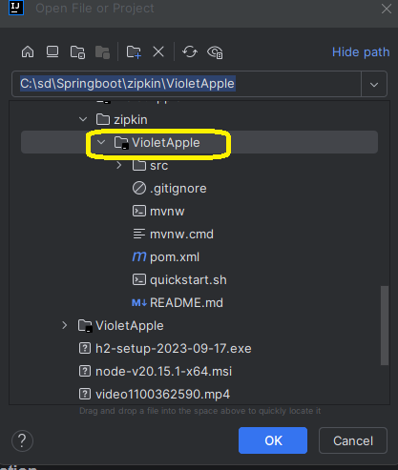

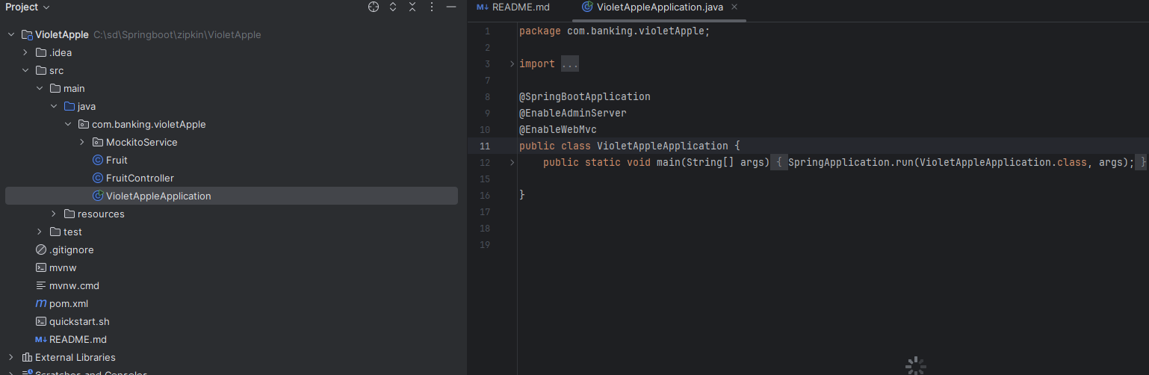

* Traverse to Main Application in Package **Src/Main/java/com.banking.violetAppie** and Comment Line no **#3** and Line **#9**

**//import de.codecentric.boot.admin.server.config.EnableAdminServer;**

**//@EnableAdminServer**

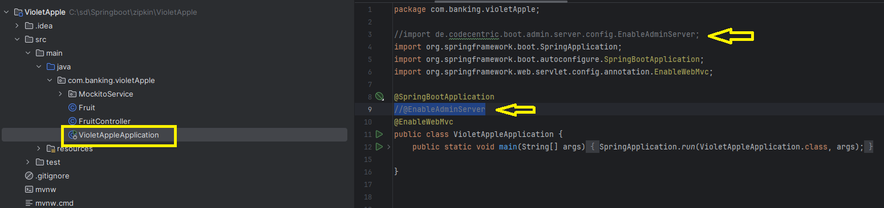

* Then in **application.properties** Change localpost to 8081 and also add new server port 8081

**spring.boot.admin.client.url=http://localhost:8081/**

**server.port=8081**

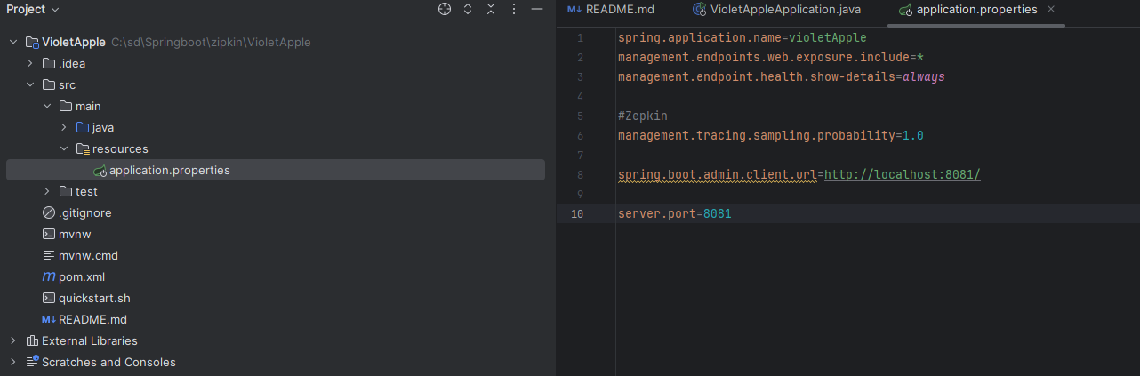

* Now Save the File and Run Application

## Get the EndPoint

This demonstrates how a **RESTful endpoint** in a Spring Boot application processes an **HTTP GET** request and returns a resource representation based on the request parameters.

• The URL **http://localhost:8081/fruit/apple** triggers the **getFruit** method in the **FruitController**.

• It extracts the path variable **apple** and uses it to create a new **Fruit** object.

• The **Fruit** object is then returned as a **JSON** response to the client.

The URL **http://localhost:8081/fruit/apple** is used to access a **specific endpoint** in a Spring Boot application that is **mapped by** the FruitController class.

Type below URL to fire get data using Zipkin

<http://localhost:8081/fruit/apple>

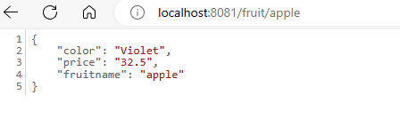

### Breakdown of the URL

* **http**: The protocol used for the request.
* **localhost**: The hostname, indicating that the application is running on the local machine.
* **8081**: The port on which the Spring Boot application is listening.
* **/fruit/apple**: The path that specifies the endpoint in the FruitController.

### What Happens When You Access the URL

1. **HTTP GET Request:**
   * An HTTP GET request is made to the URL http://localhost:8081/fruit/apple.
2. **Request Mapping:**
   * The request is mapped to the FruitController class because of the @RequestMapping("/fruit") annotation.
3. **Path Variable Extraction:**
   * The @GetMapping("/{name}") annotation maps the apple part of the URL to the name parameter of the getFruit method.
4. **Method Execution:**
   * The getFruit method is called with the name parameter set to apple.
   * A new Fruit object is created with the name "apple", color "Violet", and weight "32.5".
5. **Response:**
   * The Fruit object is returned as the response, typically serialized to JSON by Spring Boot.

## Get the Traces with Zipkin

<http://localhost:9411/zipkin/>

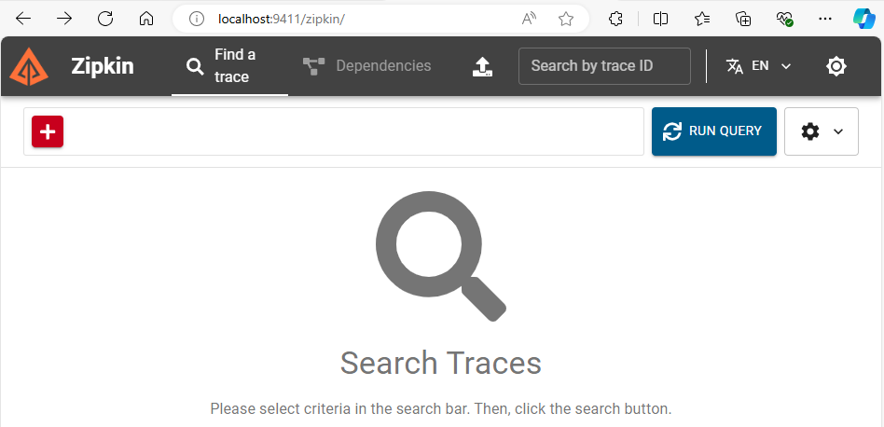

Click on Run Query to get latest

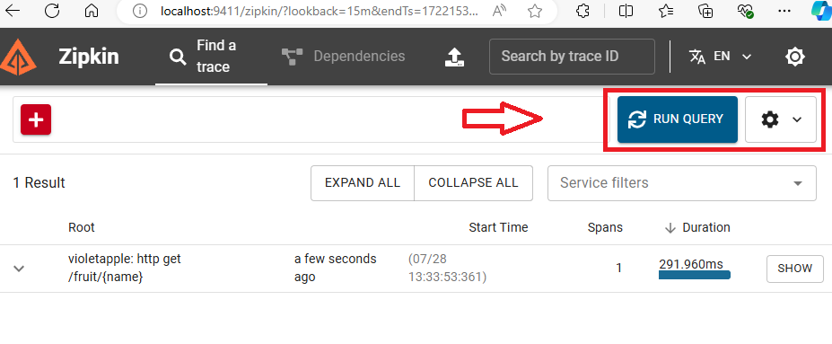

* Click **Show** Button to Get Latest

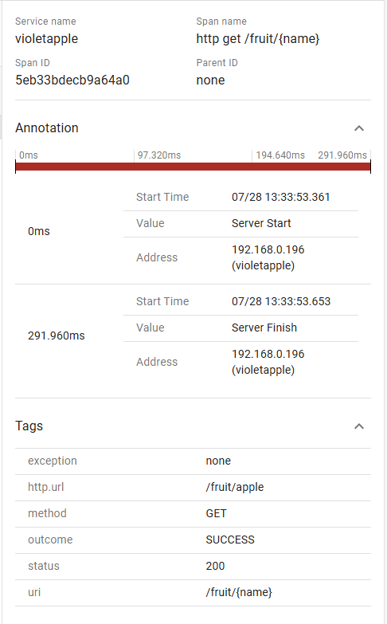

## Get the API Visual Documentation with Swagger

Swagger UI is a tool for visualizing and interacting with the API endpoints defined in your application. When you navigate to http://localhost:8081/swagger-ui/index.html, you will see a **web-based interface** that **displays the documentation** for the **API endpoints** provided by your Spring Boot application.

To Design API use Swagger Editor :

<https://editor.swagger.io/>

There are other commonly used endpoints and related features when using **springdoc-openapi** . These endpoints provide the OpenAPI (Swagger) documentation in JSON format

<http://localhost:8081/v3/api-docs>

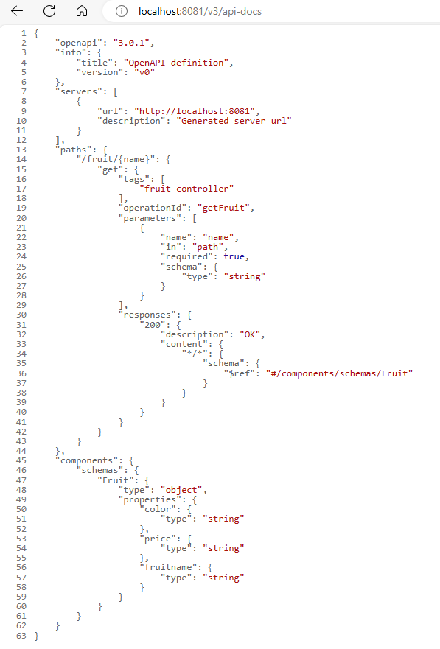

Swagger is an open-source framework that allows developers to **design, build, document**, and **consume RESTful web services**.

### Launch Swagger UI

<http://localhost:8081/swagger-ui/index.html>

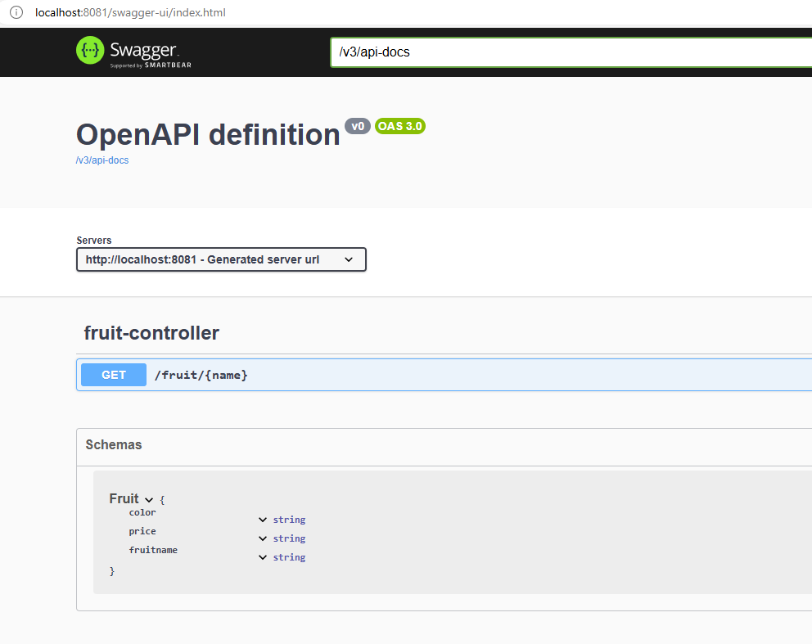

# Update Code SpringAdmin

Spring Boot Admin is a community project to **manage** and **monitor Spring Boot applications**.

It provides a web-based user interface to **view information** about running Spring Boot applications, such as **health status**, **metrics, environment properties**, and more.

It is particularly useful for administrators and developers to monitor the health and performance of their applications.

## Key Features of Spring Boot Admin

1. **Dashboard**:
   * Provides an overview of all registered applications.
   * Displays the status of each application.
2. **Application Details**:
   * Health: Shows health indicators such as disk space, database status, etc.
   * Metrics: Displays application metrics like memory usage, CPU usage, HTTP request statistics, etc.
   * Environment: Lists environment properties and configuration properties.
   * Loggers: Allows changing the log level of various packages at runtime.
   * Threads: Displays information about active threads.
   * Trace: Shows HTTP request traces.
   * JMX: Provides access to JMX beans.
3. **Notifications**:
   * Supports notifications for changes in the status of applications via various channels like email, Slack, and others.
4. **Security**:
   * Supports authentication and authorization to restrict access to the Spring Boot Admin UI.

## How to Set Up Spring Boot Admin (Example)

### Set Up Spring Boot Admin Server

* **Add Dependencies**:
  + Add the necessary dependencies to your Spring Boot Admin Server pom.xml

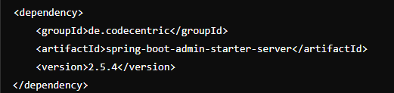

### Set Up Spring Boot Admin Client

* **Add Dependencies:**
  + Add the necessary dependencies to your Spring Boot Admin Client pom.xml:

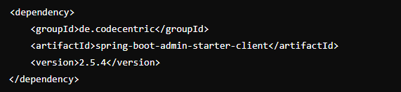

### Enable Spring Boot Admin Server:

* + Create a **configuration class** to enable Spring Boot Admin Server:

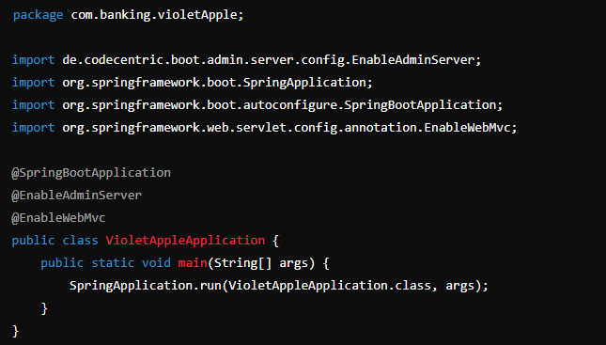

## How to Set Up Spring Boot Admin (Demo)

1. Enable Admin server in VioletAppleApplication.java at Line no #3 and Annotaion @EnableAdminServer at Line #9

import de.codecentric.boot.admin.server.config.EnableAdminServer;

@EnableAdminServer

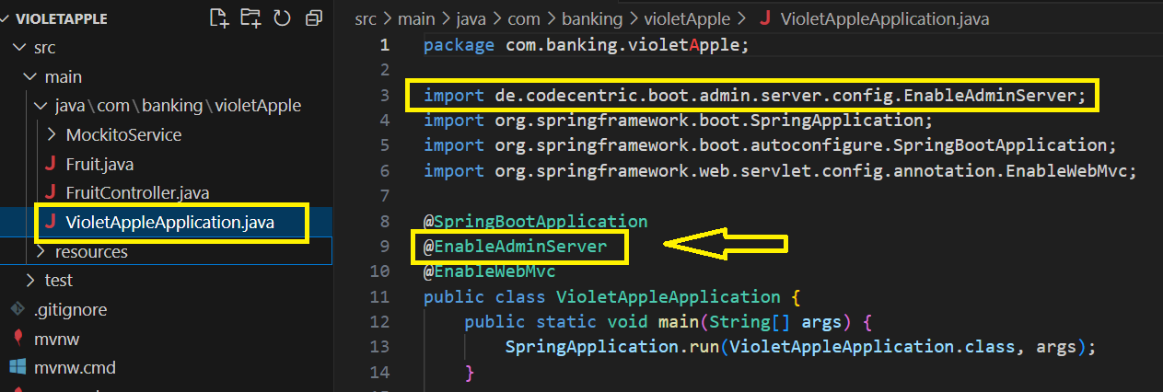

1. Uncomment below line in **POM.xml**

<dependency>

            <groupId>de.codecentric</groupId>

            <artifactId>spring-boot-admin-starter-client</artifactId>

            <version>3.3.2</version>

        </dependency>

        <!-- https://mvnrepository.com/artifact/de.codecentric/spring-boot-admin-starter-server -->

        <!-- add @EnableAdminServer in main.java -->

         <dependency>

            <groupId>de.codecentric</groupId>

            <artifactId>spring-boot-admin-starter-server</artifactId>

            <version>3.3.2</version>

        </dependency>

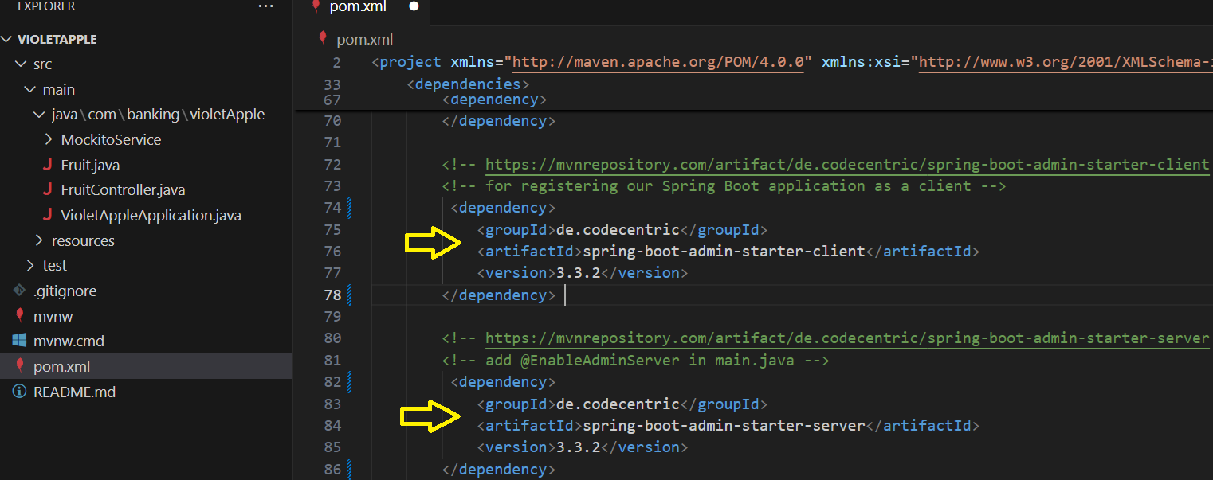

1. Disable Swagger in POM.xml

<dependency>

            <groupId>org.springdoc</groupId>

            <artifactId>springdoc-openapi-starter-webmvc-ui</artifactId>

            <version>2.6.0</version>

        </dependency>

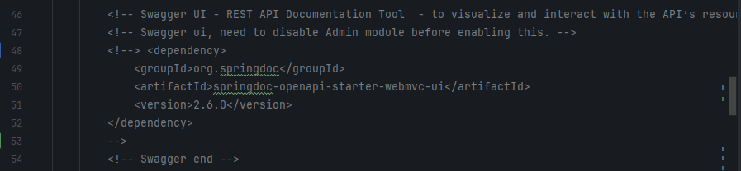

1. If Required Sync the Maven
2. Run the Application
3. Paste the URL in browser

<http://localhost:8080/applications>

