

**Lab Manual- Dependency Injection using Spring Boot ( Application Context and @Component)**

**Prepared for**:

**Date:** 18th June 2024

**Prepared by:**

Document Name: Lab Manual **Document Number** SDLab003

**Contributor:**

Contents

1. Objective 3

1. . Traditional Object Creation in Java 3

2. Object Creation in Spring Boot 4

2. Creating a Spring Boot Project 4

3. Import Spring Boot Project in IntelliJ 6

4. Understand Default Core SpringBoot Annotation 9

5. Create simple package in IntelliJ 11

6. Create simple myConfig class in IntelliJ 12

7. Create Service Class ProductService in IntelliJ 14

8. Create Bean for Class productService under config class in IntelliJ 16

9. Call Bean Class inside Main Application 16

# Objective

In Java, you typically create objects using the new keyword, which directly creates an instance of a class in the JVM. For example:

**MyClass myObject = new MyClass();**

This creates a new instance of MyClass and assigns it to the variable myObject.

In contrast, Spring Boot (and the Spring Framework in general) uses a dependency injection container (often referred to as the Spring container) to manage the lifecycle and dependencies of beans (objects).

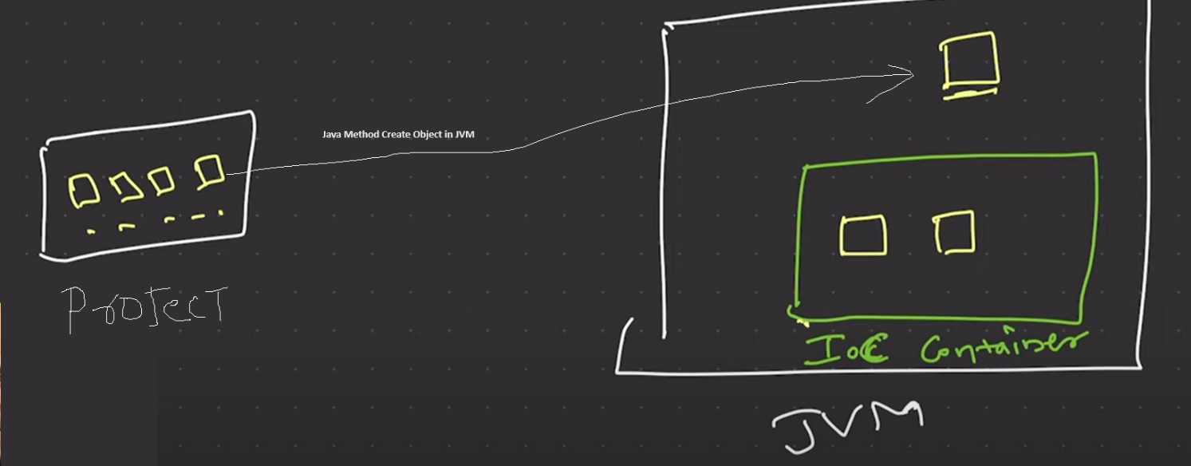

Here are some key points:

### . Traditional Object Creation in Java

When you use the new keyword in a traditional Java application:

1. **Direct Creation**: You are directly responsible for creating and managing the lifecycle of the object.
2. **Dependencies**: You have to manually handle dependencies between objects.
3. **Tight Coupling**: The code is often tightly coupled, making it harder to manage and test.

Example:

java

Copy code

public class UserService {

private UserRepository userRepository;

public UserService() {

this.userRepository = new UserRepository();

}

}

### Object Creation in Spring Boot

In Spring Boot, objects (beans) are typically created and managed by the Spring container. This provides several benefits:

1. **Dependency Injection**: Spring manages dependencies between beans, injecting them where needed.
2. **Loose Coupling**: Spring encourages loose coupling between components, making the codebase more modular and easier to test.
3. **Lifecycle Management**: Spring manages the lifecycle of beans, including their creation, initialization, and destruction.

To create a bean in Spring Boot, you typically use annotations like @Component, @Service, @Repository, or @Controller, and let Spring handle the creation and wiring.

Example:

java

Copy code

import org.springframework.beans.factory.annotation.Autowired;

import org.springframework.stereotype.Service;

@Service

public class UserService {

private final UserRepository userRepository;

@Autowired

public UserService(UserRepository userRepository) {

this.userRepository = userRepository;

}

// Business logic methods

}

In this example, UserService is annotated with @Service, indicating that it is a Spring-managed bean. The UserRepository dependency is injected by Spring through the constructor, thanks to the @Autowired annotation. The Spring container will manage the lifecycle of these beans, ensuring they are properly created, initialized, and destroyed.

# Creating a Spring Boot Project

**Step 1:** Open the Spring initializr [https://start.spring.io](https://start.spring.io/).

**Step 2:** Provide the **Group** and **Artifact** name. We have provided Group name **com.bank** and Artifact **as below**

**Group** : com.bank

**Artifact** : demoAnnotation

**Name** : demoAnnotation

**Description** : Dependencies Injection

**PackageName** : com.bank. demoAnnotation

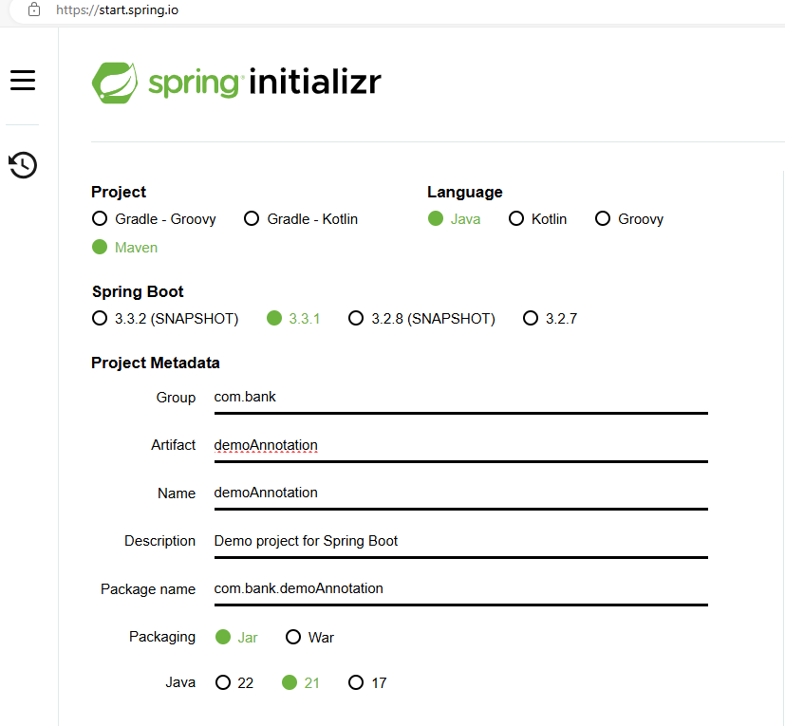

**Step 3: Click on GENERATE to download the code**

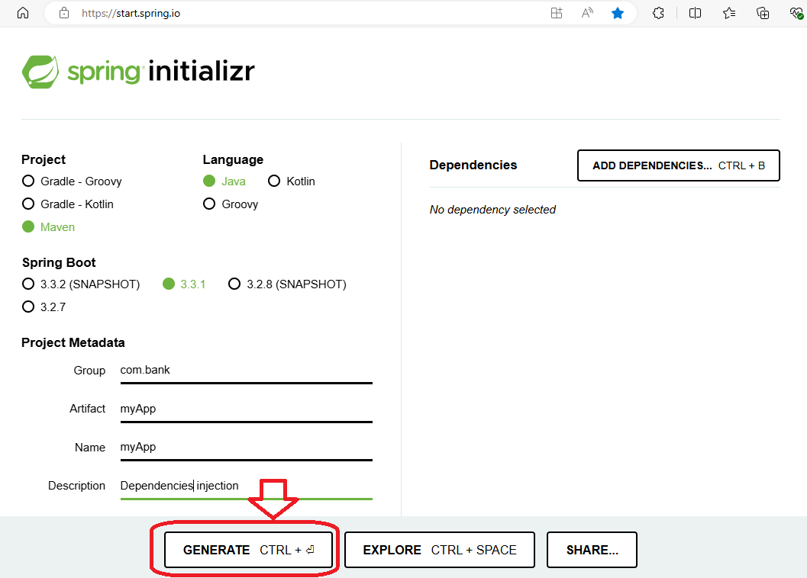

**Step 4:** Code should download now



**Step 5: Extract** the project to your Project directory

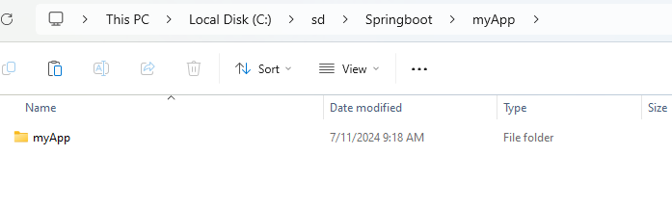

# Import Spring Boot Project in IntelliJ

* Click File🡪 Open project

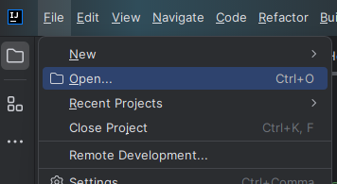

* Select your extract project and click **OK**

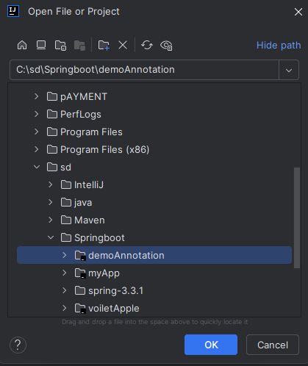

* If ask click **Trust project**

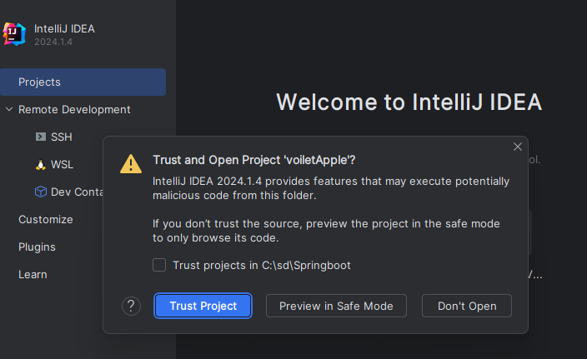

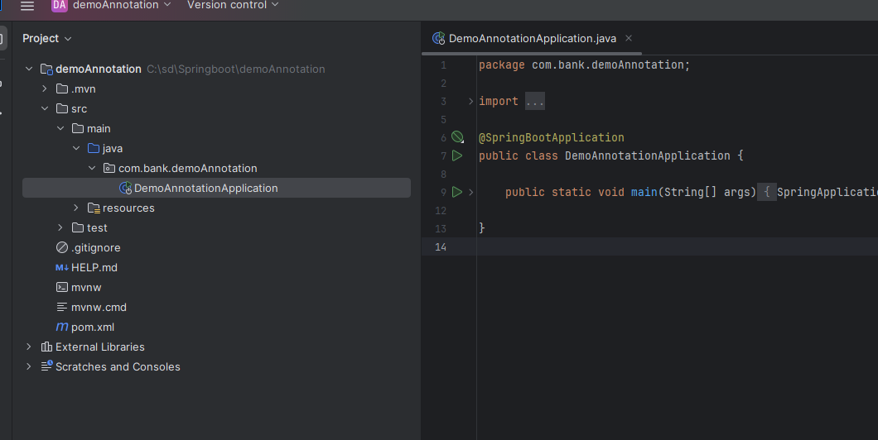

* If ask **Load** the Maven Build Script

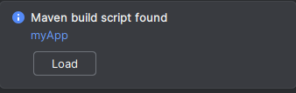

* It may takes couple of Minutes to download and Load the library

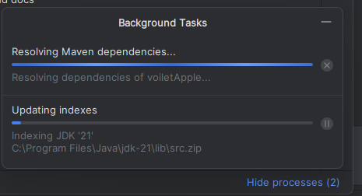

# Understand Default Core SpringBoot Annotation

Press CTRL + Click on @SpringBootApplication

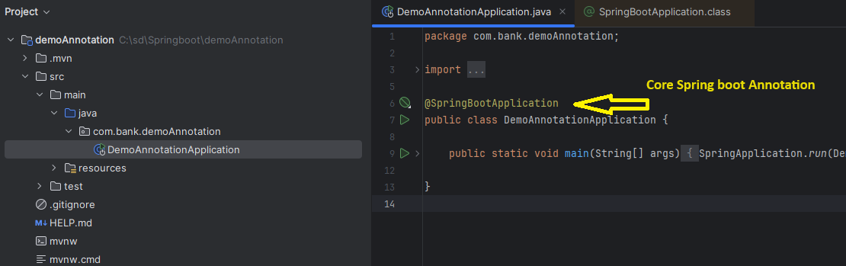

It opens Decompile version of **@SpringBootApplication**

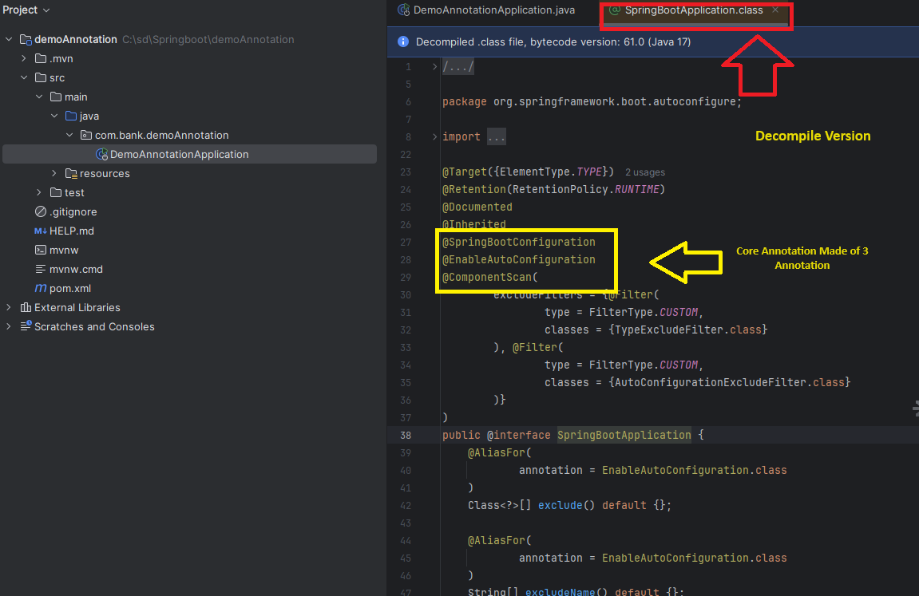

When you take the Mouse cursor to **@SpringBootConfiguration** with Press of **+CTRL** button from keyboard **it display the definition**

**@Configuration:** It is a class-level annotation. The class annotated with **@Configuration** used by Spring Containers as a source of bean definitions.

**@ComponentScan:** It is used when we want to scan a package for beans. It is used with the annotation @Configuration. We can also specify the base packages to scan for Spring Components.

**@Bean:** It is a method-level annotation. It is an alternative of XML <bean> tag. It tells the method to produce a bean to be managed by Spring Container.

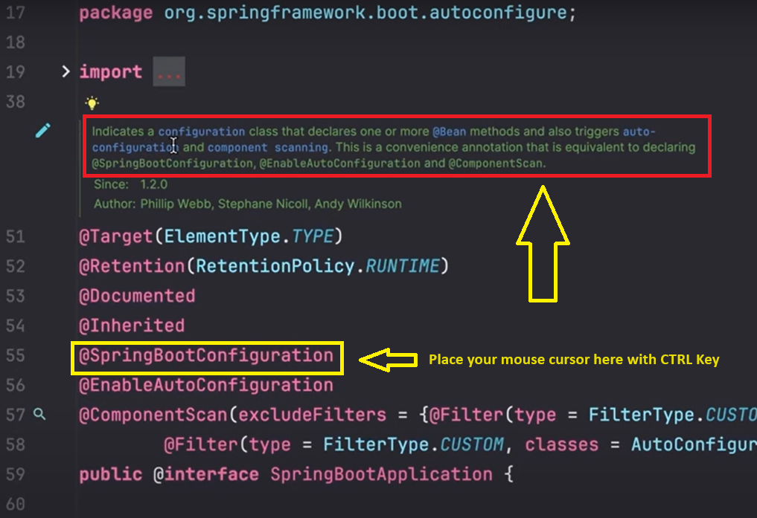

You Should Notice **@SpringBootConfiguration** and Clicking it will take you to Next screen where you can note **@configuration** class

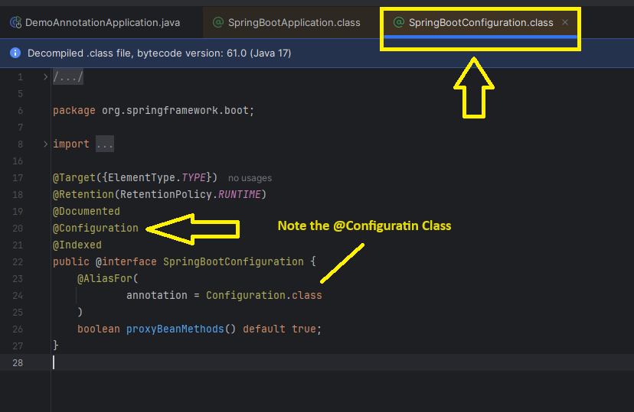

# Create simple package in IntelliJ

Right click the main package com.dev.demoAnnotation 🡪 New 🡪 Package

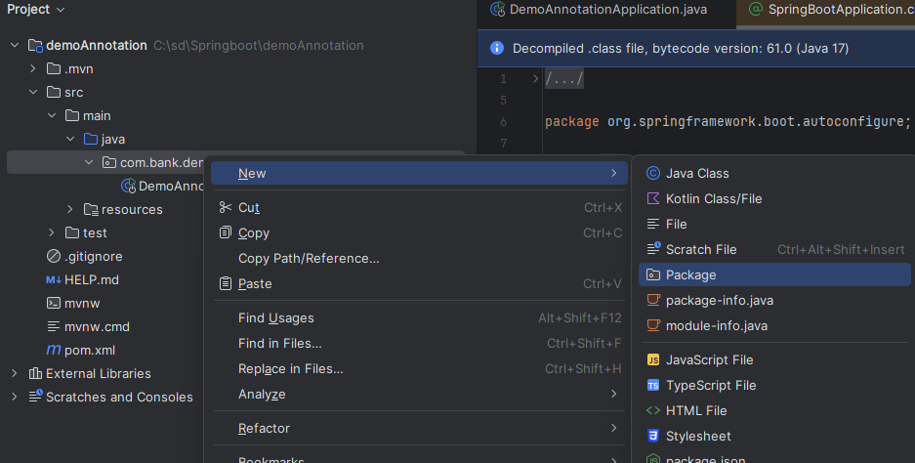

Give the package name **config** and Press Enter



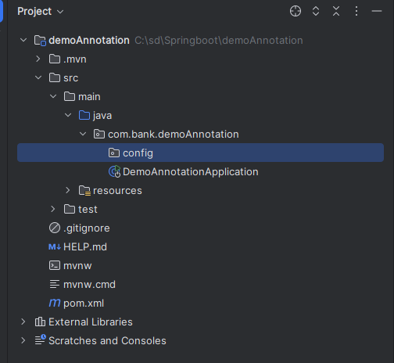

# Create simple myConfig class in IntelliJ

* Right Click the **Config** Package –New—Java Class

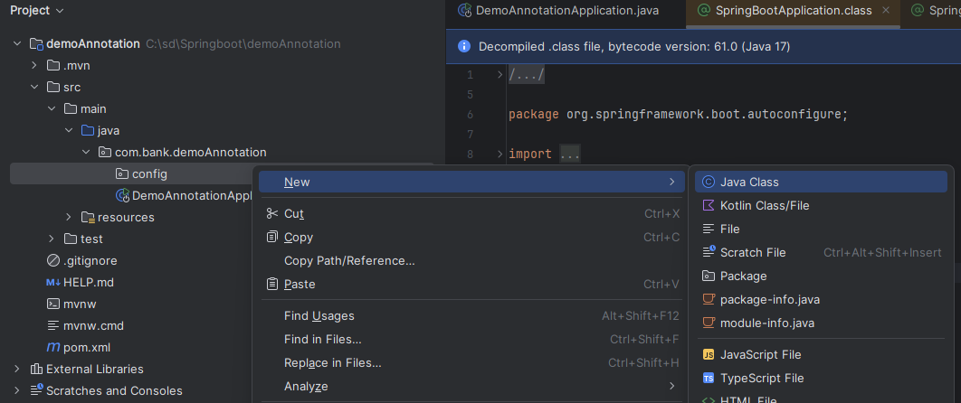

* Type **myClass** in Class Name and Press **enter** to create the class

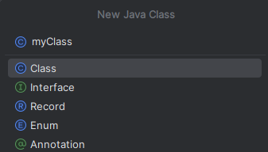

* The myConfig **class** created .
* Note that this is **normal class** not the **config class** , so even if we create **Beans** inside , spring scanner can not search it.

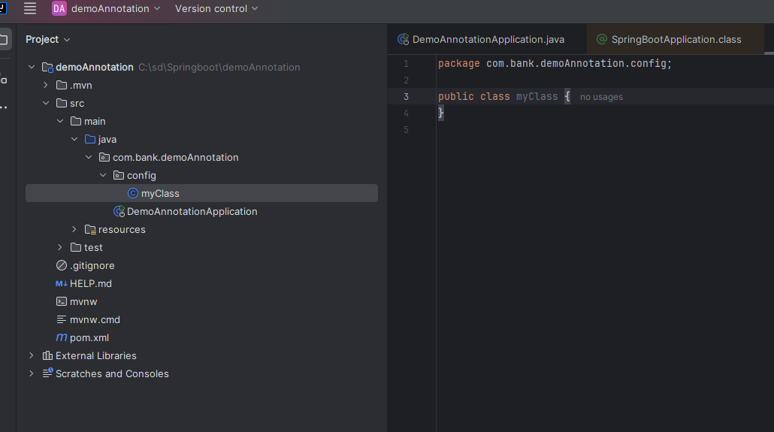

* So to make it as configuration class we have to use annotation **@configuration**

package com.bank.demoAnnotation.config;  
  
import org.springframework.context.annotation.Configuration;  
  
@Configuration  
  
public class myClass {  
}

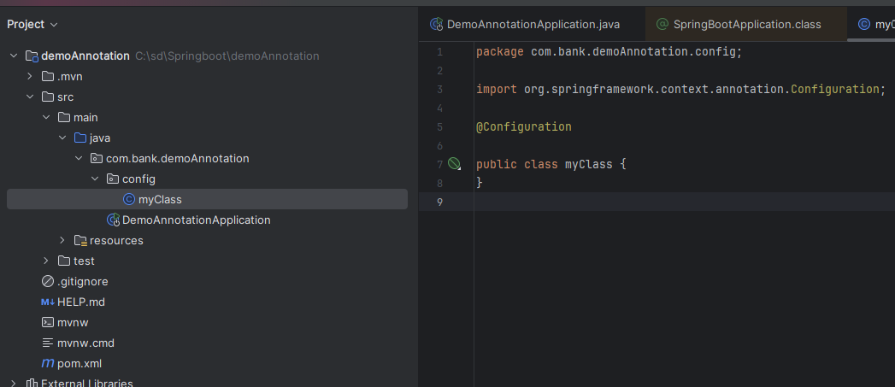

Not we can create one or more **Beans** . So now when we create **Beans** means object Creation , destruction ( **Full lifecycle** ) everything manage by Spring

# Create Service Class ProductService in IntelliJ

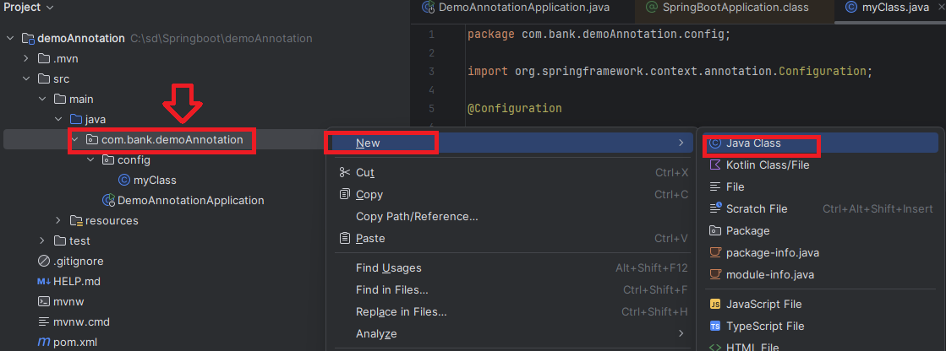

Type **services.ProductService** in class name

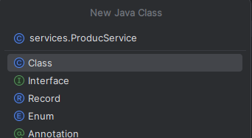

Class Created

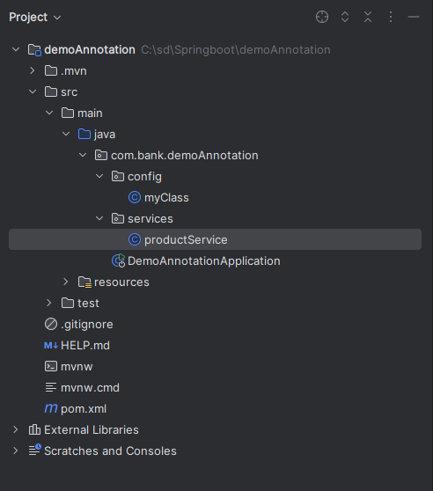

Now Lets create a simple method

package com.bank.demoAnnotation.services;  
  
public class ProductService {  
  
 public void createProduct()  
 {  
 System.*out*.println("Creating product");  
 }  
  
}

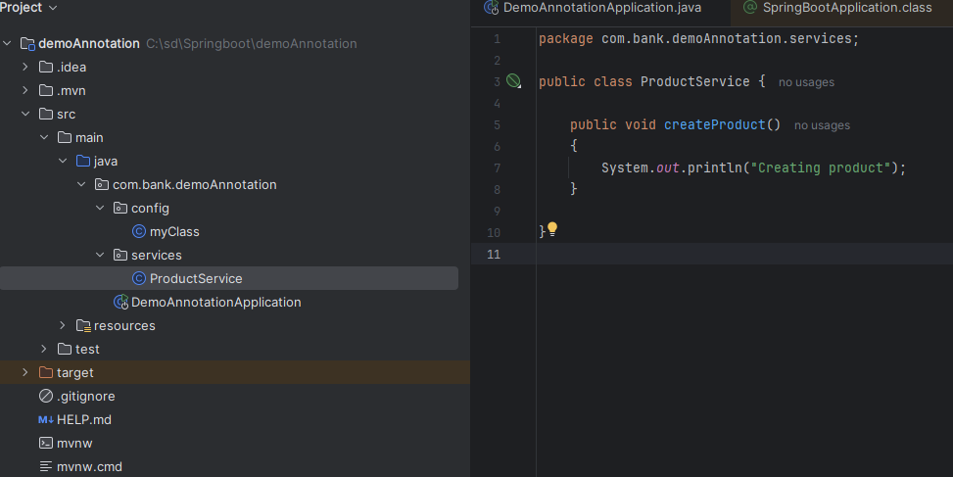

# Create Bean for Class productService under config class in IntelliJ

Now we want that the object of this class should be managed by Spring Container.

Open **myClass** under **config** Package and declare method **ProductService**() and make it as Beans by Annoting it with **@Beans**

@Bean  
public ProductService productService()  
{  
 return new ProductService();  
}

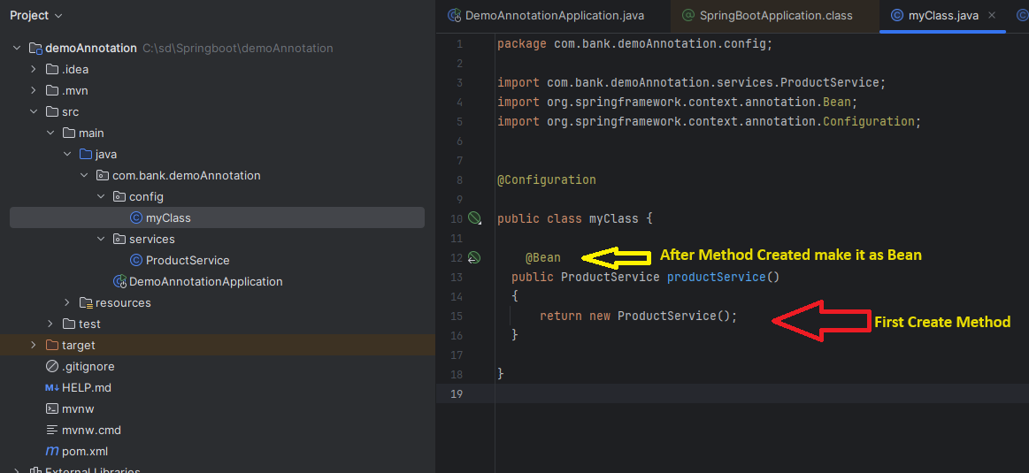

# Call Bean Class inside Main Application

Now in main method we demand Beans we created in previous 8

Enter new line Main application

ConfigurableApplicationContext context = SpringApplication.*run*(DemoAnnotationApplication.class, args);  
 ProductService productService = context.getBean(ProductService.class);  
  
System.*out*.println(productService);  
productService.createProduct();

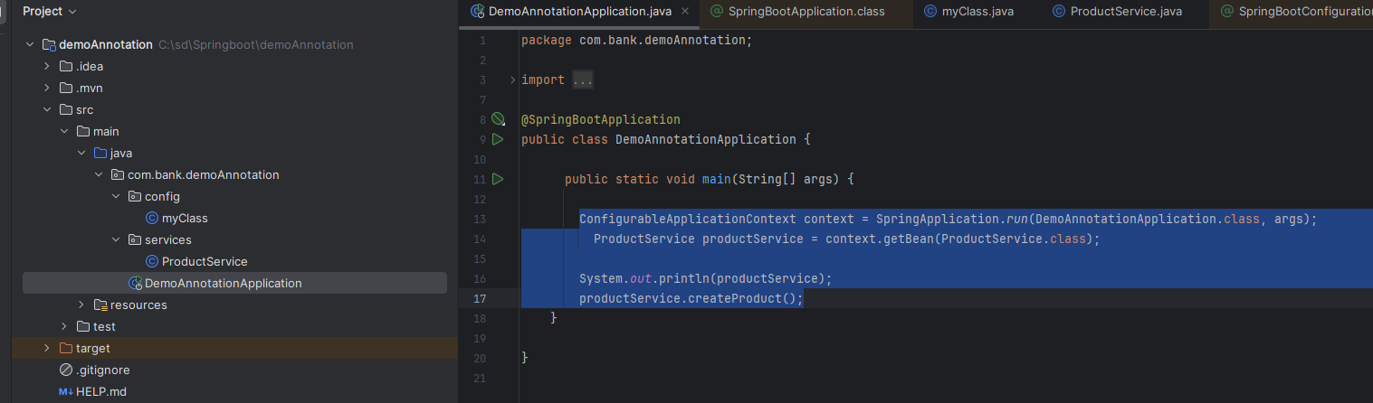

Now Run the program to Test

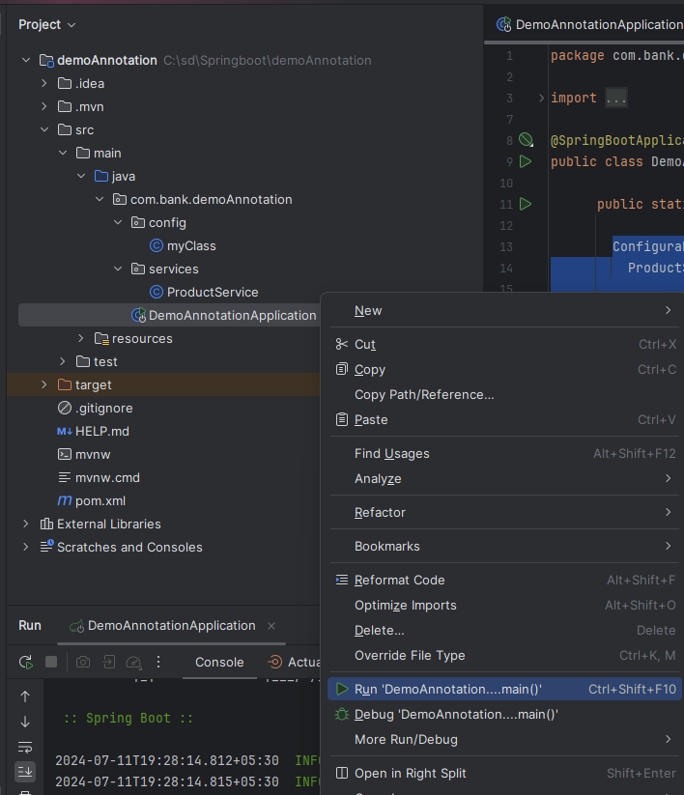

You can see the output ( Main class called Build class )

