

**Lab Manual- H2 Database with JDBC**

**Prepared for**:

**Date:** 18th June 2024

**Prepared by:**

Document Name: Lab Manual **Document Number** SDLab006

**Contributor:**

Contents

1. Objective 3

2. Creating a Spring Boot Project 3

3. Import Spring Boot Project in IntelliJ 4

4. Understand Dependencies in POM.xml 7

5. Execute to Check if H2 Connectivity is autoconfigured 7

6. Get details about the datasource 8

7. Enable H2 Console Login in our Spring boot web portal 9

8. Create database in H2 13

9. Create Schema (Table) in H2 16

# Objective

# Creating a Spring Boot Project

**Step 1:** Open the Spring initializr [https://start.spring.io](https://start.spring.io/).

**Step 2:** Provide the **Group** and **Artifact** name. We have provided Group name **com.bank** and Artifact **as below**

**Group** : com.bank

**Artifact** : demoAnnotation

**Name** : demoAnnotation

**Description** : Dependencies Injection

**PackageName** : com.bank. demoAnnotation

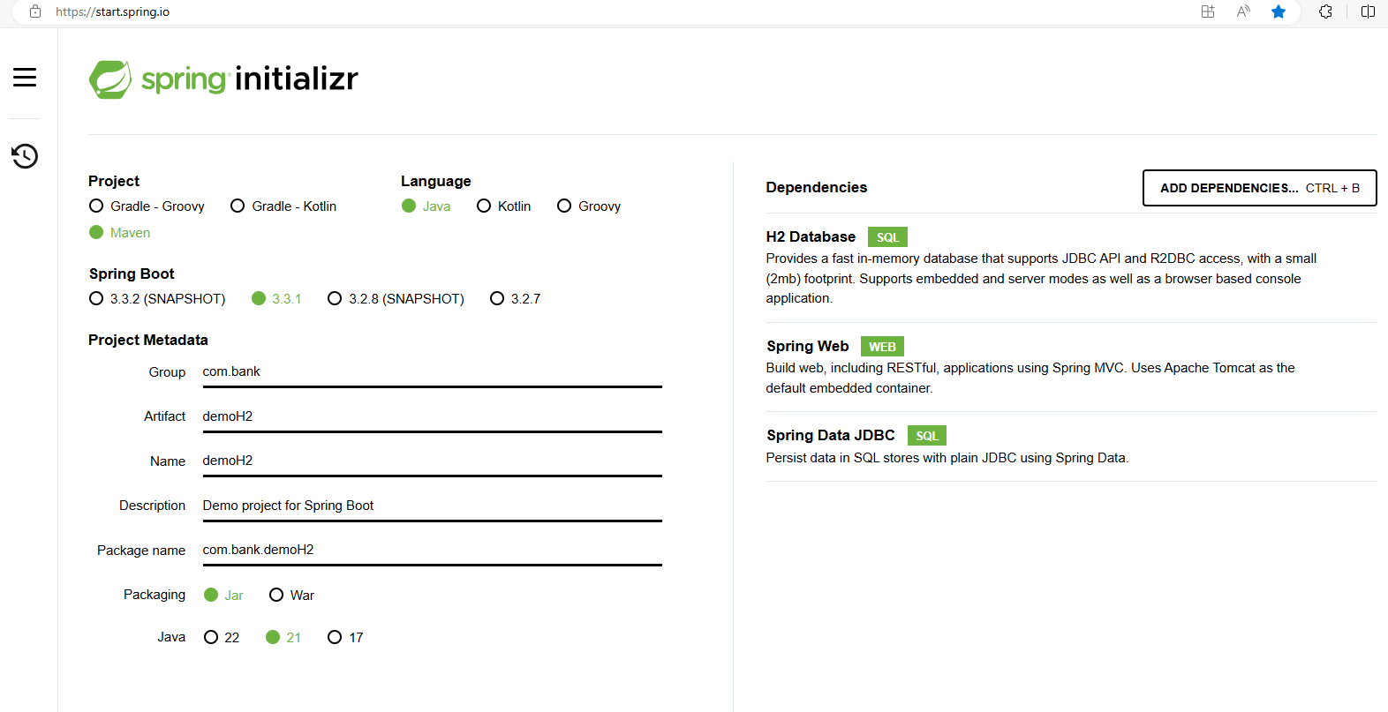

**Step 3: Click on GENERATE to download the code**

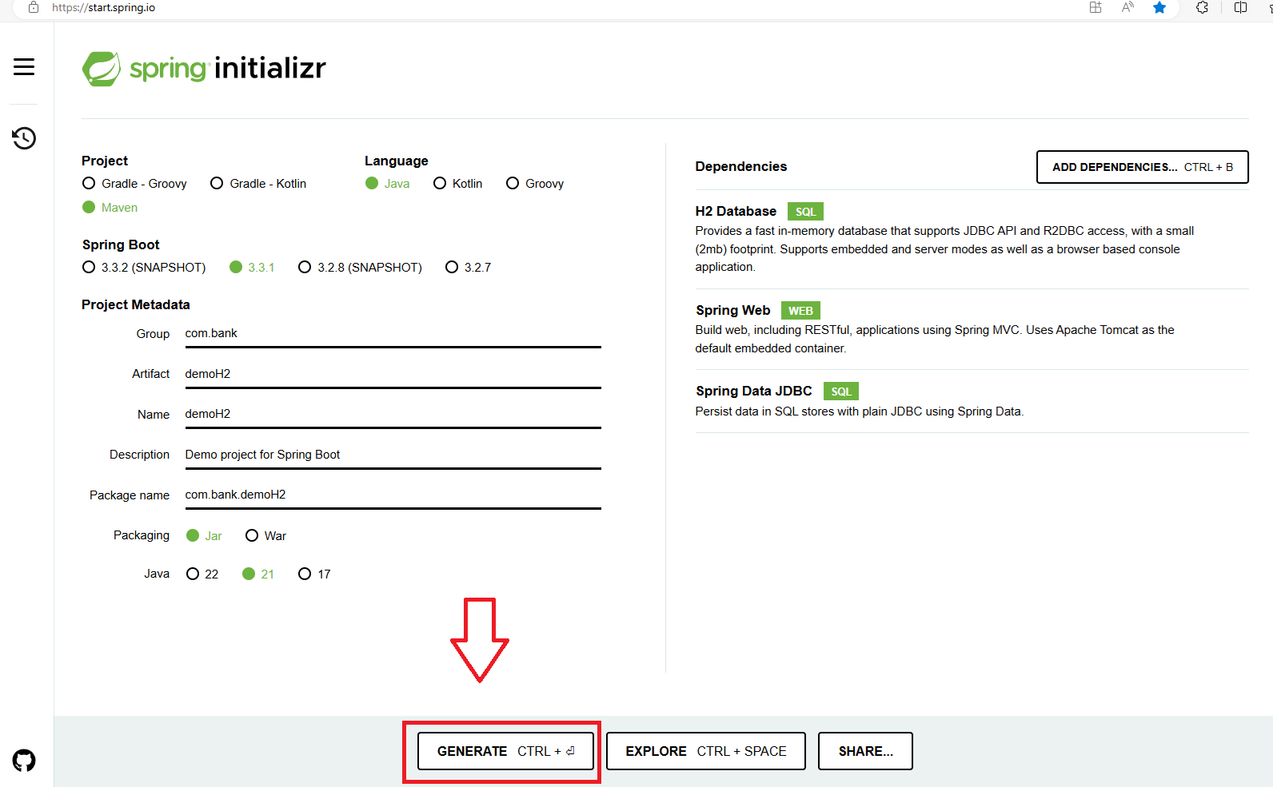

**Step 4:** Code should download now



**Step 5: Extract** the project to your Project directory

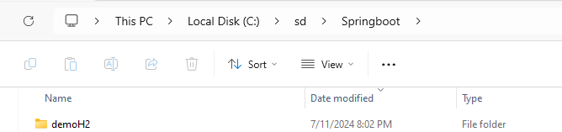

# Import Spring Boot Project in IntelliJ

* Click File🡪 Open project

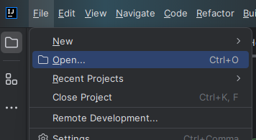

* Select your extract project and click **OK**

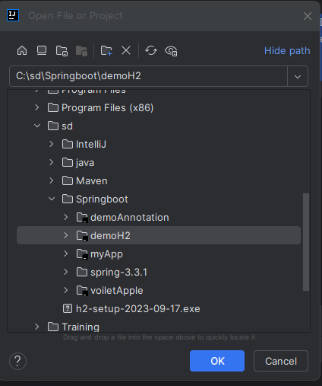

* If ask click **Trust project**

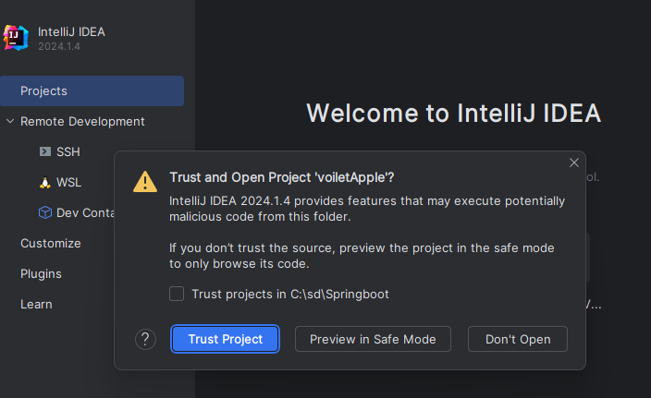

* If ask **Load** the Maven Build Script

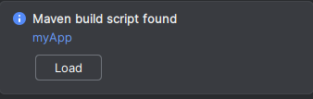

* It may takes couple of Minutes to download and Load the library

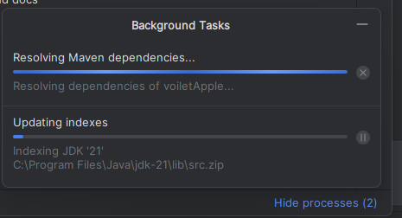

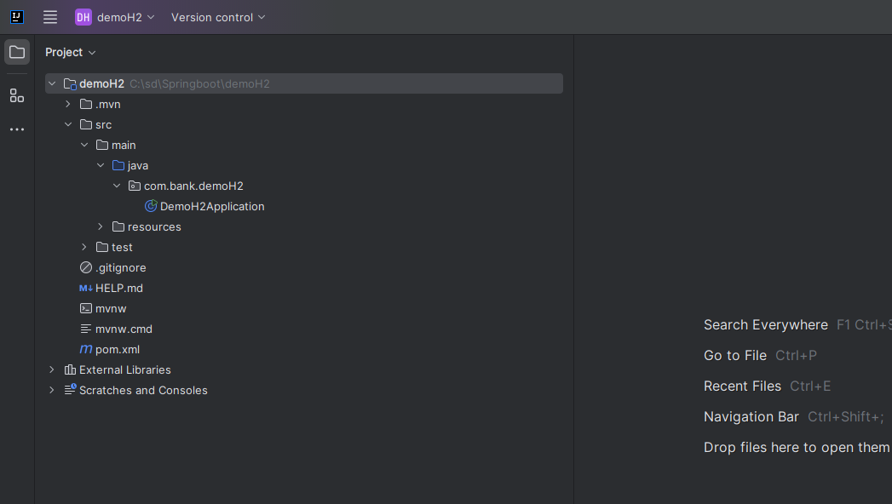

# Understand Dependencies in POM.xml

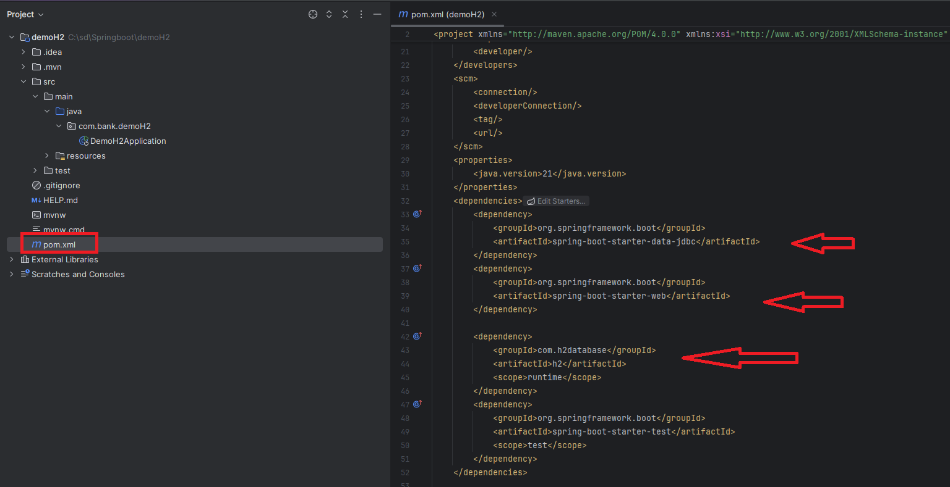

# Execute to Check if H2 Connectivity is autoconfigured

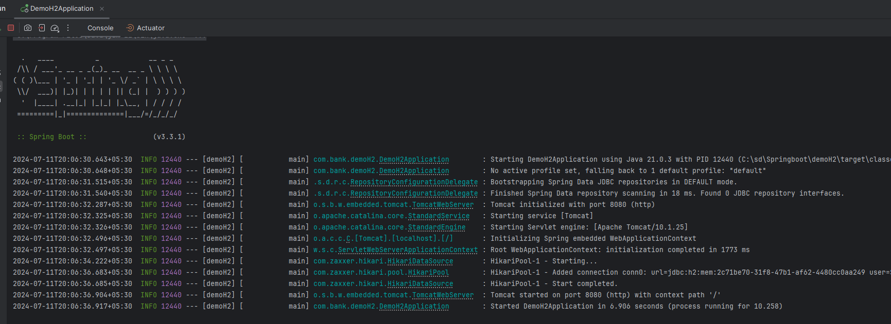

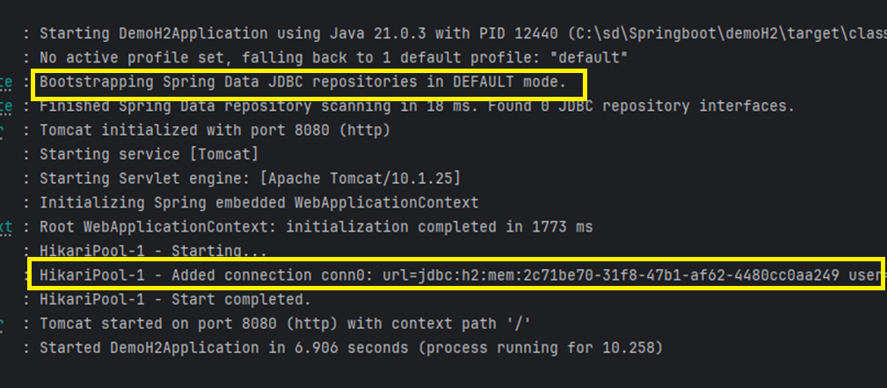

# Get details about the datasource

Called Beans inside main class

public static void main(String[] args) {  
  
ConfigurableApplicationContext context = SpringApplication.*run*(DemoH2Application.class, args);  
  
Object dataSource = context.getBean(DataSource.class);  
System.*out*.println(dataSource);  
}

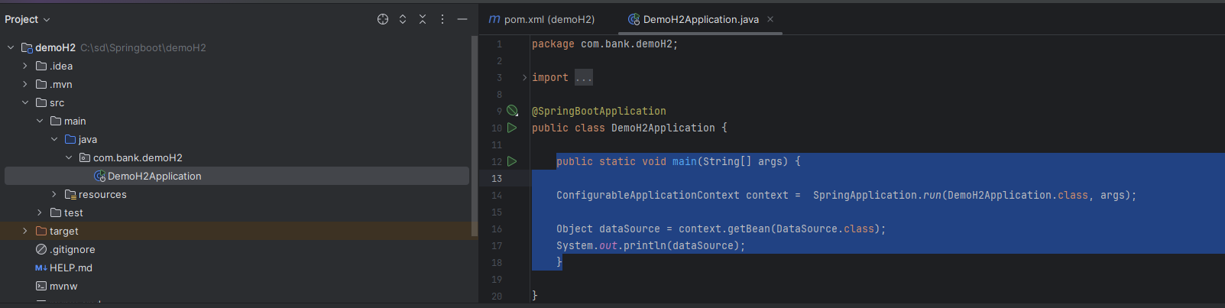

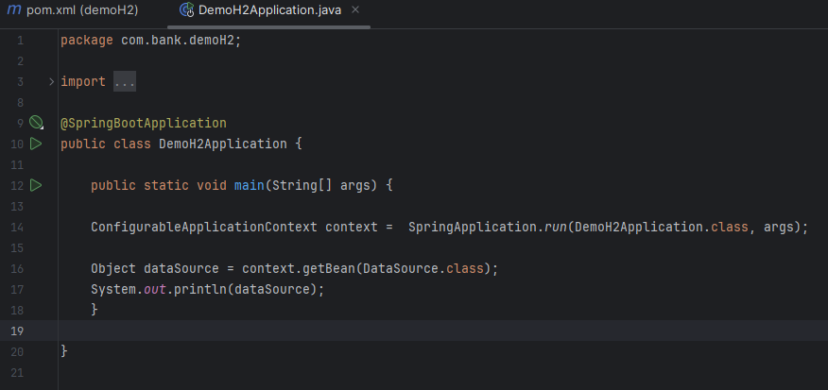

Output would be

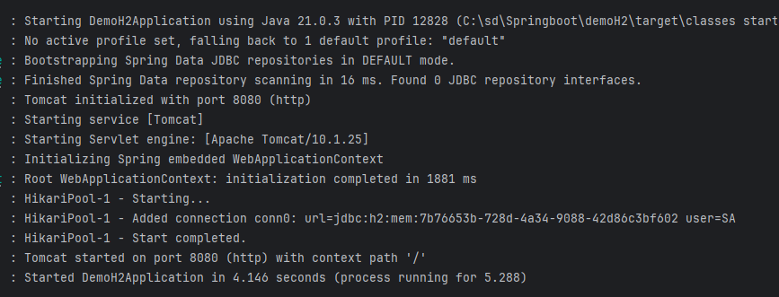

# Enable H2 Console Login in our Spring boot web portal

spring.h2.console.enabled=true

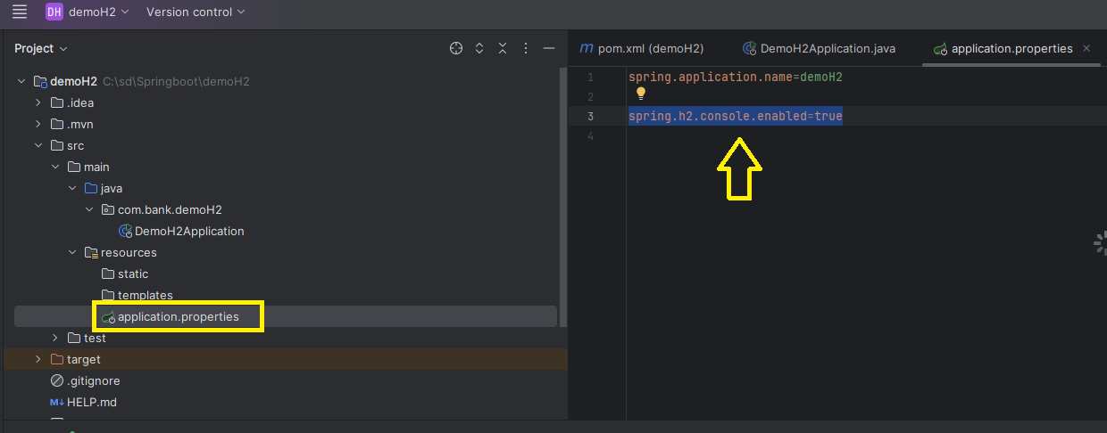

And Rerun it , note the JDBC URL

**jdbc:h2:mem:ac5f1403-68e7-40e8-9800-bbd437412a63**

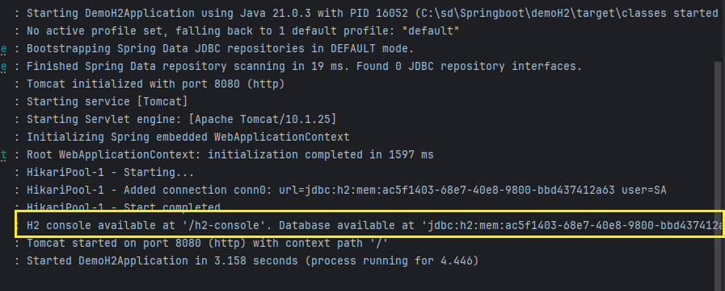

In Browser type :

<http://localhost:8080/h2-console/>

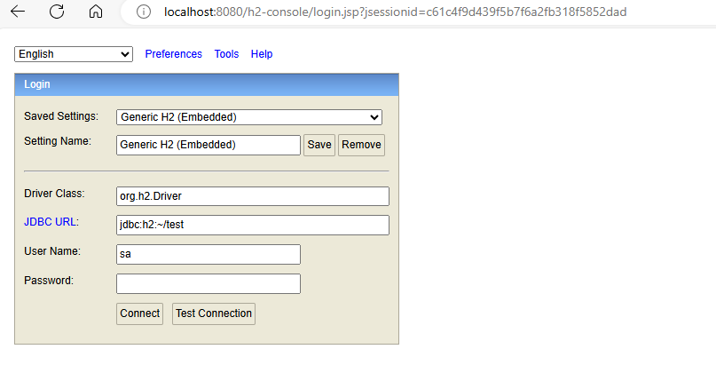

In JDBC URL type

jdbc:h2:mem:ac5f1403-68e7-40e8-9800-bbd437412a63

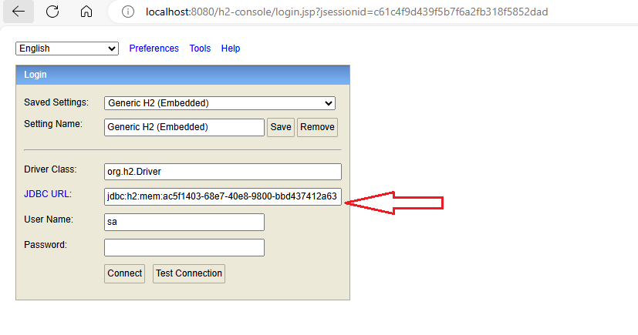

No Password required , just click Test Connection:

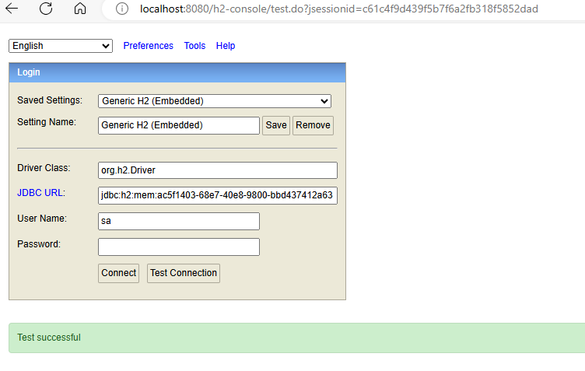

Now Click Connect Button

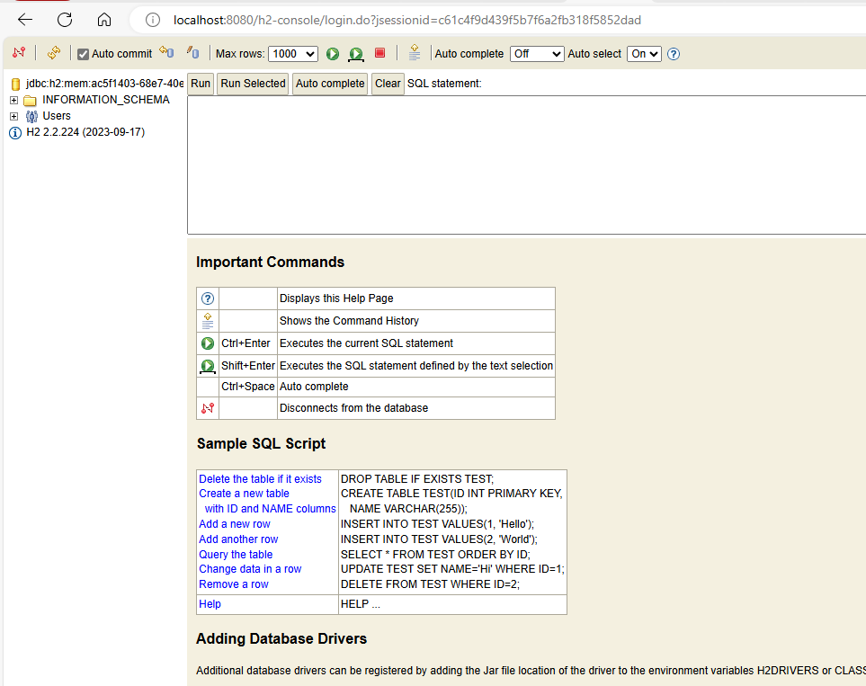

# Create database in H2

#### Disable Uniq GUID based Name

* Disable unique name for the database and create **testdb** database , Type below in **Application.properties**

spring.datasource.generate-unique-name=false

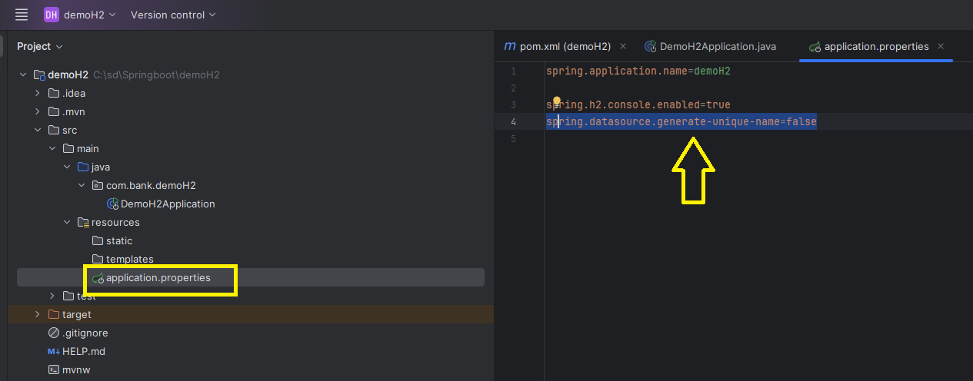

* Now Rerun to check if **testdb** created instead of unique long GUID name

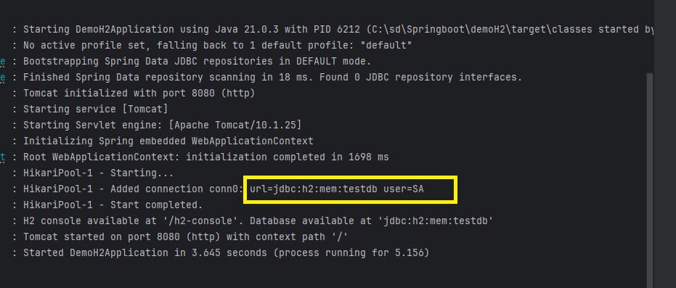

#### Create own Database

* Now we will create our own database **bookstore ,** Type below in **Application.properties**

spring.datasource.name=bookstore

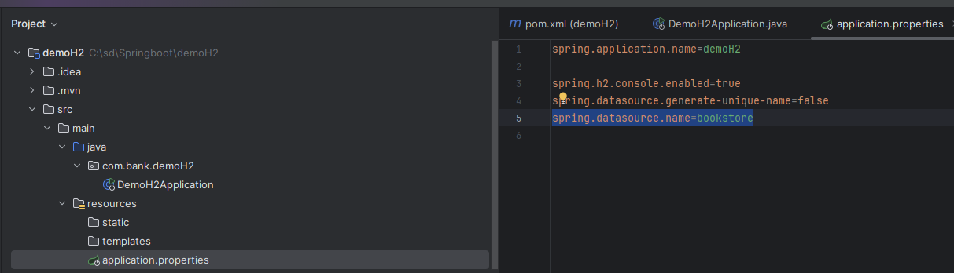

* Now Rerun it

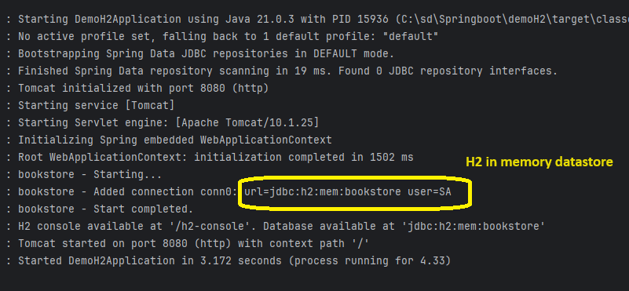

* Now Login to browser

<http://localhost:8080/h2-console/>

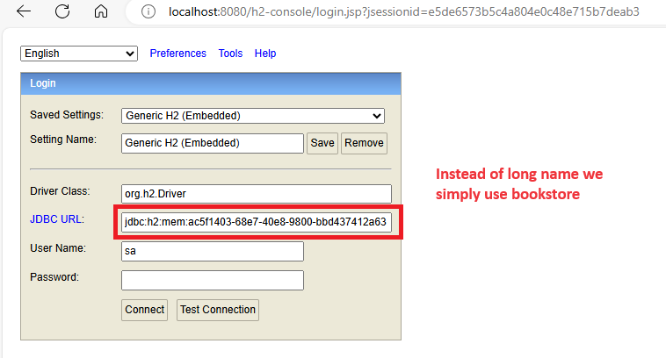

* Remove long name and add **bookstore** after **mem:** and click **Test connection**

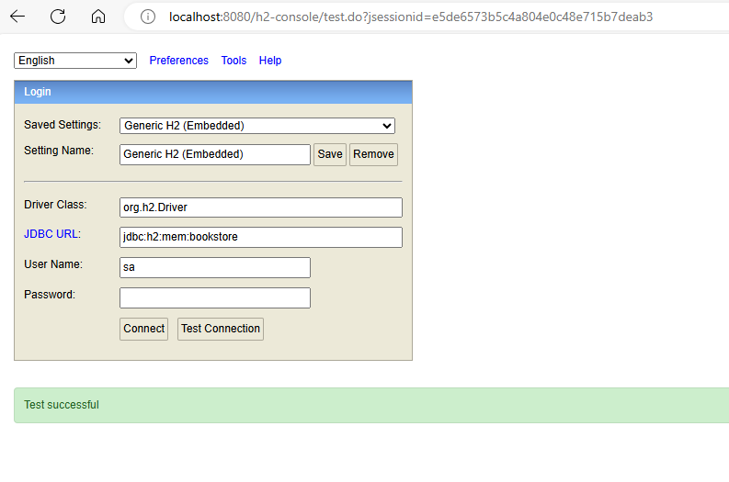

* Click **Connect** to connect the datastore

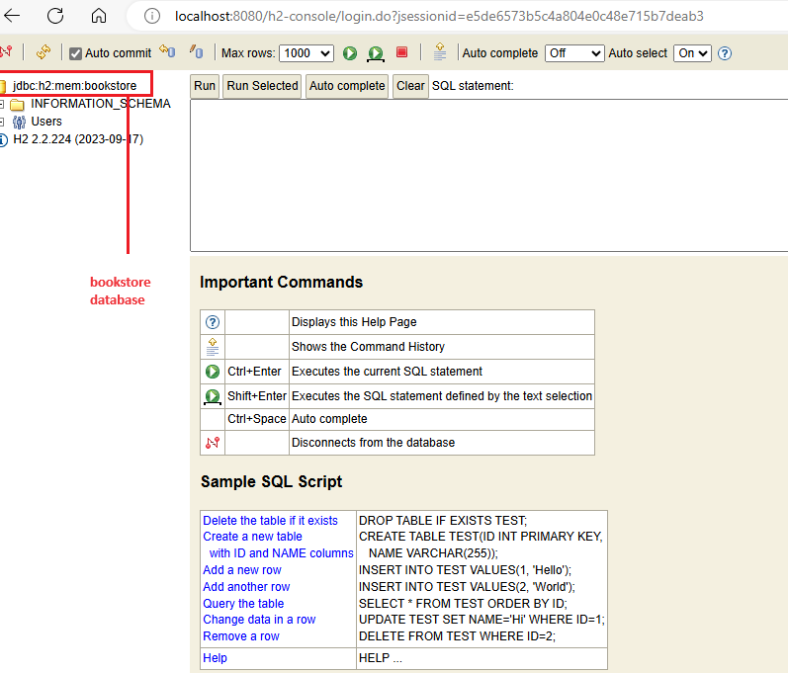

# Create Schema (Table) in H2

* Right Click the **Resources** 🡪 New 🡪 File

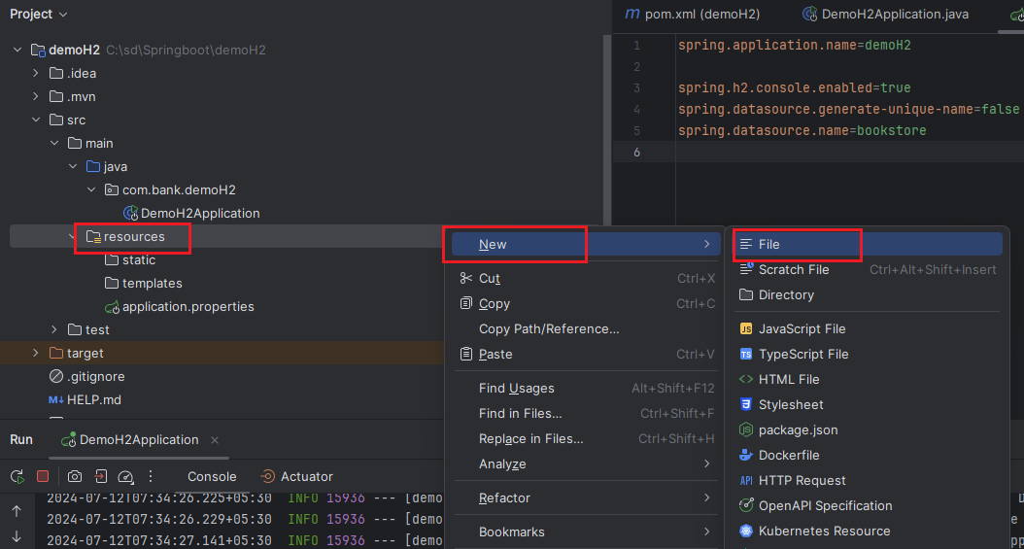

* Name the file **schema.sql**



* New File Created

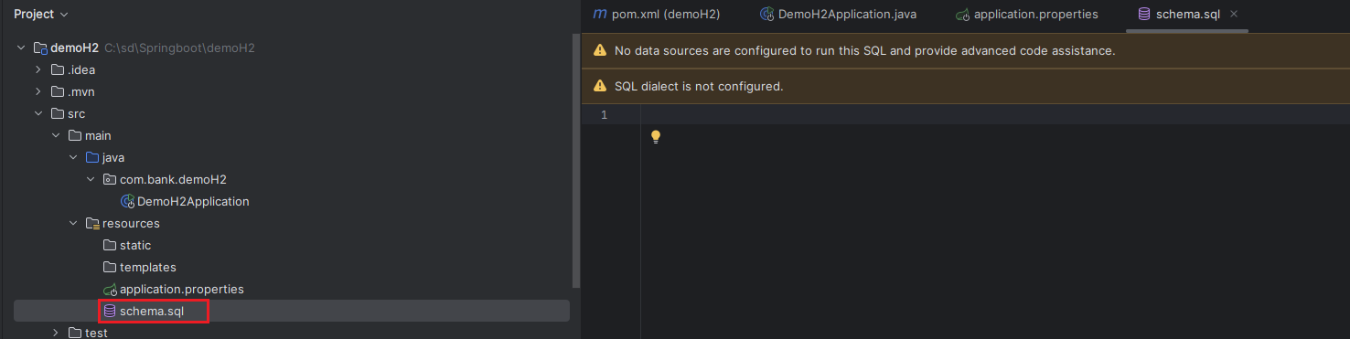

* Now Change the SQL Dialect to **H2**

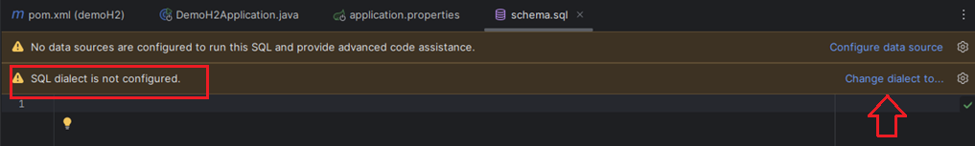

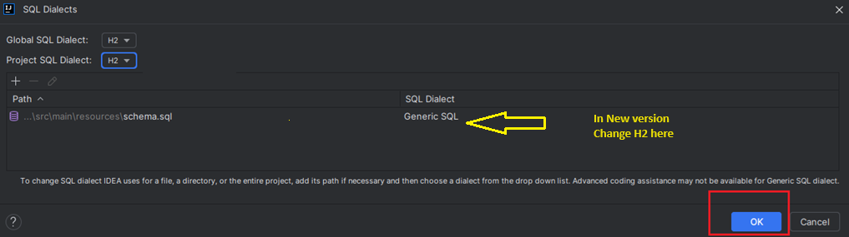

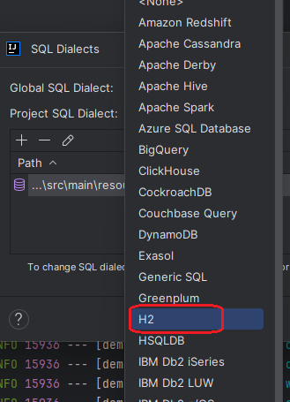

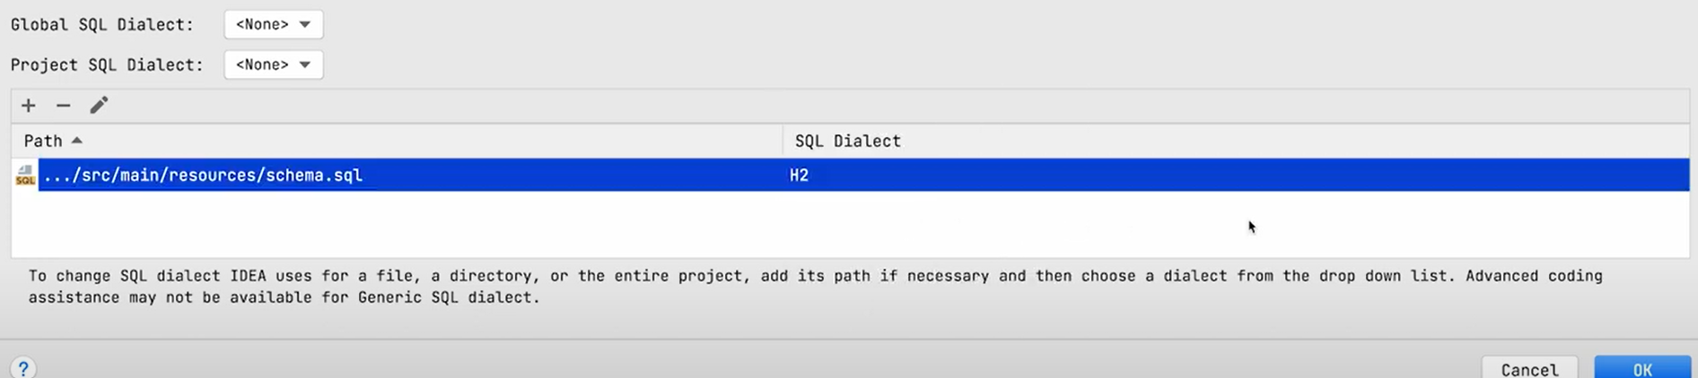

* Now we can create **schema** called **book**

create table book  
(  
 id int auto_increment,  
 title varchar(50) not null,  
 pages int,  
 author varchar(50)  
  
)

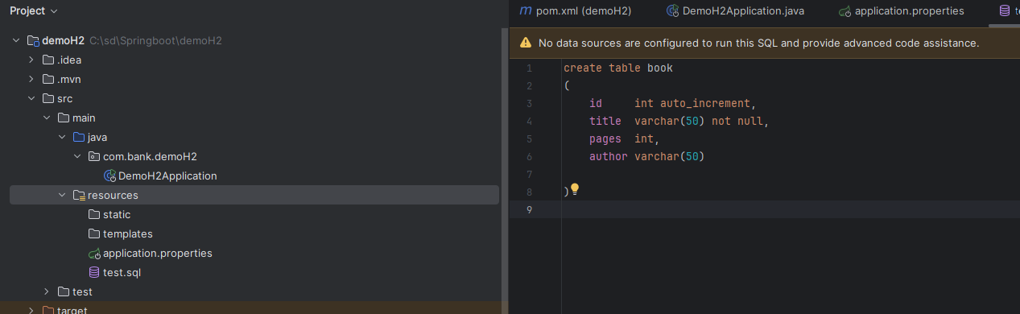

* Now Rerun it

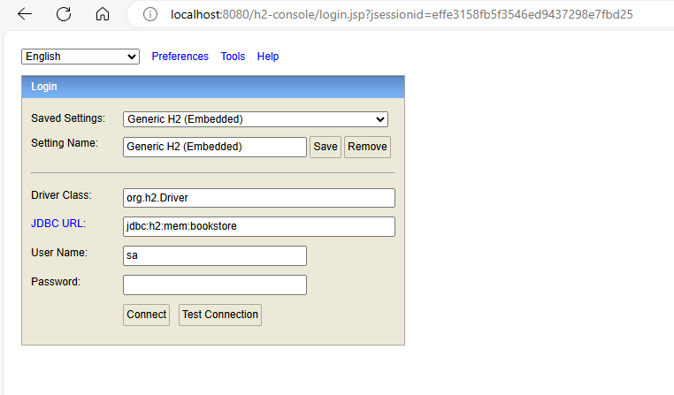

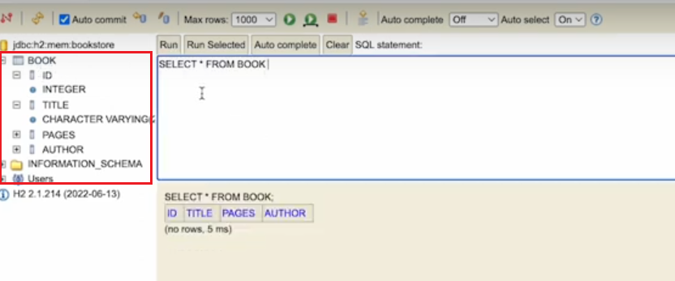

Insert new data

insert into book (title,pages,author) values ('New Book ' , 899 , 'Bipeen')

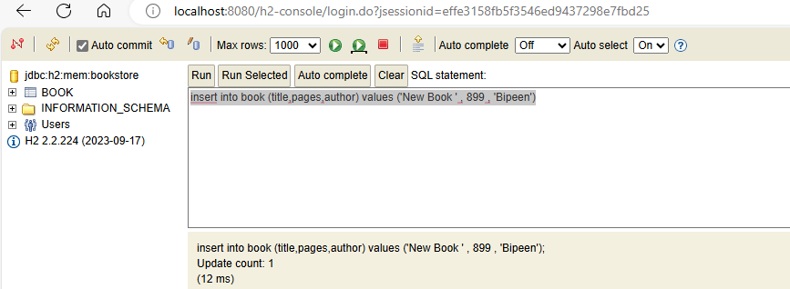

Run select statement

**select * from book**

