

**Lab Manual- Spring boot Annotation @Component**

**Prepared for**:

**Date:** 18th June 2024

**Prepared by:**

Document Name: Lab Manual **Document Number** SDLab300

**Contributor:**

Contents

1. Objective 3

2. Creating a Spring Boot Project 3

3. Import Spring Boot Project in IntelliJ 8

4. Create Hello-world class in IntelliJ 11

5. Execute Spring Boot Application in IntelliJ 14

# Objective

Creating a Spring Boot project for a "Hello World" application is a great way to get started with Spring Boot. Here's a step-by-step guide:

### Prerequisites

1. **Java Development Kit (JDK)**: Ensure you have JDK 8 or later installed.
2. **Maven**: Make sure Maven is installed (optional, as Spring Initializr can generate a Maven project for you).

This exercise takes approximately **30** minutes.

.

# Creating a Spring Boot Project

**Step 1:** Open the Spring initializr [https://start.spring.io](https://start.spring.io/).

**Step 2:** Provide the **Group** and **Artifact** name. We have provided Group name **com.bank** and Artifact **as below**

**Group** : com.bank

**Artifact** : voiletApple

**Name** : voiletApple

**Description** : Demo project for Spring Boot

**PackageName** : com.bank.voiletApple

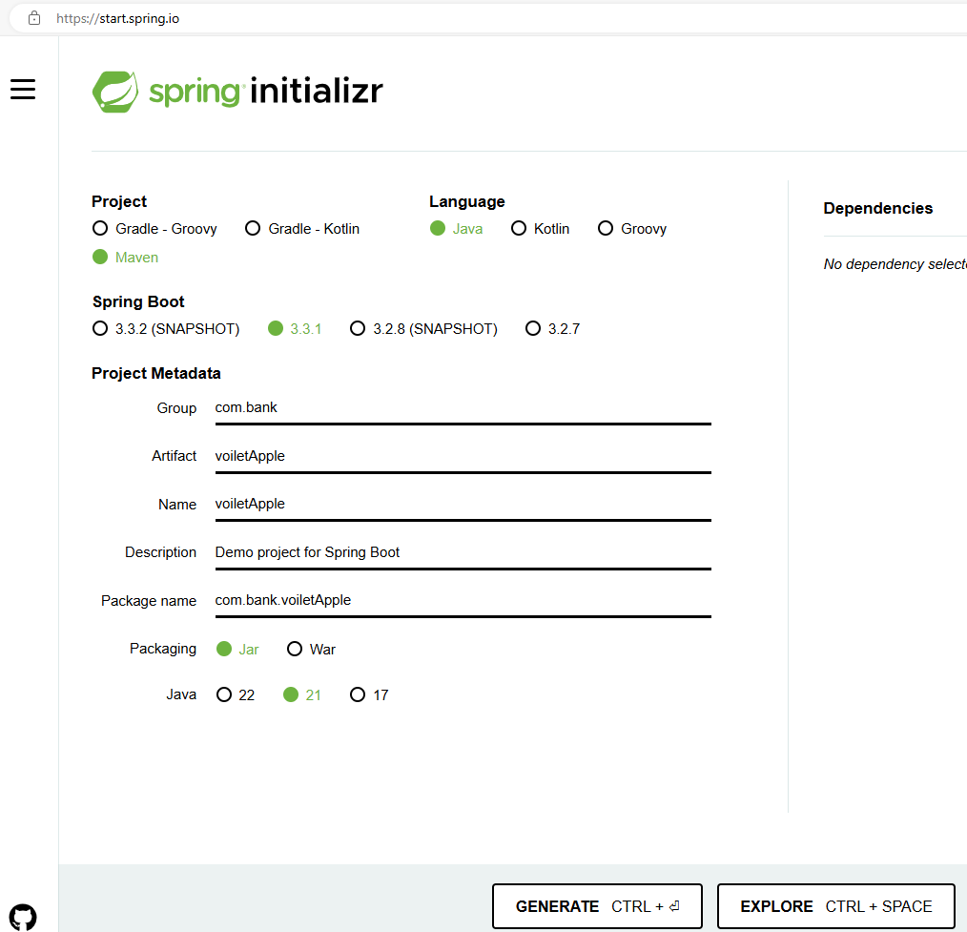

**Step 3:** Now click on the **Add** **Dependencies** button.

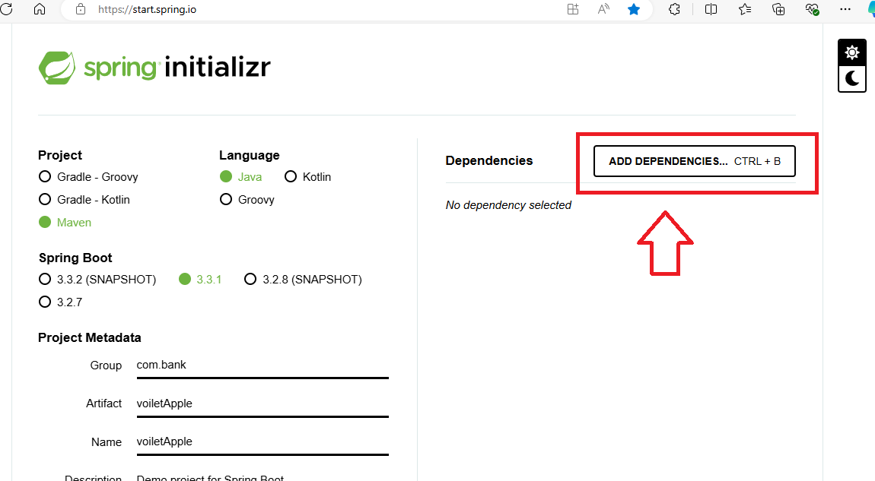

**Step 4:** Select **Spring Web** from drop downlist.

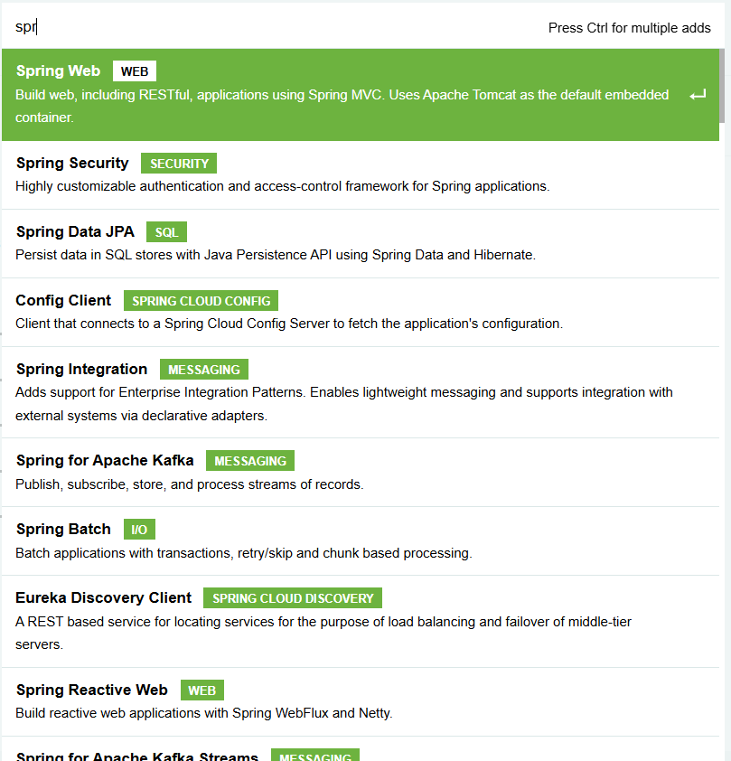

**Step 5:** Now Click **Explore** Button to review the configuration.

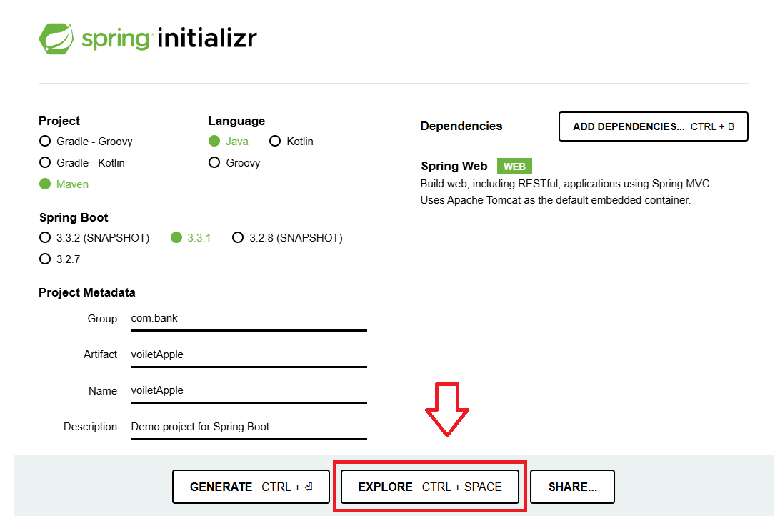

**Step 6:** Check **POM.XML**

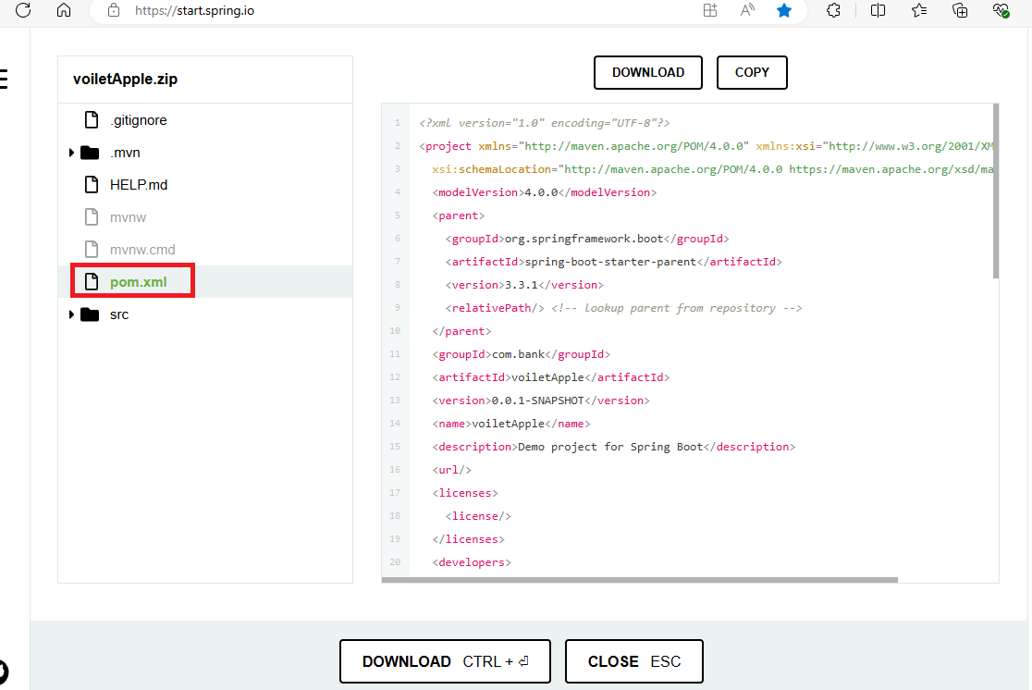

**Step 7:** Note **Java Version** and **Dependencies**

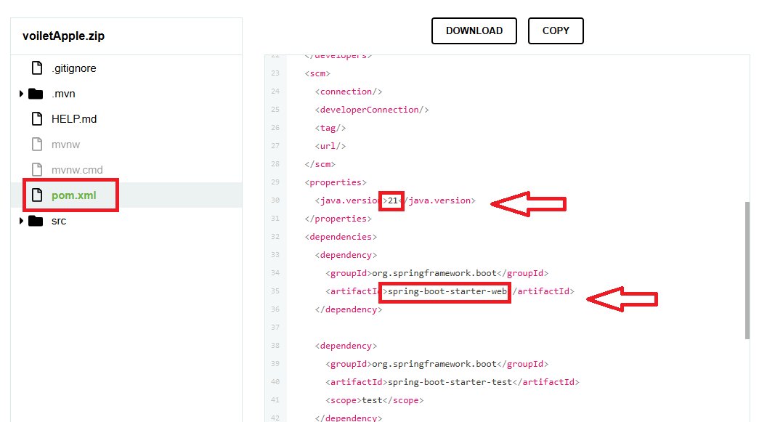

**Step 8:** Check default source code

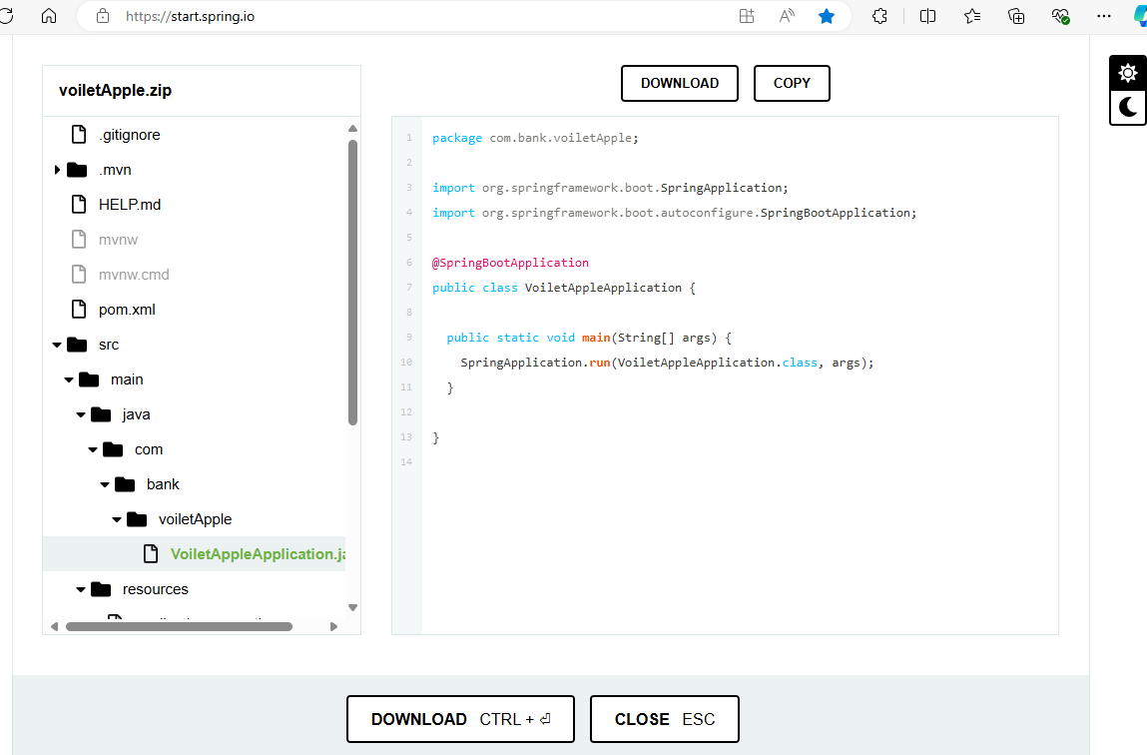

**Step 9: Click on download to download the code**

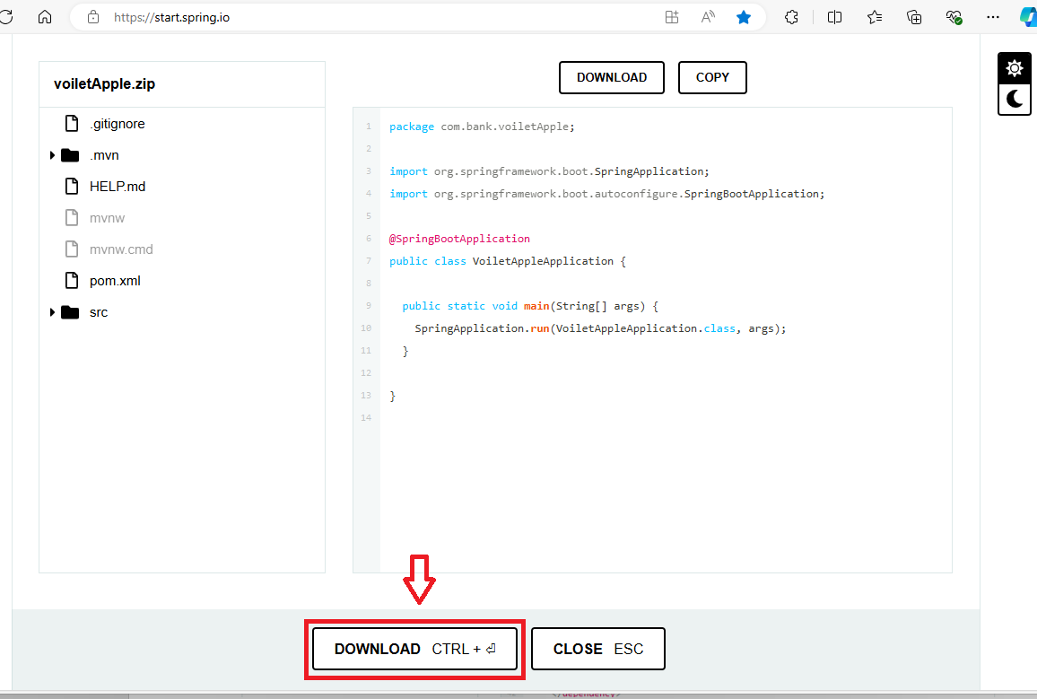

**Step 10:** Code should download now

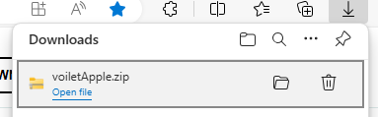

**Step 11: Extract** the project to your Projet directory

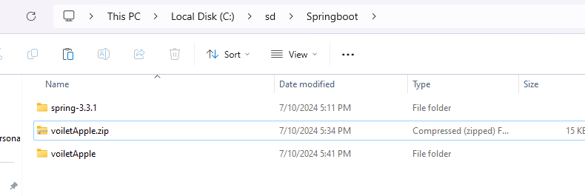

# Import Spring Boot Project in IntelliJ

* Click open project

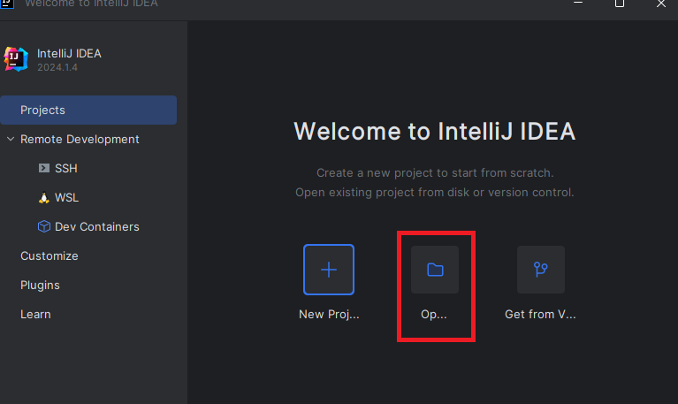

* Select your extract project and click **OK**

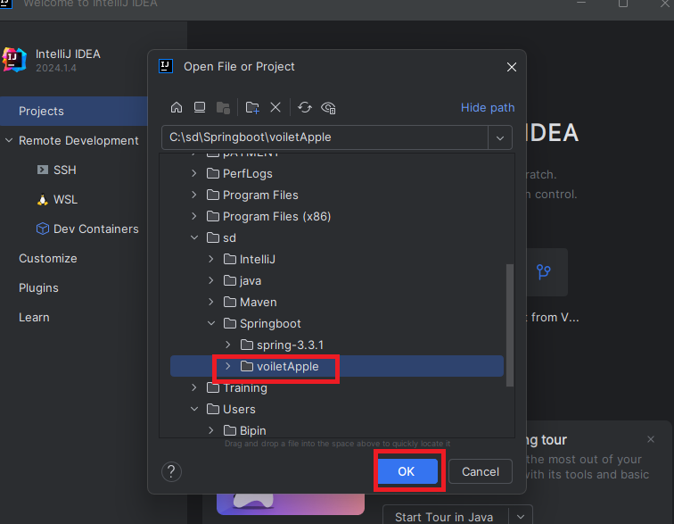

* If ask click **Trust project**

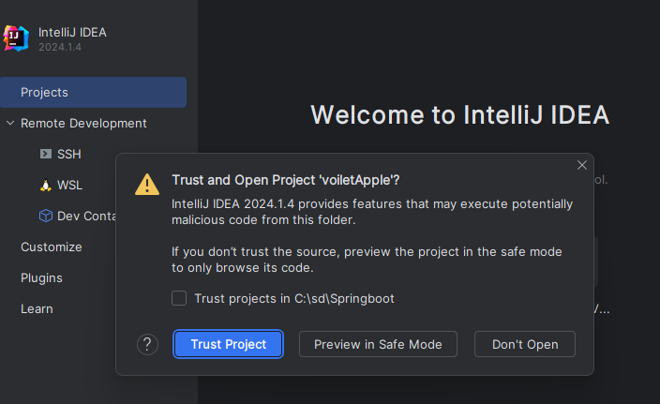

* If ask **Load** the Maven Build Script

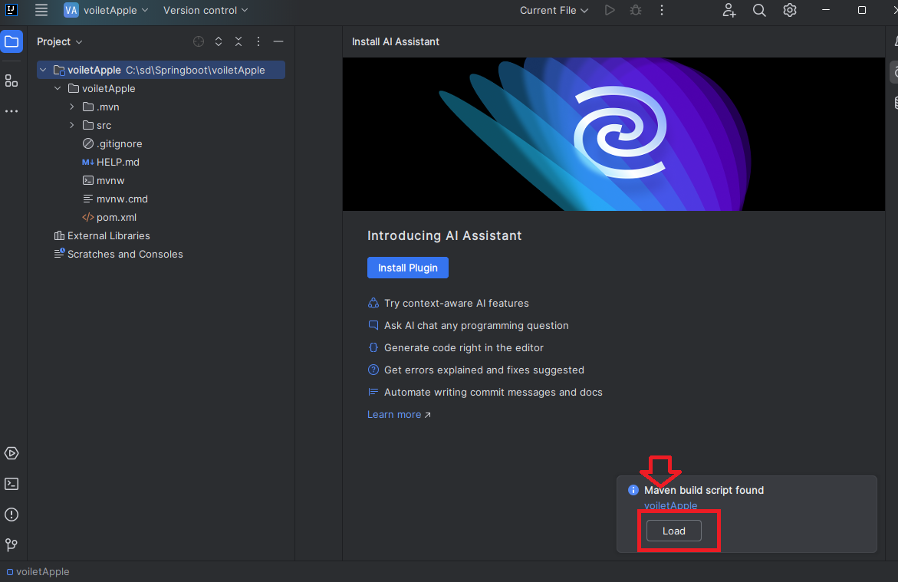

* It may takes couple of Minutes to download and Load the library

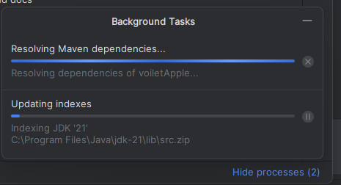

* If you expand the dependencies you can see the **jakson** ( Json conversion ) , **Micrometer** for observation and embded **Tomcat**

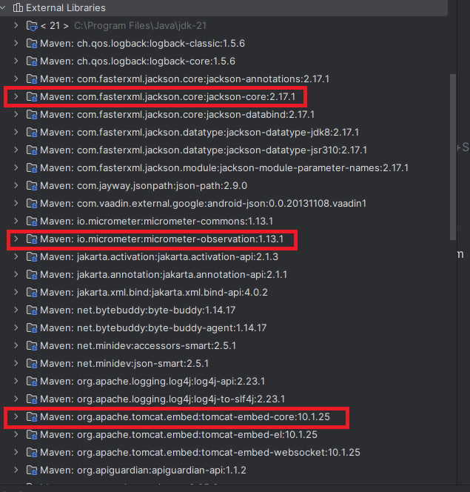

# Create Hello-world class in IntelliJ

* Right Click the Application –New—Java Class

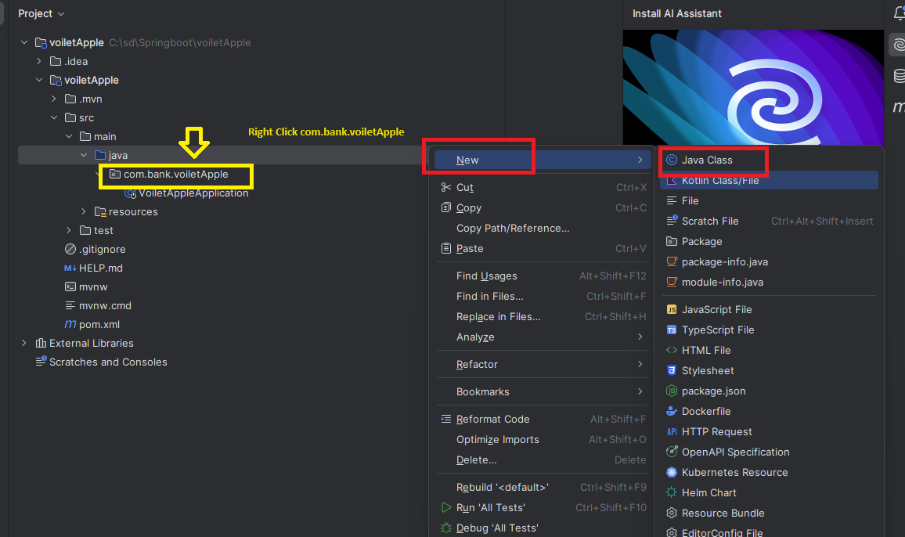

* Type **Hello** in Class Name and Press **enter** to create the class

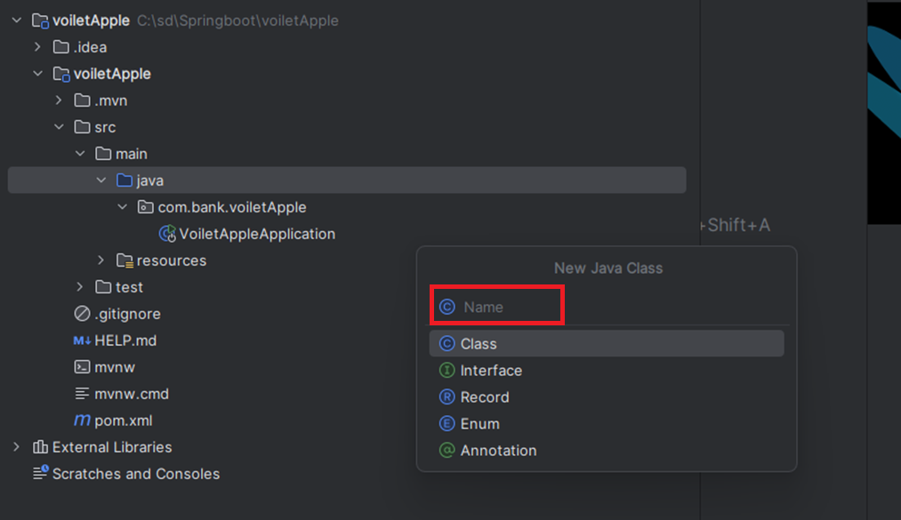

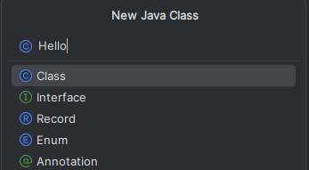

* Note the **class** created

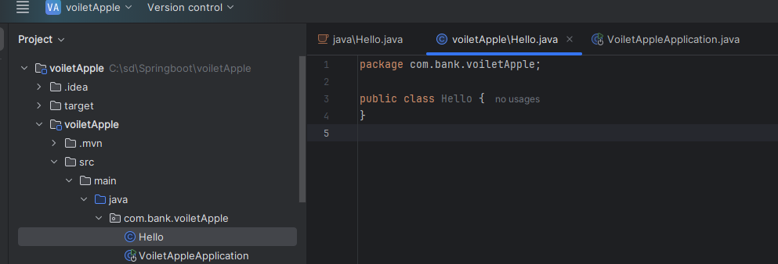

* Type Below Code to Print Hello World

public String greet()  
{  
 return "Hello World";  
}

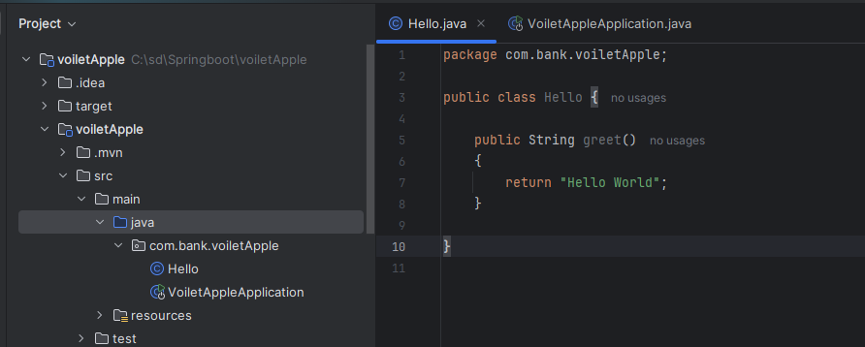

* Type Below Annotation to receive Http Request **@RestController** and You Notice It automatically import related library
* Type the **@RequestMapping** ("/")and You Notice It automatically import related library

import org.springframework.web.bind.annotation.RequestMapping;  
import org.springframework.web.bind.annotation.RestController;  
@RestController  
public class Hello {  
 @RequestMapping ("/")  
 public String greet()  
 {  
   
 return "Hello World";  
 }  
}

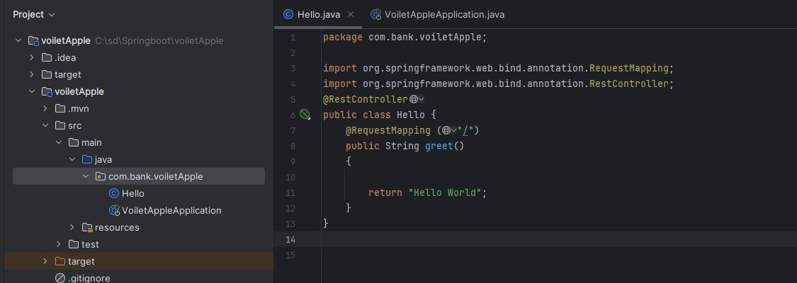

# Execute Spring Boot Application in IntelliJ

