

**Lab Manual- Create Virtual Machine Custom Image**

**Prepared for**:

**Date:** 18th Dec 2023

**Prepared by:**

Document Name: Lab Manual **Document Number** AZLabn918

**Contributor:**

Contents

1. Objective 3

2. Create a Linux VM instance 3

3. Access the Linux VM instance 7

4. Configure Snapshot from the VM Disk 8

5. Create Image from Snapshot 10

6. Launch New VM from your customer Image 12

# Objective

The ability to detect and analyze human faces is a core AI capability. In this exercise, you'll explore two Azure AI Services that you can use to work with faces in images: the **Azure AI Vision** service, and the **Face** service and using it from a client application. The goal of the exercise is not to gain expertise in any particular service, but rather to become familiar with a general pattern for provisioning and working with Azure AI services as a developer.

# Create a Linux VM instance

1. In the Google Cloud console, go to the **Compute Engine**  page and click **VM Instance**

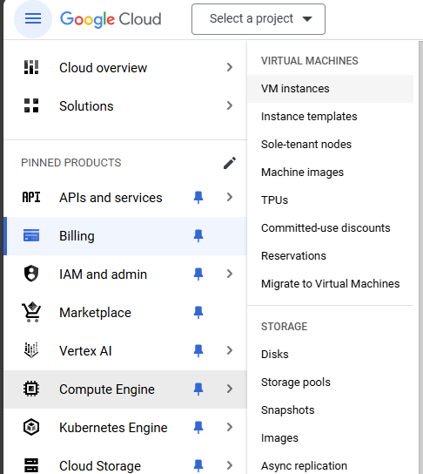

1. Go to the **Create an instance** page.

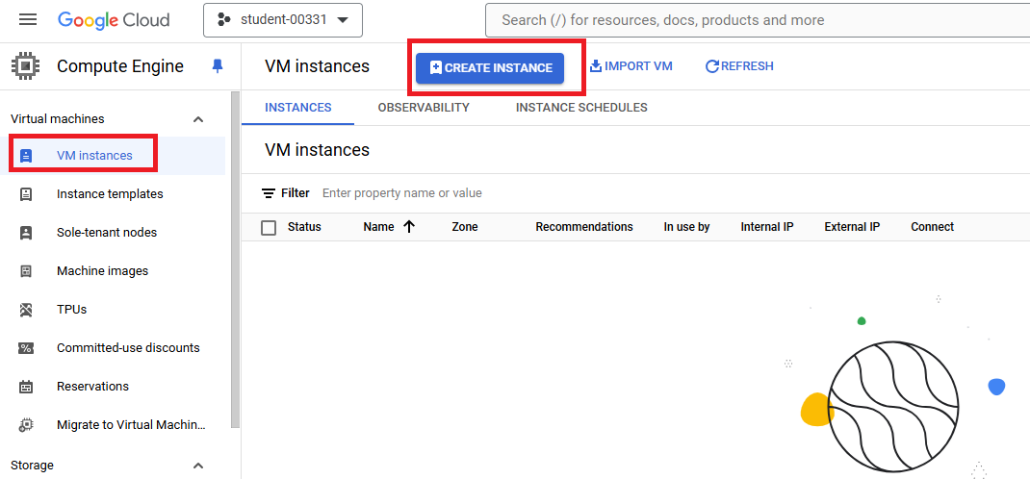

1. Select region **us-central1(lowa)** and Size **N1**

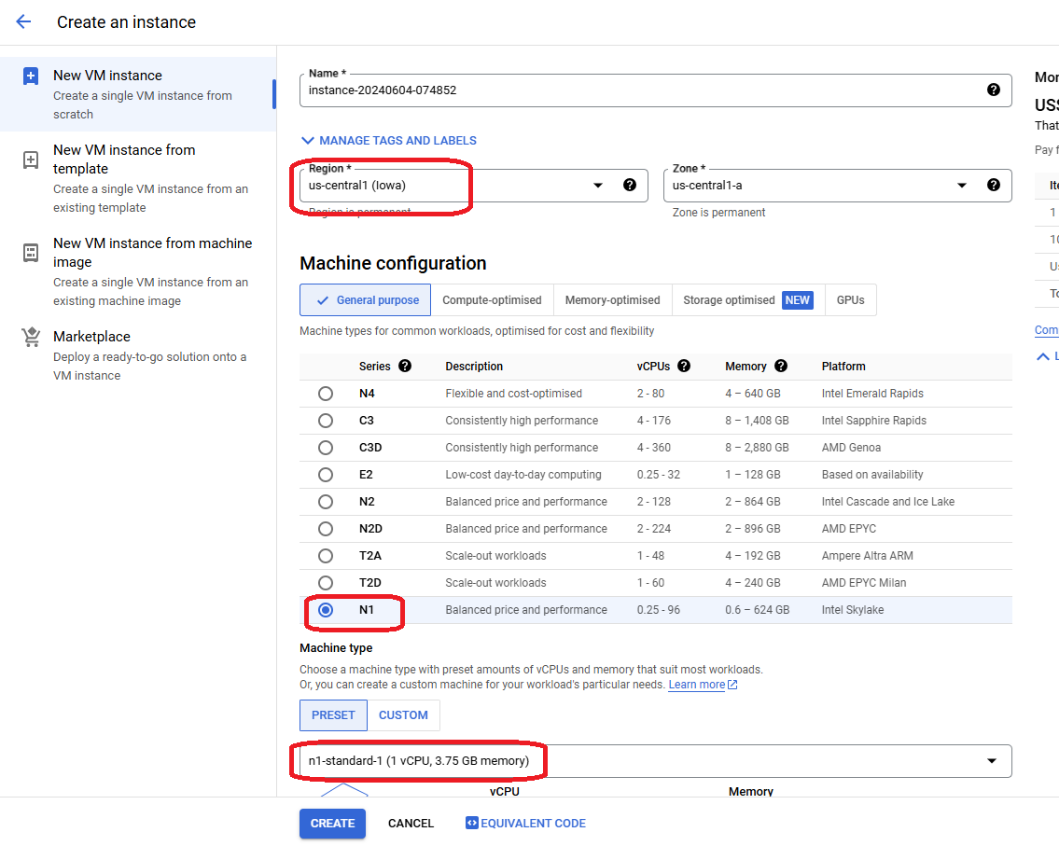

1. In the **Boot disk** section, click **Change** to begin configuring your boot disk.

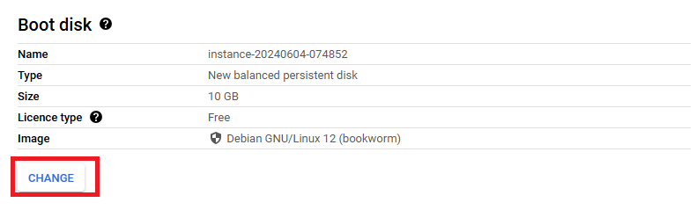

1. On the **Public images** tab, choose **Ubuntu** from the **Operating system** list.
2. Choose **Ubuntu 20.04 LTS** from the **Version** list.
3. Click **Select**.

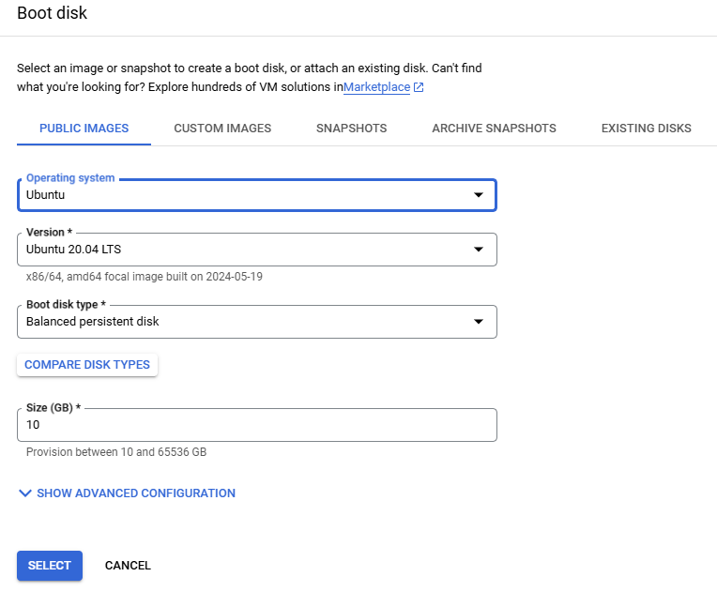

1. In the **Firewall** section, select **Allow HTTP and HTTP traffic**.

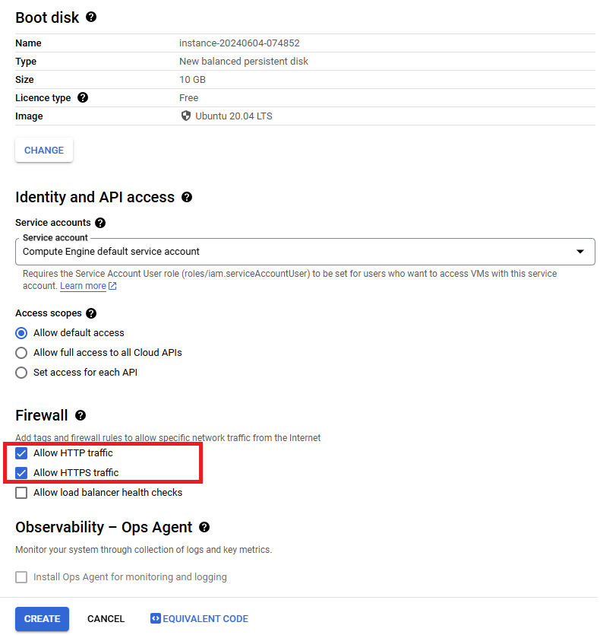

1. To create the VM, click **Create**.

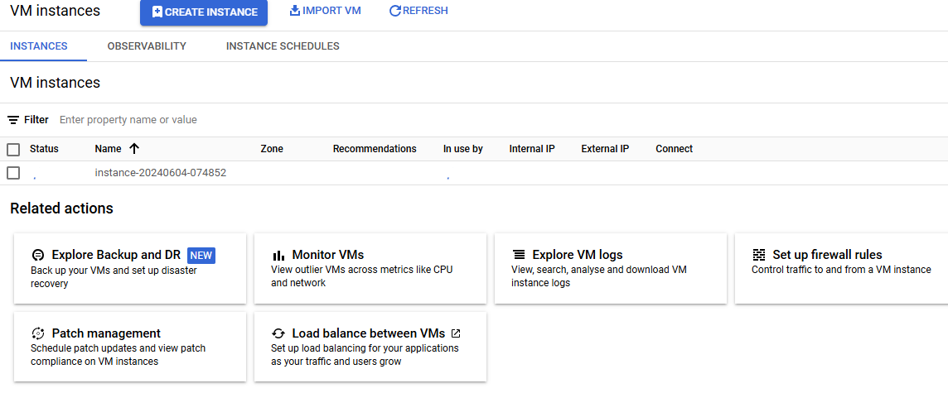

# Access the Linux VM instance

1. Once the VM is ready, click **“ open in browser windows**” under **ssh** in **connect** menu

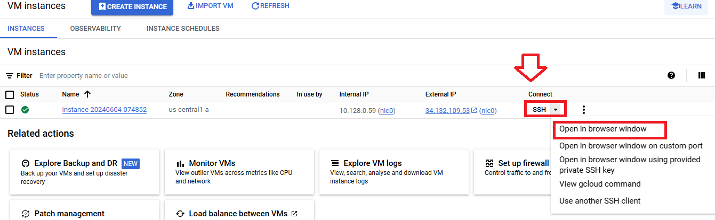

1. Once New browser windows appear with Linux user prompt $

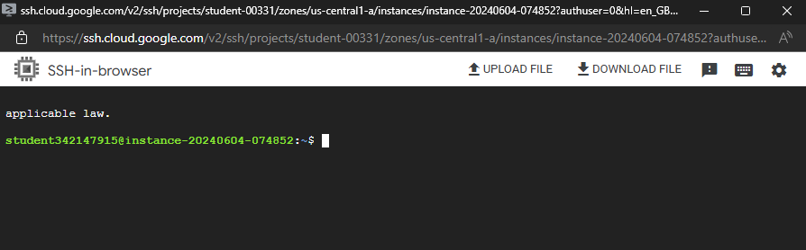

1. Type below command basic ubuntu command to list directory and create folder and files

**ls**

**mkdir BIPEEN**

**touch myfile.txt**

**ls**

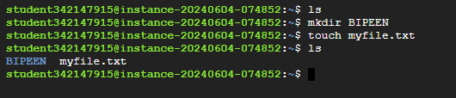

1. Change the password of root to 123

**sudo passwd root**

**su**

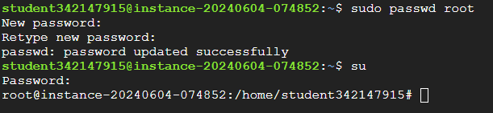

# Configure Snapshot from the VM Disk

1. Click **Snapshot** from left side **storage** menu

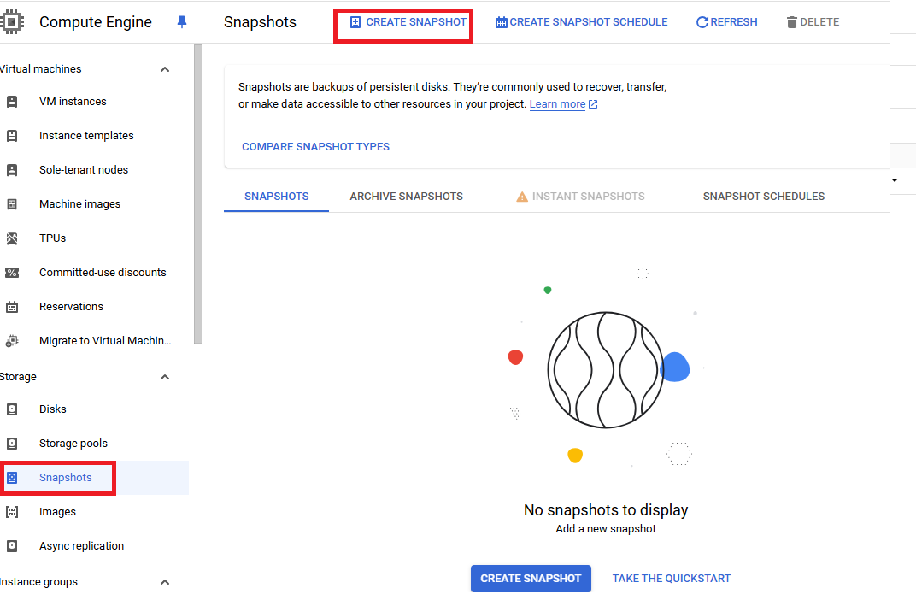**apt-**

1. Type **Name of Snapshot**, **select your disk** from source and select **regional** from **location**

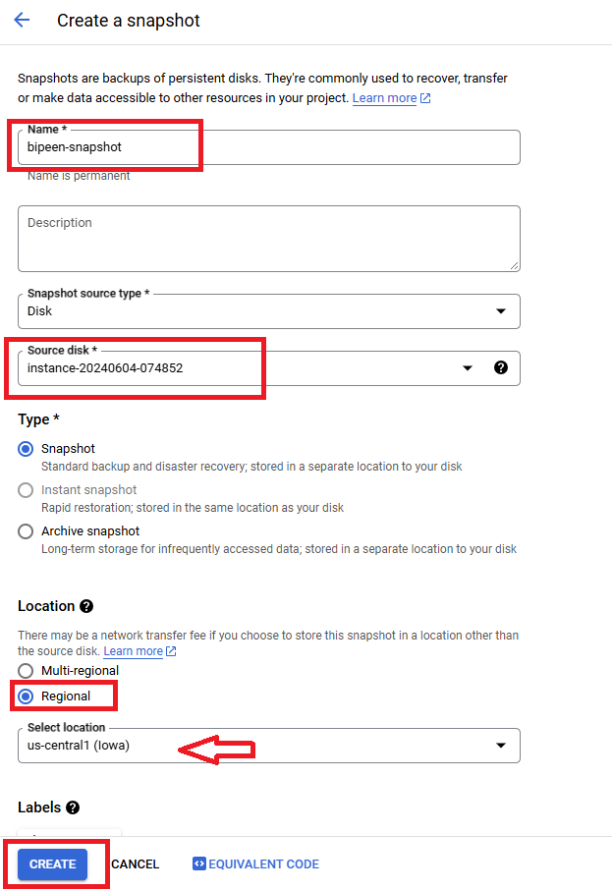

1. Check if **status** is **green**

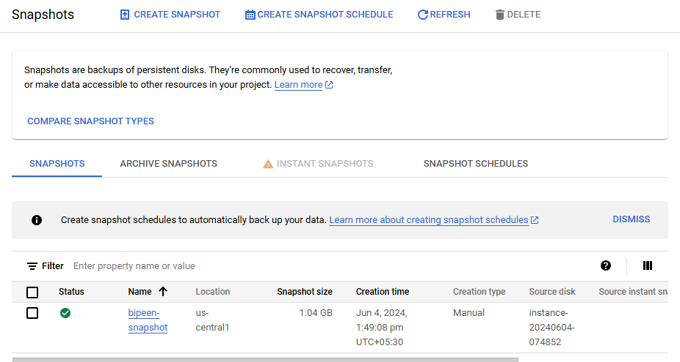

# Create Image from Snapshot

1. In the Google Cloud console, go to the **Create an image** page.

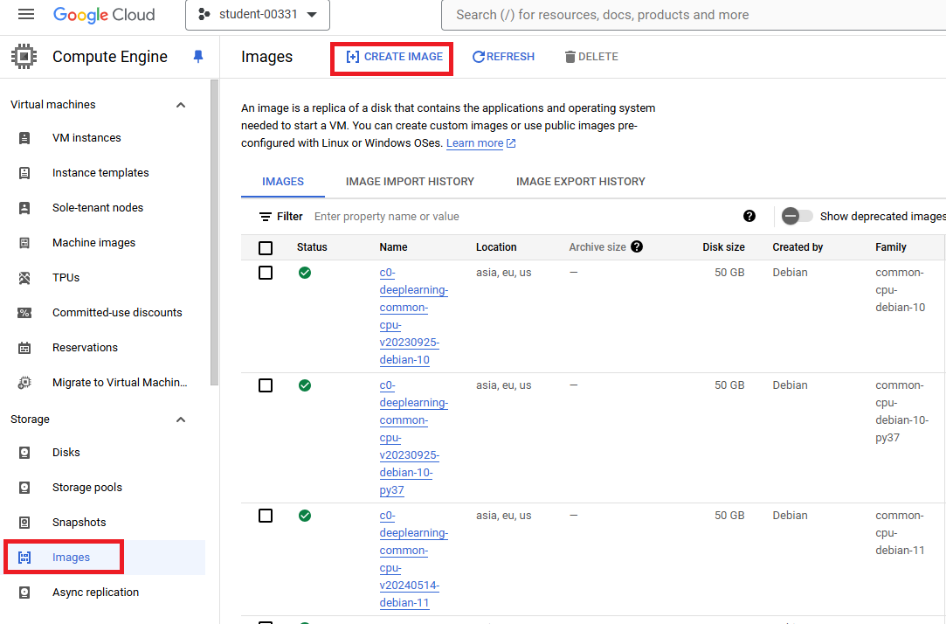

1. Specify the **Name** of your image.
2. Specify the Snapshot we created in  **Source** from which you want to create an image.
3. In the **Based on source disk location (default)** drop-down list, specify the location to store the image. For example, specify us to store the image in the us multi-region, or us-central1 to store it in the us-central1 region. If you don't make a selection, Compute Engine stores the image in the multi-region closest to your image's source location.
4. Click **Create** to create the image.

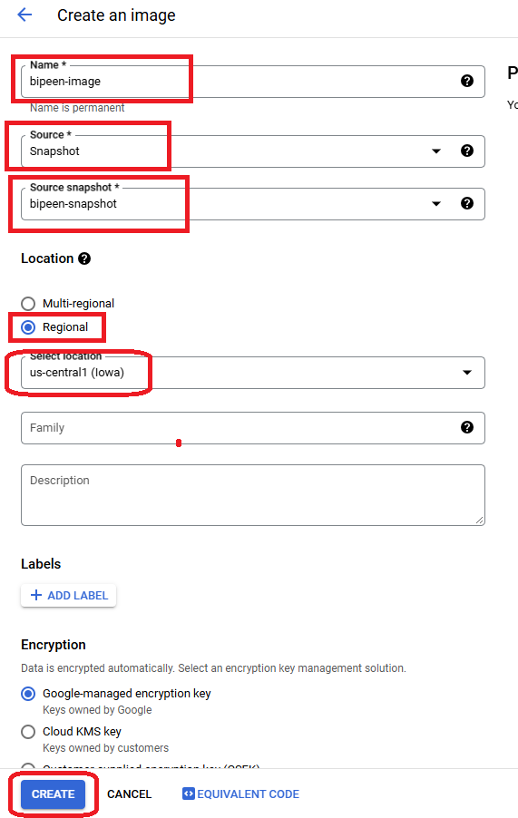

1. Check Status Green

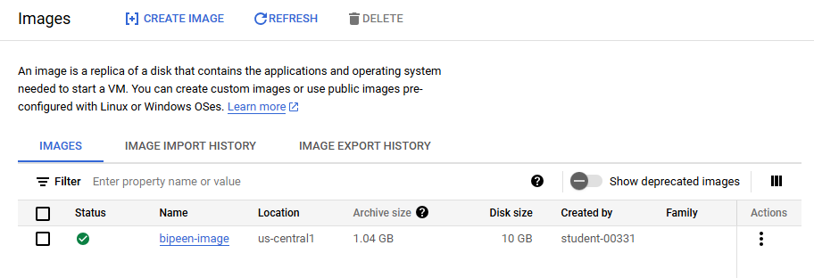

# Launch New VM from your customer Image

