

**Lab Manual- Create Virtual Machine (Ubuntu)**

**Prepared for**:

**Date:** 18th Dec 2023

**Prepared by:**

Document Name: Lab Manual **Document Number** AZLabn918

**Contributor:**

Contents

1. Objective 3

2. Create a Linux VM instance 3

3. Access the Linux VM instance 7

4. Configure Default Apache web server 8

# Objective

The ability to detect and analyze human faces is a core AI capability. In this exercise, you'll explore two Azure AI Services that you can use to work with faces in images: the **Azure AI Vision** service, and the **Face** service and using it from a client application. The goal of the exercise is not to gain expertise in any particular service, but rather to become familiar with a general pattern for provisioning and working with Azure AI services as a developer.

# Create a Linux VM instance

1. In the Google Cloud console, go to the **Compute Engine**  page and click **VM Instance**

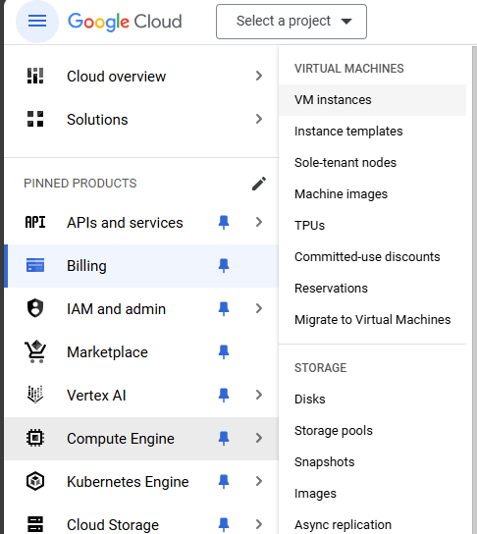

1. Go to the **Create an instance** page.

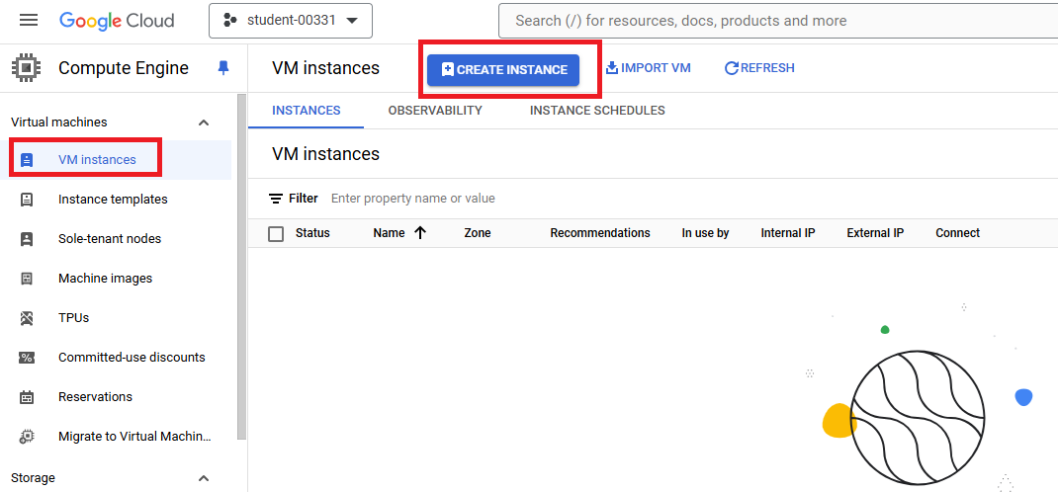

1. Select region **us-central1(lowa)** and Size **N1**

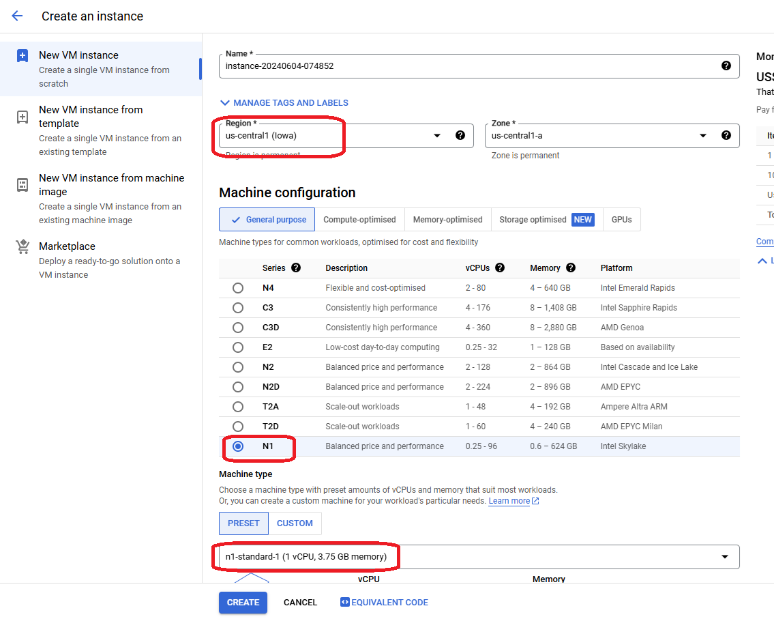

1. In the **Boot disk** section, click **Change** to begin configuring your boot disk.

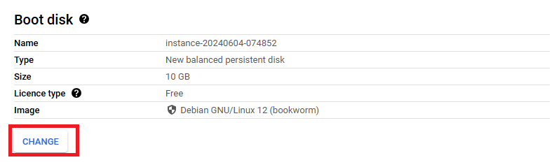

1. On the **Public images** tab, choose **Ubuntu** from the **Operating system** list.
2. Choose **Ubuntu 20.04 LTS** from the **Version** list.
3. Click **Select**.

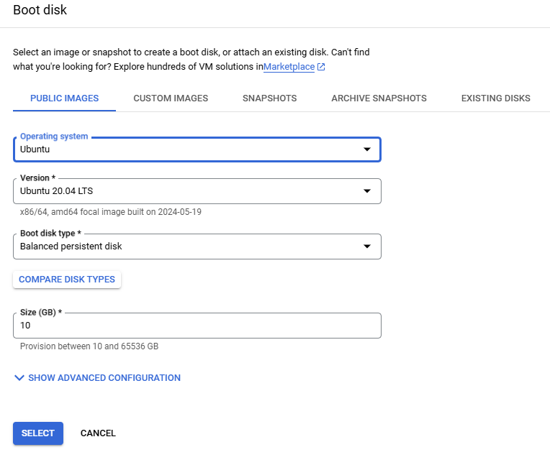

1. In the **Firewall** section, select **Allow HTTP and HTTP traffic**.

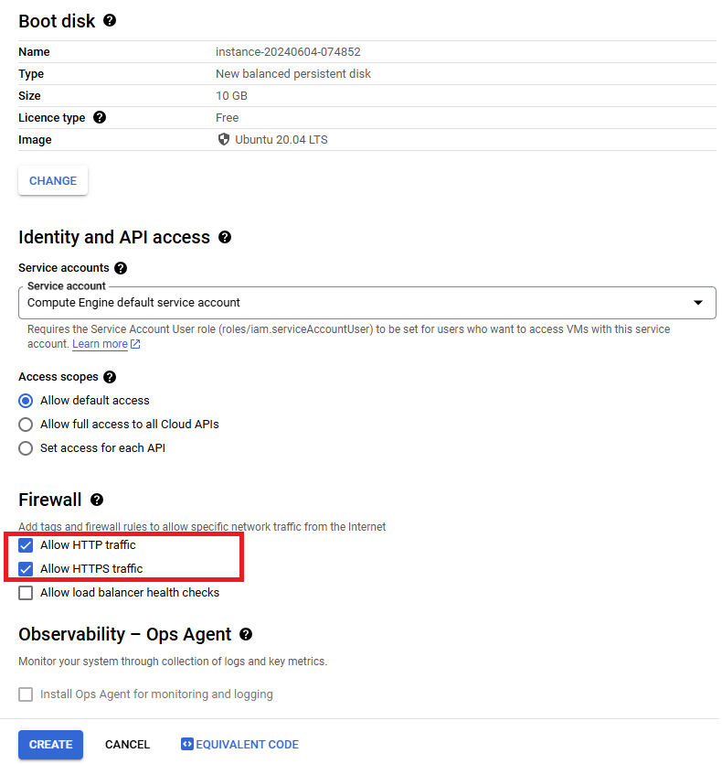

1. To create the VM, click **Create**.

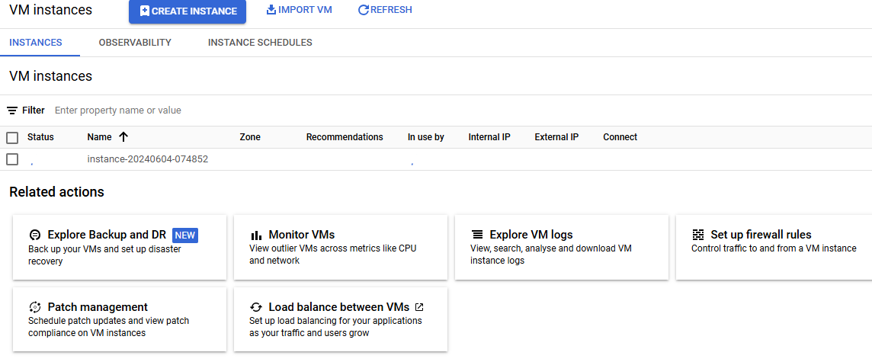

# Access the Linux VM instance

1. Once the VM is ready, click **“ open in browser windows**” under **ssh** in **connect** menu

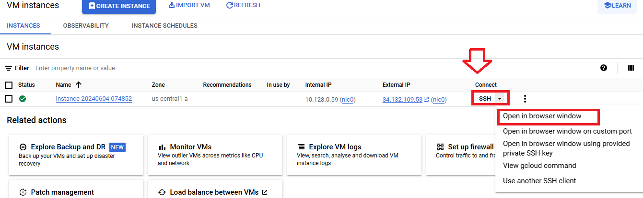

1. Once New browser windows appear with Linux user prompt $

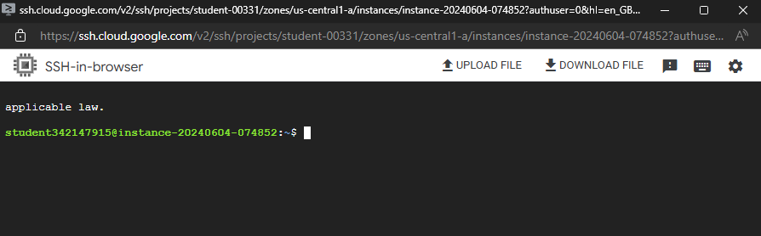

1. Type below command basic ubuntu command to list directory and create folder and files

**ls**

**mkdir BIPEEN**

**touch myfile.txt**

**ls**

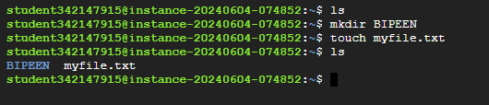

1. Change the password of root to 123

**sudo passwd root**

**su**

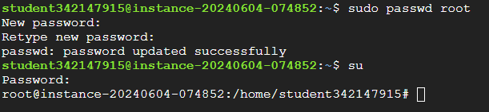

# Configure Default Apache web server

1. Type below command to install Apache web server

**apt-get install apache2 -y**

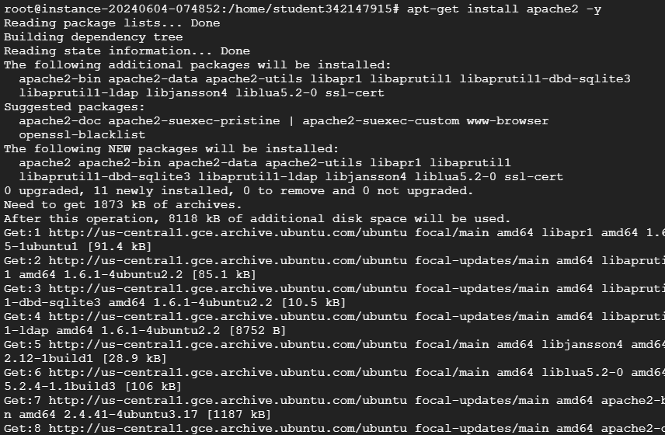

1. Now copy the **public IP** from console and paste in browser

