**Lab Manual- SysOps with Azure CLI**

**Prepared for**: TechPledge

**Date:** 10th Nov 2024

**Prepared by:** Bipin Sinhaa

Document Name: Lab Manual

**Document Number** SysOpsLab311

**Contributor:**

Shruti Sinhaa

Table of Contents

1 OBJECTIVE 3

2 PRE-REQUISISTE 3

3 Setup Up Azure CLI 3

3.1 **Download Azure CLI** 3

3.2 **Connect to Azure Cli** 5

3.3 **Azure Resource Group** 8

3.4 **Azure VM Comamnd** 10

# OBJECTIVE

Azure CLI is a cross-platform command line tool, that is used to manage and administrate Microsoft Azure. It doesn’t replace PowerShell but provides an alternative to using managing Azure from the command line. You can still continue using PowerShell, the APIs and the Azure Portal just like before. Azure CLI provides some tangible benefits over these, especially over PowerShell in that it’s very nimble and can be quickly installed on almost any platform.This Lab will cover the basics of configuring Azure cli.

Actually an Azure CLI command has the following structure:

* **a command group** which represents an Azure service and which can be the composition of subgroups
* **a command** which is the action you want to do on the group / Azure service
* arguments optionally which are a list of parameter names and values

# PRE-REQUISISTE

* Accounts in Azure
* A local Computer with 4 CPU, 16 GB RAM, 200 GB disk space

# Setup Up Azure CLI

## **Download Azure CLI**

Click on below link to downkload the Azure CLI

<https://aka.ms/installazurecliwindows>

or <https://docs.microsoft.com/en-in/cli/azure/?view=azure-cli-latest>

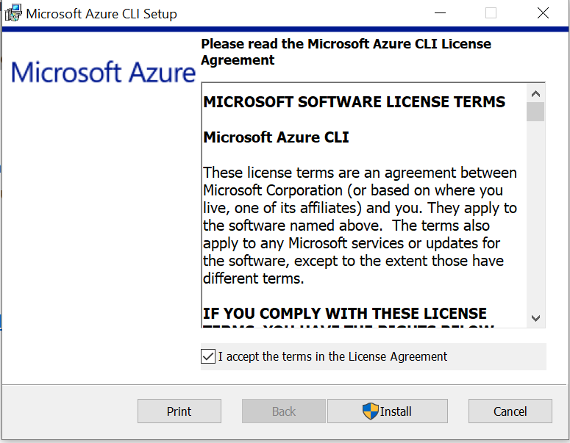

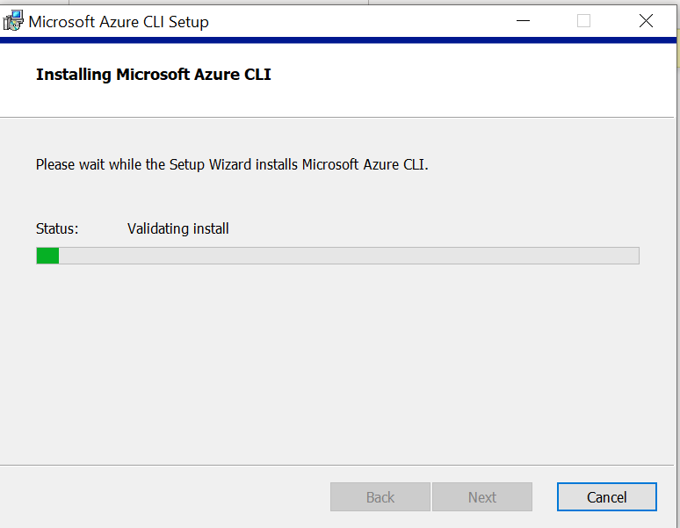

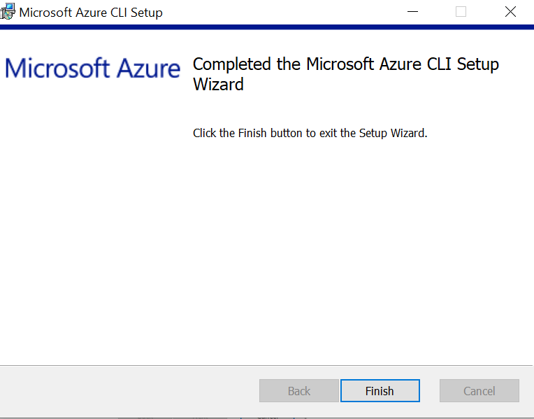

## **Connect to Azure Cli**

Open command prompt in Admin Mode and type below command

az login

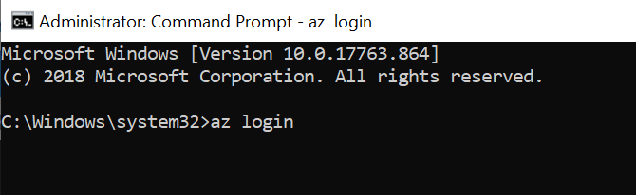

It open the login screen in browser and just type your username password

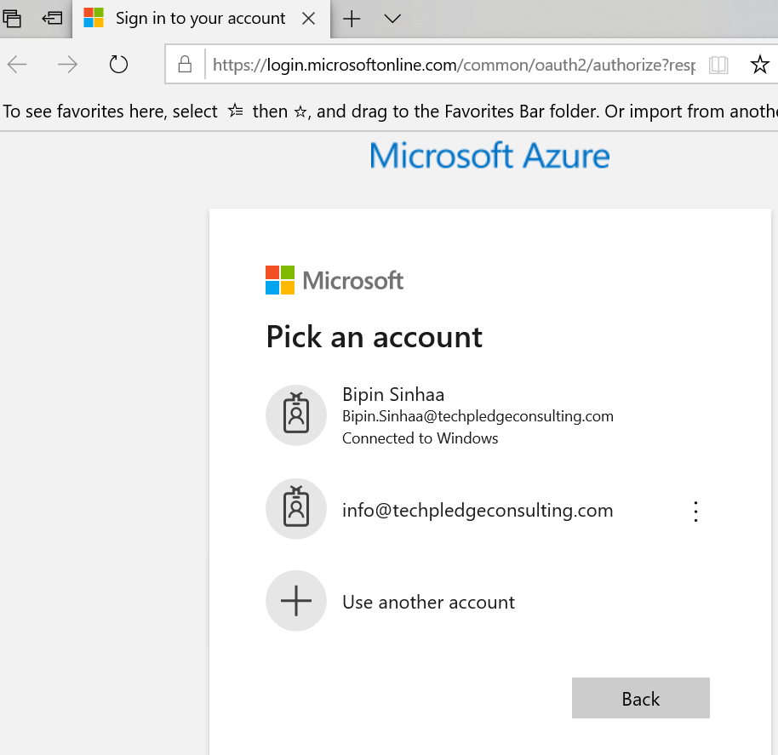

Once you get successfully authenticate you get this message on command

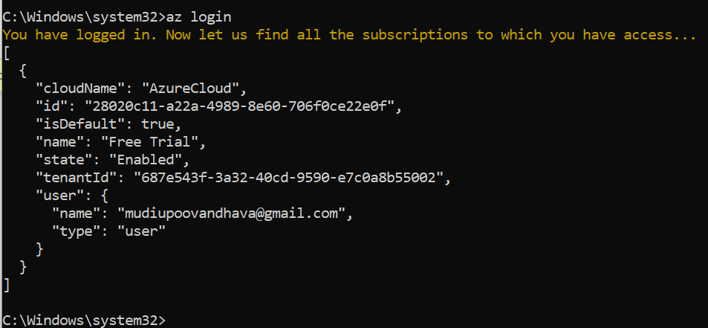

You can also login using belocw command

az login -u johndoe@contoso.com -p VerySecret

Type below command to check the current kloggin user ( Notice the output format it is called **Jason** format which is default)

az account list –all

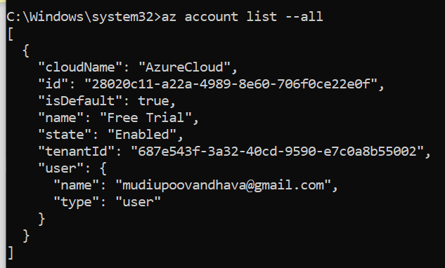

Now type the same command with different output format **table**

az account list --all --output table

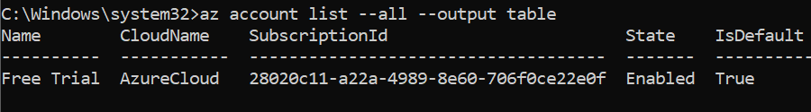

You can change the default setting like output format like table type below command and press **Y ,** press **3** when asking outperformat

az configure

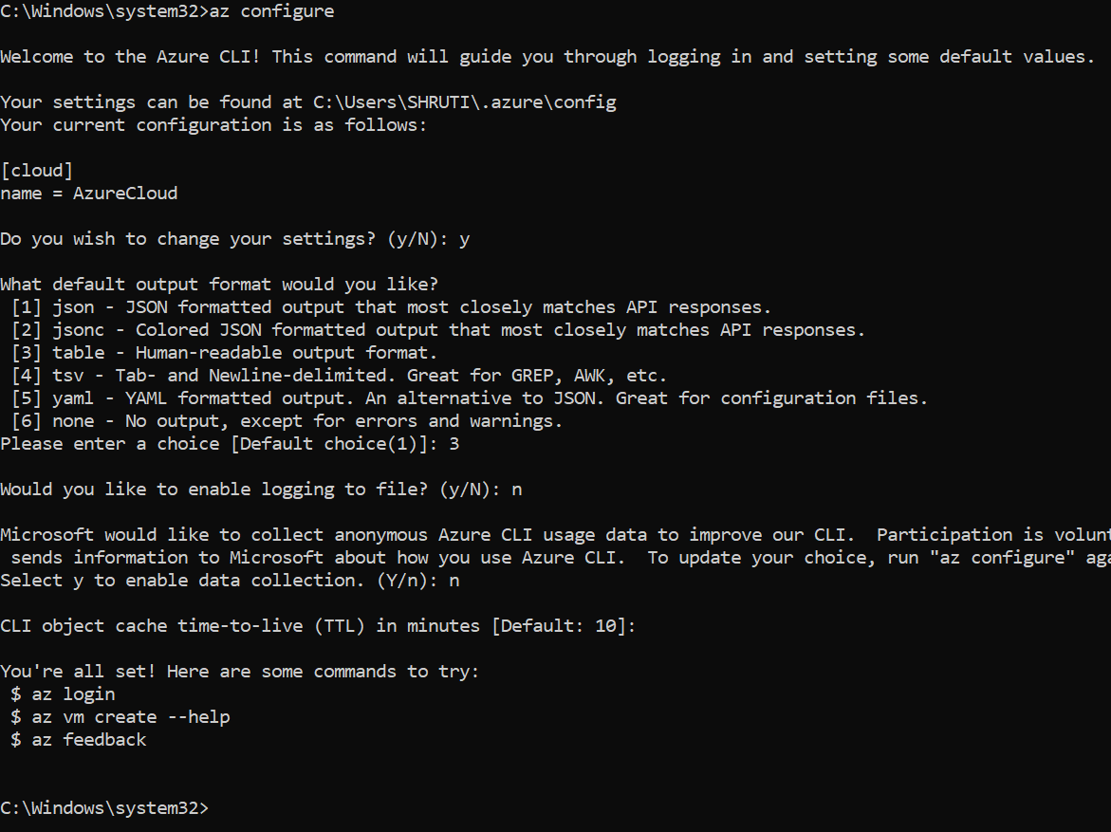

## **Azure Resource Group**

To list all Resource Groups, use:

az group list

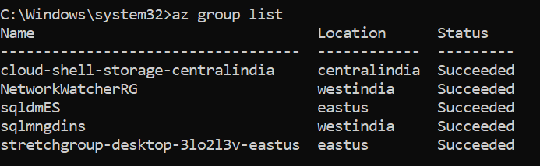

To create a new Resource Group Name **Azclidemo** at **eastuse** region , type:

az group create --name BipenRG --location Westus2

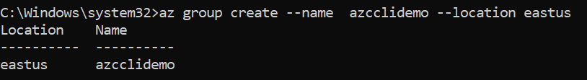

Now list the resources group again to see your created Resources group **Azclidemo**

az group list

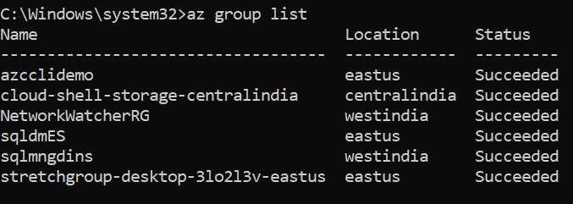

Now to delete Resources group **Azclidemo** type below command and type list command to verify

az group delete --resource-group azcclidemo --yes --no-wait

az group list

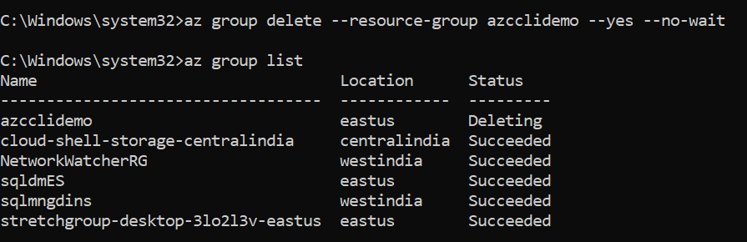

## **Azure VM Comamnd**

Type below command to create a vm name **myVM** in resource group **sqldmES** resource group with default user **demouser**

az vm create --resource-group "sqldmES" --name "myVM" --image "Win2016Datacenter" --admin-username "Demouser"--admin-password "Demouser@123" --location eastus



To list all vm type below command

az vm list

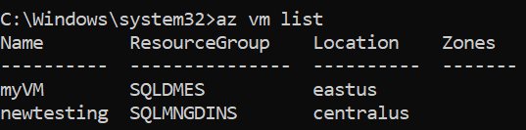

To stop vm type below command

az vm stop --resource-group sqldmES --name myVM

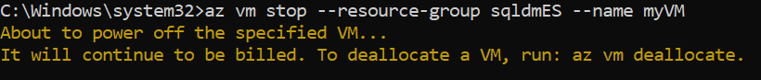

az vm start --resource-group sqldmES --name myVM



az vm delete --resource-group sqldmES --name myVM

