


Lab Manual- Kubernetes Custom Resource Defination

Prepared for:

Date: 18th Dec 2024

Prepared by:
Document Name: Lab Manual Document Number CKAD-Lab04
Contributor:

Contents
1. What is a CRD (Custom Resource Definition)? 3
Kubernetes stores the CRD and any objects created from it in etcd, just like normal resources. 3
2. Non-Technical Analogy 3
3. Lab1:- create a CRD + Custom Resource that just prints a message 3
1. Step 1: Create the CRD 3
2. Step 2: Create a Custom Resource 5
What is hello-message.yaml doing? 6
Breakdown: 6
3. Step 3: Test it 6
4. List All API Groups and Versions 6
5. delete the CRD 7

What is a CRD (Custom Resource Definition)?
In simple words:
- Kubernetes comes with built-in types like Pods, Deployments, Services, etc.
- But sometimes we want to create our own resource types to handle custom logic.
- A CRD lets you tell Kubernetes about a new kind of object that it doesn’t know about by default.
- Once registered, you can create and manage your custom resources just like native ones.

Kubernetes stores the CRD and any objects created from it in etcd, just like normal resources.

- CRDs let you create your own API types in Kubernetes.
- You define the structure (like a schema) and register it.
- Then you can create resources using that type.
- You can also create a controller to manage what happens with those custom resources.

Non-Technical Analogy
Imagine Kubernetes is like a library system:

- By default, it has Books, Magazines, and Newspapers.
- But you want to manage Comics too!
- A CRD is like going to the librarian and saying:
“Hey, from now on, please allow us to track Comics. Here's the format and rules for them.”
- Now the librarian (Kubernetes) will treat Comics just like other items.

Lab1:- create a CRD + Custom Resource that just prints a message

Step 1: Create the CRD
- This defines a new Kubernetes resource called MessagePrinter.

nano crd-messageprinter.yaml

# kubectl apply -f crd-messageprinter.yaml

apiVersion: apiextensions.k8s.io/v1
kind: CustomResourceDefinition
metadata:
name: messageprinters.demo.bipeen.com
spec:
group: demo.k8s.io
versions:
- name: v1
served: true
storage: true
schema:
openAPIV3Schema:
type: object
properties:
spec:
type: object
properties:
message:
type: string
scope: Namespaced
names:
plural: messageprinters
singular: messageprinter
kind: MessagePrinter
shortNames:
- mp

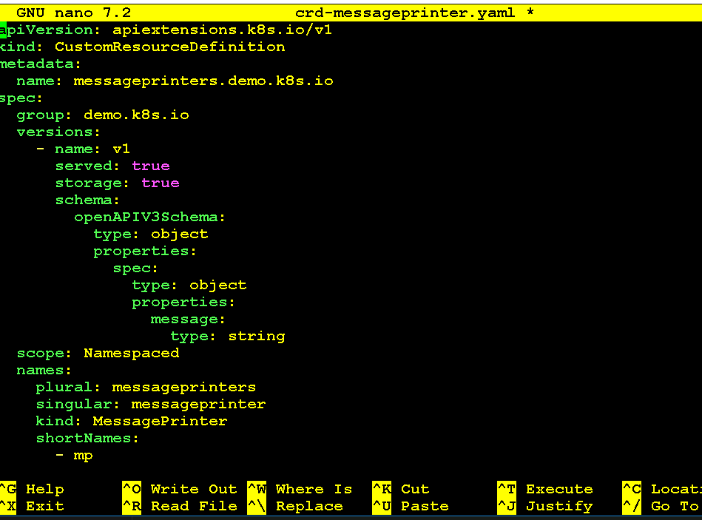

kubectl apply -f crd-messageprinter.yaml

Breakdown:
Part | Meaning
CustomResourceDefinition | We are creating a new resource type
group: demo.bipeen.com | This is a custom API group name. Must NOT be k8s.io or kubernetes.io.
names.kind: MessagePrinter | The name of the new object type
spec.scope: Namespaced | The object will live inside a namespace
spec.versions.schema | We define the structure — in this case, just a message field

Step 2: Create a Custom Resource
This is your object that uses the new type MessagePrinter and stores a message.

nano hello-message.yaml

# Create a Custom Resource
# This is your object that uses the new type MessagePrinter and stores a message.

# kubectl apply -f hello-message.yaml
# kubectl get messageprinters
# kubectl get messageprinter hello -o yaml

apiVersion: demo.bipeen.com
kind: MessagePrinter
metadata:
name: hello
spec:
message: "Hello World from CRD!"

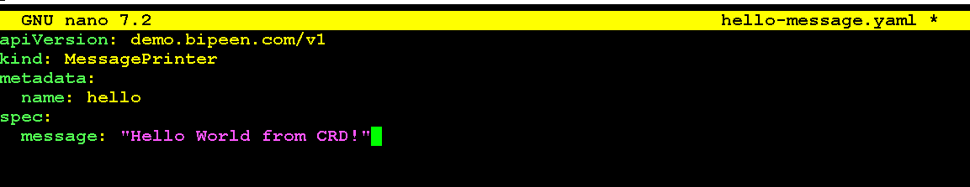

kubectl apply -f hello-message.yaml

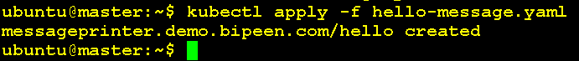

What is hello-message.yaml doing?
This file is creating an object of the new type MessagePrinter.
It’s like saying:
“Now that you know what a MessagePrinter is, here’s one named hello, and it contains this message: Hello from custom CRD!”

Breakdown:
Field | Meaning
apiVersion: demo.bipeen.com/v1 | Using the new CRD group and version
kind: MessagePrinter | Tells Kubernetes what type of object this is
metadata.name: hello | Name of this message object
spec.message: "Hello from custom CRD!" | The actual message we're storing

Step 3: Test it

kubectl get messageprinters

( Its like kubctl get pod )

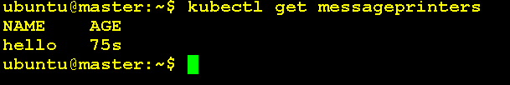

kubectl get messageprinter hello -o yaml

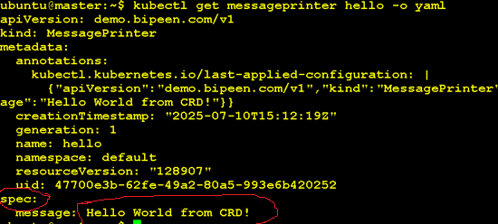

List All API Groups and Versions

kubectl api-versions
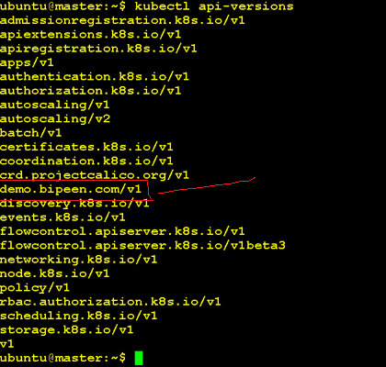

kubectl api-resources

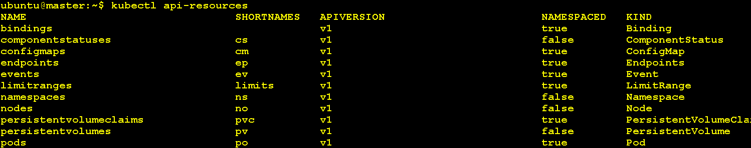

delete the CRD

kubectl delete crd messageprinters.demo.bipeen.com

