


Lab Manual- AKS Networking Basic Lab

Prepared for:

Date: 18th Dec 2023

Prepared by:
Document Name: Lab Manual Document Number AZLabn916
Contributor:

Contents
1. Objective 2
2. Dockerize Frontend and Backend 3
3. Test the Nodeport: 4
4. Test the ClusterIP: 5
5. Test The Loadbalancer: 5

Objective

In the context of Kubernetes, ClusterIP, NodePort, LoadBalancer, and Headless are different types of services that define how networking is set up for applications. Let's briefly discuss each:
- ClusterIP:
  - Type: Default service type.
  - Usage: Exposes the service on a cluster-internal IP address.
  - Access: Can only be accessed within the cluster.
  - Typical Use Case: Used for communication between different parts of an application running in the same cluster.
- NodePort:
  - Type: Exposes the service on each Node's IP at a static port.
  - Usage: Makes the service accessible on a specified port on every Node in the cluster.
  - Access: Allows external access to the service from outside the cluster.
  - Typical Use Case: Useful during development or for small-scale deployments where an external load balancer might not be available.
- LoadBalancerOnly for Cloud
  - Type: Exposes the service externally using a cloud provider's load balancer.
  - Usage: Automatically provisions a load balancer for the service.
  - Access: Allows external access, similar to NodePort, but with automatic provisioning of an external load balancer.
  - Typical Use Case: Suitable for production environments where high availability and scalability are required.

ClusterIP, NodePort, LoadBalancer

git clone https://github.com/bipeensinha/aks-network.git

cd aks-network

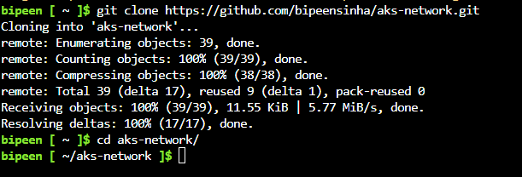

ls -l

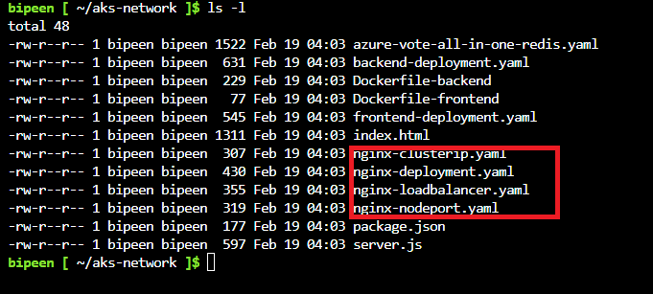

kubectl apply -f nginx-deployment.yaml

kubectl apply -f nginx-clusterip.yaml

kubectl apply -f nginx-loadbalancer.yaml

kubectl apply -f nginx-nodeport.yaml

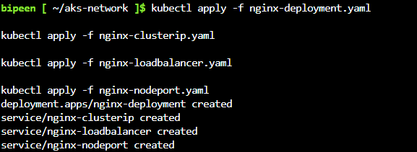

kubectl get po

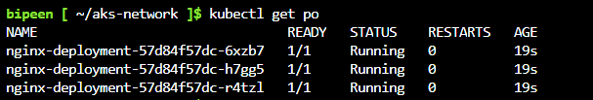

kubectl get svc

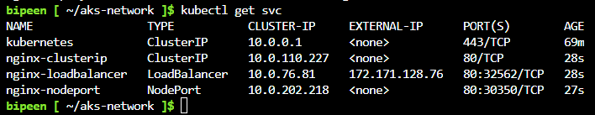

Test the Nodeport:

kubectl run --restart=Never --image=appropriate/curl curl -- curl http://10.224.0.4

kubectl get po

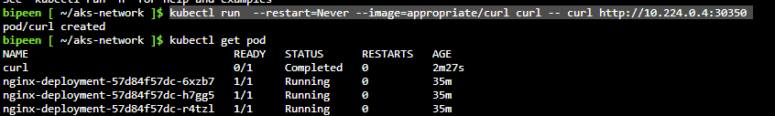

kubectl logs curl

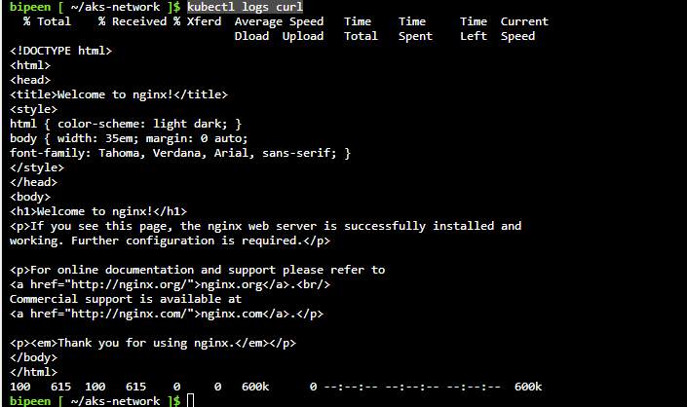

kubectl delete po curl

Test the ClusterIP:

kubectl get svc



kubectl run --restart=Never --image=appropriate/curl curl -- curl http://nginx-clusterip

kubectl delete po curl
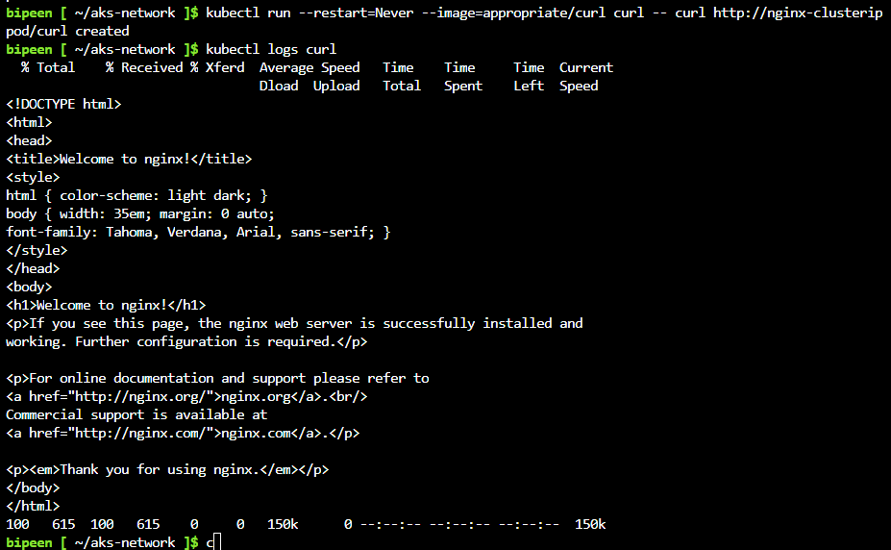

Test The Loadbalancer:

kubectl get svc



