


Lab Manual- Update Existing Image with Helm Chart (Rolling Update )

Prepared for:

Date: 18th June 2025

Prepared by:
Document Name: Lab Manual Document Number CKAD-Lab-14
Contributor:

Contents
1. Objective 3
2. Lab 1- Create and Upgrade With Helm Chart (Default NGNIX) 4
3. Step 1: Create a Helm Chart 4
4. Step 2: Edit the Chart to Use NGINX 4
5. Step 3: Install the Application 5
6. 🌐 Step 4: Access the Application (Optional) 6
7. 🔄 Step 5: Upgrade the Application (New Version) 6
8. Step 6: Uninstall If Needed 7
9. Lab 1- Create and Upgrade With Helm Chart (Custom Image) 8
10. Step 1: Create a Helm Chart 8
11. Step 2: Edit the Chart to Use NGINX 8
12. Step 3: Install the Application 9
13. 🌐 Step 4: Access the Application (Optional) 10
14. 🔄 Step 5: Upgrade the Application (New Version) 10
15. Step 6: Uninstall If Needed 12

Objective

Helm charts are structured like this:
mychart/
Chart.yaml
values.yaml
charts/
templates/
...

The templates/ directory is for template files. When Tiller evaluates a chart, it will send all of the files in the templates/ directory through the template rendering engine. Tiller then collects the results of those templates and sends them on to Kubernetes.
The values.yaml file is also important to templates. This file contains the default values for a chart. These values may be overridden by users during helm install or helm upgrade.
The Chart.yaml file contains a description of the chart. You can access it from within a template. The charts/ directory may contain other charts (which we call subcharts). Later in this guide we will see how those work when it comes to template rendering.

But another step you can take as you can convert that chart into standard Kubernetes YAML. Therefore, you can apply that to any cluster without having Helm present. It's a kind of optional

Lab 1- Create and Upgrade With Helm Chart (Default NGNIX)

- Step 1: Create a Helm Chart
helm create myapp
cd myapp

This creates a new folder myapp/ with all Helm chart files.

- Step 2: Edit the Chart to Use NGINX
Edit values.yaml using nano:
Find the section that looks like this:
image:
repository: nginx
pullPolicy: IfNotPresent
tag: "1.21"

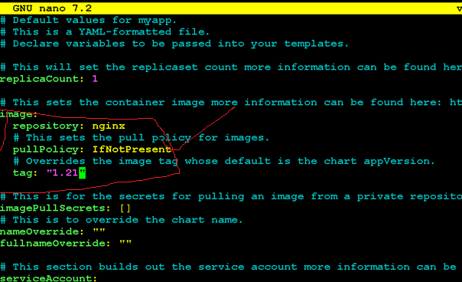
Make sure it looks exactly like above. Press Ctrl+O to save, then Enter, and Ctrl+X to exit nano.

- Step 3: Install the Application
Go back to the parent folder (if needed):
cd ..
helm install myapp ./myapp

ls

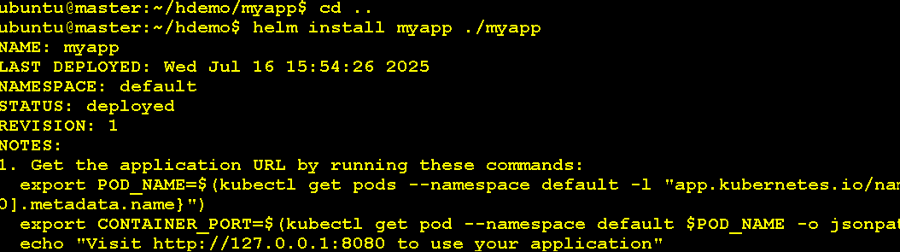
✅ This deploys an NGINX pod using Helm.
Check the pod and service:
kubectl get pods
kubectl get svc
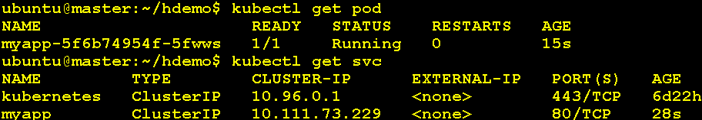

- 🌐 Step 4: Access the Application (Optional)
Forward port so you can access it in the browser:
kubectl port-forward svc/myapp 8080:80

Open a browser on your machine and go to:
http://localhost:8080

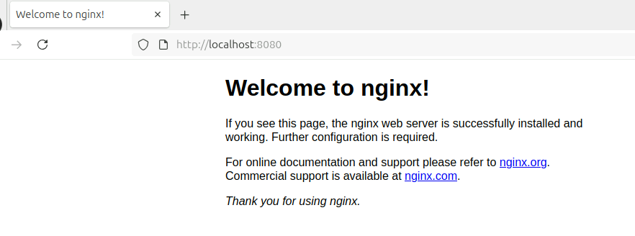
You should see the NGINX welcome page.

- 🔄 Step 5: Upgrade the Application (New Version)
Let's say you want to change to nginx version 1.23.
cd myapp
nano values.yaml

Change the tag line to:
tag: "1.23"

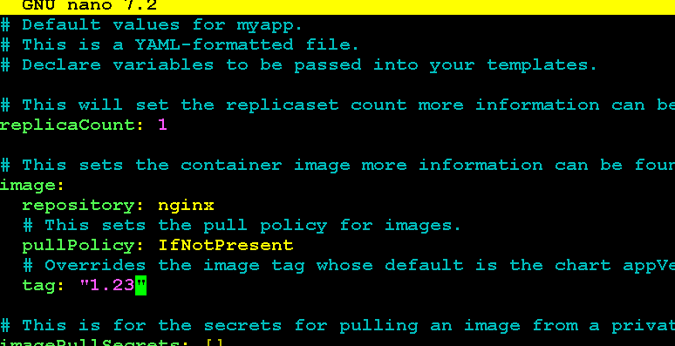
Save and exit (Ctrl+O, Enter, Ctrl+X), then go back and run:
cd ..
helm upgrade myapp ./myapp

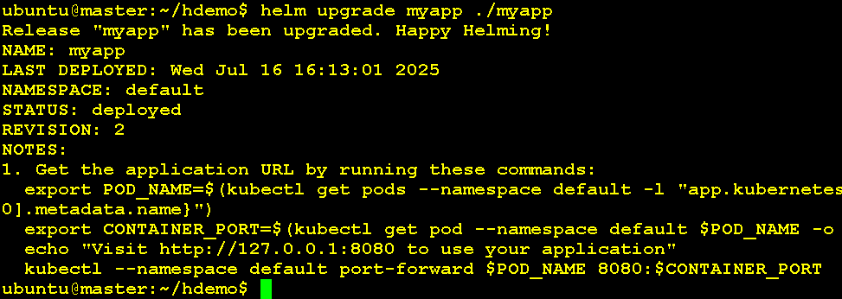
Check updated pod:
kukubectl get pods
kubectl describe pod <your-pod-name> | grep Image

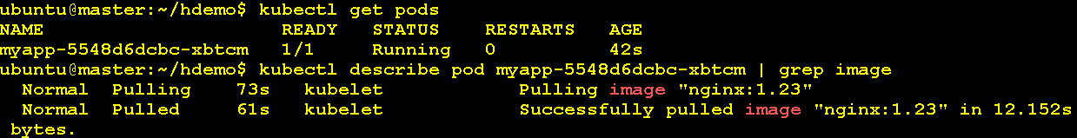
✅ It should show nginx:1.23.

- Step 6: Uninstall If Needed
helm uninstall myapp

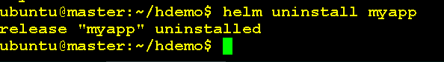

Lab 1- Create and Upgrade With Helm Chart (Custom Image)

- Step 1: Create a Helm Chart

mkdir customhelm-demo
cd customhelm-demo
helm create kchart
cd kchart

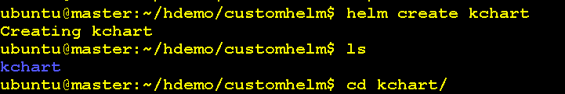
This creates a new folder myapp/ with all Helm chart files.

- Step 2: Edit the Chart to Use NGINX
Edit values.yaml using nano:
Find the section that looks like this:
image:
repository: bipeen2001/kyndryl
pullPolicy: IfNotPresent
tag: "v1"

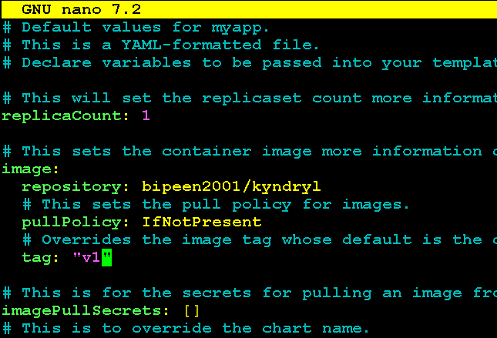
Make sure it looks exactly like above. Press Ctrl+O to save, then Enter, and Ctrl+X to exit nano.

- Step 3: Install the Application
Go back to the parent folder (if needed):
cd ..
helm install kchart ./kchart

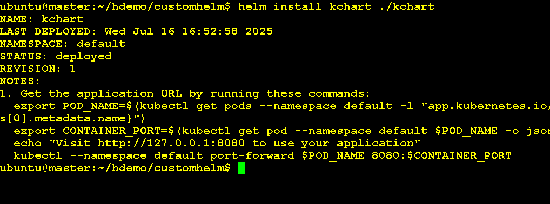

✅ This deploys an NGINX pod using Helm.
Check the pod and service:
kubectl get pods

kubectl describe pod <your-pod-name> | grep Image

kubectl get svc
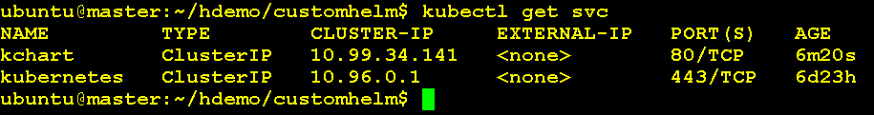

- 🌐 Step 4: Access the Application (Optional)
Forward port so you can access it in the browser:
kubectl port-forward svc/kchart 8080:80

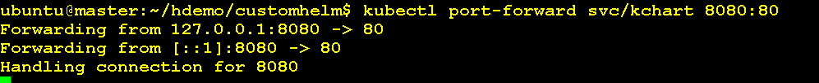
Open a browser on your machine and go to:
http://localhost:8080

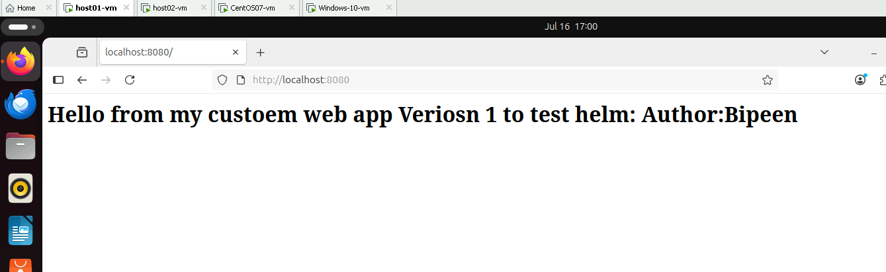
You should see the NGINX welcome page.

- 🔄 Step 5: Upgrade the Application (New Version)
Let's say you want to change to nginx version 1.23.
cd kchart
nano values.yaml

Change the tag line to:
tag: "v2"

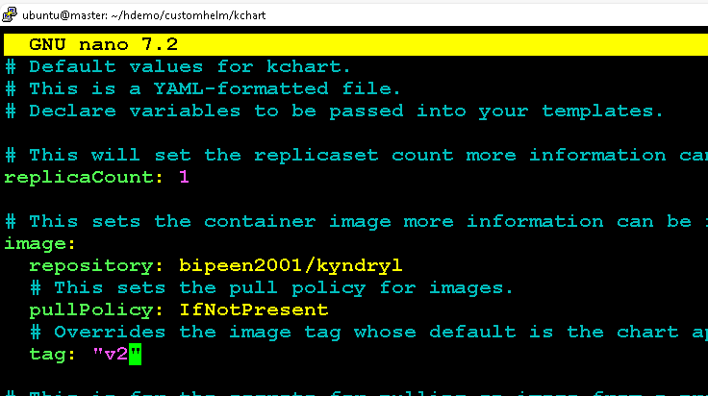
Save and exit (Ctrl+O, Enter, Ctrl+X), then go back and run:
cd ..
helm upgrade kchart ./kchart

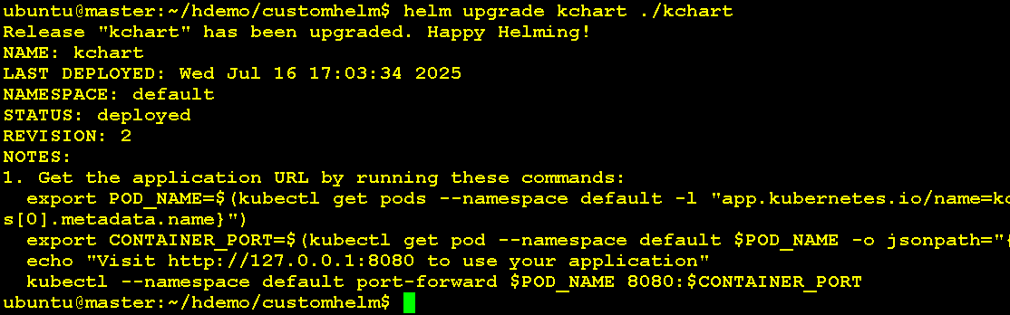
Check updated pod:
kukubectl get pods
kubectl describe pod <your-pod-name> | grep Image

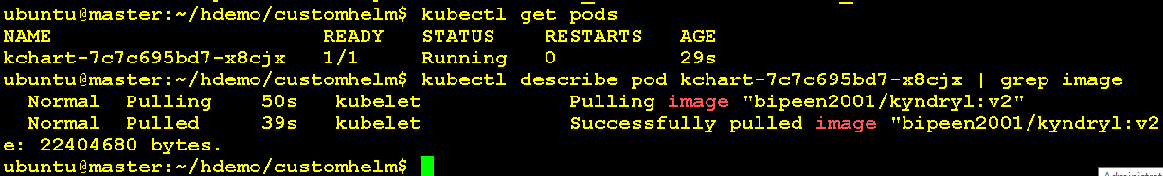
✅ It should show Bipeen2001/Kyndryl:v2
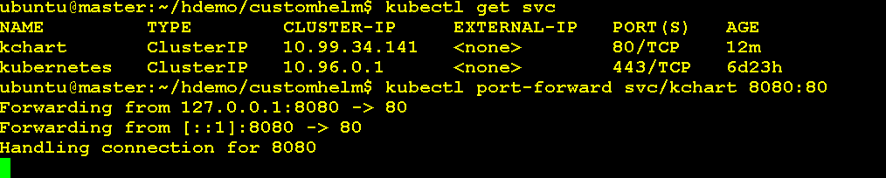
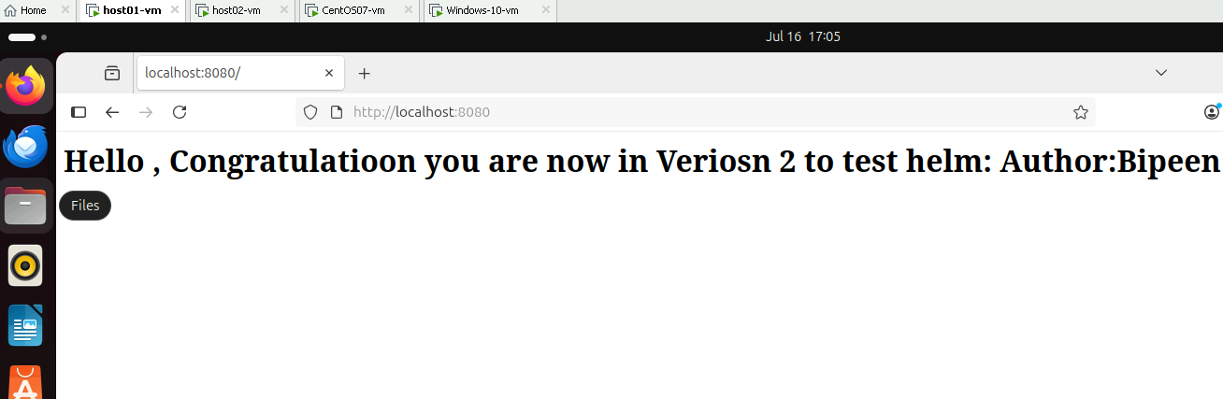

- Step 6: Uninstall If Needed
helm uninstall kchart

