1
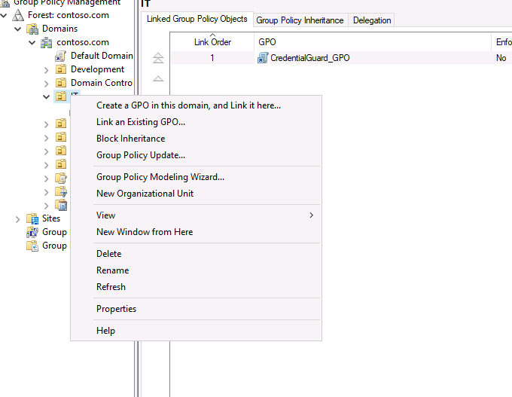

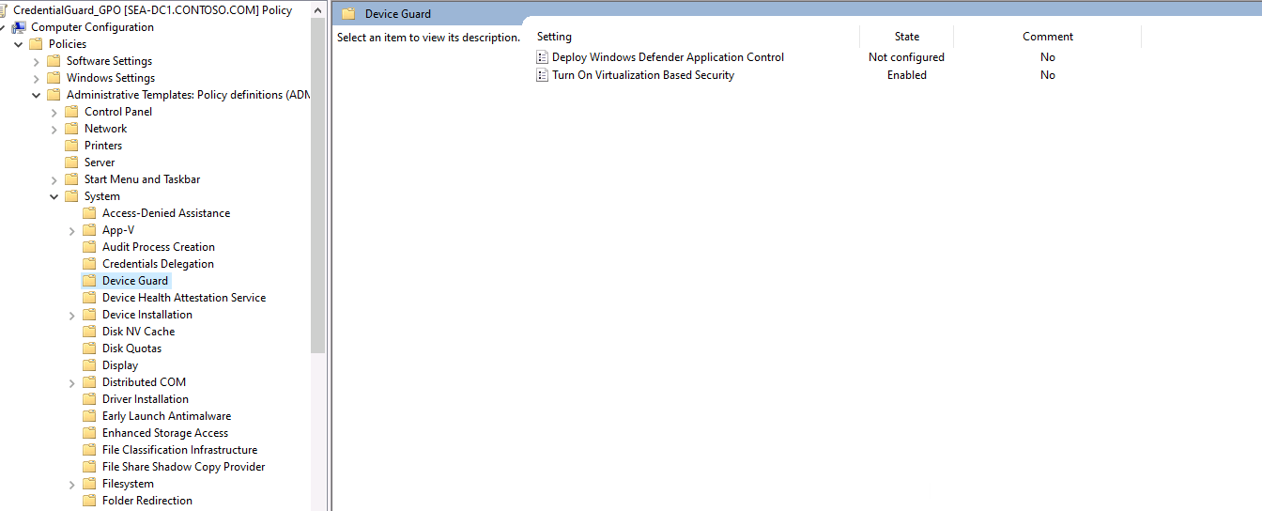

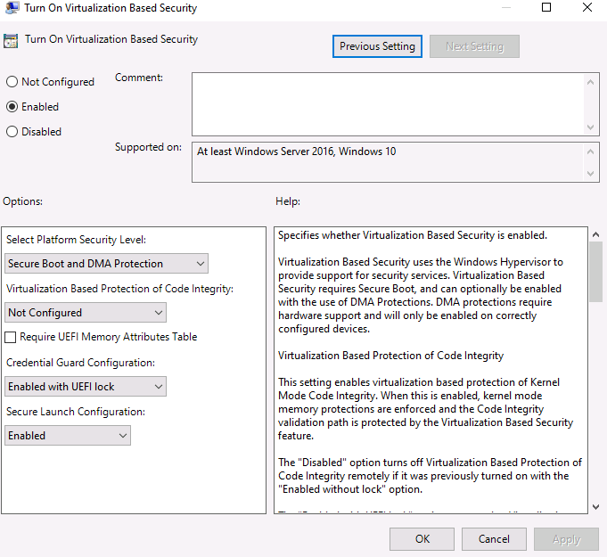
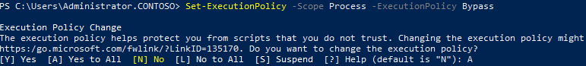

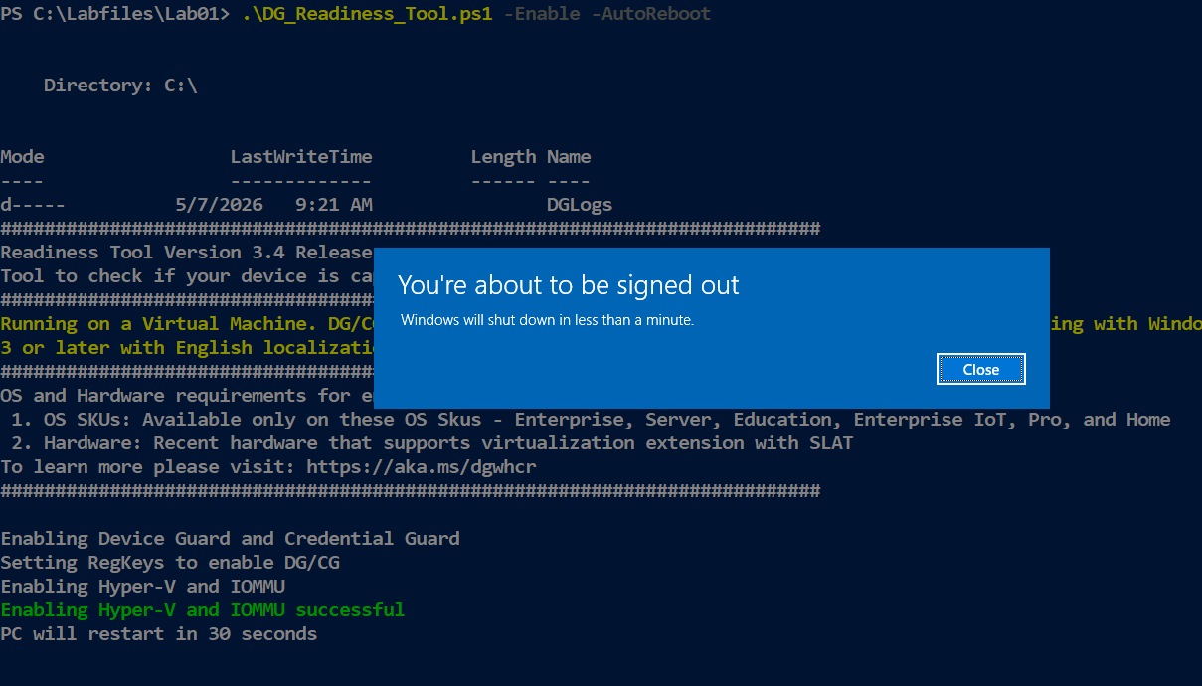

Exercise 2: Locating problematic accounts

Task 1: Locate and reconfigure domain accounts with non-expiring passwords

Why Are You Doing This Task?
Identifying and reconfiguring accounts with non-expiring passwords ensures that all user accounts follow password expiration policies, reducing the risk of compromised credentials.

On SEA-SVR2, select Start, right-click or access the context menu for Windows PowerShell ISE, and then select Run as administrator.

To list Active Directory-enabled user accounts with a non-expiring password, at the Windows PowerShell command prompt, enter the following command and press Enter:

Get-ADUser -Filter {Enabled -eq $true -and PasswordNeverExpires -eq $true}
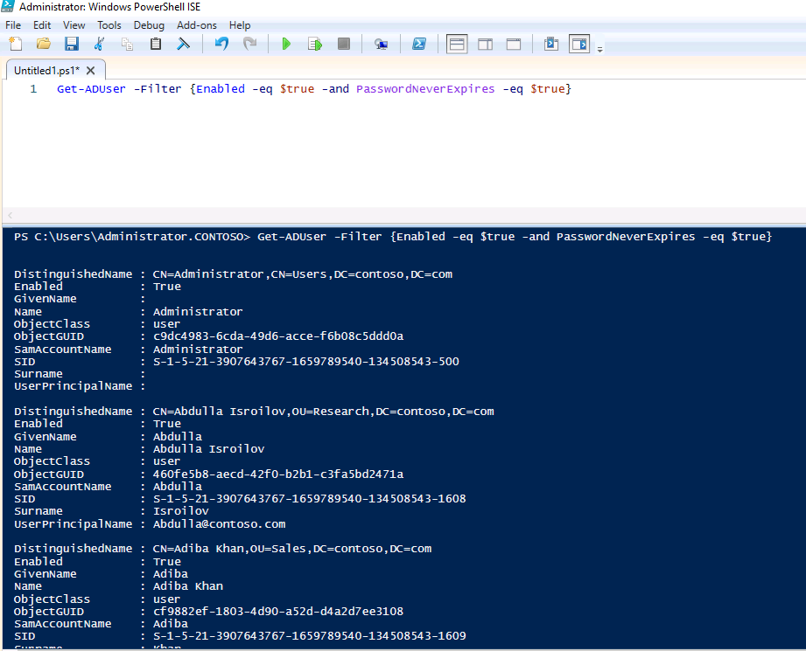

- Review the list of user accounts returned.

- To enable password expiration for all user accounts in the result set, at the Windows PowerShell command prompt, enter the following command and press Enter:

Get-ADUser -Filter {Enabled -eq $true -and PasswordNeverExpires -eq $true} | Set-ADUser -PasswordNeverExpires $false

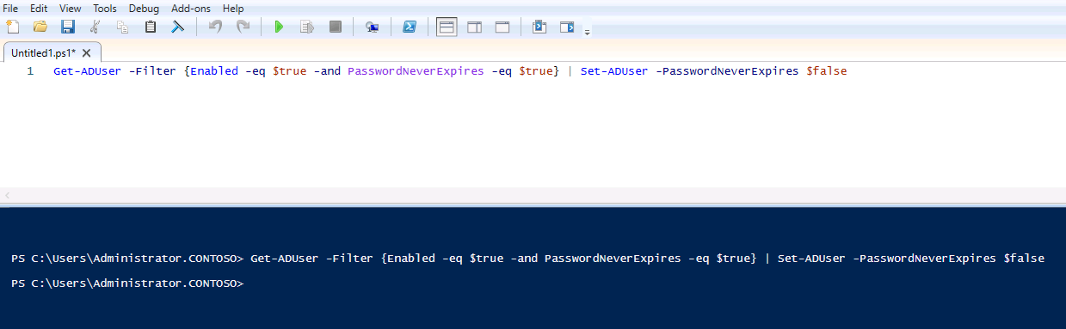

- To verify the outcome, rerun the command from step 2 and notice that no results are returned.

Get-ADUser -Filter {Enabled -eq $true -and PasswordNeverExpires -eq $true}
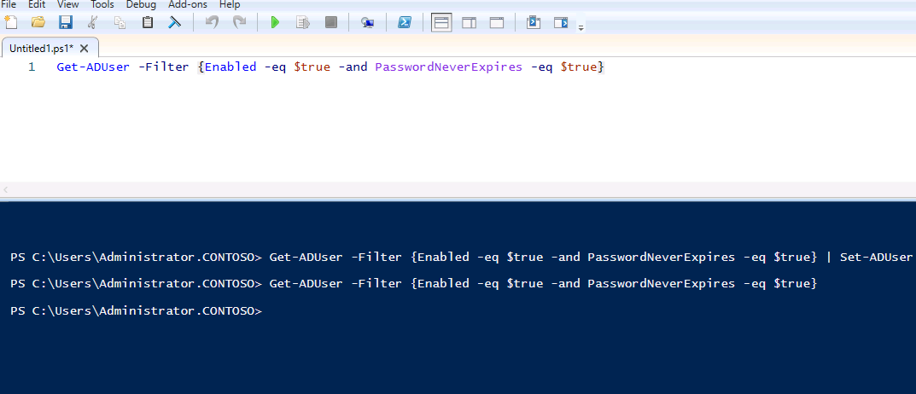

Task 2: Locate and disable domain accounts that have not been used to sign in for at least 90 days

Why Are You Doing This Task?
Disabling inactive accounts minimizes the risk of unauthorized access, ensuring that only active and legitimate accounts remain enabled in the domain.

To identify Active Directory user accounts that have not been used to sign in for at least 90 days, at the Windows PowerShell ISE command prompt, enter the following command and press Enter:
$days = (Get-Date).AddDays(-90)

Get-ADUser -Filter {LastLogonTimeStamp -lt $days -and enabled -eq $true} -Properties LastLogonTimeStamp

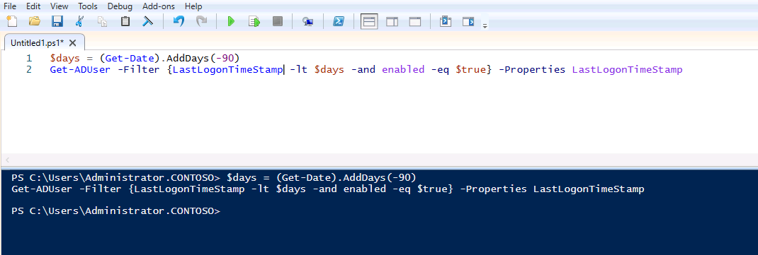

Note: In the lab environment, no results will be returned.

To disable Active Directory user accounts that have not been used to sign in for at least 90 days, enter the following command and press Enter:

Get-ADUser -Filter {LastLogonTimeStamp -lt $days -and enabled -eq $true} -Properties LastLogonTimeStamp | Disable-ADAccount

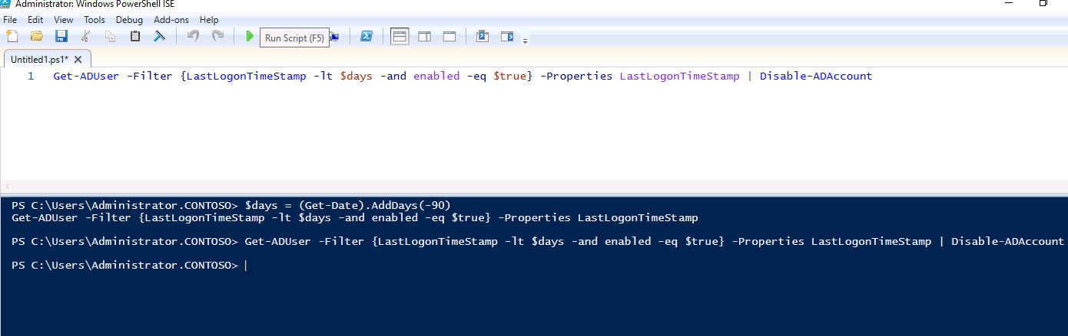

Implementing LAPS
Why Are You Doing This Exercise?:
Implementing LAPS enhances security by automatically managing and rotating local administrator passwords on domain-joined computers, reducing the risk of password compromise.

Exercise 3: Implementing LAPS
Task 1: Prepare computer accounts for implementing LAPS (Local Administrator Password Solution

Why Are You Doing This Task?
Preparing computer accounts for LAPS ensures that the necessary organizational units and permissions are in place for managing local admin passwords securely.

To create a designated OU and move the SEA-SVR1 computer account to it, on SEA-SVR2, at the Windows PowerShell ISE command prompt, enter the following command and press Enter:

New-ADOrganizationalUnit -Name "Seattle_Servers"
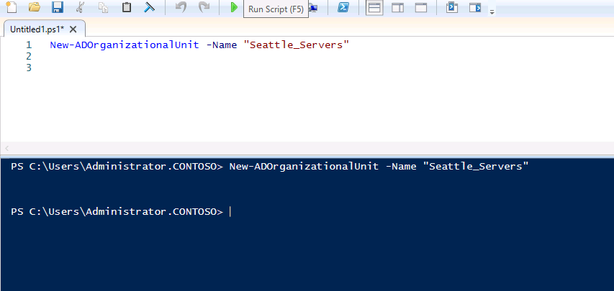
Get-ADComputer SEA-SVR1 | Move-ADObject –TargetPath "OU=Seattle_Servers,DC=Contoso,DC=com"

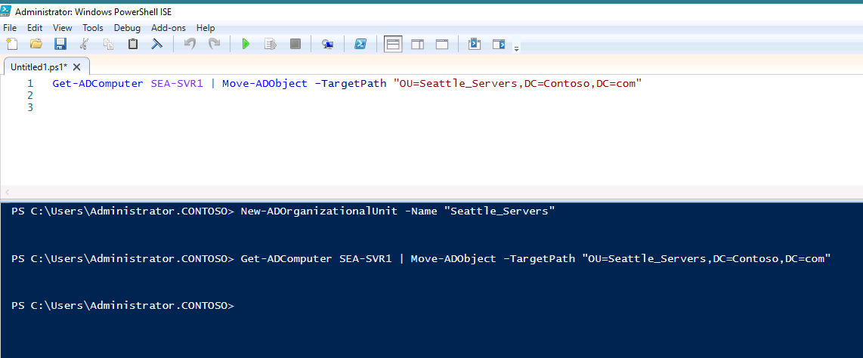

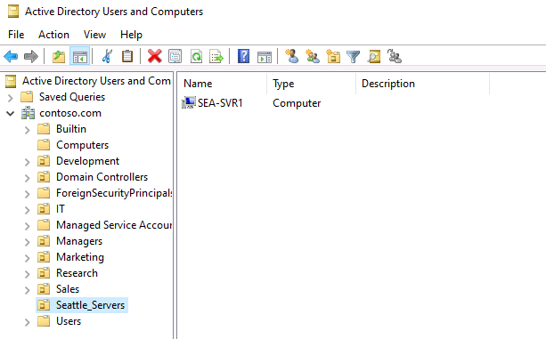

To install LAPS, at the Windows PowerShell ISE command prompt, enter the following command and press Enter:

Msiexec /i C:\Labfiles\Lab01\LAPS.x64.msi
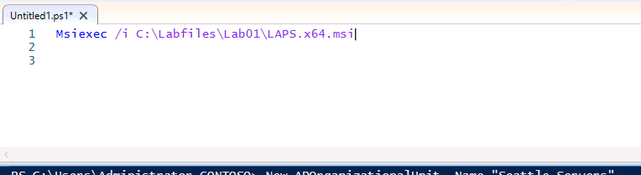
On the Welcome to the Local Administrator Password Solution Setup Wizard page of the Local Administrator Password Solution Setup wizard, select Next.
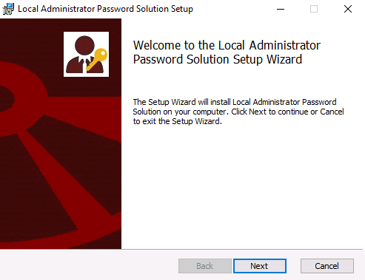
On the End-User License Agreement page of the Local Administrator Password Solution Setup wizard, select I accept the terms in the License Agreement, and then select Next.
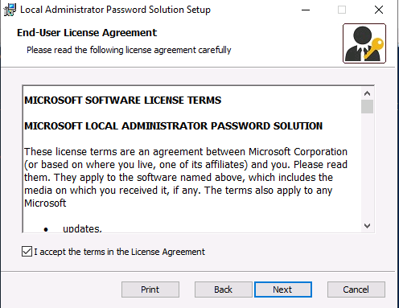
On the Custom Setup page of the Local Administrator Password Solution Setup wizard, in the drop-down menu next to Management Tools, select Entire feature will be installed on the local hard drive, and then select Next.
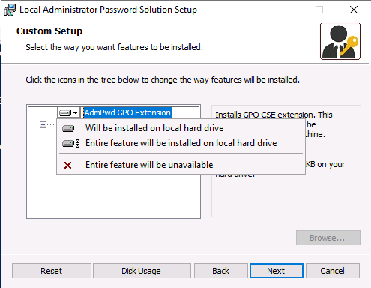

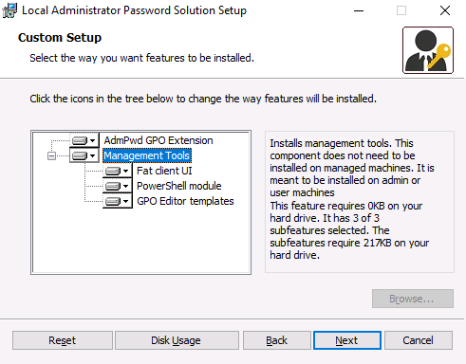
On the Ready to install Local Administrator Password Solution page of the Local Administrator Password Solution Setup wizard, select Install.
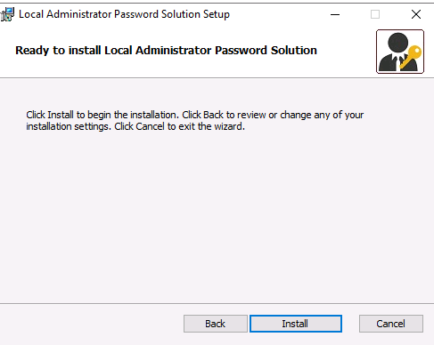
Once the installation completes, on the final page of the Local Administrator Password Solution Setup wizard, select Finish.
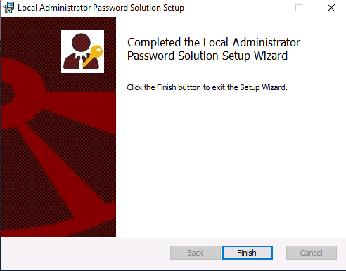

- To enable the Windows Defender Firewall with Advanced Security rule that allows incoming Server Message Block (SMB) connections from other domain-joined servers, at the Windows PowerShell command prompt, enter the following commands and, after each, press Enter:
$rule = Get-NetFirewallRule | Where-Object DisplayName -eq 'File and Printer Sharing (SMB-In)'
$rule | Set-NetFirewallRule -Profile Domain
$rule | Enable-NetFirewallRule
📝 Note: This is required to connect to SEA-SVR2 from SEA-SVR1 later in this lab.
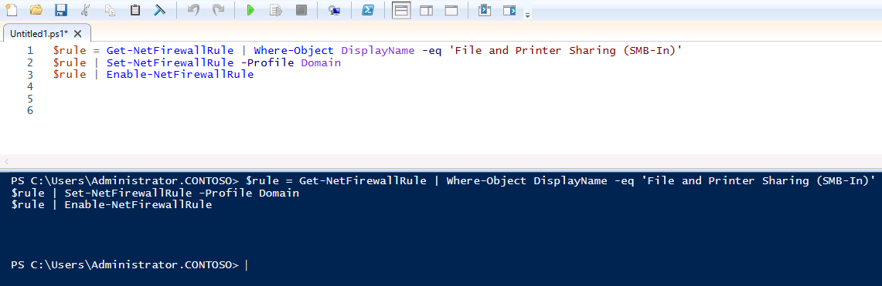

Task 2: Prepare AD DS for LAPS

Why Are You Doing This Task?
Preparing Active Directory for LAPS ensures that the schema is updated and permissions are configured, allowing computers to store and update their local admin passwords securely.

To prepare the domain for LAPS, on SEA-SVR2, at the Windows PowerShell ISE command prompt, enter the following commands, and after each, press Enter:
Install-module admpwd.ps

📝 Note: If a dialog box about an untrusted repository appears, select Yes to All.
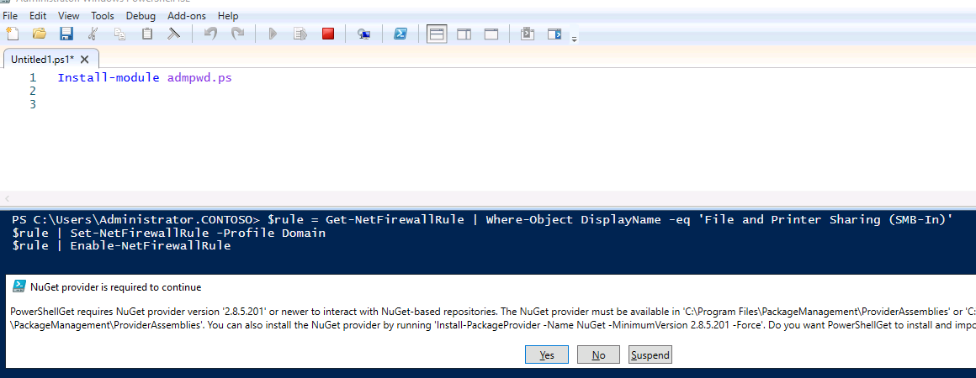

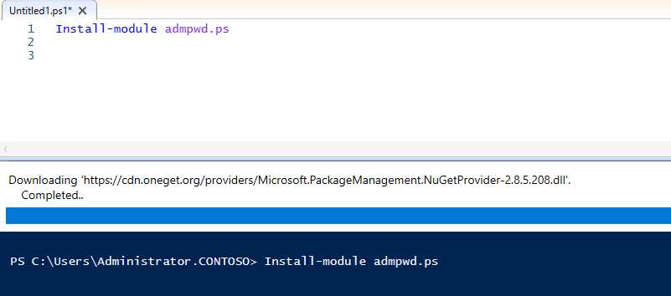

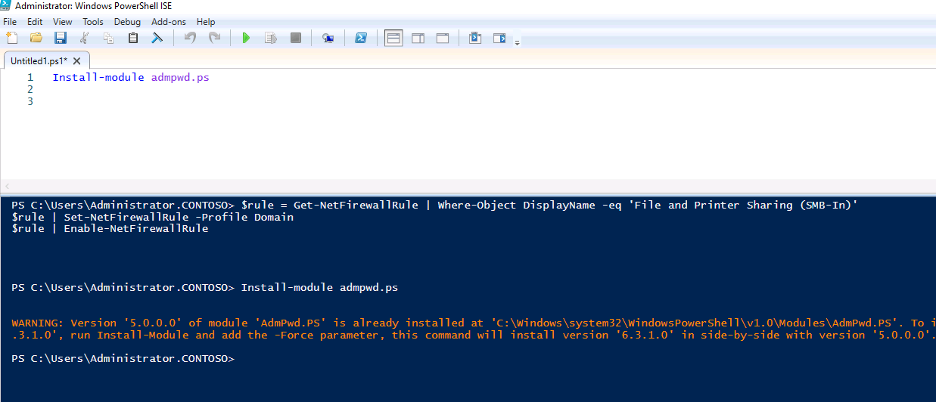
Import-Module admpwd.ps
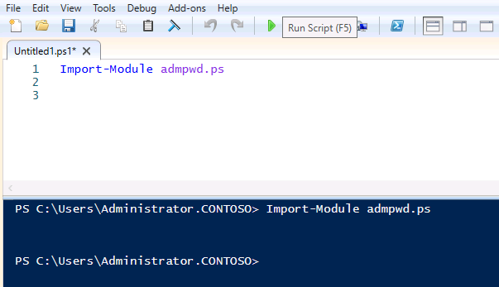
Update-AdmPwdADSchema
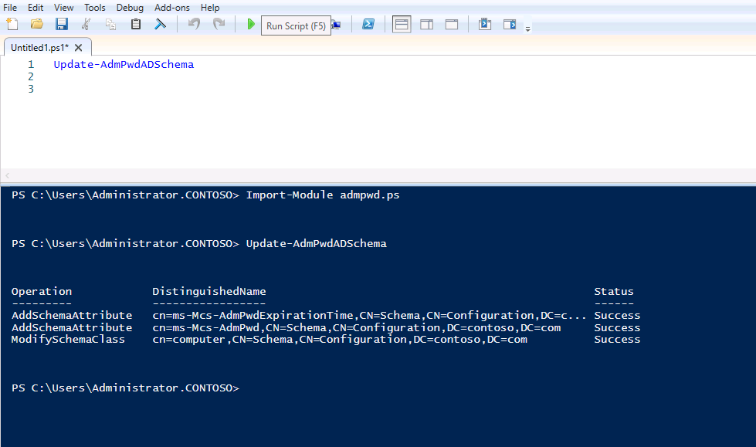
Set-AdmPwdComputerSelfPermission -Identity "Seattle_Servers"
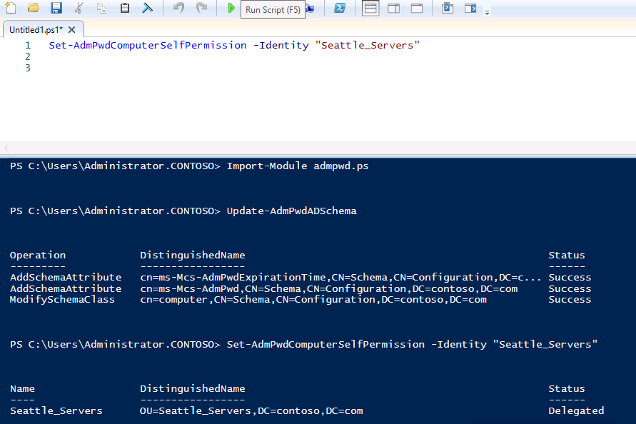
On SEA-SVR2, Group Policy Management.

In the Group Policy Management Console, expand Forest: Contoso.com, expand Domains, expand Contoso.com, right-click or access the context menu for the Seattle_Servers OU, and then select Create a GPO in this domain, and Link it here.
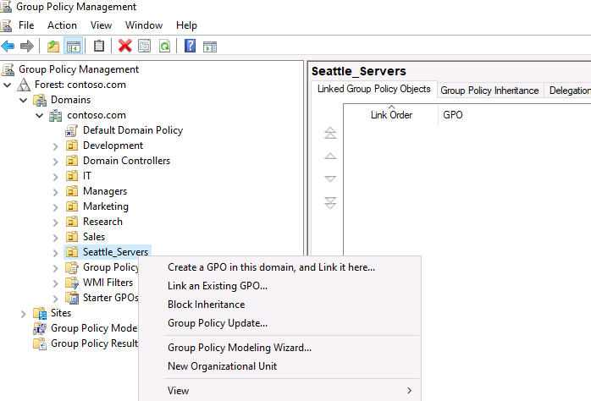
In the New GPO dialog box, in the Name text box, enter LAPS_GPO, and then select OK.
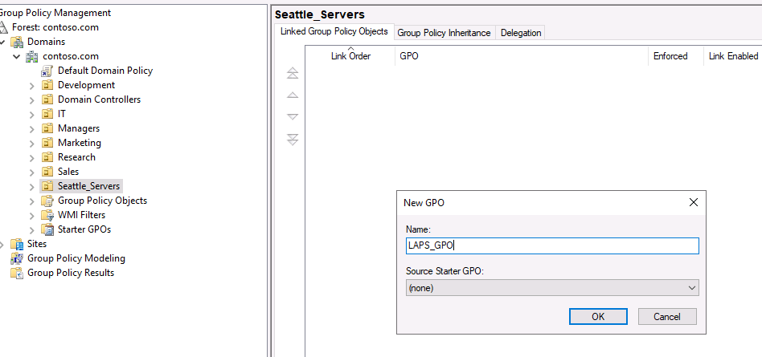
In the Group Policy Management window, under Seattle_Servers, right-click or access the context menu for LAPS_GPO, and then select Edit.

In the Group Policy Management Editor window, under Computer Configuration, expand the Policies node, expand the Administrative Templates node, and then select LAPS.
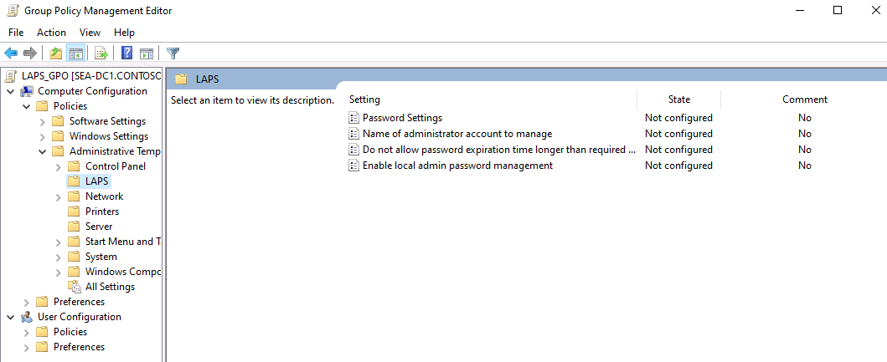
Select the Enable local admin password management policy, and then select the policy settings link.

In the Enable local admin password management window, select Enabled, and then select OK.
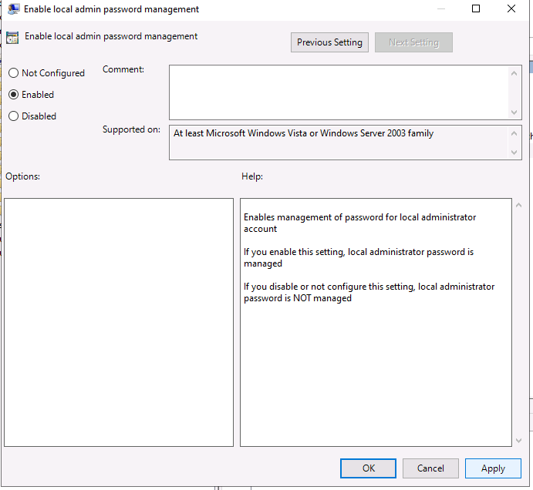

Select the Password Settings policy, and then select the policy settings link.In the Password Settings policy dialog box, select Enabled, and then configure Password Length to 20.

Verify that the Password Age (Days) is configured to 30, and then select OK.
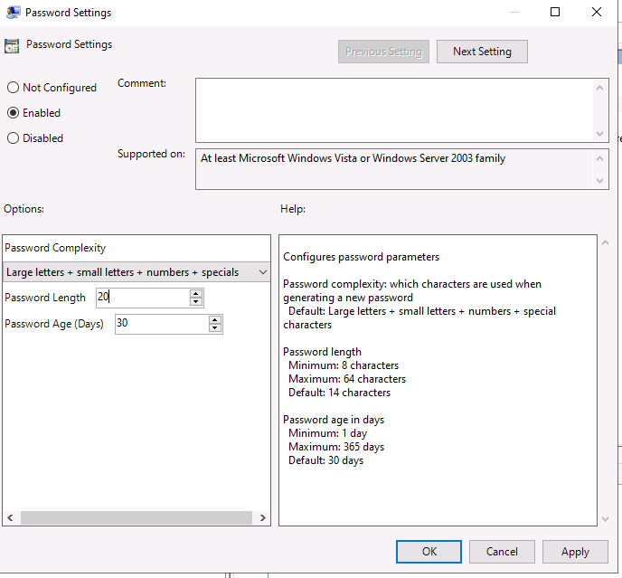

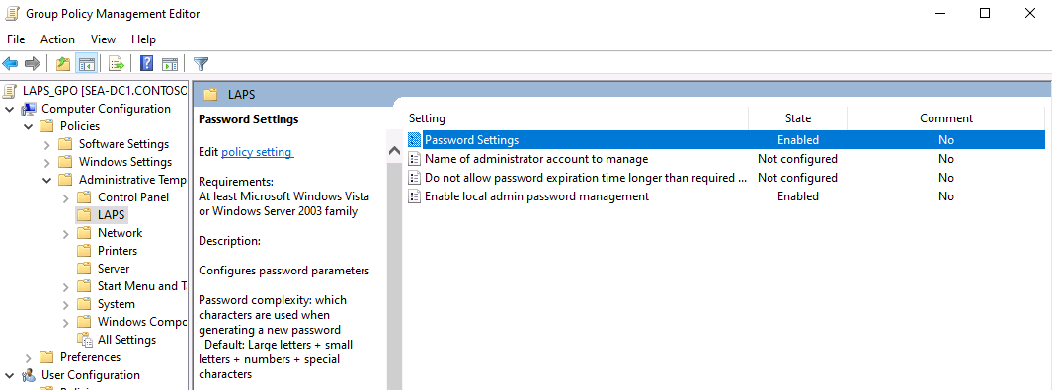
Close the Group Policy Management Editor.

Task 3: Deploy LAPS client-side extension

Why Are You Doing This Task?
Deploying the LAPS client-side extension ensures that the client computers can enforce the LAPS policies and securely update their local admin passwords.

Switch to the console session to SEA-SVR1 and then, if needed, sign in as CONTOSO\Administrator, with the password Pa55w.rd.

📝 Note: You will be prompted to change your password, as a result of running in the previous exercise the script that enables password expiration
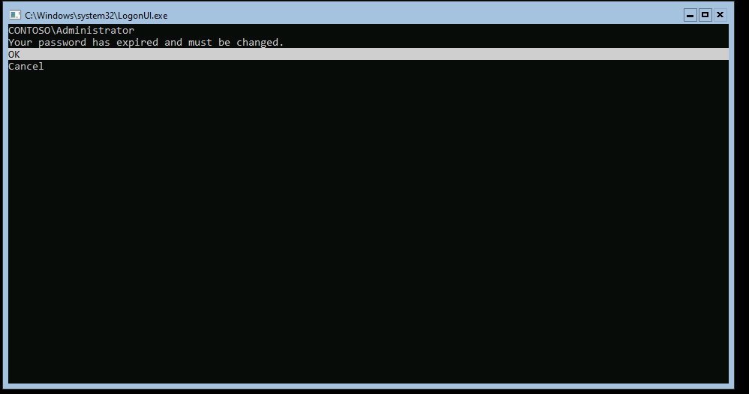
Go to Svr2 and change password from Active directory for user Administrator
Passw0rd@123
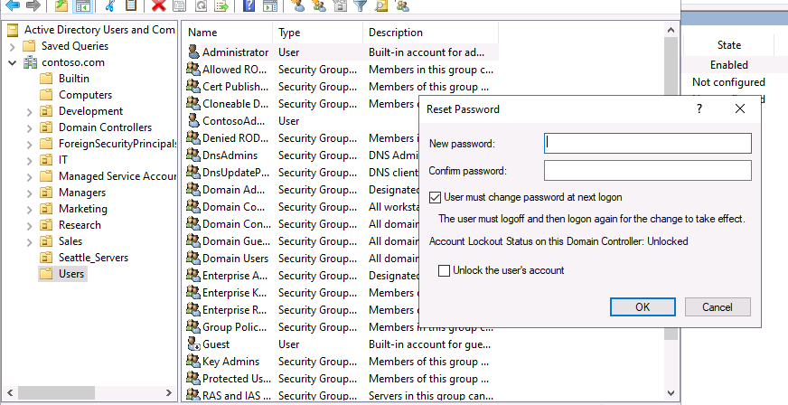

Reboot SVR1 and Login with updated Password

Once you sign in, to access the Windows PowerShell command prompt, at the SConfig menu prompt, enter 15 and press Enter.
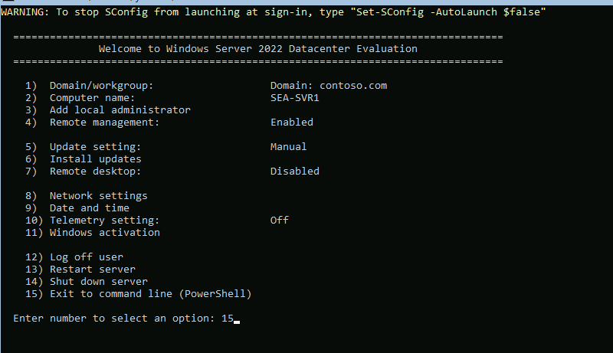

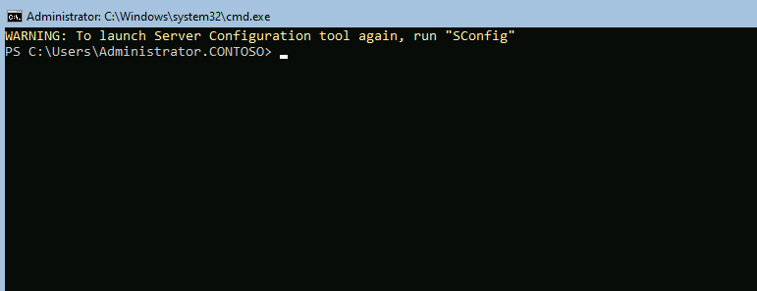
📝 Note: To open Notepad from PowerShell, type Notepad and press enter.

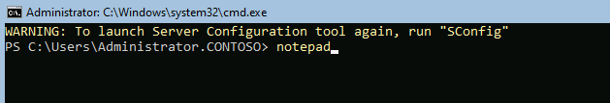

To install LAPS silently with the default settings, at the Windows PowerShell command prompt, enter the following command and press Enter:

Start-Process msiexec.exe -Wait -ArgumentList '/i \\SEA-SVR2.contoso.com\c$\Labfiles\Lab01\LAPS.x64.msi /quiet'

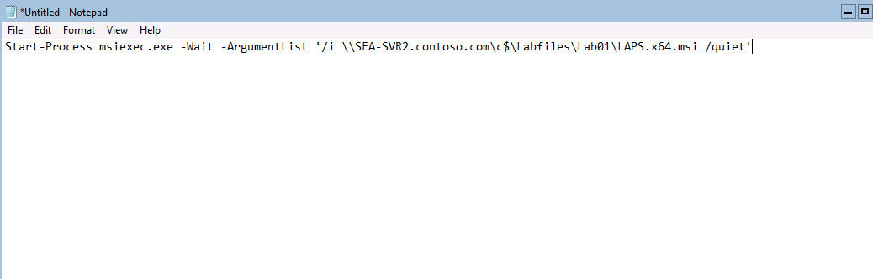

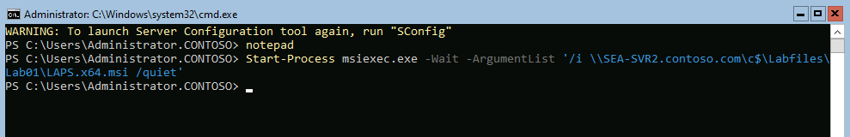
📝 Note: If pasting the command directly into Windows PowerShell is not functioning as expected, open Notepad, paste the command there, and then copy and paste it from Notepad into Windows PowerShell.

To trigger the processing of Group Policy that will apply LAPS settings locally, at the Windows PowerShell command prompt, enter the following command and press Enter:

gpupdate /force
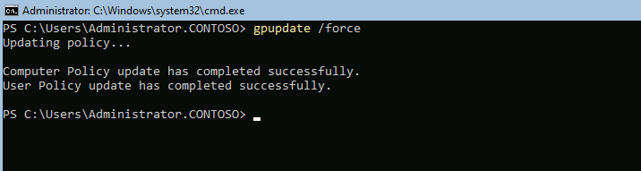

Task 4: Verify LAPS

Why Are You Doing This Task?
Verifying LAPS confirms that the solution is working correctly and that local administrator passwords are being updated and stored securely in Active Directory.

Switch to the console session to SEA-SVR2.

Select Start. In the Start menu, select LAPS, and then select LAPS UI.

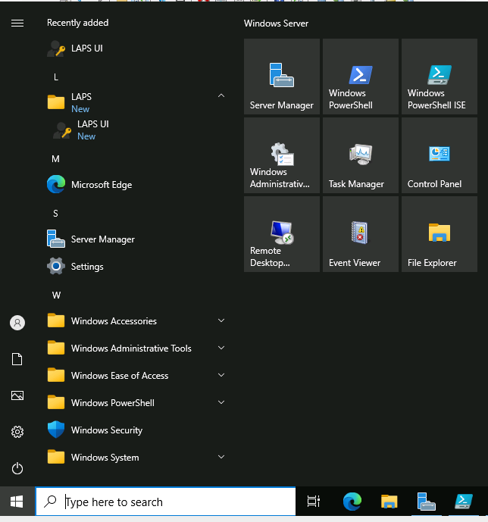

In the LAPS UI dialog box, in the ComputerName text box, enter SEA-SVR1, and then select Search.

Review the Password and the Password expires values, and then select Exit.
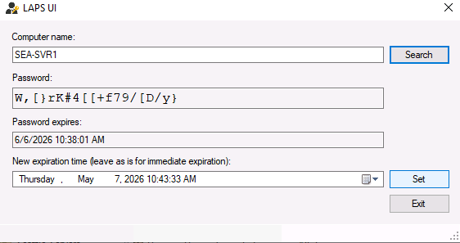
Switch to the Windows PowerShell ISE console and then, to verify the value of the password, at the Windows PowerShell command prompt, enter the following command and press Enter:

Get-ADComputer -Identity SEA-SVR1 -Properties ms-Mcs-AdmPwd
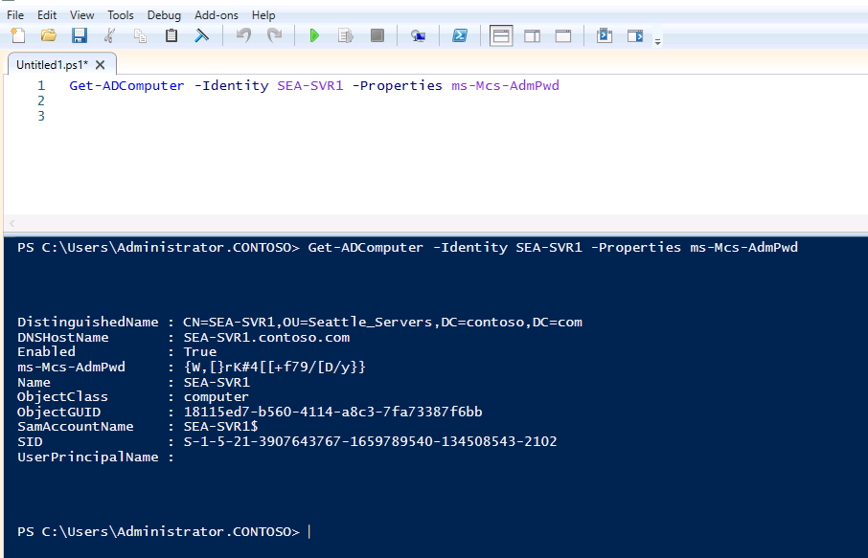
Review the password assigned to SEA-SVR1 and note that it matches the one displayed in the LAPS UI tool.
📝 Note: The value of the password is, in this case, enclosed in a pair of braces.

End of Lab:

