Exercise 1: Configuring iSCSI storage
Why Are You Doing This Exercise?:

Configuring iSCSI storage provides the shared storage required for failover clustering. This exercise will teach you how to set up and connect iSCSI virtual disks to enable clustering in Windows Server.
- On SEA-SVR2, select Start, and then select Windows PowerShell ISE (Admin).
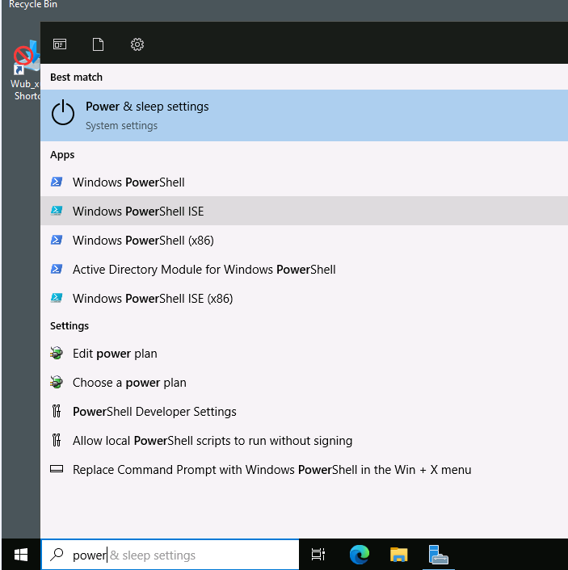
- To install the Failover Clustering server feature including the management tools on SEA-SVR1 and SEA-SVR2, at the Windows PowerShell command prompt, enter the following commands, and after entering each command, press Enter:
Install-WindowsFeature –Name Failover-Clustering –IncludeManagementTools
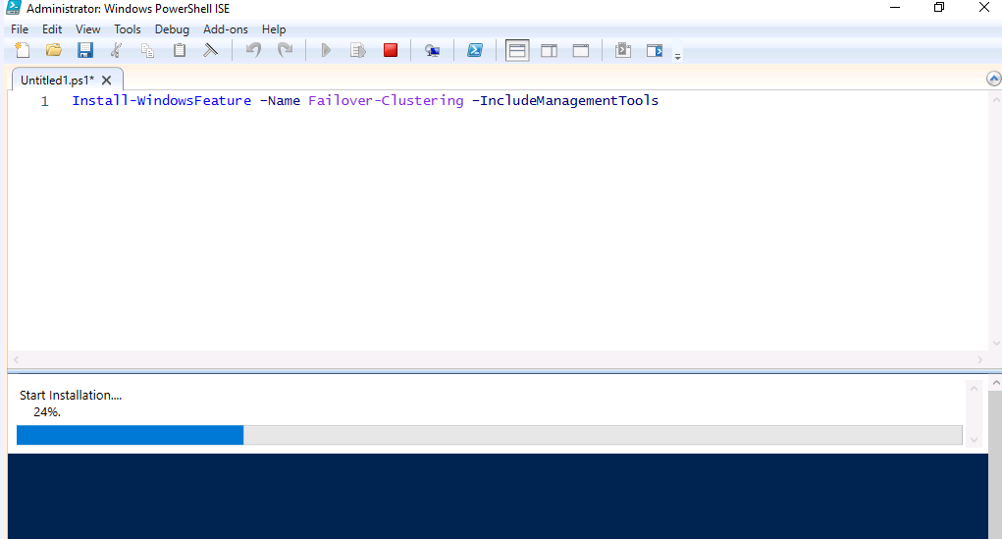

📝 Note: If a warning was encountered during the installation on SEA-SVR2: Failed to start automatic updating for installed components. This warning can be safely ignored as the Failover Clustering feature installed successfully and is fully operational.

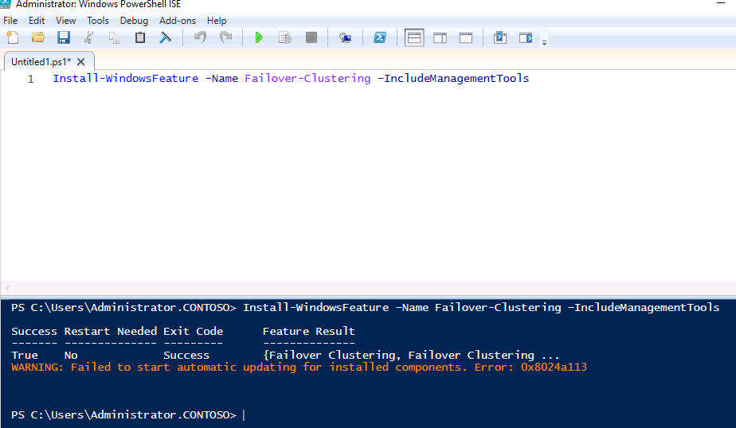

- Now Install the Failover Feature to Second Server

Install-WindowsFeature -ComputerName 'SEA-SVR1.contoso.com' –Name Failover-Clustering –IncludeManagementTools

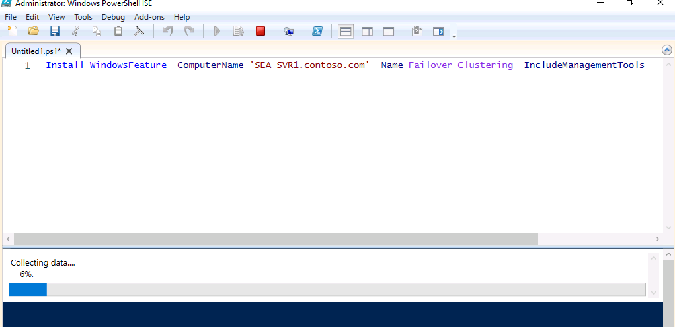
📝 Note: Wait for the installation process to complete. The installation should take about 1 minute.
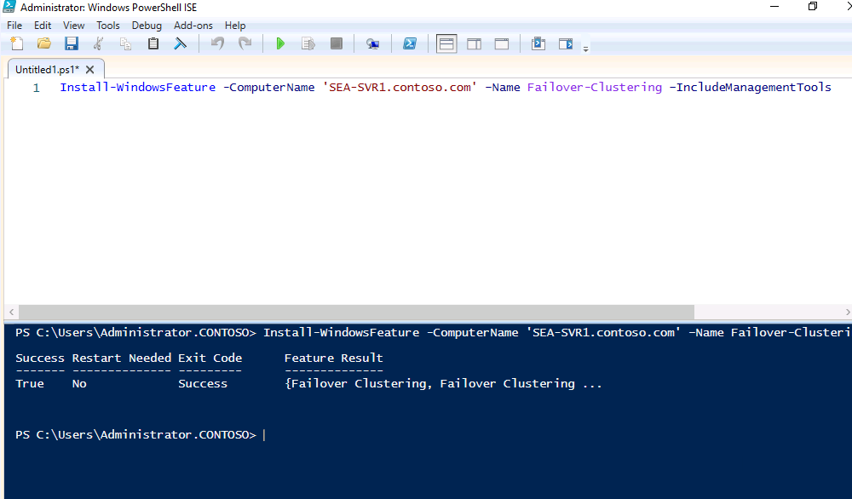

To install iSCSI Target server role service on SEA-DC1, at the Windows PowerShell command prompt, enter the following command and press Enter:
Install-WindowsFeature -ComputerName 'SEA-DC1.contoso.com' –Name FS-iSCSITarget-Server –IncludeManagementTools
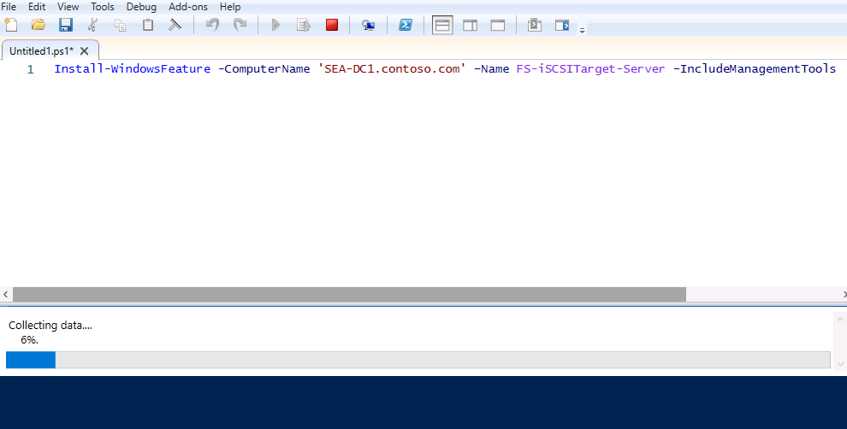
📝 Note: Wait for the installation process to complete. The installation should take about 1 minute.

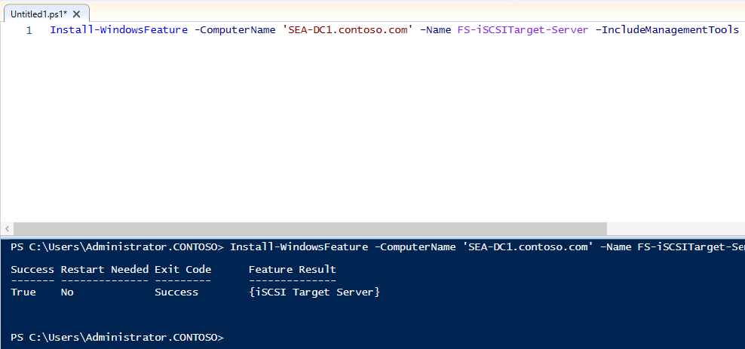

Task 2: Configure iSCSI virtual disks

Why Are You Doing This Task?
Configuring iSCSI virtual disks creates shared storage for the cluster nodes. This task is critical for providing the necessary storage infrastructure to support the failover cluster.

**Important

- On SEA-SVR2, select Start, and then select Windows PowerShell ISE (Admin).

- To establish a PowerShell Remoting session to SEA-DC1, in the newly opened Windows PowerShell ISE window, enter the following command and press Enter:

Enter-PSSession -ComputerName SEA-DC1.contoso.com
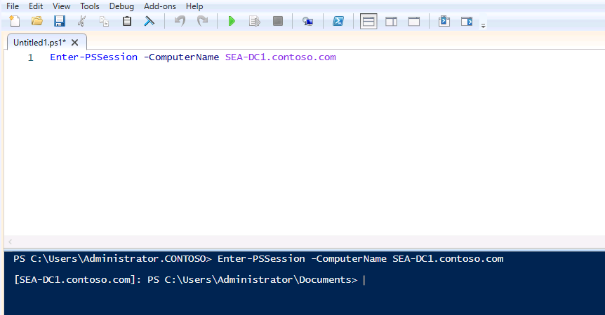

- To create iSCSI virtual disks on SEA-DC1, on SEA-SVR2, in the PowerShell Remoting session to SEA-DC1, enter the following commands, and after entering each command, press Enter:
New-Item -ItemType Directory C:\Storage -Force
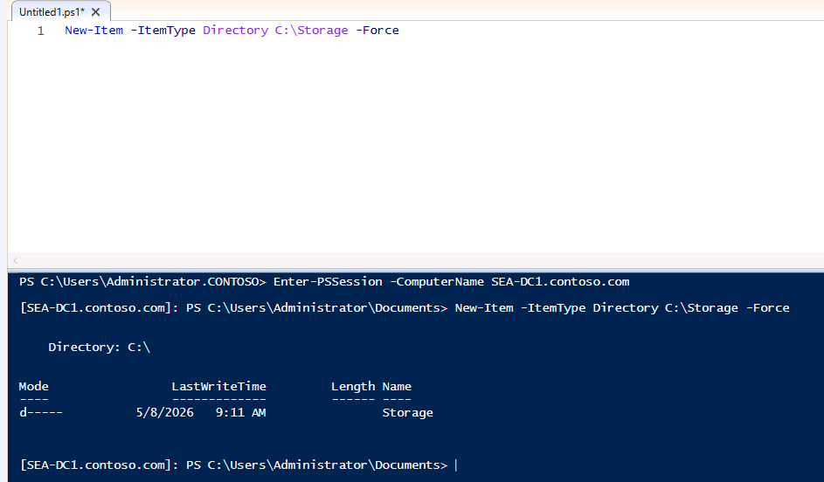
New-IscsiVirtualDisk C:\Storage\disk1.VHDX –size 10GB
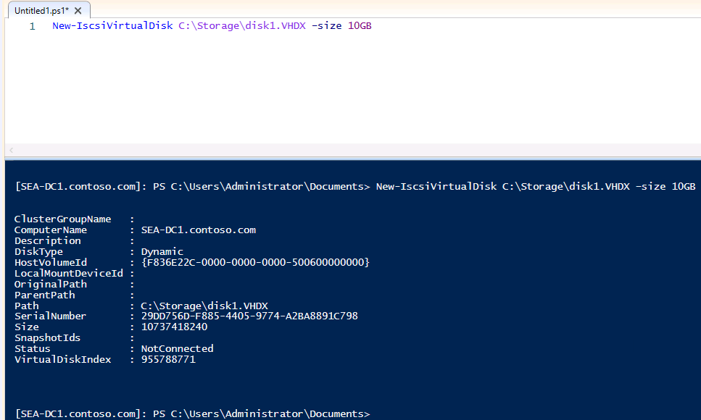
New-IscsiVirtualDisk C:\Storage\disk2.VHDX –size 10GB
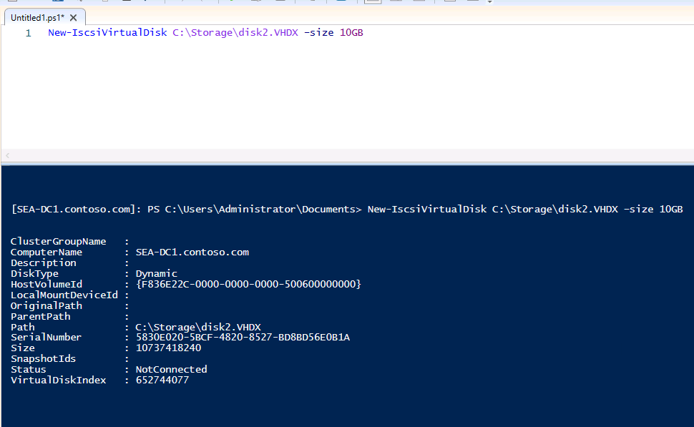
New-IscsiVirtualDisk C:\Storage\disk3.VHDX –size 10GB
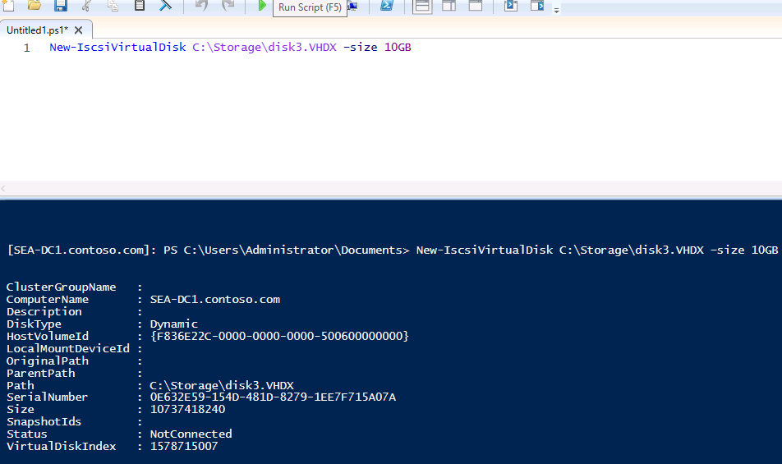
- On SEA-SVR2, select Start, and then select Windows PowerShell ISE (Admin).

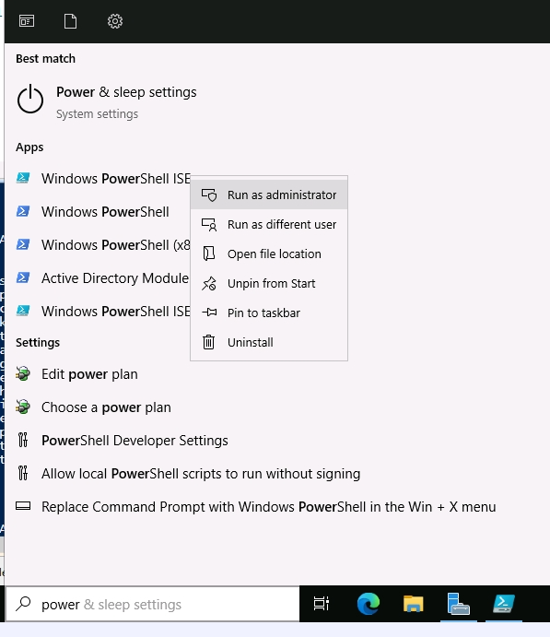

- To establish a PowerShell Remoting session to SEA-SVR1, in the newly opened Windows PowerShell ISE window, enter the following command, and then press Enter:

Enter-PSSession -ComputerName SEA-SVR1.contoso.com

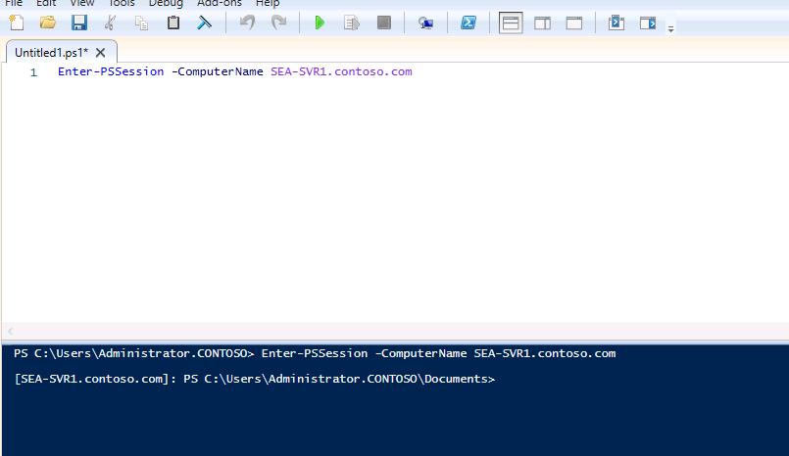
📝 Note: At this point, you should have three Windows PowerShell ISE windows opened. You will use the first one to run commands locally on SEA-SVR2, while using the other two to interact with SEA-DC1 and SEA-SVR1. You can easily recognize each of them by identifying the PowerShell prompt (for the second and third one, the prompt will contain [SEA-DC1.contoso.com] and [SEA-SVR1.contoso.com] prefix, respectively).

- To start the Microsoft iSCSI Initiator service on SEA-SVR2, at the Windows PowerShell ISE prompt providing access to the local session, enter the following commands, and after entering each command, press Enter:
Start-Service -ServiceName MSiSCSI
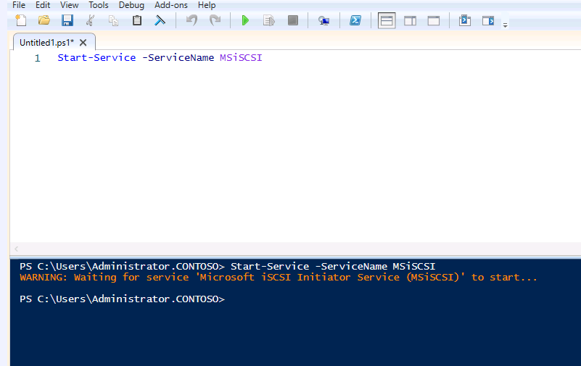
Set-Service -ServiceName MSiSCSI -StartupType Automatic
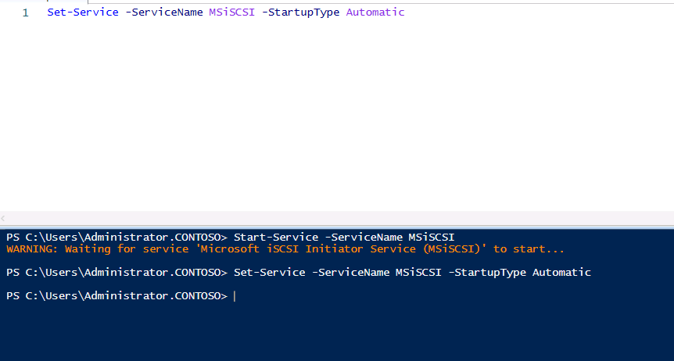
- To start the Microsoft iSCSI Initiator service on SEA-SVR1, switch to the Windows PowerShell ISE window hosting PowerShell Remoting session to SEA-SVR1, enter the following commands, and after entering each command, press Enter:
Start-Service -ServiceName MSiSCSI
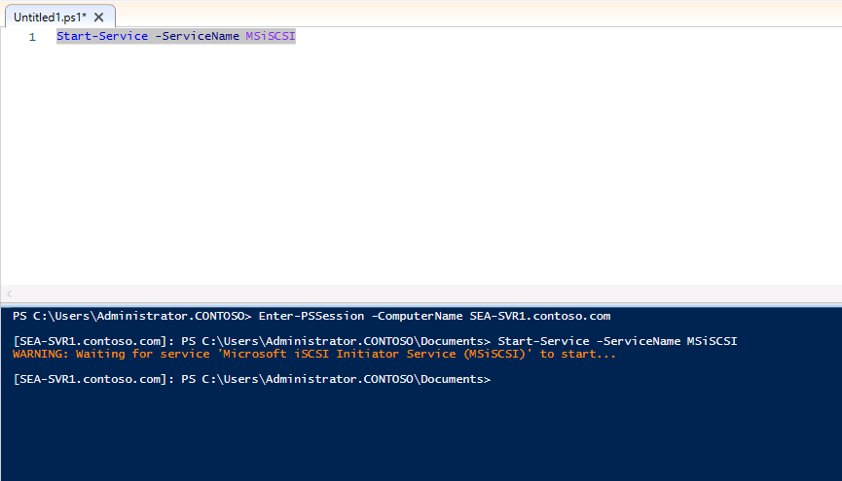
Set-Service -ServiceName MSiSCSI -StartupType Automatic
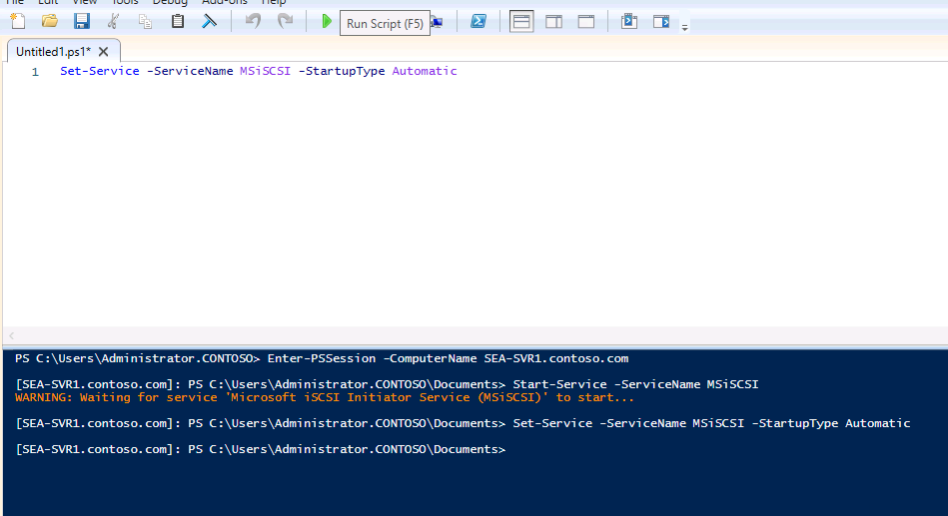
- To create the Microsoft iSCSI Target on SEA-DC1, switch to the Windows PowerShell ISE window hosting PowerShell Remoting session to SEA-DC1, enter the following command, and then press Enter:
New-IscsiServerTarget -TargetName “iSCSI-L03” –InitiatorIds “IQN:iqn.1991-05.com.microsoft:sea-svr1.contoso.com","IQN:iqn.1991-05.com.microsoft:sea-svr2.contoso.com"
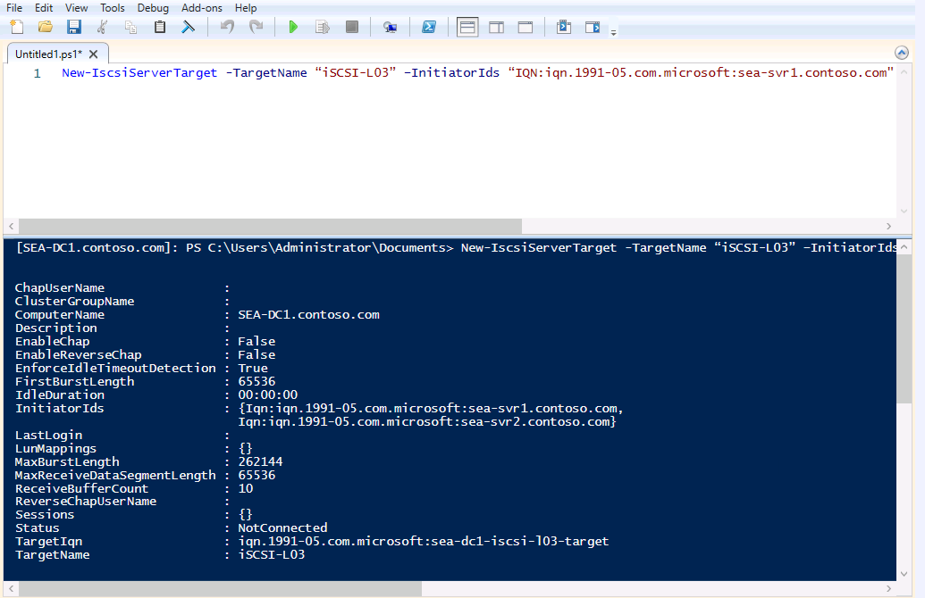

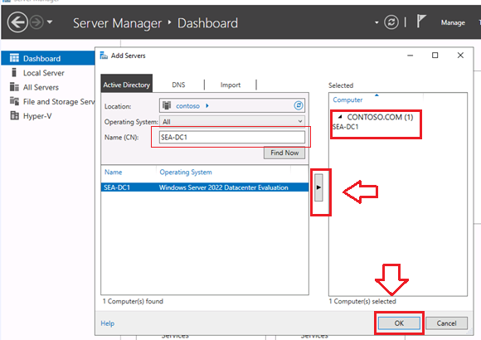

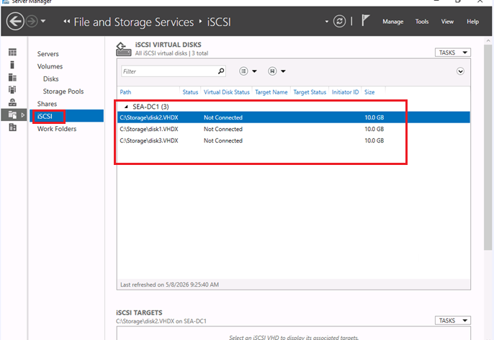

Right Click any of the Disk

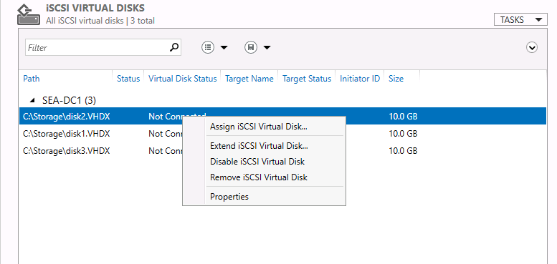

Exercise 2: Configuring a failover cluster
Why Are You Doing This Exercise?:
Configuring a failover cluster ensures that services remain available even if one of the cluster nodes fails. This exercise will guide you through connecting to iSCSI targets, initializing disks, and creating a failover cluster.

Task 1: Connect clients to the iSCSI targets

Why Are You Doing This Task?
Connecting clients to the iSCSI targets allows the cluster nodes to access the shared storage. This task is necessary for enabling the cluster to use the shared disks.
- To mount the iSCSI disks on SEA-DC1, from SEA-SVR2, in the Windows PowerShell ISE window hosting PowerShell Remoting session to SEA-DC1, enter the following commands, and after entering each command, press Enter:
Add-IscsiVirtualDiskTargetMapping -TargetName “iSCSI-L03” -DevicePath “C:\Storage\Disk1.VHDX”
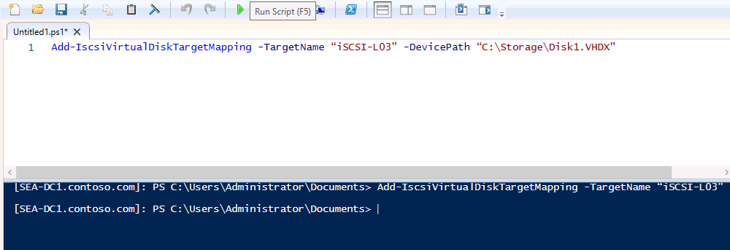
Add-IscsiVirtualDiskTargetMapping -TargetName “iSCSI-L03” -DevicePath “C:\Storage\Disk2.VHDX”
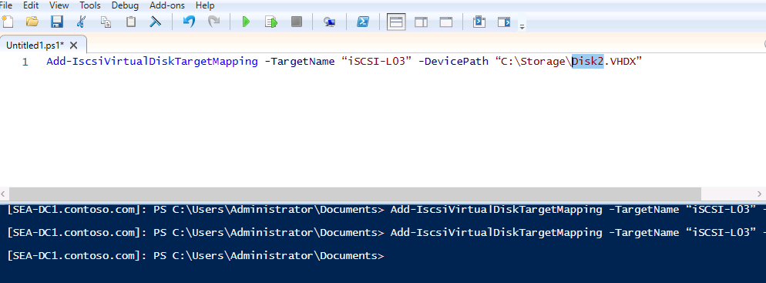
Add-IscsiVirtualDiskTargetMapping -TargetName “iSCSI-L03” -DevicePath “C:\Storage\Disk3.VHDX”
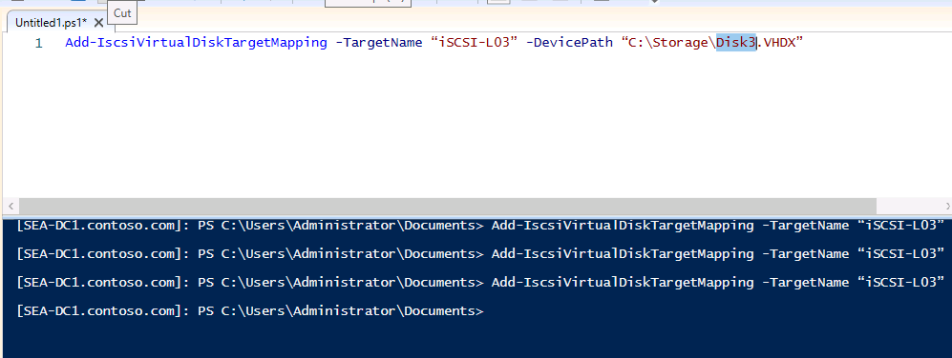

Refresh
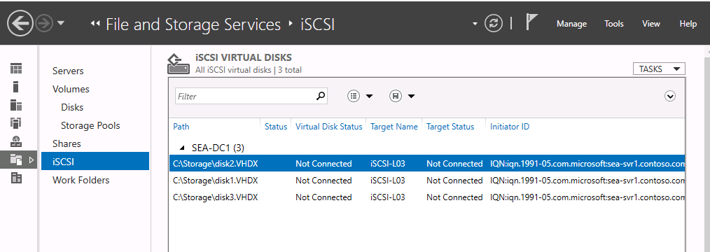
- To connect to the iSCSI Target hosted on SEA-DC1 from SEA-SVR2, switch to the Windows PowerShell ISE prompt providing access to the local session, enter the following commands, and after entering each command, press Enter:
New-iSCSITargetPortal –TargetPortalAddress SEA-DC1.contoso.com
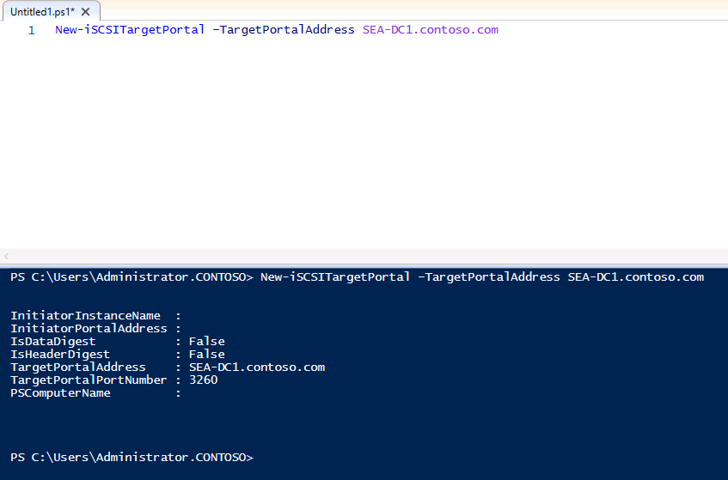
Connect-iSCSITarget –NodeAddress iqn.1991-05.com.microsoft:sea-dc1-iSCSI-L03-target
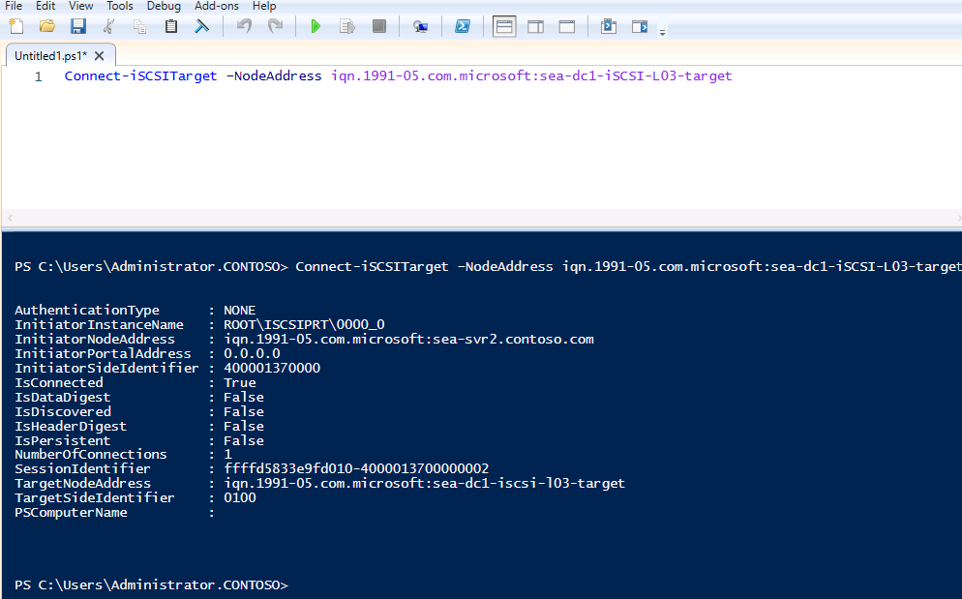
Get-iSCSITarget | fl

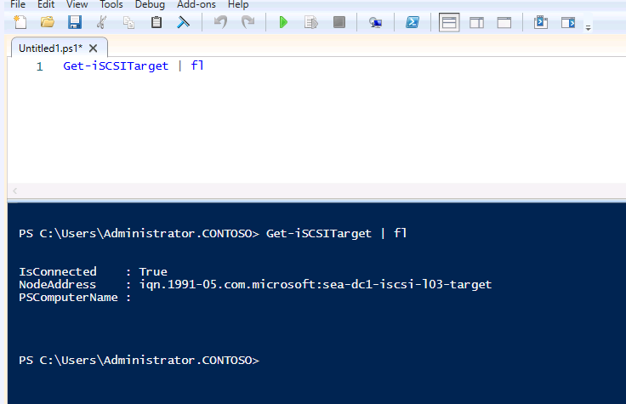
📝 Note: Verify that after you run the last command, the value for the IsConnected variable is True.
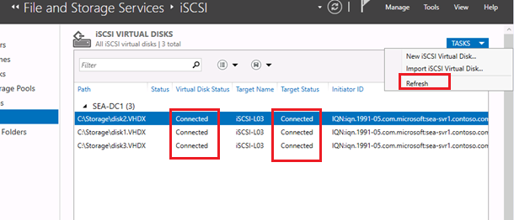

- To connect to the iSCSI Target hosted on SEA-DC1 from SEA-SVR1, switch to the Windows PowerShell window hosting PowerShell Remoting session to SEA-SVR1, enter the following commands, and after entering each command, press Enter:
New-iSCSITargetPortal –TargetPortalAddress SEA-DC1.contoso.com
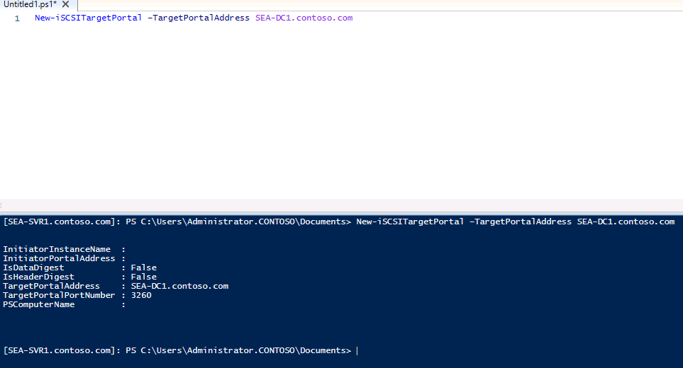
Connect-iSCSITarget –NodeAddress iqn.1991-05.com.microsoft:sea-dc1-iSCSI-L03-target
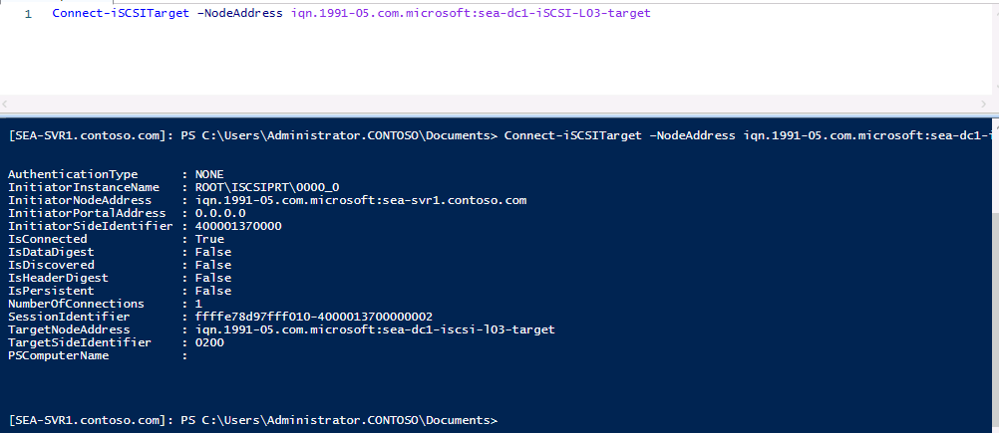
Get-iSCSITarget | fl
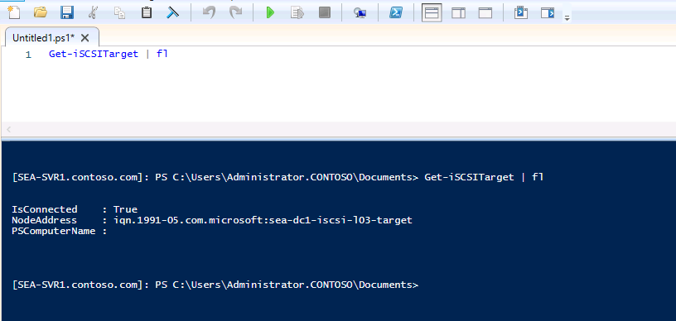
📝 Note: Verify that after you run the last command, the value for the IsConnected variable is True.

Task 2: Initialize the disks

Why Are You Doing This Task?
Initializing the disks prepares them for use in the failover cluster by setting up partitions and formatting the volumes.
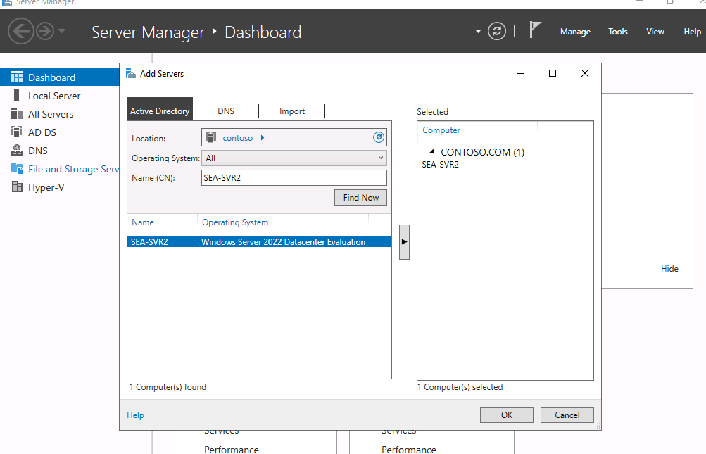

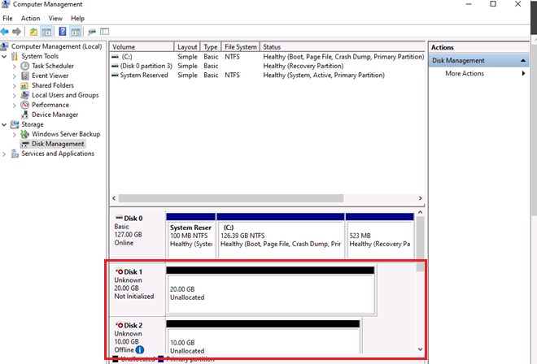

- To list the disks on SEA-SVR2, switch to the Windows PowerShell prompt providing access to the local session, enter the following command, and then press Enter:
Get-Disk
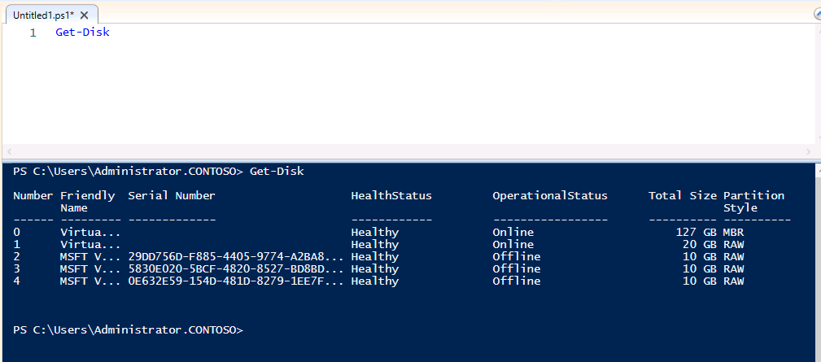
📝 Note: Ensure that the three iSCSI disks are listed with the Offline operational status. These should be disks with numbers 2, 3, and 4.

- To initialize the disks, at the Windows PowerShell prompt providing access to the local session, enter the following commands, and after entering each command, press Enter:
Get-Disk | Where OperationalStatus -eq 'Offline' | Initialize-Disk -PartitionStyle MBR
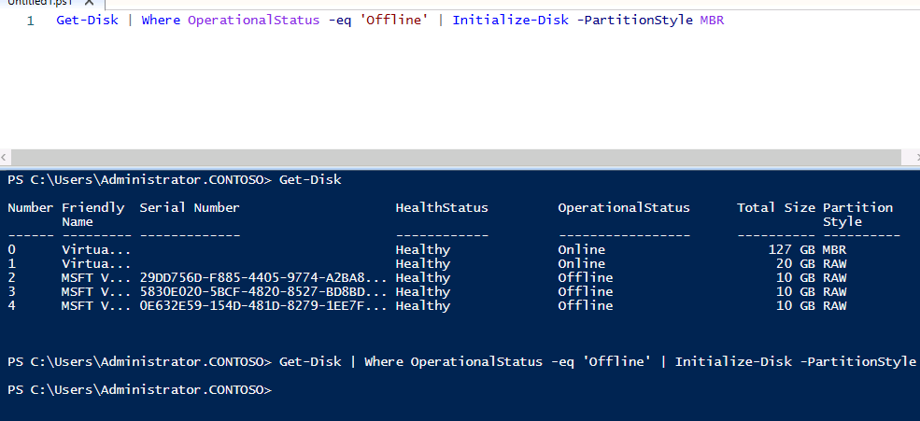
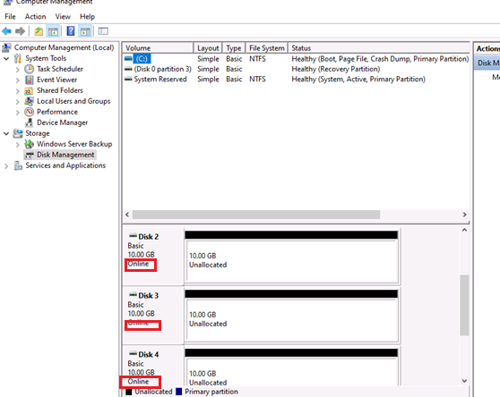

New-Partition -DiskNumber 2 -Size 5gb -AssignDriveLetter
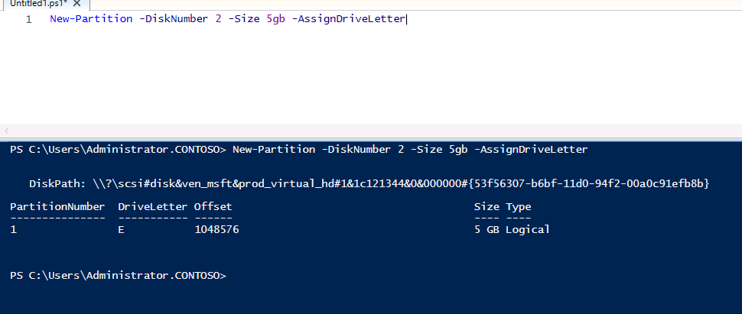
New-Partition -DiskNumber 3 -Size 5gb -AssignDriveLetter
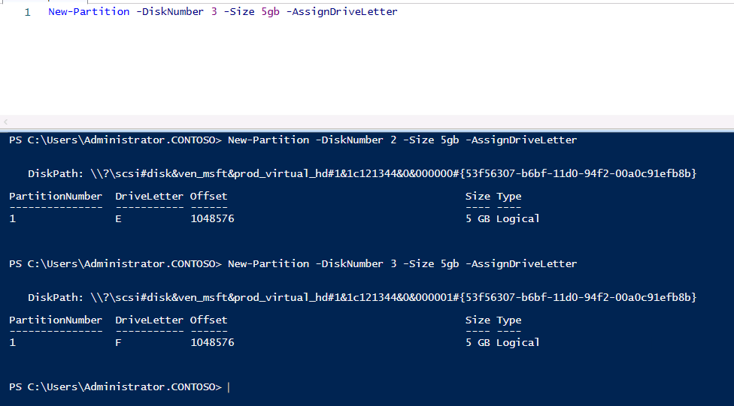
New-Partition -DiskNumber 4 -Size 5gb -AssignDriveLetter
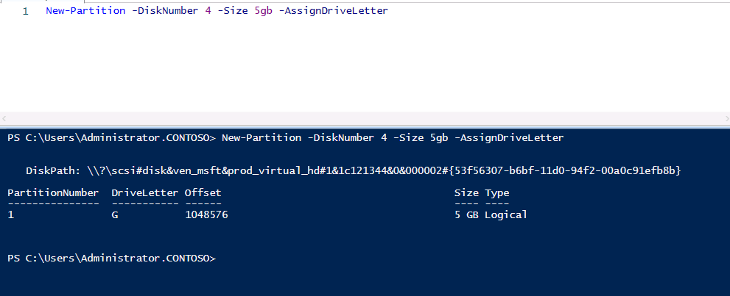
Format-Volume -DriveLetter E -FileSystem NTFS
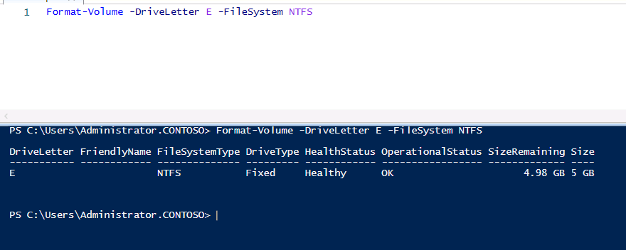
Format-Volume -DriveLetter F -FileSystem NTFS
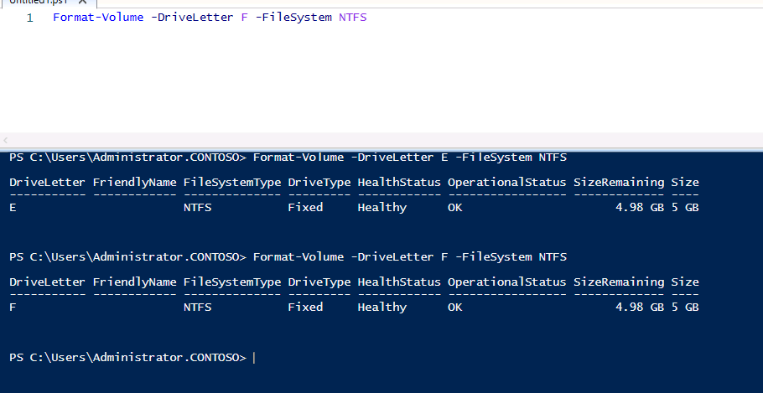
Format-Volume -DriveLetter G -FileSystem NTFS
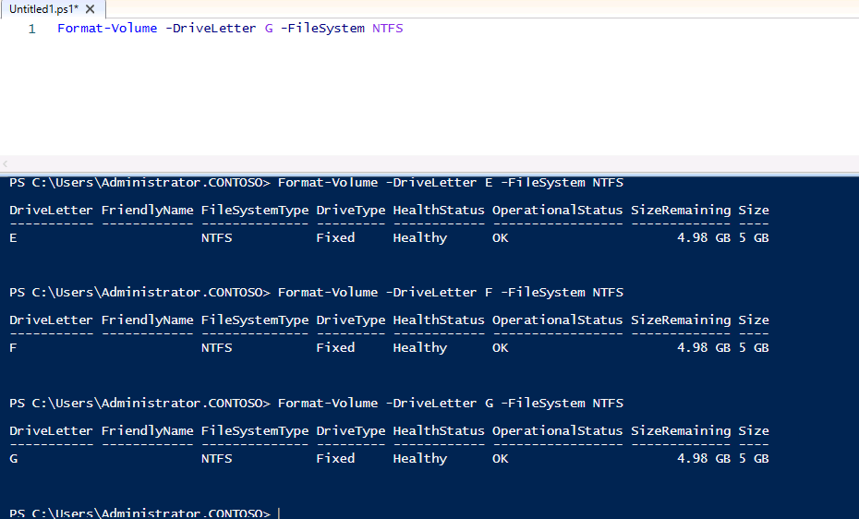
📝 Note: Verify that each command completed successfully.
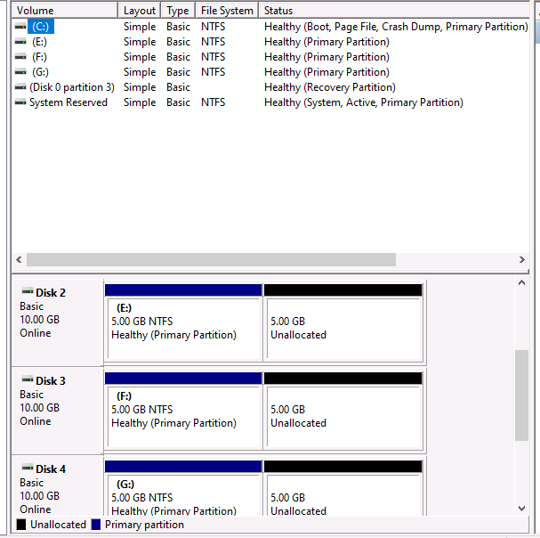

Task 3: Create a failover cluster

Why Are You Doing This Task?
Creating a failover cluster groups the nodes together and configures them to provide high availability for services. This task is essential for ensuring that workloads can fail over seamlessly between nodes.

- To create a failover cluster, on SEA-SVR2, at the Windows PowerShell prompt providing access to the local session, enter the following command, and then press Enter:

New-Cluster -Name SEA-CL03 -Node SEA-SVR2.contoso.com -StaticAddress 172.16.10.125
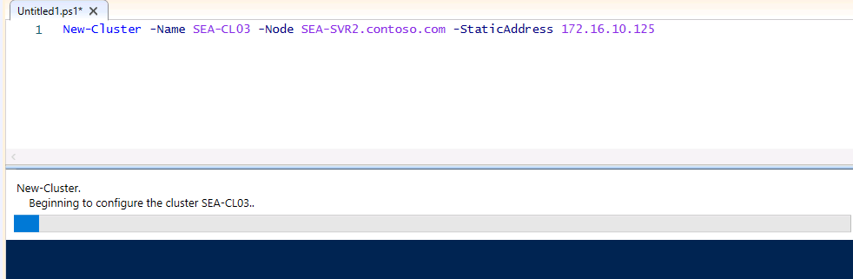
📝 Note: The command should return the name of the newly created cluster (SEA-CL03).
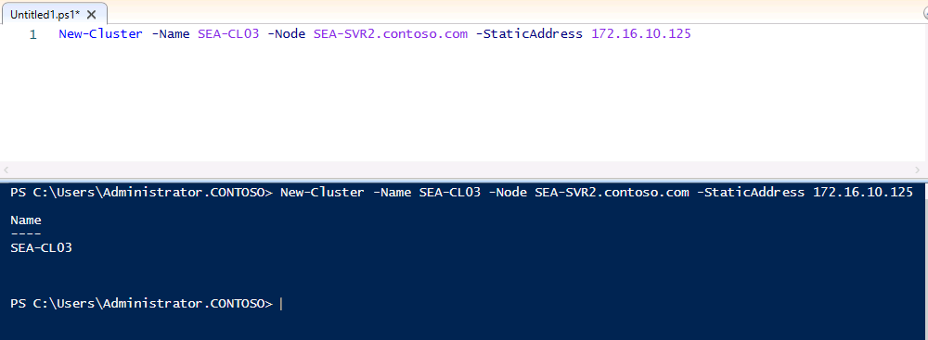

- To add SEA-SVR1 as another node to the newly created cluster, on SEA-SVR2, at the Windows PowerShell prompt providing access to the local session, enter the following command, and then press Enter:

Add-ClusterNode -Cluster SEA-CL03 -Name SEA-SVR1.contoso.com
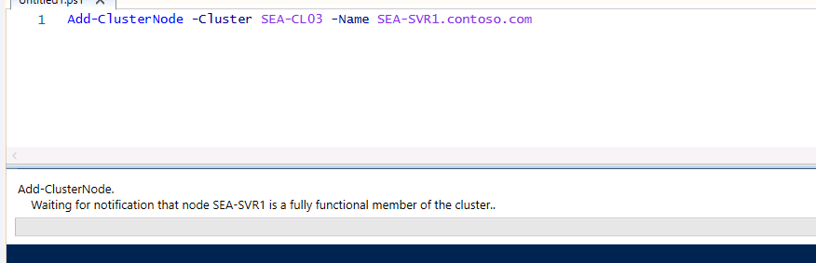
📝 Note: Verify that the command completed successfully.
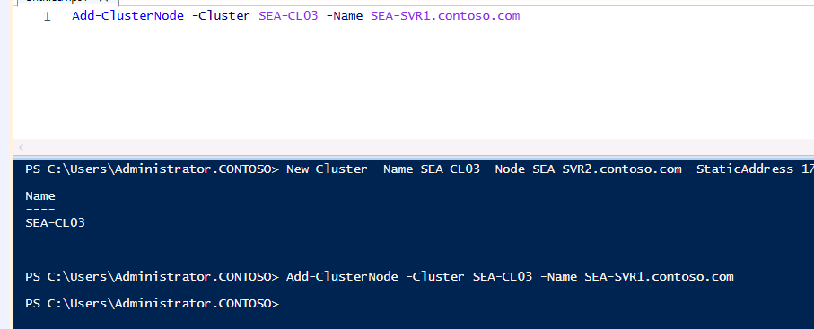

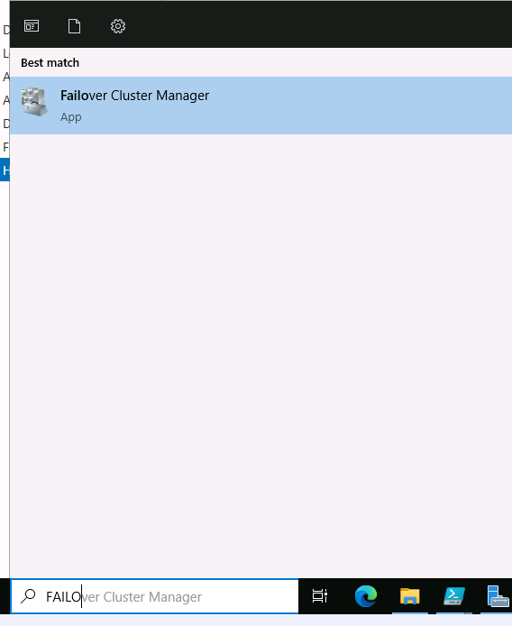

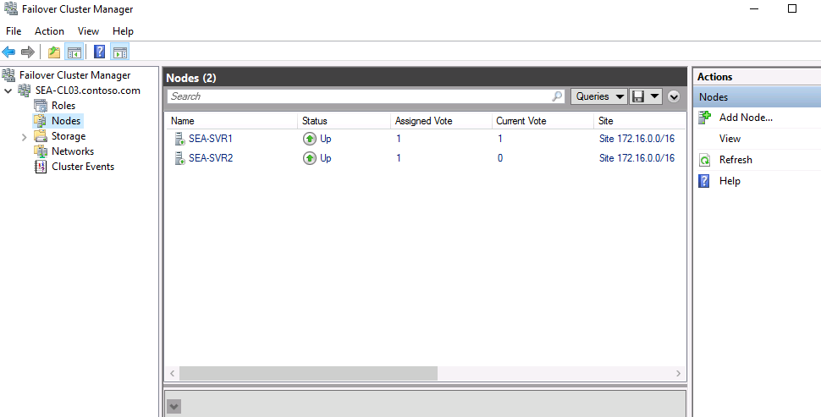

10. Exercise 3: Deploying and configuring a highly available file server
Why Are You Doing This Exercise?:
Deploying a highly available file server ensures that file services remain accessible even during hardware or software failures. This exercise teaches you how to add a file server role to a failover cluster and configure shared folders.

Task 1: Add the file server application to the failover cluster

Why Are You Doing This Task?
Adding the file server role to the failover cluster ensures that file services can fail over between cluster nodes, minimizing downtime and ensuring continuous access.

- In Failover cluster Expand the SEA-CL03.contoso.com node, select Roles and verify that the cluster does not host any roles at this point.
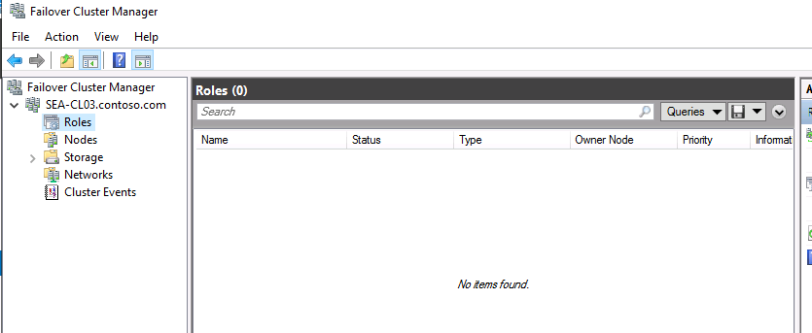
- Select the Nodes node and verify that the SEA-SVR1 and SEA-SVR2 nodes are displayed with the Up status.
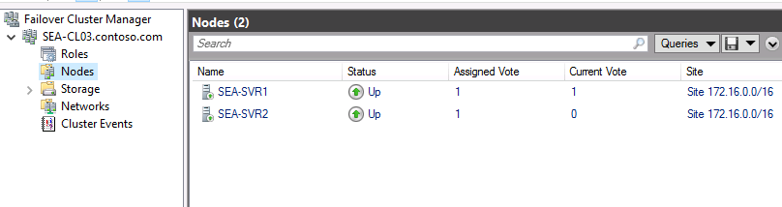

- Expand the Storage node and select Disks. Notice that three cluster disks are displayed with the Online status.
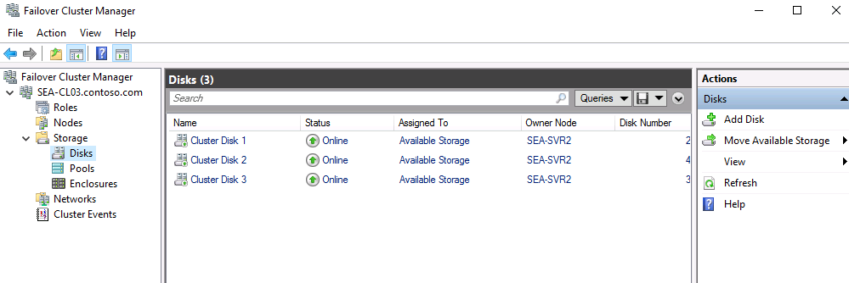
- On the Failover Cluster Manager page, right-click or access the context menu for Roles, and then select Configure Role. 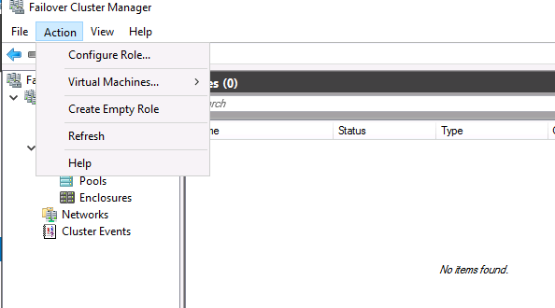

- This will start High Availability Wizard. On the Before You Begin page of High Availability Wizard, select Next.

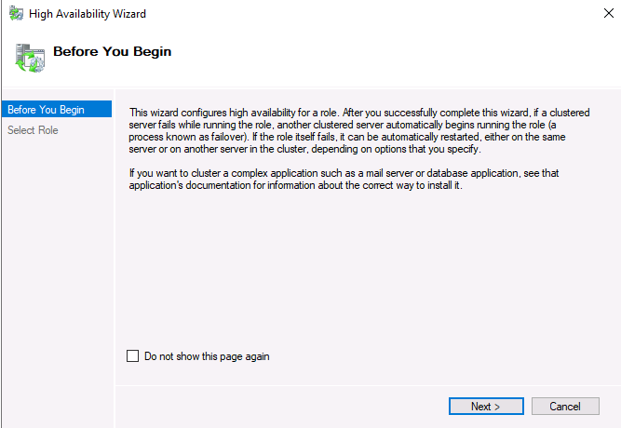

- On the Select Role page of High Availability Wizard, select File Server, and then select Next.
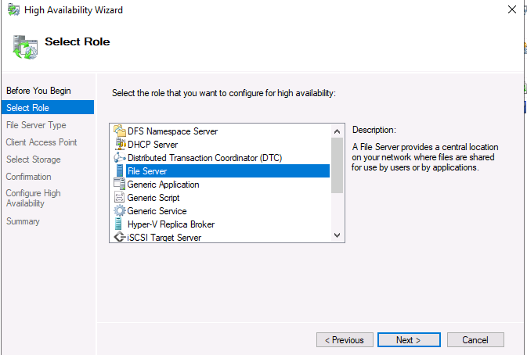
- On the File Server Type page of High Availability Wizard, ensure that the File Server for general use option is selected, and then select Next.
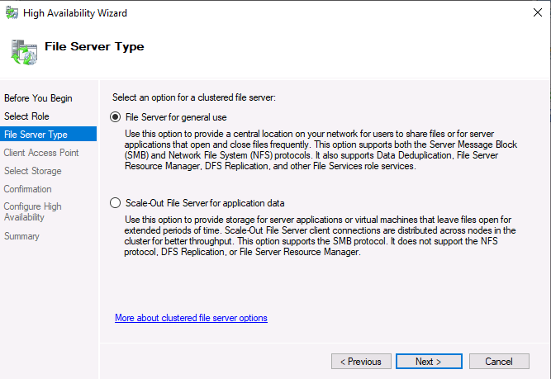

- On the Client Access Point page of High Availability Wizard, in the Name box, enter FSCluster. In the Address box, enter 172.16.10.130, and then select Next.

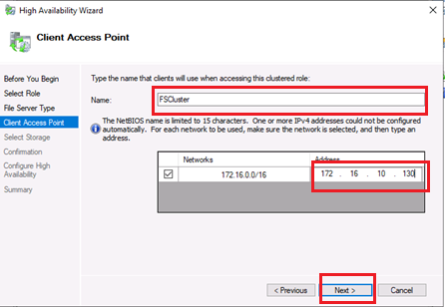

- On the Select Storage page of High Availability Wizard, select Cluster Disk 1 and Cluster Disk 2, and then select Next.
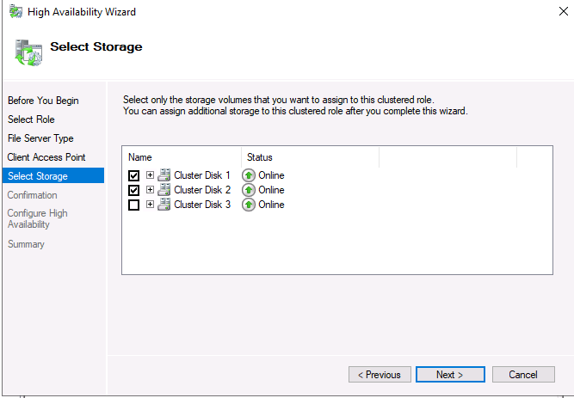
- On the Confirmation page of High Availability Wizard, select Next.
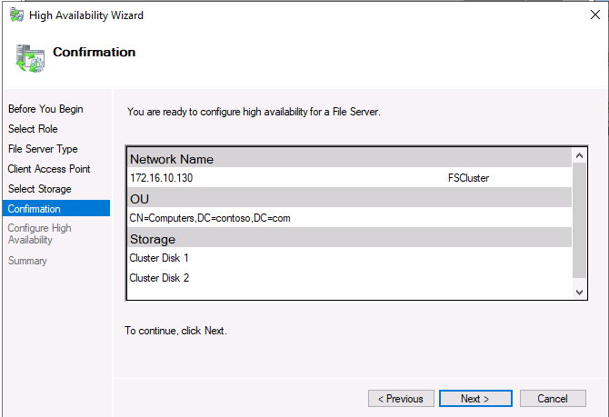
- On the Summary page of High Availability Wizard, select Finish.
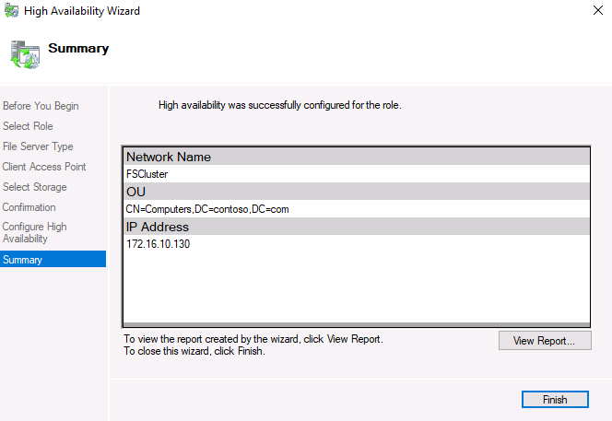
📝 Note: In the Storage node, with the Disks node selected, verify that three cluster disks are online. Cluster Disk 1 and Cluster Disk 2 should be assigned to FSCluster.

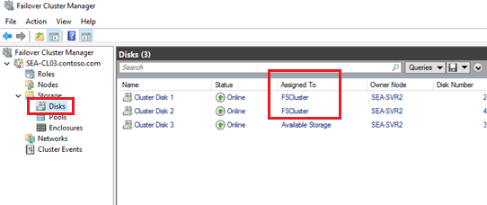

Task 2: Add a shared folder to a highly available file server

Why Are You Doing This Task?
Creating a shared folder on the highly available file server provides users with reliable access to shared resources, even if a cluster node fails.

- On SEA-SVR2, in Failover Cluster Manager, select Roles, select FSCluster, and then in the Actions pane, select Add File Share.
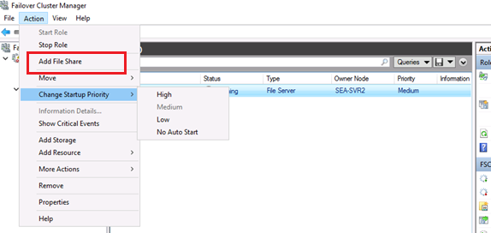

- This will start the New Share Wizard. On the Select Profile page, ensure that the SMB Share - Quick profile is selected, and then select Next.

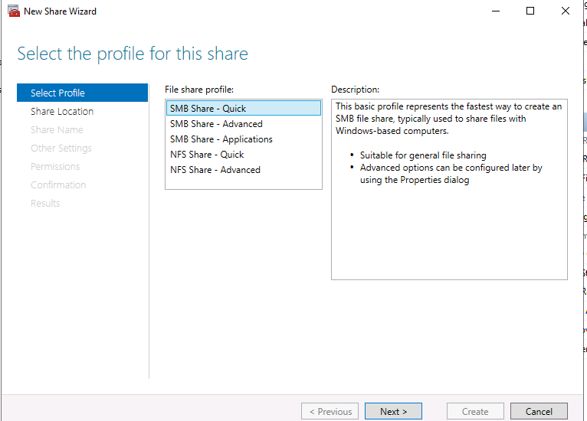

- On the Share Location page, select Next.
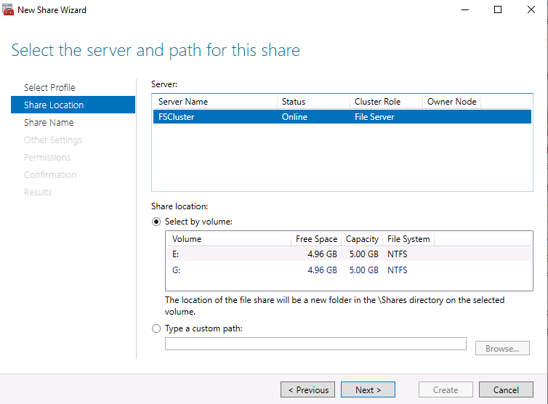
- On the Share Name page, enter Docs for the share name, and then select Next.
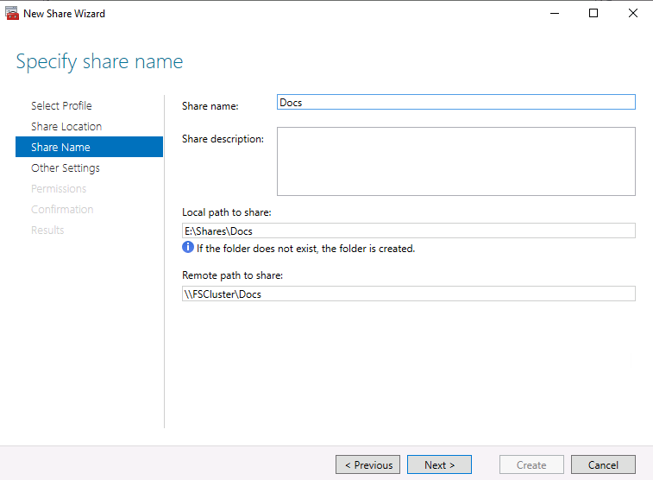
- On the Other Settings page, select Next.
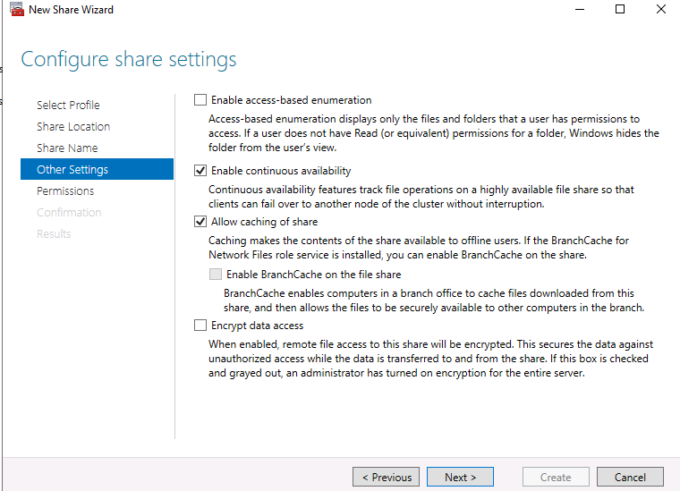
- On the Permissions page, select Next.
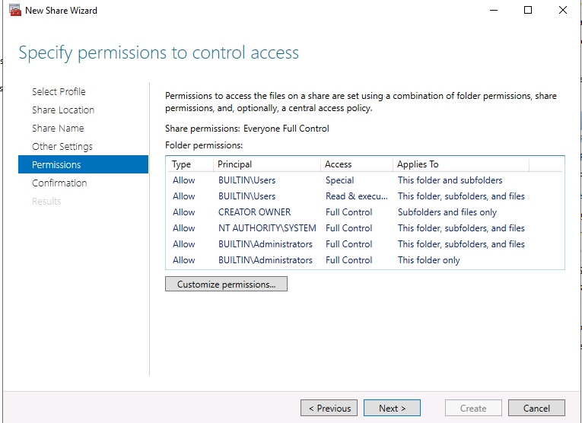
- On the Confirmation page, select Create.
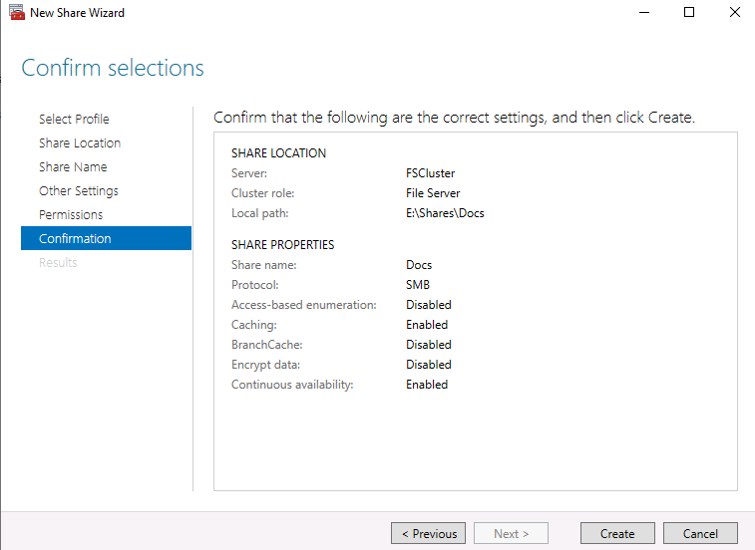
- On the View results page, select Close.
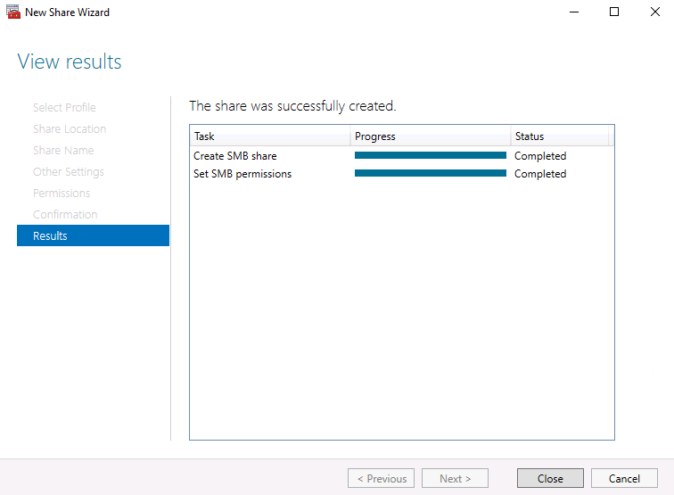

Task 3: Configure the failover and failback settings

Why Are You Doing This Task?
Configuring failover and failback settings controls how the cluster responds to node failures and recoveries. This task ensures that services fail over smoothly and return to the preferred node when possible.

- On SEA-SVR2, in the Failover Cluster Manager console, with the FSCluster selected in the Roles node, in the Actions pane, select Properties.
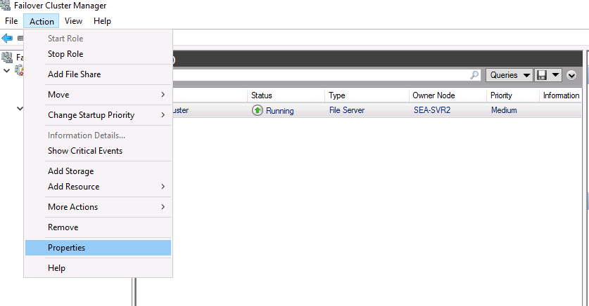
- Select the Failover tab, and then select the Allow failback option.

- Select the Failback between option, and then enter the following values:

4 in the first text box
5 in the second text box.
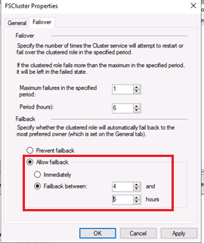

- Select the General tab.In the Preferred owners section, ensure that SEA-SVR1 is listed as the first entry, and then select OK.
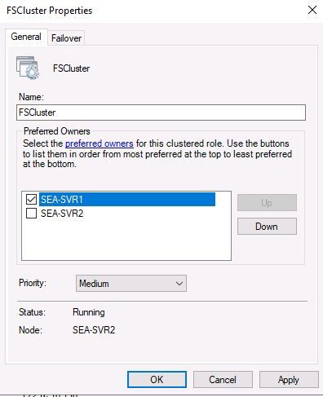

Exercise 4: Validating the deployment of the highly available file server
Why Are You Doing This Exercise?:
Validating the deployment ensures that the failover cluster and file server role are functioning correctly. This exercise tests failover, failback, and quorum configurations to ensure high availability.

Task 1: Validate the highly available file server deployment

Why Are You Doing This Task?
Validating the file server deployment ensures that shared folders remain accessible during failover, confirming that the cluster configuration is correct.

- On SEA-SVR2, open File Explorer and browse to the \\FSCluster\Docs folder.
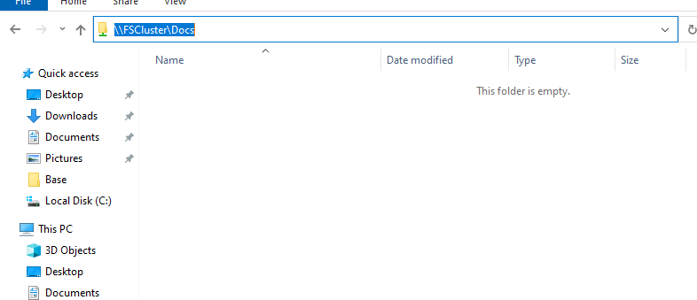
- Inside the Docs folder, right-click or access the context menu in an empty area of the folder, select New, and then select Text Document.To accept the default name of the document as New Text Document.txt, press Enter.
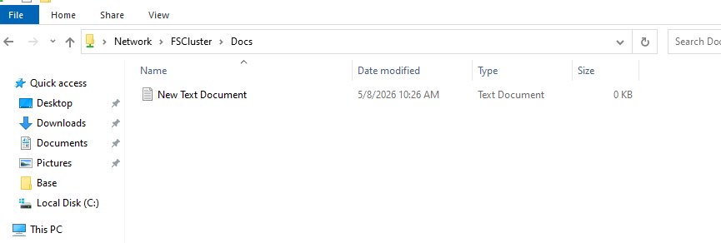

- On SEA-SVR2, switch to the Failover Cluster Manager console, right-click or access the context menu for FSCluster, select Move, select Select Node, select SEA-SVR1, and then select OK.

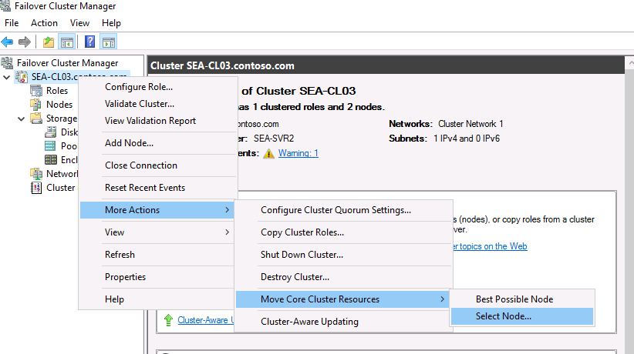

- Select SEA-SVR1, and then select OK.
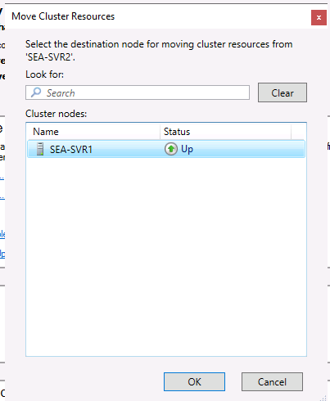

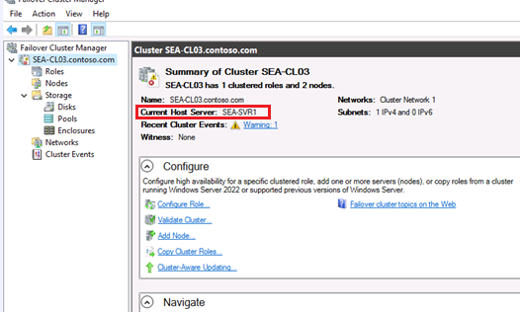

- On SEA-SVR2, switch back to File Explorer and verify that you can still access the content of the \\FSCluster\Docs folder.
