MLOPS TRAINING · HANDS-ON LAB
Lab: Compare Multiple ML Algorithms
Using MLflow
Vodafone Billing Assurance AI
MLflow + Scikit-learn + Python
Beginner-Friendly · Step-by-Step · Business Scenario Driven

1. Lab Overview
In this lab, you will train four different machine learning algorithms on the same Vodafone billing dataset, and use MLflow to track, compare, and evaluate their results. By the end, you will be able to look at a set of experiment runs and reason about which model is the best fit for a real business problem.
The Lab Workflow
Billing Dataset
↓
Train / Test Split
↓
4 ML Algorithms
↓
Accuracy / Precision / Recall
↓
MLflow Tracking
↓
Compare Runs
↓
Select Candidate Model
↓
Quality Gate

2. Business Scenario
📌 SCENARIO
Vodafone Billing Assurance AI wants to identify whether a customer billing record is likely to be a billing anomaly.

We will use a small dataset with the following fields:
Field | Meaning
Usage_GB | How much data the customer used, in GB
Bill_Amount | The amount the customer was actually billed
Expected_Bill | What the customer should have been billed
Roaming_GB | How much roaming data the customer used
Anomaly | 0 = Normal billing record, 1 = Billing anomaly

3. Learning Objectives
By the end of this lab, you will be able to:
- Prepare a simple ML classification dataset.
- Split data into training and testing sets.
- Train multiple ML algorithms on the same data.
- Track experiments using MLflow.
- Compare Accuracy, Precision, and Recall across runs.
- Select a candidate model based on business requirements.

4. Prerequisites
Before starting, make sure you have:
- A Windows PC
- Visual Studio Code (VS Code)
- Python installed
- Basic Python knowledge
- Basic understanding of machine learning concepts
- An internet connection (to install Python packages)
📝 NOTE
GitHub is NOT required for this lab. Everything happens locally on your machine.

5. Environment Setup
Set up your project folder and a clean Python environment before writing any code.
STEP 1 Create the Project Folder
What you will do:
Create a folder to hold all files for this lab.
Action:
Compare_Multiple_ML_Algorithms
Why it matters:
Keeping every lab file in one folder makes it easy to find and run your script later.
STEP 2 Open the Folder in VS Code
Action:
Open VS Code → File → Open Folder → select Compare_Multiple_ML_Algorithms.
STEP 3 Create a Virtual Environment
What you will do:
Create an isolated Python environment just for this lab.
Action (Terminal):
py -m venv labenv
Why it matters:
A virtual environment keeps this lab's packages separate from other Python projects on your machine.
STEP 4 Activate the Virtual Environment
Action (Terminal):
.\labenv\Scripts\Activate.ps1
✅ EXPECTED RESULT
Your terminal prompt now starts with (labenv), for example:
(labenv) PS C:\...\Compare_Multiple_ML_Algorithms>
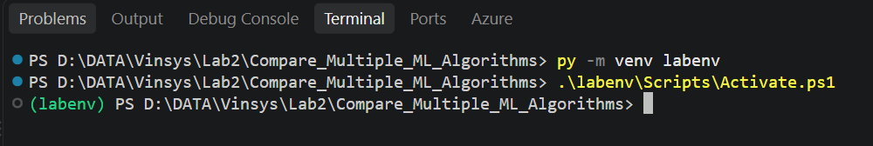
STEP 5 Install Required Libraries
Action (Terminal):
pip install pandas scikit-learn mlflow
Why it matters:
pandas loads and organizes the data, scikit-learn provides the ML algorithms, and mlflow tracks and compares your experiments.
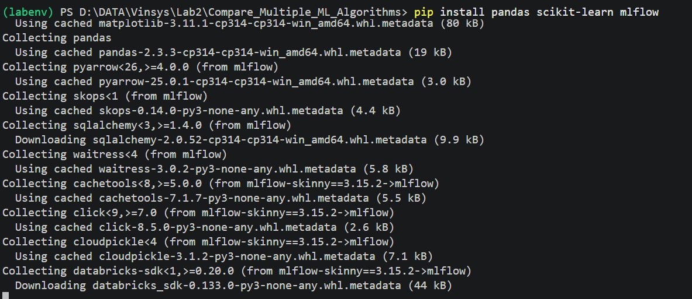

6. Step-by-Step Hands-on Lab
⚠ IMPORTANT
This lab uses TWO terminals at the same time:
Terminal 1 → runs the MLflow tracking server and stays open the whole lab.
Terminal 2 → used for installing packages and running your Python script.

6.1 Start the MLflow Server (Terminal 1)
Action (Terminal 1):
mlflow server --host 127.0.0.1 --port 5000
⚠ IMPORTANT
Keep Terminal 1 running. Do not close it for the rest of the lab.

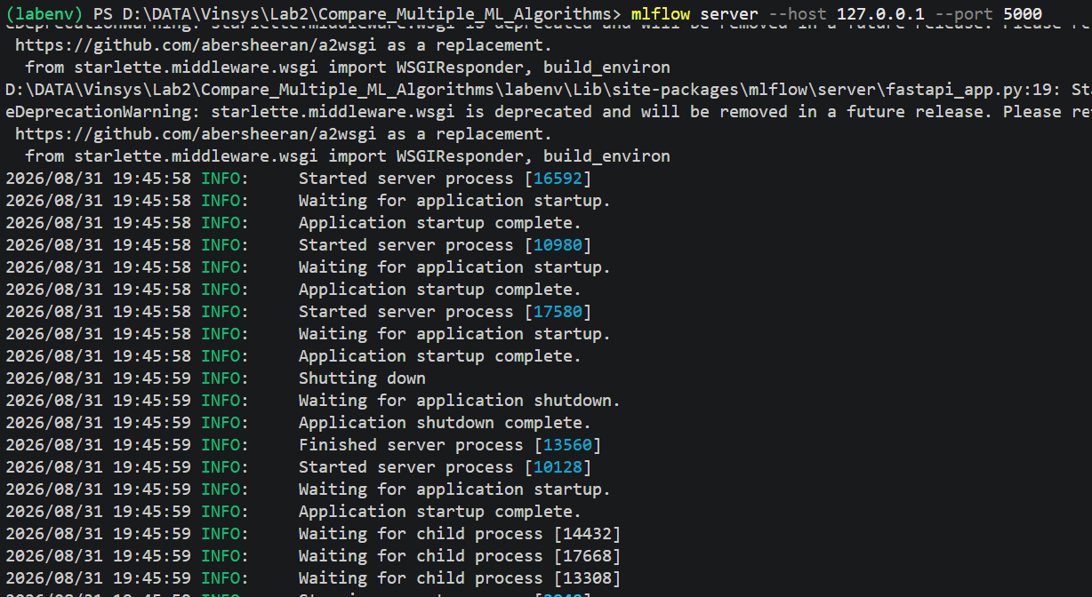6.2 Open the MLflow UI in Your Browser
Action (Browser):
http://127.0.0.1:5000
Use Terminal 2 for all Python commands while MLflow keeps running in Terminal 1. The browser page is only for viewing experiment results — you do not type commands there.
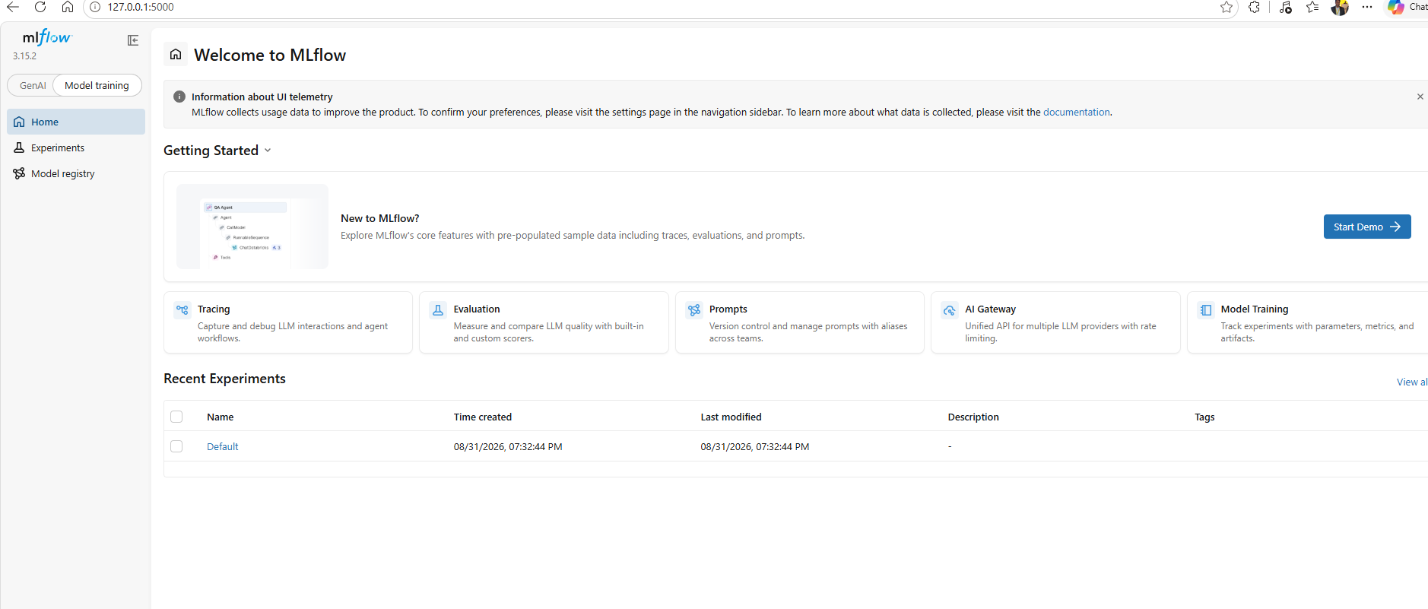

6.3 The Dataset
This lab uses a billing dataset saved as billing_data.csv, with these columns:
Usage_GB |  | Bill_Amount | Expected_Bill | Roaming_GB | Anomaly
10 |  | 520 | 500 | 0 | 0
12 |  | 610 | 600 | 1 | 0
80 |  | 4500 | 1800 | 20 | 1
15 |  | 700 | 680 | 2 | 0
75 |  | 3900 | 1700 | 18 | 1
📝 NOTE
If your billing_data.csv is not already available, use the provided sample dataset for this lab rather than inventing new data.
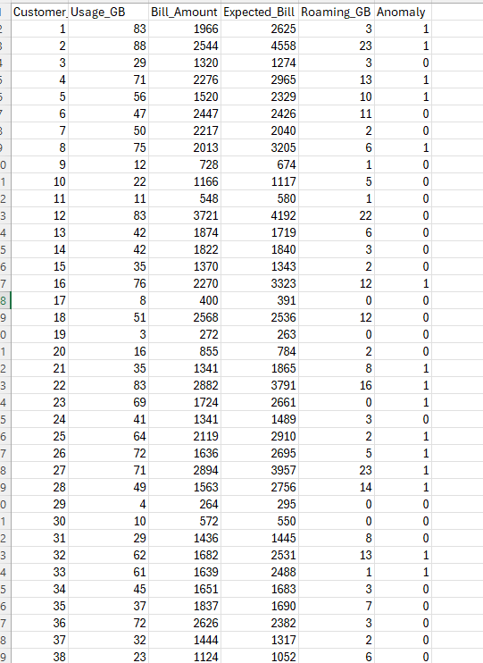

6.4 Create the Python Training Script
What you will do:
Create a new file that loads the data, trains four models, and logs the results to MLflow.
Action (VS Code Explorer):
- In the VS Code Explorer, create a new file named train_compare.py
- Paste in the script below.

import warnings
import logging

# Suppress Python warnings
warnings.filterwarnings("ignore")

# Suppress WARNING and INFO log messages
logging.disable(logging.WARNING)

import pandas as pd
import mlflow
import mlflow.sklearn

from sklearn.model_selection import train_test_split
from sklearn.metrics import accuracy_score, precision_score, recall_score

from sklearn.linear_model import LogisticRegression
from sklearn.tree import DecisionTreeClassifier
from sklearn.ensemble import RandomForestClassifier
from sklearn.neighbors import KNeighborsClassifier

# ---------------------------------------
# 1. Load Dataset
# ---------------------------------------

data = pd.read_csv("billing_data.csv")

X = data[
[
"Usage_GB",
"Bill_Amount",
"Expected_Bill",
"Roaming_GB"
]
]

y = data["Anomaly"]

# ---------------------------------------
# 2. Train/Test Split
# ---------------------------------------

X_train, X_test, y_train, y_test = train_test_split(
X,
y,
test_size=0.30,
random_state=42,
stratify=y
)

# ---------------------------------------
# 3. Define Models
# ---------------------------------------

models = {

"Logistic Regression":
LogisticRegression(max_iter=1000),

"Decision Tree":
DecisionTreeClassifier(
max_depth=4,
random_state=42
),

"Random Forest":
RandomForestClassifier(
n_estimators=100,
random_state=42
),

"KNN":
KNeighborsClassifier(n_neighbors=3)
}

# ---------------------------------------
# 4. MLflow Experiment
# ---------------------------------------

mlflow.set_experiment("Vodafone Billing Model Comparison")

# ---------------------------------------
# 5. Train and Compare Models
# ---------------------------------------

for model_name, model in models.items():

with mlflow.start_run(run_name=model_name):

# Train
model.fit(X_train, y_train)

# Predict
predictions = model.predict(X_test)

# Metrics
accuracy = accuracy_score(
y_test,
predictions
)

precision = precision_score(
y_test,
predictions,
zero_division=0
)

recall = recall_score(
y_test,
predictions,
zero_division=0
)

# Print results
print("\nModel:", model_name)
print("Accuracy:", round(accuracy, 3))
print("Precision:", round(precision, 3))
print("Recall:", round(recall, 3))

# Log parameters
mlflow.log_param(
"algorithm",
model_name
)

# Log metrics
mlflow.log_metric(
"accuracy",
accuracy
)

mlflow.log_metric(
"precision",
precision
)

mlflow.log_metric(
"recall",
recall
)

# Log model
mlflow.sklearn.log_model(
model,
name="billing_model",
serialization_format="cloudpickle"
)

print("\nAll models trained successfully!")

WHY CLOUDPICKLE?
cloudpickle lets MLflow save the exact trained model object so it can be reloaded later for comparison or deployment. It is used here because it is simple and works well for a classroom lab.
⛔ WARNING
cloudpickle is suitable for this trusted local lab demonstration. In production, model artifacts should be loaded only from trusted sources.

6.5 Run the Training Script
Before you run it:
Make sure Terminal 1 is still running the MLflow server.
Action (Terminal 2):
python train_compare.py
What the script does:
- Loads the billing dataset.
- Splits it into training and testing data.
- Creates four models: Logistic Regression, Decision Tree, Random Forest, KNN.
- Trains each model on the training data.
- Generates predictions on the test data.
- Calculates Accuracy, Precision, and Recall.
- Logs parameters and metrics to MLflow.
- Logs each trained model as an MLflow artifact.
✅ EXPECTED RESULT
Your terminal should end with:
All models trained successfully!
⚠ IMPORTANT
The exact accuracy, precision, and recall values can vary depending on the dataset and the train/test split. Do not expect identical numbers every run.
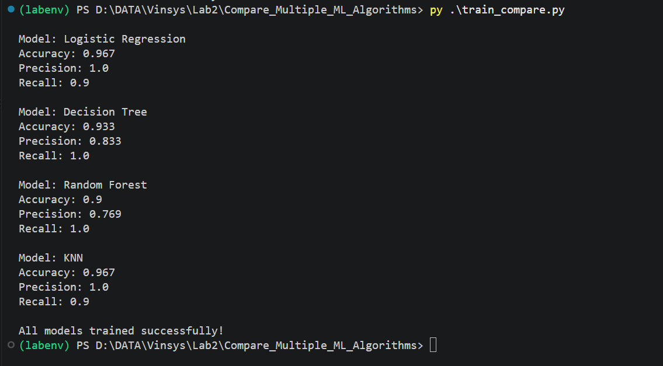

7. Understanding the Four Algorithms
All four algorithms learn patterns from the exact same billing data — they just use different approaches to make predictions. The infographic below gives you a quick visual summary before we go through each one.
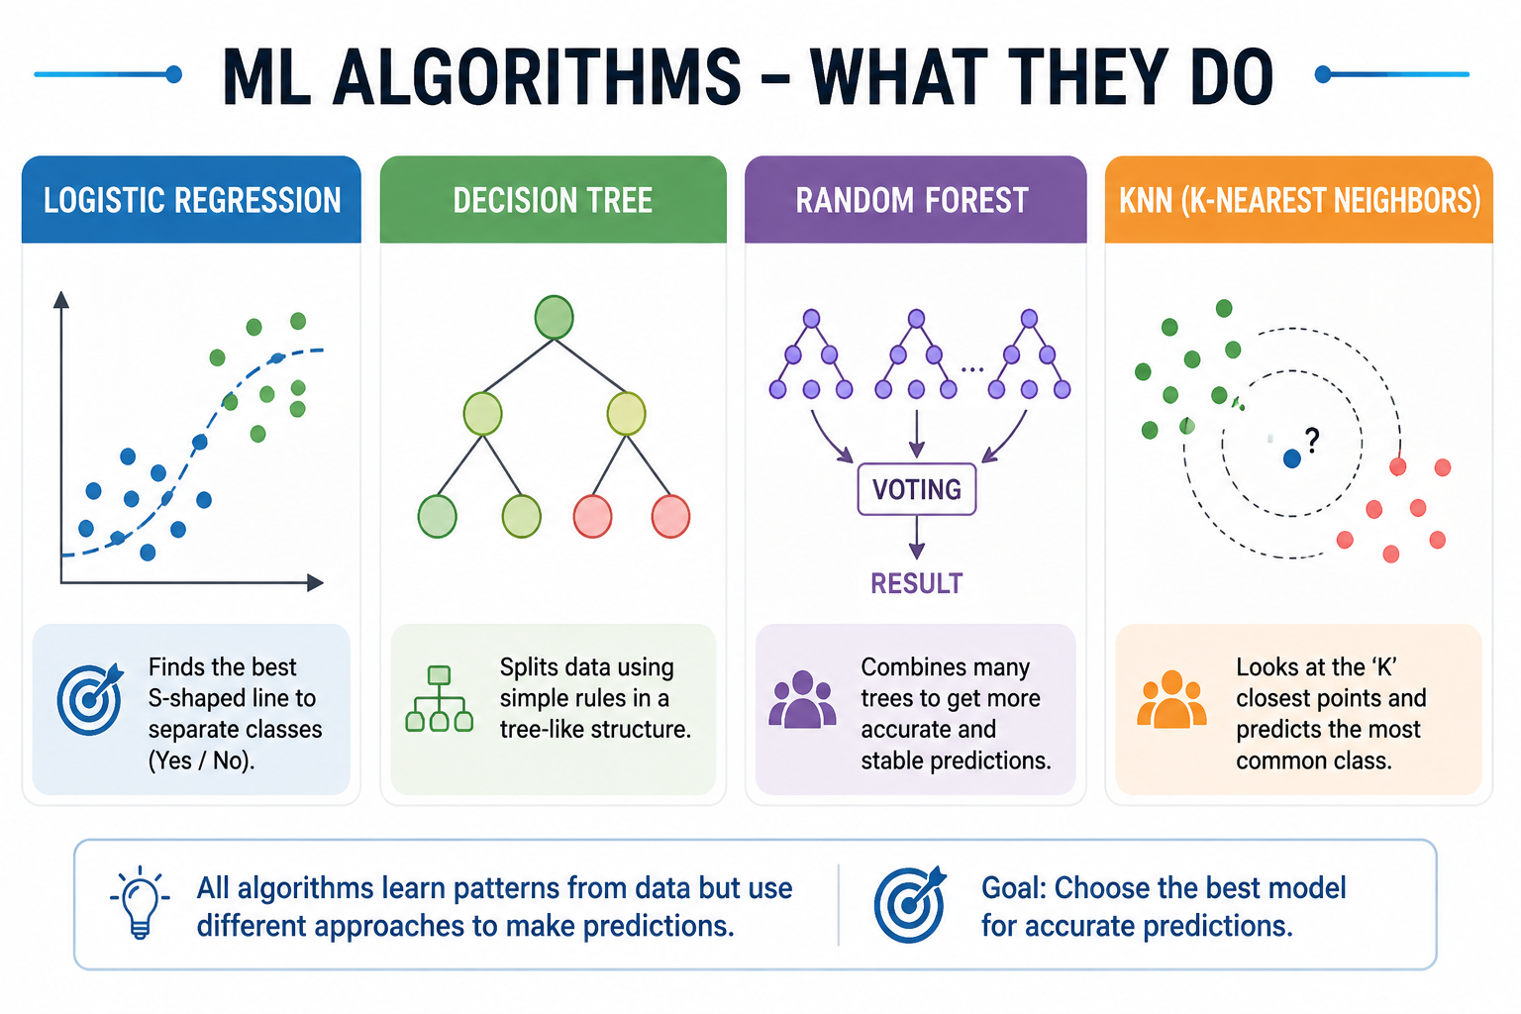
Four algorithms use different approaches to learn patterns from the same data.
Algorithm |  | Simple Meaning | Vodafone Example
Logistic Regression |  | A simple baseline model that finds a boundary between two classes. | A quick first check for whether a bill looks normal or unusual.
Decision Tree |  | Uses if/else-style rules to make a prediction. | "If usage is high AND bill is far above expected, flag it."
Random Forest |  | Combines many decision trees and lets them vote. | A more stable check that reduces mistakes from any single rule.
KNN |  | Looks at the most similar past billing records to make a decision. | "This bill looks like other confirmed anomalies we've seen before."
📝 NOTE
This lab is beginner-friendly on purpose — you do not need to understand the mathematics behind any of these algorithms to complete it.

8. MLflow Experiment Comparison
We used exactly the same dataset and training process for all four models — only the algorithm changed. Each one produced a different result. MLflow records these results so you can compare experiments instead of relying on memory or a manually maintained spreadsheet.
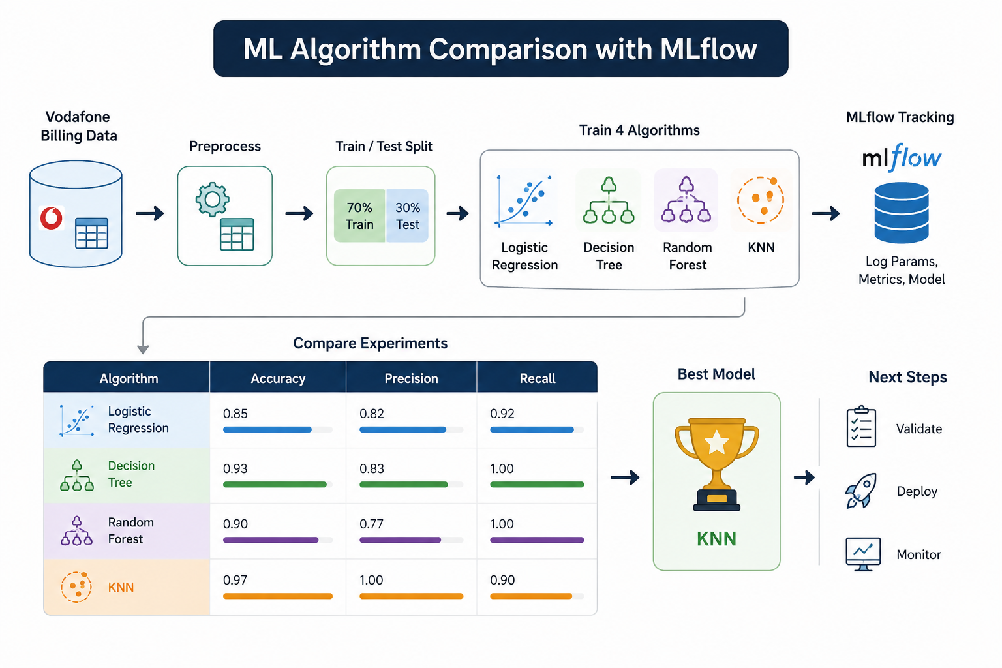
Same dataset, four algorithms, different results — MLflow helps us compare the experiments.

8.1 Open the MLflow UI
Action (Browser):
http://127.0.0.1:5000
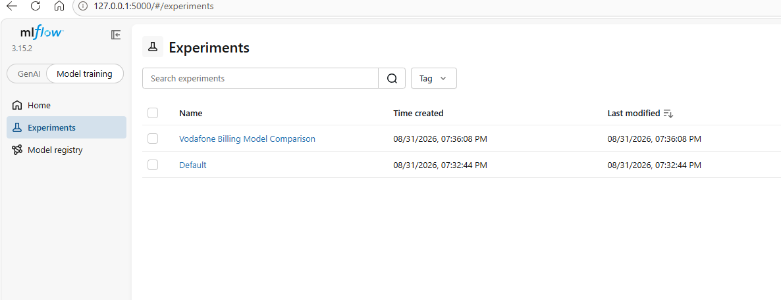

8.2 Walk Through the Experiment
- Open Experiments in the left-hand menu.
- Find Vodafone Billing Model Comparison.
- You should see four runs: Logistic Regression, Decision Tree, Random Forest, KNN.
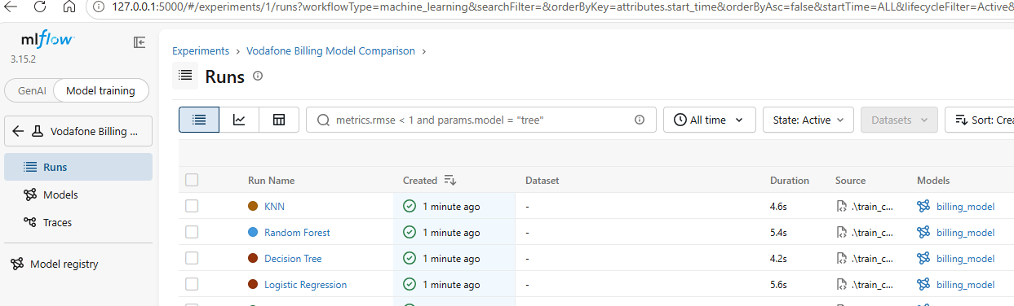
- Select all four runs using the checkboxes.
- Click Compare.
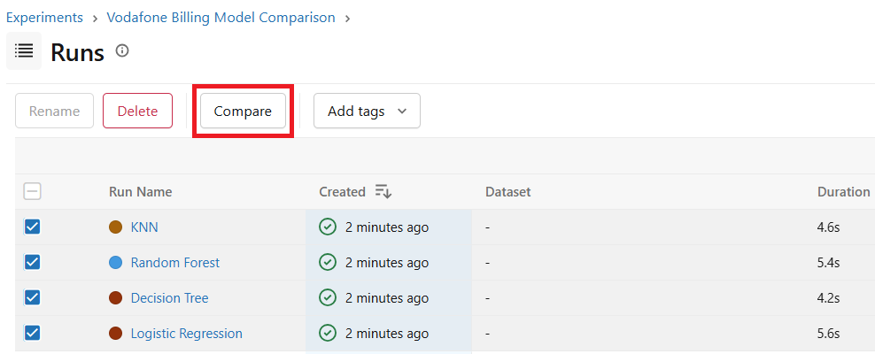
🧭 TRAINER TIP
This comparison screen is the main visual moment of the lab. Take a moment to look at how differently each algorithm performed on the same data.

What to look for on the Compare screen:
- Accuracy
- Precision
- Recall
- Algorithm (logged as a parameter)
- Run name
- Logged model

9. Understanding the Results
Before comparing models, it helps to know exactly what each metric is asking.
Metric | What it asks
Accuracy | How many predictions were correct overall?
Precision | When the model says "anomaly", how often is it correct?
Recall | How many of the actual anomalies did the model find?
Why Recall matters for billing anomaly detection
A real billing anomaly
↓
Model misses it
↓
Revenue leakage continues

If a model has low recall, it lets real billing anomalies slip through undetected — and Vodafone keeps losing revenue without knowing it. That is why recall can matter as much as, or more than, accuracy for this use case.
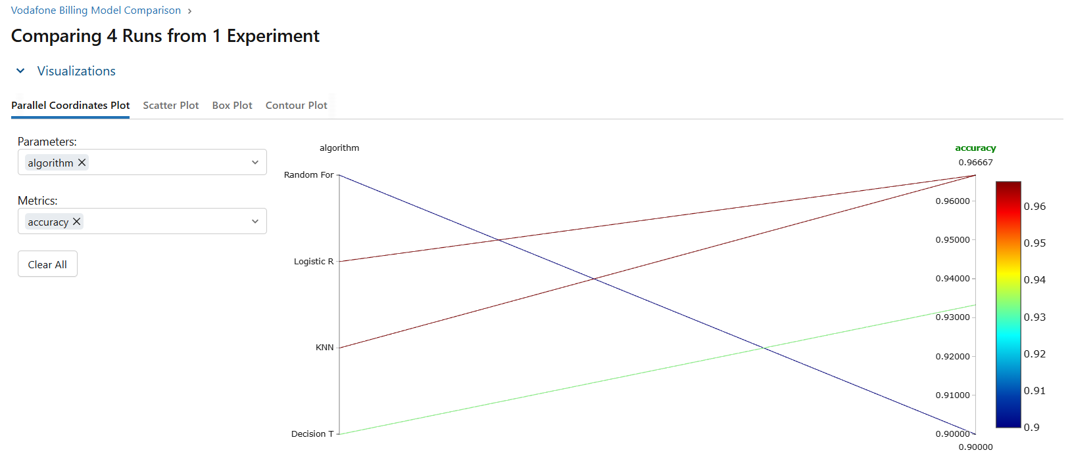

10. Model Comparison
📝 NOTE
Example results — your values may differ. Do not treat the numbers below as guaranteed.

Algorithm |  | Accuracy | Precision | Recall
Logistic Regression |  | 87% | 83% | 80%
Decision Tree |  | 90% | 88% | 85%
Random Forest |  | 93% | 91% | 90%
KNN |  | 86% | 82% | 78%
⚠ IMPORTANT
Do not automatically select a model only because it has the highest accuracy. Look at precision and recall too, and think about what matters most for this business problem.
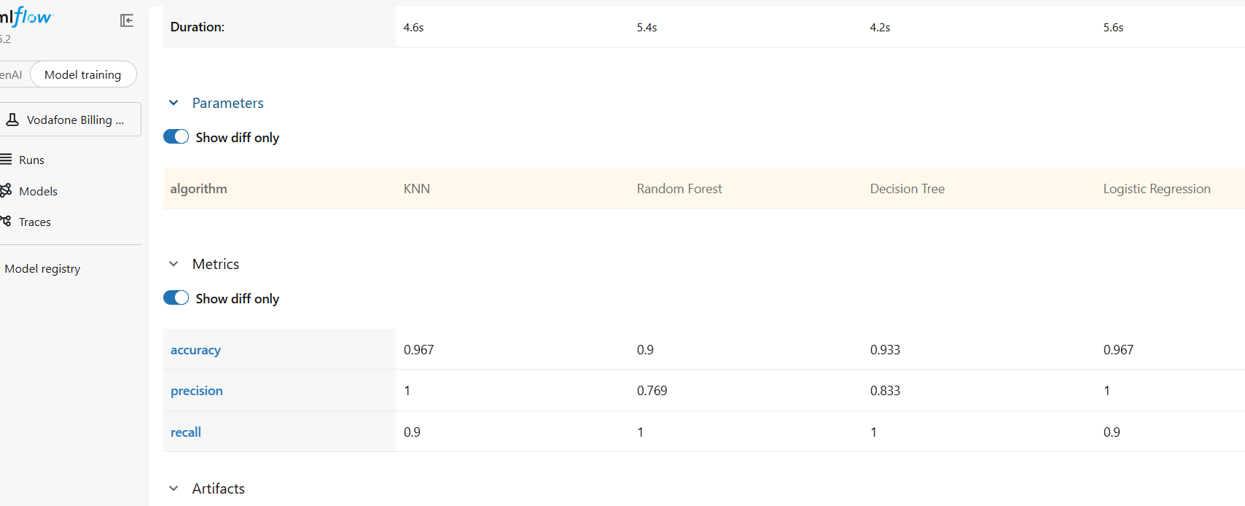

11. Model Selection Exercise
🧭 CLASSROOM ACTIVITY
Which model would you select for Vodafone Billing Assurance?

Consider:
- Accuracy
- Precision
- Recall
- Business impact of missing a real anomaly
The best model depends on the business requirement, not only one metric. A model with slightly lower accuracy but higher recall may be the safer choice for catching billing anomalies.

12. Quality Gate Concept
Suppose Vodafone defines a minimum acceptable accuracy: Minimum Accuracy = 90%
Algorithm | Accuracy | Result
Logistic Regression | 87% | ❌ FAIL
Decision Tree | 90% | ✅ PASS
Random Forest | 93% | ✅ PASS
KNN | 86% | ❌ FAIL
The pipeline can check this automatically:
Accuracy >= 90% ?
│
┌────┴────┐
YES NO
↓ ↓
PASS FAIL

- PASS → The candidate model can move forward to registration and deployment.
- FAIL → The candidate requires further investigation or retraining before it can be used.
📝 NOTE
This is the core idea behind automated model evaluation in MLOps: instead of a person eyeballing results, the pipeline applies a consistent, repeatable quality gate.

13. End-to-End MLOps Flow
This lab is one small piece of a much bigger, repeatable pipeline:
Train Models
↓
Track Experiments
↓
Compare Models
↓
Validate Candidate
↓
Quality Gate
↓
Register Model
↓
Deploy
↓
Monitor
↓
Detect Drift
↓
Retrain

Stage | What happens
Train Models | Fit each algorithm on the training data.
Track Experiments | MLflow records parameters, metrics, and models for every run.
Compare Models | Review accuracy, precision, and recall side by side.
Validate Candidate | Check the strongest model against business requirements.
Quality Gate | Automatically pass or fail the candidate against a minimum standard.
Register Model | Save the approved model as a versioned candidate (e.g. v1, v2, v3).
Deploy | Move the registered model into production use.
Monitor | Track how the model performs on real, live data over time.
Detect Drift | Watch for signs that incoming data no longer matches training data.
Retrain | Refresh the model using new data when performance or drift requires it.

14. Troubleshooting
Problem 1: ModuleNotFoundError: No module named 'pandas'
Solution:
pip install pandas
Problem 2: KNN error — Expected n_neighbors <= n_samples_fit
KNN needs at least as many training samples as the number of neighbors it is set to look at (n_neighbors=3 in this lab). Make sure your dataset has enough rows.
Problem 3: MLflow server not opening in the browser
Check that Terminal 1 is still running:
mlflow server --host 127.0.0.1 --port 5000
Problem 4: MLflow shows a cloudpickle warning
This is a warning, not a failure. As long as the script continues and the model is logged successfully, training has still completed.
Problem 5: "All models trained successfully!" does not appear
Scroll up in Terminal 2 and check for an error traceback (red text). Fix the reported error, save the file, and run python train_compare.py again.

15. Lab Summary
- We trained four algorithms using the same dataset.
- Each algorithm can produce different results.
- MLflow tracks experiments and metrics.
- Model selection should consider business requirements, not just one metric.
- MLOps uses these results to support automated validation and deployment.

16. Quick Knowledge Check
1. What does MLflow help us track?
A. Experiments and metrics
B. Windows users
C. Network cables
D. Browser history
Correct Answer: A
2. In this lab, how many algorithms are trained and compared?
A. Two
B. Three
C. Four
D. Six
Correct Answer: C
3. Which metric asks "How many of the actual anomalies did the model find?"
A. Accuracy
B. Precision
C. Recall
D. Run name
Correct Answer: C
4. In the Quality Gate example, what happens if a model's accuracy is below 90%?
A. It automatically deploys
B. It fails and needs further investigation or retraining
C. It is deleted
D. Nothing happens
Correct Answer: B
5. Which terminal should stay running throughout the whole lab?
A. Terminal 1 (MLflow server)
B. Terminal 2 (Python commands)
C. Both must be closed after setup
D. Neither
Correct Answer: A

