PROFESSIONAL HANDS-ON LAB
Deploy an ASP.NET MVC Web App
to Azure App Service using External Git
GitHub • Azure App Service • Windows • .NET Framework 4.8 • App Service Build Service
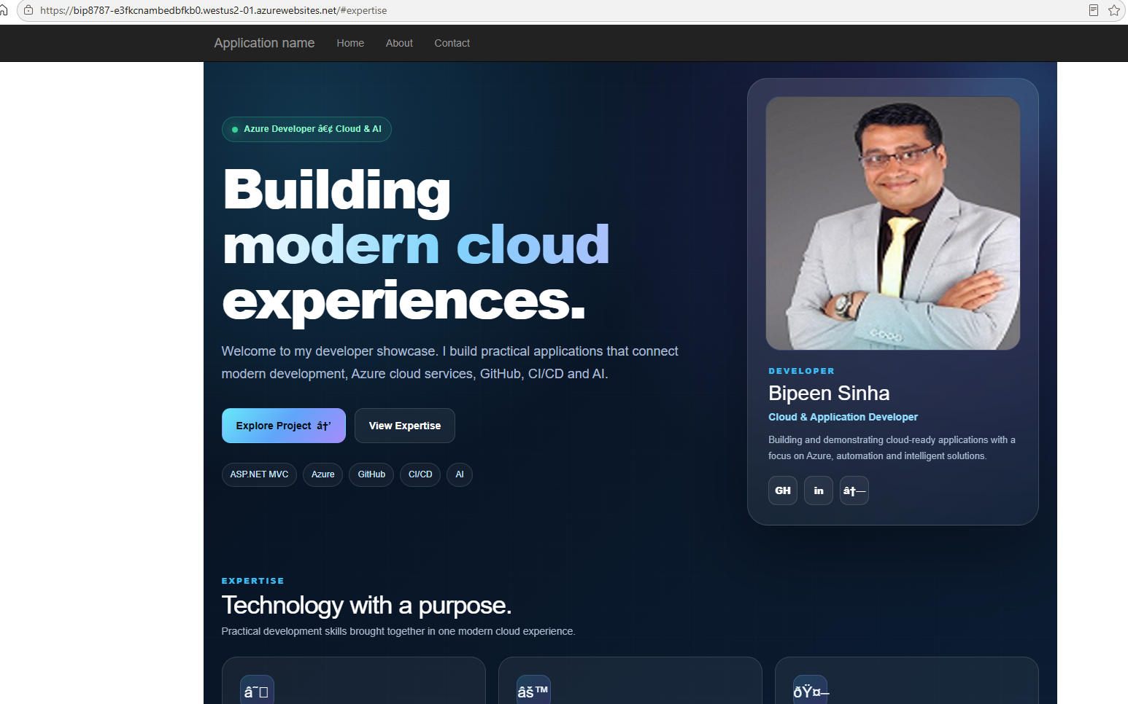
Final deployed application — live browser view captured as deployment evidence.
A screenshot-led lab guide for classroom delivery and repeatable practice

Table of Contents

(Right-click and choose “Update Field” after opening in Word to populate this list.)

1. Lab Overview
This lab documents the creation, configuration, deployment, and validation of an ASP.NET MVC web application on Azure App Service. The supplied screenshots show a Windows App Service using .NET Framework 4.8, a Basic B1 plan, GitHub as the external repository on the master branch, and the App Service Build Service.

Lab Objectives
- Create an Azure Web App with Code publishing.
- Configure a Windows App Service with ASP.NET V4.8.
- Use a Basic B1 App Service plan for the lab workload.
- Configure authentication settings required for deployment and publishing.
- Connect Azure Deployment Center to a GitHub repository using External Git.
- Select the master branch and a public repository.
- Monitor deployment progress and verify a successful deployment.
- Open the live Azure App Service URL and validate the application.

Environment Captured in the Screenshots
Component | Configuration shown
Application | ASP.NET MVC web application
Runtime | ASP.NET V4.8 / .NET Framework 4.0 runtime (shown in Overview)
Operating System | Windows
App Service tier | Basic B1
Memory | 1.75 GB
Repository | GitHub: bipeensinha/YakshithApp.git
Branch | master
Repository type | Public
Deployment source | External Git
Build provider | App Service Build Service

Prerequisites
- An Azure subscription with permission to create App Service resources.
- A GitHub repository containing the ASP.NET MVC application.
- A working ASP.NET MVC project that can build locally.
- Access to the Azure Portal and the GitHub repository.
- A browser for validating the deployed application.

Security Note — Credential hygiene
Never place a GitHub Personal Access Token (PAT) in a screenshot, source file, lab document, or chat transcript. If a credential is accidentally exposed, revoke it and issue a replacement only when required.

2. Detailed Lab Procedure

Step 1. Create the Azure Web App — Basics
- Open Azure Portal and choose Create a resource → Web App.
- Select the required Azure subscription and resource group.
- Enter the Web App name. The supplied example uses bip8787.
- Set Publish to Code.
- Set Runtime stack to ASP.NET V4.8.
- Set Operating System to Windows.
- Choose the required Azure region. The supplied example uses West US 2.
- Continue to the Database tab if required, or proceed to Deployment.
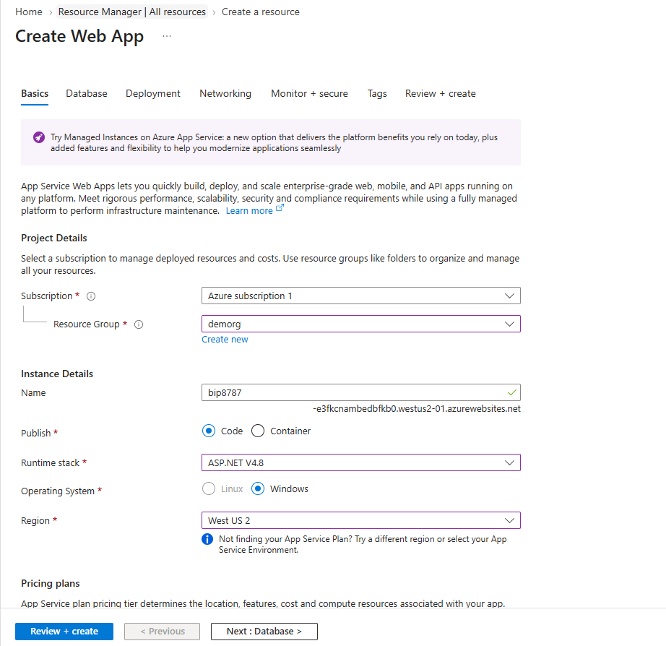
Screenshot 1 — Azure Web App: Basics configuration

Step 2. Configure Deployment Settings
- Open the Deployment tab in the Web App creation wizard.
- The supplied screenshot shows Continuous deployment set to Disable.
- GitHub authorization, repository, and branch selectors remain unavailable while continuous deployment is disabled.
- Basic authentication is explicitly enabled in the Authentication settings section.
- For this lab, deployment is configured later through Deployment Center using External Git.
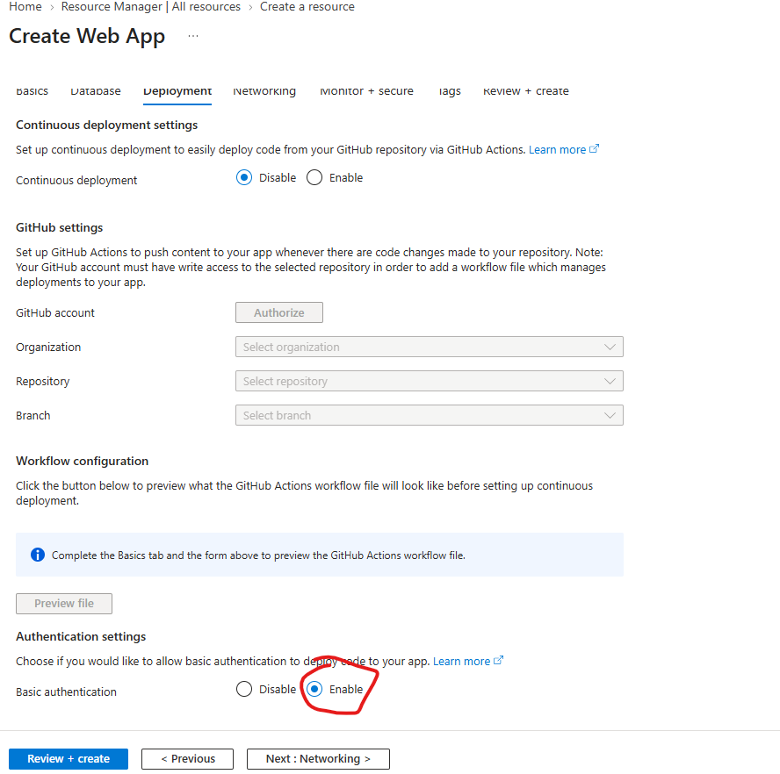
Screenshot 2 — Azure Web App: Deployment settings

Step 3. Review and Create the Web App
- Open Review + create.
- Verify the selected Basic B1 SKU. The supplied screenshot shows an estimated price of 54.75 USD/month.
- Verify Publish = Code.
- Verify Runtime stack = ASP.NET V4.8.
- Verify Operating System = Windows.
- Verify the new App Service Plan and its Basic size.
- Verify Application Insights is enabled in the supplied configuration.
- Select Create to provision the Web App.
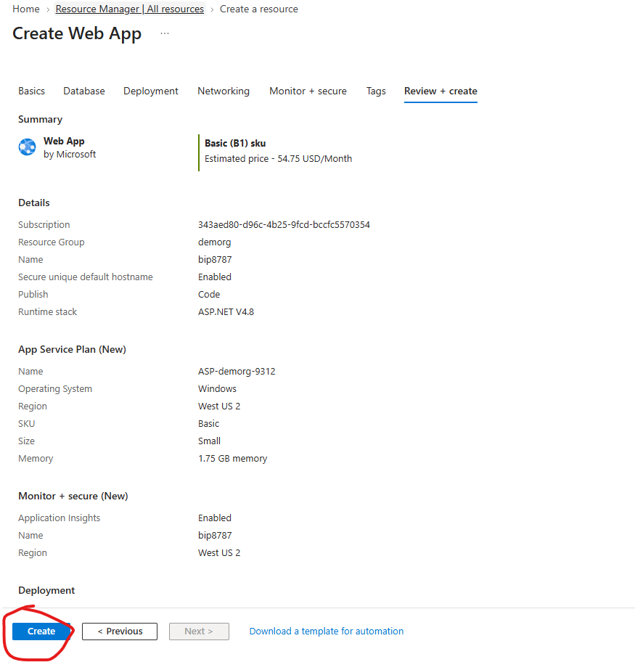
Screenshot 3 — Azure Web App: Review + create

Step 4. Verify the Azure App Service Overview
- After provisioning completes, open the Web App Overview page.
- Confirm Status = Running.
- Confirm Operating System = Windows.
- Confirm the default domain is available.
- Confirm the External Repository Project points to the intended GitHub repository.
- Confirm Deployment provider = ExternalGit.
- Open Deployment Center to inspect or configure the source integration.
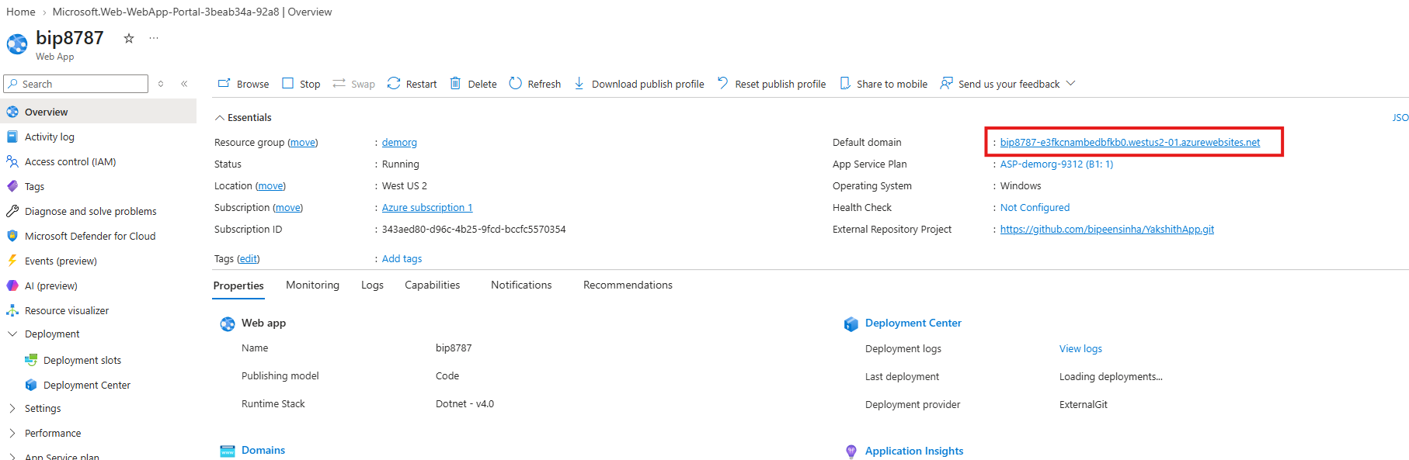
Screenshot 4 — Azure App Service Overview: status, domain, and ExternalGit provider

Step 5. Configure External Git in Deployment Center
- Open Deployment → Deployment Center.
- Select External Git as the Source.
- Keep App Service Build Service as the build provider.
- Enter the GitHub repository URL shown in the screenshot: https://github.com/bipeensinha/YakshithApp.git
- Set Branch to master.
- Select Public because the supplied repository is public.
- Select Save to commit the configuration.
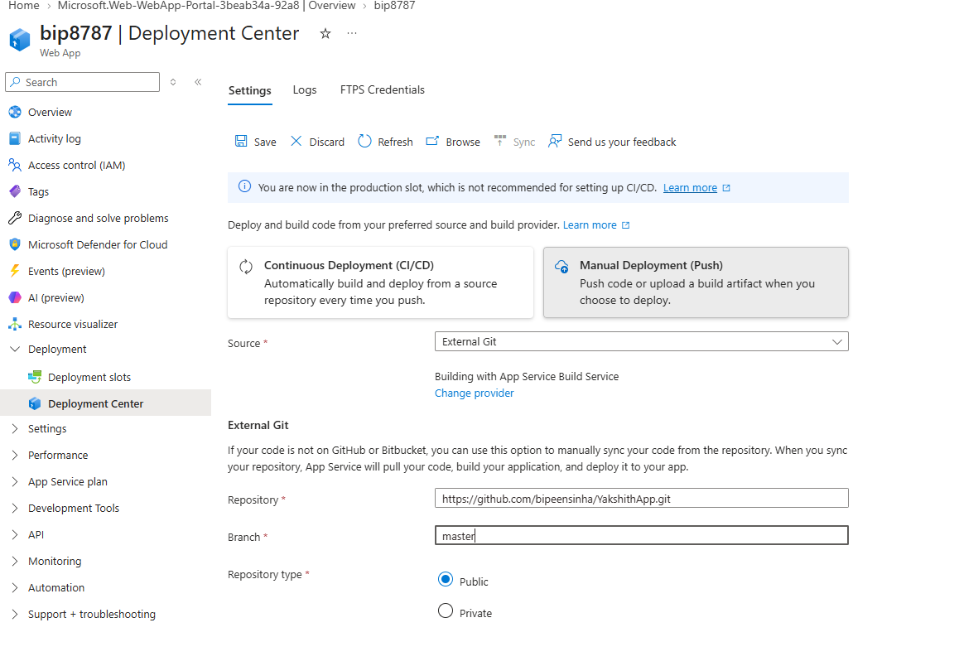
Screenshot 5a — Deployment Center: entering the External Git source, repository, and branch
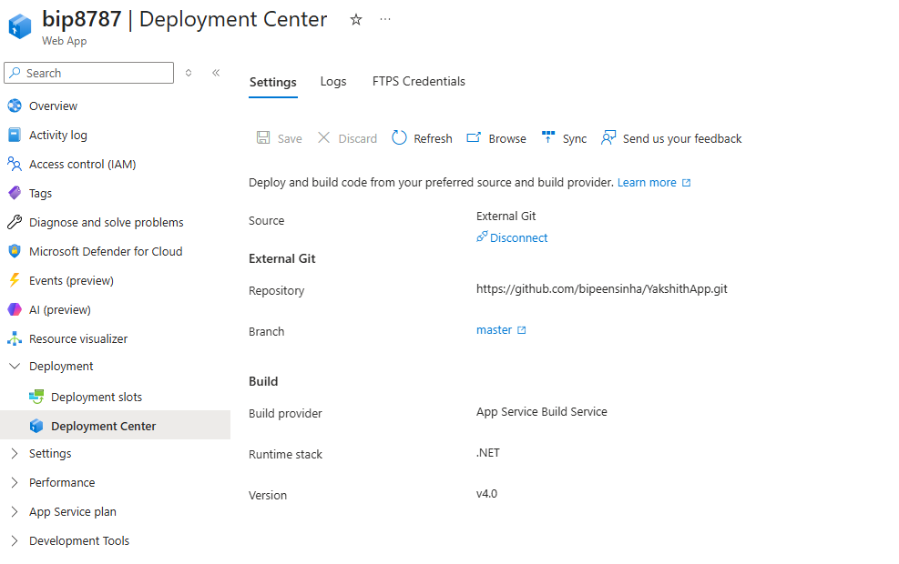
Screenshot 5b — Deployment Center: External Git configuration confirmed after Save
- Use Sync when available to retrieve the current repository contents.

Step 6. Monitor the Deployment
- Open the Deployment Center Logs tab.
- Refresh the logs immediately after saving or synchronizing the repository.
- A new deployment entry appears for the repository update, initially showing a Running status while the build service pulls and prepares the code.
- Leave the tab open and refresh periodically until the status changes.
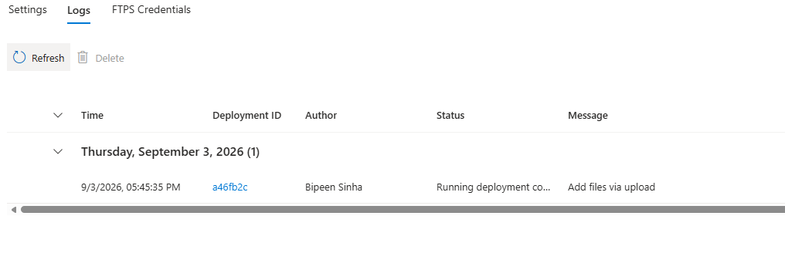
Screenshot 6 — Deployment Center Logs: deployment in progress (Running deployment command…)

Step 7. Verify Successful Deployment
- Refresh the Logs tab again once the deployment has had time to complete.
- A successful deployment is shown in the supplied evidence with status Succeeded (Active).
- The deployment entry is associated with the message Add files via upload.
- Record the deployment ID and commit/message when documenting a production or classroom run.
- If the status remains Running for an extended period, allow the deployment command to finish before testing the application. If it fails, open the deployment details and review the command output before making changes.
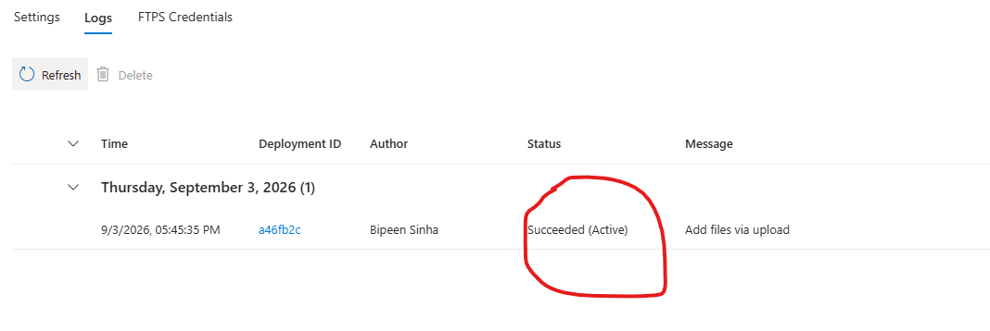
Screenshot 7 — Deployment Center Logs: deployment Succeeded (Active)

Step 8. Validate the Live Application
- Open the Azure Web App default domain from Overview, or use Browse.
- Confirm that the application renders successfully in the browser.
- Confirm that the custom application page is displayed rather than the default ASP.NET error page.
- Exercise the visible navigation and page sections as part of the functional test.
- Capture the final browser screen as deployment evidence.

Screenshot 8 — Application running live in the browser

Step 9. Review the App Service Plan (Optional)
- Open the App Service Plan → Scale up page.
- Review the available Basic tiers.
- For this lab, the plan is Basic B1 — 1 vCPU and 1.75 GB memory (see the Environment table in Section 1).
- Keep B1 if the application remains stable and the workload is light.
- For heavier workloads, evaluate a larger tier based on actual CPU and memory requirements.
Note: no screenshot of the Scale-up blade was included in the source material for this step. Capture one from your own environment if you'd like to add visual evidence here.

3. Deployment Architecture and Flow
The workflow captured by the screenshots can be explained as a simple source-to-cloud pipeline:
1. Developer | 2. GitHub | 3. Azure External Git | 4. Build | 5. Web App
ASP.NET MVC code | master branch | Repository synchronization | App Service Build Service | Live Azure URL

The important operational distinction is that source synchronization retrieves the repository, the build service prepares the application for App Service, and the resulting files are then used by the running Web App.

4. Troubleshooting
Symptom | What to check | Recommended action
No deployment appears | Repository URL and branch | Confirm the repository and master branch match the GitHub repository.
Deployment is pending | Deployment Center Logs | Refresh logs and use Sync when available.
Build/deployment fails | Deployment details | Open Show logs and inspect the first meaningful error.
Old version appears | Latest commit/deployment | Confirm Azure deployed the latest repository commit, then refresh the browser.
Static file returns 404 | Project publish/content configuration | Confirm the file is included in the ASP.NET MVC project and published output.
Default ASP.NET error page | Application/runtime | Review the deployed application and App Service configuration; check runtime logs.
Application is slow | App Service plan capacity | Review CPU/memory and consider scaling above Basic B1 if required.

5. Lab Validation Checklist
Validation item | Expected result | Complete
Azure Web App | Resource is created and running. | ☐
Runtime | ASP.NET V4.8 is selected. | ☐
OS | Windows is selected. | ☐
Plan | Basic B1 is selected for the lab. | ☐
External Git | External Git is configured. | ☐
Repository | YakshithApp.git is configured. | ☐
Branch | master is selected. | ☐
Build provider | App Service Build Service is selected. | ☐
Deployment | Deployment status becomes Succeeded (Active). | ☐
Browser | Live application loads successfully. | ☐

6. Instructor Notes / Discussion Points
- Ask learners why continuous deployment was disabled during creation and why Deployment Center can still be used afterward.
- Explain why the repository branch configured in Azure must match the branch that contains the application code.
- Use the deployment log to distinguish source retrieval problems from build/deployment problems — compare the Running and Succeeded states shown in Steps 6 and 7.
- Discuss the trade-off between Basic B1 cost/capacity and the needs of a larger application.
- Demonstrate that a deployment marked successful should still be followed by a real browser validation.
- Remind learners not to expose GitHub PATs or other deployment credentials in screenshots.

Appendix A. Complete Screenshot Evidence
All screenshots supplied for this lab are reproduced below in the corrected sequence — matching the order in which the actions actually occur in Section 2. Each image is captioned with the step it supports.

Evidence 1 (Step 1)

Evidence 1 (Step 1) — Azure Web App: Basics configuration

Evidence 2 (Step 2)

Evidence 2 (Step 2) — Azure Web App: Deployment settings

Evidence 3 (Step 3)

Evidence 3 (Step 3) — Azure Web App: Review + create

Evidence 4 (Step 4)

Evidence 4 (Step 4) — Azure App Service Overview

Evidence 5a (Step 5)

Evidence 5a (Step 5) — Deployment Center: External Git settings entry

Evidence 5b (Step 5)

Evidence 5b (Step 5) — Deployment Center: External Git settings saved

Evidence 6 (Step 6)

Evidence 6 (Step 6) — Deployment Center Logs: deployment in progress

Evidence 7 (Step 7)

Evidence 7 (Step 7) — Deployment Center Logs: deployment succeeded

Evidence 8 (Step 8)

Evidence 8 (Step 8) — Application running in the browser

