LAB MANUAL
Create and Configure an Azure Virtual Machine with IIS
and Deploy the SLGK-104 Restaurant Website
Professional step-by-step lab guide with all screenshots from the reference document
plus the supplied SLGK-104 deployment screenshots.
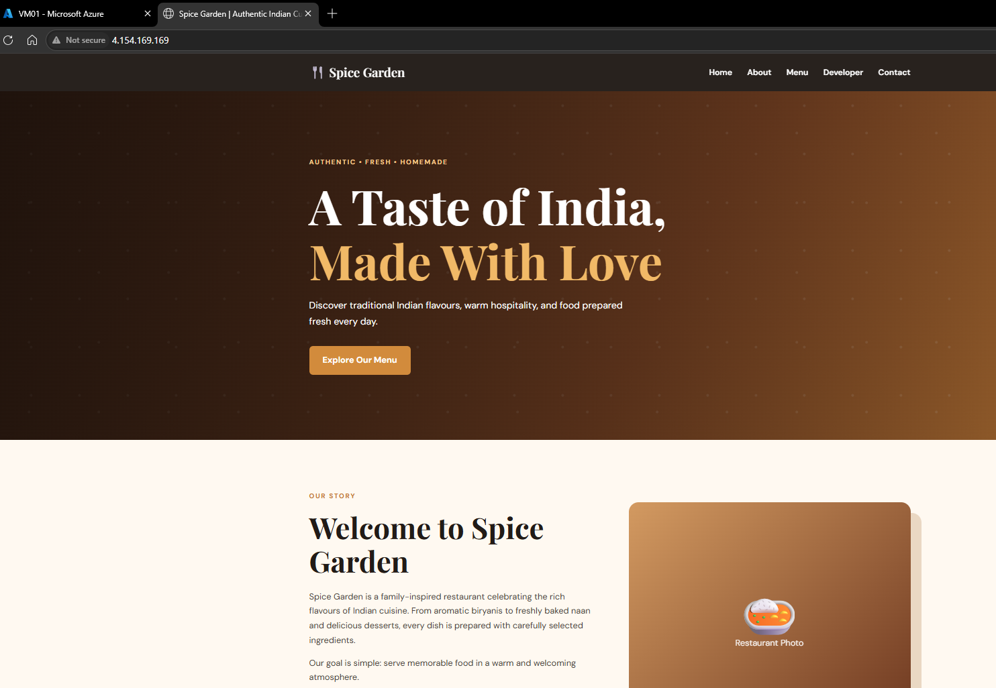
Lab / Repository | SLGK-104 — IIS with HTML CSS | Restaurant Website
Platform | Microsoft Azure Virtual Machine + Windows Server + IIS
Application | Static HTML/CSS/JavaScript restaurant website
Reference | AzureVM_With_IIS.docx
Repository | https://github.com/bipeensinha/SLGK-104

Table of Contents
- 1. Lab Objective
- 2. Lab Scenario and Architecture
- 3. Prerequisites
- 4. Create the Azure Virtual Machine
- 5. Connect to the VM Using RDP
- 6. Install IIS (Web Server)
- 7. Validate the IIS Installation
- 8. Download the SLGK-104 Website from GitHub
- 9. Extract and Copy the Website Files
- 10. Deploy the Website to IIS wwwroot
- 11. Test the Restaurant Website
- 12. Troubleshooting Checklist
- 13. Learning Objectives
- 14. Evidence / Completion Checklist
- Appendix A — Screenshot Traceability

1. Lab Objective
- Create an Azure Virtual Machine using the Azure Portal.
- Understand the core VM configuration components.
- Configure compute, networking, and storage options.
- Connect to the VM using Remote Desktop (RDP).
- Deploy and validate IIS Web Server.
- Deploy the SLGK-104 HTML/CSS restaurant website into IIS.
- Verify the final website from a browser using the VM public IP.
Lab outcome: By the end, the learner should have a running Windows Server VM with IIS hosting the SLGK-104 restaurant website.

2. Lab Scenario and Architecture
You are a Cloud Engineer responsible for deploying infrastructure in Microsoft Azure. The organization requires a Windows Server Virtual Machine to host a web application. The workflow follows the reference manual and then extends it with the supplied SLGK-104 website.
Azure VM → RDP → Windows Server → IIS → C:\inetpub\wwwroot → SLGK-104 Website → Browser

3. Prerequisites
- Access to an Azure subscription / training subscription.
- A Windows laptop or desktop with Remote Desktop Connection.
- Internet access.
- Permission to create or use an Azure VM.
- The SLGK-104 GitHub repository:
https://github.com/bipeensinha/SLGK-104
Security note: The reference document contains example credentials. In a real environment, never reuse published passwords; create a strong unique administrator password.

4. Create the Azure Virtual Machine
Follow the same sequence and terminology used in the reference manual. The screenshots below are the original screenshots embedded in that reference document.
Step 4.1: Open Virtual Machines in Azure
In the Azure Portal search bar, type Virtual Machine. From the Services results, select Virtual machines.
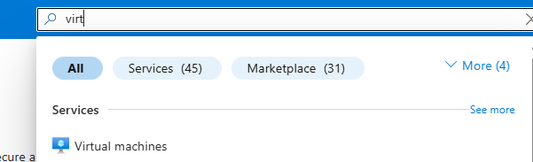
Reference screenshot — Azure search for Virtual machines.
Checkpoint: The Virtual machines service should open.

Step 4.2: Select Create → Virtual Machine
On the Virtual machines page, select Create and then select Virtual machine.
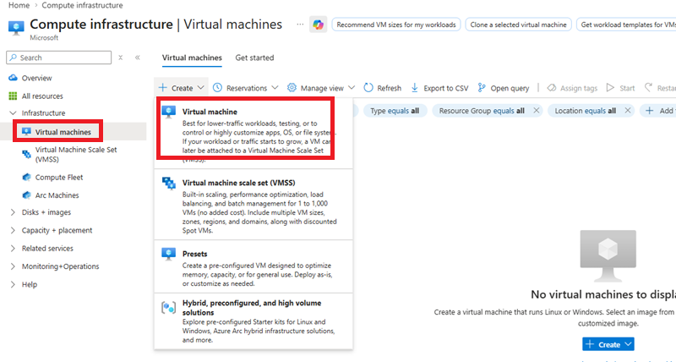
Reference screenshot — Create a virtual machine.
Checkpoint: You should now be on the Basics tab of the Create a virtual machine wizard.

4.3 Configure the VM — Basics
Enter the values specified by the reference document/training environment:
Setting | Reference value
Subscription | ODL-AZ-XXXX
VM name | IN-VM-01
Region | WestUS2
Availability option | No Infrastructure redundancy required
Security type | Standard
Image | Windows Server 2025 Azure Edition
Size | Standard_DS1_V2 — 1 CPU, 3.5 GiB memory
Administrator username | Vmadmin
Administrator password | Use the password assigned for your lab environment
Step 4.4: Review the Basics values and continue
Compare the entries on the Azure Basics screen with the table above. Then select Next to continue to Disks.
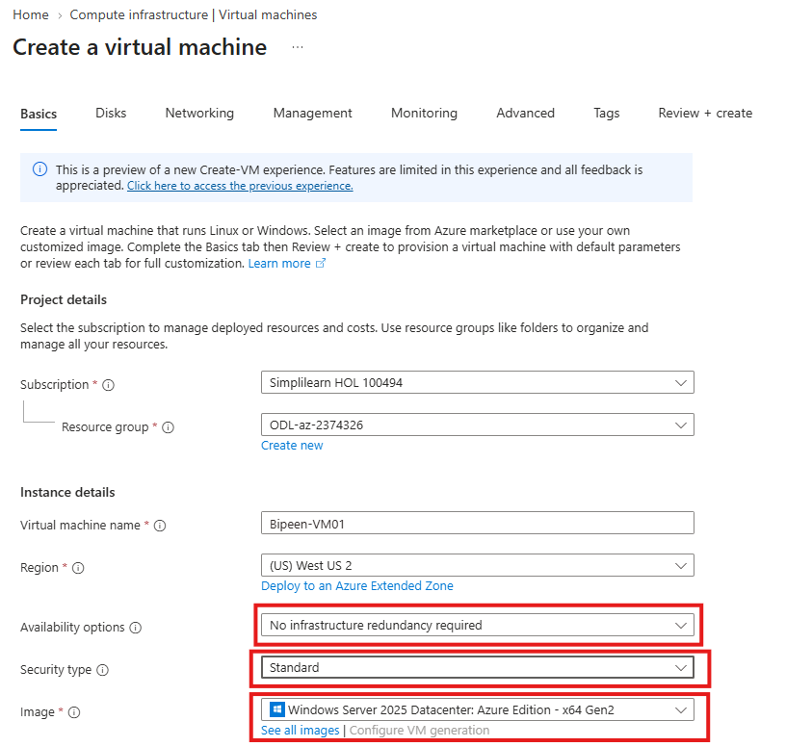
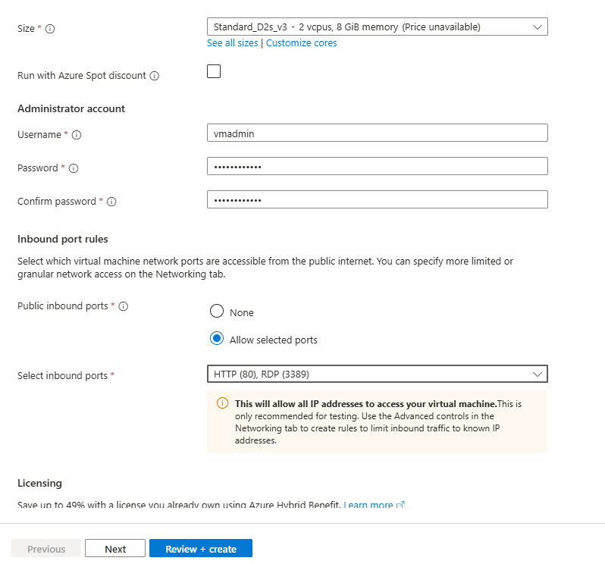
Reference screenshot — VM Basics configuration with highlighted fields.
Checkpoint: The selected VM name, region, image, size, and administrator account should match your training requirements.

Step 4.5: Configure the OS disk
On the Disks tab, use Standard HDD for the OS disk as specified in the reference manual, then select Next.
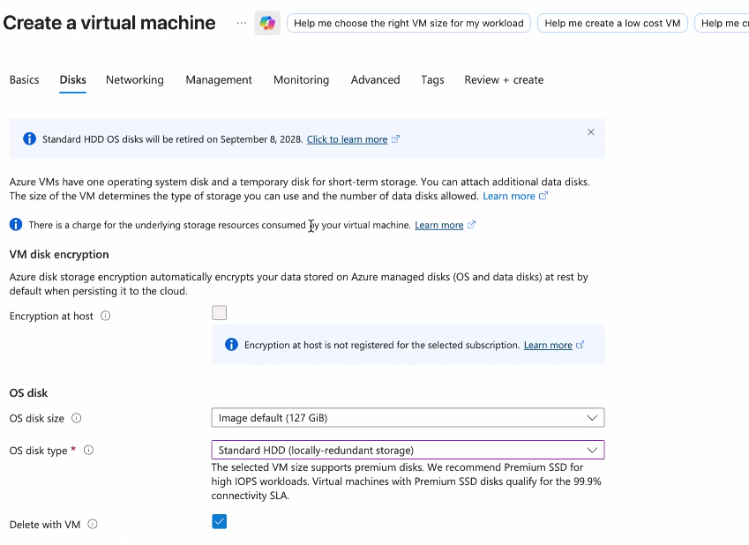
Reference screenshot — Disks tab with Standard HDD selected.
Checkpoint: The OS disk type should show Standard HDD.

Step 4.6: Review and create the VM
Select Review + create. After Azure completes validation, select Create. When deployment finishes, select Go to resource to open the VM console.
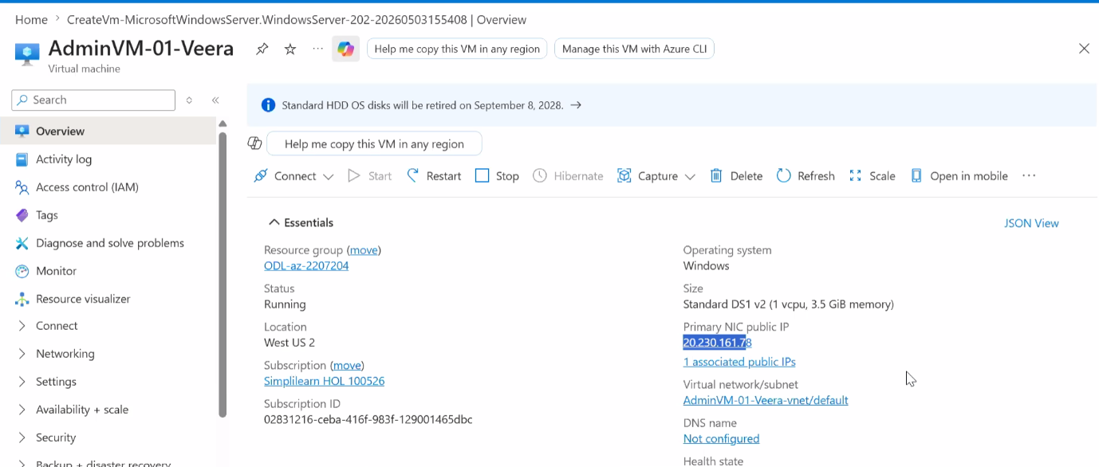
Reference screenshot — Azure VM resource overview after creation.
Checkpoint: The VM resource overview should be visible and the VM should be running.

5. Connect to the VM Using RDP
Step 5.1: Copy the VM public IP address
From the VM Overview/console, locate the Public IP address and copy it. This address is used by Remote Desktop Connection.
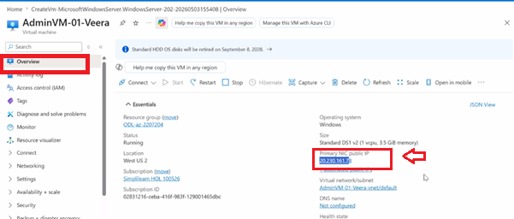
Reference screenshot — Public IP address highlighted in the VM overview.
Checkpoint: Keep the public IP available for the next steps.

Step 5.2: Launch Remote Desktop Connection
On your Windows laptop, open Start/Search and type Remote Desktop. Select Remote Desktop Connection.
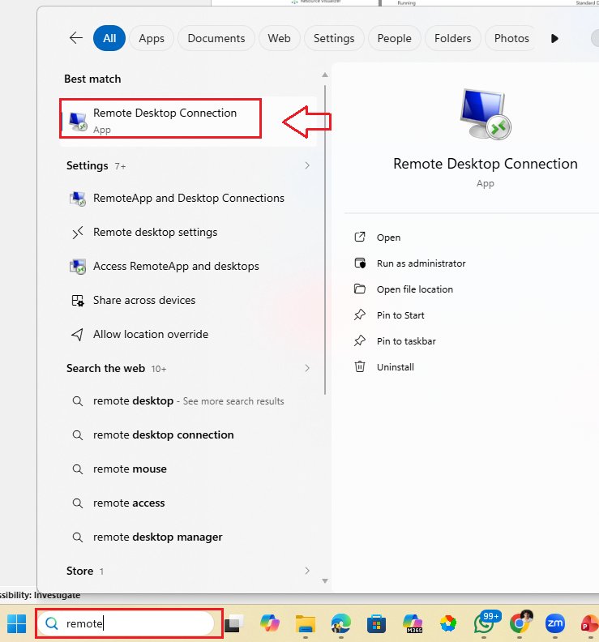
Reference screenshot — Windows search for Remote Desktop Connection.
Checkpoint: The Remote Desktop Connection window should open.

Step 5.3: Enter the VM public IP and connect
Paste the copied public IP into the Computer field and select Connect.
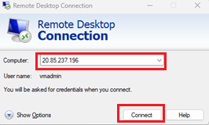
Reference screenshot — Remote Desktop Connection with the Computer field populated.
Checkpoint: The connection request should begin.

Step 5.4: Enter administrator credentials
Enter the administrator username and password that you used when creating the VM, then continue.
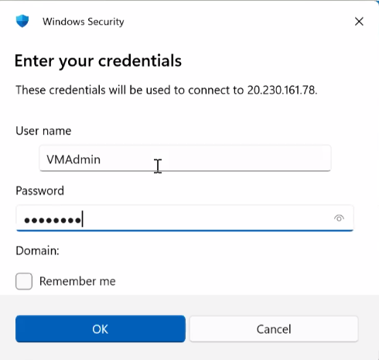
Reference screenshot — Windows Security credential prompt.
Checkpoint: The credentials should be accepted and the remote session should start.

Step 5.5: Wait for the RDP session
Allow Windows to establish the remote session. Do not close the connection window while the session is being configured.
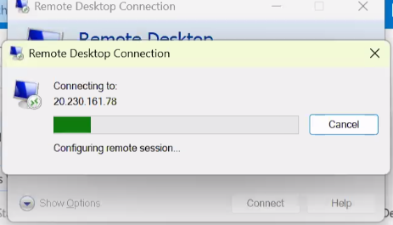
Reference screenshot — RDP connection in progress.
Checkpoint: Wait until the certificate/identity prompt or Windows desktop appears.

Step 5.6: Accept the remote computer certificate prompt
If the Remote Desktop Connection warning says the identity of the remote computer cannot be verified, review the prompt and select Yes to continue, as shown in the reference procedure.
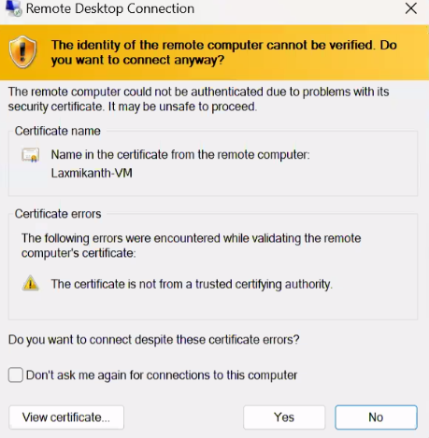
Reference screenshot — Remote Desktop identity/certificate warning.
Checkpoint: The remote session should continue.

Step 5.7: Accept diagnostic-data prompt
When Windows displays the Send diagnostic data to Microsoft screen, select Accept as shown in the reference manual.
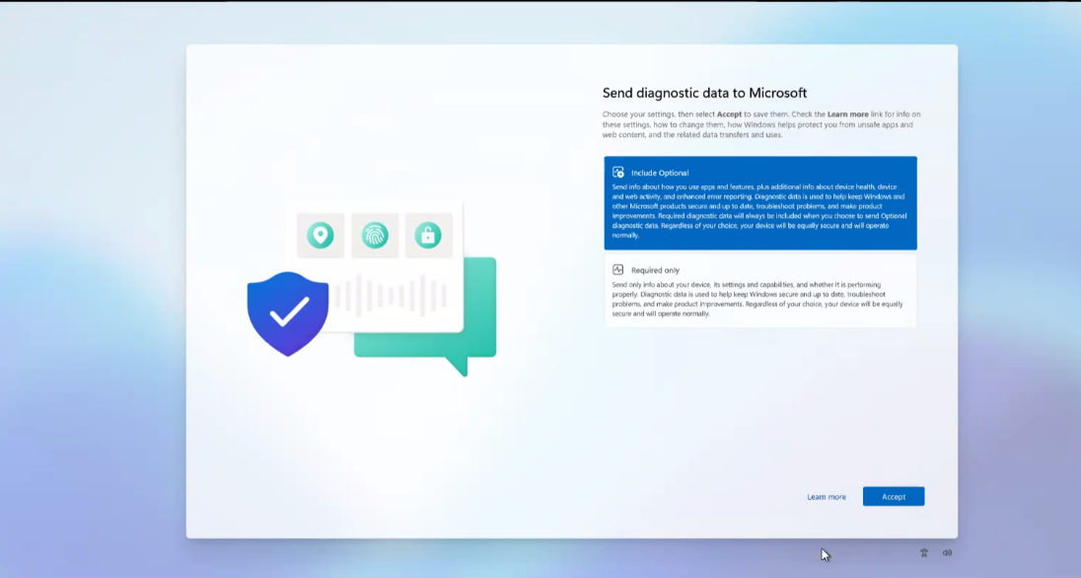
Reference screenshot — Send diagnostic data to Microsoft screen.
Checkpoint: You should reach the Windows Server session.

Step 5.8: Confirm Server Manager is visible
After the RDP session finishes loading, Server Manager should be visible. This is the starting point for installing IIS.
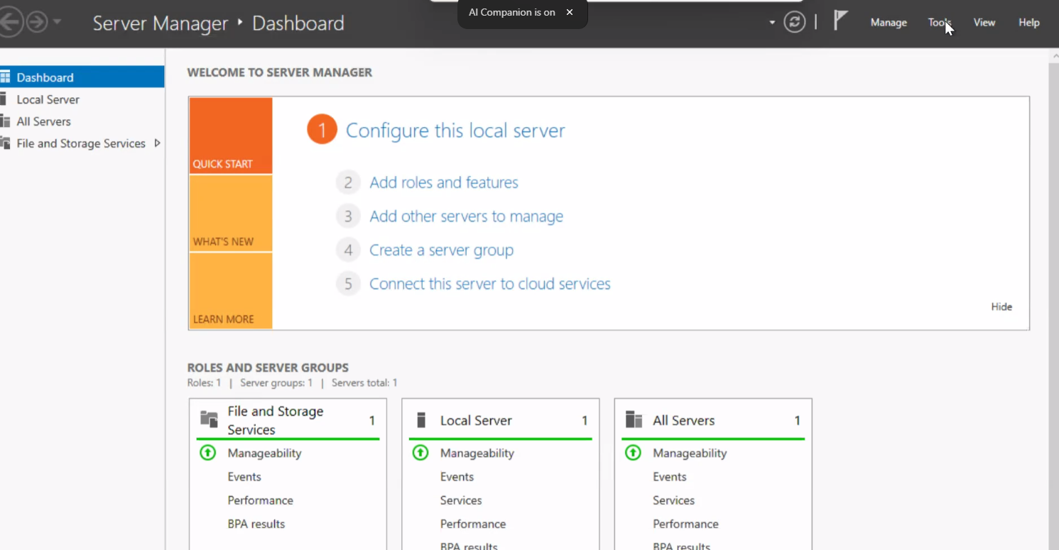
Reference screenshot — Server Manager dashboard.
Checkpoint: Server Manager should load without an error.

6. Install IIS (Web Server)
The following steps reproduce the complete IIS installation sequence from the reference document. Every reference screenshot supplied in the source manual is included below.
Step 6.1: Open Add Roles and Features
In Server Manager, select the Add roles and features link.
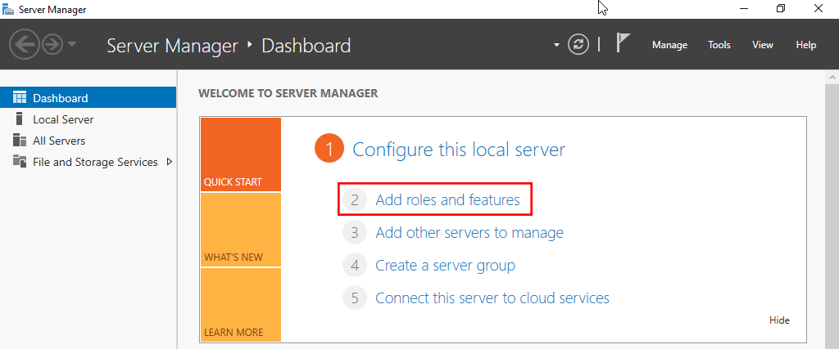
Reference screenshot — Server Manager with Add roles and features highlighted.
Checkpoint: The Add Roles and Features Wizard should open.

Step 6.2: Before you begin
On the Before you begin page, review the information and select Next.
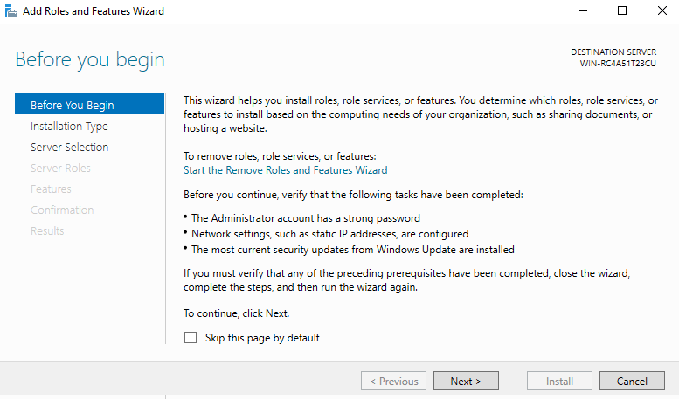
Reference screenshot — Before you begin page.
Checkpoint: The wizard should move to Select installation type.

Step 6.3: Select installation type
Leave Role-based or feature-based installation selected and select Next.
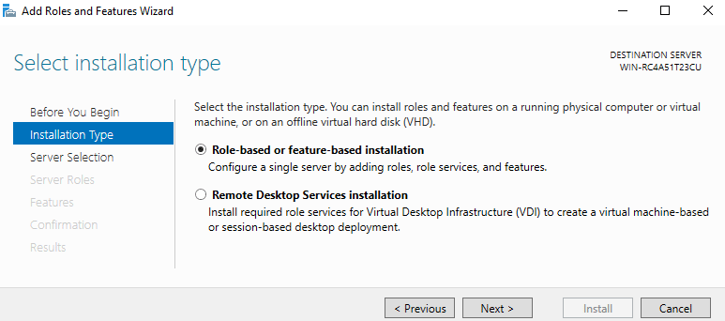
Reference screenshot — Role-based or feature-based installation.
Checkpoint: The installation type should remain Role-based or feature-based installation.

Step 6.4: Select destination server
On the Select destination server page, leave the appropriate local server selected and select Next.
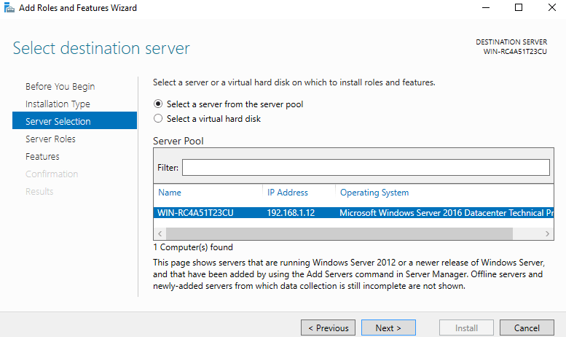
Reference screenshot — Select destination server.
Checkpoint: The intended Windows Server VM should be selected.

Step 6.5: Select Web Server (IIS)
On Select server roles, check Web Server (IIS). If Windows asks to add required features, select Add Features. Then select Next.
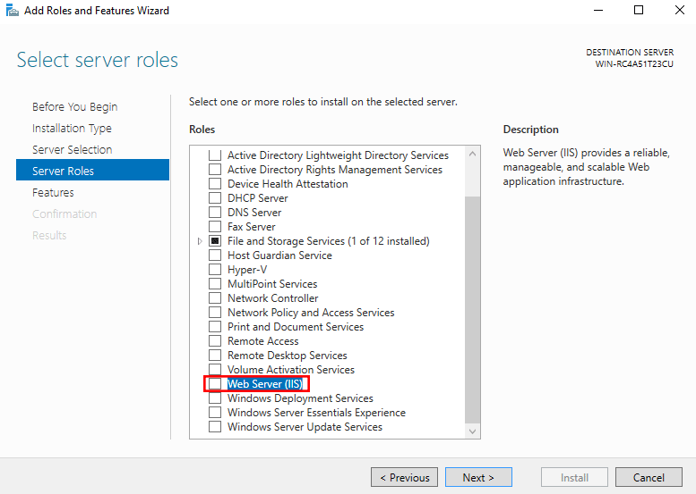
Reference screenshot — Select server roles with Web Server (IIS).
Checkpoint: Web Server (IIS) should be selected.

Step 6.6: Add required IIS features if prompted
If the Add Roles and Features Wizard displays the required features dialog, select Add Features to allow IIS to install its required management components.
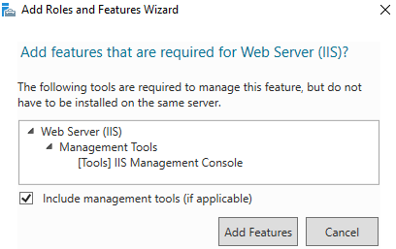
Reference screenshot — Required features for Web Server (IIS).
Checkpoint: The wizard should return to Select server roles.

Step 6.7: Select features
On the Select features page, leave the default selection unchanged and select Next.
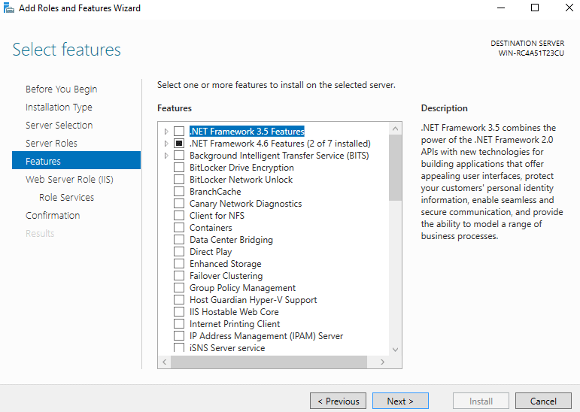
Reference screenshot — Select features.
Checkpoint: Continue with the default feature selection.

Step 6.8: Review Web Server Role information
On the Web Server Role (IIS) page, review the information and select Next.
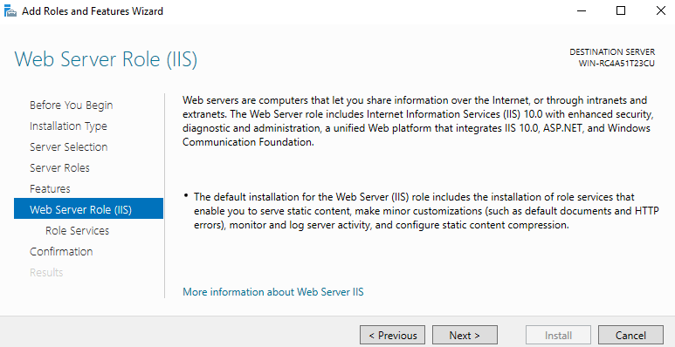
Reference screenshot — Web Server Role (IIS).
Checkpoint: The wizard should move to Select role services.

Step 6.9: Select IIS role services
On Select role services, keep the default IIS role services unless your lab requires additional services. The reference manual says additional services can be added later. Select Next.
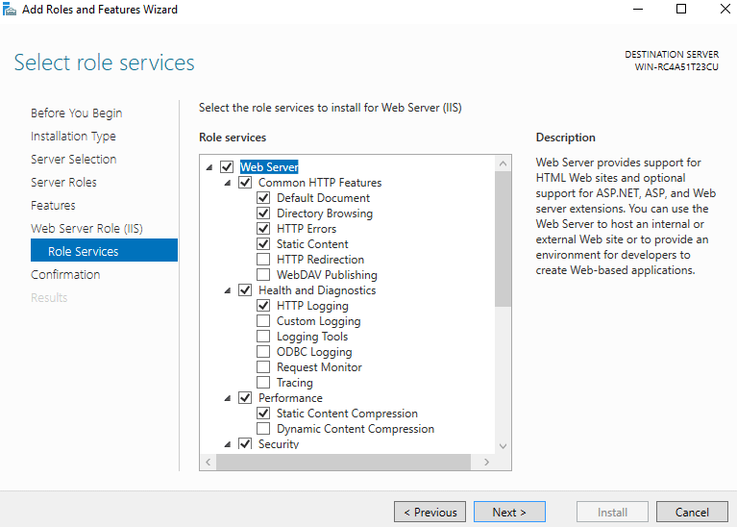
Reference screenshot — Select role services.
Checkpoint: The default IIS role services should remain selected.

Step 6.10: Confirm installation selections
On Confirm installation selections, review the items that will be installed and select Install.
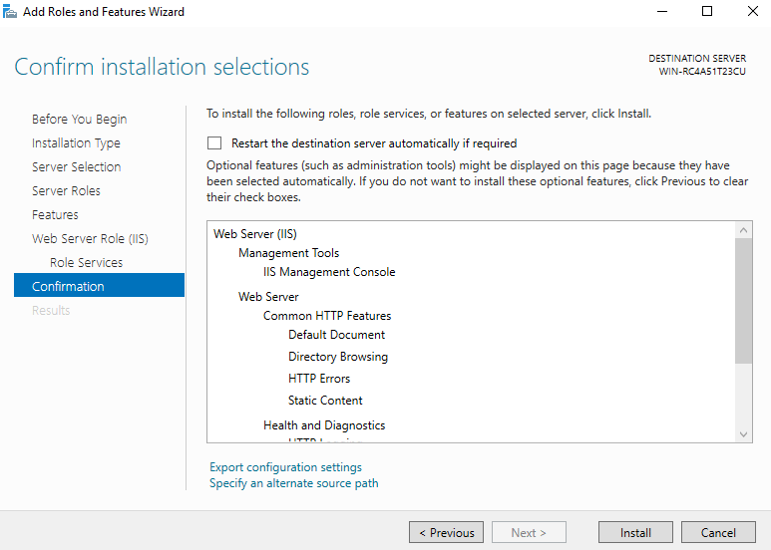
Reference screenshot — Confirm installation selections.
Checkpoint: The installation should start.

Step 6.11: Wait for IIS installation to complete
Wait while the Add Roles and Features Wizard installs IIS and its selected components.
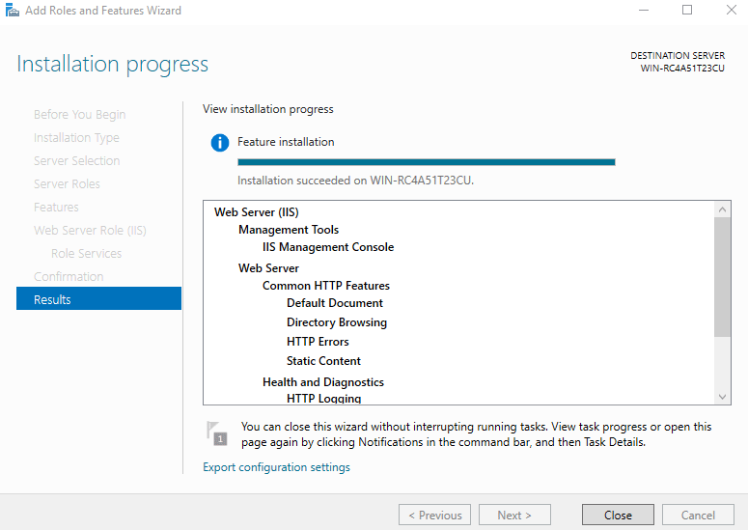
Reference screenshot — IIS installation progress/results.
Checkpoint: Installation should complete successfully.

Step 6.12: Close the wizard
When the installation succeeds, select Close. The reference manual states that IIS should be running on port 80 by default.

Reference screenshot — Installation completion/results.
Checkpoint: IIS installation is complete.

7. Validate the IIS Installation
Step 7.1: Open the default IIS page
Open a browser inside the Windows Server VM and browse to the server. The reference manual states that a successful IIS installation should display the default IIS page.
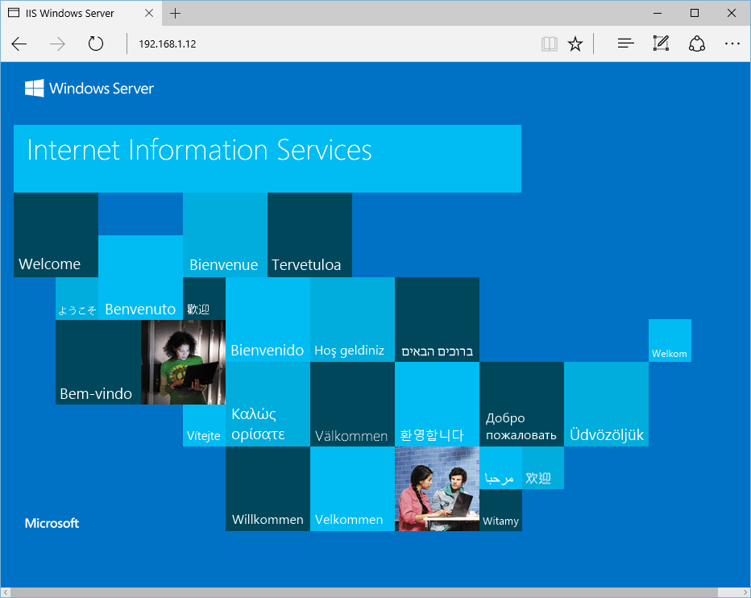
Reference screenshot — Default IIS page.
Checkpoint: If the default IIS page appears, the IIS web server is responding.

Important: The reference document explains that IIS uses HTTP port 80 by default. If the page is not reachable, check the VM networking/inbound HTTP configuration and Windows Firewall settings for the lab environment.

8. Download the SLGK-104 Website from GitHub
The reference manual ends after validating IIS. The following sections extend that workflow using the supplied SLGK-104 repository and screenshots.
Step 8.1: Open the SLGK-104 GitHub repository
Open the SLGK-104 repository in a browser. Confirm that the repository contains the website files, including index.html, style.css, script.js, the images folder, and IIS-related/default files.
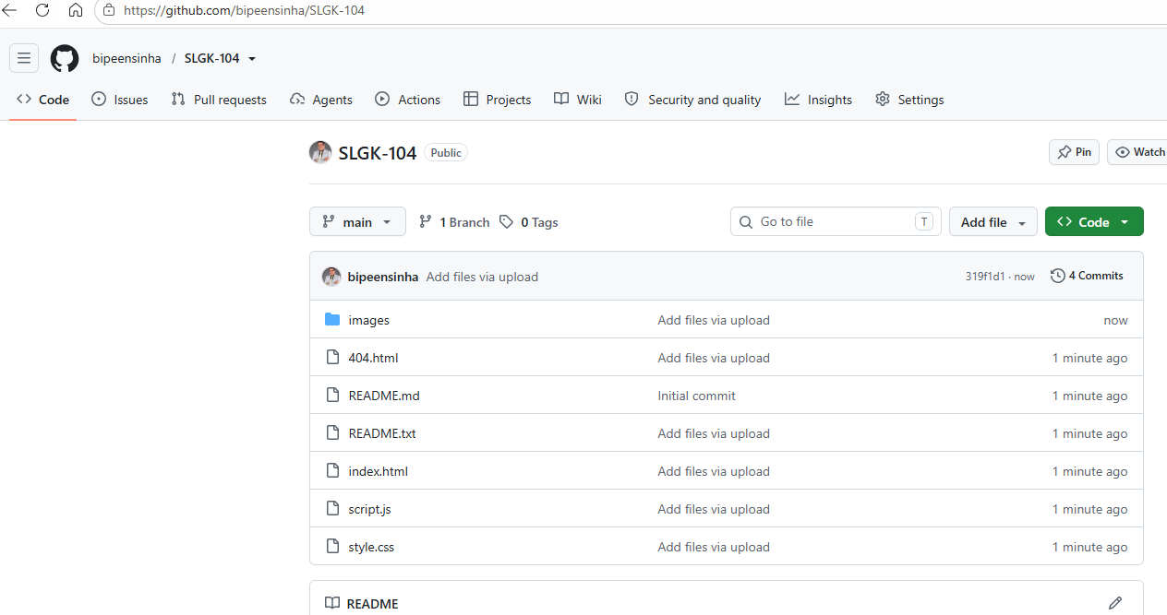
Supplied screenshot — SLGK-104 GitHub repository.
Checkpoint: You should be viewing the SLGK-104 repository.

Step 8.2: Download the repository as a ZIP
Select the GitHub Code button and choose Download ZIP. This downloads the repository as a compressed ZIP file to your Windows machine.
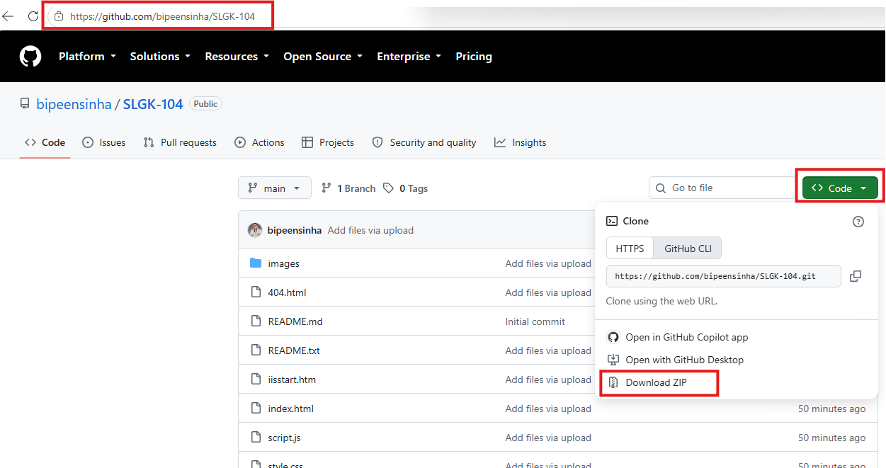
Supplied screenshot — GitHub Code menu with Download ZIP.
Checkpoint: A file similar to SLGK-104-main.zip should appear in Downloads.

9. Extract and Copy the Website Files
Step 9.1: Extract the downloaded ZIP
Open the Downloads folder. Locate SLGK-104-main.zip, right-click it, and select Extract All. Complete the extraction using the default destination or a convenient working folder.
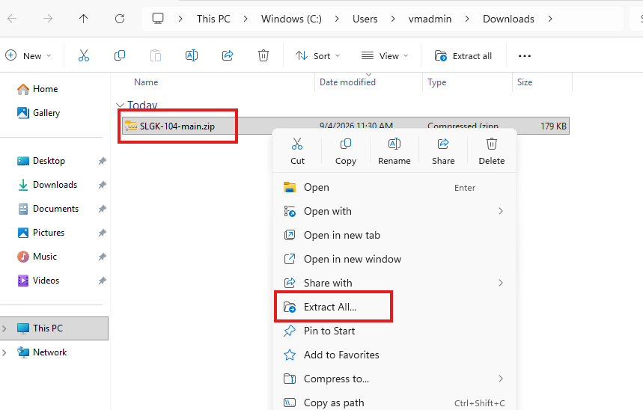
Supplied screenshot — Extract All option for the downloaded ZIP.
Checkpoint: An extracted folder such as SLGK-104-main should be created.

Step 9.2: Select and copy the website files
Open the extracted SLGK-104-main folder. Select the website files and folders required by the project and copy them.
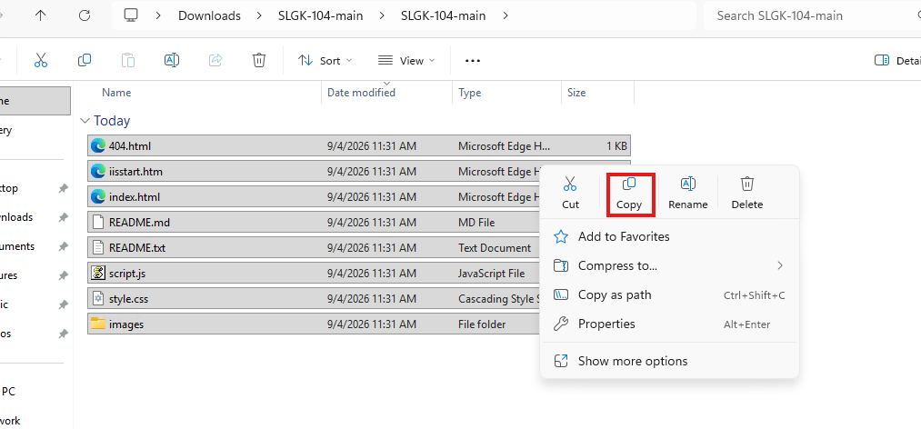
Supplied screenshot — Extracted project files selected for copying.
Checkpoint: The required HTML/CSS/JavaScript/images files should be in the copy selection.

Step 9.3: Use the supplied file-copy workflow
Follow the copy/paste action shown in the supplied screenshot so that the website files are ready to be placed into IIS's web root.
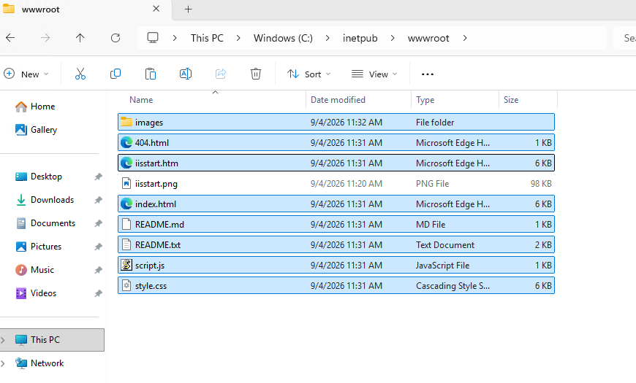
Supplied screenshot — Code/file copy workflow.
Checkpoint: The website files should be ready for deployment to C:\inetpub\wwwroot.

10. Deploy the Website to IIS wwwroot
Step 10.1: Open File Explorer
Inside the Windows Server VM, open File Explorer. Navigate to the C: drive and locate the inetpub folder.
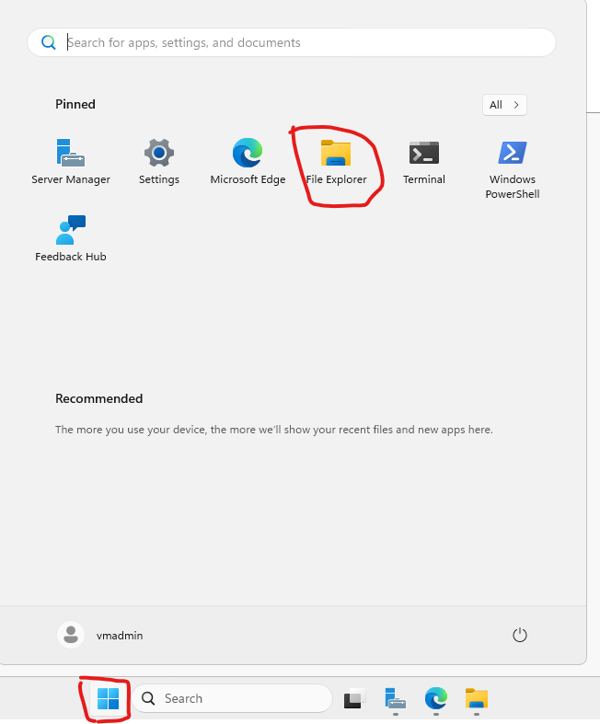
Supplied screenshot — Windows File Explorer navigation.
Checkpoint: The C:\inetpub folder should be visible.

Step 10.2: Open the inetpub folder
Open C:\inetpub and locate the wwwroot folder. IIS uses this folder as the default web root for the default website.
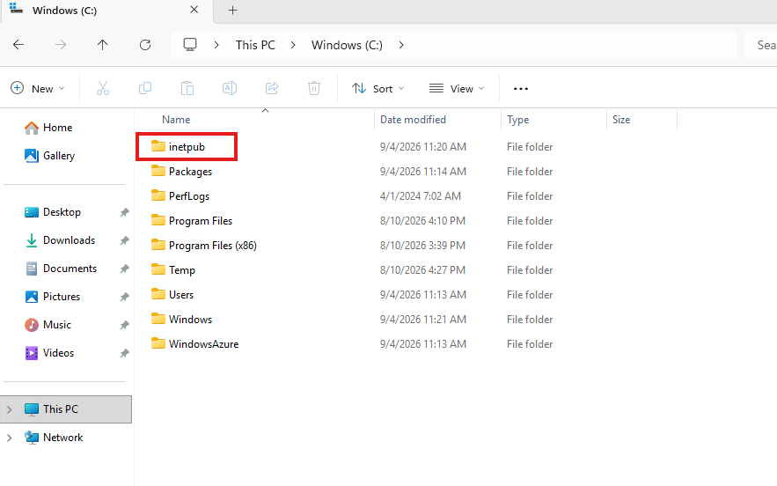
Supplied screenshot — C:\inetpub showing wwwroot.
Checkpoint: The wwwroot folder should be present.

Step 10.3: Open wwwroot and replace/copy the website content
Open C:\inetpub\wwwroot. Copy the SLGK-104 website files into this folder. If the lab already contains the default IIS files, replace or rename them only as directed by the lab environment.
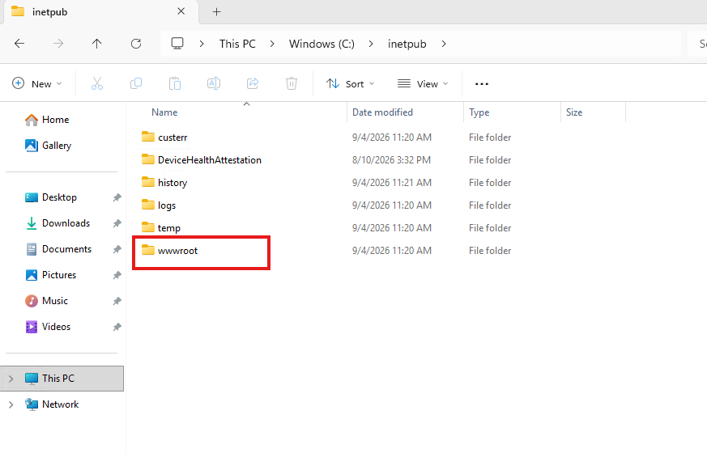
Supplied screenshot — IIS wwwroot with website files.
Checkpoint: index.html, style.css, script.js and the required images should be available under wwwroot.

Deployment rule: The browser must ultimately request files from IIS's configured website root. If files are copied to another folder, the browser may continue to show the default IIS page.

11. Test the Restaurant Website
Step 11.1: Check the IIS page before/after deployment
Use the browser to confirm the server responds. If you still see the default IIS page after copying the application, verify the IIS site root and default document configuration before continuing.
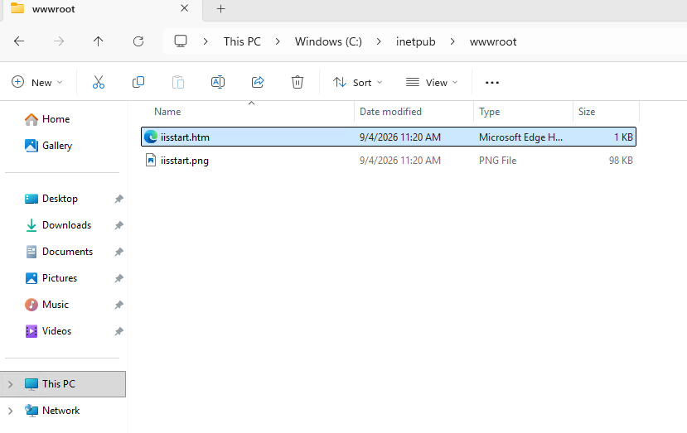
Supplied screenshot — IIS/default website page.
Checkpoint: The server should respond over HTTP.

Step 11.2: Open the deployed SLGK-104 website
In the browser, browse to the VM's public IP address over HTTP. Confirm that the Spice Garden / restaurant website loads correctly, including its HTML layout, CSS styling, JavaScript behavior, and images.

Supplied screenshot — Final SLGK-104 restaurant website.
Checkpoint: The final restaurant website should render instead of the default IIS page.

12. Troubleshooting Checklist
Symptom | Likely check | Action
Cannot RDP to VM | Public IP / RDP access | Confirm the correct public IP and that RDP access is permitted by the lab configuration.
IIS default page appears | Website files / default document | Verify the SLGK-104 files are in C:\inetpub\wwwroot and that the intended start page is configured.
Website loads but images are missing | images folder / relative paths | Confirm the images folder was copied and that HTML references use the correct relative paths.
CSS is missing | style.css path | Confirm style.css exists in wwwroot and the HTML references the correct filename.
JavaScript is not working | script.js path | Confirm script.js exists and is referenced correctly by the HTML.
Browser cannot reach site | HTTP access / port 80 | Check the Azure inbound HTTP configuration and Windows Firewall rules for the lab environment.

13. Learning Objectives
By the end of this lab, learners should be able to:
- Understand Azure VM architecture and components.
- Explain the purpose of subscription and resource group.
- Select an appropriate VM image and size based on requirements.
- Configure inbound connectivity for RDP and HTTP in the lab environment.
- Understand Azure disk options.
- Deploy and access a Windows VM using RDP.
- Install and validate IIS Web Server.
- Deploy a static HTML/CSS/JavaScript website to IIS wwwroot.
- Test a hosted website through the VM public IP.

14. Evidence / Completion Checklist
- ☐ Azure VM created successfully.
- ☐ VM is running.
- ☐ Public IP captured.
- ☐ RDP connection established.
- ☐ Server Manager opened.
- ☐ IIS role installed successfully.
- ☐ Default IIS page validated.
- ☐ SLGK-104 repository downloaded.
- ☐ ZIP extracted.
- ☐ Website files copied to C:\inetpub\wwwroot.
- ☐ Restaurant website opened successfully from the VM public IP.

Appendix A — Screenshot Traceability
This appendix explicitly records the reference-document screenshots included in this revised manual, in the same instructional sequence as the source document.
Reference image | Lab step | Purpose
image3.png | 4.1 | Azure search for Virtual Machines
image4.png | 4.2 | Create Virtual Machine entry point
image5.png | 4.4 | VM Basics configuration
image6.png | 4.5 | Disk configuration
image7.png | 4.6 | VM resource overview
image8.png | 5.1 | Public IP address
image9.png | 5.2 | Launch Remote Desktop
image10.png | 5.3 | RDP computer/IP and Connect
image11.png | 5.4 | Windows Security credentials
image12.png | 5.5 | RDP connection progress
image13.png | 5.6 | Certificate/identity prompt
image14.png | 5.7 | Diagnostic-data screen
image15.png | 5.8 | Server Manager dashboard
image16.png | 6.1 | Add roles and features
image17.png | 6.2 | Before you begin
image18.png | 6.3 | Installation type
image19.png | 6.4 | Destination server
image20.png | 6.5 | Select server roles
image21.png | 6.6 | Required IIS features
image22.png | 6.7 | Select features
image23.png | 6.8 | Web Server Role (IIS)
image24.png | 6.9 | Select role services
image25.png | 6.10 | Confirm installation selections
image26.png | 6.11–6.12 | Installation progress/results
image27.png | 7.1 | Default IIS page

Reference and Repository
Primary reference document: AzureVM_With_IIS.docx — supplied with this lab request.
Application repository: https://github.com/bipeensinha/SLGK-104
Repository description: IIS with HTML CSS | Restaurant Website

