ShopSmart E-Commerce Recommendation System
Hands-on Lab: Unsupervised Learning with Apriori Association Rules
Python + Flask + JavaScript + MLxtend + Sample E-Commerce Data

Lab Level | Beginner to Intermediate
Learning Type | Unsupervised Learning
Algorithm | Apriori / Association Rule Mining
Application | E-Commerce Product Recommendation

1. Lab Overview
In this lab, you will build a small e-commerce website that recommends products customers are likely to buy together. The recommendation engine learns product associations from historical orders instead of using predefined recommendation lists.

Business Scenario
Imagine an online store with historical orders. If many customers purchase a Laptop with a Mouse and Laptop Bag, the system can learn that relationship and show those items as recommendations when a customer selects a Laptop.

Learning Objectives
- Understand a practical example of unsupervised learning.
- Prepare transaction/basket data for association rule mining.
- Generate frequent itemsets using the Apriori algorithm.
- Generate association rules using support and confidence.
- Expose recommendations through a Flask REST-style endpoint.
- Connect a JavaScript e-commerce interface to the Python backend.
- Test recommendations from the browser and explain the end-to-end flow.

End-to-End Flow
Historical Orders → Transaction Encoding → Apriori → Association Rules → Flask API → JavaScript → E-Commerce Recommendations
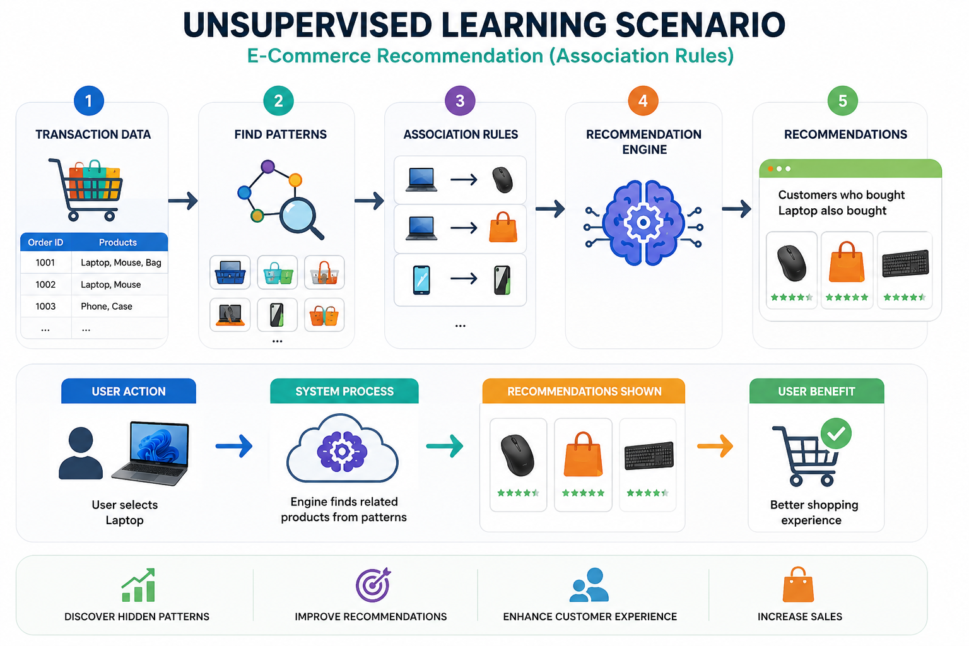

2. Prerequisites
- Windows 10/11 or equivalent development environment.
- Python 3.x installed.
- VS Code or another Python editor.
- Basic Python knowledge: variables, lists, functions, imports.
- Basic HTML/CSS/JavaScript knowledge is helpful but not required.
- A browser such as Edge or Chrome.

3. Lab Files
File | Purpose
app.py | Python/Flask backend and Apriori recommendation engine.
transactions.csv | Historical e-commerce transaction dataset.
requirements.txt | Python packages required by the application.
templates/index.html | E-commerce webpage.
static/style.css | Website styling.
static/script.js | Browser interaction and calls to the Python API.
static/developer-photo.svg | Placeholder developer image.

4. Environment Setup
Step 1 – Open the project
Extract the supplied ShopSmart ZIP and open the extracted folder in VS Code.
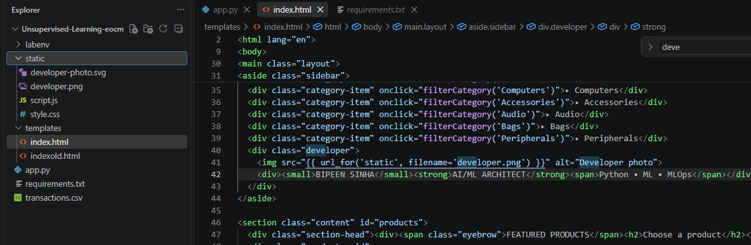
Step 2 – Open a terminal
In VS Code, select Terminal → New Terminal. Make sure the terminal is inside the project folder.
Step 3 – Create a virtual environment
This keeps the lab packages isolated from other Python projects.
python -m venv labenv

Step 4 – Activate the environment
On Windows PowerShell, activate the virtual environment.
.\labenv\Scripts\Activate.ps1

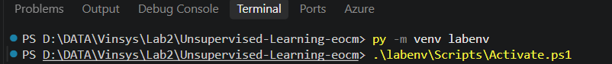
If PowerShell blocks activation, you can alternatively run the Python executable directly from the environment or use Command Prompt with the corresponding activate.bat file.
Step 5 – Install packages
Install Flask, Pandas, and MLxtend from requirements.txt.
pip install -r requirements.txt
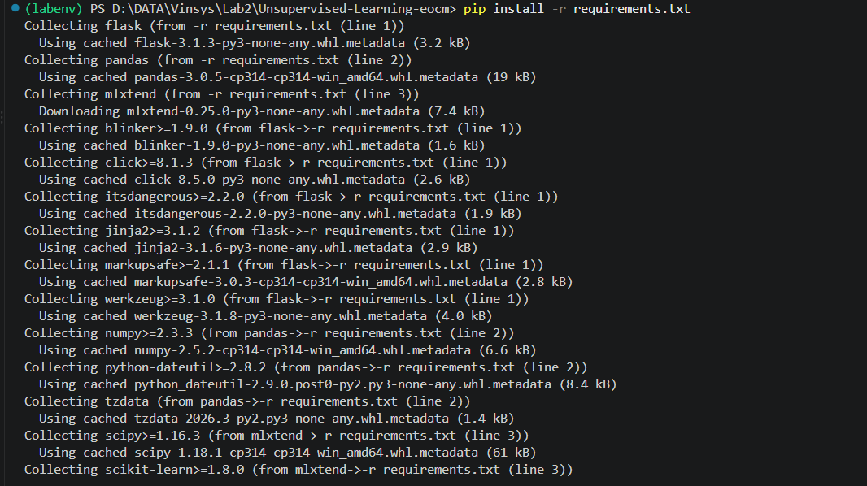
Step 6 – Verify installation
Confirm that Flask, Pandas, and MLxtend are available.
pip show flask pandas mlxtend

5. Understand the Dataset
The dataset contains one row per customer order. The Products column contains the items purchased together in that order.
OrderID | Products
1001 | Laptop,Mouse,Laptop Bag
1002 | Laptop,Mouse
1003 | Laptop,Laptop Bag
1004 | Phone,Phone Case,Screen Guard
1005 | Phone,Phone Case
1006 | Laptop,Mouse,Keyboard
1007 | Phone,Earphones
1008 | Laptop,Mouse,Laptop Bag
The supplied ZIP contains the complete sample dataset. You can open transactions.csv in VS Code to inspect all rows.
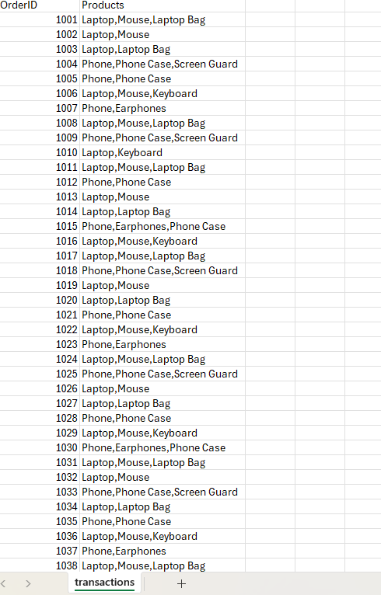

Why this is Unsupervised Learning
There is no target column such as Yes/No, Fraud/Not Fraud, or Churn/No Churn. The algorithm discovers relationships among products from the transaction history.

6. Understand the Python Backend
Open app.py. The important sections are described below.
from flask import Flask, render_template, request, jsonify
import pandas as pd
from mlxtend.preprocessing import TransactionEncoder
from mlxtend.frequent_patterns import apriori, association_rules

app = Flask(__name__)

data = pd.read_csv("transactions.csv")
transactions = data["Products"].apply(lambda x: [p.strip() for p in x.split(",")]).tolist()

encoder = TransactionEncoder()
basket = pd.DataFrame(
encoder.fit(transactions).transform(transactions),
columns=encoder.columns_
)

frequent_items = apriori(basket, min_support=0.20, use_colnames=True)
rules = association_rules(frequent_items, metric="confidence", min_threshold=0.40)

PRODUCTS = sorted({p for t in transactions for p in t})
PRODUCT_INFO = {
"Laptop": {"price": 750, "emoji": ""},
"Mouse": {"price": 25, "emoji": "🖱️"},
"Laptop Bag": {"price": 35, "emoji": ""},
"Keyboard": {"price": 45, "emoji": "⌨️"},
"Phone": {"price": 450, "emoji": ""},
"Phone Case": {"price": 15, "emoji": ""},
"Screen Guard": {"price": 10, "emoji": "🛡️"},
"Earphones": {"price": 20, "emoji": ""},
}

def get_recommendations(products):
selected = set(products)
scores = {}
for _, rule in rules.iterrows():
if set(rule["antecedents"]).intersection(selected):
for item in set(rule["consequents"]):
if item not in selected:
scores[item] = max(scores.get(item, 0), float(rule["confidence"]))
ranked = sorted(scores.items(), key=lambda x: x[1], reverse=True)[:4]
return [
{
"product": item,
"confidence": round(conf * 100),
"price": PRODUCT_INFO.get(item, {"price": 0})["price"],
"emoji": PRODUCT_INFO.get(item, {"emoji": "🛍️"})["emoji"]
}
for item, conf in ranked
]

@app.route("/")
def home():
return render_template("index.html", products=PRODUCTS, product_info=PRODUCT_INFO)

@app.route("/recommend", methods=["POST"])
def recommend():
payload = request.get_json(silent=True) or {}
products = payload.get("products", [])
return jsonify({"selected": products, "recommendations": get_recommendations(products)})

if __name__ == "__main__":
app.run(debug=True)

Step A – Load the data
Pandas reads the CSV file into a DataFrame.
data = pd.read_csv("transactions.csv")
Step B – Create transactions
Each Products string is split into a Python list representing one shopping basket.
transactions = data["Products"].apply(lambda x: [p.strip() for p in x.split(",")]).tolist()
Step C – Encode baskets
TransactionEncoder converts product lists into a one-hot table of True/False values.
encoder = TransactionEncoder()
basket = pd.DataFrame(
encoder.fit(transactions).transform(transactions),
columns=encoder.columns_
)
Step D – Find frequent itemsets
Apriori identifies combinations of products that appear frequently in the orders.
frequent_items = apriori(basket, min_support=0.20, use_colnames=True)
Step E – Generate association rules
Association rules are created using confidence as the rule-quality measure.
rules = association_rules(frequent_items, metric="confidence", min_threshold=0.40)
Step F – Generate recommendations
get_recommendations() checks learned rules against selected products and returns the strongest associated items.
Step G – Expose the API
The /recommend endpoint receives selected products from JavaScript and returns recommendations as JSON.
@app.route("/recommend", methods=["POST"])
def recommend():
payload = request.get_json(silent=True) or {}
products = payload.get("products", [])
return jsonify({
"selected": products,
"recommendations": get_recommendations(products)
})

7. Apriori Concepts to Explain During the Demo
Term | Simple Meaning | Lab Example
Support | How often an itemset appears in all orders. | Laptop + Mouse occurs in many baskets.
Confidence | How often the consequent appears when the antecedent appears. | Laptop → Mouse has high confidence if most Laptop orders also contain Mouse.
Association Rule | A learned relationship between items. | Laptop → Laptop Bag
Frequent Itemset | A product combination that occurs often enough. | {Laptop, Mouse}
For this training demo, min_support=0.20 and confidence threshold=0.40 are intentionally simple values. Changing these thresholds changes which patterns are considered strong enough.

8. Start the Application
Step 1 – Run Flask
Keep the terminal in the project directory and run the Python backend.
python app.py
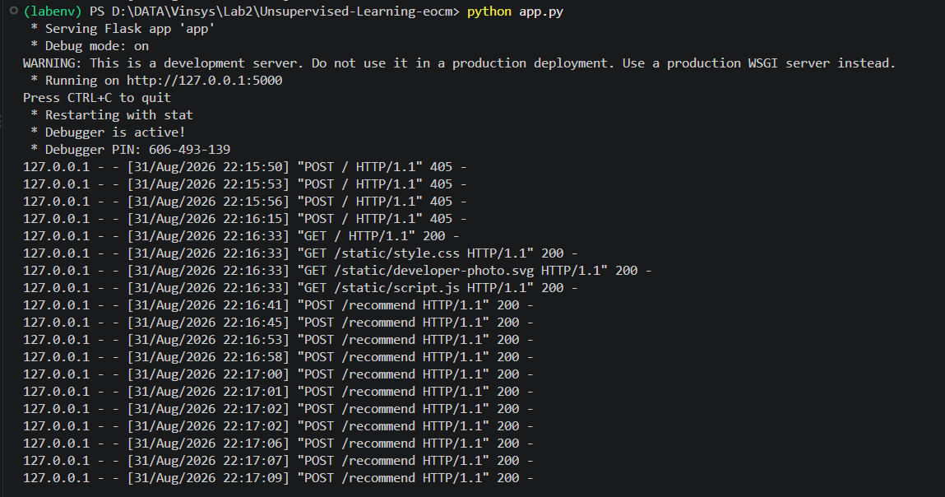
Step 2 – Open the website
When Flask starts, open the local address shown in the terminal, normally:
http://127.0.0.1:5000
Do not type Python commands into the browser. Python commands are run in the VS Code terminal; the browser is used to interact with the website.
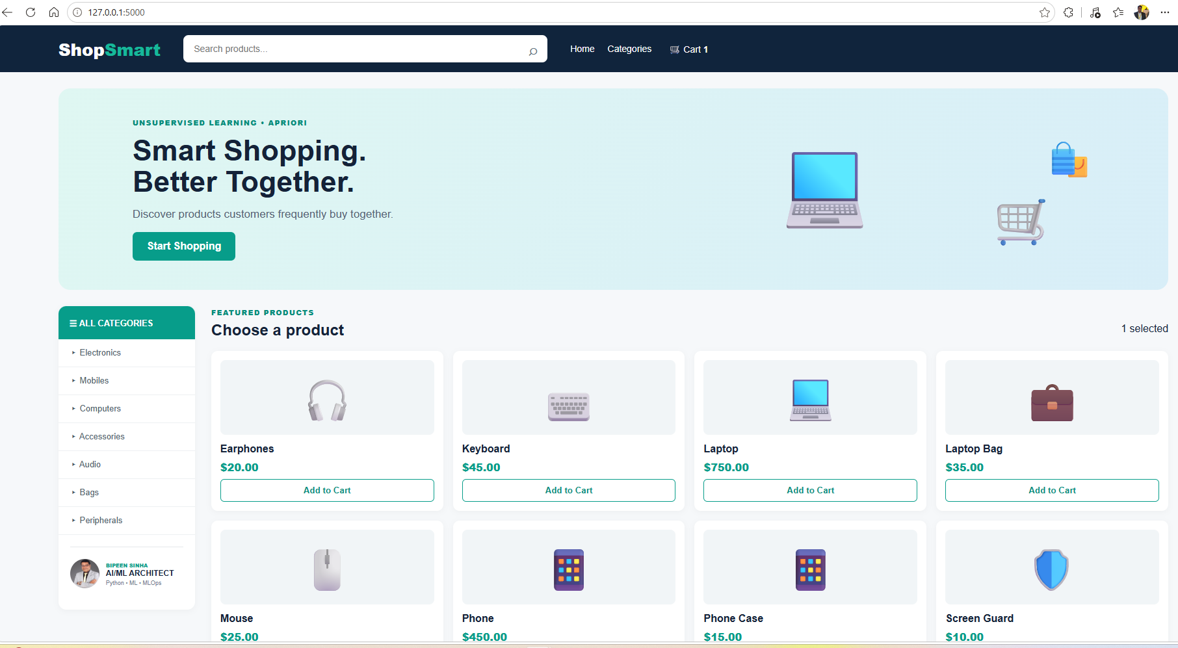

9. Perform the E-Commerce Recommendation Demo
Step 1 – Click Start Shopping
The page moves to the product area.
Step 2 – Select Laptop
Click Add to Cart under Laptop. The product is added to the cart and sent to the recommendation engine.
Step 3 – Observe recommendations
The AI Recommendation Engine section is populated from the Flask /recommend endpoint.
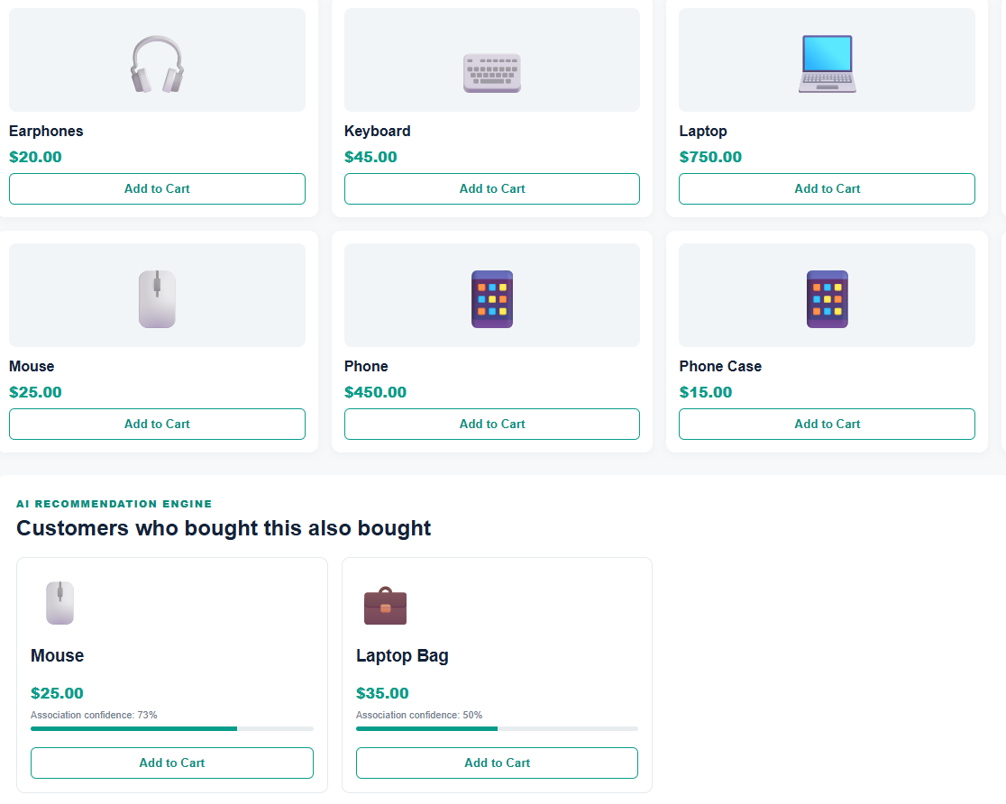
Step 4 – Select a recommended item
Click Add to Cart on a recommended product. The selected basket and recommendations update.
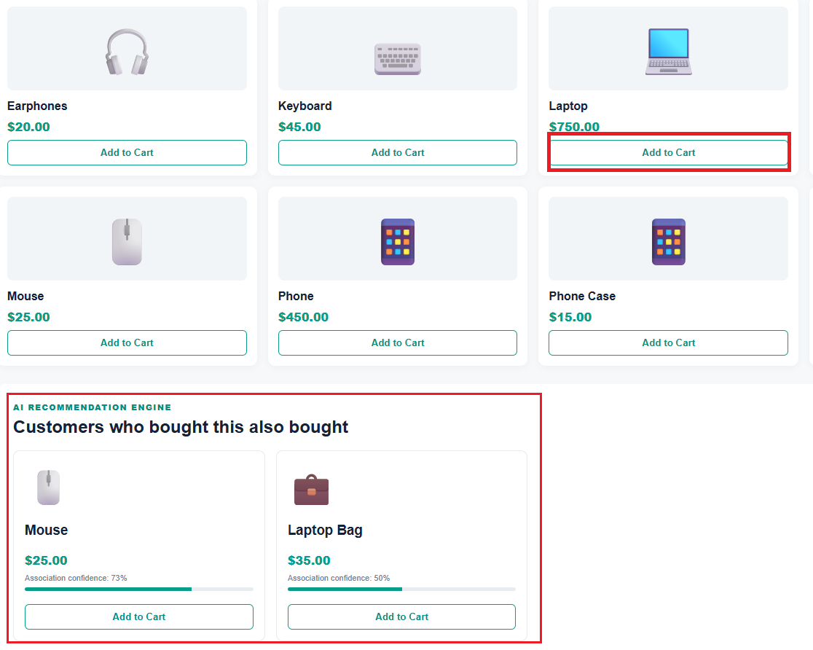
Step 5 – Open Cart
Click the Cart button in the top navigation to open the cart drawer.
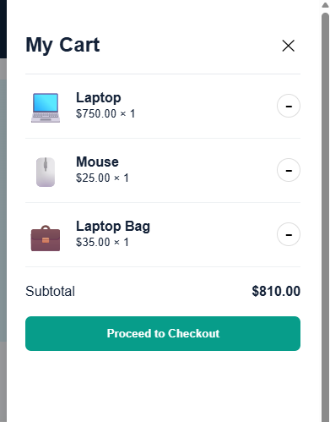
Step 6 – Remove an item
Use the minus button to remove one item and observe the subtotal change.
Step 7 – Search
Enter a product name in the search box to filter products.
Step 8 – Try categories
Click a category such as Computers, Audio, or Bags and observe the product filtering.
Step 9 – Checkout
Click Proceed to Checkout. This is a training-only checkout message; no real payment is processed.

Suggested Demo Sequence
For a classroom demonstration, select Laptop first. Then explain that the backend looks at historical baskets and searches the association rules it learned. Select Mouse or Laptop Bag next and show how the recommendations change.

10. Explain the Architecture
Layer | Technology | What Happens
Browser | HTML/CSS/JavaScript | Customer selects products.
JavaScript | fetch('/recommend') | Sends selected products to Python.
Flask | /recommend API | Receives JSON and calls recommendation logic.
ML Engine | Apriori + association_rules | Finds product relationships.
Flask | JSON response | Returns recommended products and confidence.
Browser | Recommendation cards | Displays results to the customer.

11. How JavaScript Connects to Python
The frontend does not directly run Apriori. It calls the Flask API using JavaScript fetch(). This separation is useful because the ML logic remains in Python while the website remains a frontend application.
const response = await fetch("/recommend", {
method: "POST",
headers: {"Content-Type": "application/json"},
body: JSON.stringify({products: selectedProducts})
});
const data = await response.json();
The Python API returns JSON similar to:
{
"selected": ["Laptop"],
"recommendations": [
{"product": "Mouse", "confidence": 90, "price": 25, "emoji": "🖱️"}
]
}

12. Suggested Test Cases
Test Case | Action | Expected Result | Status
TC01 | Open home page | ShopSmart page loads
TC02 | Click Add to Cart | Cart count increases
TC03 | Select Laptop | Recommendations appear when rules match
TC04 | Open Cart | Cart drawer opens
TC05 | Remove item | Item quantity and subtotal decrease
TC06 | Search 'Phone' | Phone-related products remain visible
TC07 | Click Audio category | Earphones is shown
TC08 | Checkout with empty cart | Empty-cart message appears
TC09 | Checkout with items | Demo checkout message appears
TC10 | Stop Flask and refresh | Frontend cannot obtain recommendations

13. Troubleshooting
ModuleNotFoundError: No module named 'flask' / 'pandas' / 'mlxtend'
- Activate labenv and run: pip install -r requirements.txt
Address already in use
- Stop the previous Flask process or use another port. If you changed the port, open that port in the browser.
Recommendations are empty
- Check that transactions.csv is in the same directory as app.py and that selected products exist in the dataset. You can also lower min_support or min_threshold for experimentation.
Browser says unable to contact recommendation service
- Make sure python app.py is still running and that the browser is using the same Flask address.
PowerShell activation is blocked
- Use Command Prompt, activate with the Windows batch file, or run the Python interpreter from labenv directly.

14. Hands-on Exercises
- Change min_support from 0.20 to 0.10. Run the application and compare the number of learned rules.
- Change min_threshold from 0.40 to 0.70. Observe whether fewer recommendations are returned.
- Add a new product combination to transactions.csv and restart the application. Observe whether the learned associations change.
- Change the developer name in index.html.
- Replace the placeholder developer-photo.svg with a real developer image.
- Add one new product card and corresponding price/emoji information.
- Create a test case that verifies the /recommend endpoint when no product is selected.

15. Key Takeaway
Orders → Patterns → Rules → Recommendations
This demo shows how an unsupervised learning algorithm can discover useful relationships without a labeled target. In a production e-commerce platform, the same idea can be combined with additional signals such as customer history, product popularity, inventory, price, and real-time behavior.

16. Instructor / Tester Focus
For testers, focus on validating the complete workflow rather than only the ML algorithm: dataset loading, API request/response, recommendation behavior, UI state, cart calculations, search/category filters, empty states, and failure handling.

