Identify compatibility issues for SQL migration
In our scenario, you've been asked to assess the readiness of a legacy SQL Server database for migration to Azure SQL Database. Your task is to perform an assessment of their legacy database and identify any potential compatibility issues or changes that need to be made before migration. You should also review the schema of the database and identify any features or configurations that aren't supported in Azure SQL Database.

Download in a folder C:\LabFiles from below url

https://github.com/Microsoft/sql-server-samples/releases/download/adventureworks/AdventureWorksLT2019.bak
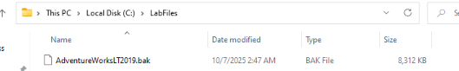

Restore a SQL Server database and run a command
- Select the Windows Start button and type SSMS. Select Microsoft SQL Server Management Studio 18 from the list.
- When SSMS opens, notice that the Connect to Server dialog will be pre-populated with the default instance name. Select Connect.
- Select the Databases folder, and then New Query.
- In the new query window, copy and paste the below T-SQL into it. Ensure that the database backup file name and path match your actual backup file. If they don’t, the command will fail. Execute the query to restore the database.
RESTORE DATABASE AdventureWorksLT
FROM DISK = 'C:\Labfiles\AdventureWorksLT2019.bak'
WITH RECOVERY,
MOVE 'AdventureWorksLT2019_Data'
TO 'C:\ Labfiles\AdventureWorksLT2019.mdf',
MOVE 'AdventureWorksLT2019_Log'
TO 'C:\ Labfiles\ AdventureWorksLT2019.ldf';

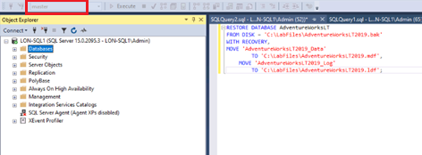

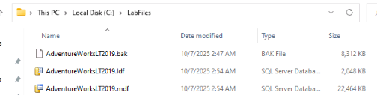
Run the following command on the AdventureWorksLT database in the SQL Server instance.

ALTER TABLE [SalesLT].[Customer] ADD [Next] VARCHAR(5);
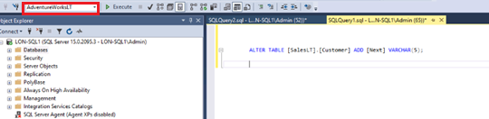

Install and launch the Azure migration extension for Azure Data Studio

- Open the extensions manager in Azure Data Studio.
- Search for Azure SQL Migration, and install the extension. Once you install it, the Azure SQL Migration extension is in the list of installed extensions.
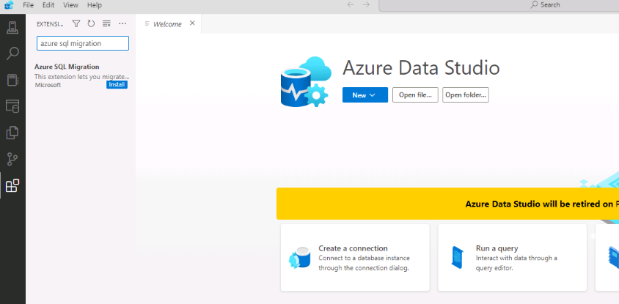

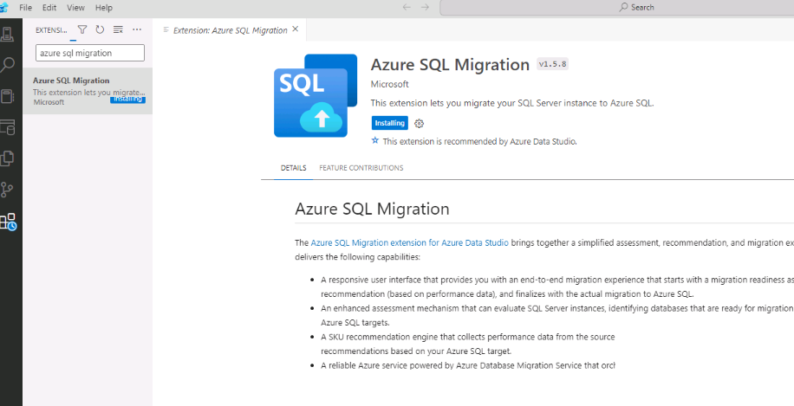

- Select the Connections icon, and then select New Connection.
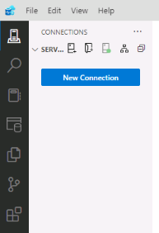
- In the new Connection tab, type the server name. Select Optional (False) for the Encrypt option.
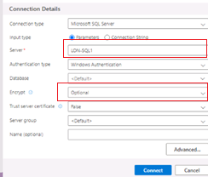
- Select Connect.
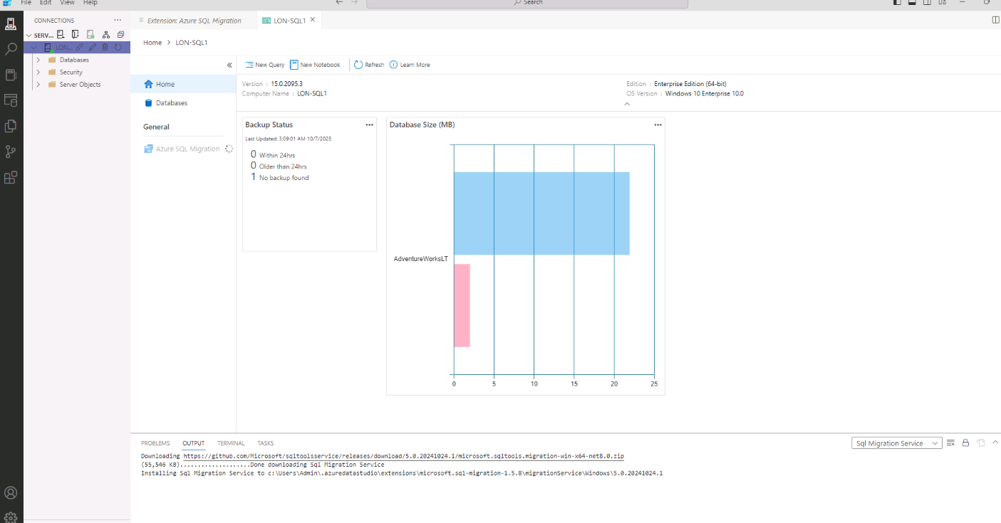
- To launch the Azure migration extension, simply right-click on the name of the source instance and select Manage.
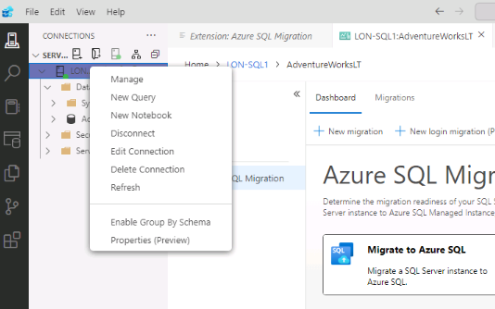
- In the server menu, under General, select Azure SQL Migration. This will take you to the main page of the Azure SQL Migration extension.
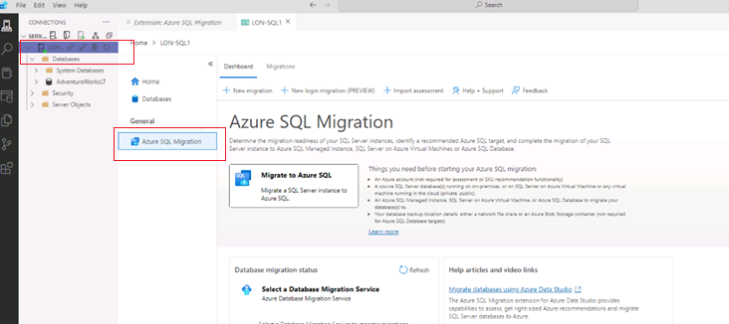

Run the compatibility assessment
The compatibility assessment helps identify potential migration issues and provides detailed guidance on how to resolve them before the migration process begins. This can save significant time and resources.
You'll run the Azure migration extension for Azure Data Studio, run the compatibility assessment, and then view the results for an Azure SQL Database target.
- In the Azure SQL Migration dashboard, select Migrate to Azure SQL to open the migration wizard.
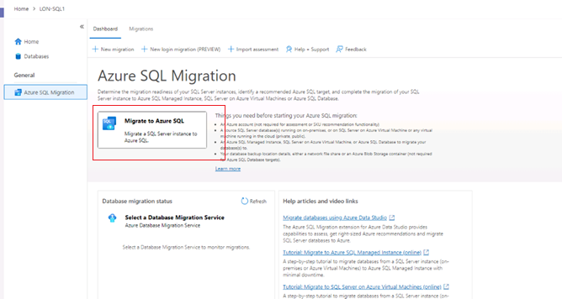
- On Step 1: Databases for assessment, select No on "Do you want to track the migration process in Azure portal?", then select the AdventureWorksLT database. Select Next.
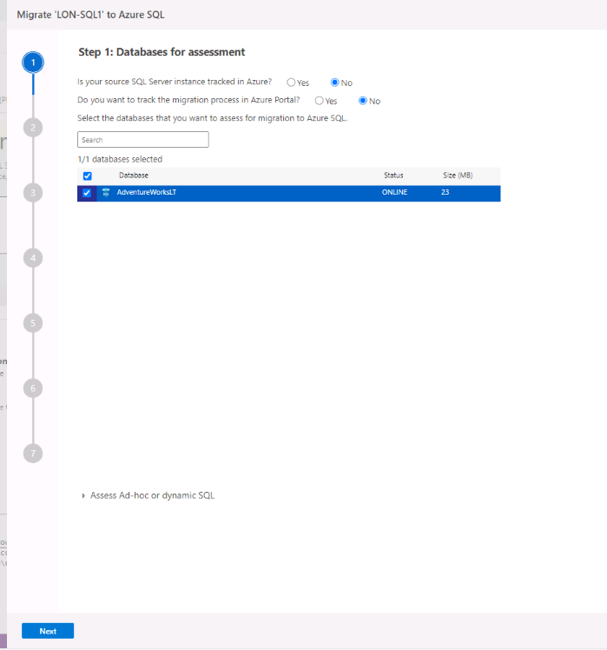
- On Step 2: Assessment results and SKU recommendations, wait for the assessment to complete and select Next.
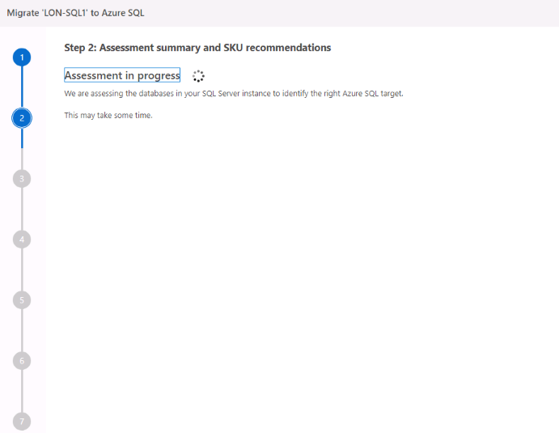

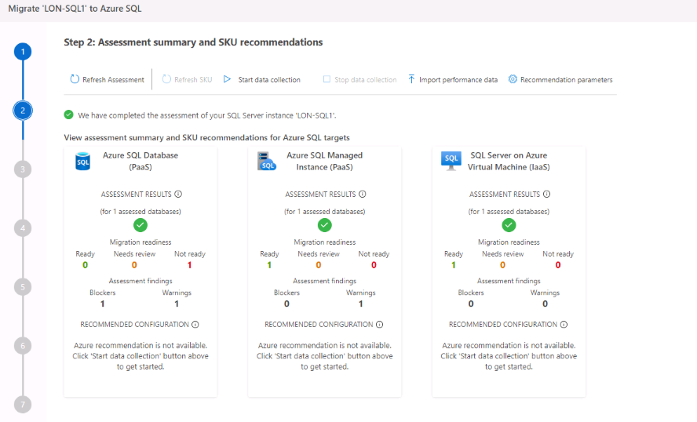
Review the assessment results
You are now able to review the recommendations generated by the migration extension.
- On Step 3: Target platform & assessment results, select Azure SQL Database as the target platform.
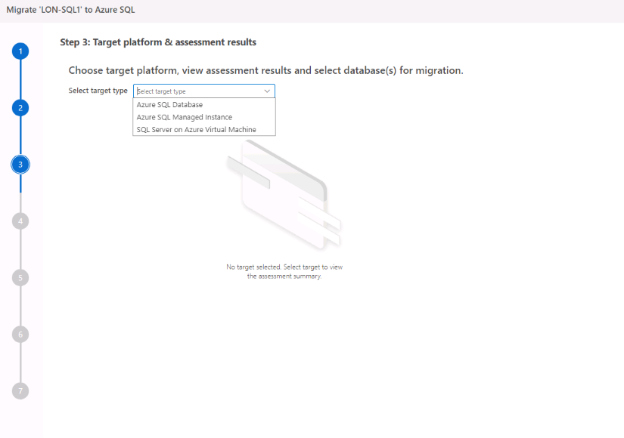
- Select the AdventureWorks database. Take a moment to review the assessment results on the right side.
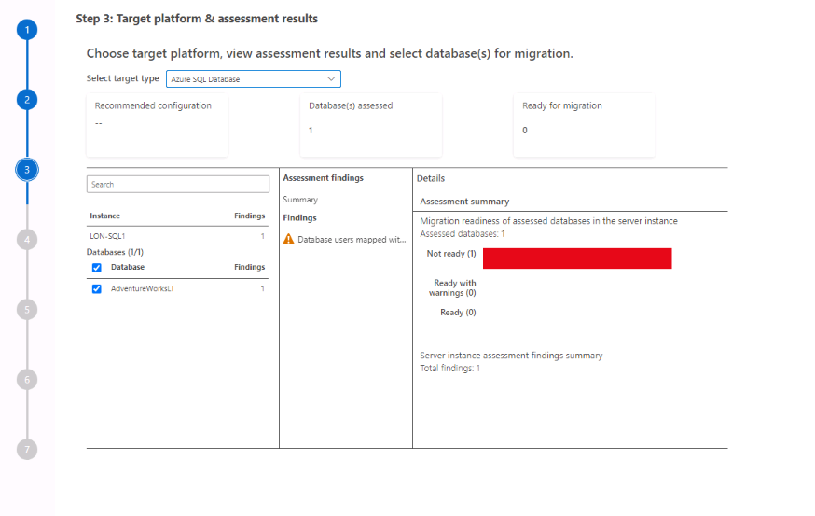

Choose Azure SQL Managed Instance instead as the Azure SQL Database target platform.

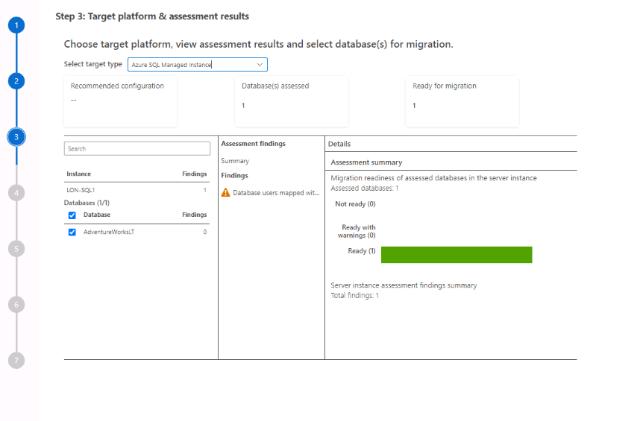

Select Save assessment report to save the report in a JSON format

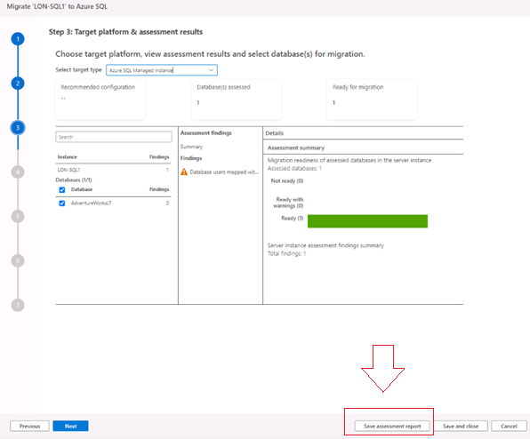

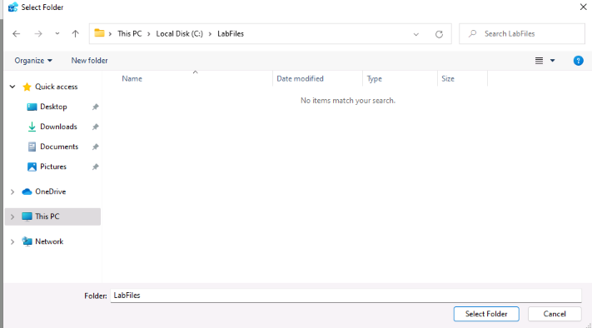

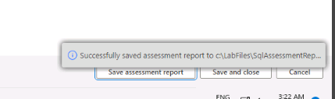
- Take a moment to review the JSON file, and its properties. You will Notice Next Columns is the Issues .

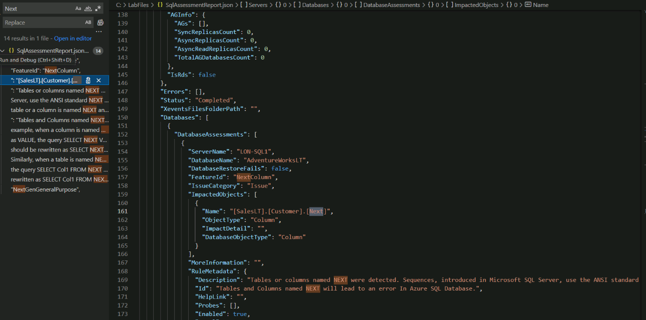

Fix the issue
- Run the following T-SQL command on the AdventureWorks database.
ALTER TABLE [SalesLT].[Customer] DROP COLUMN [Next];

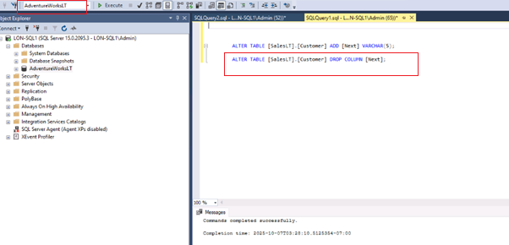

- Go back to the Step 2: Assessment results and SKU recommendations page in the wizard, and select Refresh assessment.
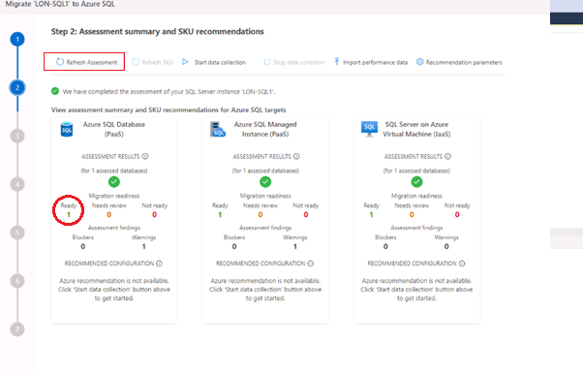
- Select Azure SQL Database as the target platform.
- Select the AdventureWorks database.

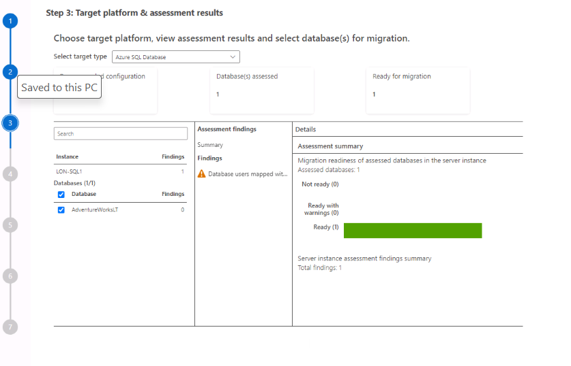

You've learned how to assess the readiness of a SQL Server database for migration to Azure SQL Database. By addressing compatibility issues and making essential schema changes or reporting them, you've taken an important step in mitigating potential technical issues that could arise in the future on Azure SQL Database.

