

**Lab Manual- AKS Networking with Frontend and Backend (Voting App) (Lab2)**

**Prepared for**:

**Date:** 18th Dec 2023

**Prepared by:**

Document Name: Lab Manual **Document Number** AZLabn916

**Contributor:**

Contents

1. Objective 2

2. Create Voting App Front and Redis Backend 3

3. Get the data from Redis 4

4. Delete Deployment and service 5

# Objective

Here's a step-by-step guide to creating a sample frontend with a form that sends data to a backend database, and deploying both the frontend and backend applications in Kubernetes using ClusterIP for the backend and LoadBalancer for the frontend, along with necessary YAML configurations and a **package.json** file for the backend:

# Create Voting App Front and Redis Backend

git clone https://github.com/bipeensinha/aks-network.git

cd aks-network

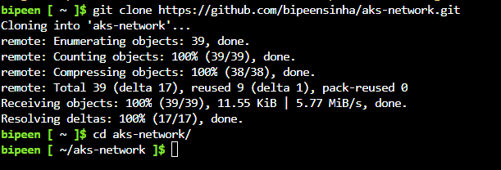

kubectl apply -f azure-vote-all-in-one-redis.yaml

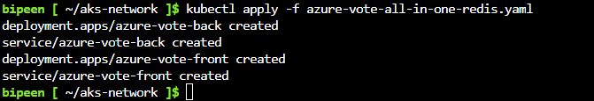

kubectl get po

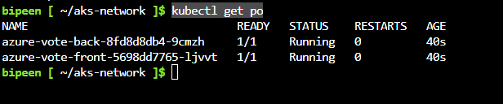

kubectl get svc

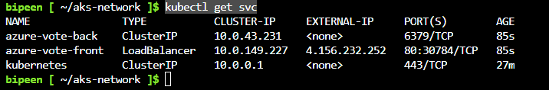

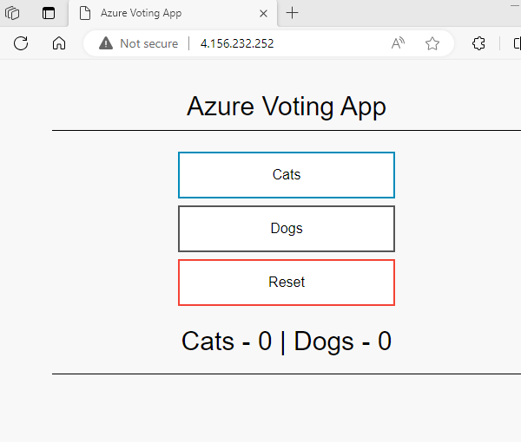

Click button to change the vale

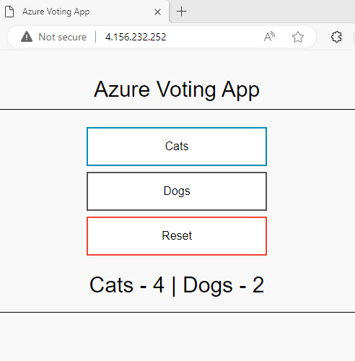

# Get the data from Redis

Connect the Redis pods

kubectl get po



kubectl exec -it azure-vote-back-8fd8d8db4-9cmzh -- /bin/bash



redis-cli -h 127.0.0.1 -p 6379



KEYS "*"

get Dogs

get Cats

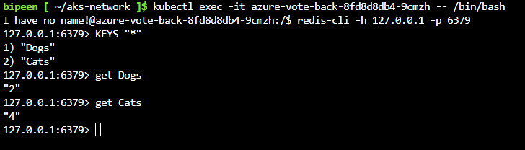

exit

exit

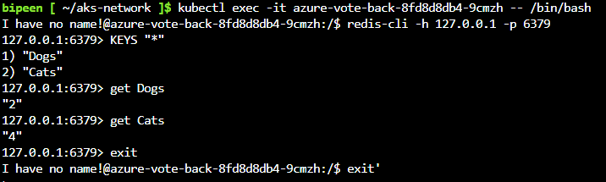

# Delete Deployment and service

kubectl delete deployment azure-vote-back

kubectl delete deployment azure-vote-front

kubectl get po

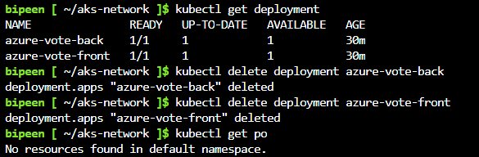

kubectl get svc

kubectl delete svc azure-vote-back

kubectl delete svc azure-vote-front

