1. Create Storage Account

1. Create two Blob container data and backup

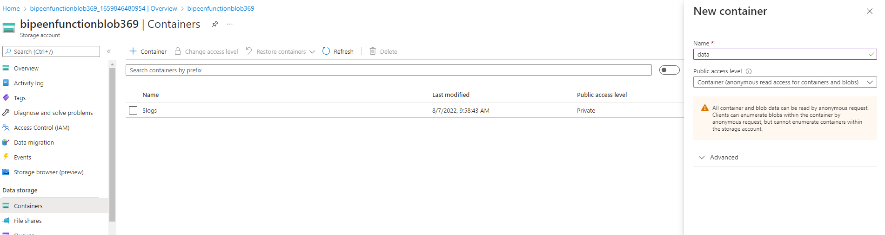

1. Create function App

1. Create function and add trigger to data folder

1. Test the function

--- In storage account data folder upload any file

1. Add output action as copy data to output

Change the outcontainer to backup



1. Write dotnet code to copy the data

public static void Run(Stream myBlob, string name,Stream outputBlob, ILogger log)

{

log.LogInformation($"C# Blob trigger function Processed blob\n Name:{name} \n Size: {myBlob.Length} Bytes");

outputBlob=myBlob;

}

1. Test the function by uploading file to data folder

You should able to see file copy in output

1. Create Service bus queue
2. Create queue
3. Add event trigger to storage
4. Upload the file and test everything