**Lab Manual- Implement Azure Container Instances**

Table of Contents

1 OBJECTIVE 3

2 PRE-REQUISISTE 3

3 Architecturel Diagram 3

4 Deploy a Docker image by using the Azure Container Instance 4

1. Sign in to the Azure portal. 4

5 Review the functionality of the Azure Container Instance 8

# OBJECTIVE

Contoso wants to find a new platform for its virtualized workloads. You identified a number of container images that can be leveraged to accomplish this objective. Since you want to minimize container management, you plan to evaluate the use of Azure Container Instances for deployment of Docker images.

In this lab, you will:

* Task 1: Deploy a Docker image by using the Azure Container Instance
* Task 2: Review the functionality of the Azure Container Instance

# PRE-REQUISISTE

* Accounts in Azure
* A local Computer with 4 CPU, 16 GB RAM, 200 GB disk space

# Architecturel Diagram

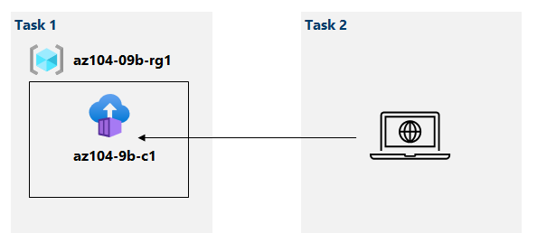

# Deploy a Docker image by using the Azure Container Instance

# Sign in to the [Azure portal](https://portal.azure.com/).

1. In the Azure portal, search for locate **Container instances**  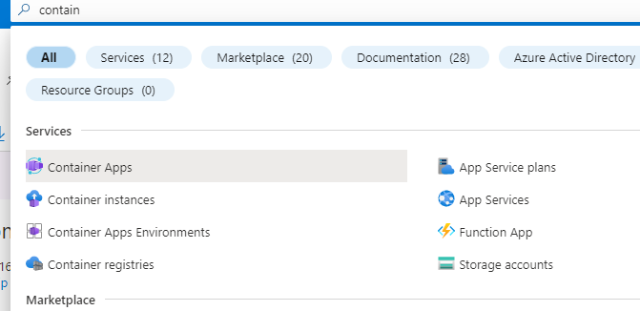
2. On the **Container instances** blade, click **+ Create**.

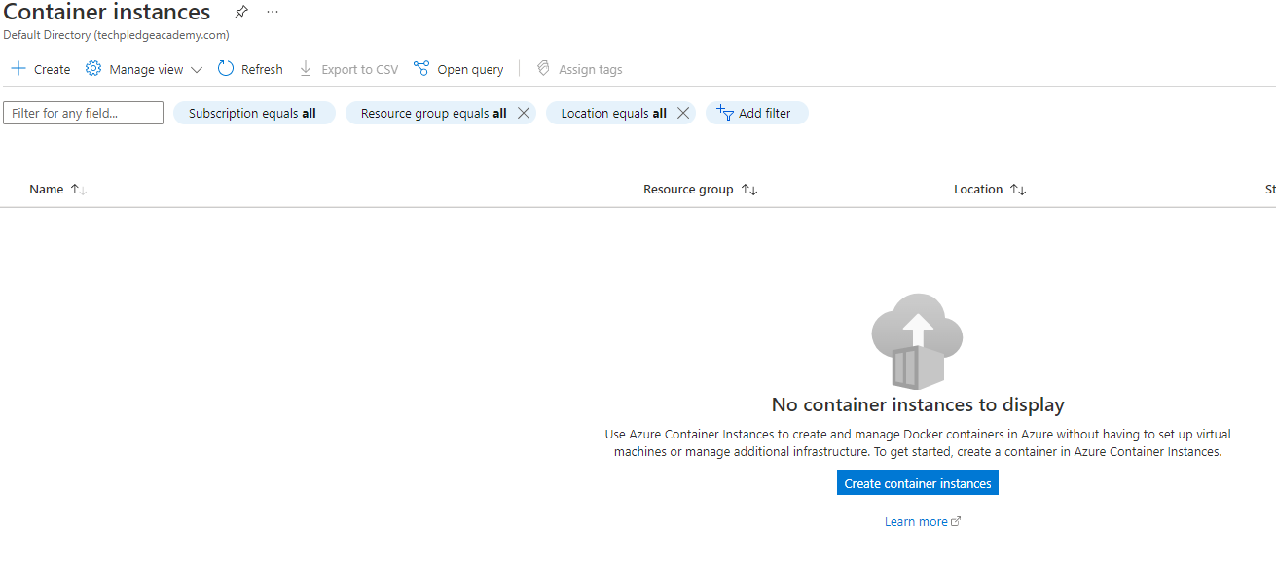

1. On the **Basics** tab of the **Create container instance** blade, specify the following settings (leave others with their default values):

| Setting | Value |
| --- | --- |
| Subscription | the name of the Azure subscription you are using in this lab |
| Resource group | Select Resource Group |
| Container name | **Unique name** |
| Region | East-US |
| Image Source | **Other Registry** |
| Image | **Tuitum/hello-world** |

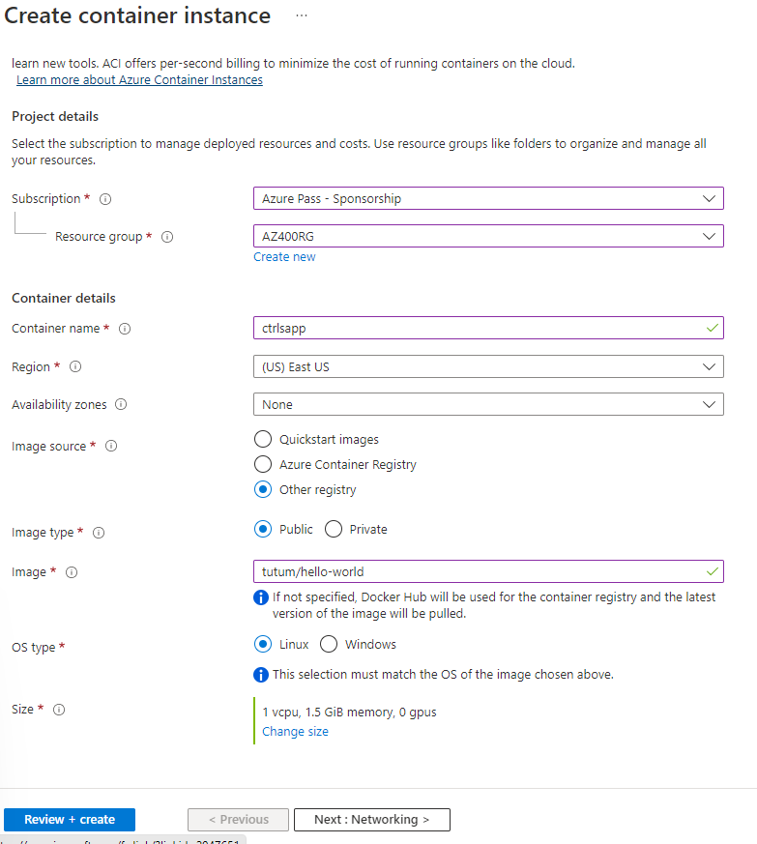

1. Click **Next: Networking >** and, on the **Networking** tab of the **Create container instance** blade, specify the unique DNS Name settings (leave others with their default values):

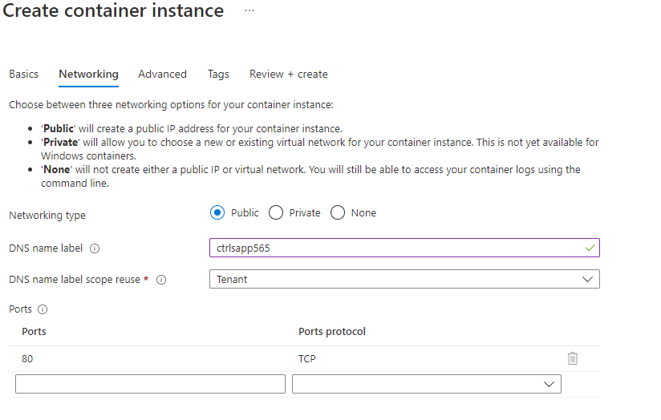

1. Click **Next: Advanced >**, review the settings on the **Advanced** tab of the **Create container instance** blade without making any changes, click **Review + Create**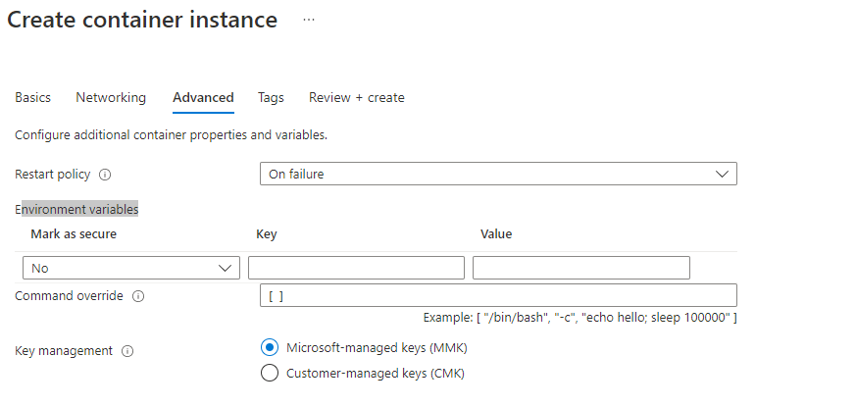
2. Ensure that the validation passed and click **Create**.

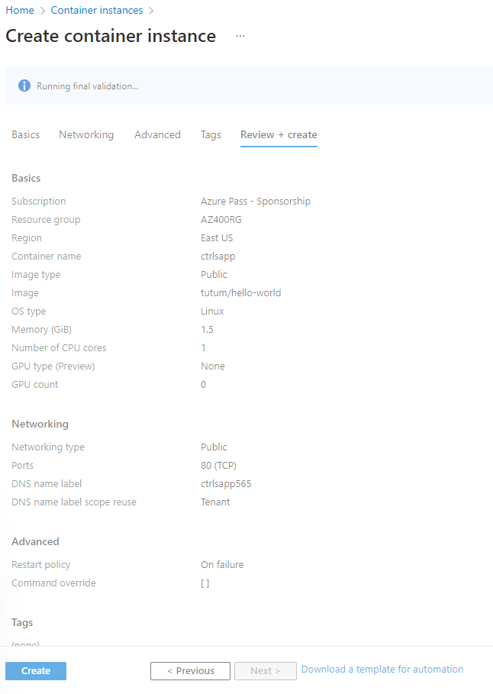

1. Wait for the deployment to complete. This should take about 3 minutes.

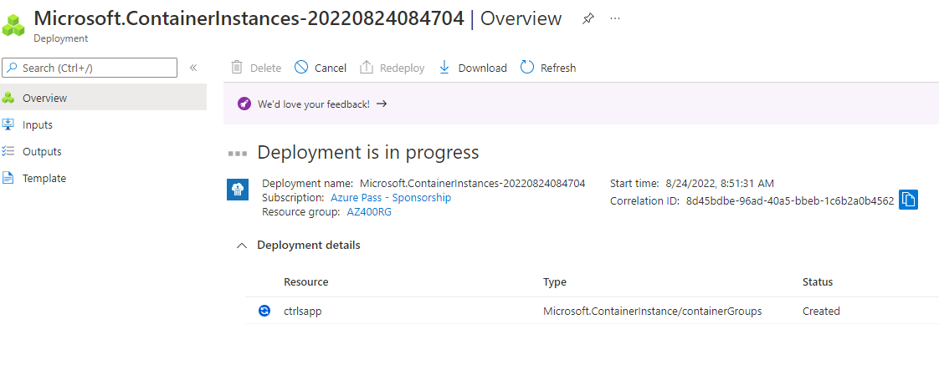

# Review the functionality of the Azure Container Instance

In this task, you will review the deployment of the container instance.

1. On the deployment blade, click the **Go to resource** link.

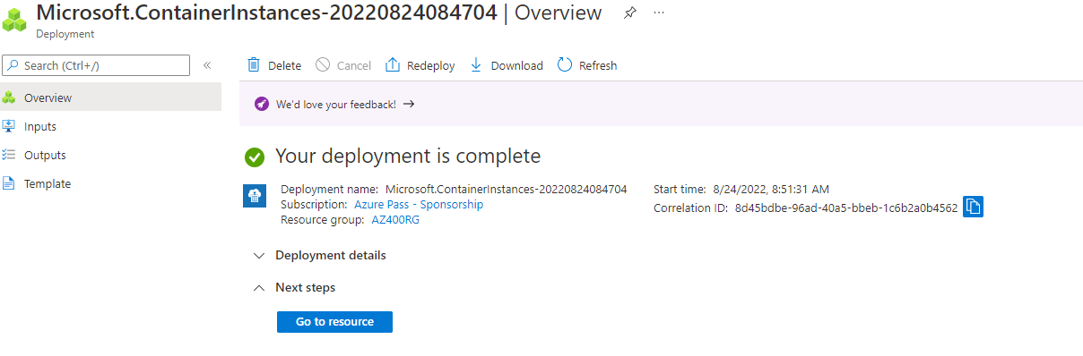

1. On the **Overview** blade of the container instance, verify that **Status** is reported as **Running**



1. Copy the Public IP address or FQDN and Paste in Brwoser. Verify that the **Tutum Hello-world website is displayed**

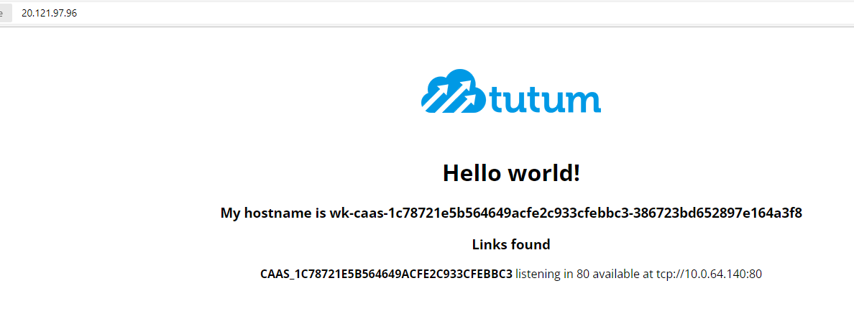

1. Close the new browser tab, back in the Azure portal, in the **Settings** section of the container instance blade, click **Containers**

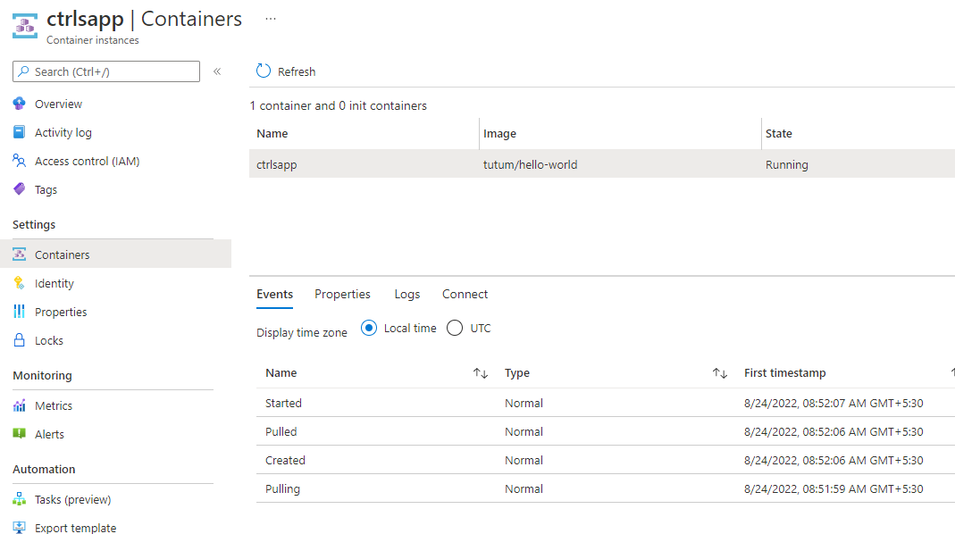

5, Click Connect Menu to connect the **container**

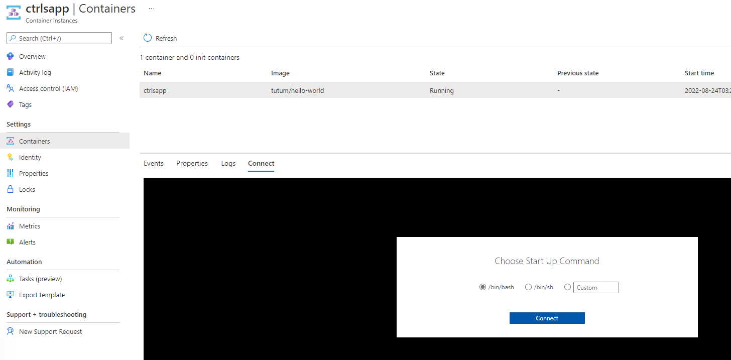

1. Select **/bin/sh** and click ***Connect***

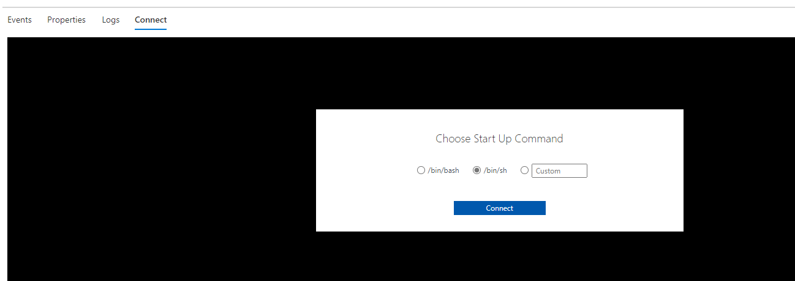

1. You can now access the container

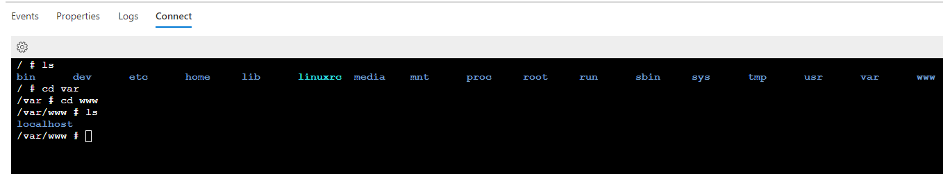

1. Click **Logs** Menu to Check the logs

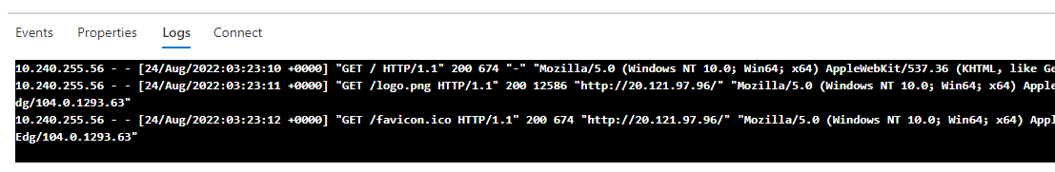

1. Click **Properties**  Menu to Review the Properties.

