
Lab Manual- Manage Azure Resources with ARM/BICEP Teamplate

Table of Contents
1 OBJECTIVE 2
2 BICEP Playground 3
3 PRE-REQUISISTE 4
4 Provision Resource with ARM/Bicep 4
4.1 Review the Build own Template Option Deployment Template 4
4.2 Create Windows VM from Common Template 6

OBJECTIVE
When deploying Azure resources with an Infrastructure as Code tool, you need to understand what resource types are available, and what values to use in your files
Azure Resource Manager is the deployment and management service for Azure. It provides a management layer that enables you to create, update, and delete resources in your Azure account.
Bicep is a domain-specific language (DSL) that uses declarative syntax to deploy Azure resources similer to ARM . Syntax of Biceps is shorter than ARM. During deployment, the Bicep CLI converts a Bicep file into ARM template JSON.
The following examples show the difference between a Bicep file and the equivalent JSON template. Both examples deploy a SQL Server .
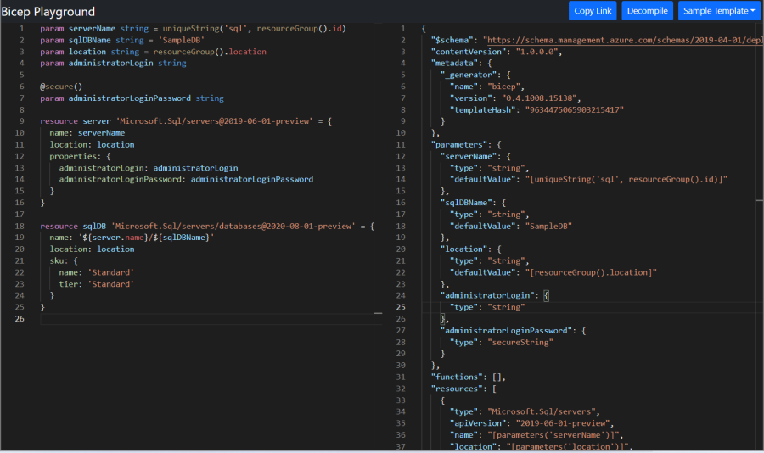

BICEP Playground
The Bicep Playground lets you view Bicep and equivalent JSON side by side. You can compare the implementations of the same infrastructure.
https://bicepdemo.z22.web.core.windows.net/

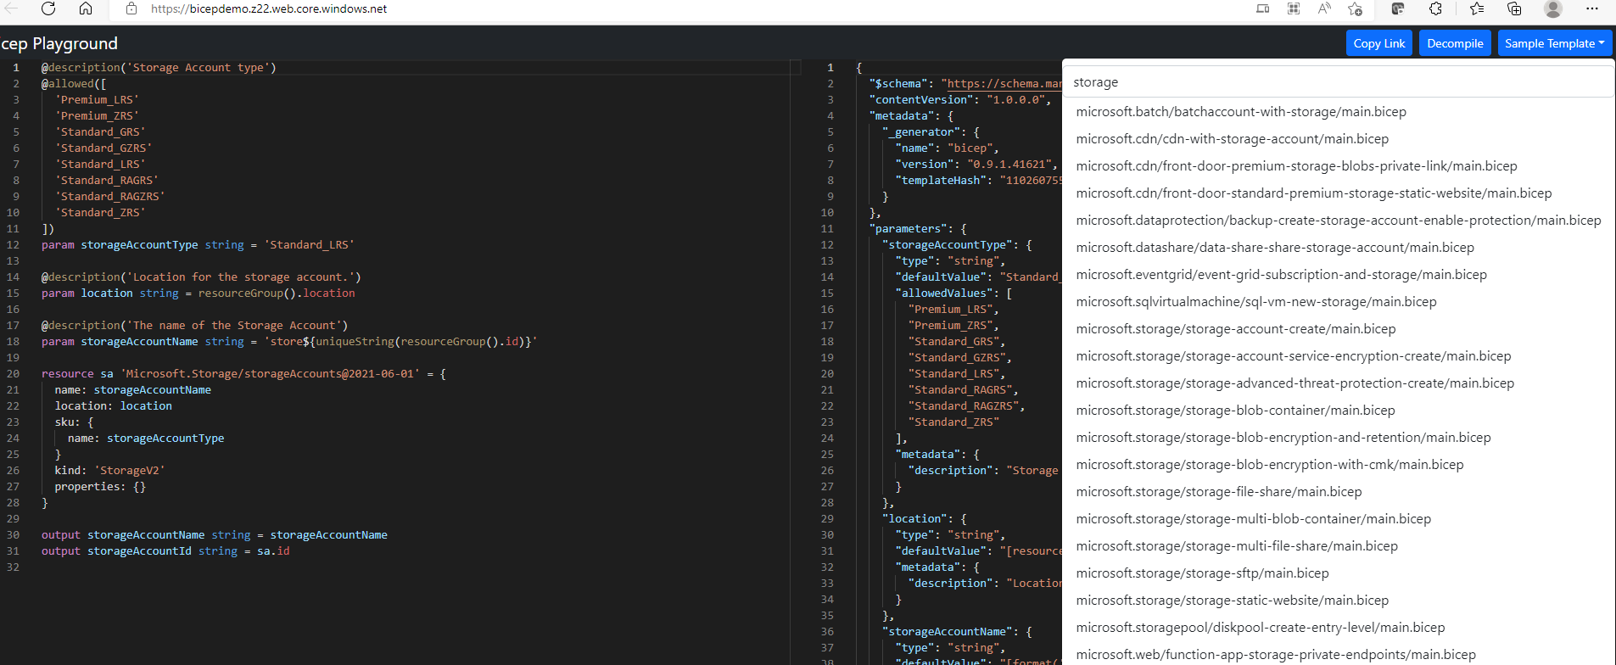

PRE-REQUISISTE
- Accounts in Azure
- A local Computer with 4 CPU, 16 GB RAM, 200 GB disk space

Provision Resource with ARM/Bicep

Review the Build own Template Option Deployment Template
- Sign in to the Azure portal
- From the Azure portal search bar, search for deploy a custom template and then select it from the available options.

- Click “Build your own Template in editor”

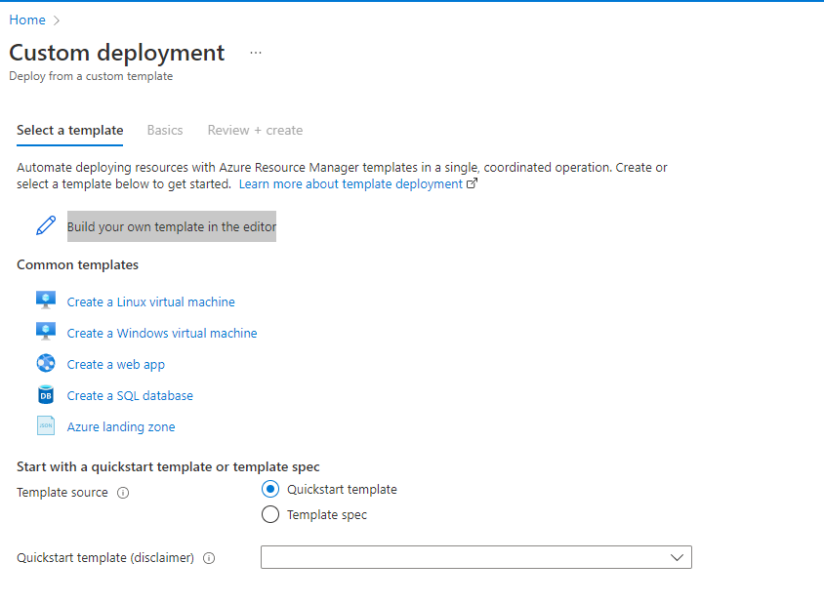
- Review the Editor and Parameter and Resource
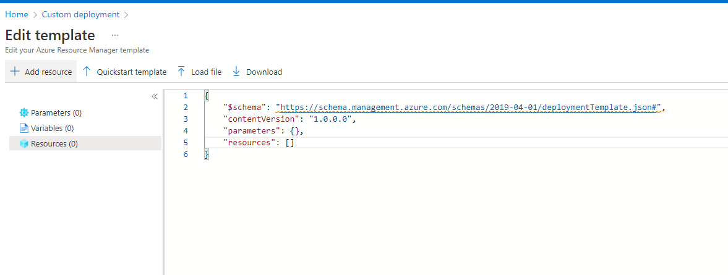c
- Review the Editor and Parameter and Resource

Create Windows VM from Common Template
- From common Template Select select „ Create a Windows Virtual Machine“
- Following Wizard will apper

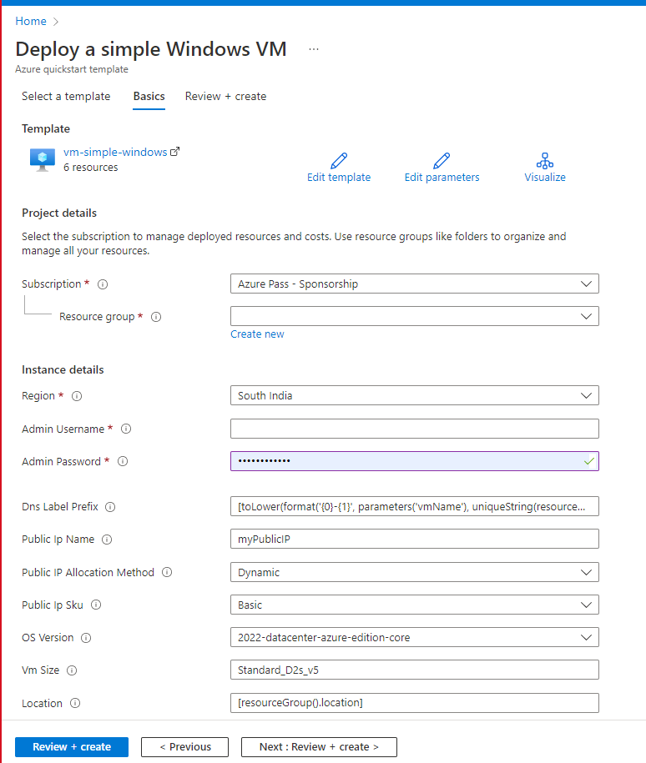
- Click Edit Parameters Iocn from Top
- It will load the Json as below

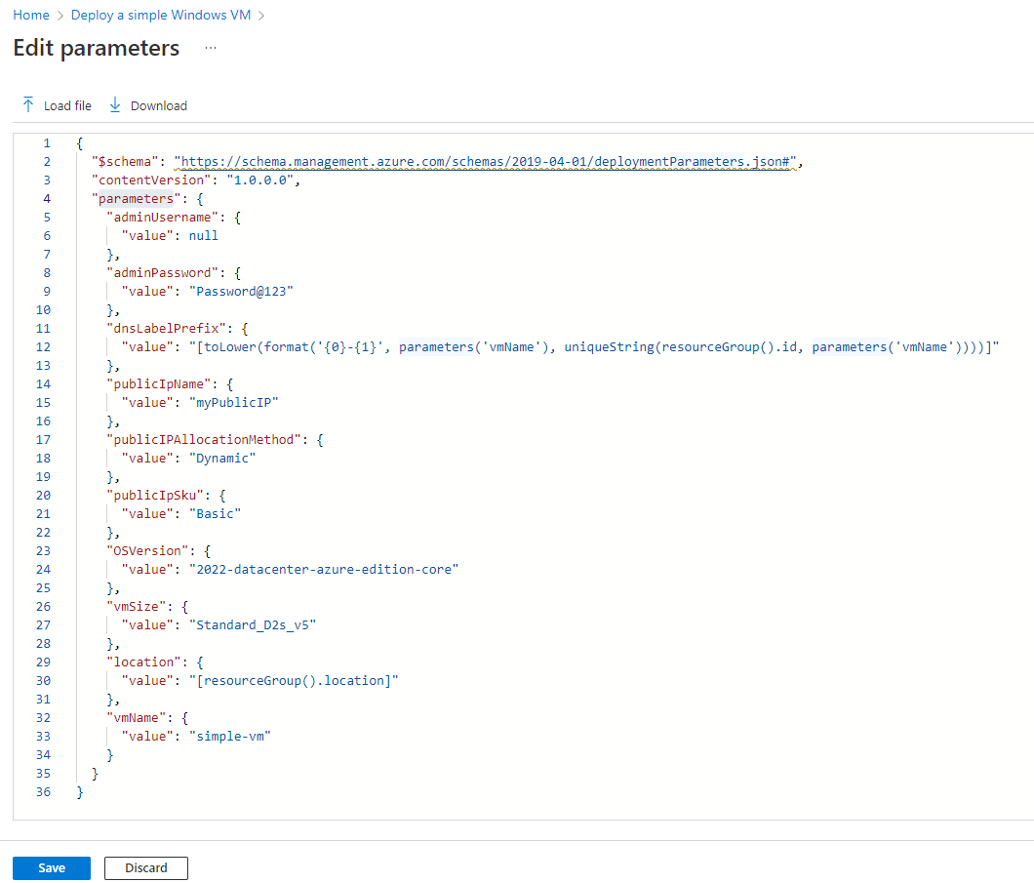

- Change the value of Public IP name and VM Name Parameter ( Add your Name as prefix) and Click Save

- Validate the changes
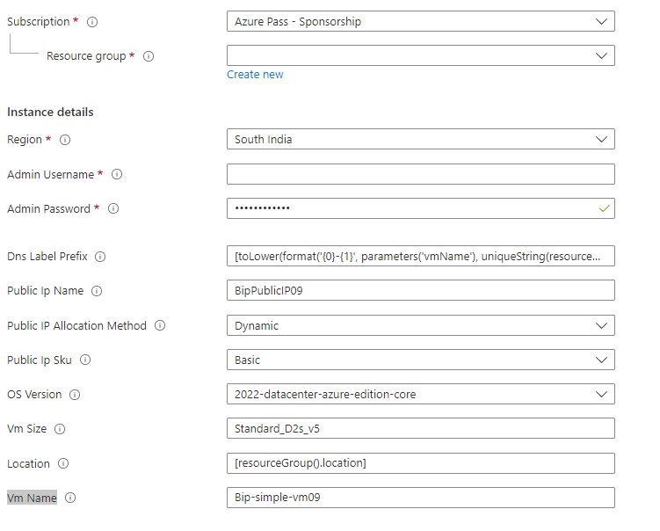
- Now Click Edit Template
- Change the default Value in Public IP name (it should be asme as parametrer value)
- Also Change the Default Value of VM Name same as parameter) and Save the Template

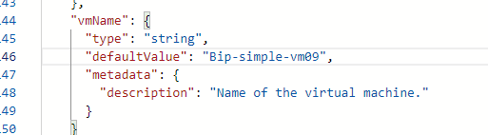

- Now Fill the value as
  - Resource Group : Choose From existing resource Group
  - Admin Username : VMAdmin
  - Admin Password: Password@123456789

- Once Validation Passwed Click create Button

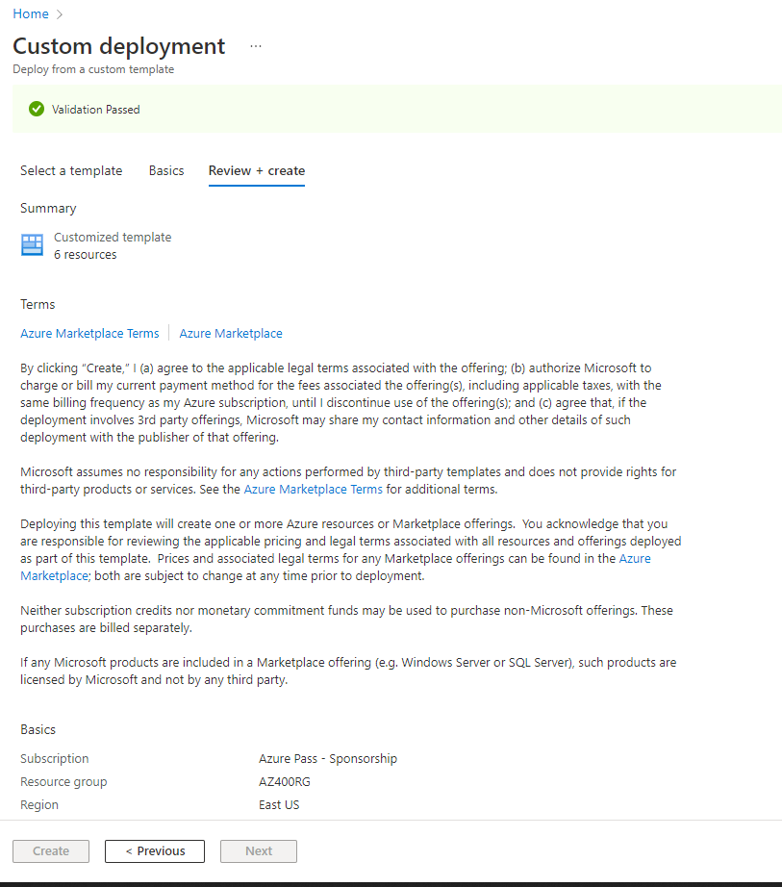
- Your Deployment Begin

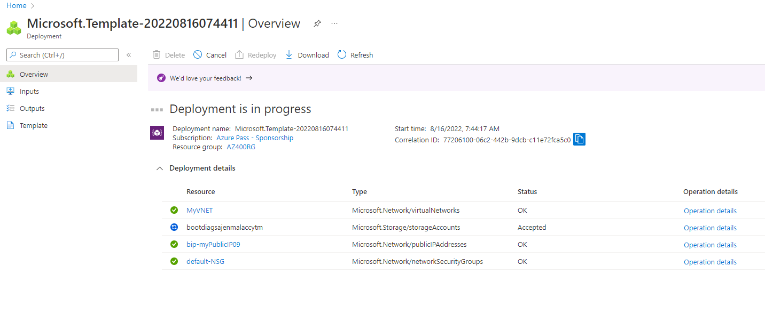
- Once your deployment Complete Go to Virtual Machine

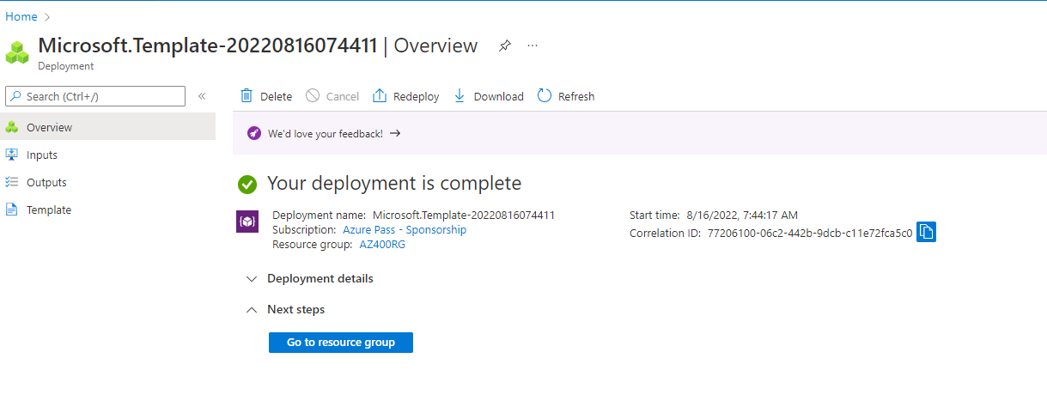
- Your VM must be Visible now.

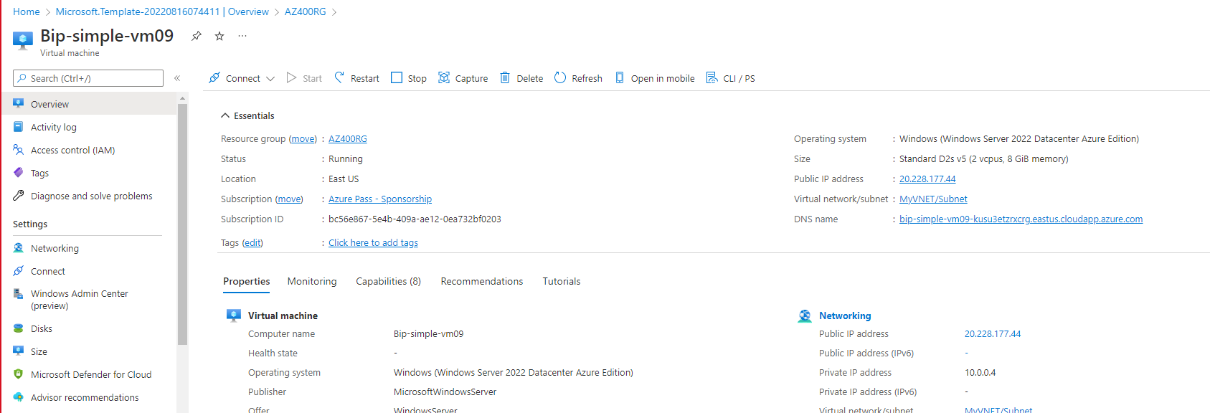

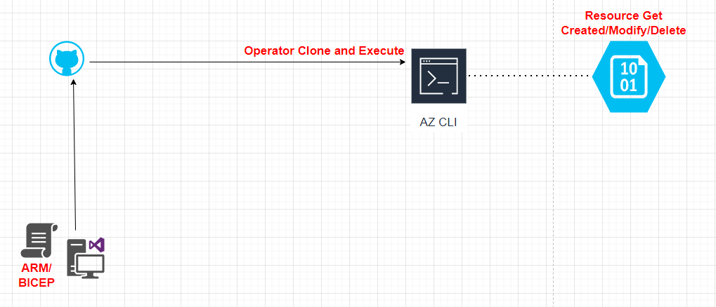

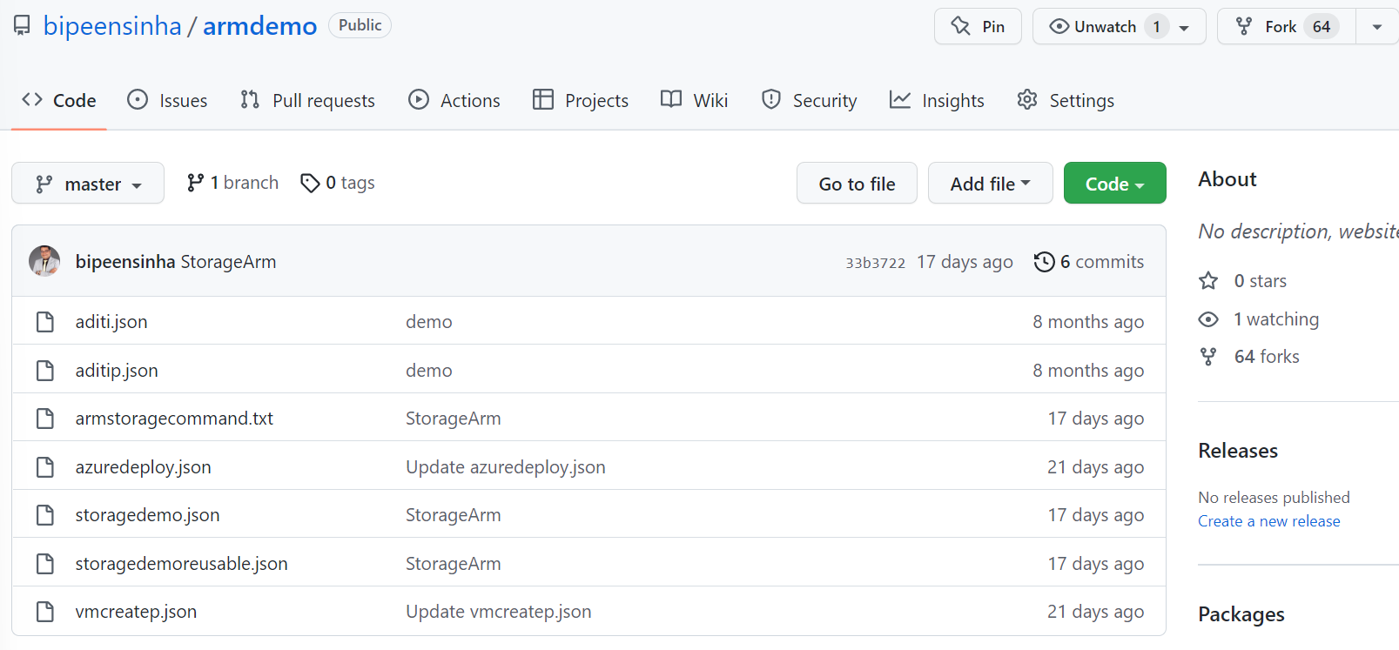

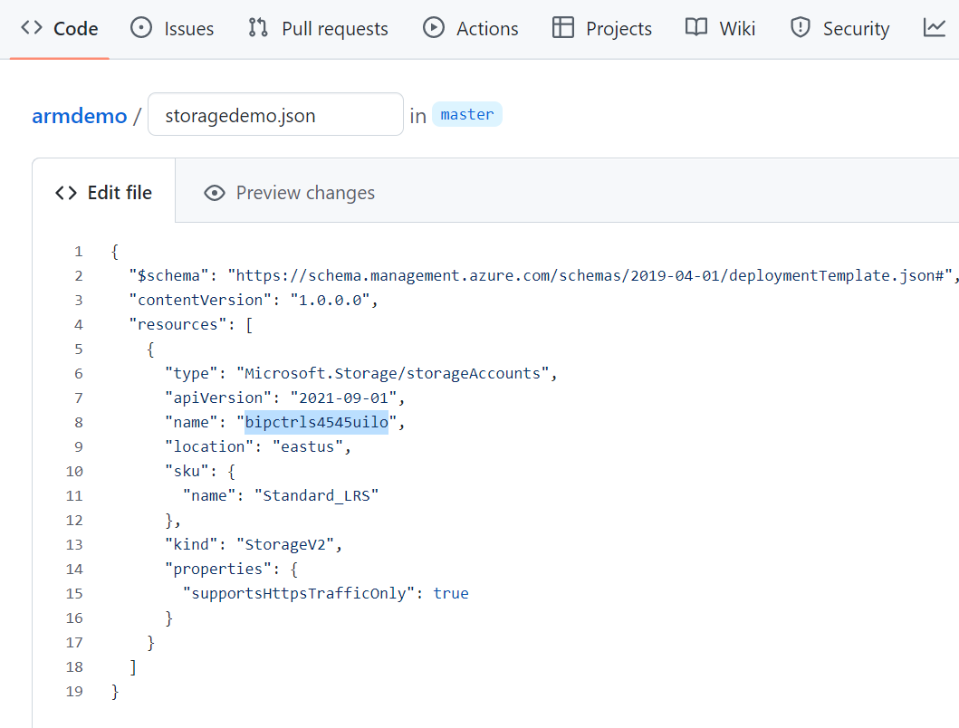

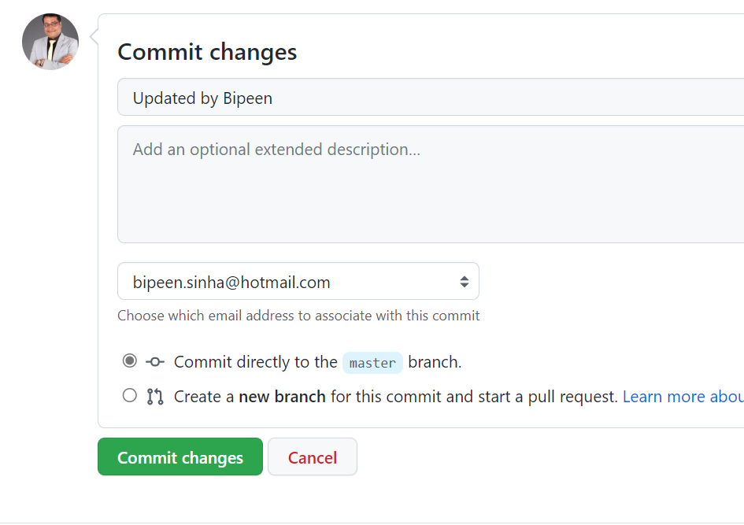
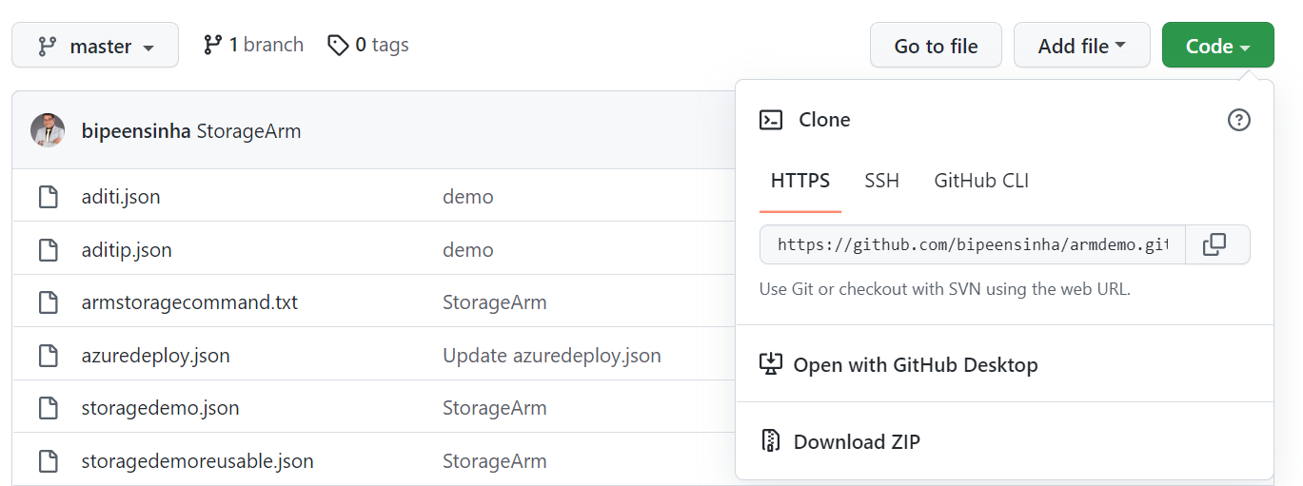

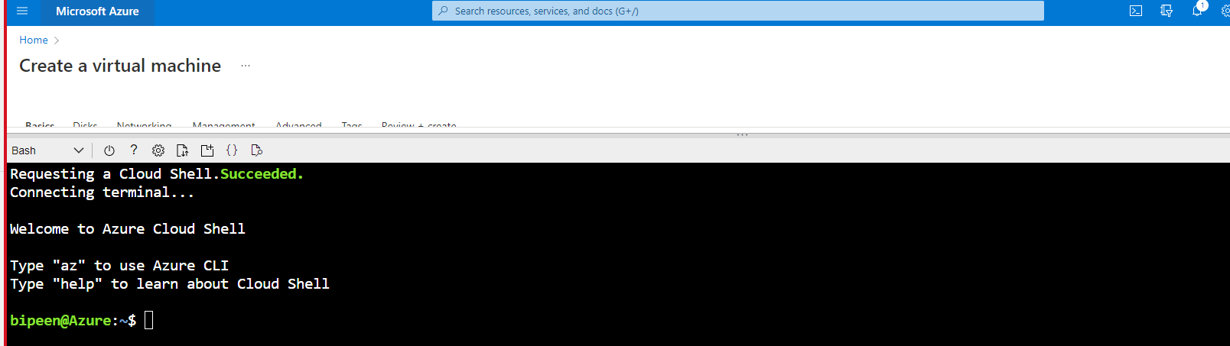

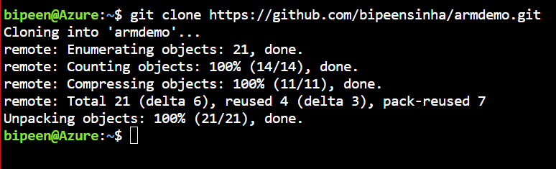

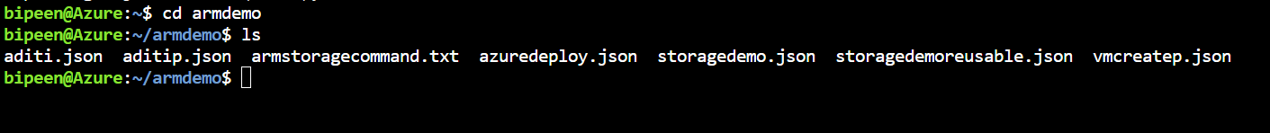

az deployment group create --name noparameter --resource-group AZ400RG --template-file storagedemo.json

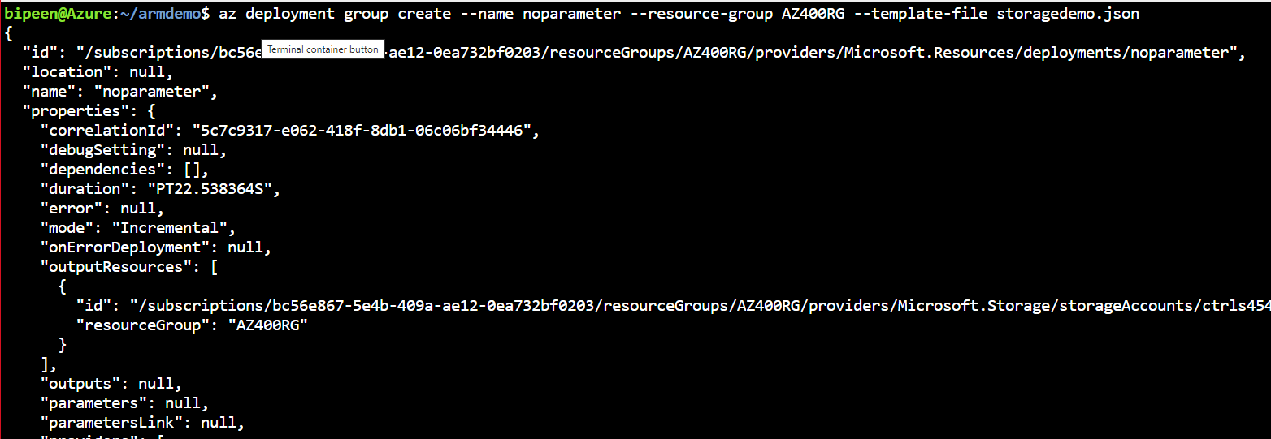

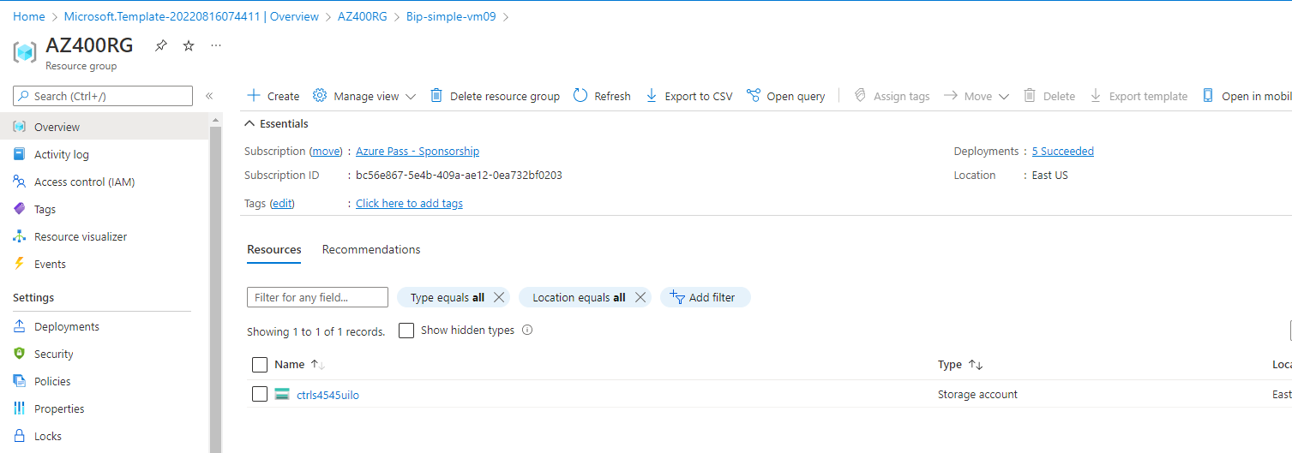

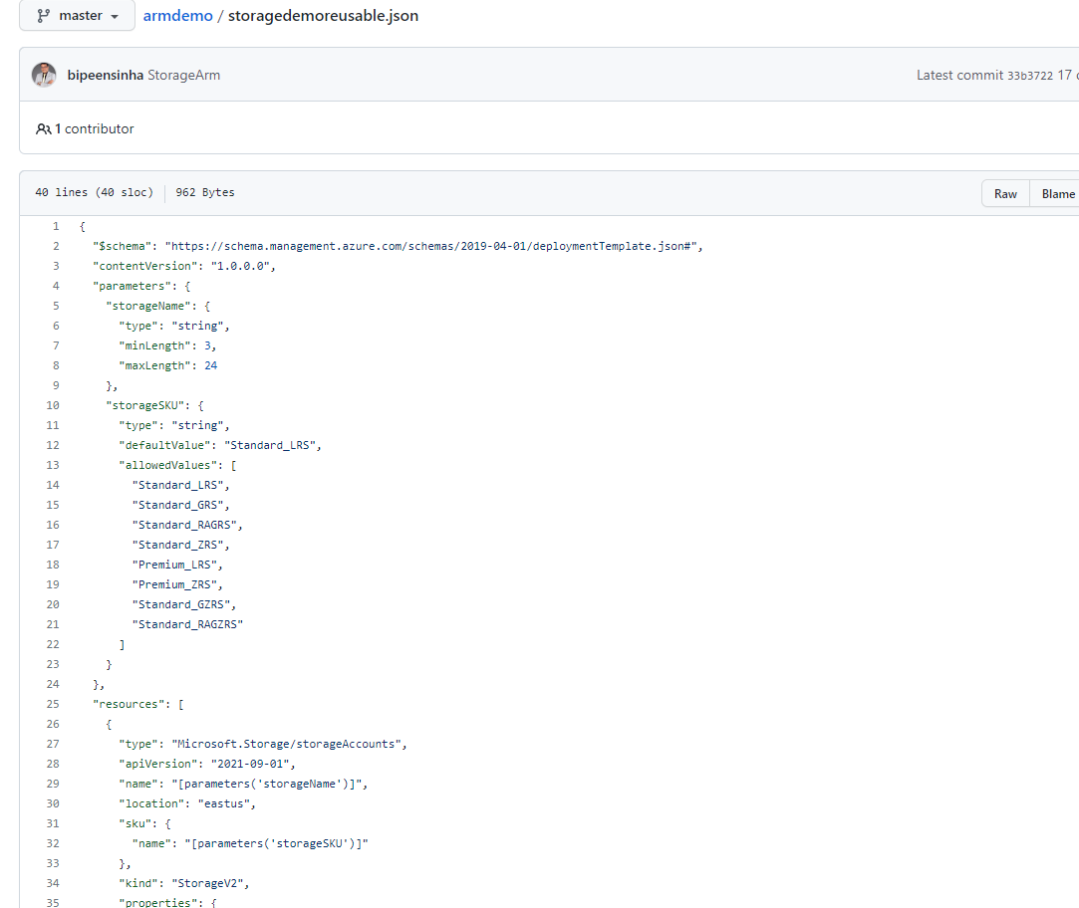

az deployment group create --name noparameter --resource-group AZ400RG --template-file storagedemoreusable.json --parameters storageName=crtrlstr43sewdr

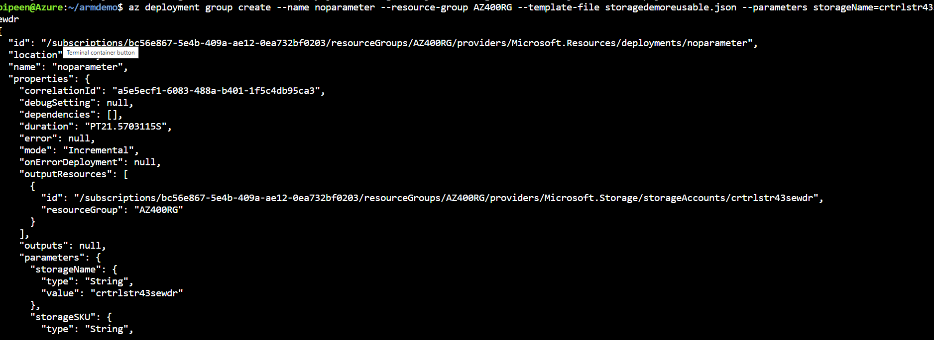

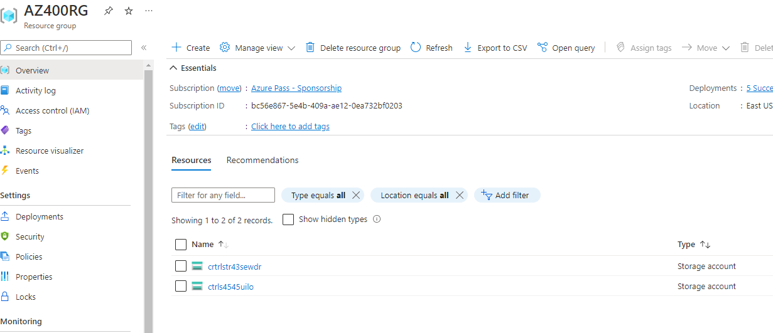

\
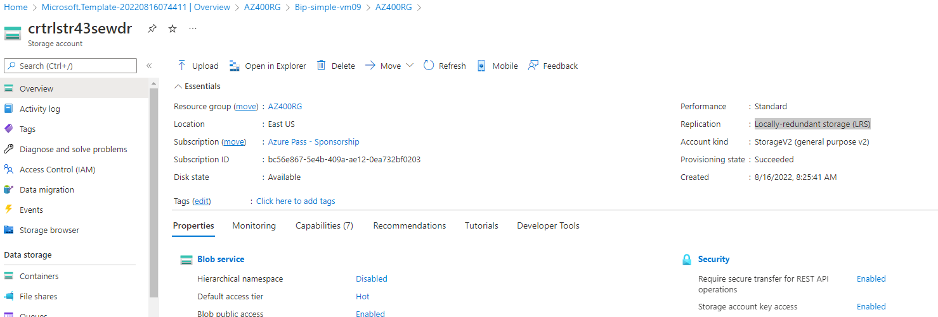

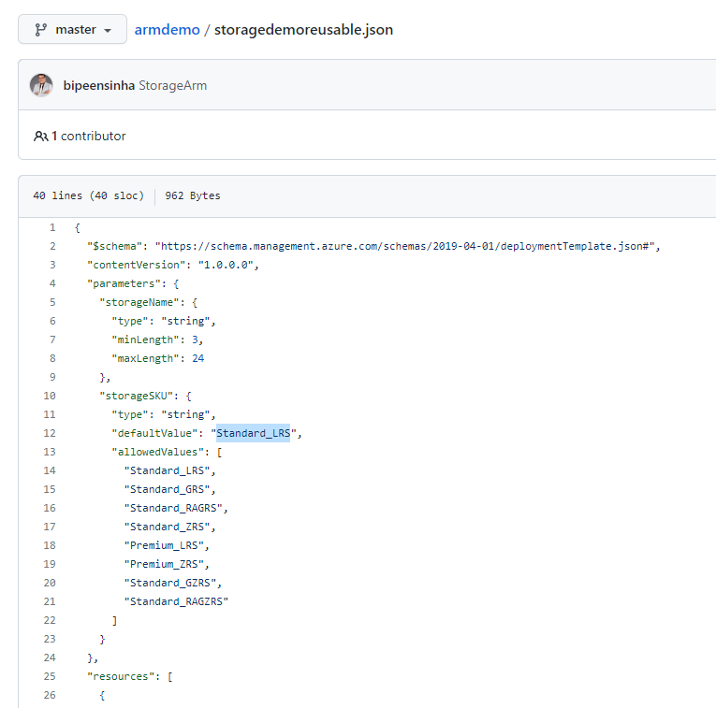

az deployment group create --name noparameter --resource-group AZ400RG --template-file storagedemoreusable.json --parameters storageSKU=Standard_GRS storageName=crtrlstr43sewdr

