
Lab Manual- Deploy Code to Azure App with Git Action

Table of Contents
1 OBJECTIVE 3
2 PRE-REQUISISTE 3
3 Setup Up Github Action for Code Deploy 4
3.1 Create a App Service with ASP.Net V4.8 4
3.2 Create Dev and UAT Slot in App 9
3.3 Prepare Code and Publsih the Repositiry to Githib account 11
3.4 Push the code to your repository 14
3.5 Push the code to App service dev Slot 18

OBJECTIVE
  - Azure App Service is an HTTP-based service for hosting web applications, REST APIs, and mobile back ends. You can develop in your favorite language, be it .NET, .NET Core, Java, Ruby, Node.js, PHP, or Python. Applications run and scale with ease on both Windows and Linux-based environments.
  - App Service not only adds the power of Microsoft Azure to your application, such as security, load balancing, autoscaling, and automated management. You can also take advantage of its DevOps capabilities, such as continuous deployment from Azure DevOps, GitHub, Docker Hub, and other sources, package management, staging environments, custom domain, and TLS/SSL certificates.
  - With App Service, you pay for the Azure compute resources you use. The compute resources you use are determined by the App Service plan that you run your apps on

PRE-REQUISISTE
- Accounts in Azure
- A local Computer with 4 CPU, 16 GB RAM, 200 GB disk space

Setup Up Github Action for Code Deploy 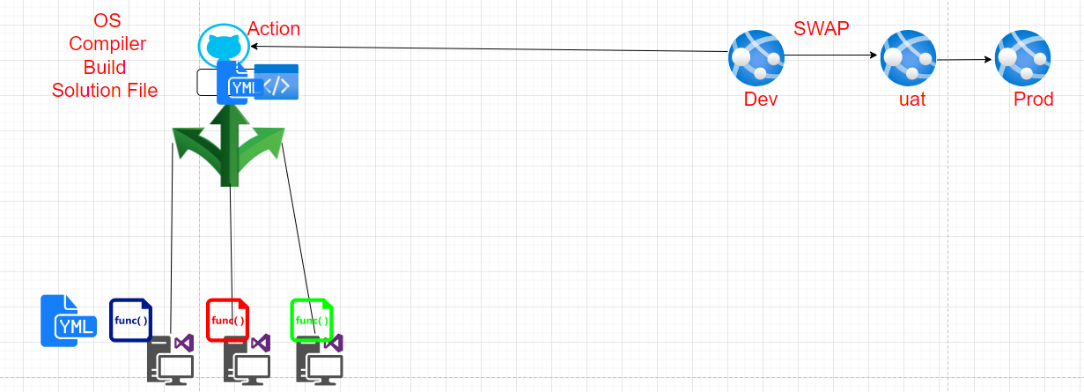

Create a App Service with ASP.Net V4.8
- Sign in to the Azure portal
- In the Search Box type app

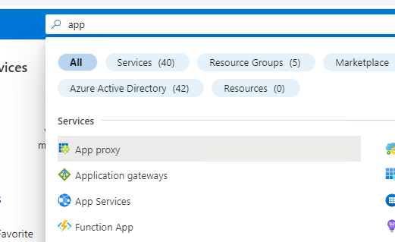
- Click App Services from search list

- In the App service Wizard
  - Subscription Name : Select your Azure Subscription
  - Resource Group Name : Select Your Resource Group or Type name of Resource Group
  - Name: type Unique name for your webapp
  - Runtime Stack: ASP.Net V4.8
  - Regions : EastUS
Click Review & Create Button
- Click Create Button
- App service Deployment begin
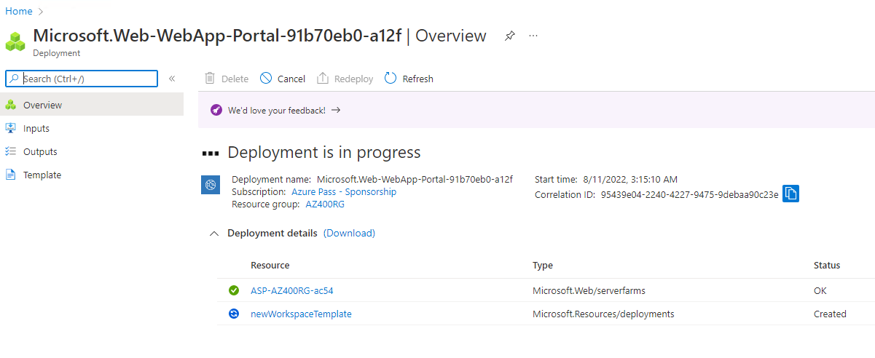
- Once deployment complete , Click Go to Resource
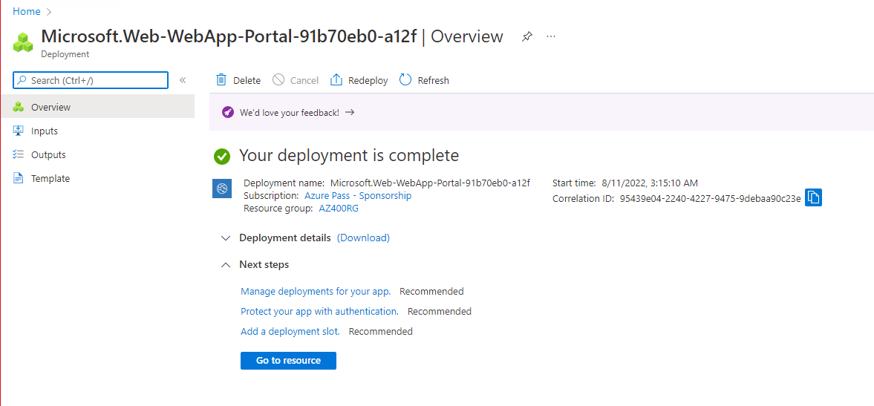
- Copy the Default URL
- You should see website similar to below
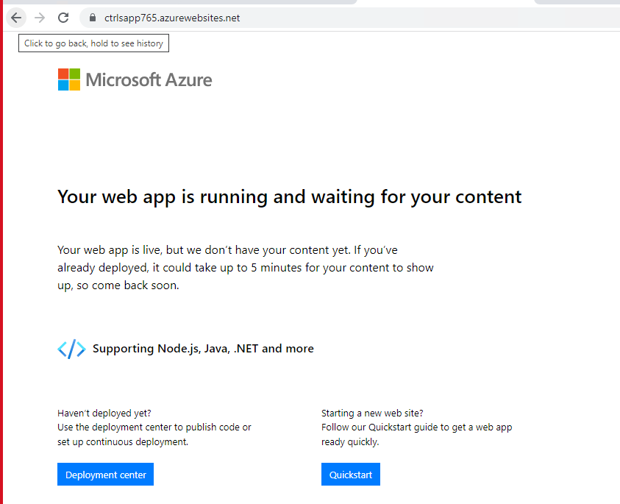

Create Dev and UAT Slot in App
- Click the deployment slots
- Click the Add Slot and type dev and click Add
- Repeat the process and add UAT and click Add
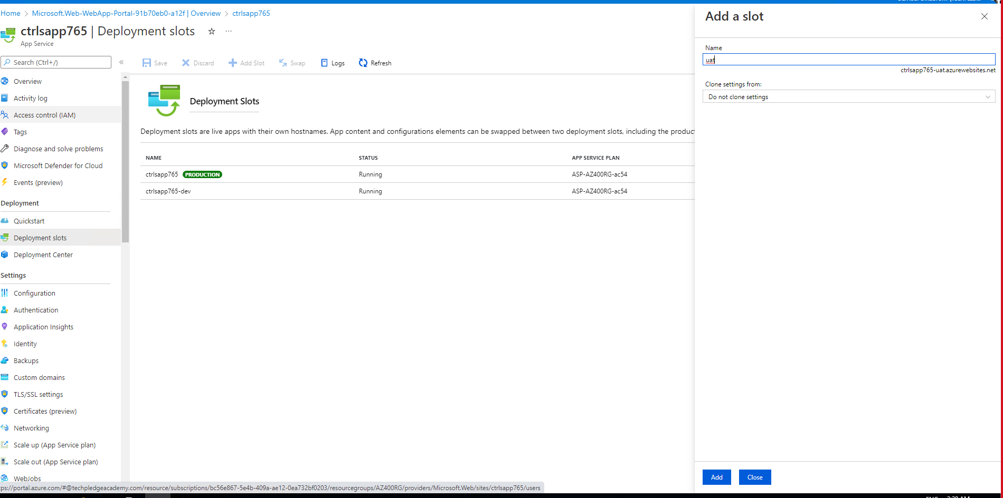
- This is how your deployment slots look like

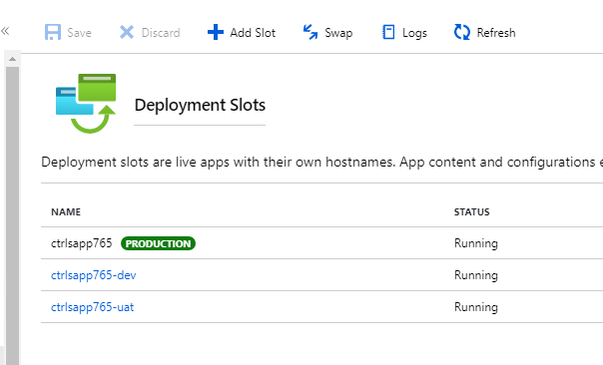
- You already have the default URL , add –dev after appName you get Dev URL

Dev Web Site
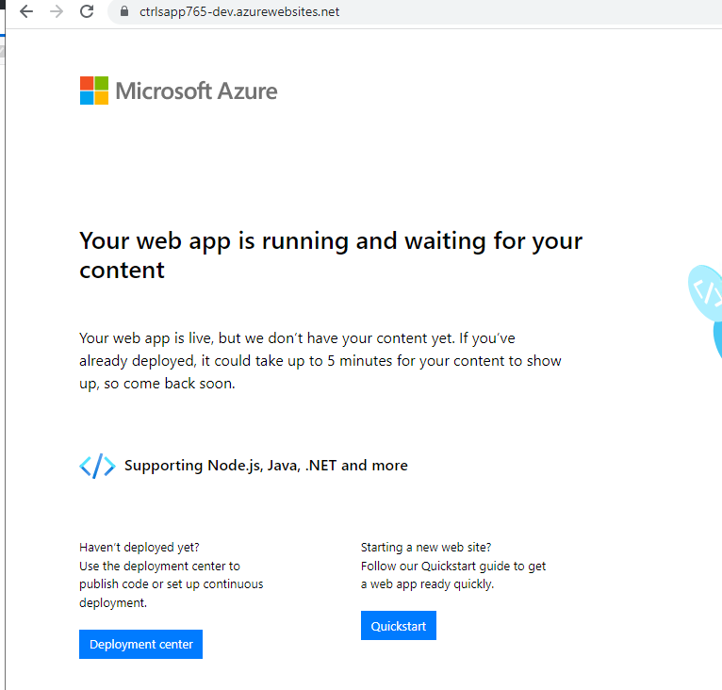

Prepare Code and Publsih the Repositiry to Githib account
- Create New Folder name Project in Local Drive
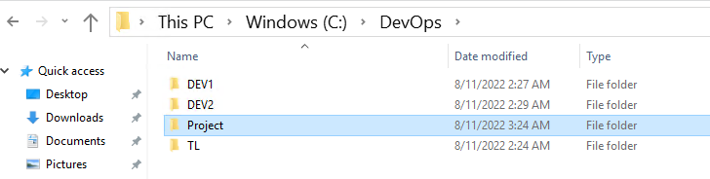
- Open git desktop and Click File Menu and click Clone Repository
- Click URL tab in Clone Repository and Type the URL given by instructor and also set the Path to Project Folder and Click Clone button
https://github.com/bipeensinha/YakshithApp.git

- You should see all the code in your local project Folder
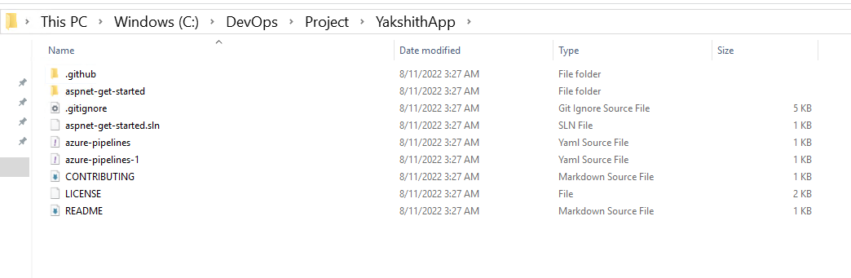
- Enable Hidden Items in Explorer
- Select Both the Folder named .Git and .github

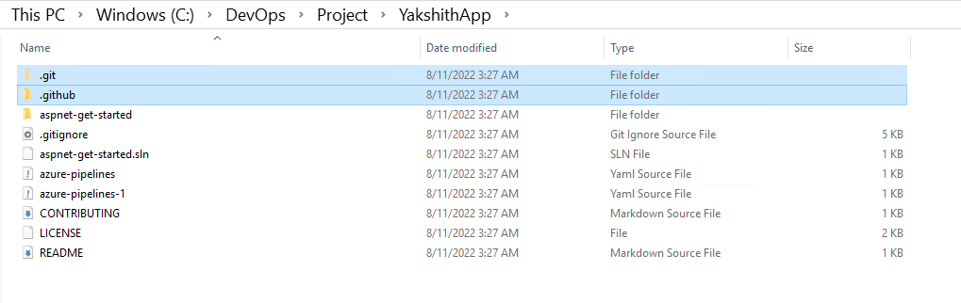
- Now Your Code should look like this

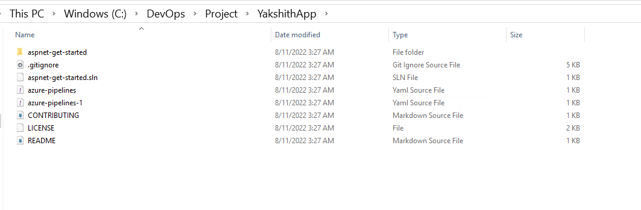

- In your git Desktop again click File Create New Repository.
- In the Dialog Box
  - Type unique name of repository
  - Set the Path to Project Folder
  - Click the Checkbox – Initialize this Repository
And click create repository
- Click Publish Repository

- In the Publish Repository Dialogue Box Uncheck – Keep this code private and click publish repository Button

- Now Go to github.com and check your repository must be visible.

Push the code to your repository
- Go back to your Clone Folder in Local drive and copy all the code

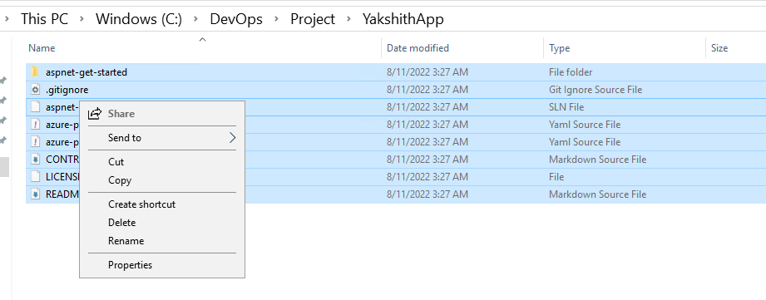
- Paste the Code in your local Repository we just created

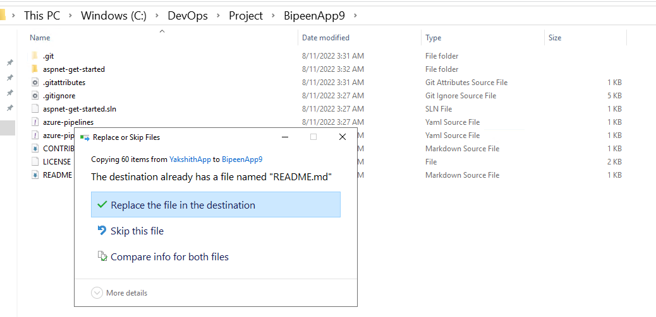
- Go back to GitHub desktop. You should see all your as below

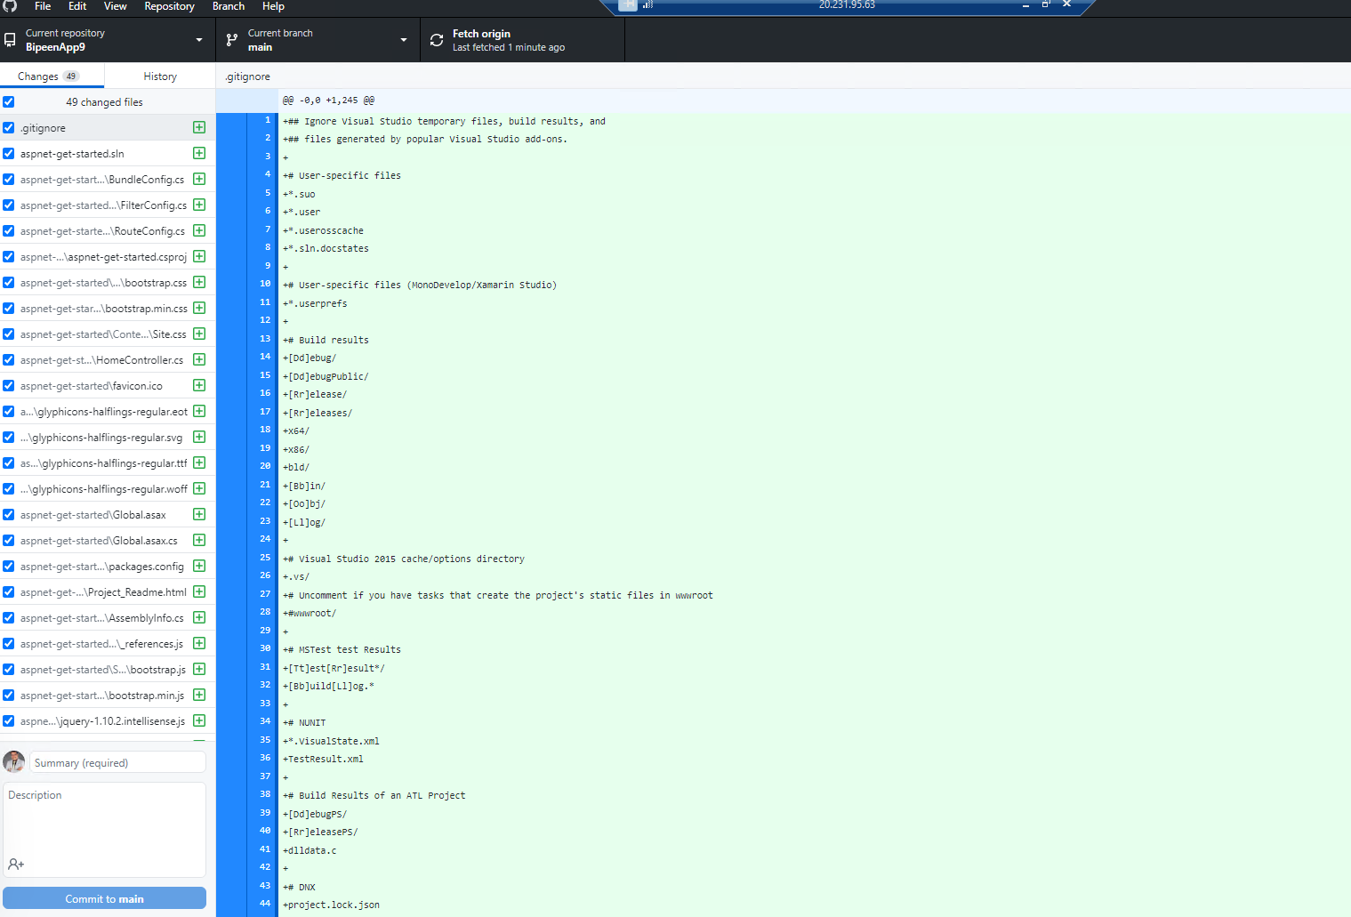
- Type your comment and Click “ Commit to main”

- Click “ Push to Origin”

- Review Code in github.com repository

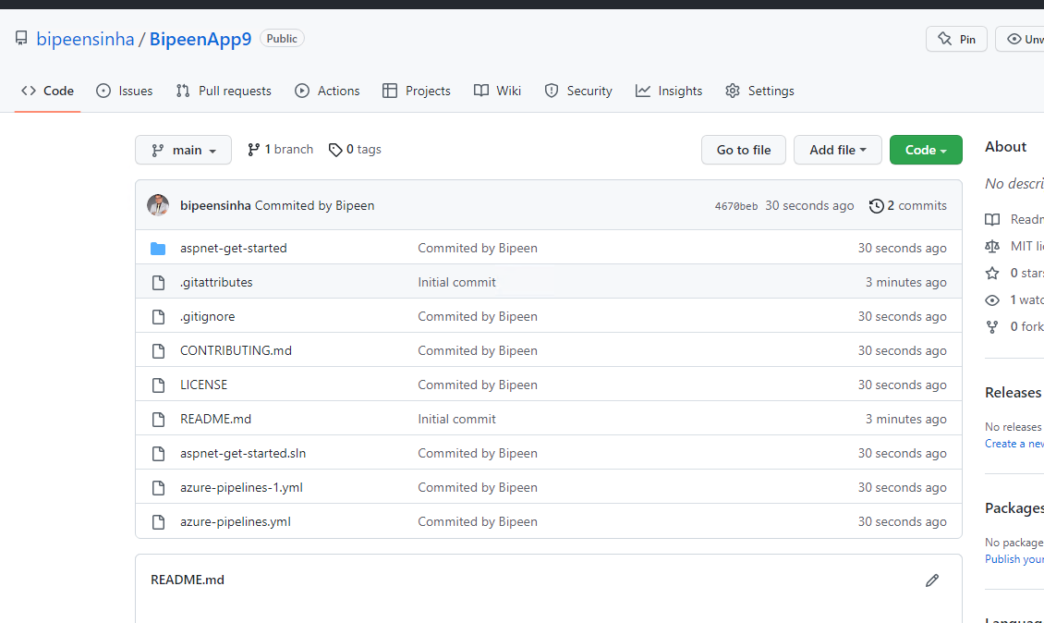

Push the code to App service dev Slot

- In your app service go to Deployment slots and Click dev Slots name
- Click Deployment center and from source drop down select GitHub. If Authorized Button appear click it and authorized it.

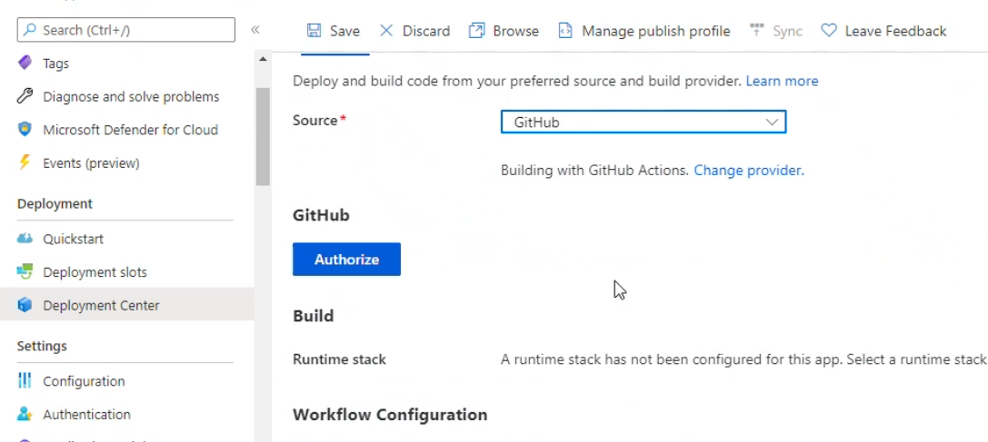

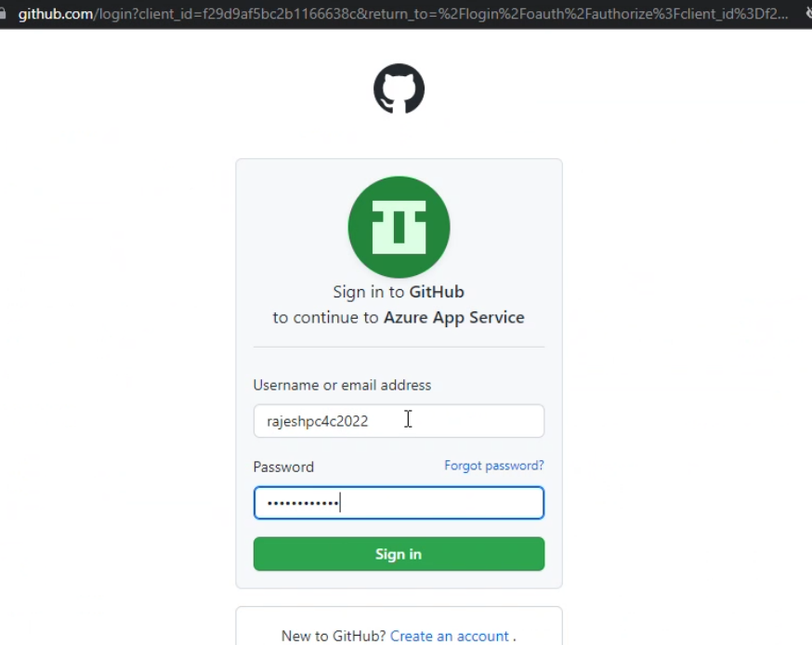

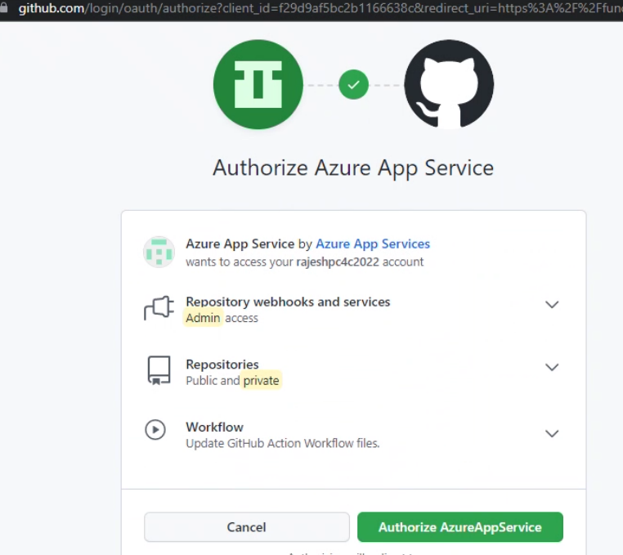

- Once you authorized , select your Organization , Repository and Branch and save your setting
- After save your setting you should get the screen similar as below
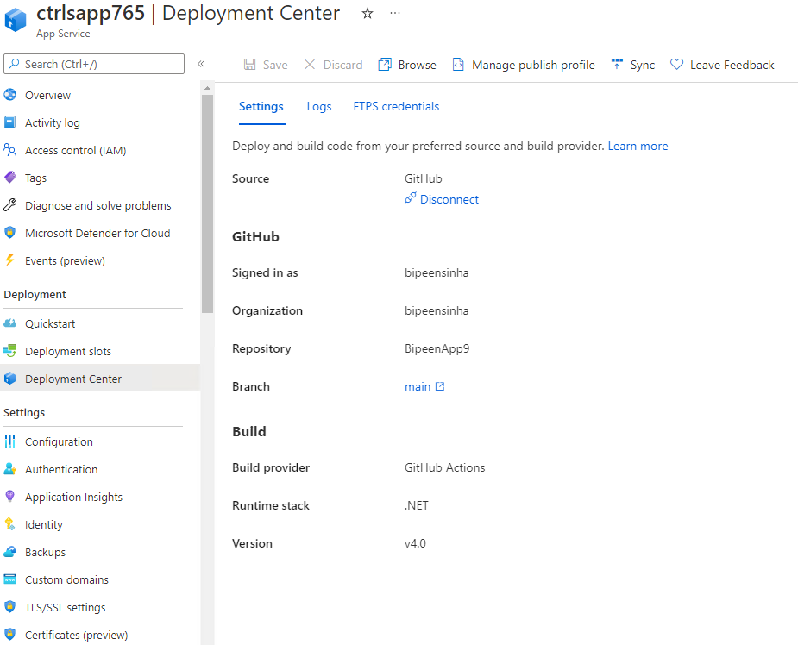
- Go Back to Guthub.com and in repository click Action Tab. You should see workflow has been triggered

- In few Minute Build process should start

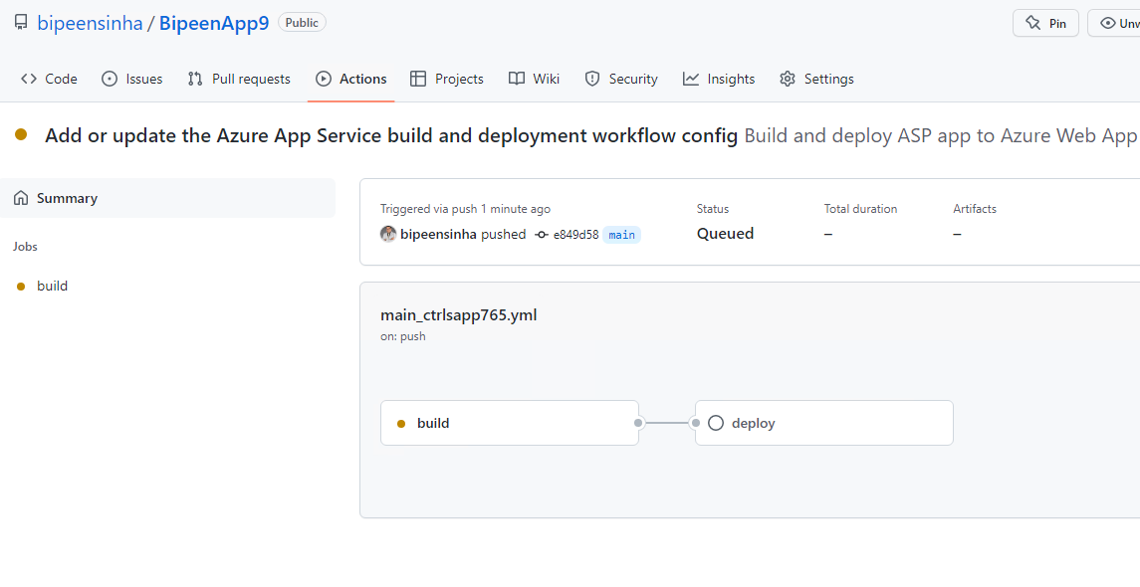
- Click the Build process to see its details

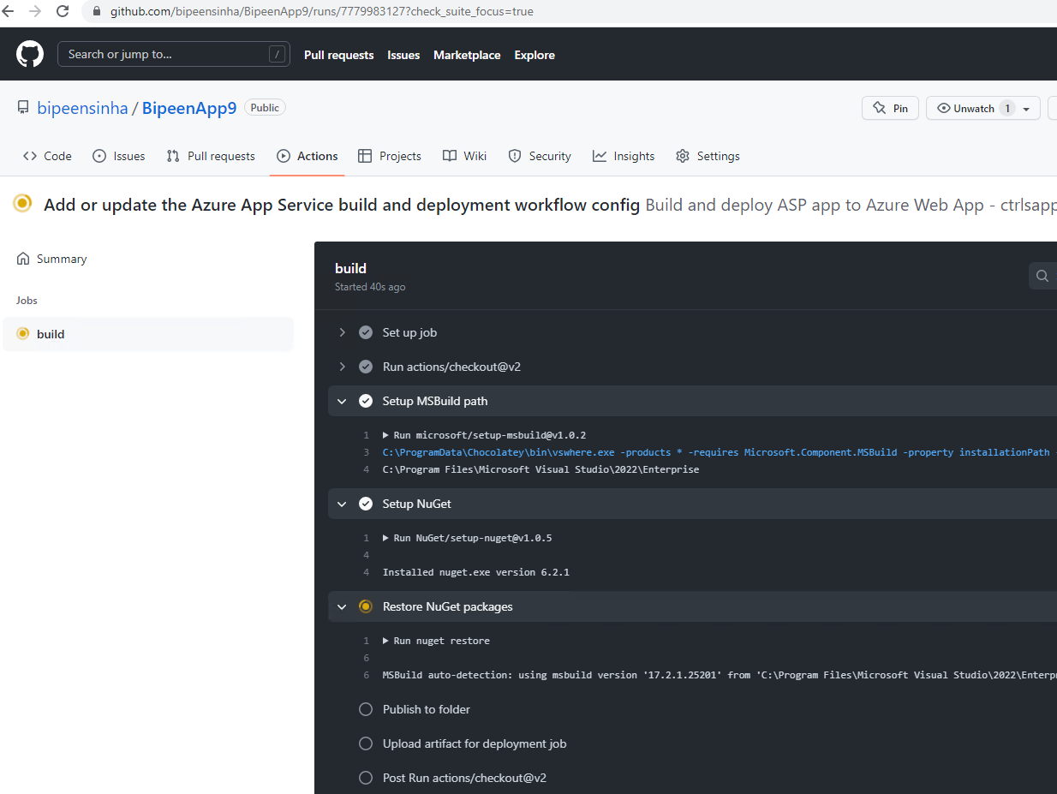
- Once the Build process completed Deploy process should start

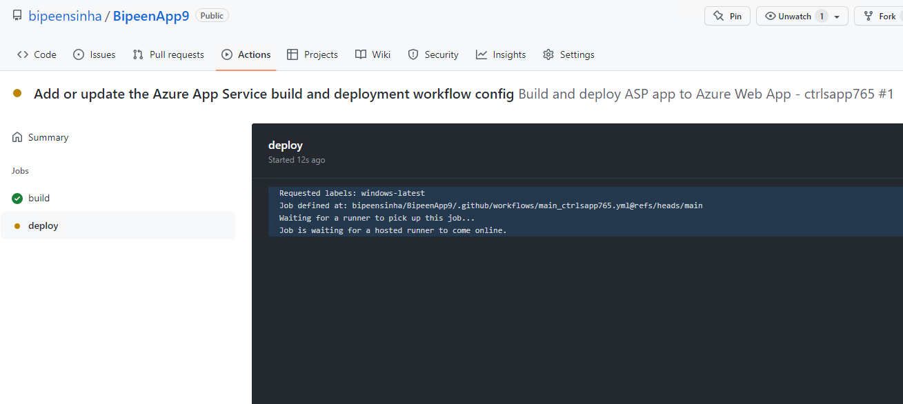

- In few Minutes both Build and deploy Completed

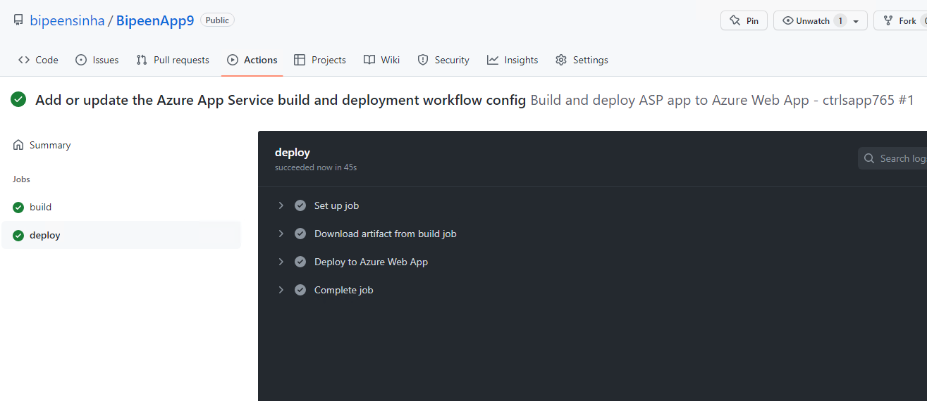

- Now go and Check dev URL

