
Lab Manual- Build and deploy to Azure Kubernetes Service with Azure Pipelines

Table of Contents
1 OBJECTIVE 3
2 PRE-REQUISISTE 3
3 Provision Resource with ARM/Bicep 3
3.1 Get the Code from GitHub 3
3.1.1 Create a Container Registry and Kubernetes Cluster 3
3.2 Create the pipeline 6
3.3 See your app deploy 16
3.4 Clean up resources 18

OBJECTIVE
Use Azure Pipelines to automatically deploy to Azure Kubernetes Service (AKS). Azure Pipelines lets you build, test, and deploy with continuous integration (CI) and continuous delivery (CD) using Azure DevOps.
In this article, you'll learn how to create a pipeline that continuously builds and deploys your app. Every time you change your code in a repository that contains a Dockerfile, the images are pushed to your Azure Container Registry, and the manifests are then deployed to your AKS cluster.

PRE-REQUISISTE
- Accounts in Azure
- A local Computer with 4 CPU, 16 GB RAM, 200 GB disk space

Provision Resource with ARM/Bicep

Get the Code from GitHub
- Fork the following repository containing a sample application and a Dockerfile:
https://github.com/bipeensinha/Azuredevops-Kubernetes

Create a Container Registry and Kubernetes Cluster
- Sign in to the Azure portal,
- Select the Cloud Shell button in the upper-right corner.

- Click create Storage to Initialize the cloudshell

- Run Following Command One after another to get ResourceGroup , Container Registry and Kubernetes Cluster Created.
# Create a resource group
az group create --name myapp-rg --location eastus
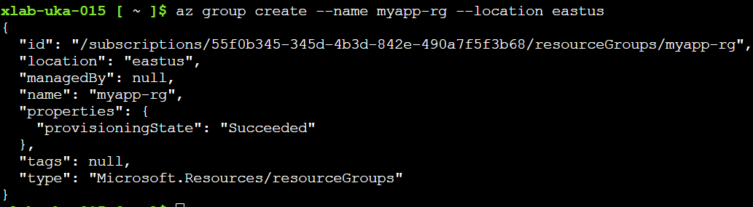
# Create a container registry
az acr create --resource-group myapp-rg --name mycontainerclksegistry --sku Basic
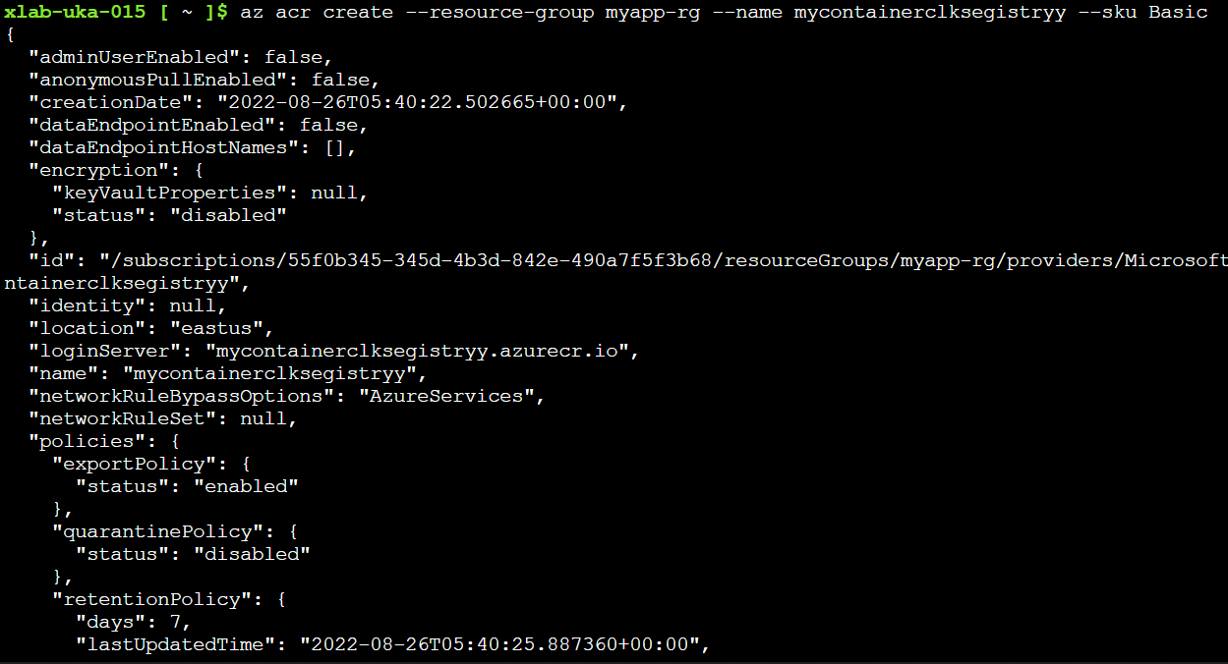

# Create a Kubernetes cluster
az aks create --resource-group myapp-rg --name myapp --node-count 1 --enable-addons monitoring --generate-ssh-keys

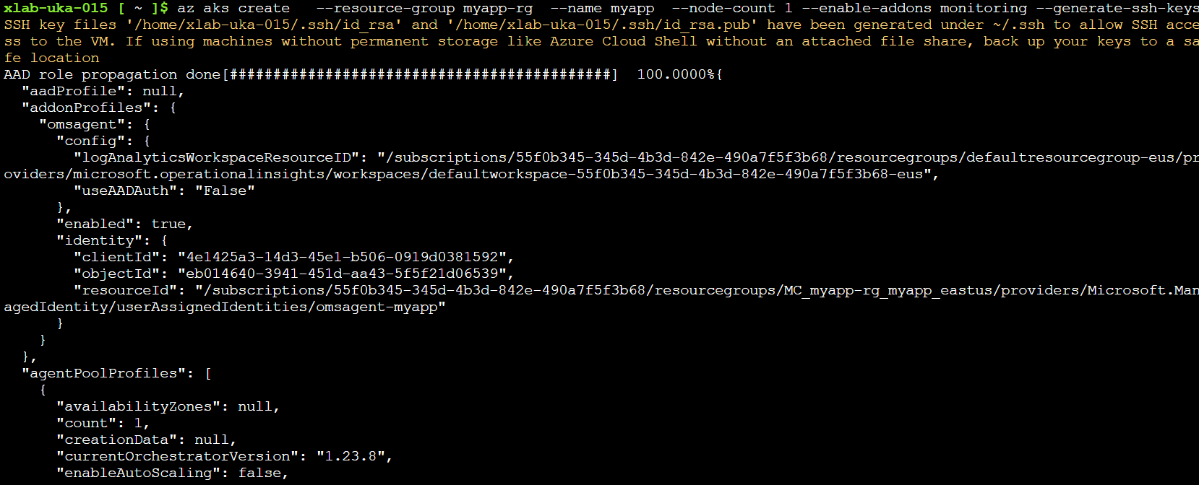
# Attach the Container registry with Kubernetes cluster

az aks update -n myapp -g myapp-rg --attach-acr mycontainerclksegistryy

Create the pipeline
- Sign in to your Azure DevOps organization
- Create New Project.
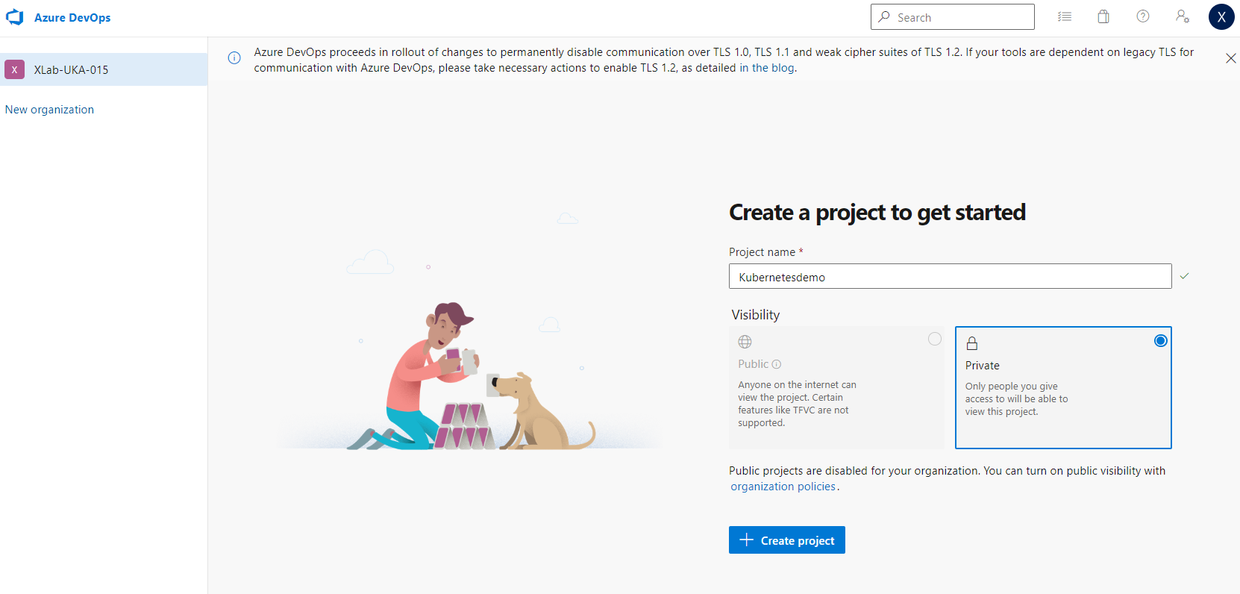
- Go to Pipelines, and then select New pipeline.
- Do the steps of the wizard by first selecting GitHub as the location of your source code.
- You might be redirected to GitHub to sign in. If so, enter your GitHub credentials.
- When you see the list of repositories, select your repository.
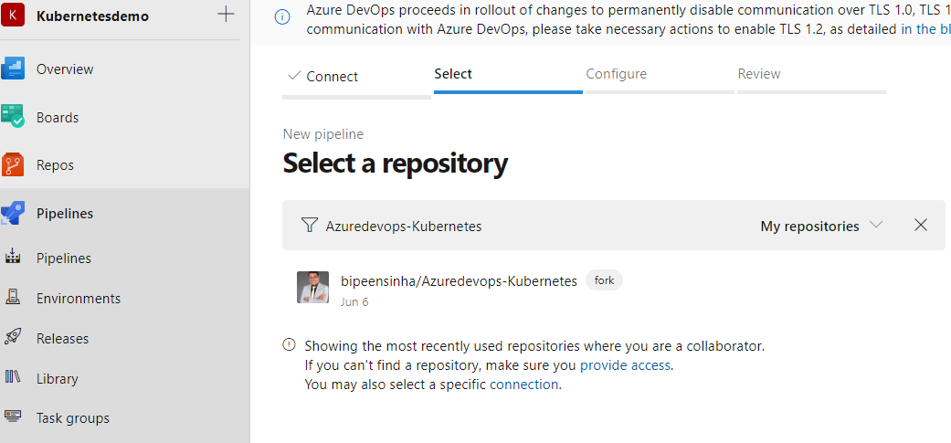
- You might be redirected to GitHub to install the Azure Pipelines app. If so, select Approve & install.
- Select Deploy to Azure Kubernetes Service.
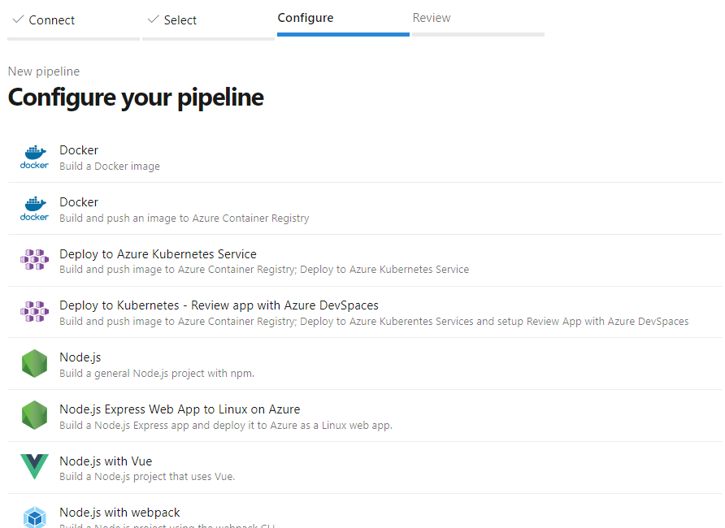

- If you're prompted, select the subscription in which you created your registry and cluster.
- Setu as below
  - Select the myapp cluster.
  - For Namespace, select Existing, and then select default.
  - Select the name of your container registry.
  - You can leave the image name set to the default.
  - Set the service port to 8080.
  - Set the Enable Review App for Pull Requests checkbox for review app related configuration to be included in the pipeline YAML auto-generated in subsequent steps.
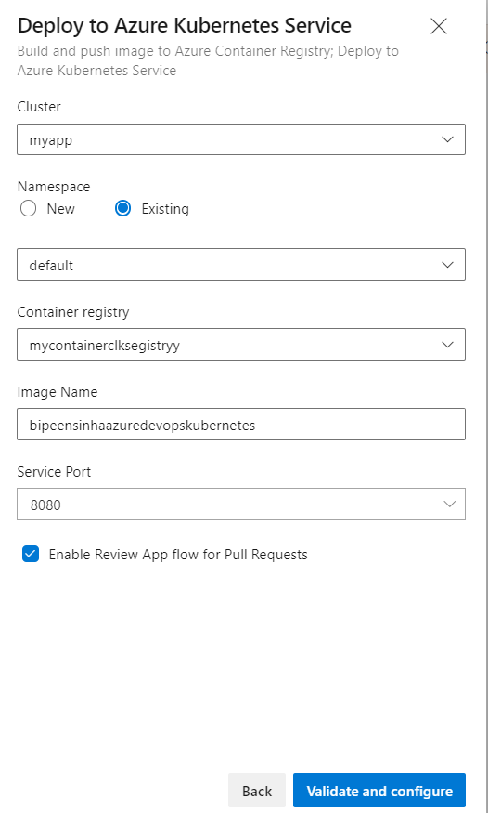
- Select Validate and configure.
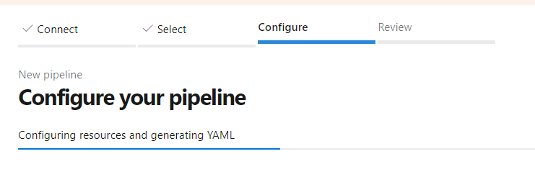

- As Azure Pipelines creates your pipeline, the process will:
  - Create a Docker registry service connection to enable your pipeline to push images into your container registry.
  - Create an environment and a Kubernetes resource within the environment. For an RBAC-enabled cluster, the created Kubernetes resource implicitly creates ServiceAccount and RoleBinding objects in the cluster so that the created ServiceAccount can't perform operations outside the chosen namespace.
  - Generate an azure-pipelines.yml file, which defines your pipeline.
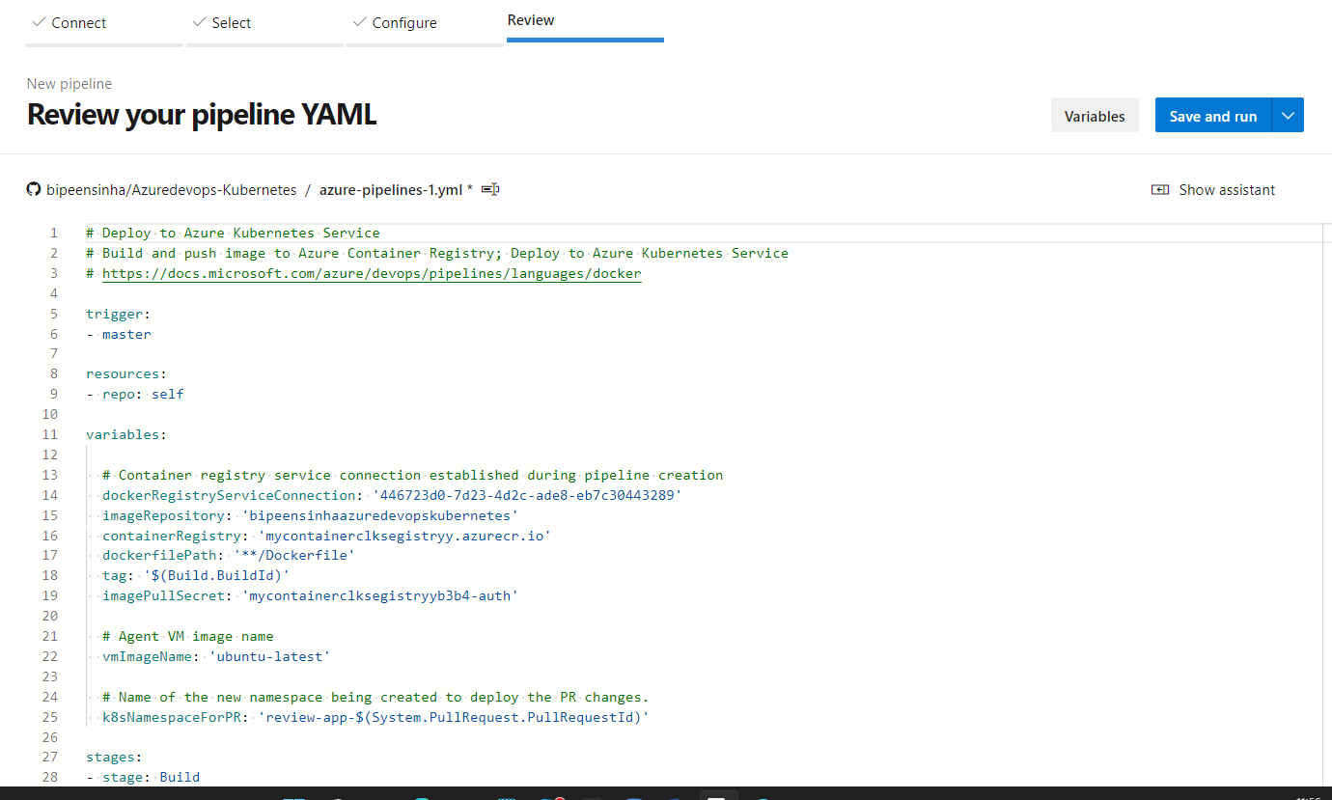
  - Generate Kubernetes manifest files. These files are generated by hydrating the deployment.yml and service.yml templates based on selections you made. When you're ready, select Save and run.
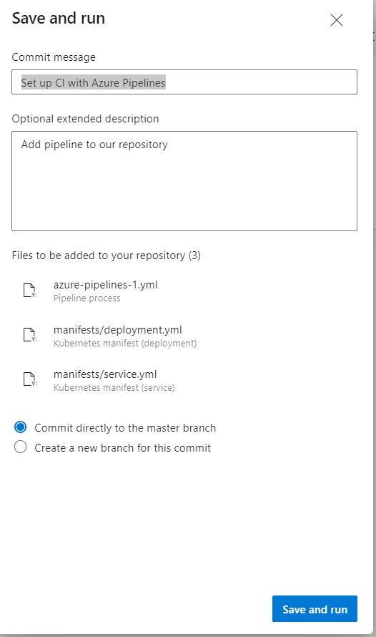
- Select Save and run.

- You can change the Commit message to something like Add pipeline to our repository. When you're ready, select Save and run to commit the new pipeline into your repo, and then begin the first run of your new pipeline!
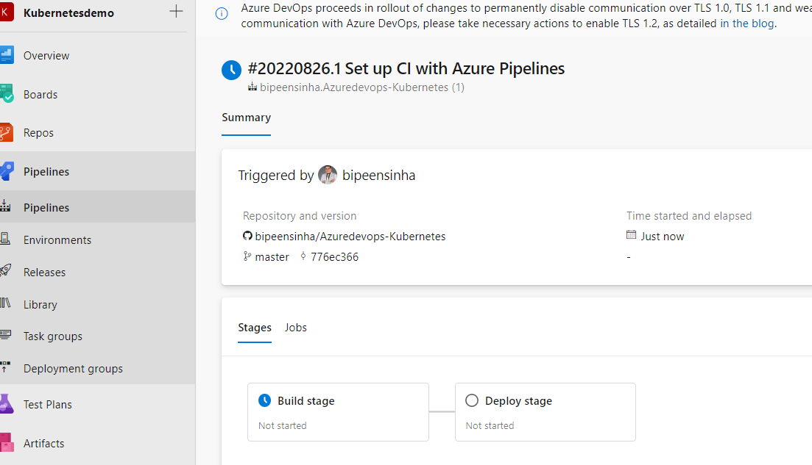

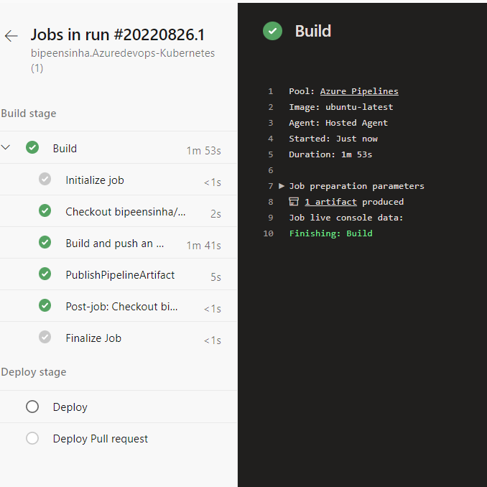

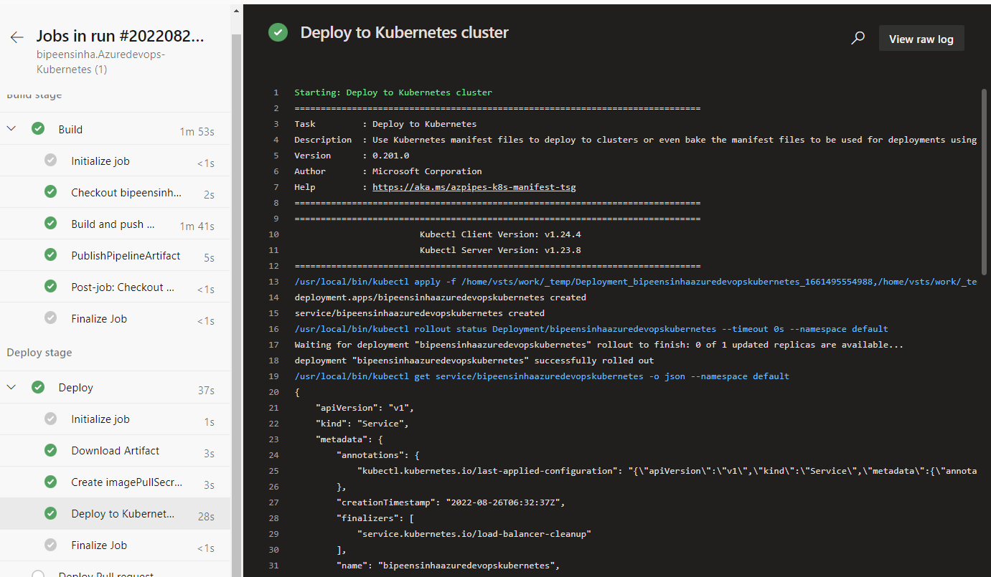

See your app deploy
As your pipeline runs, watch as your build stage, and then your deployment stage, go from blue (running) to green (completed). You can select the stages and jobs to watch your pipeline in action.
After the pipeline run is finished, explore what happened and then go see your app deployed. From the pipeline summary:
- Select the Environments tab.
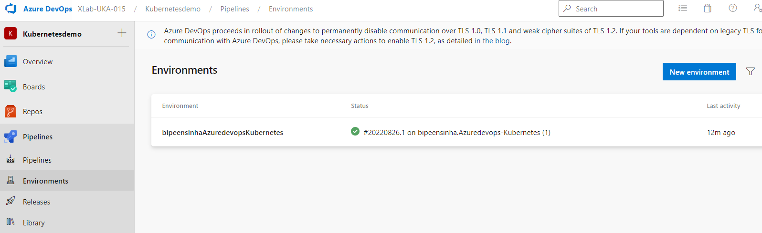
- Select View environment.
- Select the instance of your app for the namespace you deployed to. If you stuck to the defaults we mentioned above, then it will be the myapp app in the default namespace.
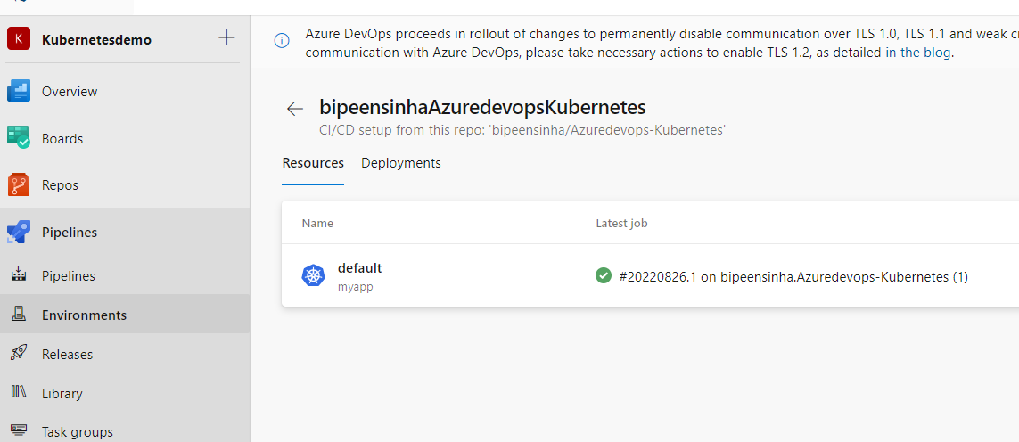
- Select the Services tab.
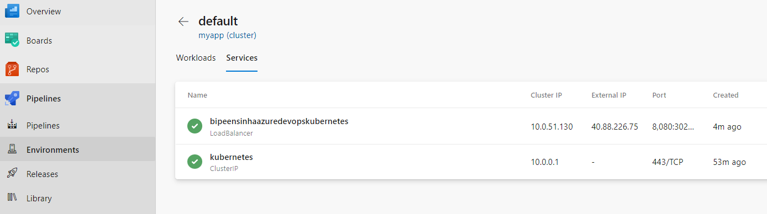

- Select and copy the external IP address to your clipboard.
- Open a new browser tab or window and enter <IP address>:8080.
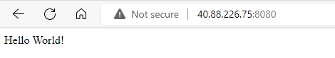
If you're building our sample app, then Hello world appears in your browser.

Clean up resources
Whenever you're done with the resources you created, you can use the following command to delete them:
