

**Lab Manual- AKS Networking Basic Lab**

**Prepared for**:

**Date:** 18th Dec 2023

**Prepared by:**

Document Name: Lab Manual **Document Number** AZLabn916

**Contributor:**

Contents

1. Objective 2

2. Dockerize Frontend and Backend 3

3. Test the Nodeport: 4

4. Test the ClusterIP: 5

5. Test The Loadbalancer: 5

# Objective

In the context of Kubernetes, ClusterIP, NodePort, LoadBalancer, and Headless are different types of services that define how networking is set up for applications. Let's briefly discuss each:

1. **ClusterIP:**
   * **Type:** Default service type.
   * **Usage:** Exposes the service on a cluster-internal IP address.
   * **Access:** Can only be accessed within the cluster.
   * **Typical Use Case:** Used for communication between different parts of an application running in the same cluster.
2. **NodePort:**
   * **Type:** Exposes the service on each Node's IP at a static port.
   * **Usage:** Makes the service accessible on a specified port on every Node in the cluster.
   * **Access:** Allows external access to the service from outside the cluster.
   * **Typical Use Case:** Useful during development or for small-scale deployments where an external load balancer might not be available.
3. **LoadBalancer:**
   * **Type:** Exposes the service externally using a cloud provider's load balancer.
   * **Usage:** Automatically provisions a load balancer for the service.
   * **Access:** Allows external access, similar to NodePort, but with automatic provisioning of an external load balancer.
   * **Typical Use Case:** Suitable for production environments where high availability and scalability are required.

# ClusterIP, NodePort, LoadBalancer

 git clone https://github.com/bipeensinha/aks-network.git

cd aks-network

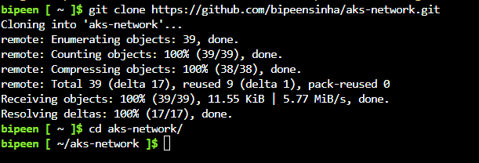

ls -l

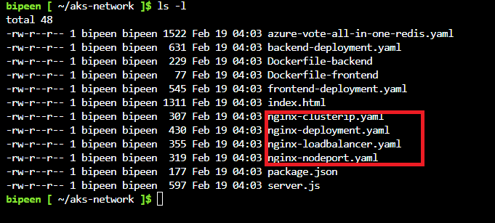

kubectl apply -f nginx-deployment.yaml

kubectl apply -f nginx-clusterip.yaml

kubectl apply -f nginx-loadbalancer.yaml

kubectl apply -f nginx-nodeport.yaml

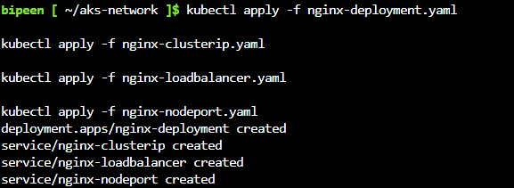

kubectl get po

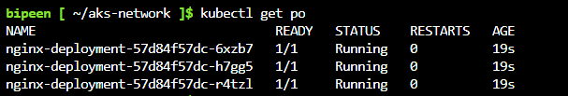

kubectl get svc

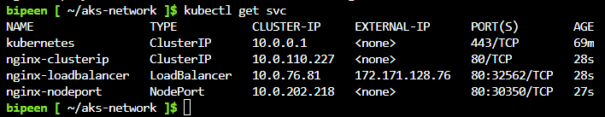

# Test the Nodeport:

kubectl run --restart=Never --image=appropriate/curl curl -- curl http://10.224.0.4:30350

kubectl get po

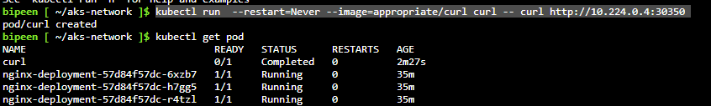

kubectl logs curl

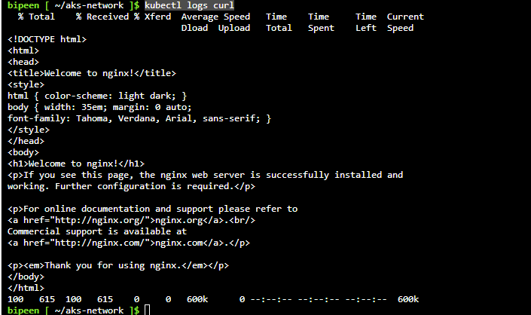

kubectl delete po curl



# Test the ClusterIP:

kubectl get svc



kubectl run --restart=Never --image=appropriate/curl curl -- curl http://nginx-clusterip

kubectl delete po curl

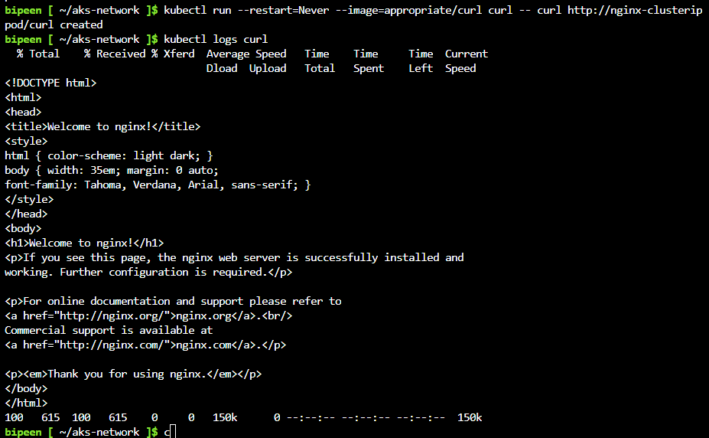

# Test The Loadbalancer:

kubectl get svc



