**Lab Manual- Create and Update AWS S3 with Terraform**

Table of Contents

1 OBJECTIVE 3

2 PRE-REQUISISTE 3

3 Create S3 with Terraform Direct Definition approach 3

4 Create S3 with Terraform Variable 6

# OBJECTIVE

The objective of this exercise is to create an Amazon S3 bucket using Terraform, configure it with appropriate permissions (via ACLs or Object Ownership), and apply tags, while ensuring compliance with AWS best practices.

# PRE-REQUISISTE

* + 1. Login on AWS with cli

**aws configure**

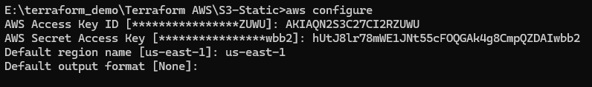

# Create S3 with Terraform Direct Definition approach

1. Create Another Folder and Create **Main.tf** file inside it.

provider "aws" {

region = "us-west-2"

}

# Create the S3 bucket

resource "aws_s3_bucket" "example" {

bucket = "bipeen-bucket-tf"

}

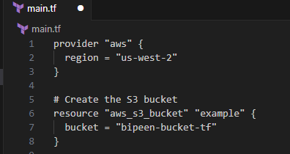

1. Run [terraform init](https://www.terraform.io/docs/commands/init.html)

**terraform init**

1. Run [terraform plan](https://www.terraform.io/docs/commands/plan.html) to create an execution plan.

**terraform plan**

1. Run [terraform apply](https://www.terraform.io/docs/commands/apply.html) to apply the execution plan to your cloud infrastructure.

**terraform Apply**

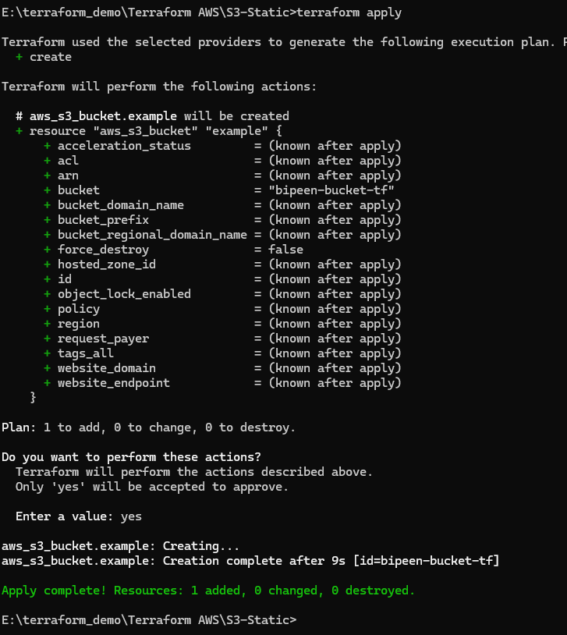

Go to AWS Console and Verify

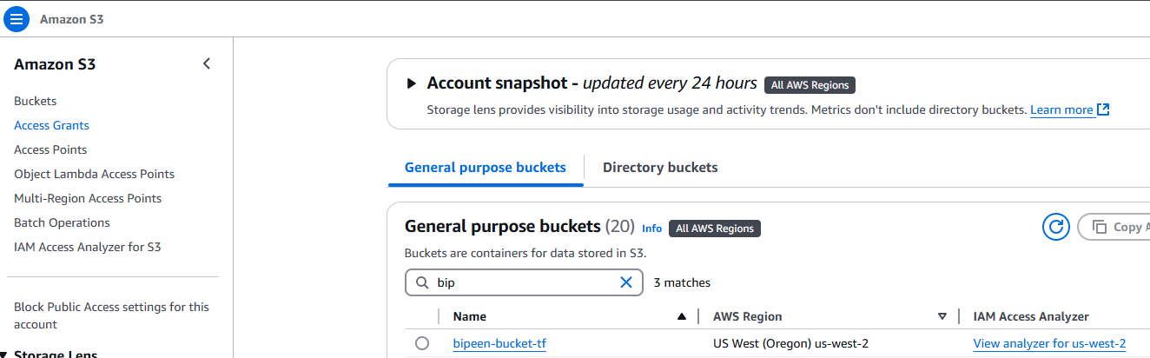

# Create S3 with Terraform Variable

1. Create **Main.tf** with following code

provider "aws" {

region = var.aws_region

}

resource "aws_s3_bucket" "example" {

bucket = var.bucket_name

tags = {

Name = var.bucket_name

Environment = var.environment

}

}

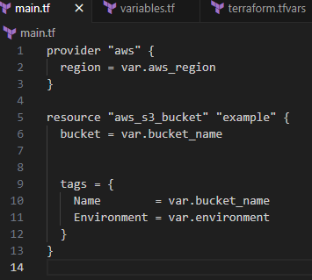

1. Create **variables.tf** with following code

variable "aws_region" {

description = "AWS region"

default = "us-west-2"

}

variable "bucket_name" {

description = "Name of the S3 bucket"

type = string

}

variable "environment" {

description = "Environment name"

default = "Dev"

}

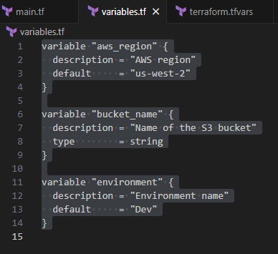

1. Create **terraform.tfvars** with following code

bucket_name = "bipeen-s3-bucket-123"

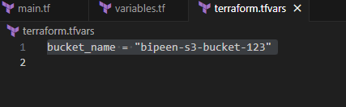

Run Terraform Init , Plan and Then apply

**terraform init**

**terraform plan**

**terraform Apply**

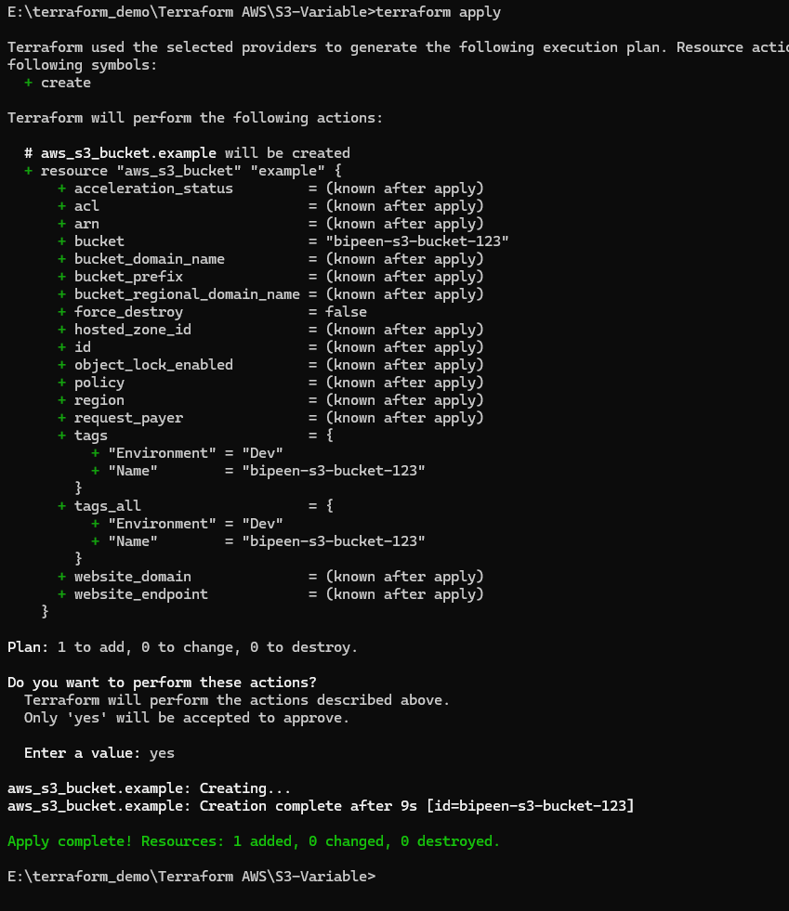

and go to console to verify

