–

Step-by-step walkthrough for Deployment Strategy

**Jenkins Advance**

PREPARED BY:

PREPARED FOR:

**Version:** 1.0  
**Department:** Architect Department  
**Delivery:** End of Month

Table of Contents

**1.** Lab Summary 5

2. Stage 1: Blue-Green Deployment Strategy 5

3. Stage 2: Canary Deployment Strategy 10

4. Stage 3: Rolling Update Strategy 14

# Lab Summary

**This document provides a comprehensive guide to To configure SonarQube with Jenkins and enable both Freestyle and Pipeline jobs to perform Code Quality Analysis using SonarQube**

# Stage 1: Blue-Green Deployment Strategy

Create New Pipeline Project

Paste Script

pipeline {

    agent any

    stages {

        stage('Deploy BLUE') {

            steps {

                echo "=== BLUE-GREEN: Deploy BLUE ==="

                bat '''

                echo Hello from BLUE v1 > current-env.txt

                type current-env.txt

                '''

            }

        }

        stage('Deploy GREEN') {

            steps {

                input message: "Ready to deploy GREEN environment?"

                bat '''

                echo Hello from GREEN v2 > green-env.txt

                type green-env.txt

                '''

            }

        }

        stage('Switch Traffic') {

            steps {

                input message: "Switch traffic from BLUE -> GREEN?"

                bat '''

                copy green-env.txt current-env.txt >nul

                echo Current traffic now points to:

                type current-env.txt

                '''

            }

        }

        stage('Cleanup BLUE') {

            steps {

                input message: "Cleanup BLUE environment?"

                bat 'del green-env.txt >nul'

            }

        }

    }

    post {

        always {

            bat 'del current-env.txt 2>nul'

            echo "Demo cleaned up!"

        }

    }

}

Now go TO Console Output , it approve the green deployment

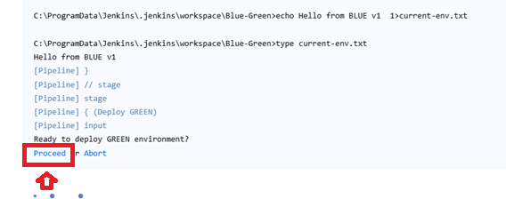

approve the Switch Traffic from Blue to Green

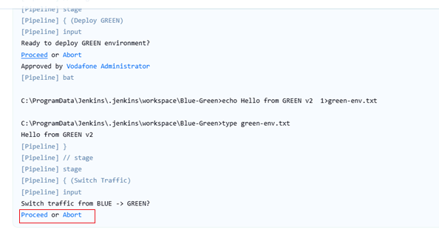

approve the Cleamup

# Stage 2: Canary Deployment Strategy

Paste Script

pipeline {

    agent any

    stages {

        stage('Deploy Stable') {

            steps {

                echo "=== CANARY: Stable v1 ==="

                bat '''

                echo Hello from STABLE v1 > stable.txt

                type stable.txt

                '''

            }

        }

        stage('Deploy Canary') {

            steps {

                input message: "Deploy CANARY v2 (10% traffic)?"

                bat '''

                echo Hello from CANARY v2 > canary.txt

                echo Simulating traffic split (4 stable, 1 canary):

                type stable.txt

                type stable.txt

                type stable.txt

                type stable.txt

                type canary.txt

                '''

            }

        }

        stage('Increase Canary') {

            steps {

                input message: "Increase CANARY to 50%?"

                bat '''

                echo Simulating 50-50 traffic:

                type stable.txt

                type canary.txt

                type stable.txt

                type canary.txt

                '''

            }

        }

        stage('Promote Canary') {

            steps {

                input message: "Promote CANARY to 100% (make stable)?"

                bat '''

                copy canary.txt stable.txt >nul

                type stable.txt

                del canary.txt >nul

                '''

            }

        }

    }

    post {

        always {

            bat 'del stable.txt 2>nul'

            echo "Demo cleaned up!"

        }

    }

}

Approve to Switch 10% Traffic

Approve to Switch 50% Traffic

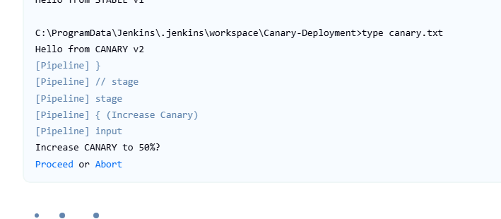

Approve to Switch 100% Traffic

# Stage 3: Rolling Update Strategy

Paste Script

pipeline {

    agent any

    stages {

        stage('Start v1 Servers') {

            steps {

                echo "=== ROLLING UPDATE: v1 ==="

                bat '''

                echo Hello from SERVER1 v1 > s1.txt

                echo Hello from SERVER2 v1 > s2.txt

                echo Hello from SERVER3 v1 > s3.txt

                type s1.txt & type s2.txt & type s3.txt

                '''

            }

        }

        stage('Update Server 1') {

            steps {

                input message: "Update SERVER1 to v2?"

                bat 'echo Hello from SERVER1 v2 > s1.txt & type s1.txt'

            }

        }

        stage('Update Server 2') {

            steps {

                input message: "Update SERVER2 to v2?"

                bat 'echo Hello from SERVER2 v2 > s2.txt & type s2.txt'

            }

        }

        stage('Update Server 3') {

            steps {

                input message: "Update SERVER3 to v2?"

                bat 'echo Hello from SERVER3 v2 > s3.txt & type s3.txt'

            }

        }

    }

    post {

        always {

            bat 'del s1.txt s2.txt s3.txt 2>nul'

            echo "Demo cleaned up!"

        }

    }

}

Approve Server 1 Update

Approve Server2 Update

Approve Server 3 Update

