–

Step-by-step walkthrough for Docker Container Build and Run

**Jenkins Advance**

PREPARED BY:

PREPARED FOR:

**Version:** 1.0  
**Department:** Architect Department  
**Delivery:** End of Month

Table of Contents

**1.** Lab Summary 3

2. Stage 1:Install Docker Engine on Windows VM 3

3. Stage 2: Test Image Locally 6

4. Stage 3: Configure Jenkins Pipeline 8

# Lab Summary

**This document provides a comprehensive guide to To configure SonarQube with Jenkins and enable both Freestyle and Pipeline jobs to perform Code Quality Analysis using SonarQube**

# Stage 1:Install Docker Engine on Windows VM

* **Enable Hyper-V**

dism.exe /Online /Enable-Feature:Microsoft-Hyper-V /All

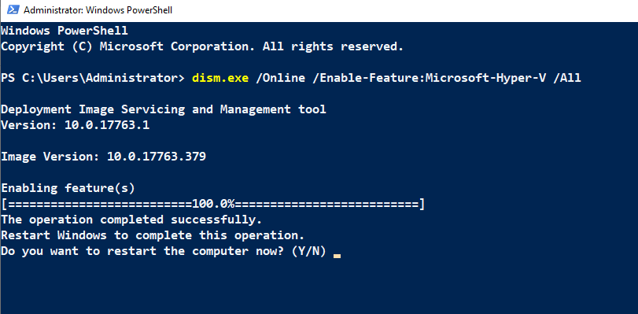

* **Restart Server**

* **Install Docker Engine (no Desktop)**

Install-WindowsFeature -Name Containers

* **Restart Server**

Install-WindowsFeature -Name Hyper-V -IncludeManagementTools

[Net.ServicePointManager]::SecurityProtocol = [Net.SecurityProtocolType]::Tls12



Install-Module -Name DockerMsftProvider -Repository PSGallery -Force

Type Y to Yes

* **Download Docker CE MSI manually:**
* Visit Docker CE for Windows Server and download the latest Docker installer.

[raw.githubusercontent.com/microsoft/Windows-Containers/Main/helpful_tools/Install-DockerCE/install-docker-ce.ps1](https://raw.githubusercontent.com/microsoft/Windows-Containers/Main/helpful_tools/Install-DockerCE/install-docker-ce.ps1)

* Save this script in Jenkins server with ps1 extension
* Temporarily bypass the restriction by running PowerShell with a relaxed execution policy just for this session:

Set-ExecutionPolicy -Scope Process -ExecutionPolicy Bypass

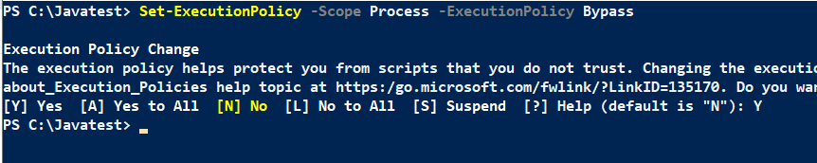

* Then run your script

.\install-docker-ce.ps1

* **After installation, restart your server.**

Now test

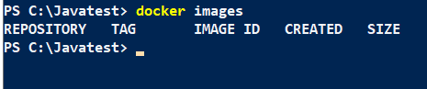

# Stage 2: Test Image Locally

Create a Folder **dockerdemo** in C:\ and Launch VS Code

Place Dockerfile and index.html there.

# Just use the existing Windows base image and rebuild it locally

FROM bipeen2001/devops:dotnet

Test Locally

cd /

cd C:\dockerdemo



docker pull bipeen2001/devops:dotnet

docker run -it -p 8081:80 bipeen2001/devops:dotnet

# Stage 3: Configure Jenkins Pipeline

node {

    def imageName = "my-dotnet"

    def tag = "v${env.BUILD_NUMBER}"

    def fullImage = "${imageName}:${tag}"

    def testPort = "8086"

    stage('Build Image') {

        bat "docker build -t ${fullImage} C:\\dockerdemo"

    }

    stage('Run Container') {

        bat "docker rm -f dotnetdemo || ver>nul"

        bat "docker run -d --name dotnetdemo -p ${testPort}:80 ${fullImage}"

        bat 'powershell -NoLogo -NoProfile -Command "Start-Sleep -Seconds 5"'

    }

    stage('Smoke Test') {

        bat """powershell -NoLogo -NoProfile -Command "Invoke-WebRequest http://localhost:${testPort}/ -UseBasicParsing | Select-Object -ExpandProperty StatusCode" """

    }

    stage('Manual Approval to Cleanup') {

        input message: "App is running at http://localhost:${testPort}. Test manually and click Proceed to cleanup.", ok: "Proceed"

    }

    stage('Cleanup') {

        bat "docker rm -f dotnetdemo || ver>nul"

    }

}

Waiting for Manual Approval to clean up

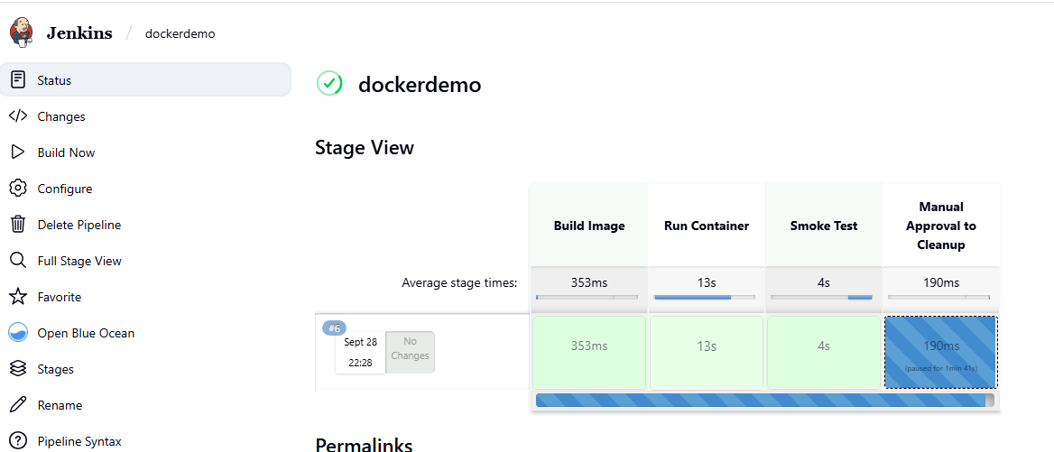

Check Console Output and Copy and Run the URL

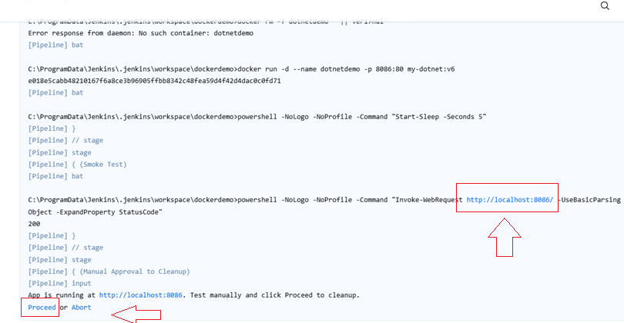

Copy and Run the URL in Browser

Now do the Cleanup

