1. How to list the files in Linux?

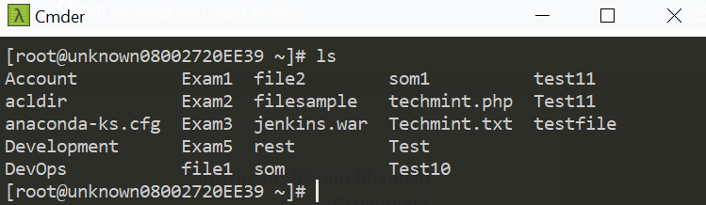

1. How to list the files based on the size in Linux?

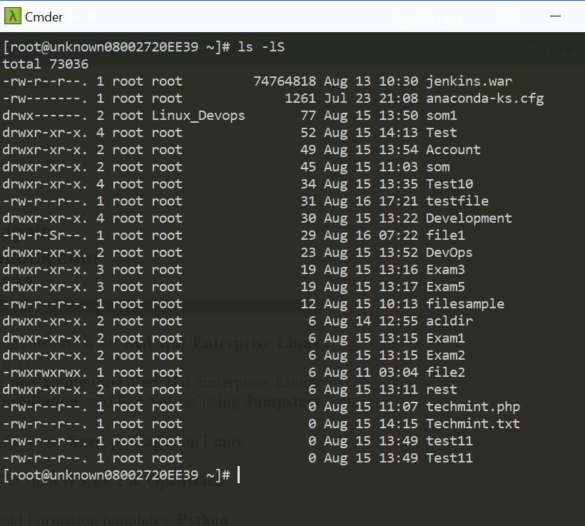

1. How to list the last modified files at the bottom of the list on Linux?

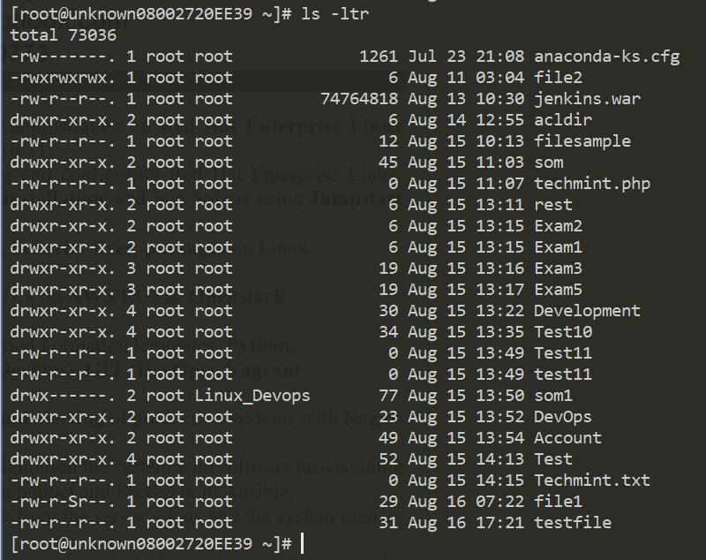

1. How to show the hidden files in Linux?

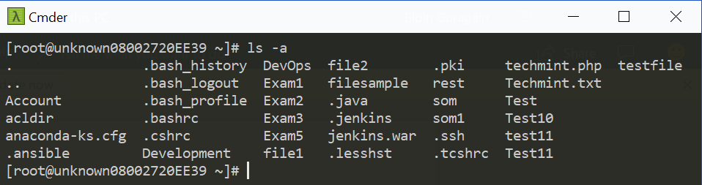

1. How to list the files in the long listing?

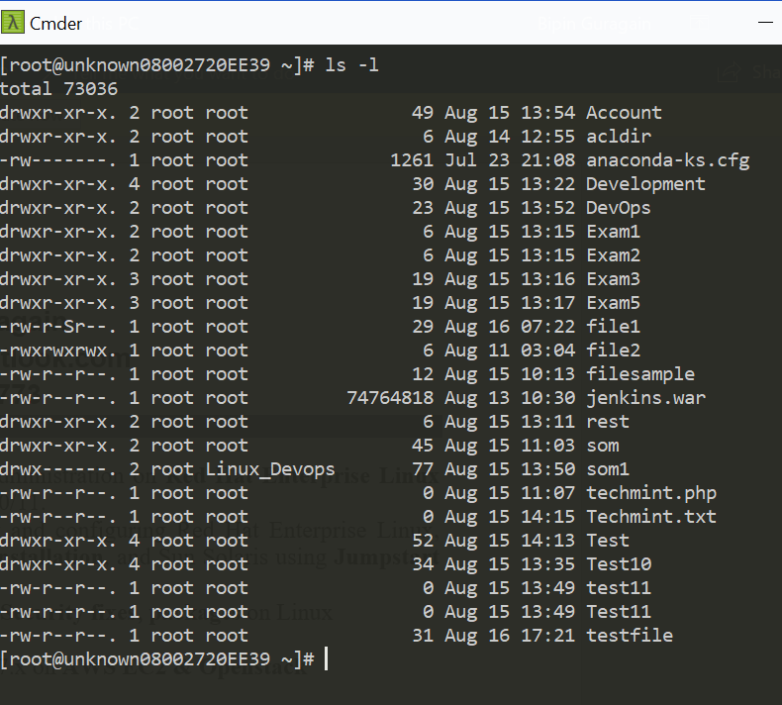

1. How to list the files in the human readable format?

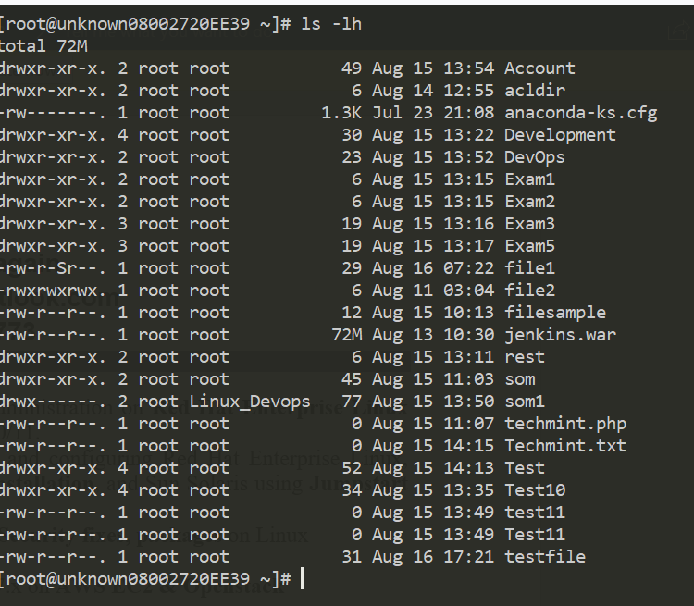

1. How to list the contents of the directory and so on?

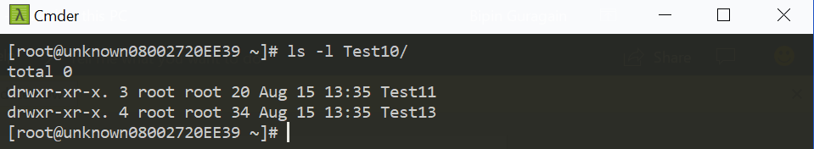

1. How to differentiate the files vs directory from the list command?

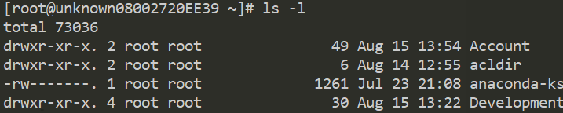

1. How to create the directory in Linux?



1. How to create the five directory test1, test2 …test5 from the single command in linux

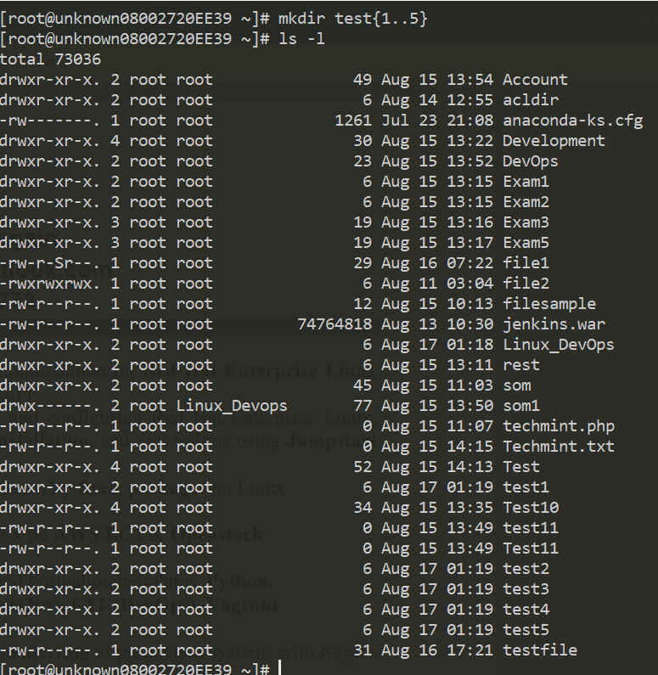

1. How to create the 100 directory test1, test2 …test100 from the single command in Linux?

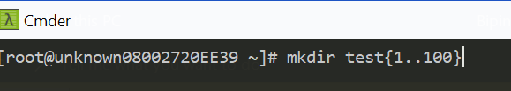

1. How to create multiples directory test1 and test2 inside the test 3?
2. How to create the test1 inside test2 and test3 inside test2?

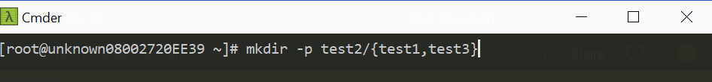

1. How to create the directory test6 with the permission 700?



1. How to rename the file in Linux?

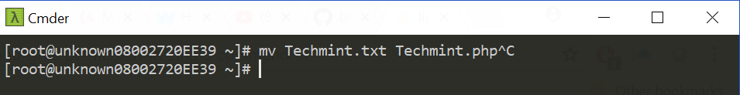

1. How to move the file from /tmp to /opt?

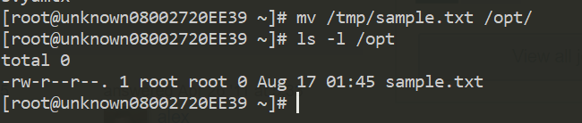

1. How to move the file test1, test2, test3 from /opt to /etc?

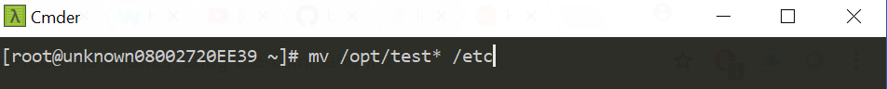

1. How to delete the file?

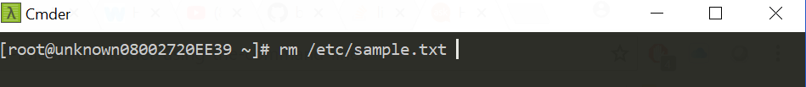

1. How to delete the directory?

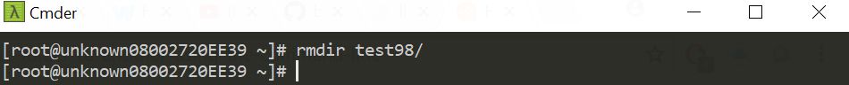

1. How to delete the directory and the contents of the directory?

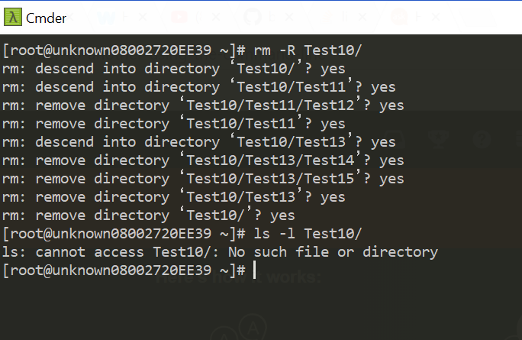

1. Delete the directory test1 and its contents file1 and file2 in the interactive mode?

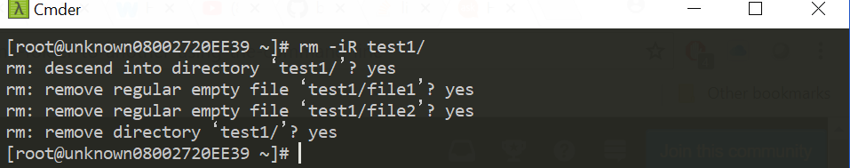

1. How to cp file named usa from /var to /bin

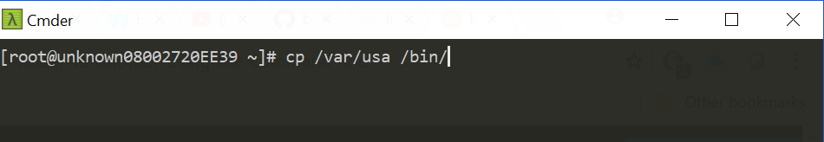

1. How to cp directory Canada with multiple files inside it from /home to /root?

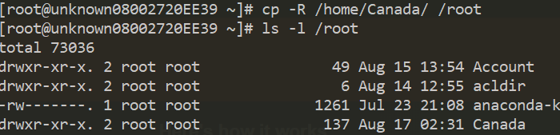

1. Display only first 5 lines from the text file?

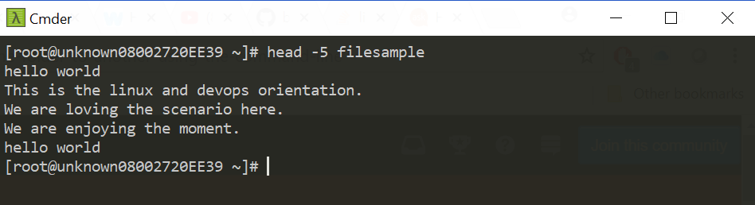

1. Display only last 5 lines from the text file?

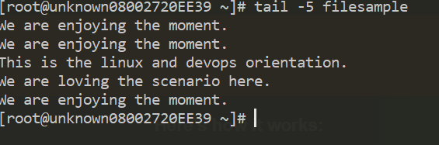

1. Display the contents from Line 8 till 15 from the file?

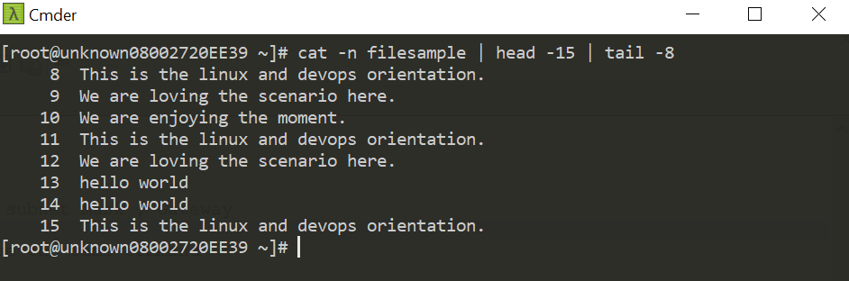

1. How to display the continuous flow of the logs?

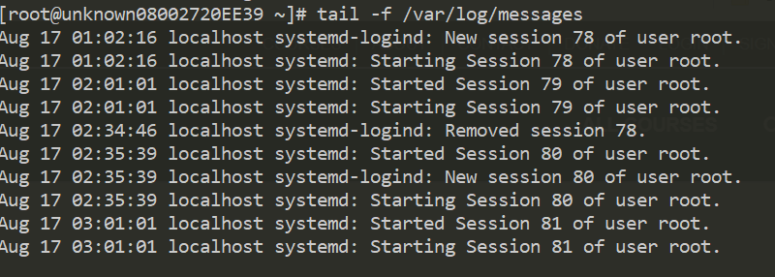

1. How to change the directory level backward?

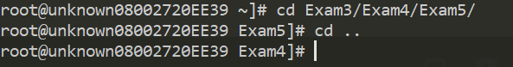

1. How to change the directory forward?

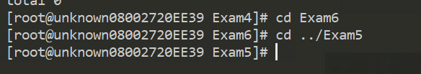

1. How to jump into the last directory?



1. Display the line from 14 and onwards in Linux?

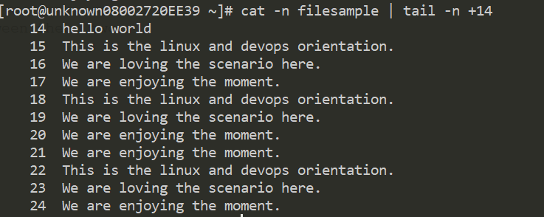

1. Display the contents of the file in the page like structure?
2. Display the contents of the file in the page like structure and search for the word error on it?

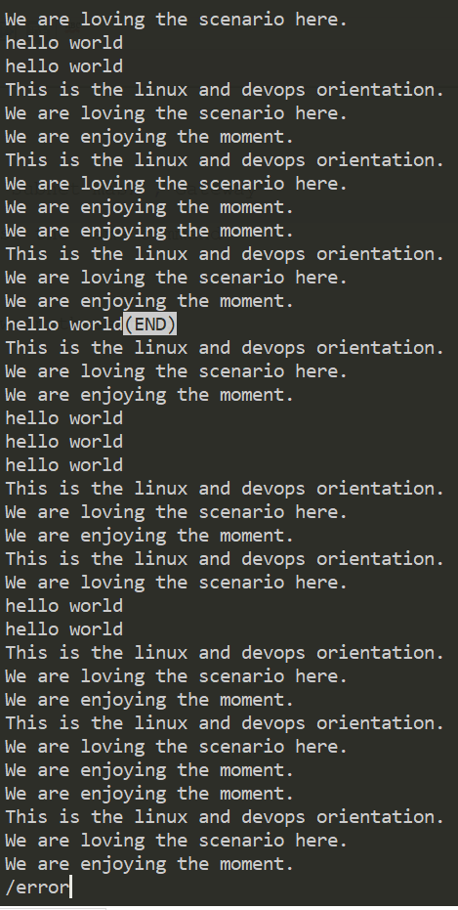

1. How to count the no of sentence in the file?

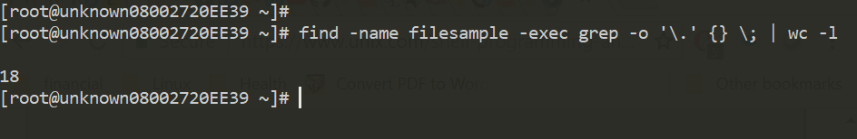

1. How to count the no of words in the file?
2. How to count the no of char in the file?

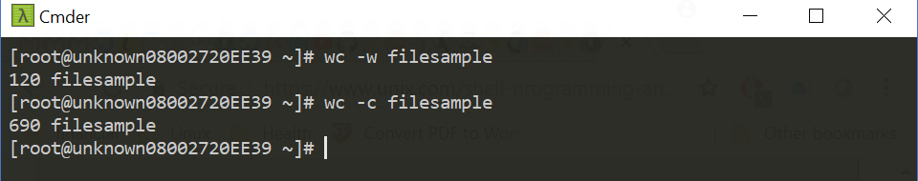

1. How to display the contents of the file?
2. How to create the file and add the contents without opening the file?
3. How to append the contents without opening the file?

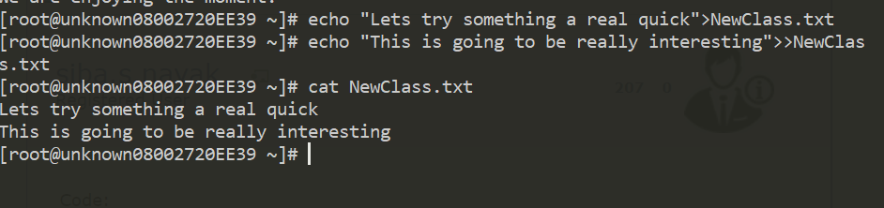

1. What does the PWD stands for and what it us use for?

PWD stands for present working directory and it is used to check what is our current working directory in a shell.

1. What is / in Linux?

/ is the root of the whole OS. No one can modified the contents of the root unless you are logged in as root user or have sudo privileges.

1. What is ~ in Linux?

~ is the home directory of the logged in user. If the user is logged in as Jenkins then the home directory for the Jenkins will be /home/Jenkins.

1. How to look for the last 10 command typed in Linux?

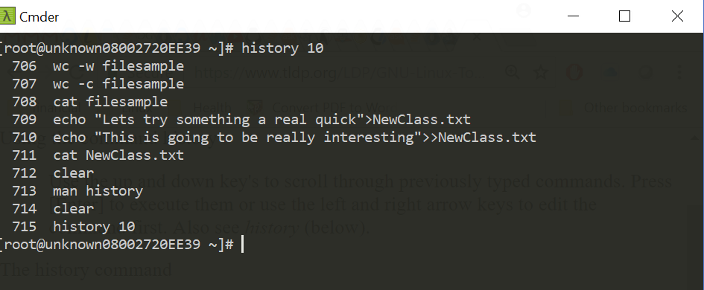

1. What is $, >>,> in Linux?

$ is usually for assigning variables.>> is used to redirect the output and append it to the file.> is used to overwrite the contents of the file.

1. What is exit code status in Linux?

Exit code status gives the result of the code being successfully completed or not. 0 is on successful completetion whereas 1 is on error code status.

1. What is the home directory for the root user?

/root is the home directory for the root user.

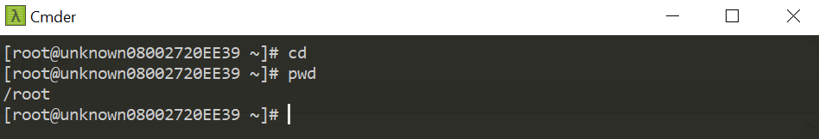

1. How to view the contents of the root directory?

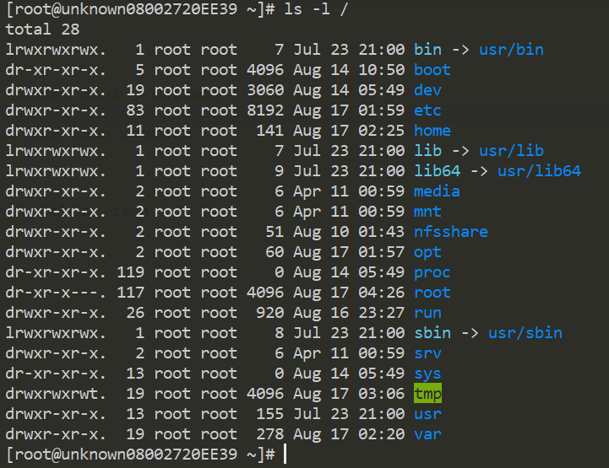

1. What is /bin and /sbin used for ?

/bin

This directory contains executable programs which are needed

in single user mode and to bring the system up or repair it.

/sbin

Like /bin, this directory holds commands needed to boot the

system, but which are usually not executed by normal users.

1. What is the /lib and /lib64 used for?

The difference is in 32bit verse 64bit architecture on the libraries. so /lib is 32 bit and the /lib64 are 64 bit libraries used for 64 bit applications etc.

What is the location of the root directory of the entire system?

/

What is the symbol of the home directory?

~

What is the symbol for the root directory?

/root